Table 5. GRADE assessment for RCTs
Table 6. MINORS Assessment Tool for the non-RCT studies.

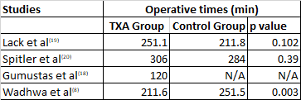
Table 8- Average operative times in individual studies.

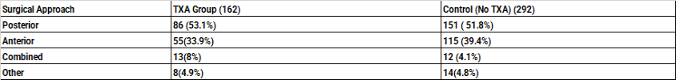Table 9- Surgical approach utilised in the different studies

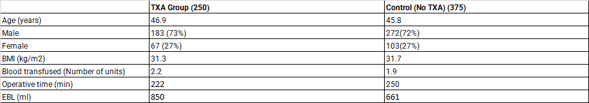Table 10- Average cumulative Pooled Data from the studies

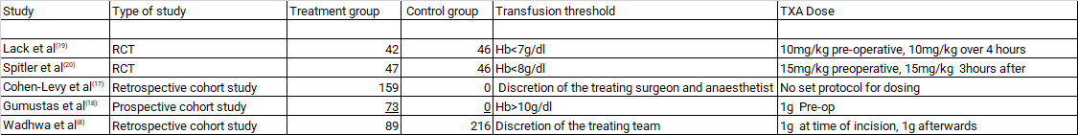
Table 11- Characteristics of the study highlighting the transfusion thresholds

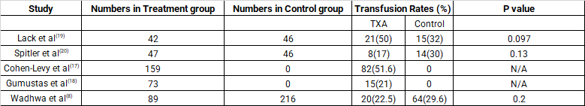
Table 12-Rates of transfusion in the different studies

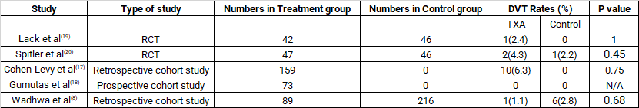
Table 13- DVT Rates in the different studies

