Supplementary tables
Table.S1 independent genetic loci associated with HDL, LDL, TG and TC in individuals of African ancestry for meta-analysis of genome-wide association studies.

Table.S2 Independent genetic loci associated with HDL, TG and TC in individuals of African ancestry for MTAG analysis.

Tables.S3 Comparison of MTAG novel loci among individuals of African ancestry, GLGC European and East Asian ancestry

Tables.S4 Fine mapping between multi-trait fine-mapping and single-trait fine-mapping

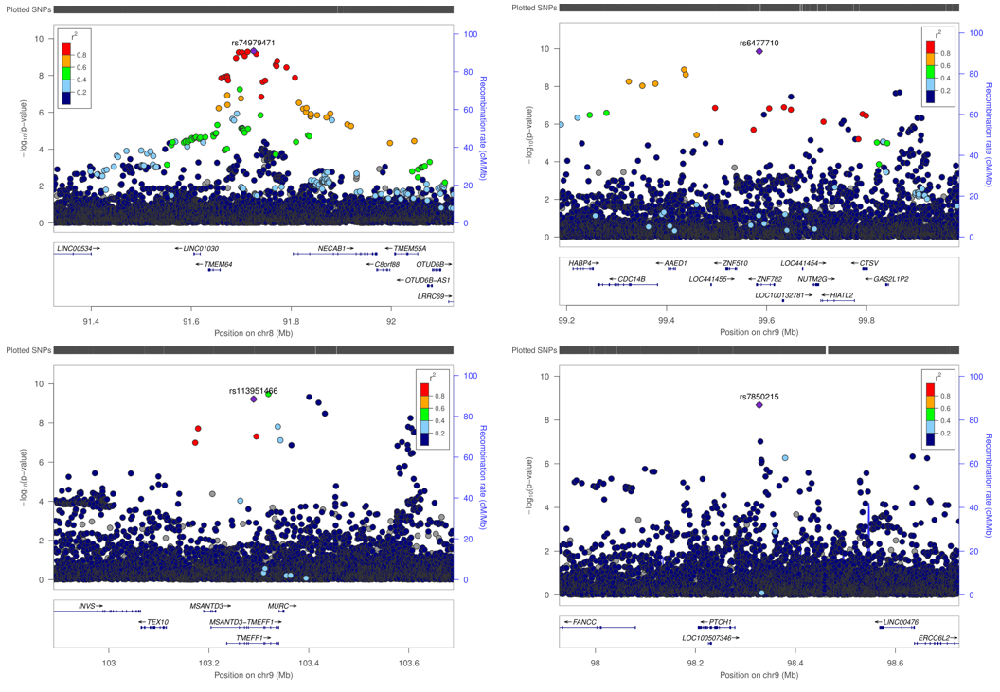
Supplementary figures

Fig.S1 Locus zoom plot for top novel loci associated with lipid traits in individuals of African ancestry from the MTAG analysis

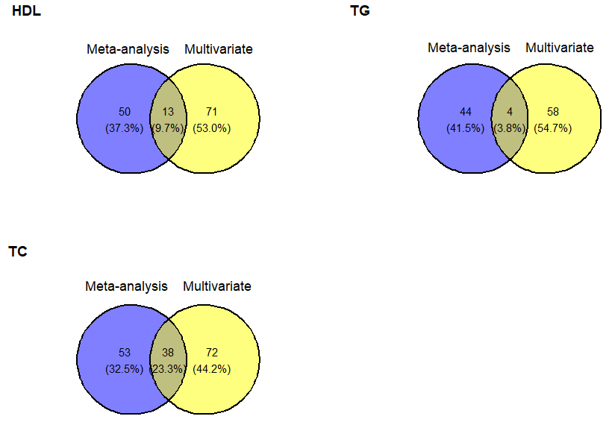

Fig.S2 Venni diagram comparing the number of independent genetic loci associated with lipid traits identified by meta-analysis and MTAG approach in individuals of African ancestry.

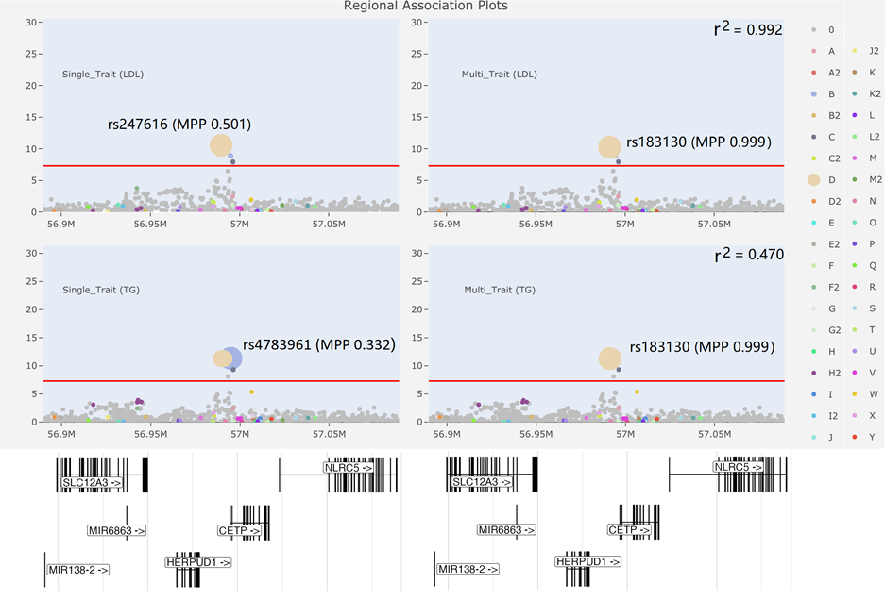

Fig.S3 Regional association plots of 16:56889590-57089590 for LDL and TG, integrated with fine-mapping MPP. We display p-values by location height (y-axis) and MPP by diameter of the points. Variants that are the same colour may be thought of as interchangeable and are said to belong to the same SNP group; variants in different groups have r²>0.6 and rarely appear in a model together. This figure was generated using the web tool flashfm-ivs (http://shiny.mrc-bsu.cam.ac.uk/apps/flashfm-ivis/ )

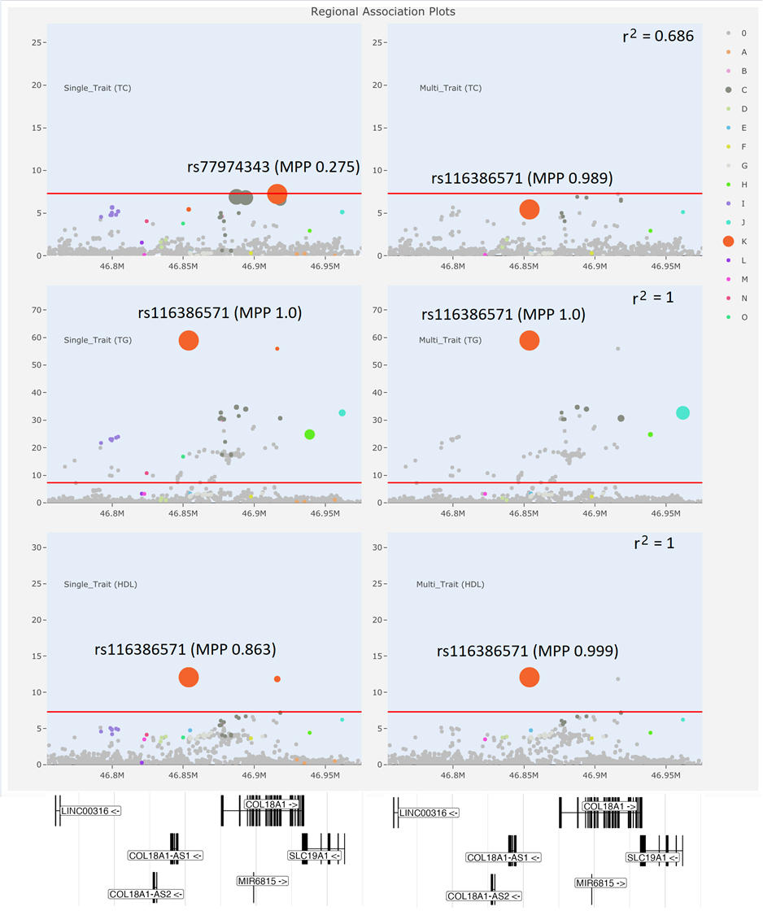
Fig.S4 Regional association plots of 21:46753876-46975775 for TC, TG, and HDL, integrated with fine-mapping. We display p-values by location height (y-axis) and MPP by diameter of the points. Variants that are the same colour may be thought of as interchangeable and are said to belong to the same SNP group; variants in different groups have r²>0.6 and rarely appear in a model together. This figure was generated using the web tool flashfm-ivs (http://shiny.mrc-bsu.cam.ac.uk/apps/flashfm-ivis/ )

