Article Title: Targeted alpha immunotherapy of CD20-positive B-cell lymphoma model: Dosimetry estimate of ²²⁵Ac-DOTA-rituximab using ⁶⁴Cu-DOTA-rituximab
Journal Name: EJNMMI Physics
Author names: Chul-Hee Lee, Ilhan Lim, Sang-Keun Woo, Wook Kim, Kwang Il Kim, Kyo Chul Lee, Kanghyon Song, Sang Moo Lim
Affiliation and e-mail address of the corresponding author:
a
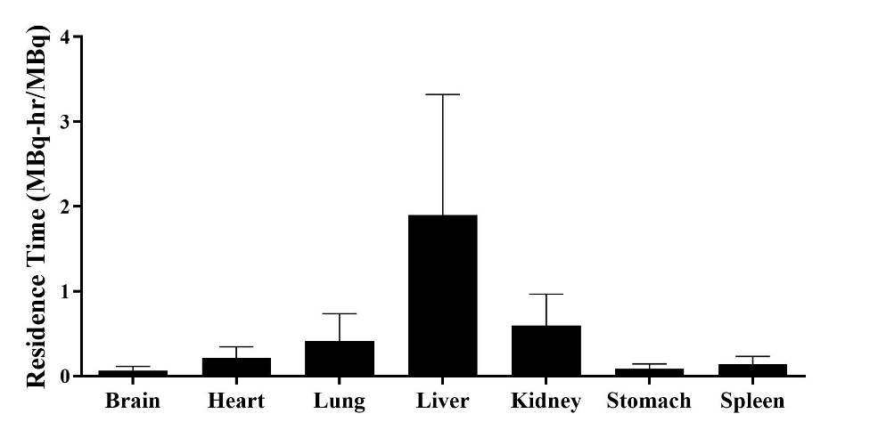
b
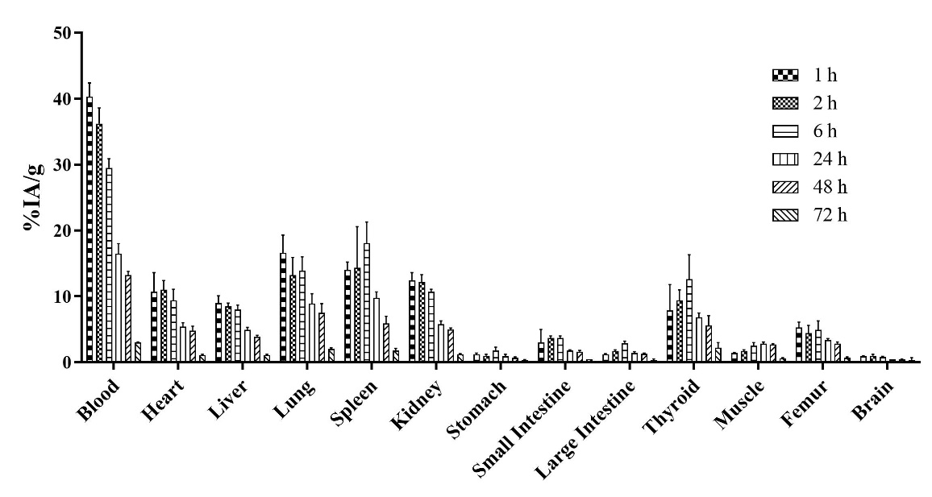
Supplementary fig. 3 Biodistribution study and estimation of radiation dose for clinical trials. a Accumulation pattern of ⁶⁴Cu-DOTA-rituximab in normal mice (n=4) at various time points. b Estimation of residence time of representative organs

