Article Title: Targeted alpha immunotherapy of CD20-positive B-cell lymphoma model: Dosimetry estimate of ²²⁵Ac-DOTA-rituximab using ⁶⁴Cu-DOTA-rituximab
Journal Name: EJNMMI Physics
Author names: Chul-Hee Lee, Ilhan Lim, Sang-Keun Woo, Wook Kim, Kwang Il Kim, Kyo Chul Lee, Kanghyon Song, Sang Moo Lim
Affiliation and e-mail address of the corresponding author:

a b
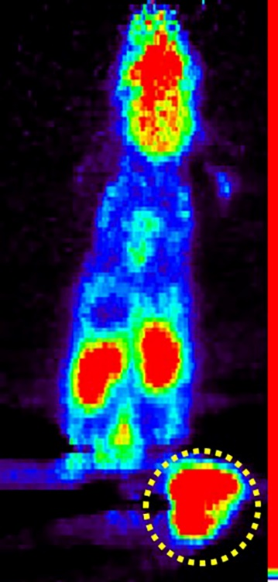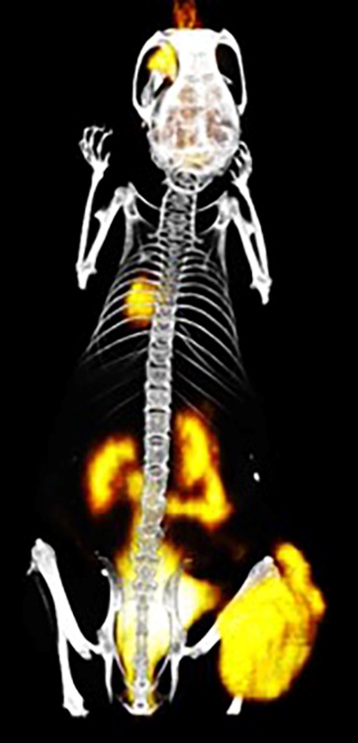

Supplementary fig.2 In vivo lymphoma models and ¹⁸F-FDG PET/CT imaging a Representative ¹⁸F-FDG PET imaging 1 h after i.v. injection. b Representative PET/CT imaging using 3D visualization software

