Solar overall water-splitting by a spin-hybrid all-organic semiconductor
Xinyu Lin¹, Yue Hao¹, Yanjun Gong², Peng Zhou³, Dongge Ma⁴, Zhonghuan Liu¹, Yuming Sun¹, Hongyang Sun¹, Yahui Chen¹, Shuhan Jia¹, Wanhe Li¹, Chengqi Guo¹, Yiying Zhou¹, Pengwei Huo¹, Yan Yan^{1*}, Wanhong Ma^{2*}, Shouqi Yuan^{1*}, Jincai Zhao²
¹School of Chemistry & Chemical Engineering/Research Center of Fluid Machinery Engineering and Technology, Jiangsu University, Zhenjiang, China, 212013.
²Key Laboratory of Photochemistry, Institute of chemistry, Chinese Academy of Sciences, Beijing, China, 100190; University of Chinese Academy of Sciences, Beijing, China, 100049.
³Electrical Engineering & Computer Science, University of Michigan, Michigan, USA, 48109-2122.
⁴Department of Chemistry, College of Chemistry and Materials Engineering, Beijing Technology and Business University, Beijing, China, 100048.

Corresponding authors:
Prof. Yan Yan (dgy5212004@163.com)
Prof. Wanhong Ma (whma@iccas.ac.cn)
Prof. Shouqi Yuan (shouqiy@ujs.edu.cn)

Supplementary Figures

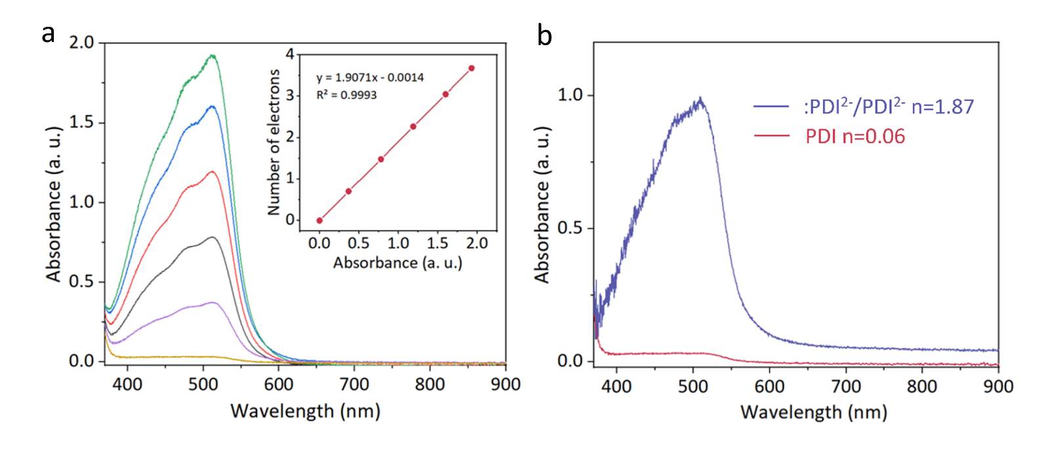
Supplementary Fig. 1. (a) Standard curves for Fe(III)-1, 10-phenanthroline back titration measurements. (b) UV-vis absorption spectra of Fe(II)-1, 10-phenanthroline after the titration of reductive electrons on PDI and :PDI²⁻/PDI²⁻.

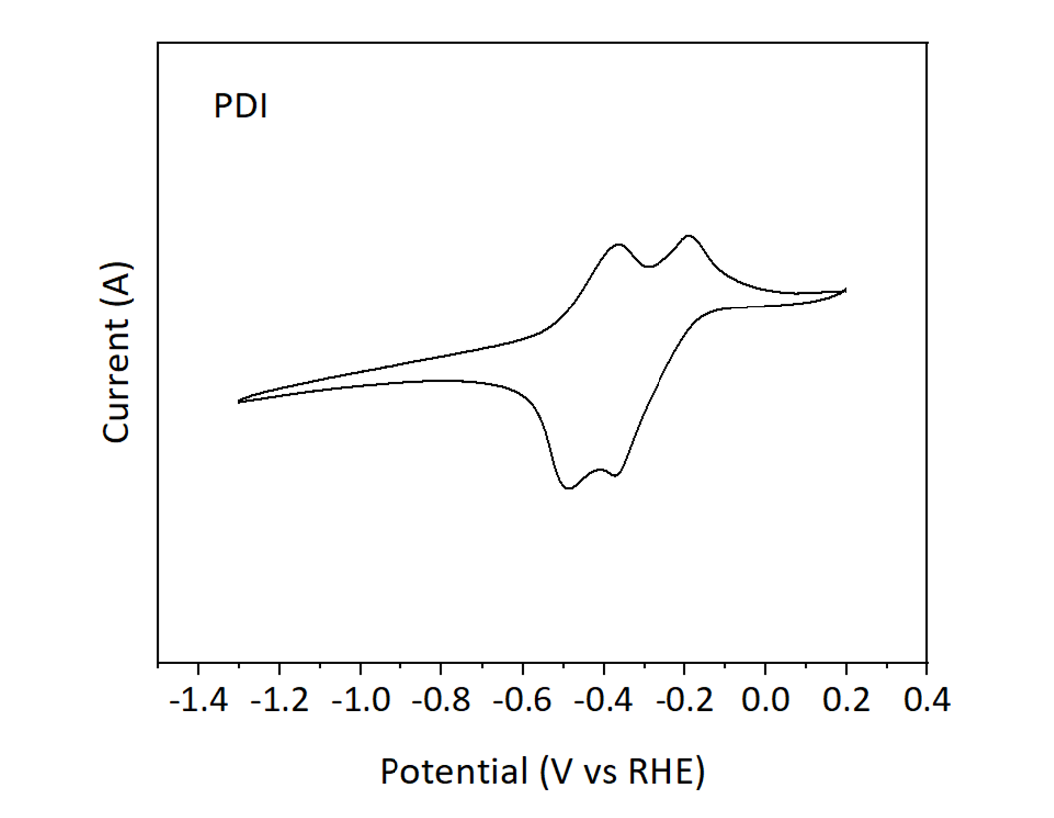
Supplementary Fig. 2. Cyclic voltammetry curves of PDI. The polarization curves in 0.15 M TBATFB/DMSO at a scan rate is 10 mV s⁻¹, and the loading amounts of all catalysts on carbon papers are 0.5 mg cm⁻².

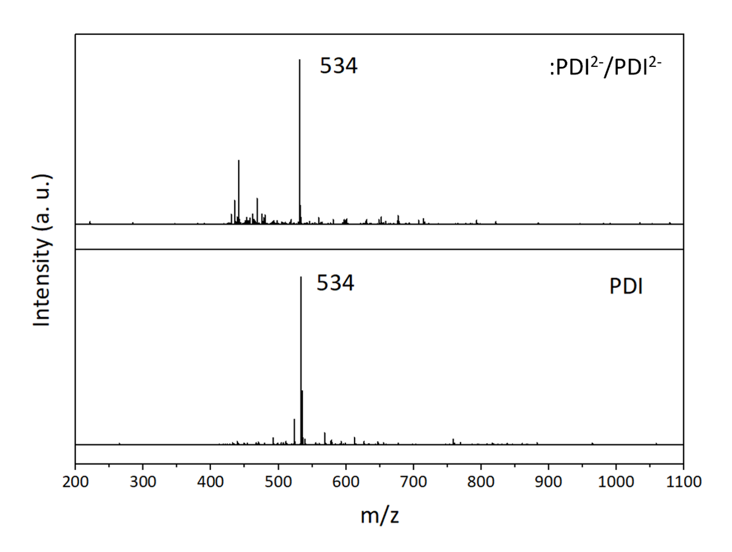
Supplementary Fig. 3. Mass spectra of PDI and :PDI²⁻/PDI²⁻.

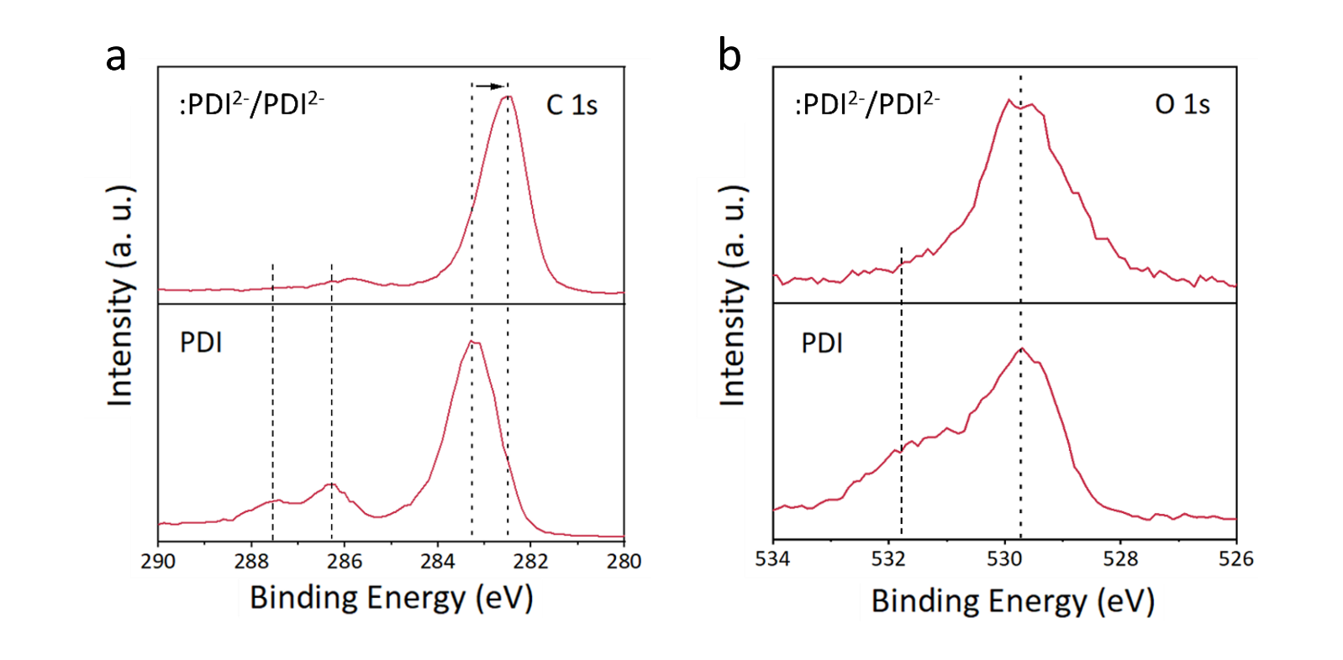
Supplementary Fig. 4. NAP-XPS (a) C 1s and (b) O1s spectra of PDI and :PDI²⁻/PDI²⁻.

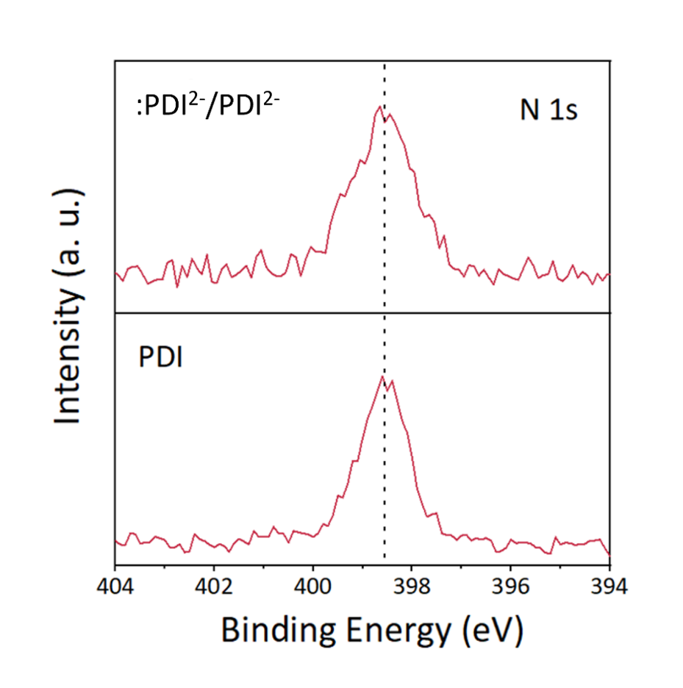
Supplementary Fig. 5. NAP-XPS N 1s spectra of PDI and :PDI²⁻/PDI²⁻.

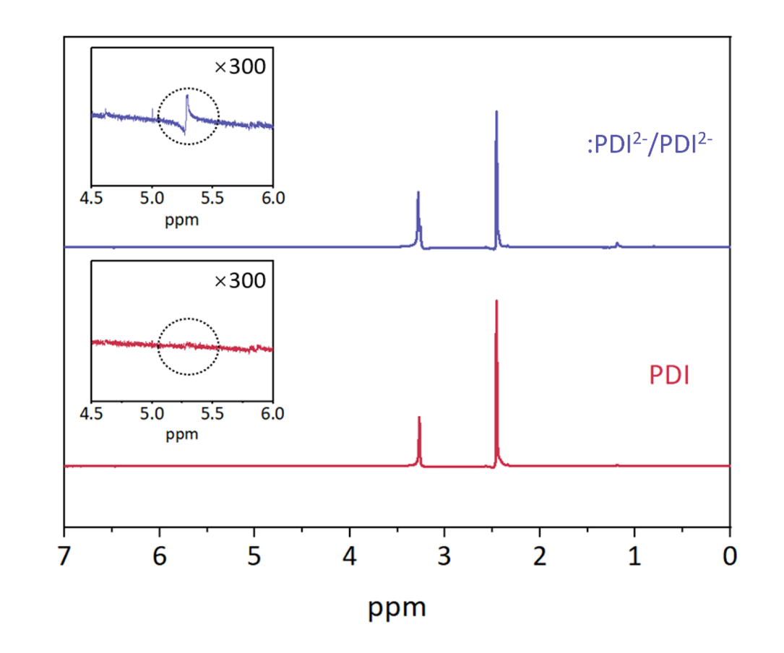
Supplementary Fig. 6. ¹H NMR spectra of PDI and :PDI²⁻/PDI²⁻.

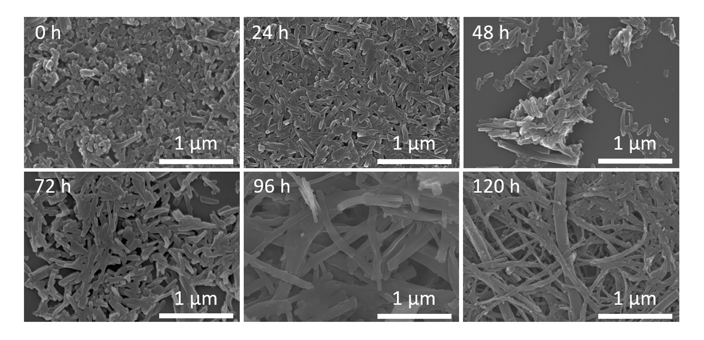
Supplementary Fig. 7. SEM images to show the morphology evolution of pristine PDI during the self-assembly.

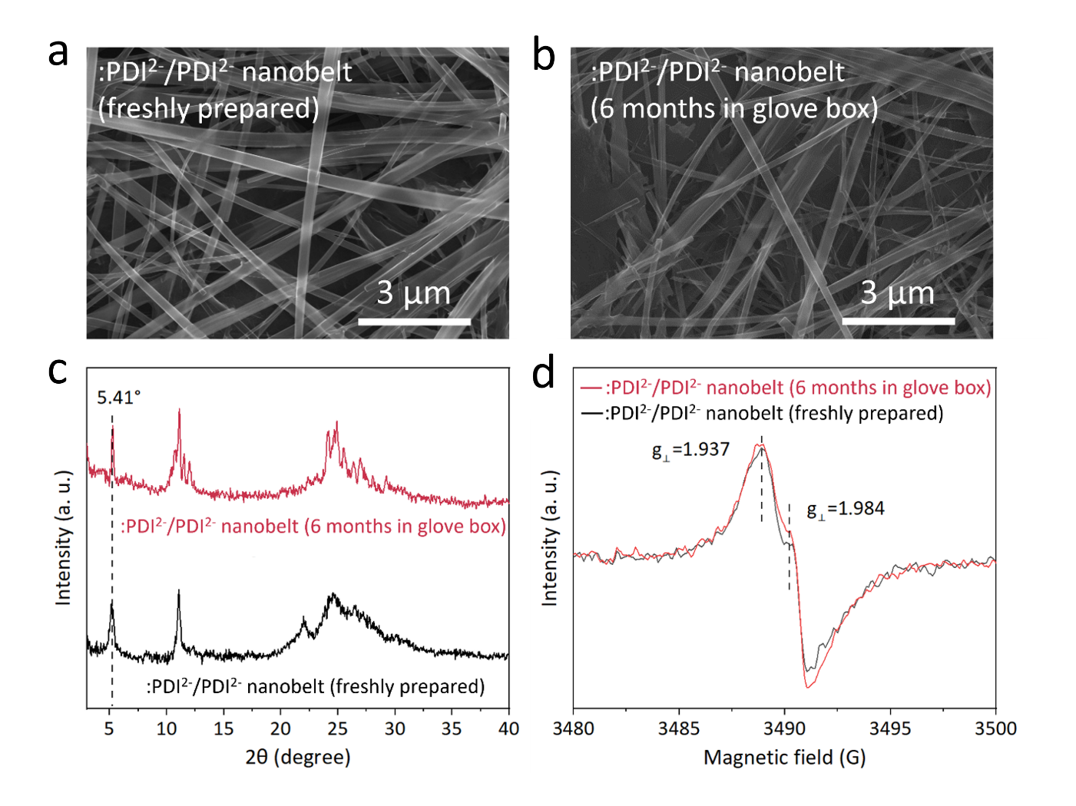
Supplementary Fig. 8. SEM images of (a) freshly prepared :PDI²⁻/PDI²⁻ nanobelt (120 h) and (b) :PDI²⁻/PDI²⁻ nanobelt stored in N₂ glove box for 6 months. (c) XRD patterns of :PDI²⁻/PDI²⁻ nanobelt (120 h) freshly prepared and stored in N₂ glove box for 6 months. (d) ESR spectra of :PDI²⁻/PDI²⁻ nanobelt (120 h) freshly prepared and stored in N₂ glove box for 6 months.

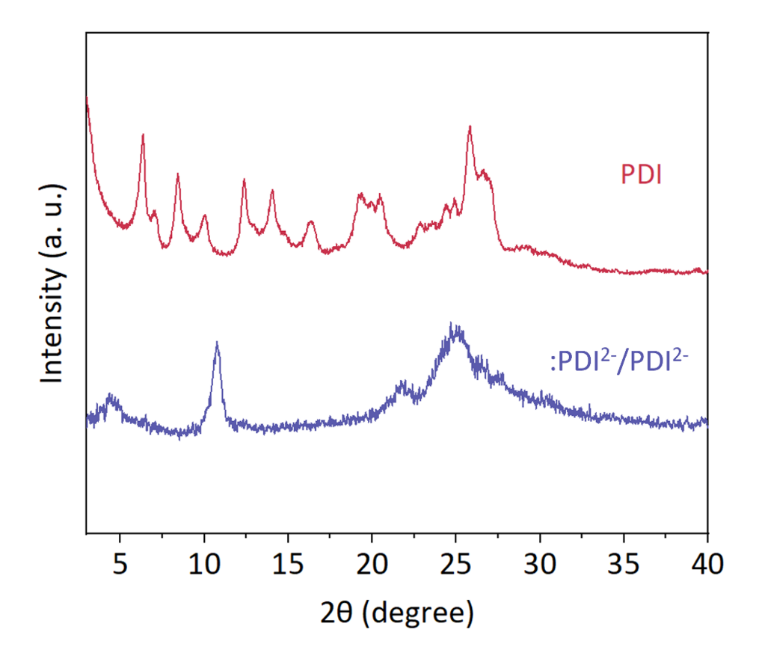
Supplementary Fig. 9. XRD patterns of PDI and :PDI²⁻/PDI²⁻.

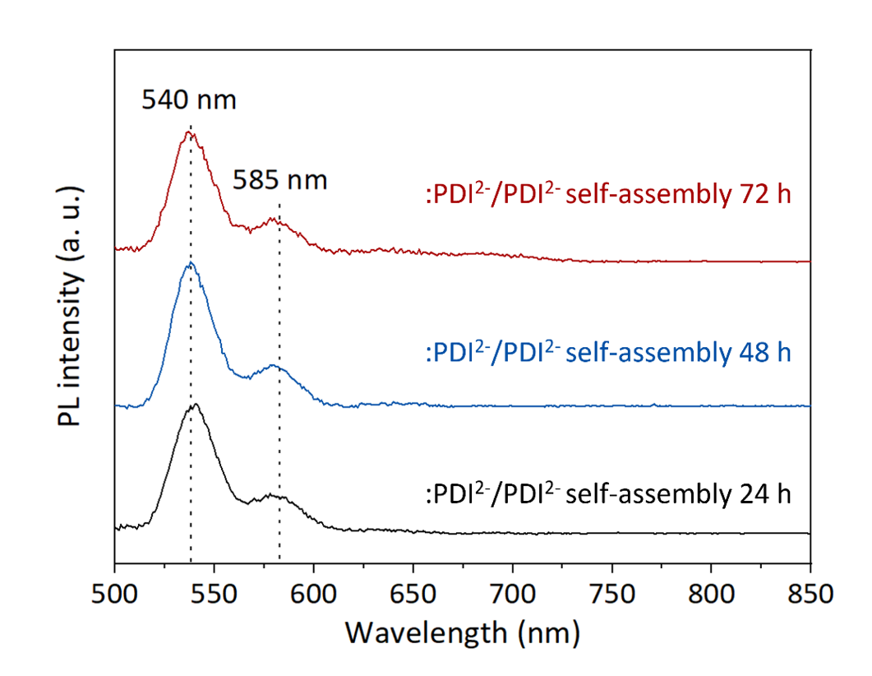
Supplementary Fig. 10. Photoluminescence spectra (λ_{ex}=450 nm) of :PDI²⁻/PDI²⁻ (solid) with different self-assembly times.

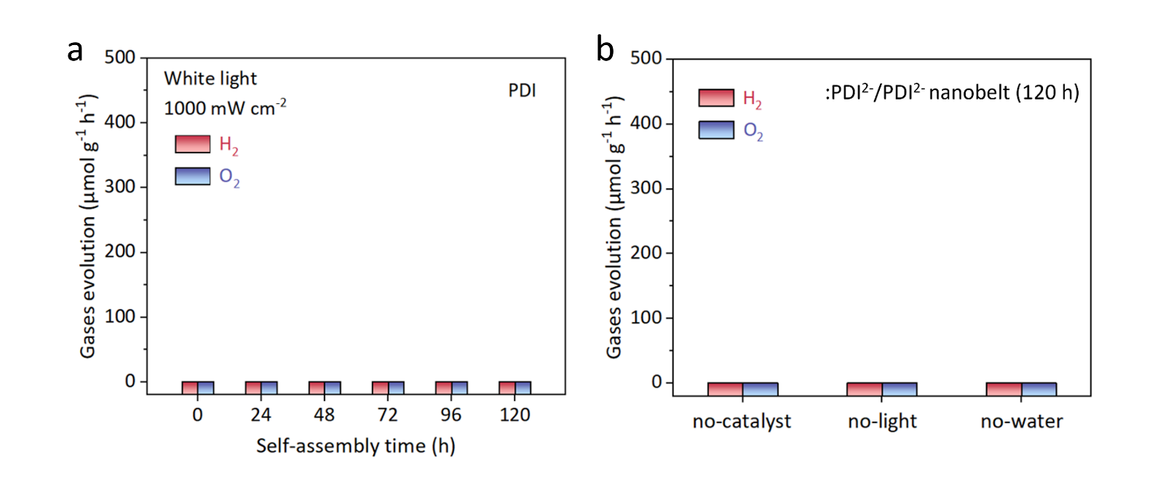
Supplementary Fig. 11. (a) Water-splitting performances on PDI with different self-assembly time. (b) Water-splitting experiments without catalysts, light or H₂O over :PDI²⁻/PDI²⁻ nanobelt (120 h) catalyst.

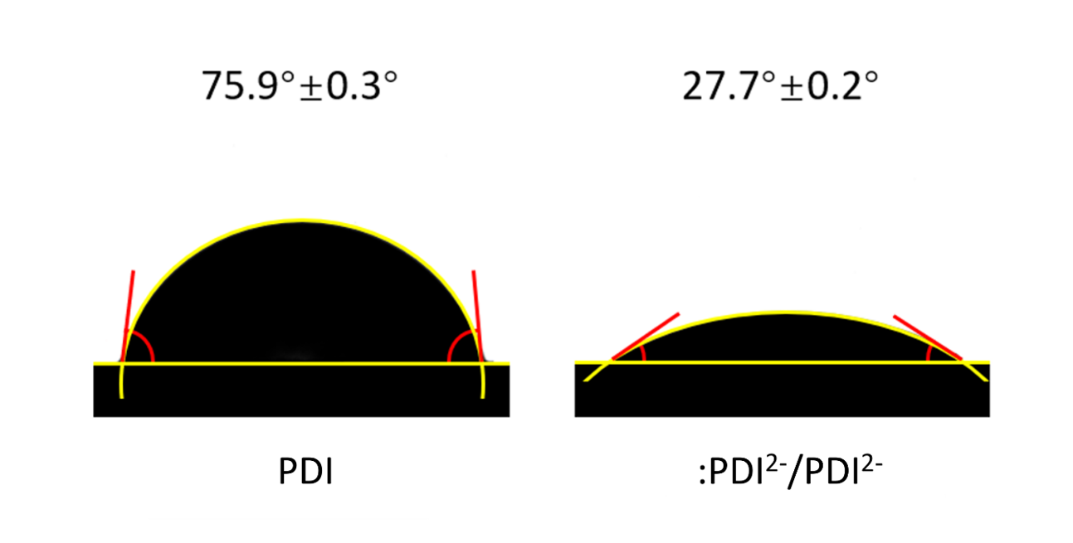
Supplementary Fig. 12. The water contact angle measurement on PDI and :PDI²⁻/PDI²⁻.

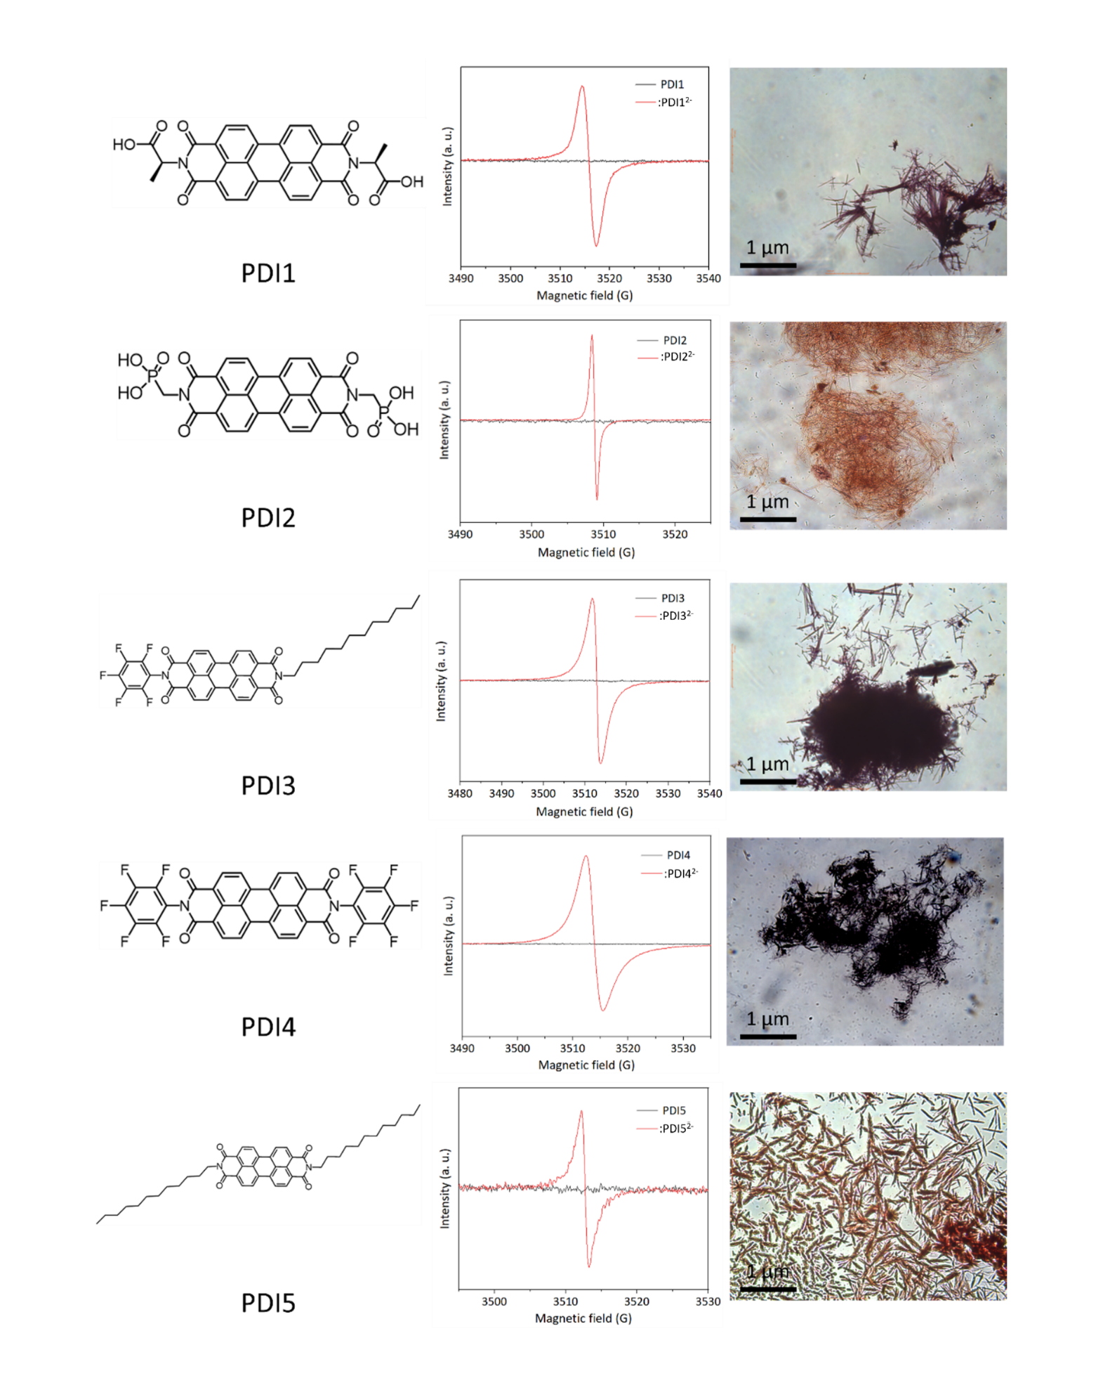
Supplementary Fig. 13. Radical self-assembly strategy applies to five PDI derivatives (PDI1-PDI5) with ESR spectra and optical microscope photos.

Supplementary Table 1. Wavelength-dependent AQYs and corresponding H₂ production amount on :PDI²⁻/PDI²⁻ nanobelt (120 h).
Wavelength (nm) | H₂ evolution (μmol) | Light intensity (mW cm⁻²) | Irradiation area (cm²) | Irradiation time (h) | AQY  (%)
365 | 0 | 23.7 | 4 | 5 | 0
420 | 12.5 | 236.6 | 4 | 5 | 0.4247
425 | 26.2 | 241.5 | 4 | 5 | 0.8494
450 | 37.6 | 275.2 | 4 | 5 | 1.0138
475 | 45.9 | 266 | 4 | 5 | 1.1097
500 | 43.8 | 240.7 | 4 | 5 | 1.2193
530 | 56.8 | 195.2 | 4 | 5 | 1.5755
550 | 87.5 | 269.8 | 4 | 5 | 1.9591
580 | 61.3 | 210.5 | 4 | 5 | 1.6714
600 | 38.3 | 166.9 | 4 | 5 | 1.2741
630 | 56.1 | 201.2 | 4 | 5 | 1.4796
650 | 45.3 | 154.7 | 4 | 5 | 1.5344
670 | 46.4 | 143.1 | 4 | 5 | 1.6166
700 | 28.4 | 100.5 | 4 | 5 | 1.3426
725 | 26.9 | 99.5 | 4 | 5 | 1.2467
760 | 28.2 | 102.7 | 4 | 5 | 1.2056
850 | 18.7 | 80.2 | 4 | 5 | 0.9453

Supplementary Table 2. Wavelength-dependent AQYs and corresponding H₂ production amount on :PDI²⁻/PDI²⁻ nanorod (24 h).
Wavelength (nm) | H₂ evolution (μmol) | Light intensity (mW cm⁻²) | Irradiation area (cm²) | Irradiation time (h) | AQY(%)
365 | 0 | 15.9 | 4 | 5 | 0
420 | 3.3 | 154.2 | 4 | 5 | 0.17
425 | 5.3 | 220.5 | 4 | 5 | 0.19
450 | 7.8 | 253.2 | 4 | 5 | 0.23
475 | 9.7 | 260 | 4 | 5 | 0.26
500 | 12.9 | 244.7 | 4 | 5 | 0.35
530 | 12.4 | 200 | 4 | 5 | 0.39
550 | 17.4 | 250.7 | 4 | 5 | 0.42
580 | 10.4 | 170.5 | 4 | 5 | 0.35
600 | 7.6 | 155 | 4 | 5 | 0.27
630 | 5.2 | 180.7 | 4 | 5 | 0.16
650 | 2.7 | 100.8 | 4 | 5 | 0.13
670 | 2.6 | 131.1 | 4 | 5 | 0.1
700 | 1.7 | 98 | 4 | 5 | 0.08
725 | 1.3 | 82.7 | 4 | 5 | 0.072
760 | 0.8 | 69.5 | 4 | 5 | 0.05
850 | 0.6 | 70.2 | 4 | 5 | 0.034

Supplementary Table 3. AQYs and corresponding H₂ production amount on :PDI²⁻/PDI²⁻ with different self-assembly time under λ=550 nm illumination.
Self-assembly time (h) | H₂ evolution (μmol) | Light intensity (mW cm⁻²) | Irradiation area (cm²) | Irradiation time (h) | AQY(%)
0 | 0.99 | 200 | 4 | 5 | 0.03
24 | 23.8 | 200 | 4 | 5 | 0.72
48 | 31.4 | 200 | 4 | 5 | 0.95
72 | 43.6 | 200 | 4 | 5 | 1.32
96 | 59.2 | 200 | 4 | 5 | 1.79
120 | 64.8 | 200 | 4 | 5 | 1.96

