Self-immolative nanocapsules precisely regulate depressive neuronal microenvironment for synergistic antidepression therapy

Ziyao Liu, Bei Chen, Shijun Xiang, Shuo Hu*

Z.Liu, B.Chen, S.Xiang, S.Hu
Department of Nuclear Medicine, Xiangya Hospital, Central South University, Changsha 410008, China
E-mail: hushuo2018@163.com

S. Hu
National Clinical Research Center for Geriatric Diseases, Xiangya Hospital, Central South University, Changsha 410008, China

Z.Liu, S.Hu
Key Laboratory of Biological Nanotechnology of National Health Commission, Xiangya Hospital, Central South University, Changsha 410008, China

Materials and methods

Synthesis protocol of inner-core nanoparticles
To synthesize inner-core nanoparticles, 33.6 mg of 5-HT was dissolved in water at a concentration of C_{5-HT} = 32 mg/mL. Then, 0.45 mL of the 5-HT aqueous solution was added to 21 mL of Tris-HCl buffer (pH 9.5 or pH 7.4) under vigorous stirring at room temperature. Separately, CAT and HSA were dissolved in PBS (pH 7.4) at a mass concentration of C_{CAT/HS}A = 3.2 mg/mL. Next, 300 μL of CAT solution and 1200 μL of HSA solution were mixed, and after 16 h, 750 μL of the resulting protein solution was added to the reaction mixture. After 1 h, another 750 μL of the protein mixture was added to the reaction mixture. Following another h, 0.6 mL of the 5-HT aqueous solution was added to the reaction mixture. After an additional 2 h of standing with vigorous stirring, the mixture was centrifuged at 1000 rpm for 10 min to remove any remaining aggregated big nanoparticles (NPs) that remained in the black pellet. To purify the inner-NPs, the pellet was removed, and the clear supernatant was kept. Then, the unreacted 5-HT was washed out by membrane dialysis (2 kDa) in ultrapure water at pH 9.5 solution for 6 h, with the ultrapure water at pH 9.5 solution being changed every two h.

FITC labeling proteins
To label the proteins with FITC, the fluorophore was dissolved in ethanol, while the proteins were dissolved in Tris-HCl buffer at pH 9.5. The FITC solution was then added immediately to the protein solution and kept under gentle stirring at room temperature for 5 h, using a ratio of 1 mole of FITC per 2 moles of protein. Unconjugated dyes were subsequently removed through membrane dialysis (2 kDa) in ultrapure water for 6 h.

HPLC methods
The mobile phase gradient in HPLC comprised two solvents: Solvent A, a solution of 0.01 M CH3COONa and 0.02 M citric acid adjusted to pH 4.0, and Solvent B, 100% methanol. The solvents were filtered through a 0.22 μm membrane filter before use in the assay. The eluent consisted of 95% solvent A and 5% solvent B from t = 0-10 min and 5% solvent A and 95% solvent B from t = 10-15 min. The velocity was maintained at 2 mL/min and signals were obtained at a wavelength of 254 nm. To determine the release profile of VCNCs, CNCs, and VNCs at a concentration of C5-HT = 50 μg/mL, the samples were incubated at pH 7.4, pH 6.4, pH 7.4+ROSUP, and pH 6.4+ROSUP for 0, 7, 12, 24, 48, 72, 120, and 168 h. After incubation, the samples were ultracentrifuged with a 3 kDa tube at 8000 rpm for 30 min, and the eluents were collected and quantified using HPLC as described above. First, a calibration curve for 5-HT was prepared using 5-HT monomers (Alaadin, #S111161, China) at different concentrations (C5-HT: 31.25 - 0.49 μg/mL) in ultrapure water. The peak areas at retention time 2-4 min were plotted against the concentration of 5-HT as determined by weighing. Finally, the liberated 5-HT was calculated from the peak area at 2-4 min of each sample according to the standard curve.

Fluorescence labeling
The Cy5.5 NHS or Cy7.5 NHS was dissolved in dimethylformamide (DMF) at a concentration of 1 mg/mL, and the HSA was dissolved in Tris-HCl buffer (pH = 9.5) at a concentration of 5 mg/mL (50 mg in 5 mL, 150.38 μM of HSA). Under gentle stirring, 269.3 μL of the Cy5.5 NHS solution (75.19 μM of Cy5.5 NHS) or 294.1 μL of the Cy7.5 NHS solution (75.19 μM of Cy7.5 NHS) was immediately added to the protein solution. The mixture was kept stirring for 5 h. Free fluorophores were separated from labeled proteins by membrane dialysis with a 2 kDa cutoff. Next, we used lyophilization to obtain the Cy5.5 labeled HSA (HSA-Cy5.5) and Cy7.5 labeled HSA (HSA-Cy7.5). The labeling efficiency was characterized by the UV-vis spectrum and fluorescence spectrum at 678 nm excitation and 788 nm excitation, respectively.Next, 866 μL of FITC/DMF solution at a concentration CFITC = 1 mg/mL (445 μM) and 15 mg of RVG29 (890 μM) were dissolved in 5mL of pH 9.5 buffer (Tris-HCl buffer). The reaction mixture was allowed to stir for 5 h at RT. The unlabeled FITC was removed by membrane dialysis with a 2 kDa cutoff for 6 h. The final product, FITC-labeled RVG29 (RVG29-FITC), was dried through lyophilization. Then, we used HSA-Cy5.5 and RVG29-FITC to synthesize double-labeled VCNCs and VNCs by the method described above. The FITC labeling efficiency was also tested by the UV-vis spectrum and fluorescence spectrum.

Cellular anti-inflammation by incubating with nanocapsules and reagents
PC-12 cells were seeded into 24-well plates (surface area/well = 1.9 cm2) at a density of 150,000 cells/well with a volume of 1 mL and were incubated overnight. Then, the cells were respectively exposed to VCNCs, CNCs, VNCs, 5-HT, CAT, and HSA at different concentrations and incubated for 3 h. The specific concentrations of the samples used for the study are provided in Table S5. After exposure, the cell medium was removed, and the cells were washed twice with 1 mL of PBS. The cells were then incubated with 1.0 mL FBS-supplemented medium containing 1.0 μL ROSUP reagent for 0.5 h at 37°C. As a reference control, one group of cells was not exposed to samples or the ROSUP reagent. We then used DCFH-DA to detect the level of ROS. The data were recorded using the fluorescent microplate reader (Envision@2015, PerkinElmer, USA). Furthermore, the intracellular ROS level was visualized using the inverted fluorescence microscope (Eclipse Ti2, Nikon, Japan) at the FITC channel.

Behavioral tests
To establish SPT, we used the two-bottle free-choice method. Mice were individually housed during the measurement and trained to adapt to two bottles of 1.5% sucrose solution (w/v) in each cage for 2 h, 48 h prior to the test. Before 24 h, mice were trained to adapt to one bottle of 1.5% sucrose solution (w/v) and one bottle of ultrapure water for 2 h. Following this, mice were completely deprived of food and water, and presented with two pre-weighed bottles for 2 h, one containing 1.5% sucrose solution and the other containing pure water. The bottles were weighed again after the measurement, and the sucrose preference was calculated as a percentage using the following equation: Sucrose preference [%] = sucrose consumption / (sucrose consumption + water consumption) × 100. For OFT, each mouse was placed in a black open box (60 cm × 40 cm × 30 cm) within a quiet room. The testing session lasted 5 min, preceded by a 3-min habituation session. The total traveled distance was recorded and analyzed using Smart V03, while the percentage of the distance traveled in the center zone was used to measure locomotion in the open field. In FST, mice were placed individually in a plastic cylinder (30 cm height × 11 cm diameter) containing water at 25°C in a quiet room. The mice were allowed to adapt to the environment for 15 min before 24 h. During the measurements, the mouse was placed in the water and forced to swim for 5 min, and the immobility time within this period was recorded using the video tracking system. Smart V03 was used for the analysis of immobility time.

Slice staining
For Hematoxylin-eosin staining (HE) staining, the first step is the dewax procedure. The organ slides were placed at 60°C for 2 h, followed by deparaffinization with xylene (20 min for three times) and alcohol solutions with gradient concentrations (5 min in 100% ethanol twice, 5 min in 90%, 80%, and 70% ethanol) and rehydration in ultra-pure water (5 min). The slides were then treated with PBS three times for 5 min. Afterward, the slides were stained with hematoxylin for 10 min, washed with running water for 1 min, differentiated with 1% hydrochloric acid ethanol for 30 seconds, washed with running water for 1 min, placed with blue returning liquid (Servicebio, #G1040, China) for 30 seconds, and washed with running water for 1 min. Thereafter, the slides were stained with eosin (Biosharp, #BL700A-2, China) solution for 2 min. The final step is dehydration, where the tissue slides were immersed in gradient concentrations of ethanol (5 min in 100% ethanol twice, 5 min in 90%, 80%, and 70% ethanol) and fresh xylene (10 min). Finally, the slides were sealed with neutral gum. For brain slides, the samples were visualized by Vectra Polaris (Akoya Bioscience, USA), while for major tissue slides, the samples were captured by a microscope (Zeiss, Germany).

For immunohistochemistry (IHC) staining, the dewax procedures were conducted after obtaining the paraffin slides, which are described in HE staining. The slides were microwaved in EDTA solution (pH = 9) for 20 min to repair antigens, washed with ultra-pure water three times for 5 min, and incubated with 3% hydrogen peroxide solution for 10 min. Next, slices were washed with ultra-pure water twice for 5 min, PBS once for 5 min, and blocked with 10% goat serum (Solarbio, #SL038, China) for 1 h at room temperature. Then, the slides were covered with primary antibodies, including anti-BDNF (Abcam, #ab108319, UK, 1:200) and 5-HT (Serotonin) Rabbit Antibody (Immunostar, #20080, USA, 1:2000), and incubated at 4°C overnight. On the next day, the slides were put at 37°C for 30 min, removed the primary antibodies, covered with the secondary antibodies (1:400, Goat Anti-Rabbit IgG (H+L) (peroxidase/HRP conjugated, Elabscience, China), and incubated for 30 min at 37°C. Then, the slides were washed with PBS three times for 5 min, stained with a DAB kit (ZSGB-BIO, China), and washed with running water for 3 min. Finally, the slides were stained with hematoxylin and dehydrated with alcohol and xylene, following the protocols described in HE staining.
For Nissl staining, the slides were first dewaxed using the procedures described in HE staining. Subsequently, the slides were stained with the Nissl kit for 10 min at room temperature, followed by two washes with ultrapure water for 5 min each. Lastly, the slides were dehydrated using the methods described in HE staining.

The ROS fluorescent staining was performed on frozen brain slides. The slides were left at room temperature for 30 min, then incubated with anti-fluorescence quenching agents for 5 min and washed with running water for 10 min. Next, the slides were stained with ROS fluorescence solution (Sigma, #D7008, United States) at 37°C for 30 min, followed by incubation with DAPI solution (Servicebio, #G1012, China) at room temperature for 10 min. The slides were then washed with PBS three times for 5 min each. Lastly, the slides were visualized using the fluorescent imaging system (Eclipse C1 and DS-U3, Nikon, Japan).

Supplementary Figures and tables
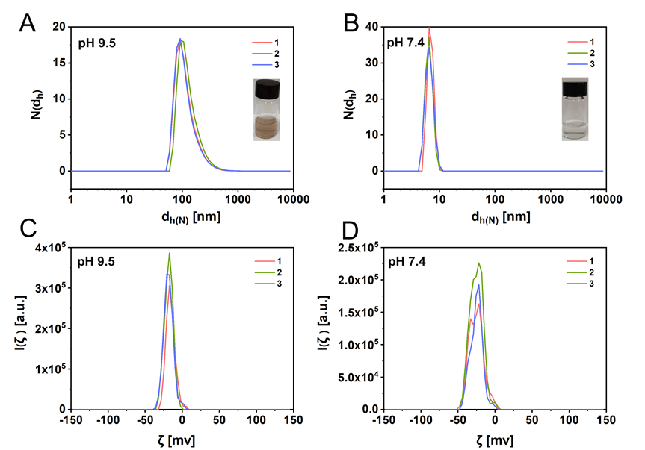
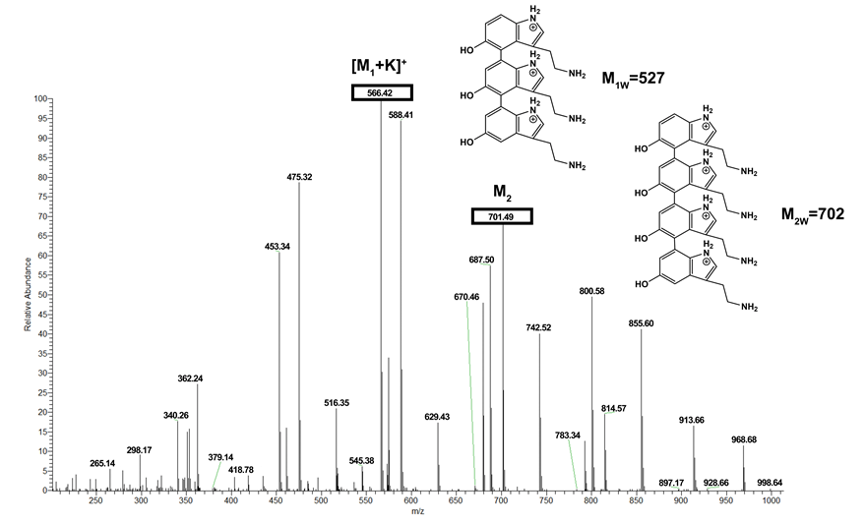
Fig. S1. The number distribution N(d_{h}) of hydrodynamic diameters of CNCs synthesized in (A) pH 9.5 and (B) pH 7.4 buffers. The distribution of ζ-potential I(ζ) of CNCs synthesized in (C) pH 9.5 and (D) pH 7.4 buffers.
Fig. S2. Mass spectrum of the formation of 5-HT covalent bonds at pH=9.5 (Tris-HCl buffer). From the data. The molecular weight of the 5-HT covalent bonds from three monomers and four monomers can be distinguished from the data.
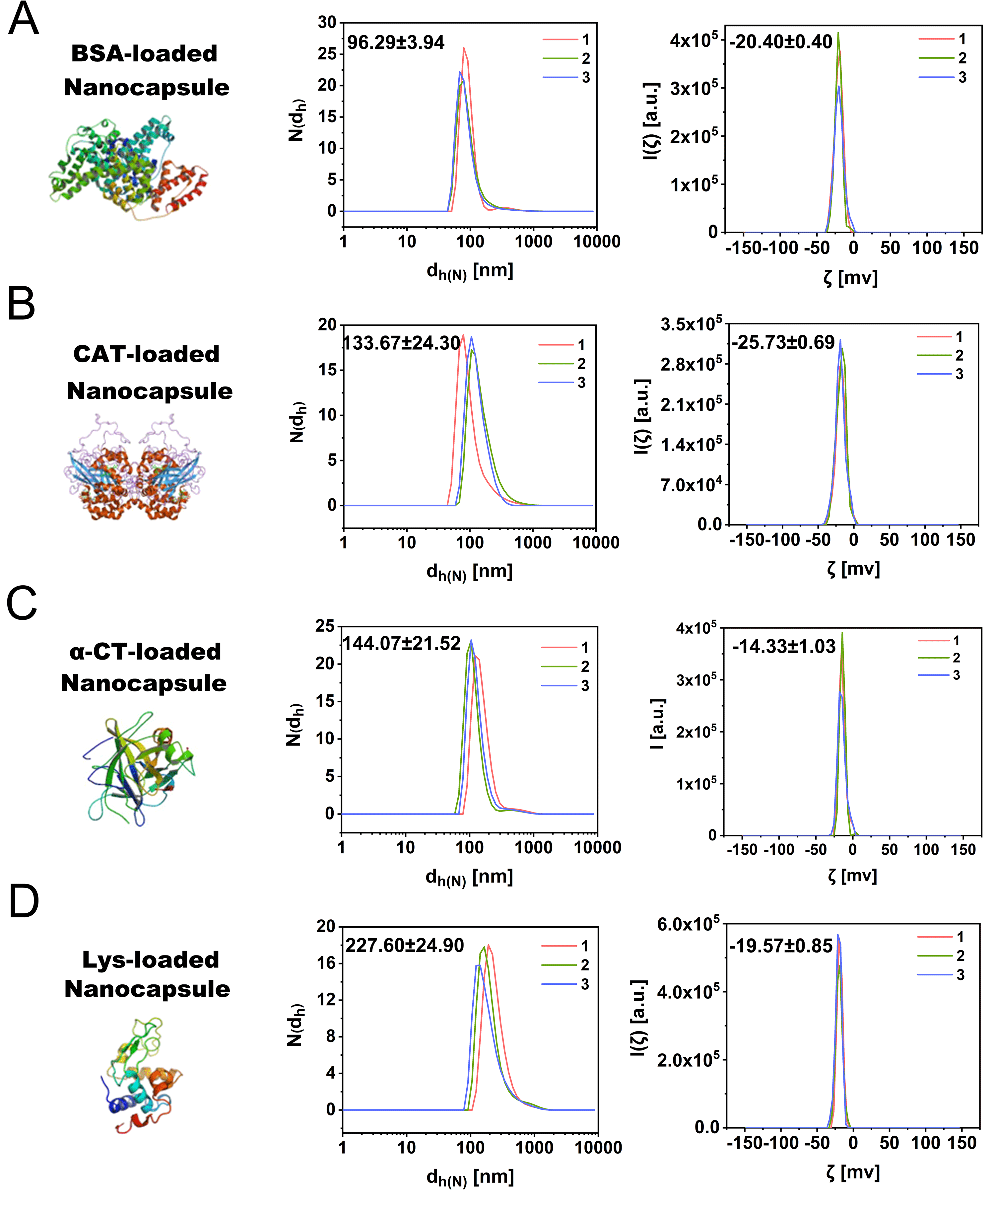
Fig. S3. Compilation of data from Fig. 1B. The number distribution of hydrodynamic diameters N(d_{h}) and the distribution of ζ-potential I(ζ) of nanocapsules loaded with (A) BSA, (B) CAT, (C) α-CT and (D) Lys at a concentration C_{NPs} = 1mg/mL.

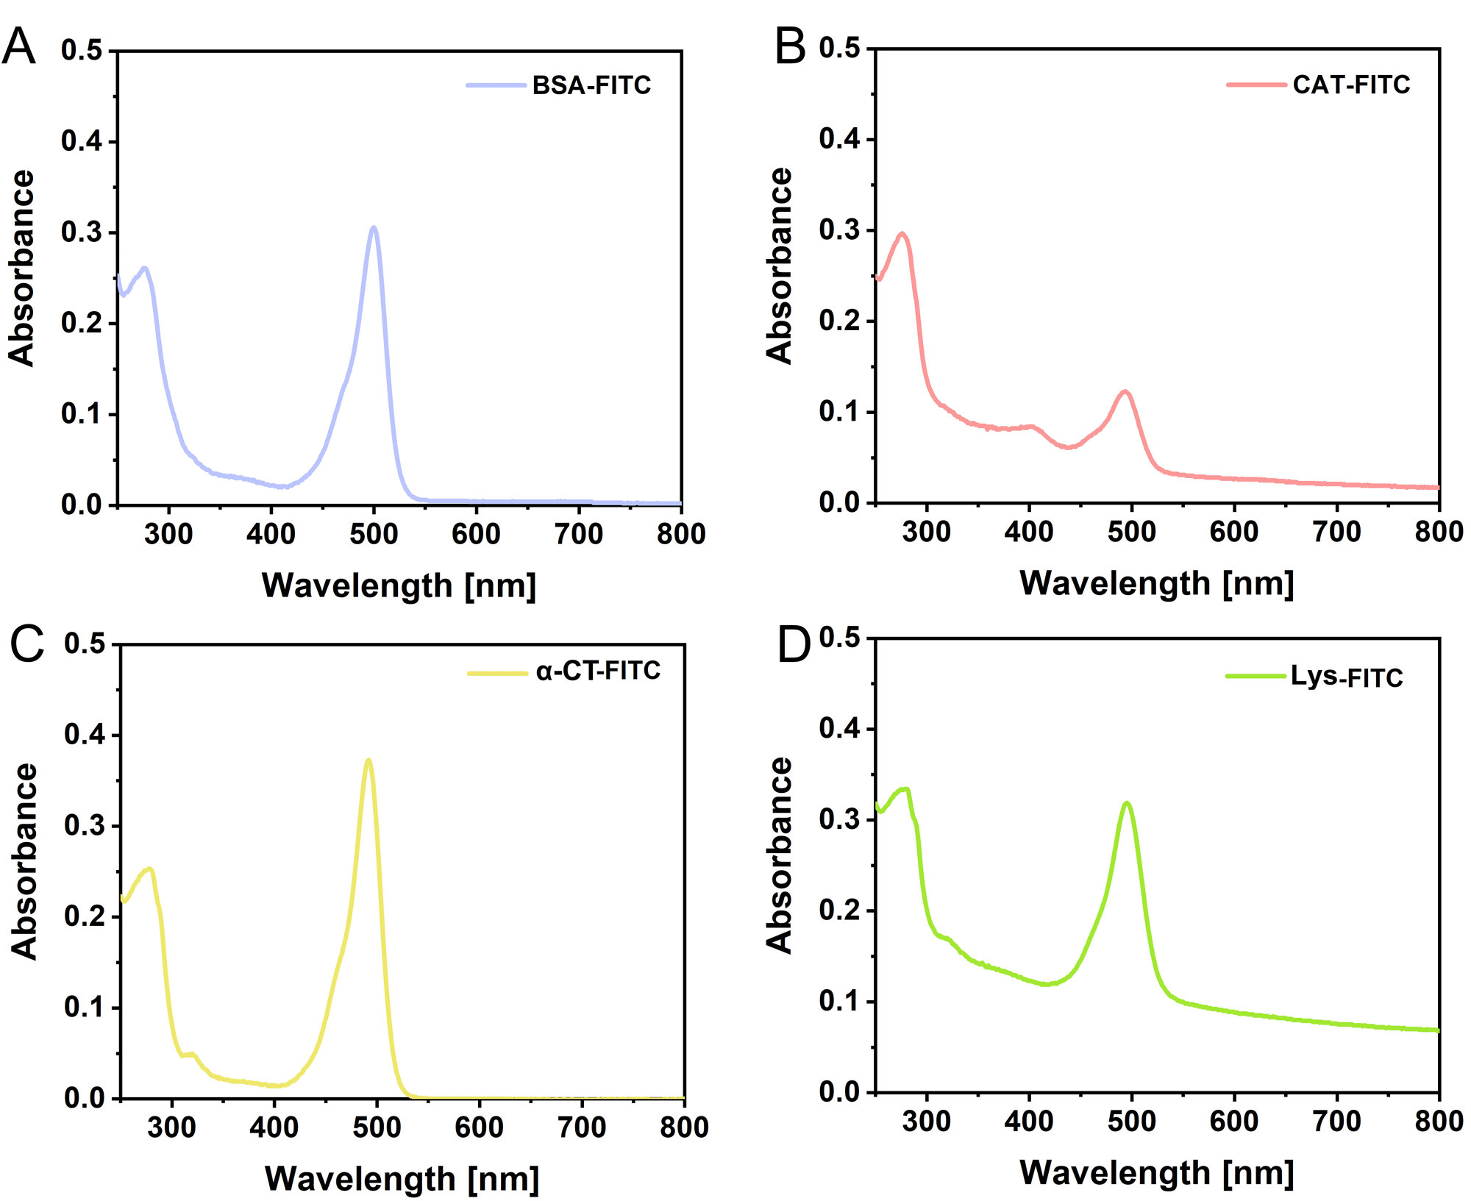
Fig. S4. UV-vis spectrum of (A)BSA-FITC, (B) CAT-FITC, (C)α-CT-FITC, and (D)Lys-FITC at concentration C_{protein-FITC}=1 mg/mL.

Table S1. The labeling efficiency of proteins-FITC is calculated from Beer-Lambert’s law.
BSA-FITC |  | CAT-FITC |  | α-CT-FITC |  | Lys-FITC
ε_{FITC,492} | 75000 | ε_{FITC,492} | 75000 | ε_{FITC,492} | 75000 | ε_{FITC,492} | 75000
ε_{BSA,280} | 43824 | ε_{CAT,280} | 24600 | ε_{α-CT,280} | 50000 | ε_{Lys,280} | 38940
A₂₈₀ | 0.25 | A₂₈₀ | 0.29 | A₂₈₀ | 0.25 | A₂₈₀ | 0.33
A₄₉₂ | 0.26 | A₄₉₂ | 0.12 | A₄₉₂ | 0.37 | A₄₉₂ | 0.31
C_{BSA} | 5.77×10⁻⁶ | C_{CAT} | 1.18×10⁻⁵ | C_{α-CT} | 5.04×10⁻⁶ | C_{Lys} | 8.58×10⁻⁶
C_{FITC} | 3.52×10⁻⁶ | C_{FITC} | 1.64×10⁻⁶ | C_{FITC} | 4.97×10⁻⁶ | C_{FITC} | 4.19×10⁻⁶
C_{FITC}/C_{BSA} | 0.61 | C_{FITC}/C_{CAT} | 0.14 | C_{FITC}/C_{α-CT} | 0.99 | C_{FITC}/C_{Lys} | 0.49

The labeling efficiency of α-CT-FITC has a significant difference between the theoretical result. α-CT easily precipitate in pH 9.5 Tris-HCl buffer, which is close to its isoelectric points (8.9).

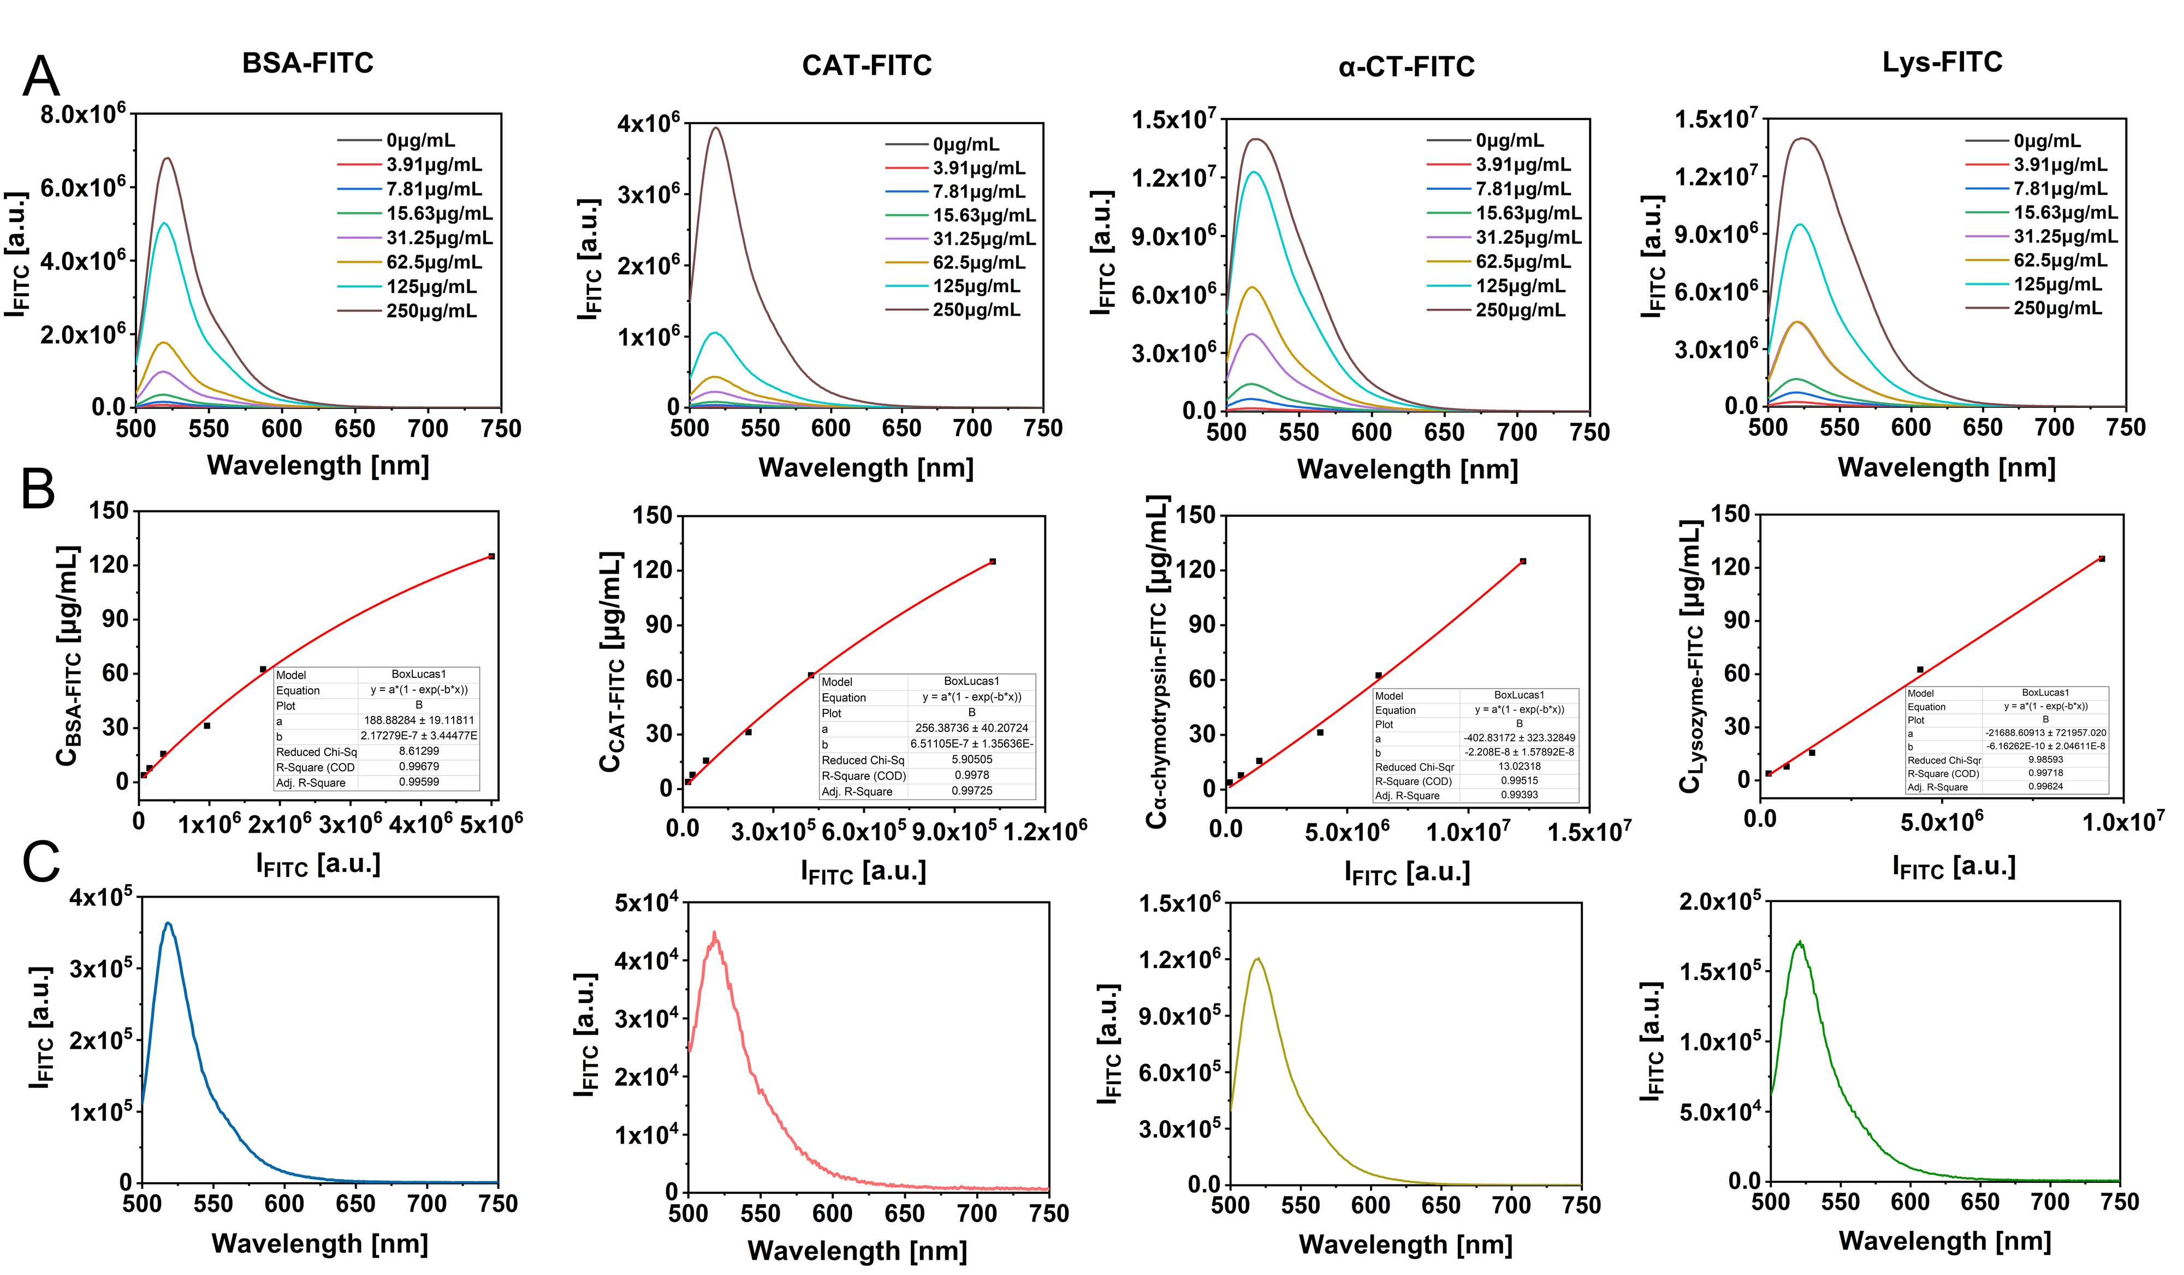
Fig. S5. The payload efficiencies of nanocapsules. (A) Fluorescence spectra of FITC intensity I_{FITC} at 488 nm excitation of free proteins-FITC at different concentrations C_{protein} dispersed in PBS. (B)Fluorescence intensity I_{FITC} (488 nm excitation,520 nm emission) plotted versus the protein mass concentration C_{poteins} via Boxlucas 1 model. The equations are represented as follows, C_{BSA-FITC} = 188.88×(1-exp(-2.17×10⁻⁷×I_{FITC})), R² = 0.9960; C_{CAT-FITC} = 256.39×(1-exp(-6.51×10⁻⁷×I_{FITC})), R² = 0.9973 C_{α-CT-FITC} = -402.83×(1-exp(2.21×10⁻⁸×I_{FITC})), R² = 0.9939; C_{Lys-FITC} = -21688.61×(1-exp(6.13×10⁻¹⁰×I_{FITC})), R² = 0.9962. (C)Fluorescence spectrum I_{FITC} at 488 nm excitation of nanocapsules within FITC-labeled proteins. The encapsulation efficiencies of payload proteins were calculated using the Boxlucas 1 model equation in (B).

Table S2. The loading efficiencies of different proteins in nanocapsules. The mass concentration of proteins-FITC C_{protein-FITC} was calculated from Boxlucas equation representing the relationship between the fluorescence intensity and concentration of FITC labeled proteins. The mass concentrations of the samples C_{NPs} were obtained from weighting after lyophilization.
 | BSA-FITC loaded nanocapsules | CAT-FITC loaded nanocapsules | α-CT-FITC | Lys-FITC loaded nanocapsules
 | BSA-FITC loaded nanocapsules | CAT-FITC loaded nanocapsules | loaded nanocapsules | Lys-FITC loaded nanocapsules
C_{protein-FITC} [μg] | 14.23 | 0.58 | 10.87 | 2.25
C_{NPs} [μg] | 700 | 200 | 700 | 300
C_{protein-FITC} /C_{NPs} | 2.03% | 0.29% | 1.55% | 0.75%

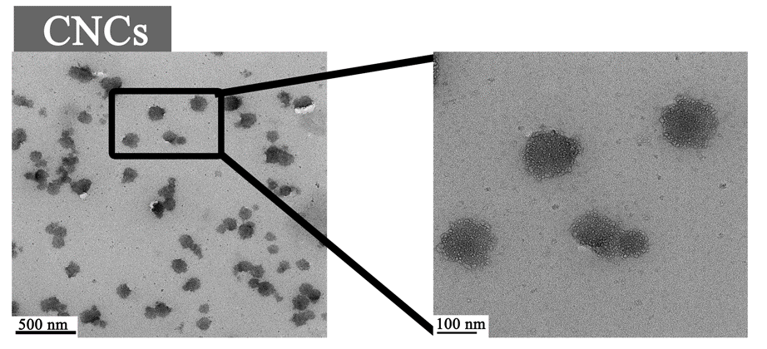
Fig. S6. TEM images of CNCs.

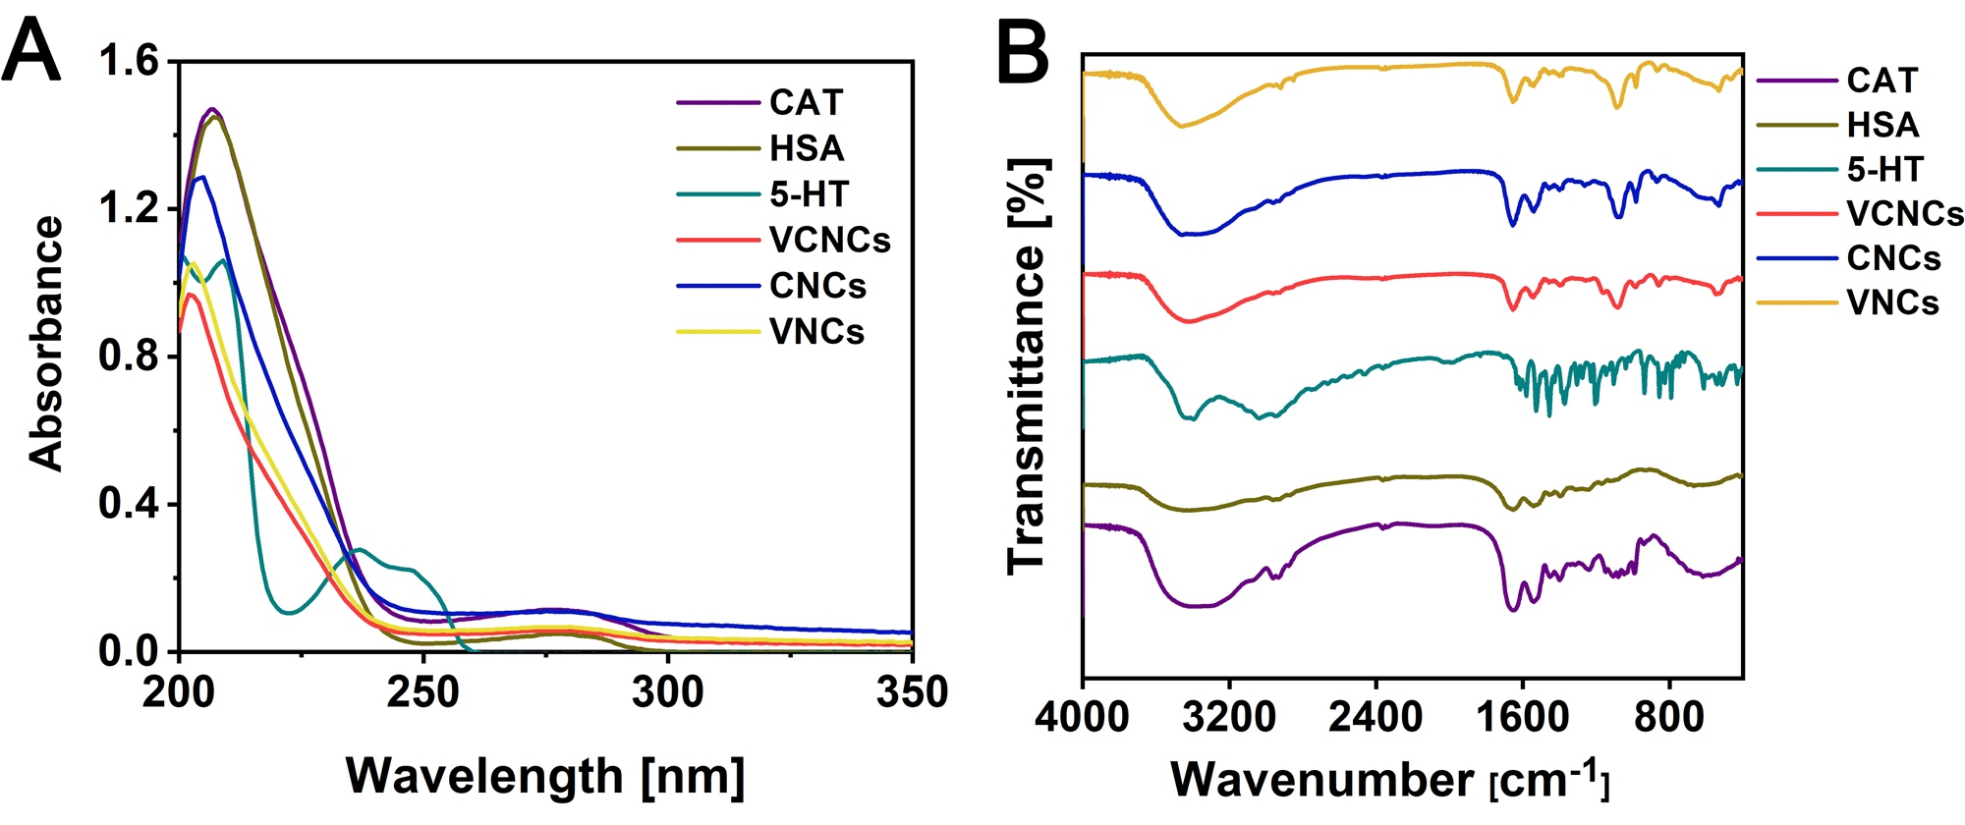
Fig. S7. (A) UV-vis spectra and (B) FTIR spectra of CAT, HSA, 5-HT, VCNCs, CNCs, and VNCs at a concentration 1mg/mL.

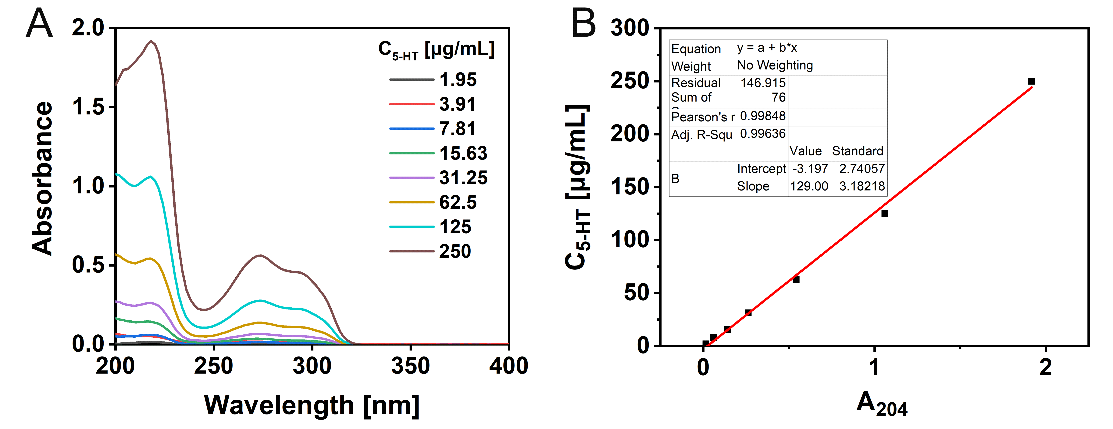
Fig. S8. (A)UV-vis spectra of 5-HT at different dilutions. (B) Linear fitting of the absorbance at 204 nm versus the concentration of 5-HT using the equation C_{5-HT} = 129.00×A₂₀₄-3.20, R² = 0.9964.

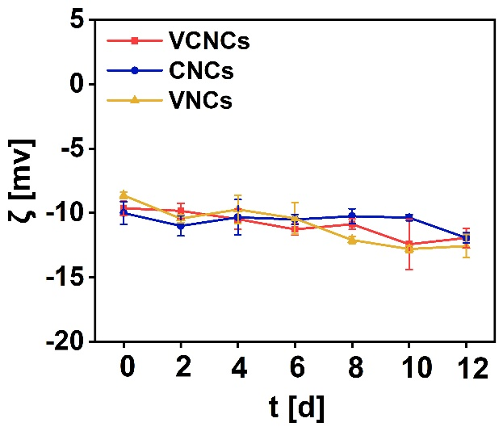
Fig. S9. The ζ-potential of VCNCs, CNCs, and VNCs in PBS at specific time points (C = 1mg/mL).

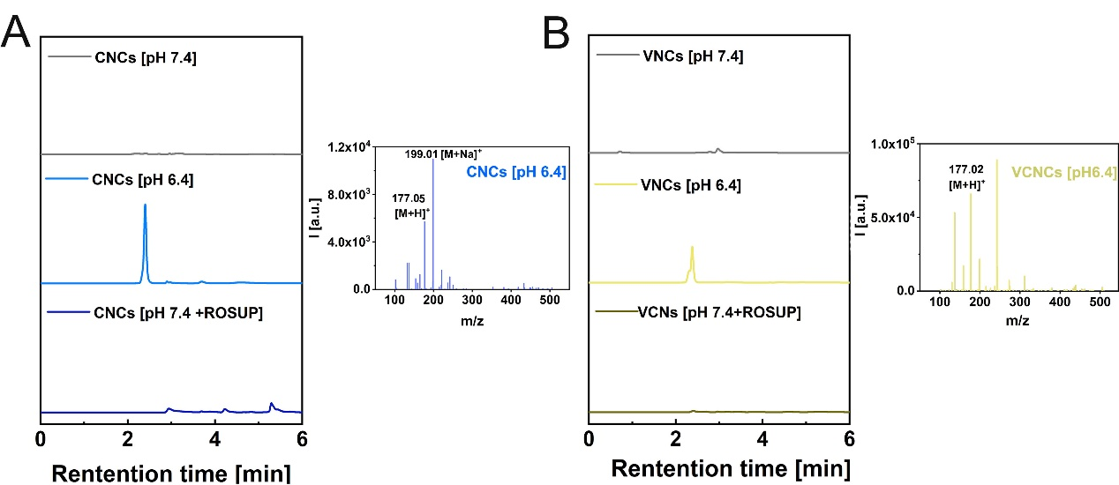
Fig. S10. CNCs and VNCs immersed in solutions of pH 7.4, pH 6.4, and pH 7.4+ROSUP at a concentration of C_{5-HT} = 5000 μg/mL for 72 h. The samples were centrifuged with an ultracentrifuge filter (cutoff Mw = 3 kDa), and the eluent was collected for analysis by HPLC spectrum. The collected samples with retention times from 2 min to 4 min were further characterized by ESI-MS.

The concentration of 5-HT at different concentrations was determined by HPLC. The linear correlation between the peak area from HPLC spectra and 5-HT concentration was used to construct a standard curve.
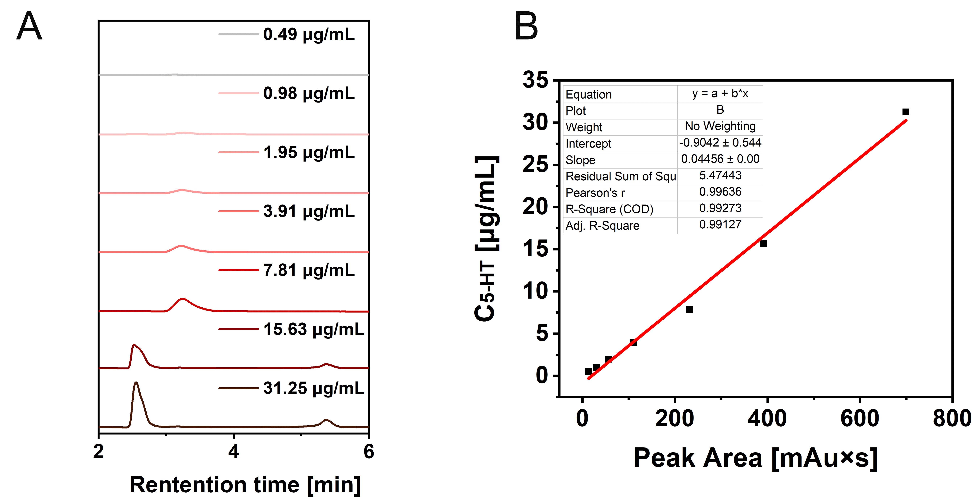
Fig. S11. Linear fitting of the peak area of 5-HT determined by HPLC versus the 5-HT concentration (C_{5-HT}:31.25 -0.49 μg/mL)d etermined by weight. The results are C_{5-HT} [μg/mL] = 0.045×peak area-0.90，R² = 0.9913.
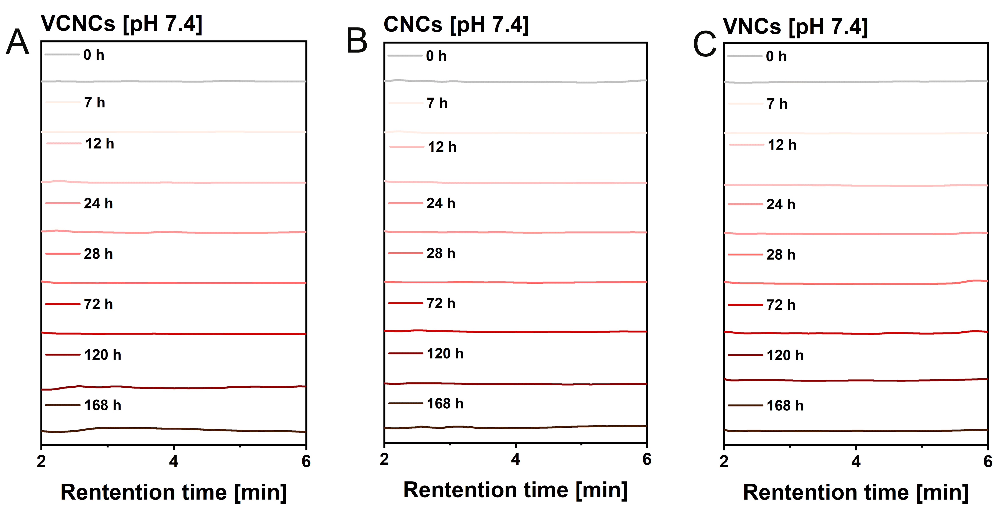
Fig. S12. (A)VCNCs, (B)CNCs, and (C)VNCs at a concentration C_{5-HT} = 50 μg/mL incubated with pH 7.4 buffer for specific time points. The samples were centrifuged at 8000 rpm for 30 min with an ultracentrifuge filter (cutoff M_{w} = 3 kDa). The eluents were collected and quantified by HPLC.
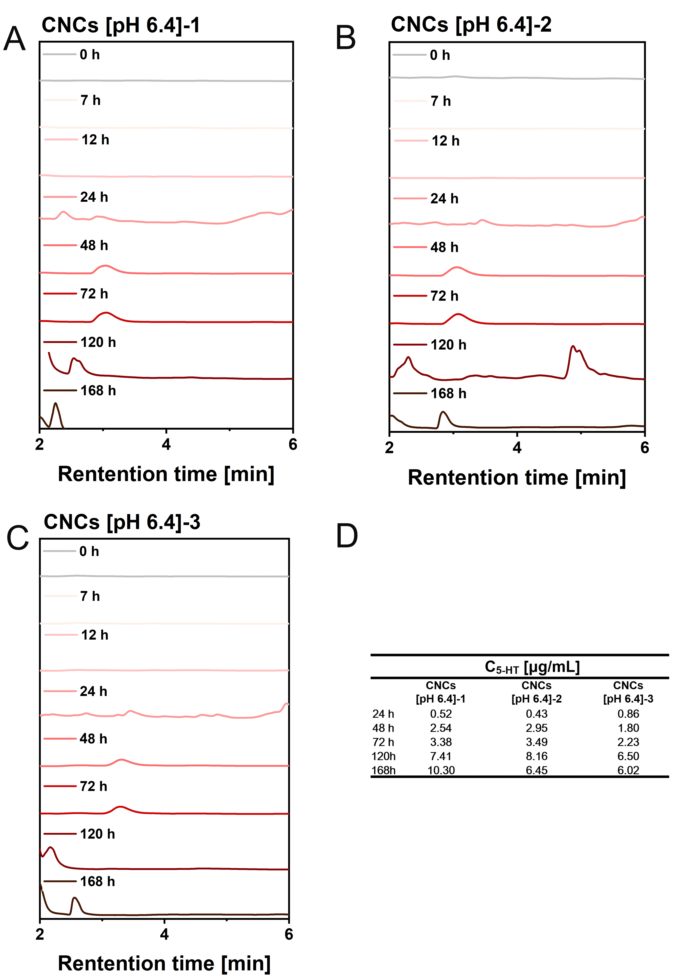
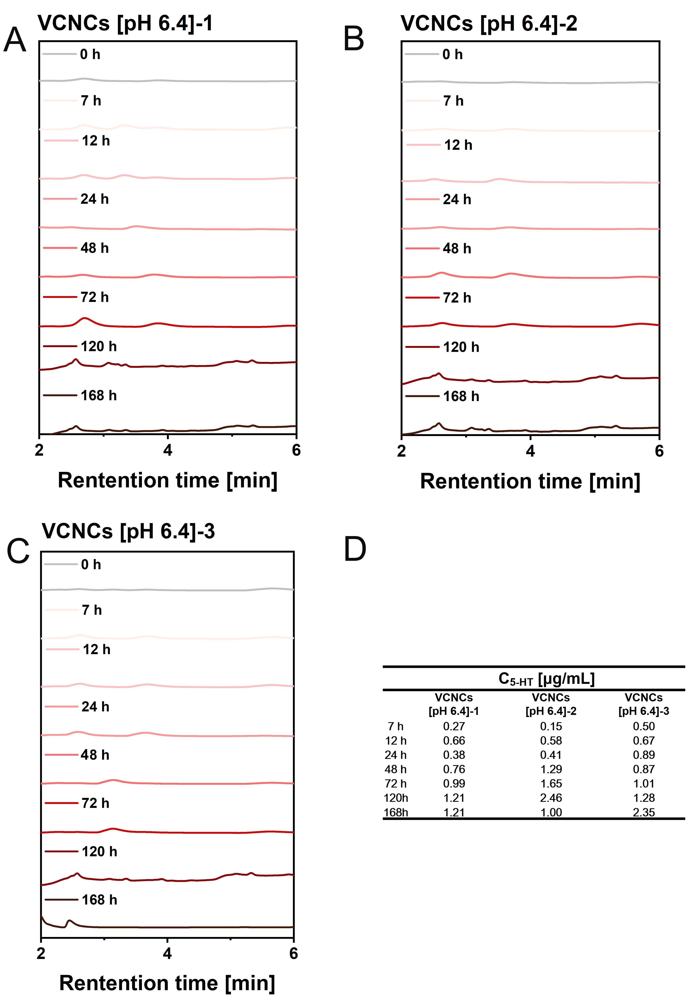
Fig. S13. Compilation of data from Fig. 2F. VCNCs at a concentration of C_{5-HT} = 50 μg/mL were incubated with pH 6.4 buffer for specific time points. The samples were centrifuged at 8000 rpm for 30 min with an ultracentrifuge filter (cutoff Mw = 3 kDa). The eluents were collected and quantified by HPLC. The results were represented by three independent samples, and the amounts of released 5-HT were quantified through peak area at t = 2-4 min according to the standard curve shown in Figure S11.
Fig. S14. Compilation of data from Fig. 2F. CNCs at a concentration of C_{5-HT} = 50 μg/mL were incubated with pH 6.4 buffer for specific time points. The samples were centrifuged at 8000 rpm for 30 min with an ultracentrifuge filter (cutoff Mw = 3 kDa). The eluents were collected and quantified by HPLC. The results were represented by three independent samples, and the amounts of released 5-HT were quantified through peak area at t = 2-4 min according to the standard curve shown in Figure S11.
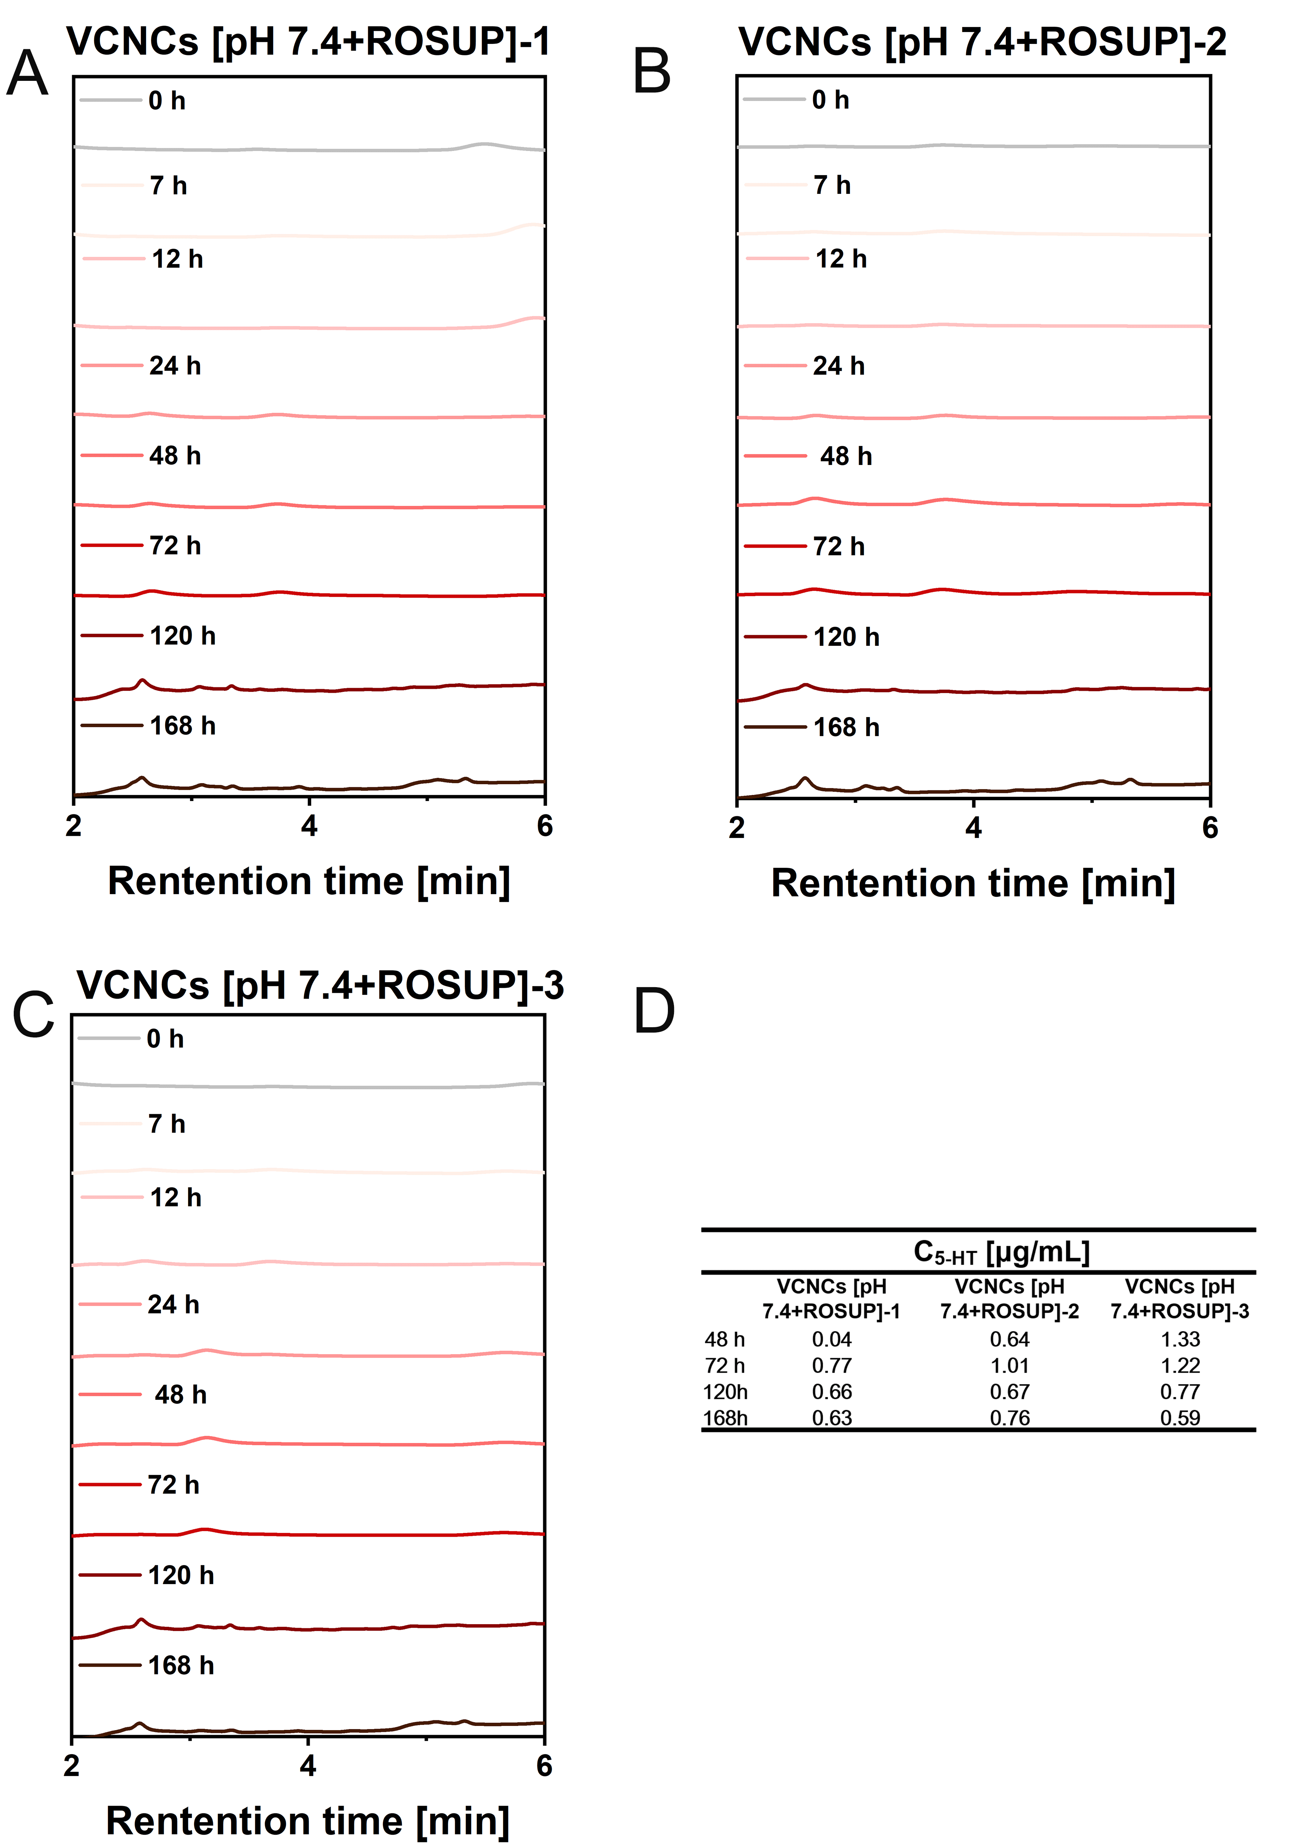
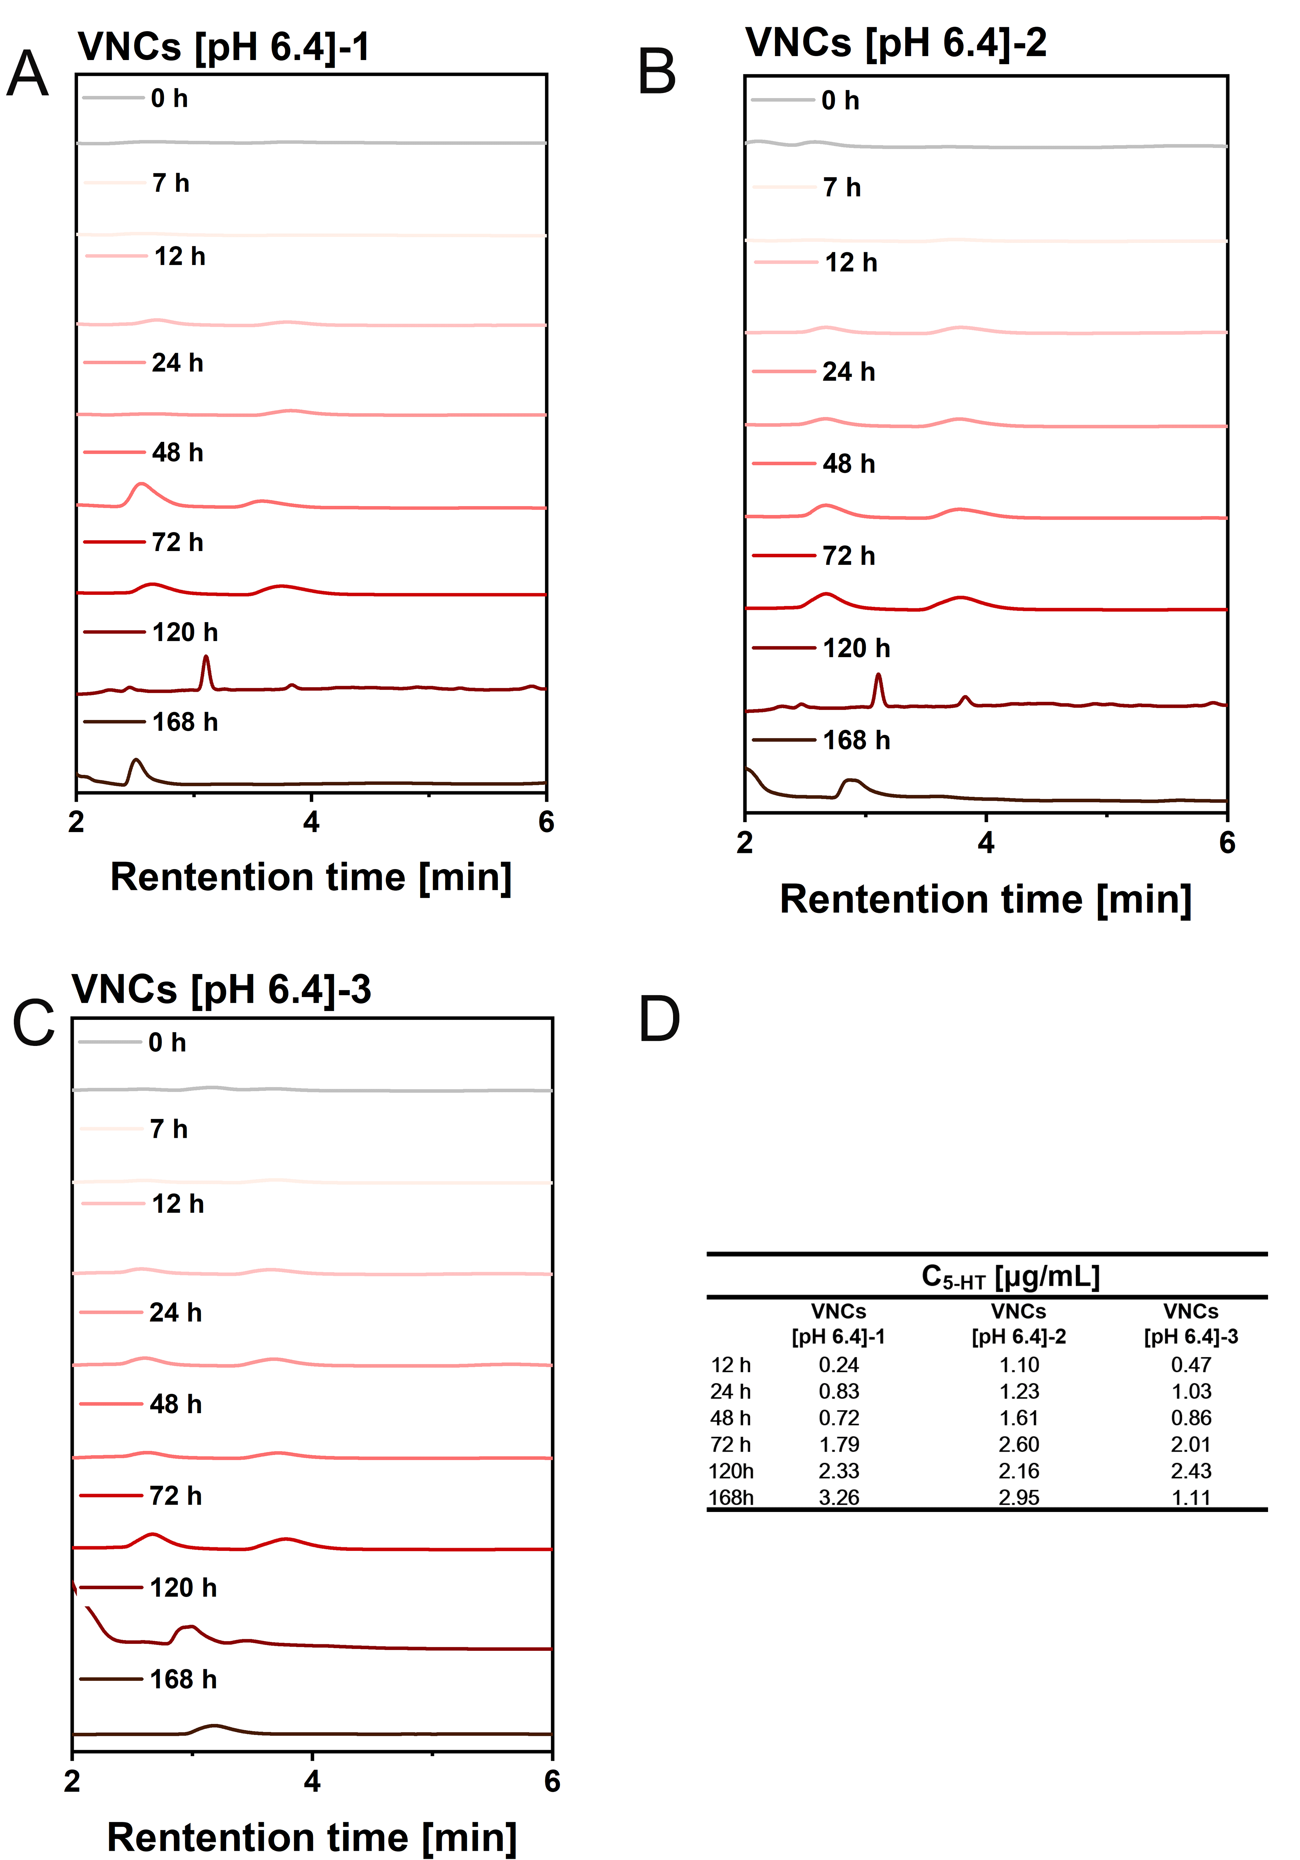
Fig. S15. Compilation of data from Fig. 2F. VNCs at a concentration of C_{5-HT} = 50 μg/mL were incubated with pH 6.4 buffer for specific time points. The samples were centrifuged at 8000 rpm for 30 min with an ultracentrifuge filter (cutoff Mw = 3 kDa). The eluents were collected and quantified by HPLC. The results were represented by three independent samples, and the amounts of released 5-HT were quantified through peak area at t = 2-4 min according to the standard curve shown in Figure S11.

Fig. S16. Compilation of data from Fig. 2F. VCNCs at a concentration of C_{5-HT} = 50 μg/mL were incubated with pH 7.4+ROSUP buffer for specific time points. The samples were centrifuged at 8000 rpm for 30 min with an ultracentrifuge filter (cutoff Mw = 3 kDa). The eluents were collected and quantified by HPLC. The results were represented by three independent samples, and the amounts of released 5-HT were quantified through peak area at t = 2-4 min according to the standard curve shown in Figure S11.
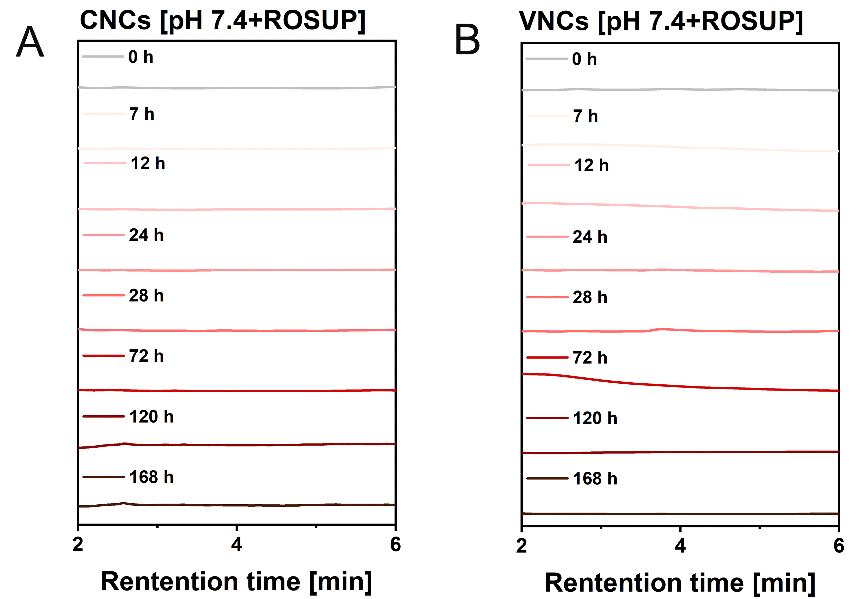
Fig. S17. CNCs and VNCs at a concentration C_{5-HT} = 50 μg/mL incubated with pH 7.4+ROSUP buffer for specific time points. The samples were centrifuged at 8000 rpm for 30 min with an ultracentrifuge filter (cutoff M_{w} = 3 kDa). The eluents were collected and quantified by HPLC.

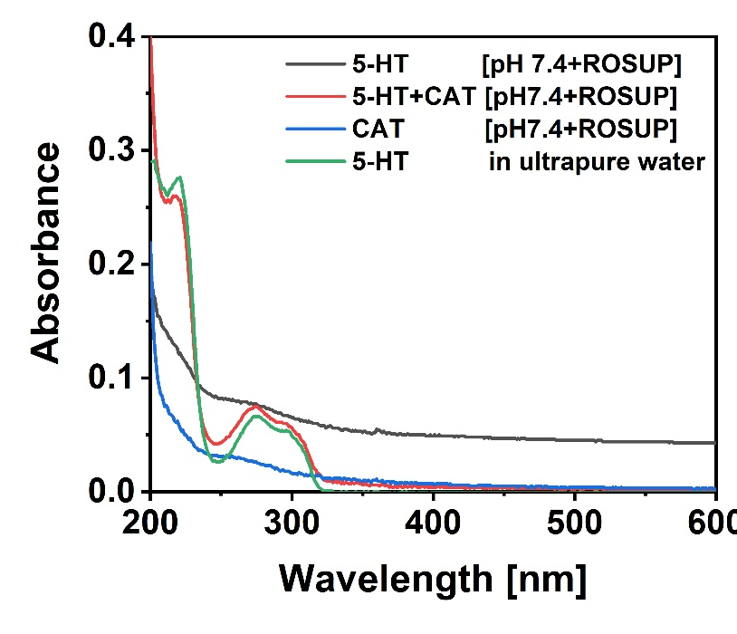
Fig. S18. UV-vis spectra of 5-HT in ultrapure water, 5-HT in pH 7.4+ROSUP buffer, CAT in pH 7.4+ROSUP buffer, 5-HT with CAT in pH 7.4+ROSUP buffer.

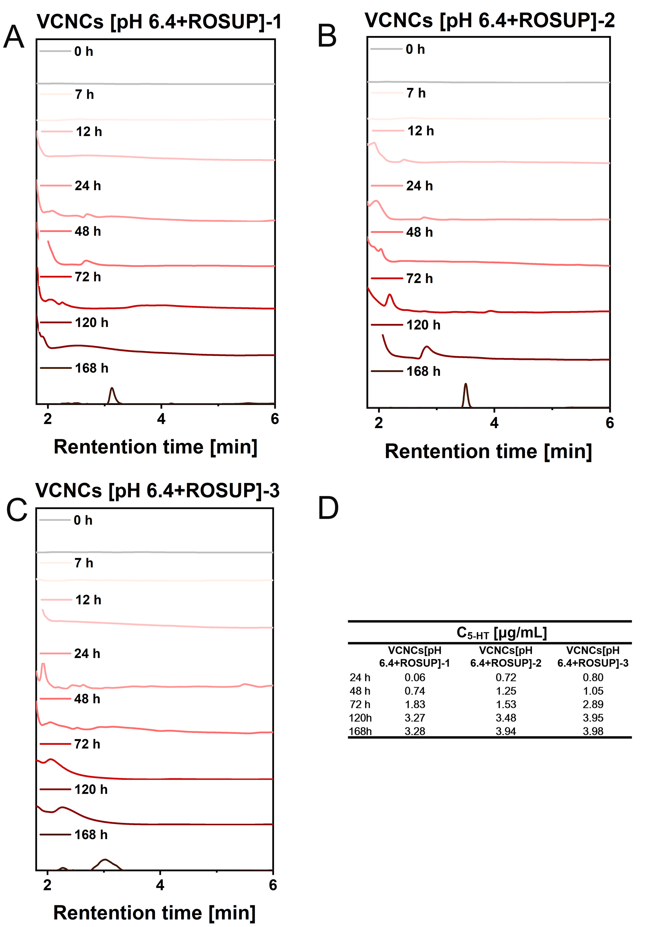

Fig. S19. Compilation of data from Fig. 2F. VCNCs at a concentration of C_{5-HT} = 50 μg/mL were incubated with pH 6.4+ROSUP buffer for specific time points. The samples were centrifuged at 8000 rpm for 30 min with an ultracentrifuge filter (cutoff Mw = 3 kDa). The eluents were collected and quantified by HPLC. The results were represented by three independent samples, and the amounts of released 5-HT were quantified through peak area at t = 2-4 min according to the standard curve shown in Figure S11.

Table S3. The concentrations of released 5-HT over time was normalized to the initial 5-HT concentration (50 μg/mL) in the nanocapsules and plotted as C_{5-HT}/C_{5-HT(NPs)} .
t [h] | C_{5-HT} [%]
 | VCNCs [pH 6.4]-1 | VCNCs [pH 6.4]-2 | VCNCs [pH 6.4]-3 | VCNCs [pH 6.4]
7 h | 0.54 | 0.30 | 1.01 | 0.62±0.36
12 h | 1.32 | 1.16 | 1.34 | 1.28±0.10
24 h | 0.77 | 0.83 | 1.79 | 1.13±0.57
48 h | 1.52 | 2.58 | 1.74 | 1.94±0.56
72 h | 1.99 | 3.31 | 2.01 | 2.43±0.75
120h | 2.42 | 4.91 | 2.55 | 3.29±1.40
168h | 2.43 | 1.99 | 4.70 | 3.04±1.46
 | CNCs [pH 6.4]-1 | CNCs [pH 6.4]-2 | CNCs [pH 6.4]-3 | CNCs [pH 6.4]
24 h | 1.03 | 0.86 | 1.72 | 1.20±0.46
48 h | 5.08 | 5.89 | 3.60 | 4.86±1.17
72 h | 6.76 | 6.98 | 4.46 | 6.07±1.40
120h | 14.82 | 16.33 | 13.00 | 14.72±1.67
168h | 20.59 | 12.90 | 12.05 | 15.18±4.71
 | VNCs [pH 6.4]-1 | VNCs [pH 6.4]-2 | VNCs [pH 6.4]-3 | VNCs [pH 6.4]
12 h | 0.47 | 2.19 | 0.93 | 1.20±0.89
24 h | 1.66 | 2.47 | 2.06 | 2.06±0.40
48 h | 1.44 | 3.23 | 1.72 | 2.13±0.97
72 h | 3.57 | 5.20 | 4.01 | 4.26±0.84
120h | 4.67 | 4.31 | 4.86 | 4.61±0.28
168h | 6.51 | 5.90 | 2.22 | 4.88±2.32
 | VNCs [pH 7.4+ROSUP]-1 | VNCs [pH 7.4+ROSUP]-2 | VNCs [pH 7.4+ROSUP]-3 | VNCs [pH 7.4+ROSUP]
48 h | 0.082726 | 1.284064 | 2.660077 | 1.34±1.29
72 h | 1.547859 | 2.029998 | 2.431038 | 2.00±0.44
120h | 1.323277 | 1.337536 | 1.532709 | 1.40±0.12
168h | 1.258219 | 1.513994 | 1.179794 | 1.32±0.17
 | VNCs  [pH 6.4+ROSUP]-1 | VNCs  [pH 6.4+ROSUP]-2 | VNCs  [pH 6.4+ROSUP]-3 | VNCs  [pH 6.4+ROSUP]
24 h | 0.12 | 1.44 | 1.61 | 1.06±0.81
48 h | 1.48 | 2.50 | 2.09 | 2.02±0.51
72 h | 3.67 | 3.07 | 5.78 | 4.17±1.43
120 h | 6.53 | 6.95 | 7.91 | 7.13±0.70
168 h | 6.57 | 7.88 | 7.95 | 7.47±0.78

Table S4. Ranges of concentrations of different samples for cytotoxicity assays.
 | VCNCs  (C_{5-HT}[μg/mL]) | CNCs  (C_{5-HT}[μg/mL]) | VNCs  (C_{5-HT}[μg/mL]) | 5-HT  (C_{5-HT}[μg/mL]) | CAT  (C_{CAT}[μg/mL]) | HSA  (C_{HSA}[μg/mL])
1# | 50 | 50 | 50 | 50 | 8 | 600
2# | 25 | 25 | 25 | 25 | 4 | 300
3# | 12.50 | 12.50 | 12.50 | 12.50 | 2 | 150
4# | 6.25 | 6.25 | 6.25 | 6.25 | 1 | 75
5# | 3.13 | 3.13 | 3.13 | 3.13 | 0.50 | 37.50
6# | 1.56 | 1.56 | 1.56 | 1.56 | 0.25 | 18.75

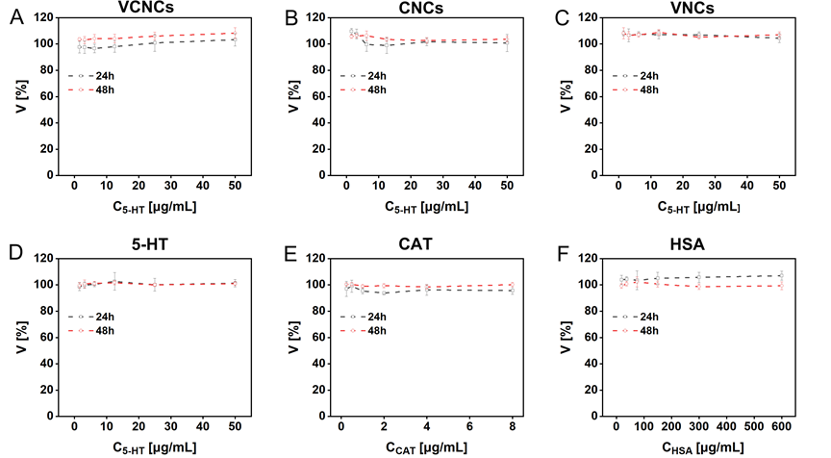
Fig. S20. Cell viability V studies of PC-12 cells exposed to (A)VCNCs, (B) CNCs, and (C)VNCs, (D)5-HT, (E)CAT, and (F) HSA at various concentrations (provided in Table S4). PC-12 cells were incubated with test samples in the cell medium for 24 h and 48 h. Cell viability was assessed using the resazurin assay and presented as the mean ± standard deviation of n≥3 measurements.

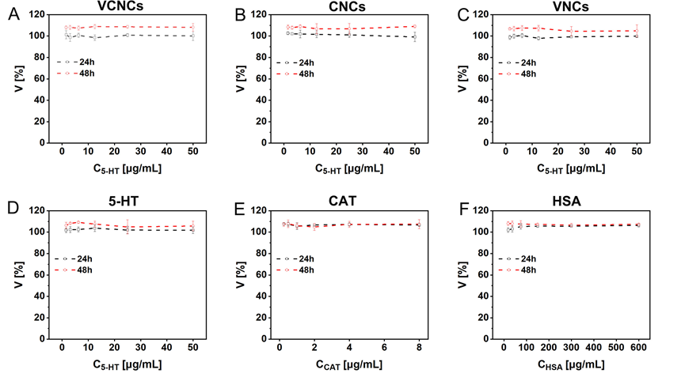
Fig. S21. Cell viability V studies of bEnd.3 cells exposed to (A)VCNCs, (B) CNCs, and (C)VNCs, (D)5-HT, (E)CAT, and (F) HSA at various concentrations (provided in Table S4). PC-12 cells were incubated with test samples in the cell medium for 24 h and 48 h. Cell viability was assessed using the resazurin assay and presented as the mean ± standard deviation of n≥3 measurements.

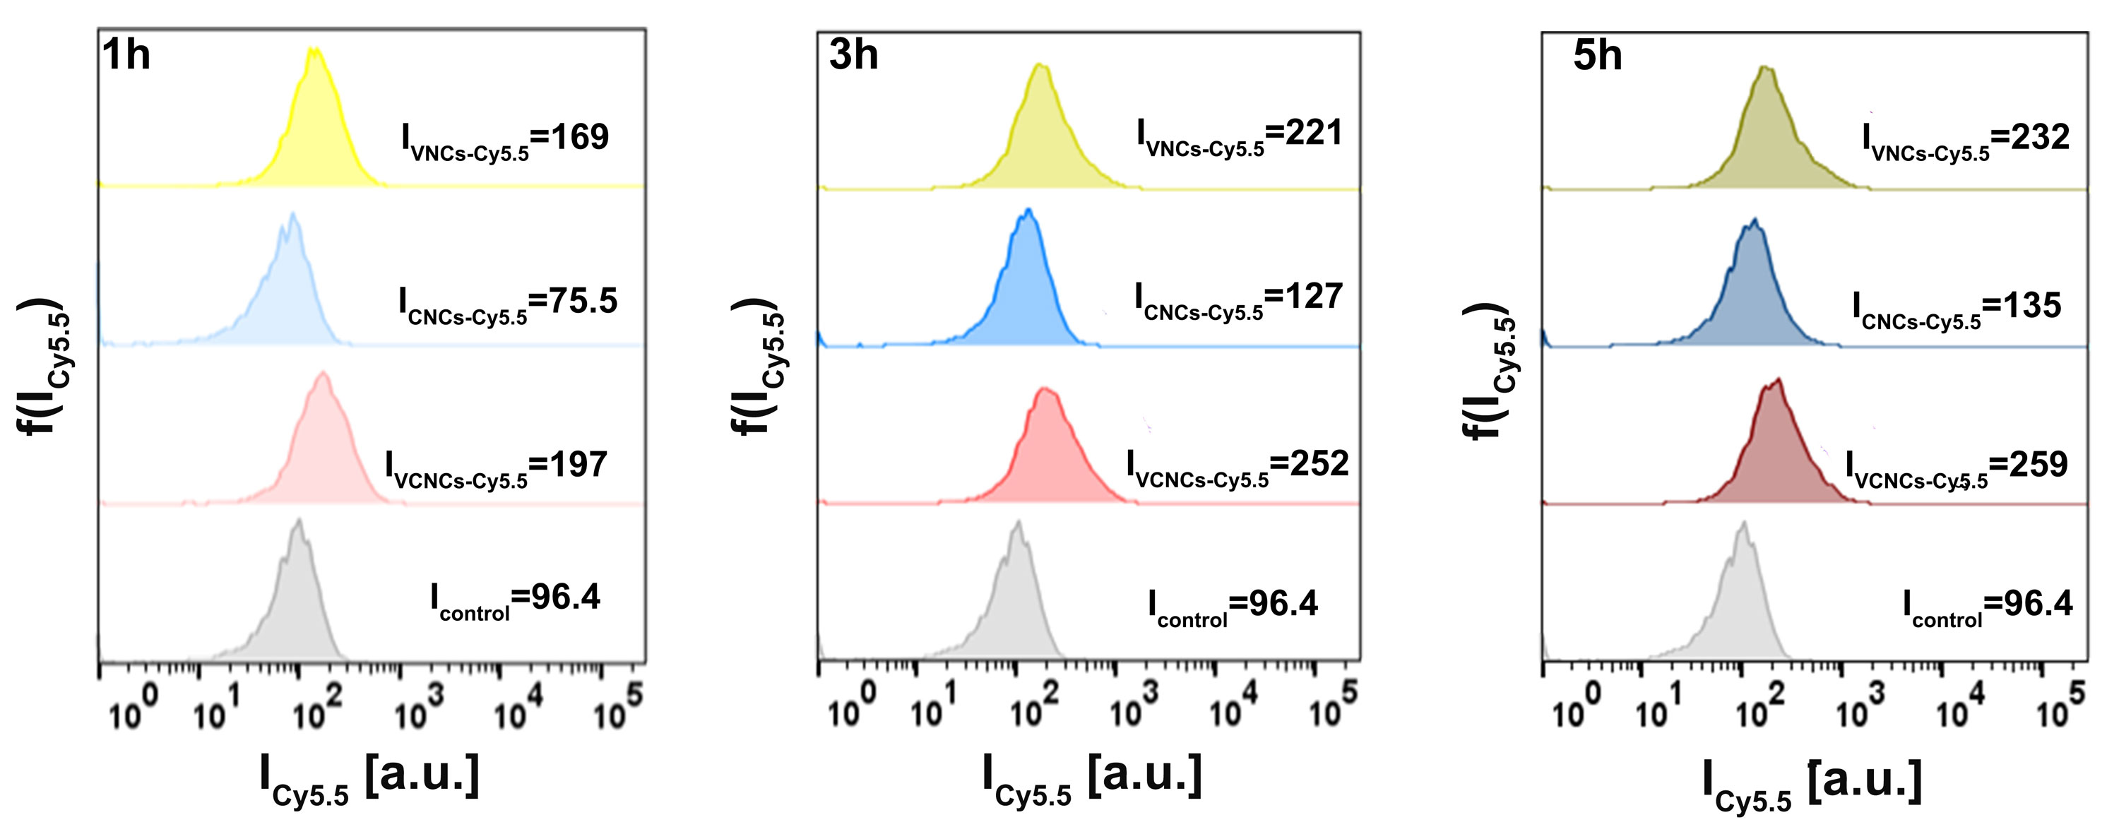
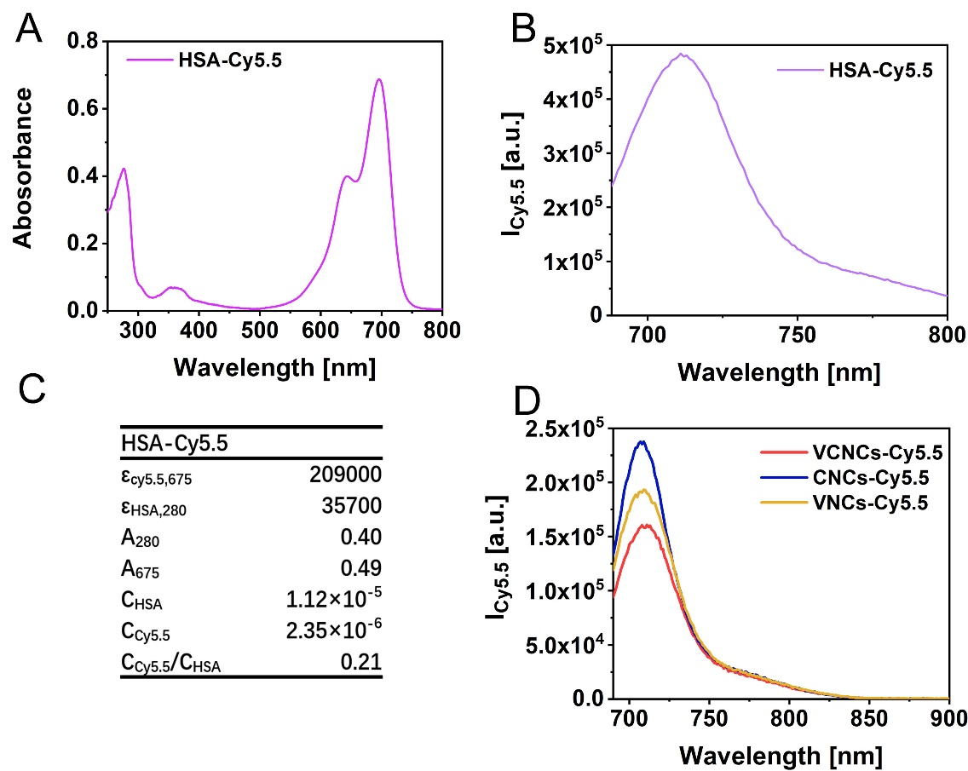
Fig. S22. (A)The UV-vis spectrum and (B)fluorescence spectrum I_{Cy5.5} of HSA-Cy5.5. (C) The labeling efficiency of HSA-Cy5.5 was calculated by Beer-Lambert’s law. (D)The fluorescence spectrum I_{Cy5.5} at 678 nm excitation of VCNCs-Cy5.5, CNCs-Cy5.5, and VNCs-Cy5.5 at C_{NPs}=1mg/mL.
Fig. S23. Distributions of Cy5.5 fluorescence per cell f(I_{Cy5.5}) as measured by flow cytometry for bEnd.3 cells which had been exposed to VCNCs-Cy5.5, CNCs-Cy5.5, and VNCs-Cy5.5 at a concentration C_{5-HT} = 25 μg/mL for 1, 3, and 5 h.

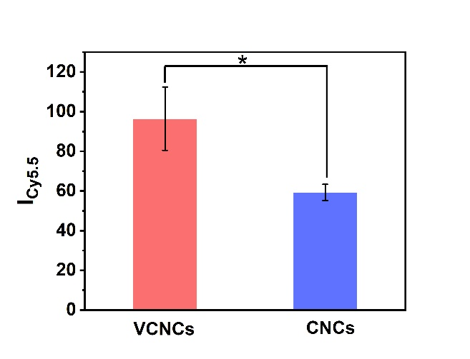
Fig. S24. Compilation of data from Fig. 3A, bEnd.3 cells in the transwell filter were exposed to VCNCs-Cy5.5 and CNCs-Cy5.5 at a concentration C_{5-HT} = 25 μg/mL in cell medium for 3 h. For uptake study, mean Cy5.5. fluorescence I_{Cy5.5} was determined by flow cytometry at t_{exp} = 3 h. Data are from n=3 experiments, and significant differences between groups were analyzed using one-way ANOVA, * P＜0.05.

In the uptake studies, bEnd.3 cells were exposed to nanocapsules for a duration of t_{exp} = 3 h, resulting in a total cell count of N_{cell} (t_{exp:3h}). Subsequently, PC-12 cells were co-incubated with bEnd.3 cells for a further duration of t_{inc} = 24 h, resulting in a total cell count of N_{cell} (t_{exp:3h}+t_{inc:24h}). The number of cells had increased by a factor of N_{cell} (t_{exp:3h}+t_{inc:24h})/ N_{cell} (t_{exp:3h}) from the initial cell count at t_{exp:3h}.

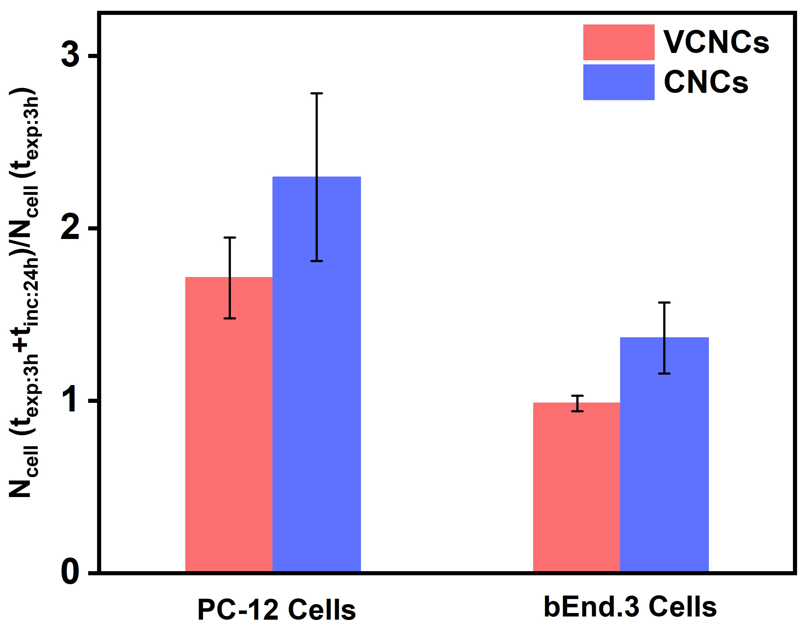
Fig. S25.The factor by which the number of cells N_{cell} had proliferated during t_{exp} + t_{inc} = 3 h+ 24 h. The absolute cell numbers at t_{exp} = 3 h were 111.4±7.8 ×10⁴ cells/mL (VCNCs) and 119.7±18.8×10⁴ cells/mL (CNCs). The factor N_{cell}(t_{exp:3h}+t_{inc:24h})/ N_{cell}(t_{exp:3h}) was calculated accordingly.

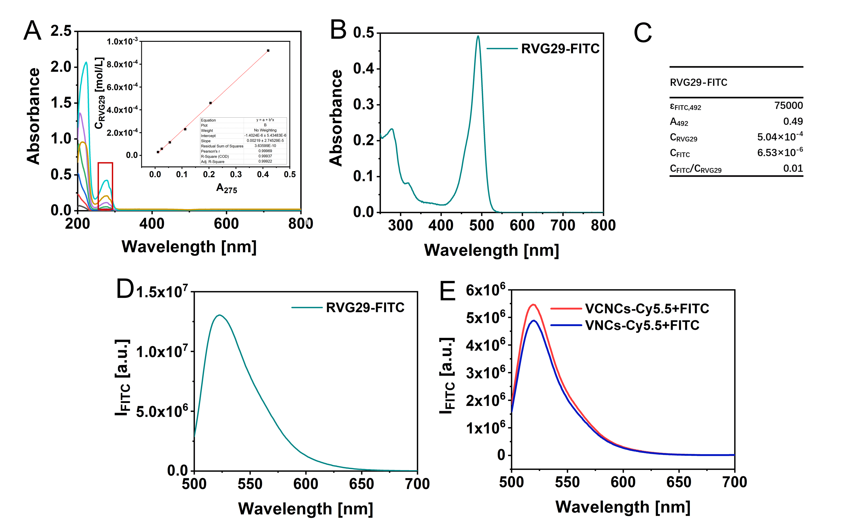
Fig. S26. The labeling efficiency of RVG29. (A) The RVG29 concentration was determined by the weight of the powder before dissolution versus the absorbance at 275 nm. Linear analysis was applied to the obtained data and fit results are shown as C_{RVG29} = 2.19×10⁻³×A₂₇₆-1.40×10⁻⁶, R² = 0.9992. (B) The UV-vis spectrum of RVG29-FITC. (C) The concentration of RVG29 C_{RVG29} was calculated from the absorbance at 275 nm using the standard curve from the fit results in A. The concentration of FITC C_{FITC} was calculated using Beer-Lambert's law. The fluorescence spectrum IFITC at 488 nm excitation of (D) free RVG29-FITC and (E) doubly labeled VCNCs-Cy5.5+FITC and VNCs-Cy5.5+FITC were also analyzed.

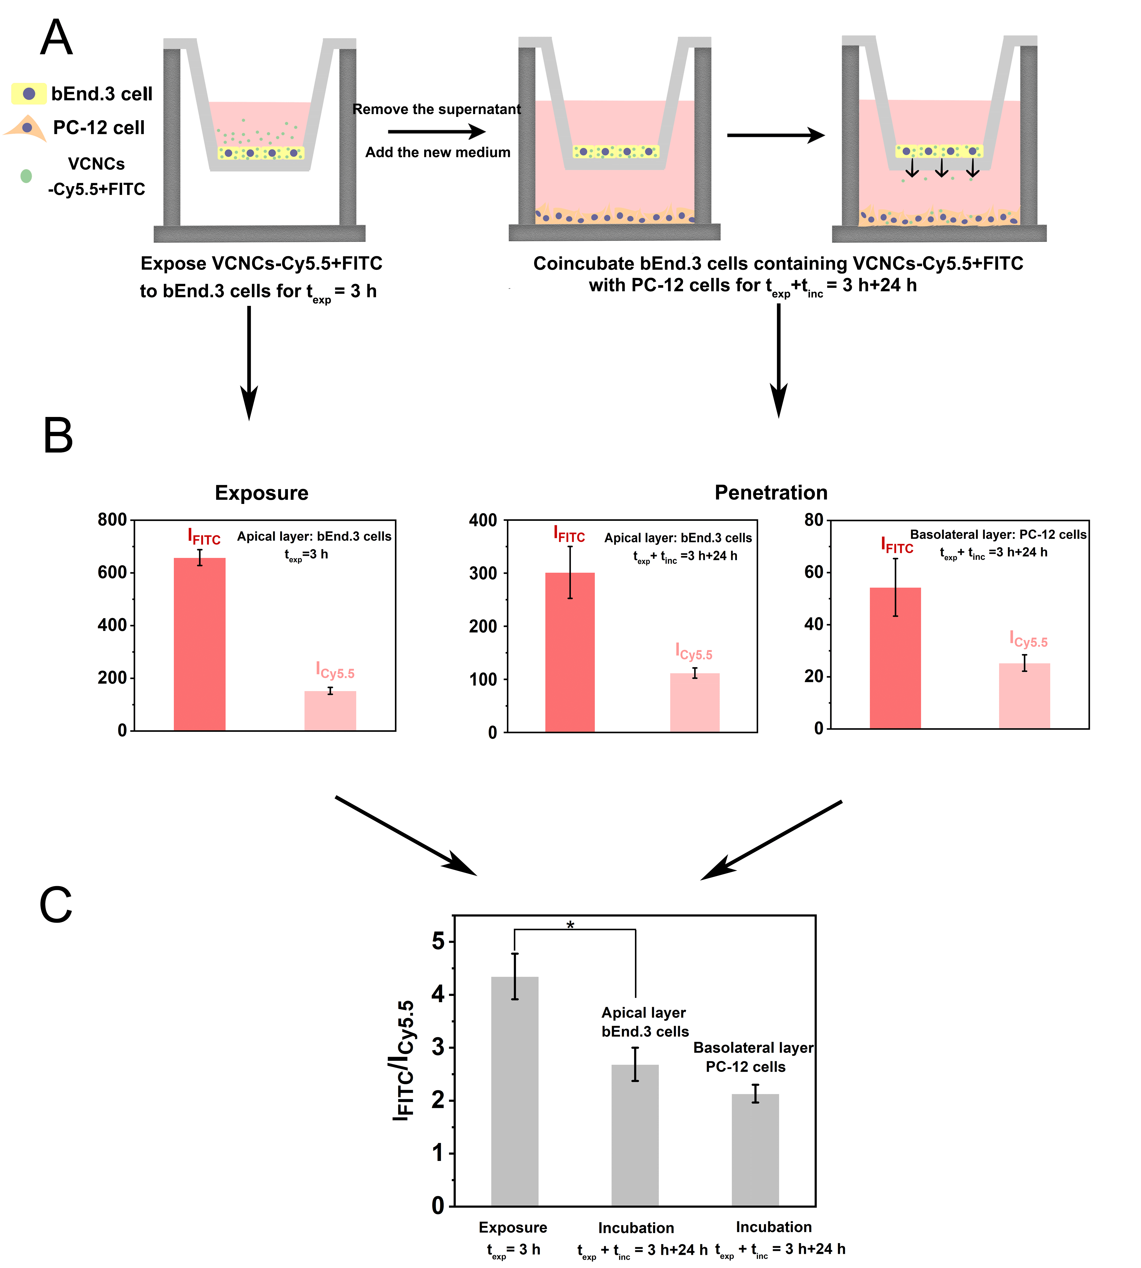
Fig. S27. (A)The schematic illustration of the in vitro BBB penetration model for studying the integrity of nanocapsules after passing through bEnd.3 cells. The doubly labeled VCNCs-Cy5.5+FITC was added to bEnd.3 cells in the transwell filter at a concentration of C_{5-HT} = 25 μg/mL. After exposure for the time texp = 3 h, cellular uptake was characterized by flow cytometry. The mean Cy5.5 fluorescence I_{Cy5.5} and mean FITC fluorescence IFITC originating from each cell were background-corrected by control cells without nanocapsules. For the penetration study, the supernatant was replaced with fresh medium after exposure. bEnd.3 cells in the apical layer were then further incubated for the time t_{exp} + t_{inc} = 3 h + 24 h with PC-12 cells in the basolateral layer. (B) The mean Cy5.5 fluorescence I_{Cy5.5} and mean FITC fluorescence IFITC in bEnd.3 cells and PC-12 cells were analyzed by flow cytometry. (C) Ratios of fluorescence per cell originating from RVG29-FITC and HSA-Cy5.5 were determined from the data shown in B. Data correspond to the mean value and standard deviation of n = 3 measurements. One-way ANOVA was used to analyze significant differences between groups (* P＜0.05).
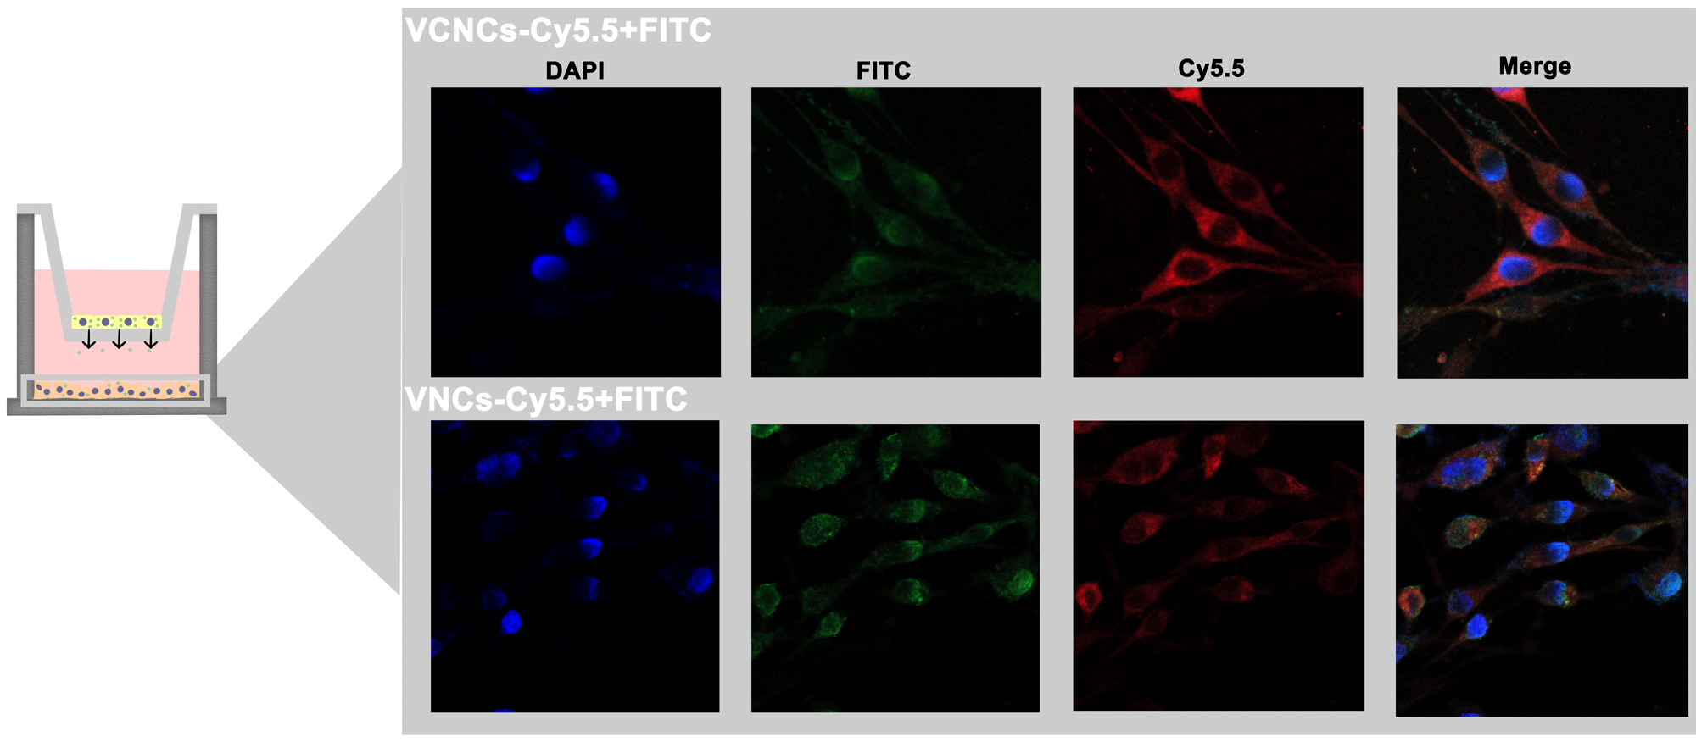
Fig. S28. Confocal images of PC-12 cells containing doubled labeled VCNCs-Cy5.5+FTIC and VNCs-Cy5.5+FITC at t_{exp} + t_{inc} = 3 h+ 24 h (Cy5.5: red; FITC: green). Nuclei were stained with DAPI (blue).

Table S5. Concentration ranges of the different samples used for studying the effect on the cellular ROS level.
 | VCNCs  (C_{5-HT}[μg/mL]) | CNCs  (C_{5-HT}[μg/mL]) | VNCs  (C_{5-HT}[μg/mL]) | 5-HT  (C_{5-HT}[μg/mL]) | CAT  (C_{CAT}[μg/mL]) | HSA  (C_{HSA}[μg/mL])
1# | 50 | 50 | 50 | 50 | 4 | 300
2# | 25 | 25 | 25 | 25 | 2 | 150
3# | 12.50 | 12.50 | 12.50 | 12.50 | 1 | 75
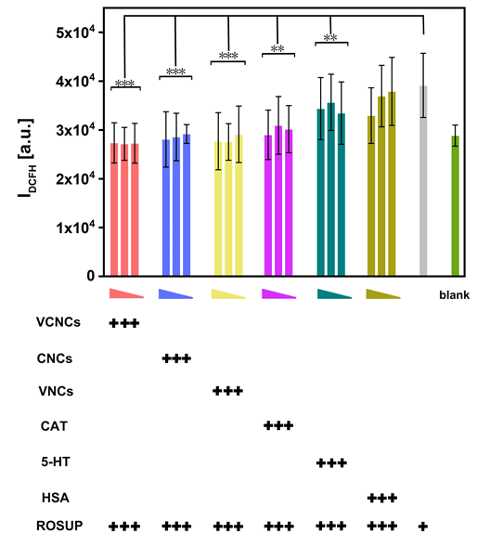

Fig. S29. Detection of DCFH fluorescence in cells after 3 h exposure to VCNCs, CNCs, and VNCs, 5-HT, CAT, and HSA at different concentrations. The legend “triangle” refers to samples exposed at higher concentrations to lower concentrations as indicated in Table S5. Fluorescence was detected by the microplate reader. Results are from three independent experiments. PC-12 cells incubated with DCFH-DA were used as the blank group. The significant differences between groups were analyzed by one-way ANOVA method, * *P＜0.01, * * * P＜0.001.
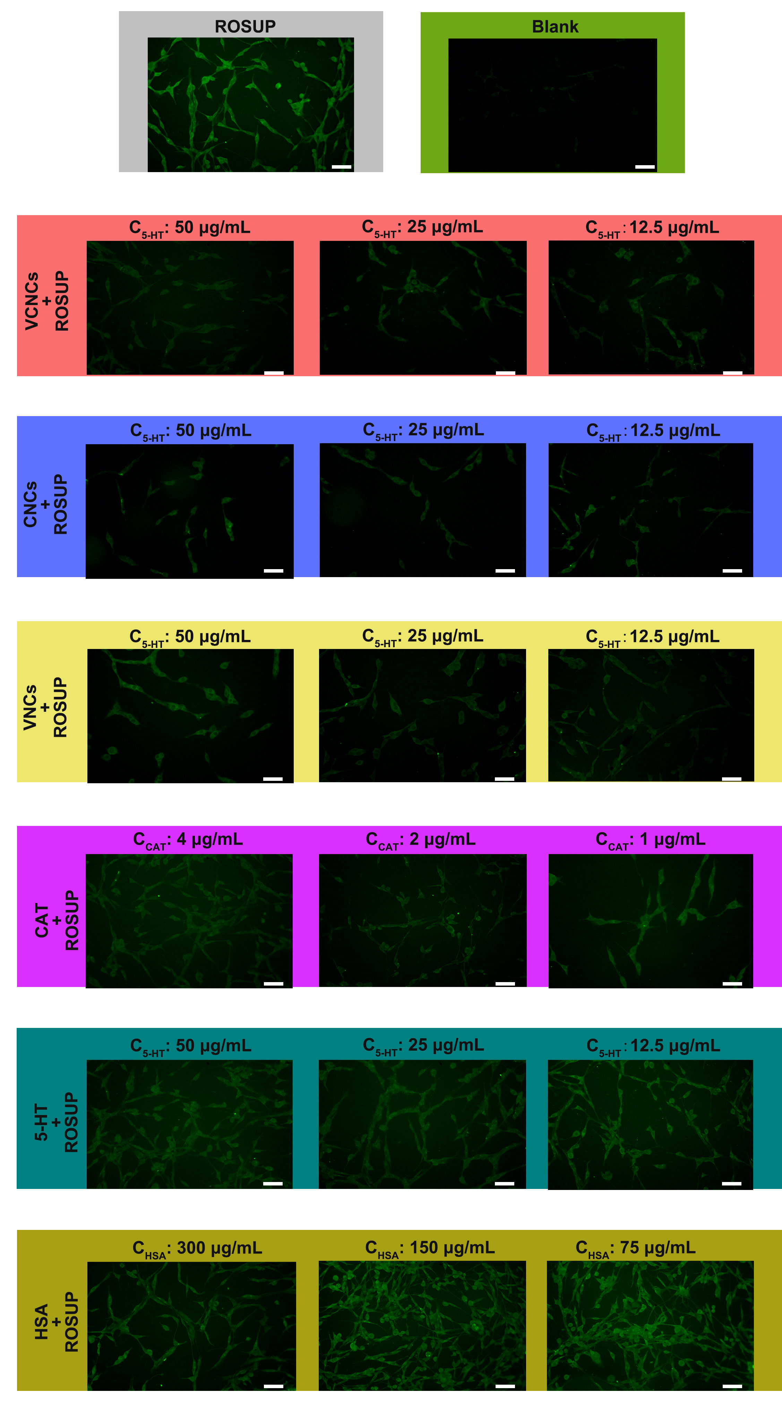
Fig. S30. Fluorescence images of intracellular ROS in PC-12 cells incubated with nanocapsules and reagents at different concentrations for 3 h. The scale bar represents 50 μm

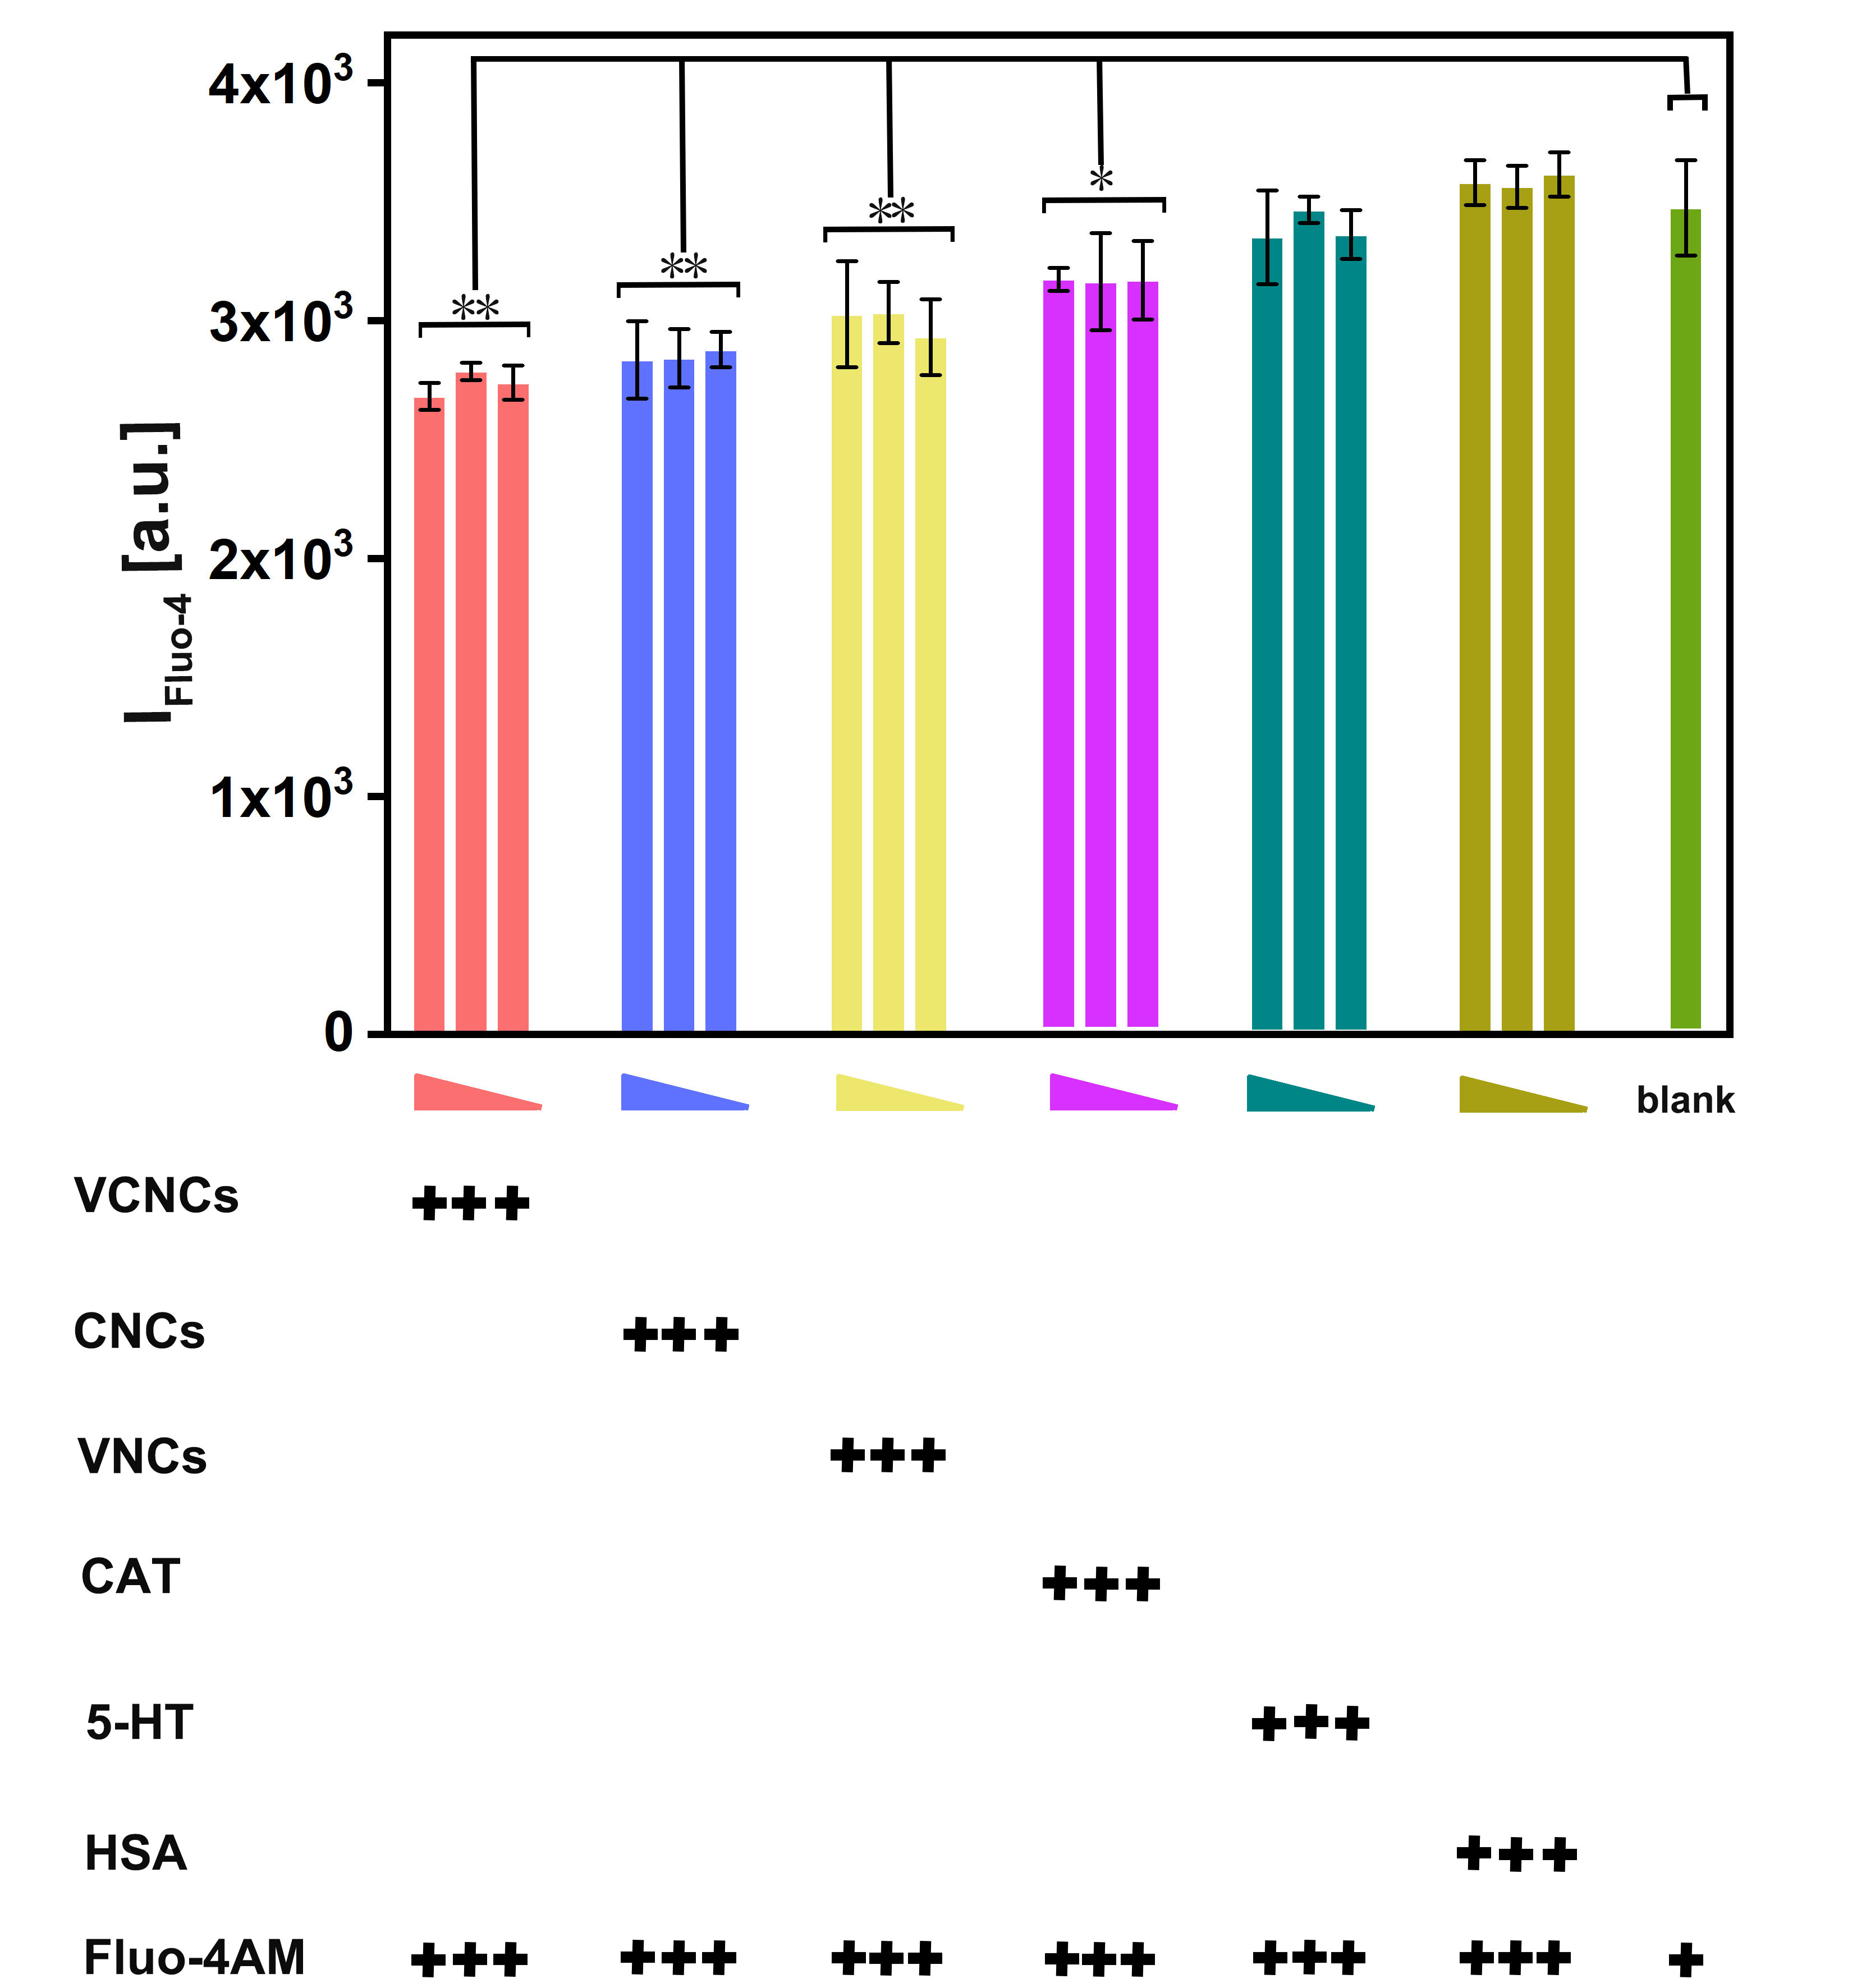
Fig. S31. Cellular fluorescence of Fluo-4 in cells incubated with nanocapsules and reagents for 3 h, recorded by a microplate reader at the FITC channel. The concentrations of nanocapsules and reagents are displayed in Table S5. The intensity of Fluo-4 fluorescence is proportional to the level of cytoplasmic calcium. PC-12 cells incubated with Fluo-4AM were used as the blank group. Results are from three independent experiments. The significant differences between groups were analyzed by the one-way ANOVA method, *P＜0.05, **P＜0.01.

Table S6. Mice were subjected to different stressors for 5 weeks.
 | Day1 | Day2 | Day3 | Day4 | Day5 | Day6 | Day7
Week1 | Wet bedding 24 h | Food deprivation 24 h | Tail pinch  1 min | Water deprivation 24 h | Cage tilting  2 h | Cold swim 3 min | Crowding 24 h
Week2 | Restrain  2 h | Light cycle reversal | Dark cycle reversal | Food deprivation 24 h | Strobe light 2 h | Tail pinch  1 min | Cage tilting 2 h
Week3 | Wet bedding 24 h | Water deprivation 24 h | Restrain  2 h | Crowding 24 h | Cold swim  3 min | Light cycle reversal | Dark cycle reversal
Week4 | Strobe light 2 h | Food deprivation 24 h | Water deprivation 24 h | Cage tilting 2 h | Tail pinch  1 min | Cold swim 3 min | Crowding 24 h
Week5 | Wet bedding 24 h | Restrain  2 h | Light cycle reversal | Dark cycle reversal | Strobe light 2 h | Food deprivation 24 h | Water deprivation 24 h

Table S7. The CUMS schedule during the treatment session.
 | Day1 | Day2 | Day3 | Day4 | Day5 | Day6 | Day7
Week1 | Wet bedding  24 h | Food deprivation 24 h | Water deprivation 24 h | Cage tilting 2 h | Restrain  2 h | Light cycle reversal | Crowding 24 h
Week2 | Water deprivation 24 h | Wet bedding  24 h | Cage tilting 2 h | Food deprivation 24 h | Crowding 24 h | Restrain  2 h | Dark cycle reversal

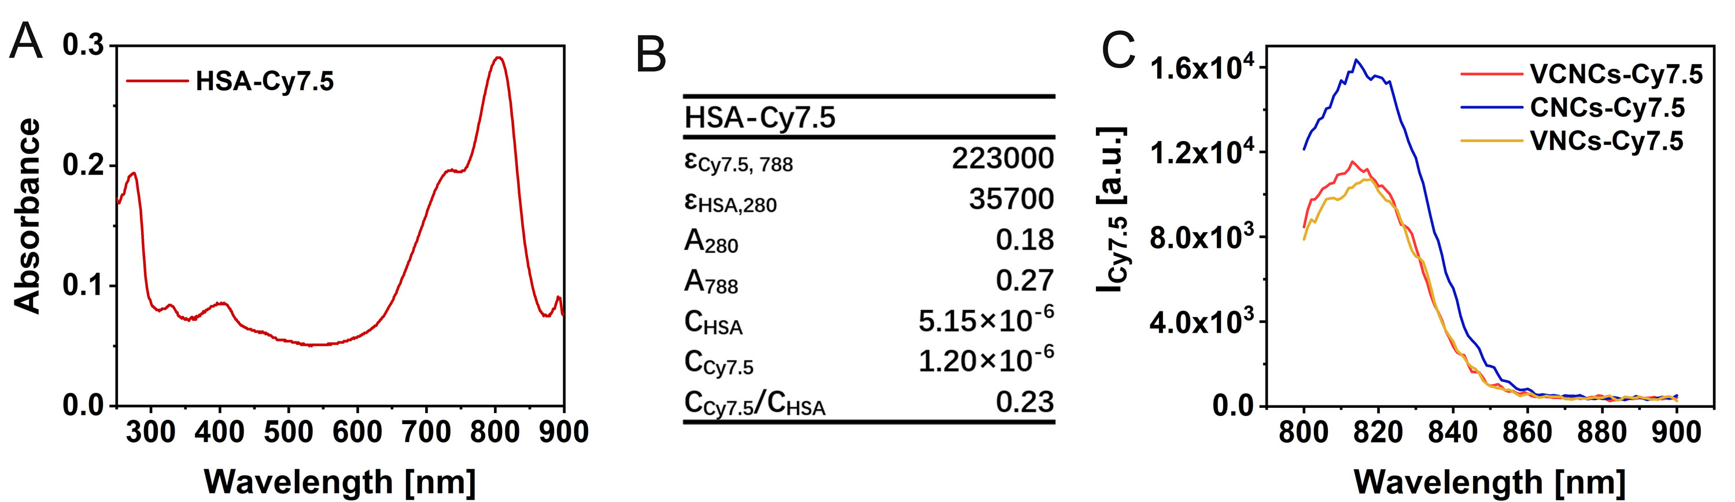
Fig. S32. (A) The UV-vis spectrum of HSA-Cy7.5. (B) The labeling efficiency of HSA-Cy7.5 was calculated by Beer-Lambert’s law. (C)The fluorescence spectrum I_{Cy7.5} at 788 nm excitation for VCNCs-Cy7.5, CNCs-Cy7.5, and VNCs-Cy7.5 at C_{NPs} = 1mg/mL.

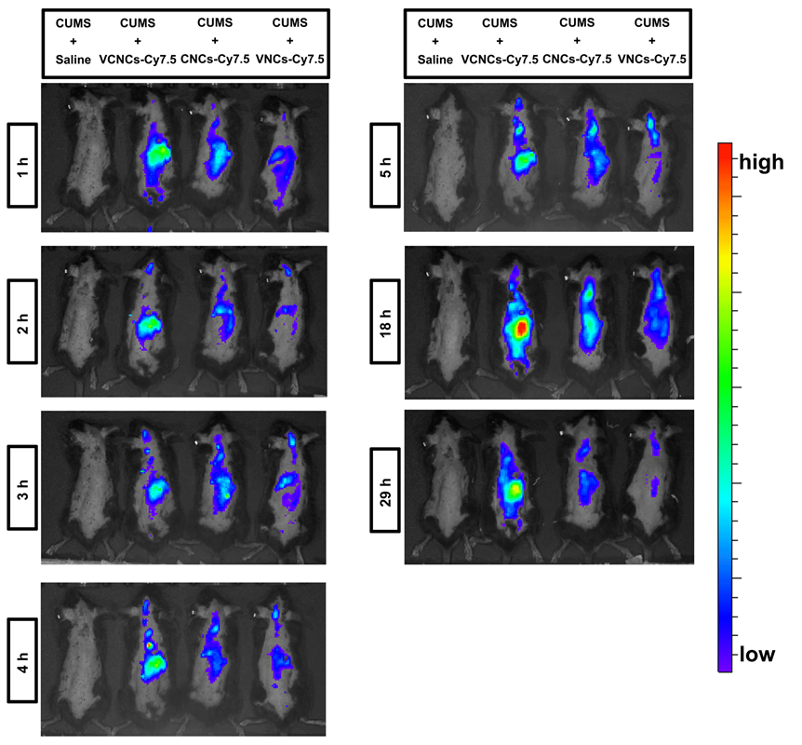
Fig. S33. In vivo Cy7.5 fluorescence of CUMS mice after intravenous injection with VCNCs-Cy7.5, CNCs-Cy7.5, and VNCs-Cy7.5 at a concentration C_{5-HT} :400 μg/kg for 3 h.

Fig. S34. The levels of (A) TNF-α and (B) IL-1β in the mice hippocampi after different antidepressive treatment were detected using ELISA kits. The results normalized by the protein concentration of each sample (n = 3).

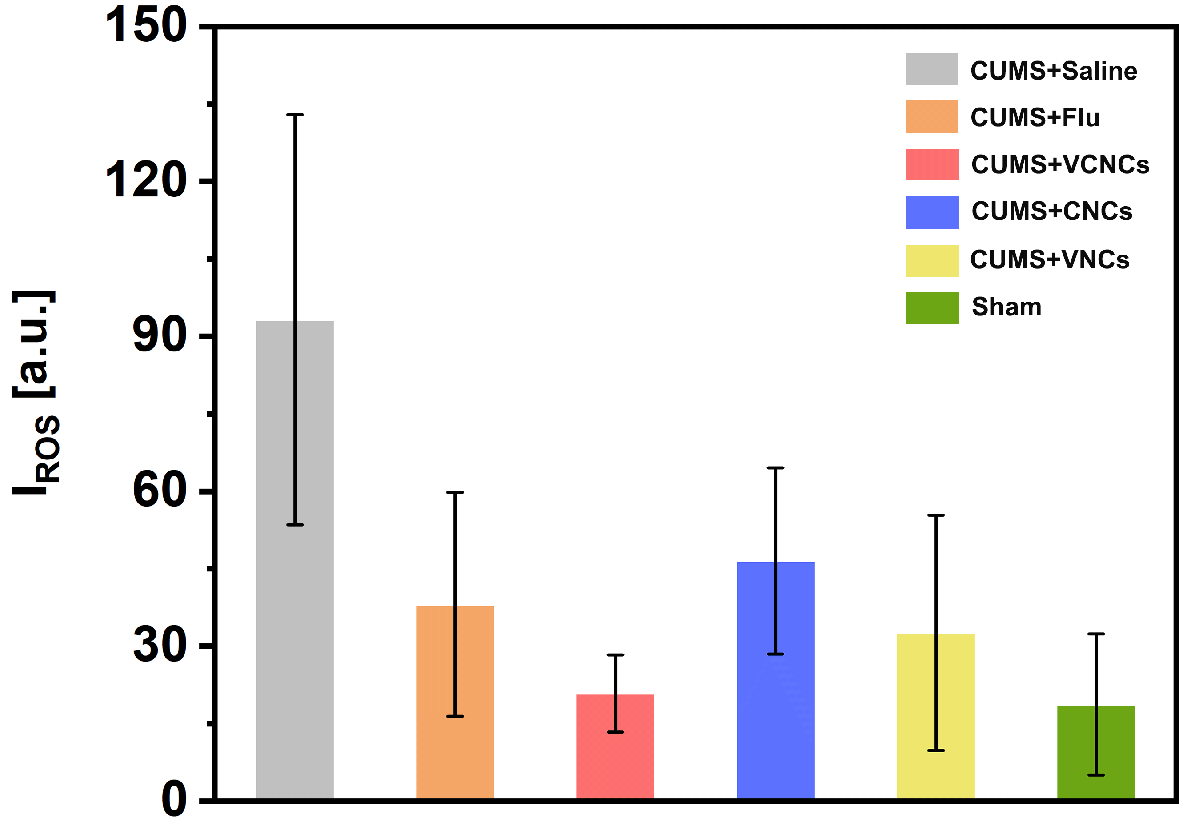

Fig. S35. Compilation of data from Fig. 5F. Quantitative evaluation of the ROS intensity in Fig. 5F analyzed by Image J.

Fig. S36. The cortisol level of serum in the mice after different antidepressant treatments. The data are from three independent experiments.

Table S8. The blood indexes examination from the mice after the treatments. Data are presented as mean±s.d.(n=3)
 | Normal range | Saline | Fluoxetine | VCNCs | CNCs | VNCs | Sham
WBC | 0.80-6.80  (10⁹/L) | 4.70±0.22 | 4.6±1.25 | 5.13±1.01 | 2.45±0.64 | 3.25±1.91 | 3.80±0.85
Gran# | 0.10-1.80  (10⁹/L) | 1.18±0.17 | 0.97±0.23 | 1.33±0.64 | 0.55±0.21 | 0.40±0.28 | 0.70±0.28
RBC | 6.36-9.42  (10¹²/L) | 8.89±0.55 | 8.18±0.19 | 8.48±0.16 | 7.93±1.64 | 8.20±0.25 | 9.41±0.04
HGB | 110.00-143.00  (g/L) | 143.25±13.30 | 143.33±2.08 | 135.00±7.55 | 139.00±2.83 | 131.00±12.73 | 154.50±6.36
MCH | 15.80-19.00  (pg) | 16.05±1.22 | 17.50±0.40 | 15.83±0.61 | 17.90±4.10 | 15.95±1.06 | 16.35±0.64
PLT | 450.00-1590.00  (10⁹/L) | 574.75±141.19 | 723.67±126.47 | 534.333±11.02 | 853.50±649.83 | 567.50±144.96 | 507.50±12.02

