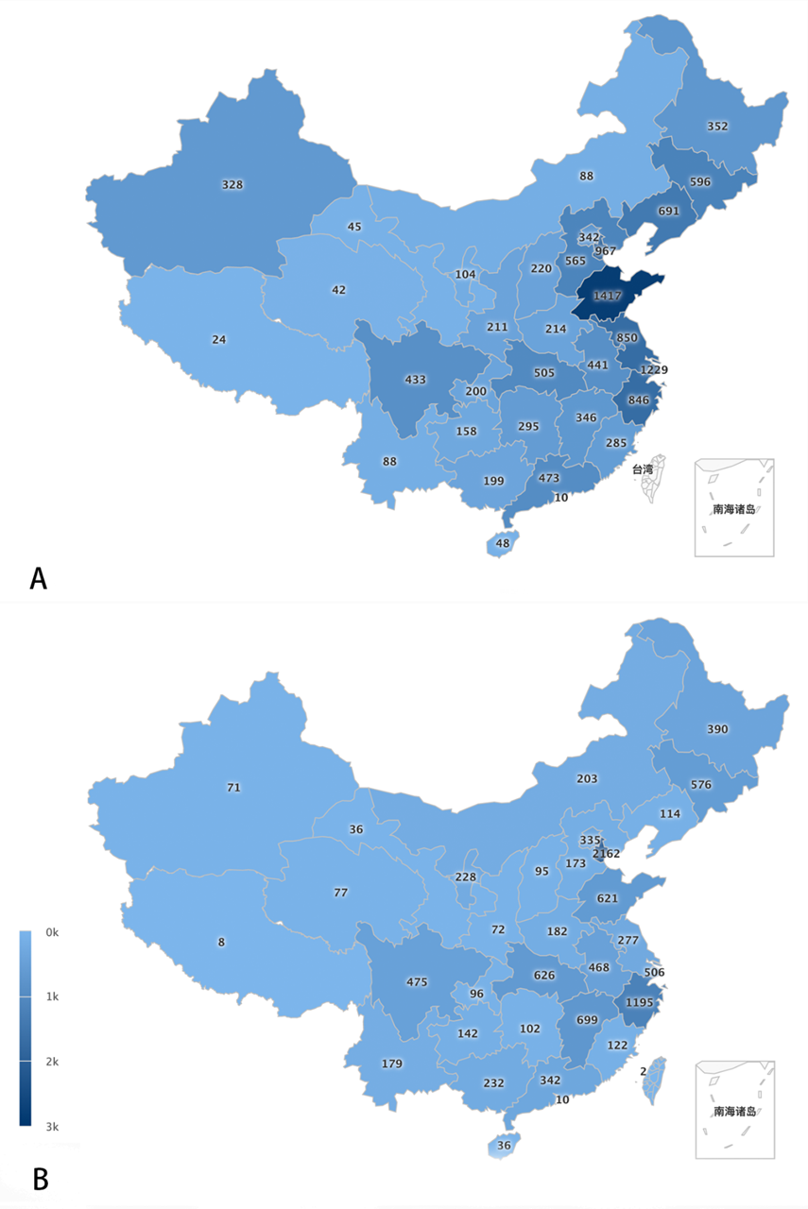
Supplementary Figure 1. The distribution of respondents to the questionnaire. (A) medical care version; (B) patient version. The vertical bar on the left indicates the number of participants that answered questionnaires.

