Supplementary Information for

On-surface synthesis of a polyynic carbon chain with ~40 alkyne units

Wenze Gao, Faming Kang, Luye Sun, Zheng Zhou, Wei Zheng, Wei Xu*

*Corresponding author: xuwei@tongji.edu.cn

The supplementary information includes:

Materials and General Methods
Synthetic Protocols
Supplementary Figures 1-6

Materials and General Methods
Bruker Ascend 500 (Bruker Biospin, Billerica, MA) spectrometer operating at 500 MHz for 1H and 126 MHz for 13C using tetramethylsilane as the internal standard. Recycling preparative high-performance liquid chromatography (HPLC) was performed with a JAI LC-7080 liquid chromatograph (JAI, Tokyo, Japan) equipped with a JAI UV-800LA UV detector at room temperature. JAIGEL-1HR and JAIGEL-2HR (60 cm × 2.0 cm (i.d.)) connected in series were used as columns (JAI), and chloroform was used as the eluent at a flow rate of 9.0 mL min^{–1}.

Synthetic Protocols

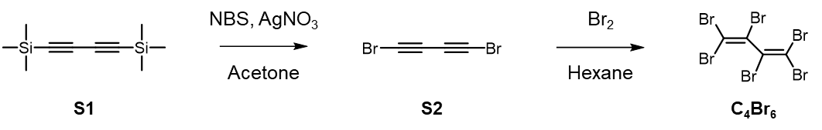
Supplementary Scheme 1. Synthesis of C₄Br₆.

Synthesis of Dibromobutadiyne (S2)
To a 500 mL round-bottom flask were added 1,4-bis(trimethylsilyl)-1,3-butadiyne (S1) (0.50 g, 2.58 mmol), Nbromosuccinimide (1.0 g, 5.7 mmol), AgNO₃ (0.88 g, 5.16 mmol), and acetone (200 mL). The round-bottom flask was wrapped with aluminum foil, and the mixture was stirred at room temperature for 4 h. The solvent was removed in vacuo at 0°C, and the mixture was poured into cooled hexane (200 mL). The solution was washed with ice water, and then dried over Na₂SO₄. After removing the solvent by evaporation at 0°C, the crude dibromobutadiyne (400 mg) was obtained as a white flaky solid and was used for the next step without further purification. Caution: the flaky solid melts and decomposes in seconds at room temperature; therefore, keep it cold and use it immediately after it is prepared.

Synthesis of 1,1,2,3,4,4-hexabromobutadiene (C₄Br₆)
Dibromobutadiyne (0.40 g, 1.92 mmol) was dissolved in cold hexane (4 mL) and the solution was stirred at -25°C. Br₂ (0.25 mL, 4.8 mmol) was added dropwise with vigorous stirring. After stirring at -25°C for 2 h, the solvent was removed under reduced pressure and the residue was passed through a short pad of silica gel using n-hexane/dichloromethane (1/2, v/v) as the eluent. After concentrating in vacuo, the crude product was purified by recycling preparative HPLC on JAIGEL-1H and JAIGEL-2H (60 cm × 2.0 cm (i.d.)) using chloroform as the eluent to give the desired product as a pale yellow solid (600 mg, 59% yield). Mp: 44.8–45.5 °C. ¹³C NMR (126 MHz, CDCl₃, 25 °C): 121.24, 97.31.

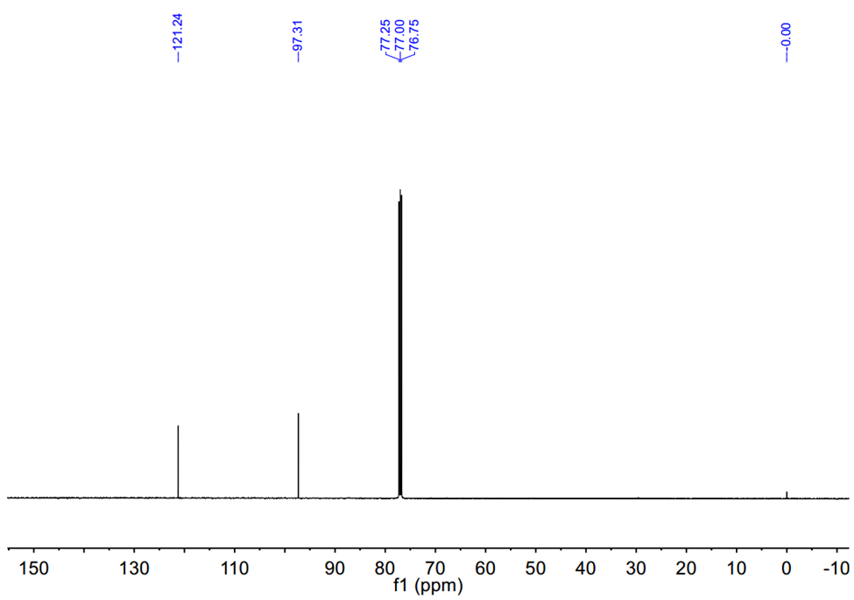

Supplementary Figure 1. ¹³C NMR spectrum of C₄Br₆ (126 MHz, CDCl₃, 25 ℃).

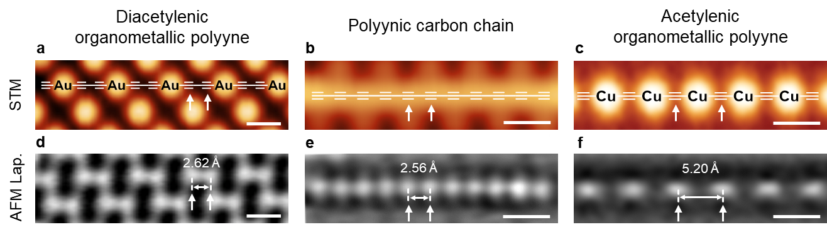

Supplementary Figure 2. Period comparison between polyynic carbon chain and organometallic polyynes. a-f, STM images (a-c) and Laplace-filtered AFM images (d-f) of diacetylenic organometallic polyynes, polyynic carbon chain, and acetylenic organometallic polyyne, respectively. The STM images in a-c are overlaid with the chemical structures as guides. The STM images are taken at: V = 400 mV, I_{t} = 100 pA (a,b); V = 5 mV, I_{t} = 500 pA (c). Scale bars: 0.5 nm.

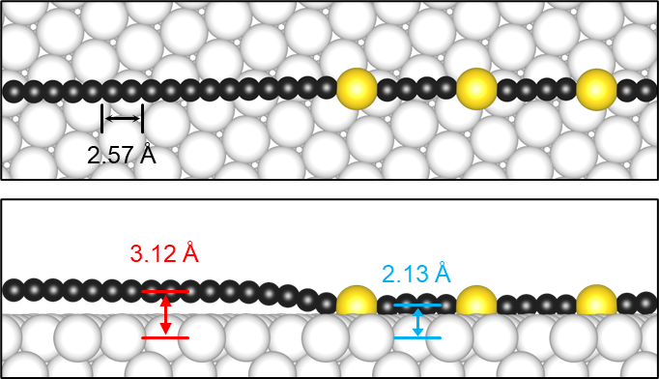

Supplementary Figure 3. Top and side-view DFT models of partially demetallized organometallic polyyne on Au(111). Black, gold, and white balls represent C, Au atoms in organometallic polyyne, and Au atoms in Au(111) substrate, respectively.

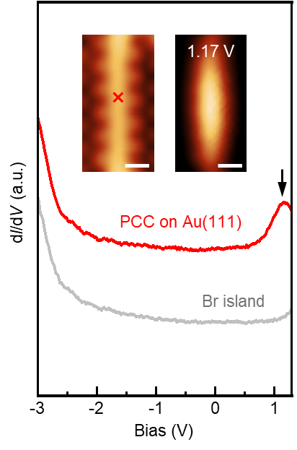
Supplementary Figure 4. The dI/dV spectra of the PCC on Au(111) acquired at the position indicated by the red cross in the inserted STM image (red curve) and the reference spectrum taken on the Br island (grey curve). The inserted constant-height dI/dV map is acquired at 1.17 V.

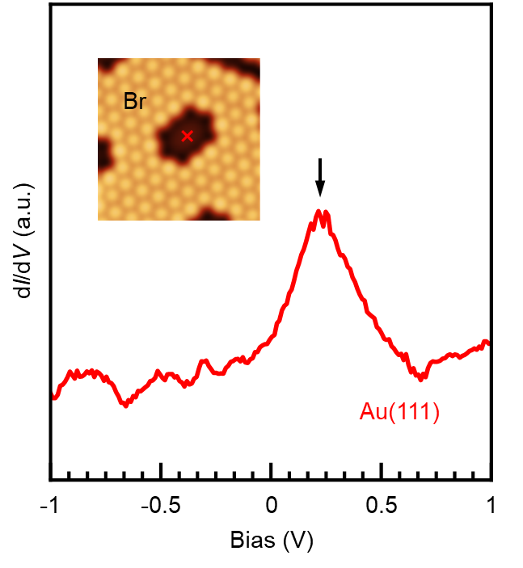
Supplementary Figure 5. The dI/dV spectrum of the Au(111) surface acquired at the position indicated by the red cross in the inserted STM image.

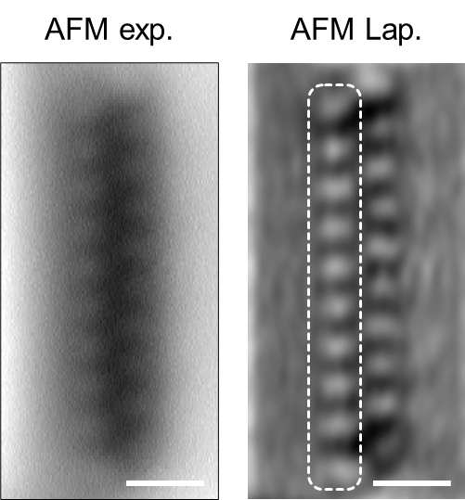

Supplementary Figure 6. The close-up AFM image and the corresponding Laplace-filtered AFM image of decoupled PCCs shown in manuscript Fig. 4c. The AFM image is recorded with a Br-functionalized tip at tip offset Δz = -160 pm with respect to an STM set point (V = 0.40 V, I_{t} = 100 pA). Scale bars: 0.5 nm.

