Supporting Information for
Improved equality of human exposure to greenspace in the 21st century urbanization
Shengbiao Wu¹, Bin Chen^{1,2,3,*}, Chris Webster^{2,3,4}, Bing Xu⁵, and Peng Gong^{2,6}
- Future Urbanity & Sustainable Environment (FUSE) Lab, Division of Landscape Architecture, Faculty of Architecture, The University of Hong Kong, Hong Kong SAR, China
- Urban Systems Institute, The University of Hong Kong, Hong Kong SAR, China
- HKU Musketeers Foundation Institute of Data Science, The University of Hong Kong, Hong Kong SAR, China
- HKUrbanLabs, Faculty of Architecture, The University of Hong Kong, Hong Kong SAR, China
- Department of Earth System Science, Ministry of Education Ecological Field Station for East Asian Migratory Birds, and Institute for Global Change Studies, Tsinghua University, Beijing, 100084, China
- Department of Geography, and Department of Earth Sciences, The University of Hong Kong, Hong Kong SAR, China

*Corresponding author: Bin Chen (binley.chen@hku.hk)

Table of Contents
Supplementary information
Supplementary figures 1-16
Supplementary table4 1-4
Supplementary references

1. Supplementary information
1.1. Calculation of inequality index
In this study, we used three types of widely used measures¹⁻² to quantify inequality in human exposure to greenspace, including Lorenz curve-based (i.e., Gini coefficient index), social welfare-based (i.e., Atkinson index), and generalized entropy metrics (i.e., Theil index).

1.1.1. Gini index
As shown in Supplementary Fig. 16, the Gini index is calculated by the Lorenz curve framework, and defined as the ratio of the area that lies between the line of equality (i.e., straight diagonal line) and the Lorenz curve (i.e., cumulative share of greenspace exposure ranked by residents that are exposed from lowest to highest greenspace; region A) over the total area under the line of equality (region A plus region B):

$Gini= \frac{S_{A}}{S_{A}+S_{B}}$ (S1)
where $s_{A}$ and $s_{B}$ represent the areas of regions A and B, respectively.
According to previous studies³⁻⁴, Gini index can be mathematically formulated as:
$Gini= 1- \frac{\sum_{i=1}^{N}{\sum_{j=1}^{i-1}{g_{j}}} + \sum_{i=1}^{N}{\sum_{j=1}^{i}{g_{j}}}}{N × \sum_{j=1}^{N}{g_{j}}}$ (S2)
where $g_{j}$ is the greenspace coverage that exposed to j^{th} resident and N is the number of total residents within the target city.

1.1.2. Atkinson index
The Atkinson index is another inequality metric based on the concept of welfare equivalent equally distributed greenspace, which is defined as the percentage of total greenspace for one society that must forego to have more equal shares of greenspace among individuals in that society². The advantage of the Atkinson index is that it can provide a complete ranking of greenspace distribution in the explicitly social welfare function. Mathematically, the Atkinson index can be calculated as:
$Atkinson (ε)= 1- {(\frac{1}{N}\sum_{j = 1}^{N}{{\left(\frac{g_{j}}{\overline{g}}\right)}^{1-ε}})}^{\frac{1}{1-ε}} ε≠1$ (S3)
$Atkinson (ε)= 1- \frac{\prod_{j=1}^{N}{\left({g_{j}}^{\frac{1}{N}}\right)}}{\overline{g}} ε=1$ (S4)
where $\overline{g}$ represents the average greenspace exposure and $ε$ is the inequality aversion parameter that regulates the sensitivity of the social welfare losses from inequality to greenspace exposure inequality. As $ε$ increases, the Atkinson index is more sensitive to changes in the lower end of the greenspace distribution and vice versa.

1.1.3. Theil index
The Theil index is another generalized entropy indicator that measures the ranking greenspace inequality that can overcome the limitation of the Gini index when the Lorenz curves of the two target cities cross ². It is defined as:

$Theil= \frac{1}{N}\sum_{j = 1}^{N}{\frac{g_{j}}{\overline{g}}ln\left(\frac{g_{j}}{\overline{g}}\right)}$ (S5)

Supplementary figures
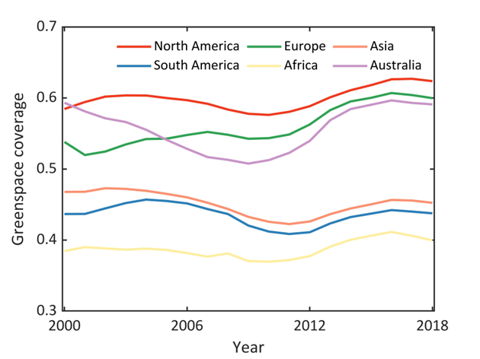
Supplementary Fig. 1. Continental-scale mean annual dynamics of physical greenspace coverage (GC) for global 1028 cities from 2000-2018.

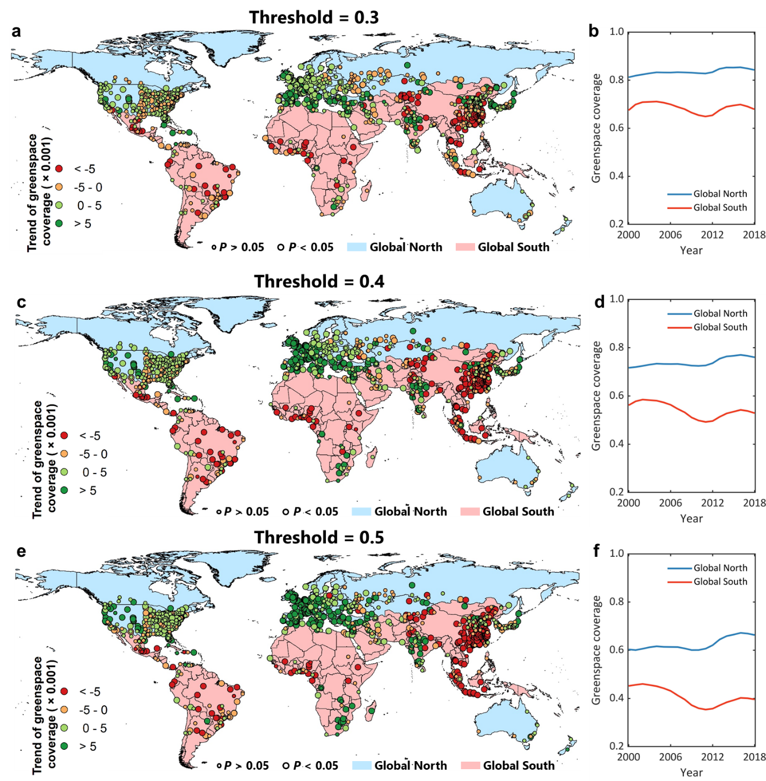
Supplementary Fig. 2. Sensitivity of threshold in the linear unmixing-based greenspace classification to the temporal changes of physical greenspace coverage (GC) for global 1028 cities from 2000-2018. a and b. Threshold = 0.3. c and d. Threshold = 0.4. e and f. Threshold = 0.5. First column is the city-level temporal trend of GC changes (a, c, and e). Second column is the mean annual GC dynamics for Global North and Global South cities (b, d, and f). The non-parametric Theil–Sen slope estimator approach is used to determine the long-term trends of GC. The non-parametric Mann-Kendall is used to evaluate the significance of these detected temporal trends. Large bubble sizes represent a statistically significant level of 0.05 (p-value <0.05) and small bubble sizes represent a non-significant trend with p-value >0.05.
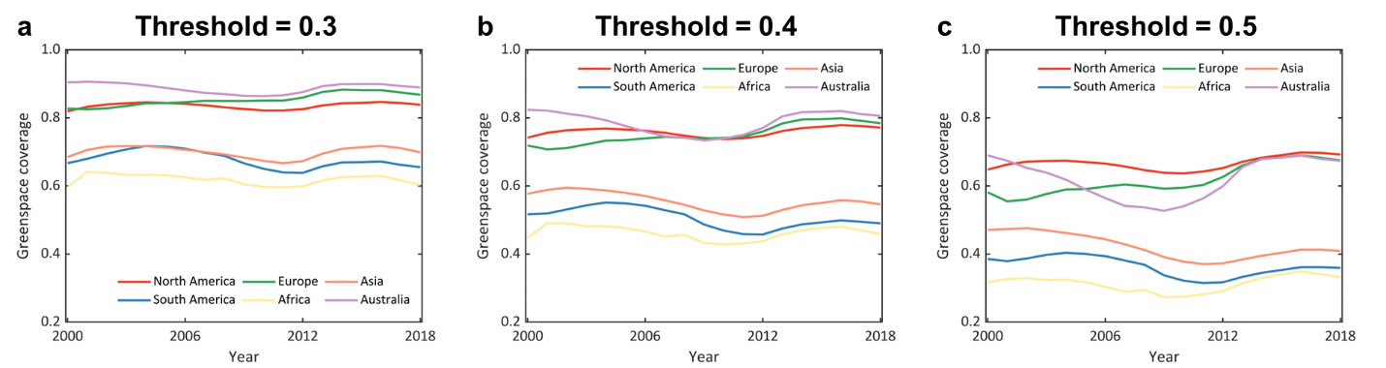

Supplementary Fig. 3. Sensitivity of threshold in the linear unmixing-based greenspace classification to the mean annual dynamics of physical greenspace coverage (GC) for global 1028 cities from 2000-2018. a. Threshold = 0.3. b. Threshold = 0.4. c. Threshold = 0.5.

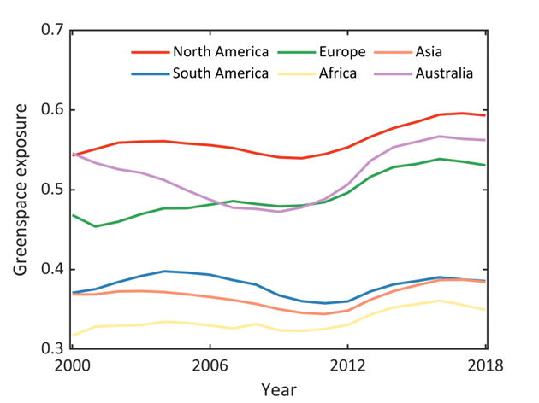
Supplementary Fig. 4. Continental-scale mean annual dynamics of real greenspace exposure (GE) for global 1028 cities from 2000-2018.

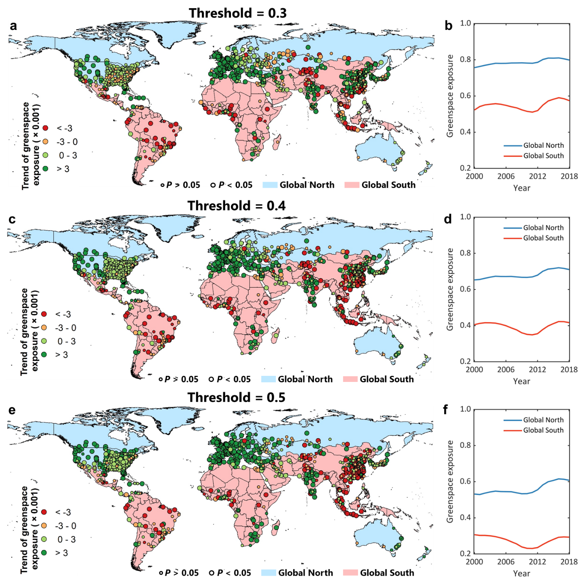

Supplementary Fig. 5. Sensitivity of threshold in the linear unmixing-based greenspace classification to the temporal changes of real greenspace exposure (GE) for global 1028 cities from 2000-2018. a and b. Threshold = 0.3. c and d. Threshold = 0.4. e and f. Threshold = 0.5. First column is the city-level temporal trend of GE changes (a, c, and e). Second column is the mean annual GE dynamics for Global North and Global South cities (b, d, and f). The non-parametric Theil–Sen slope estimator approach is used to determine the long-term trends of GE. The non-parametric Mann-Kendall is used to evaluate the significance of these detected temporal trends. Large bubble sizes represent a statistically significant level of 0.05 (p-value <0.05) and small bubble sizes represent a non-significant trend with p-value >0.05.

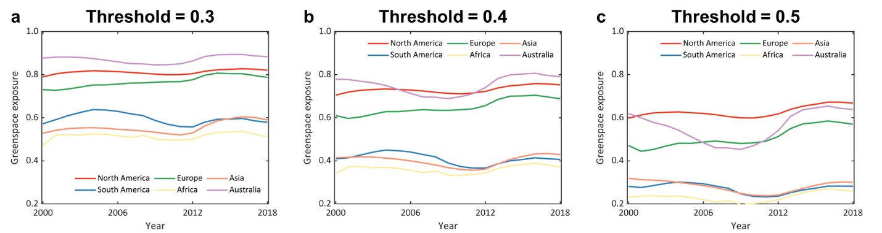

Supplementary Fig. 6. Sensitivity of threshold in the linear unmixing-based greenspace classification to the mean annual dynamics of real greenspace exposure (GE) for global 1028 cities from 2000-2018. a. Threshold = 0.3. b. Threshold = 0.4. c. Threshold = 0.5.

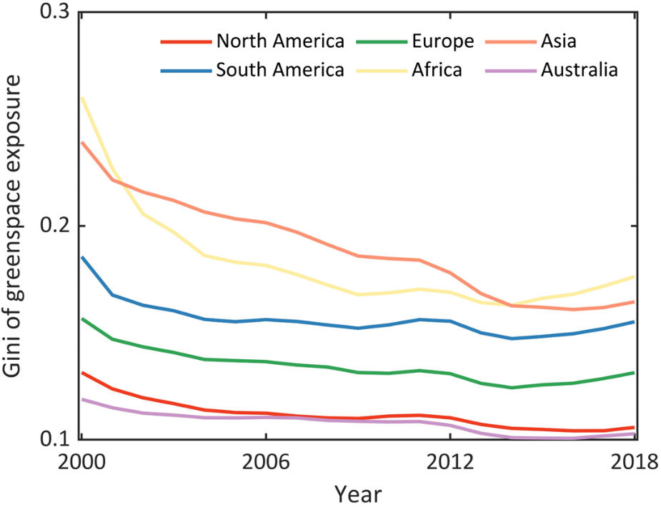

Supplementary Fig. 7. Continental-scale mean annual dynamics of greenspace exposure inequality measured by the Gini index for global 1028 cities from 2000-2018.

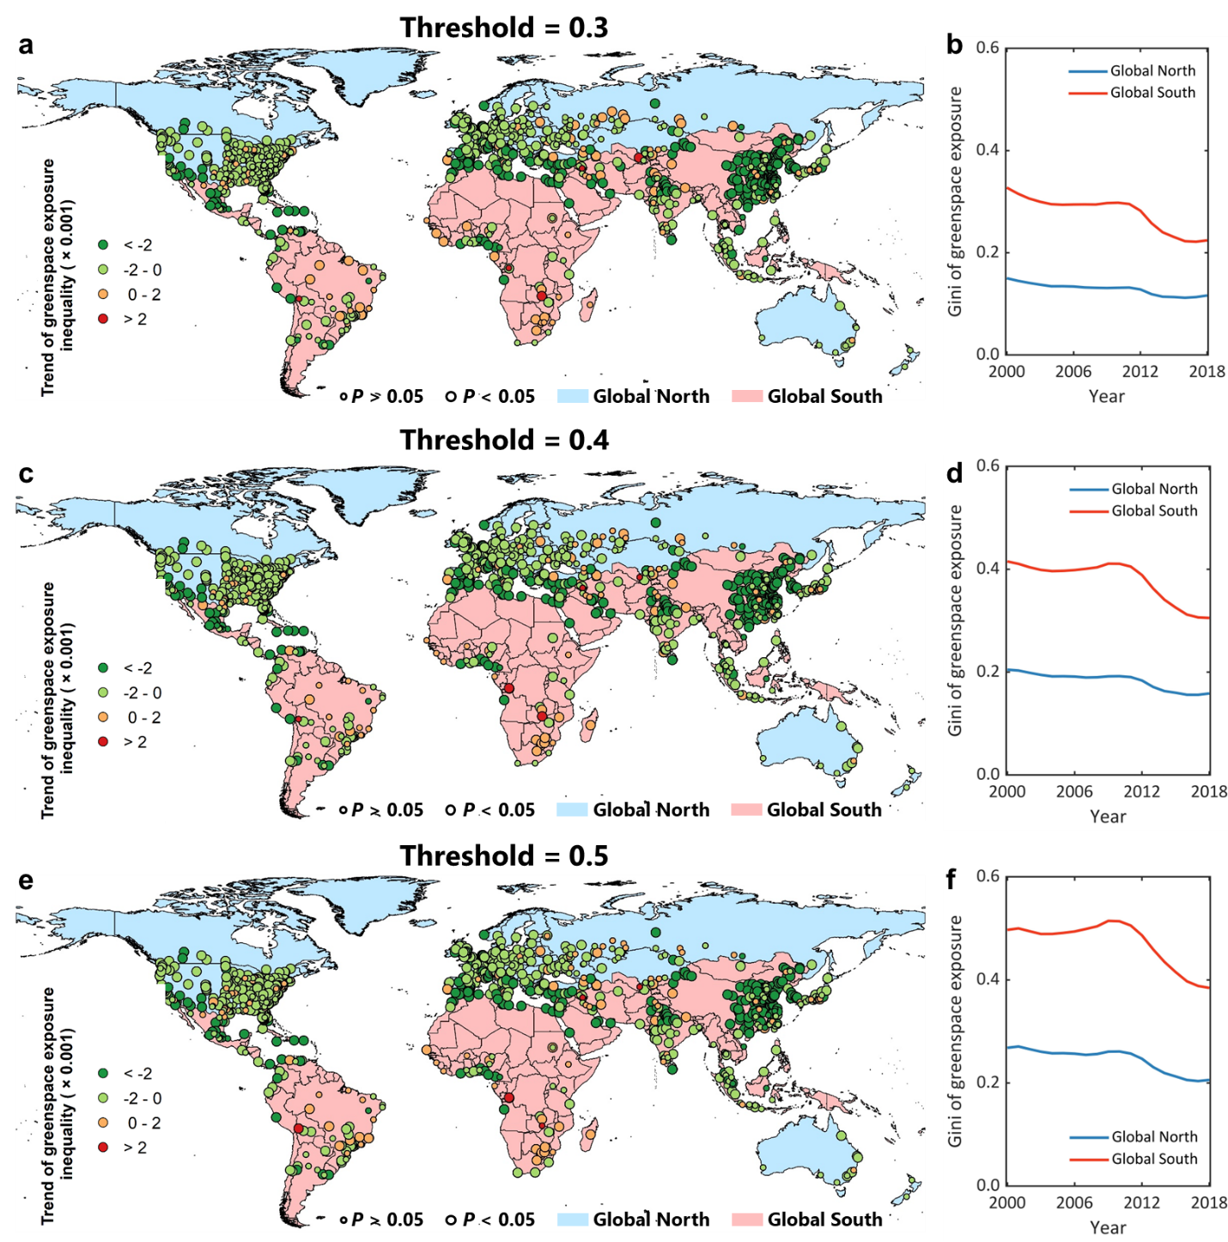
Supplementary Fig. 8. Sensitivity of threshold in the linear unmixing-based greenspace classification to the temporal changes of greenspace exposure inequality measured by the Gini index for global 1028 cities from 2000-2018. a and b. Threshold = 0.3. c and d. Threshold = 0.4. e and f. Threshold = 0.5. First column is the city-level temporal trend of Gini changes (a, c, and e). Second column is the mean annual Gini dynamics for Global North and Global South cities (b, d, and f). The non-parametric Theil–Sen slope estimator approach is used to determine the long-term trends of Gini. The non-parametric Mann-Kendall is used to evaluate the significance of these detected temporal trends. Large bubble sizes represent a statistically significant level of 0.05 (p-value <0.05) and small bubble sizes represent a non-significant trend with p-value >0.05.

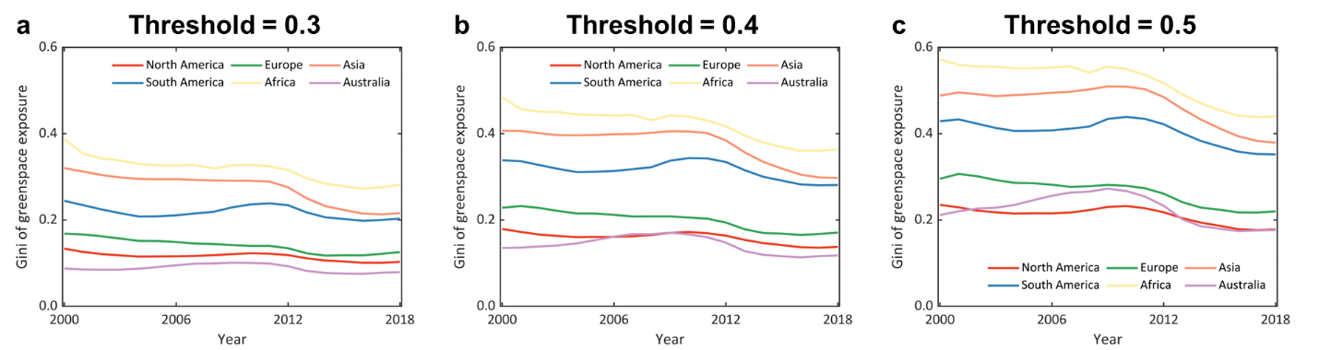
Supplementary Fig. 9. Sensitivity of threshold in the linear unmixing-based greenspace classification to the mean annual dynamics of greenspace exposure inequality measured by the Gini index for global 1028 cities from 2000-2018. a. Threshold = 0.3. b. Threshold = 0.4. c. Threshold = 0.5.

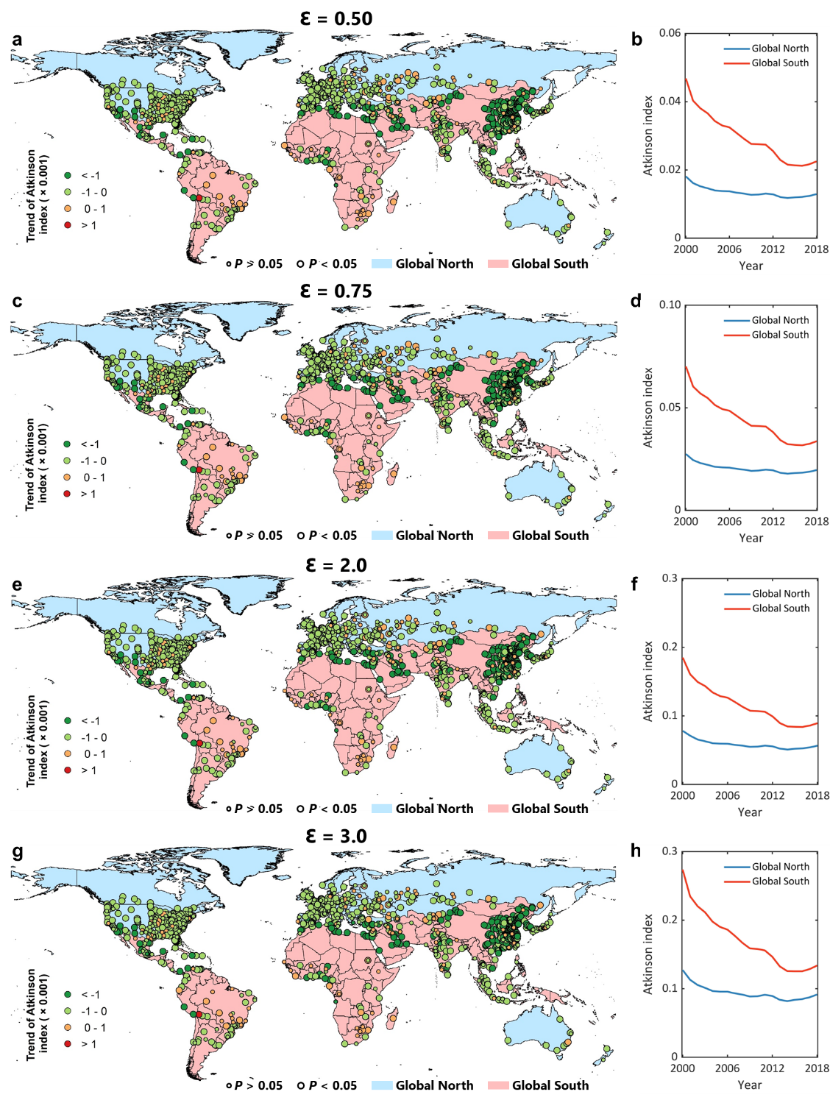
Supplementary Fig. 10. Temporal change of greenspace exposure inequality measured by the Atkinson index for global 1028 cities from 2000-2018. a and b. Inequality aversion parameter ($ε$) = 0.50. c and d. $ε$ = 0.75. e and f. $ε$ = 2.0. g and h. $ε$ = 3.0. First column is the city-level temporal trend of Atkinson changes (a, c, e, and g). Second column is the mean annual Atkinson dynamics for Global North and Global South cities (b, d, f, and h). The non-parametric Theil–Sen slope estimator approach is used to determine the long-term trends of Atkinson. The non-parametric Mann-Kendall is used to evaluate the significance of these detected temporal trends. Large bubble sizes represent a statistically significant level of 0.05 (p-value <0.05) and small bubble sizes represent a non-significant trend with p-value >0.05.

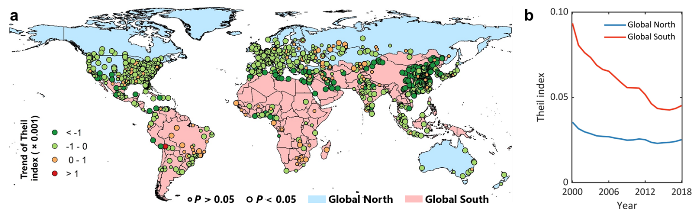
Supplementary Fig. 11. Temporal change of greenspace exposure inequality measured by the Theil index for global 1028 cities from 2000-2018. a. City-level temporal trend of Theil changes. a. Mean annual Theil dynamics for Global North and Global South cities. The non-parametric Theil–Sen slope estimator approach is used to determine the long-term trends of Theil. The non-parametric Mann-Kendall is used to evaluate the significance of these detected temporal trends. Large bubble sizes represent a statistically significant level of 0.05 (p-value <0.05) and small bubble sizes represent a non-significant trend with p-value >0.05.

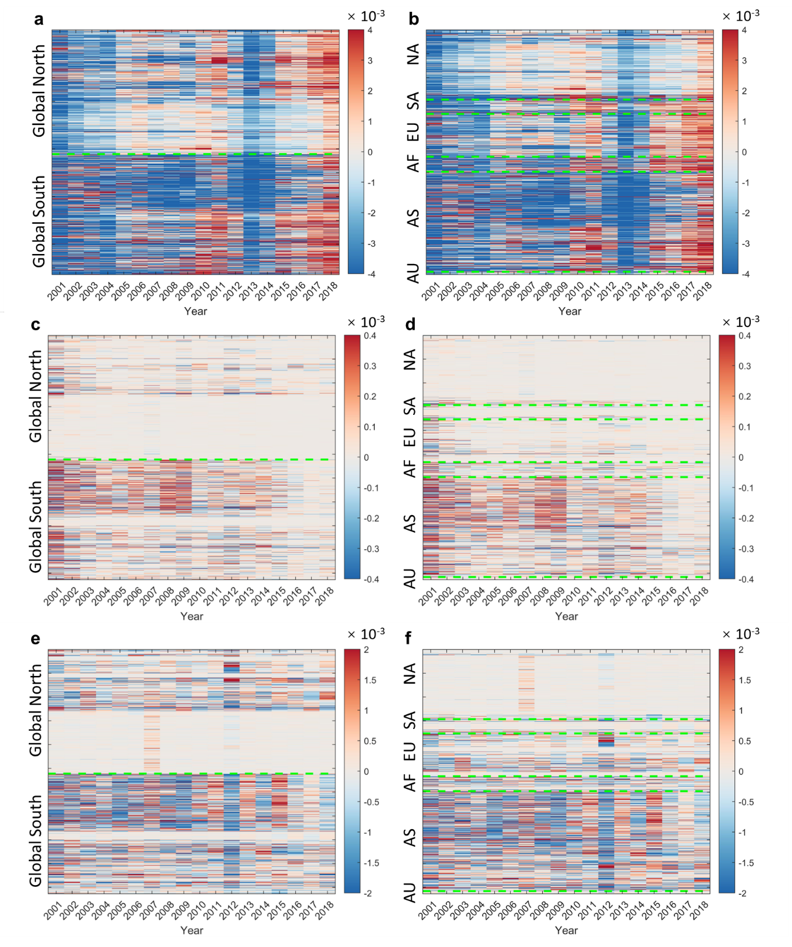
Supplementary Fig. 12. Individual and joint contributions of greenspace and population to the temporal change of the Gini index across global 1028 cities. a-b. Individual effect of greenspace. c-d. Individual effect of population. e-f. Joint effects of greenspace and population. Each line denotes the temporal change of one city. First column (a, c, and e) represents cities in the Global North and Global South region. Second column (b, d, and f) represents cities in different continents. AU: Australia. AS: Asia. AF: Africa. EU: Europe. SA: South America. NA: North America.

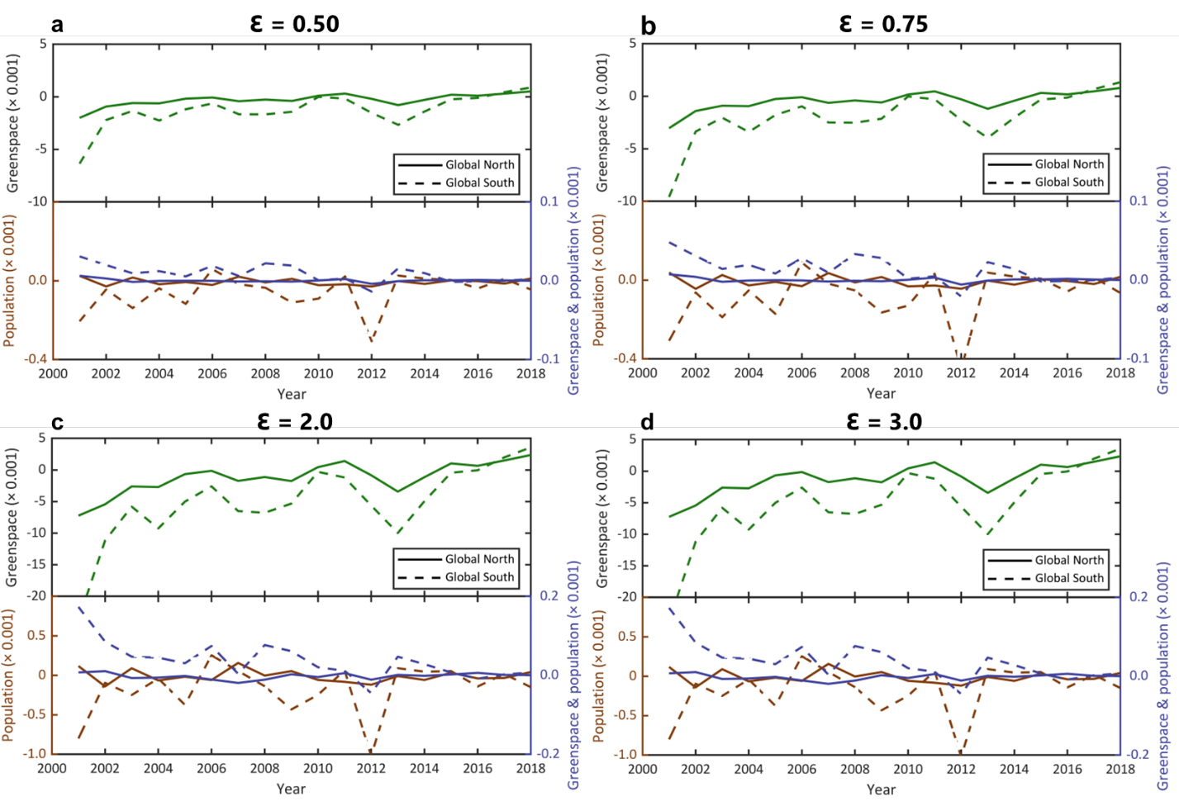
Supplementary Fig. 13. Attribution of drivers accounting for temporal change in greenspace exposure inequality measured by the Atkinson index. a. Inequality aversion parameter ($ε$) = 0.50. b. $ε$ = 0.75. c. $ε$ = 2.0. d. $ε$ = 3.0.

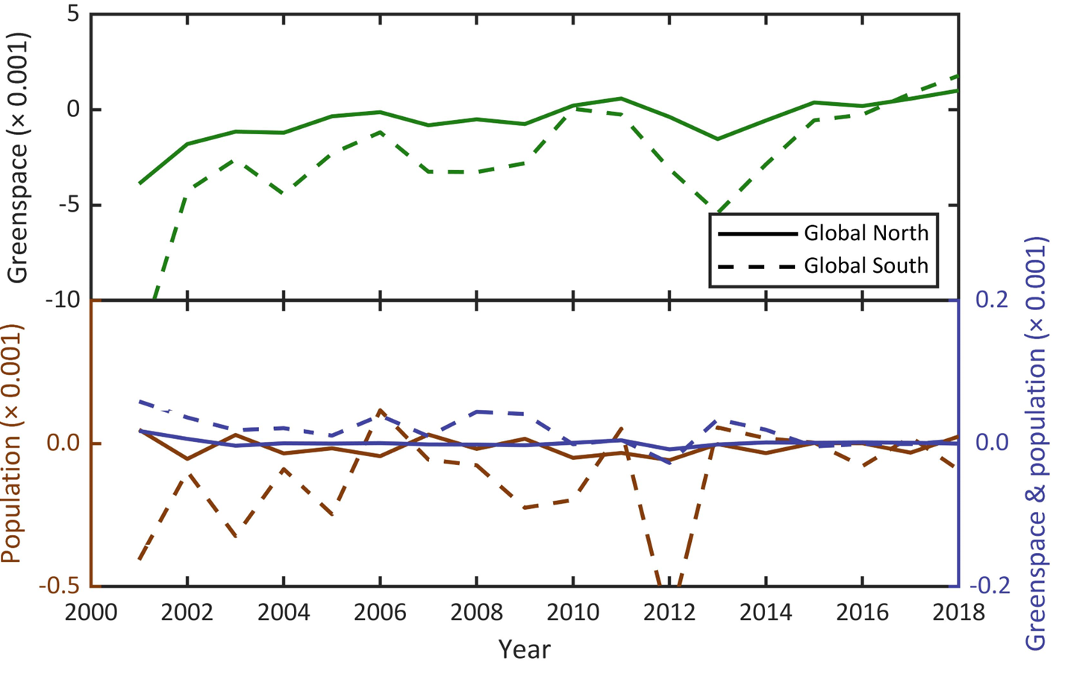
Supplementary Fig. 14. Attribution of drivers accounting for temporal change in greenspace exposure inequality measured by the Theil index.

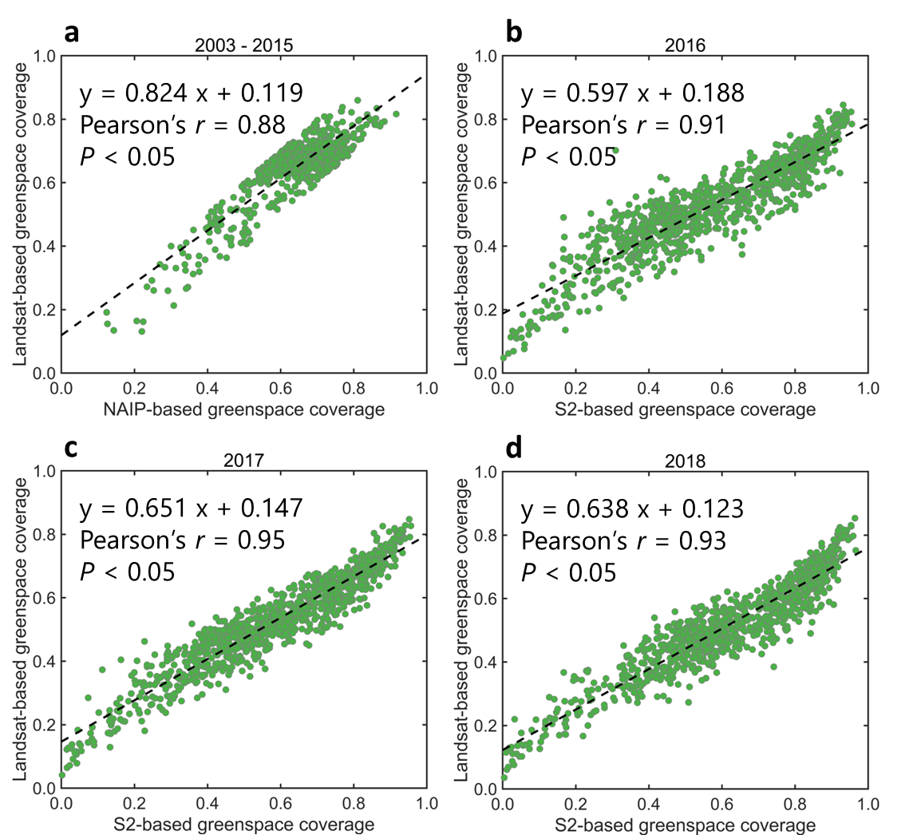
Supplementary Fig. 15. Comparison of physical greenspace coverage (GC) derived from 1-m NAIP and 10-m Sentinel-2 imageries (x-axis) and Landsat imagery (y-axis) across global 1028 cities. a. NAIP vs. Landsat in 2003-2015. b-d. Sentinel-2 vs. Landsat in 2016-2018. The GCs of NAIP and Sentinel-2 imageries are linear unmixed and resampled to 30-m resolution of Landsat for comparison. Linear regression was used to measure their correlation with Pearson’s r coefficient.

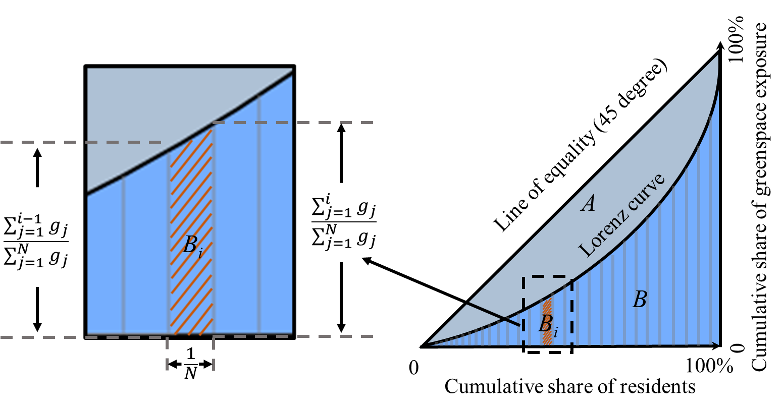
Supplementary Fig. 16. Illustrative diagram of Gini index for inequality assessments of greenspace exposure. The Gini index is defined as the ratio of the area that lies between the line of equality and the Lorenz curve (region A) over the total area under the line of equality (region A plus region B), where the Lorenz curve plots the proportion of the greenspace exposure (y-axis) that is cumulatively shared by the residents (x-axis). B_{i} indicates the contribution of ith residents to the accumulated greenspace exposure and is estimated by the trapezoid area as shown in the left panel, where g_{i} represents the greenspace that is exposed to ith resident, and N represents the resident number. Y-axis shows the cumulative share of greenspace exposure; X-axis shows the cumulative share of residents from lowest to highest greenspace exposure. This figure is revised from Fig. A14 in Chen et al. 2022 ¹⁸.

Table S1. Statistics of temporal trends of city-level greenspace coverage, human exposure to greenspace, and greenspace exposure inequality across regions. The greenspace coverage is calculated by the spectral unmixing-based threshold classification approach, with a 0.3 threshold.
Region (# of cities) | Greenspace coverage  (× 0.001 yr⁻¹) | Greenspace exposure  (× 0.001 yr⁻¹) | Gini of greenspace exposure  (× 0.001 yr⁻¹)
Global North (522) | 1.57 ± 3.57 | 2.41 ± 3.77 | -1.80 ± 2.78
Global South (506) | -2.24 ± 5.89 | 1.60 ± 6.77 | -5.16 ± 5.58
North America (293) | -0.58 ± 2.54 | 0.88 ± 2.56 | -1.22 ± 2.52
South America (60) | -2.11 ± 3.69 | -2.26 ± 4.38 | -1.18 ± 2.92
Europe (180) | 2.56 ± 3.26 | 4.32 ± 4.14 | -2.77 ± 2.95
Africa (63) | -1.47 ± 4.76 | 0.16 ± 6.12 | -4.20 ± 6.24
Asia (420) | -0.82 ± 6.75 | 2.74 ± 6.80 | -5.60 ± 5.44
Australia/Oceania (12) | -0.12 ± 0.51 | 0.71 ± 1.10 | -0.62 ± 0.47
Global (1028) | -0.20 ± 5.15 | 2.01 ± 5.47 | -3.45 ± 4.70

Table S2. Statistics of temporal trends of city-level greenspace coverage, human exposure to greenspace, and greenspace exposure inequality across regions. The greenspace coverage is calculated by the spectral unmixing-based threshold classification approach, with a 0.4 threshold.
Region (# of cities) | Greenspace coverage  (× 0.001 yr⁻¹) | Greenspace exposure  (× 0.001 yr⁻¹) | Gini of greenspace exposure  (× 0.001 yr⁻¹)
Global North (522) | 2.38 ± 4.19 | 3.46 ± 4.16 | -2.65 ± 3.23
Global South (506) | -5.17 ± 7.44 | -0.67 ± 6.71 | -5.61 ± 5.94
North America (293) | -0.16 ± 3.05 | 1.90 ± 3.18 | -1.82 ± 2.45
South America (60) | -2.47 ± 4.72 | -2.14 ± 4.36 | -2.44 ± 3.03
Europe (180) | 4.42 ± 4.57 | 5.95 ± 4.37 | -3.84 ± 3.28
Africa (63) | -1.36 ± 7.92 | 0.36 ± 6.98 | -5.92 ± 7.12
Asia (420) | -4.08 ± 8.31 | -0.19 ± 6.89 | -5.85 ± 5.97
Australia/Oceania (12) | 1.17 ± 1.09 | 2.26 ± 2.43 | -1.67 ± 1.00
Global (1028) | -1.13 ± 7.01 | 1.43 ± 5.93 | -4.11 ± 4.99

Table S3. Statistics of temporal trends of city-level greenspace coverage, human exposure to greenspace, and greenspace exposure inequality across regions. The greenspace coverage is calculated by the spectral unmixing-based threshold classification approach, with a 0.5 threshold.
Region (# of cities) | Greenspace coverage  (× 0.001 yr⁻¹) | Greenspace exposure  (× 0.001 yr⁻¹) | Gini of greenspace exposure  (× 0.001 yr⁻¹)
Global North (522) | 3.55 ± 5.52 | 4.72 ± 4.66 | -3.68 ± 3.67
Global South (506) | -6.74 ± 8.93 | -1.64 ± 6.78 | -5.82 ± 6.15
North America (293) | 0.69 ± 3.78 | 3.20 ± 3.65 | -2.66 ± 2.74
South America (60) | -2.15 ± 5.18 | -1.17 ± 3.85 | -3.76 ± 3.09
Europe (180) | 6.92 ± 6.81 | 7.67 ± 5.01 | -5.10 ± 3.75
Africa (63) | 0.26 ± 8.25 | 1.68 ± 7.18 | -7.42 ± 7.00
Asia (420) | -6.25 ± 9.50 | -1.84 ± 6.80 | -5.80 ± 6.31
Australia/Oceania (12) | 4.10 ± 2.74 | 4.58 ± 3.69 | -3.31 ± 2.08
Global (1028) | -1.23 ± 8.92 | 1.59 ± 6.61 | -4.73 ± 5.16

Table S4. Statistics of temporal trends of greenspace exposure inequality measured by the Atkinson index across regions. Four inequality aversion parameters of 0.50, 0.75, 2.0, and 3.0 are used.
Region (# of cities) | Atkinson,  Ɛ = 0.50  (× 0.001 yr⁻¹) | Atkinson,  Ɛ = 0.75  (× 0.001 yr⁻¹) | Atkinson,  Ɛ = 2.0  (× 0.001 yr⁻¹) | Atkinson,  Ɛ = 3.0  (× 0.001 yr⁻¹)
Global North (522) | -0.20 ± 0.35 | -0.31 ± 0.53 | -0.84 ± 1.49 | -1.35 ± 2.41
Global South (506) | -1.15 ± 1.43 | -1.73 ± 2.09 | -4.54 ± 5.08 | -6.51 ± 7.15
North America (293) | -0.23 ± 0.66 | -0.34 ± 0.95 | -0.87 ± 2.15 | -1.30 ± 3.06
South America (60) | -0.26 ± 0.78 | -0.40 ± 1.14 | -1.15 ± 3.05 | -1.77 ± 4.20
Europe (180) | -0.26 ± 0.30 | -0.39 ± 0.46 | -1.07 ± 1.26 | -1.78 ± 2.18
Africa (63) | -0.81 ± 1.53 | -1.23 ± 2.24 | -3.39 ± 5.75 | -5.01 ± 8.29
Asia (420) | -1.21 ± 1.36 | -1.81 ± 2.00 | -4.76 ± 4.89 | -6.81 ± 6.91
Australia/Oceania (12) | -0.14 ± 0.08 | -0.22 ± 0.13 | -0.68 ± 0.44 | -1.23 ± 0.92
Global (1028) | -0.67 ± 1.14 | -1.01 ± 1.67 | -2.66 ± 4.15 | -3.89 ± 5.89

Table S5. Statistics of temporal trends of greenspace exposure inequality measured by the Theil index across regions
Region (# of cities) | Theil (× 0.001 yr⁻¹)
Global North (522) | -0.41 ± 0.68
Global South (506) | -2.29 ± 2.99
North America (293) | -0.47 ± 1.47
South America (60) | -0.52 ± 1.54
Europe (180) | -0.51 ± 0.60
Africa (63) | -1.63 ± 3.26
Asia (420) | -2.39 ± 2.81
Australia/Oceania (12) | -0.27 ± 0.15
Global (1028) | -1.33 ± 2.35

Table S6. The numbers of NAIP image and city used in this study for the accuracy validation of Landsat-derived greenspace coverage.
Year | Image number | City number
2003 | 668 | 20
2004 | 1302 | 45
2005 | 2231 | 74
2006 | 1976 | 69
2007 | 641 | 25
2008 | 677 | 23
2009 | 697 | 33
2010 | 2197 | 75
2011 | 1192 | 38
2012 | 3177 | 76
2013 | 1947 | 66
2014 | 1434 | 42
2015 | 1441 | 53

Supplementary references
1 Atkinson AB, Bourguignon F. Handbook of income distribution. Elsevier (2014).
2 Sitthiyot T, Holasut K. A simple method for measuring inequality. Palgrave Communications 6, 1-9 (2020).
3 Chen B, Wu S, Song Y, Webster C, Xu B, Gong P. Contrasting inequality in human exposure to greenspace between cities of Global North and Global South. Nature communications 13, 1-9 (2022).
4 Song Y, et al. Observed inequality in urban greenspace exposure in China. Environment International 156, 106778 (2021).

