Programming Conformational Cooperativity to Regulate Allosteric Protein-Oligonucleotide Signal Transduction
Yuan Liang^{1†}, Yunkai Qie^{2,3,4,5†}, Jing Yang⁶, Shuang Cui¹, Yuliang Zhao^{2,3,4}, Greg J Anderson⁷, Guangjun Nie^{2,3,4}*, Suping Li^{2,3,4}*, Cheng Zhang¹*

¹School of Computer Science, Key Lab of High Confidence Software Technologies, Peking University, Beijing 100871, China
²CAS Key Laboratory for Biomedical Effects of Nanomaterials & Nanosafety, CAS Center for Excellence in Nanoscience, National Center for Nanoscience and Technology, Beijing 100190, China
³University of Chinese Academy of Sciences, Beijing 100049, China
⁴GBA Research Innovation Institute for Nanotechnology, Guangzhou 510530, China
⁵Department of Urology, Tianjin Institute of Urology, The Second Hospital of Tianjin Medical University, Tianjin 300211, China
⁶School of Control and Computer Engineering, North China Electric Power University, Beijing 102206, China
⁷QIMR Berghofer Medical Research Institute, Royal Brisbane Hospital, QLD 4029, Australia
†These authors contributed equally to this work.

Table of contents
Supplementary Figures 1-26
S1. Scheme of using the CAST mechanism to regulate gene expressions..............3
S2. Designs and optimizations of AST operations triggered by thrombin..............4
S2.1 Designs of the AST triggered by thrombin.....................................................4
S2.2 Optimizations of the AST operations triggered by thrombin..........................6
S3. Designs and optimizations of AST operations triggered by streptavidin.......10
S3.1 Designs of the AST operations triggered by streptavidin.............................10
S3.2 Optimizations of the AST operations triggered by streptavidin...................12
S4. Designs and results of the AST operations triggered by PDGF-BB...............16
S4.1 Designs of the AST operations triggered by PDGF-BB...............................16
S4.2 Results of the AST operations triggered by PDGF-BB................................18
S5. Triggering AST with saturated protein concentrations...................................19
S6. Designs and results of cooperative regulation of the allosteric signal transducer..............................................................................................................20
S7. Designs of the OR logic operations based on the CAST strategy...................23
S8. Designs and optimizations of the AND logic operations based on CAST strategy..................................................................................................................24
S8.1 Designs of the AND logic operations...........................................................25
S8.2 Optimizations of the AND logic operations..................................................26
S9. The cascading circuit based on the CAST strategy.........................................27
S10. Using CAST to regulate GFP gene expression.............................................31
S10.1 Designs of the allosteric transducer to control GFP gene expression.........31
S10.2 Cooperative regulation allosteric transducer to regulate GFP gene expression..............................................................................................................35
S11. Using CAST to regulate PLK1 gene expression...........................................37
S11.1 Designs of the AST to regulate PLK1 gene expression........................37
S11.2 Two input logical operations to cooperatively regulates PLK1 gene based on CAST strategy..................................................................................................39

Supplementary Tables 1-11
Table S1. DNA sequence of the basic allosteric signal transduction system........41
Table S2. DNA sequence of change the length of regulator T2............................41
Table S3. DNA sequence of change the length of hairpin H................................42
Table S4. DNA sequence of the AST triggered by streptavidin...........................43
Table S5. DNA sequence of the AST triggered by PDGF-BB.............................43
Table S6. DNA sequences of CAST using regulators T1 and T2.........................43
Table S7. OR logic operations sequences.............................................................45
Table S8. AND logic operations sequences..........................................................45
Table S9. Cascade circuit sequences.....................................................................46
Table S10. DNA sequences of CAST to regulate GFP gene expression..............47
Table S11. DNA sequences of CAST to regulate PLK1 gene expression............48
Supplementary Figures
S1. Scheme of using the CAST mechanism to regulate gene expressions.

Supplementary scheme. 1 | Scheme of using the CAST mechanism to regulate gene expressions.

S2. Designs and optimizations of AST operations triggered by thrombin
S2.1 Designs of the AST operations triggered by thrombin
The signal translator triggered by thrombin is assembled by four DNA strands: A, B ,C and D. The 3' and 5' ends of strand A and strand B are designed with thrombin aptamer sequences with the lengths of 29 nt and 15 nt, respectively, and the complementary domains of DNA C are both 18 bp in length. The length of domain T1 is 3 nt, that of domains T2 is 12 nt, and that of domain H is 12 nt. In particular, the DNA C is a hairpin structure with a 12 nt base complementary hybridization region (domain H). In addition, a 39 nt poly T (domain L) was designed at the 3' end of the D strand to improve the allosteric releasing efficiency. The detailed design is shown in supplementary Fig. 1 and Table 1-3.

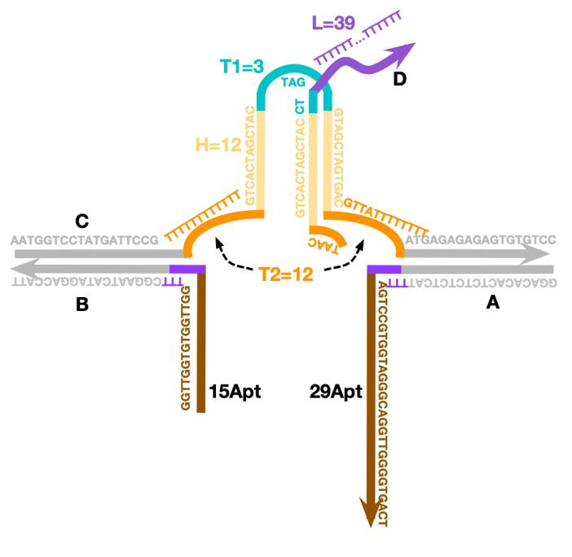
Supplementary Fig. 1 | Schematic diagram of AST using complex CDAB triggered by thrombin.

In the initial state, although the strand C complementary domain H can hybridize to form an intra-hairpin, the thermodynamic state favors hybridization between the strand C and strand D due to the stable state produced by longer hybridization region with 18 nt (Supplementary Fig. 2a). Therefore, strand C preferentially hybridizes with strand D. However, the metastable complex C/D is irritated by conformational changes. To test the binding induced allosteric transduction, we firstly using DNA A5TB to simulate the protein triggering, where two ends of the strand C get close together as shown in supplementary Fig. 2b. In this state, domains (1) and (2) are adjacent to each other, thus results in a significant increase of the local concentrations of domains (1) and (2), to promote the release of strand D. The NUPACK simulation results verify our designs. In the experimental allosteric regulation, the input proteins are designed to bind to specific allosteric sites on the strands A and B to induce conformational changes and release the corresponding single DNA strand, thus achieving the allosteric signal transduction.
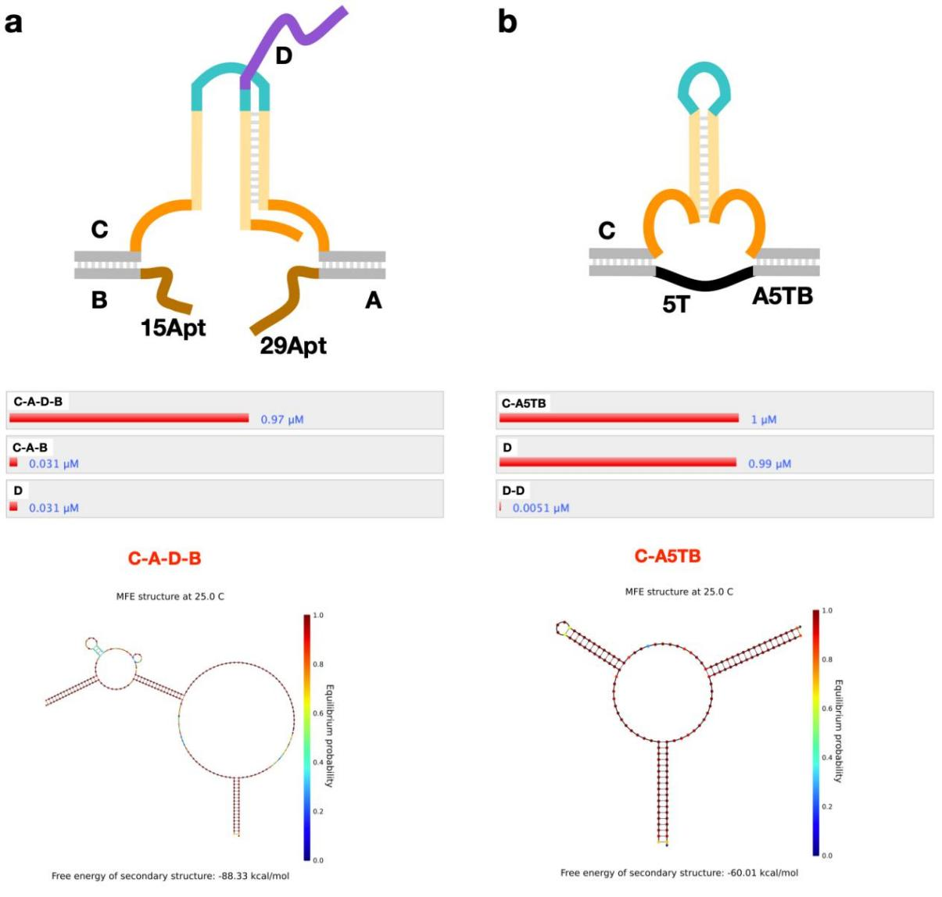
Supplementary Fig. 2 | NUPACK sequence simulation of the AST operations. a, Schematic diagram and NUPACK simulation results of the assembly of strands C, D, A and B (at 25℃ and 1 μM concentration). b, Schematic diagram and NUPACK simulation results of the assembly of strands C, D and A5TB (at 25℃ and 1 μM concentration).

S2.2 Optimizations of the AST operations triggered by thrombin
We explored the optimal structure of the thrombin triggering AST operations by optimizing the lengths of regulator T2 as 4 nt, 8 nt, 12 nt, 16 nt, respectively (Supplementary Fig. 3a and 3b). Upon analysis of fluorescence experiments and PAGE experiments (Supplementary Fig. 3c-3f), better signal noise ratio of the released DNA product was obtained when T2 length was 12 nt. Therefore, we choose 12 nt as the optimal structure for the domain T2 in the following experiments.
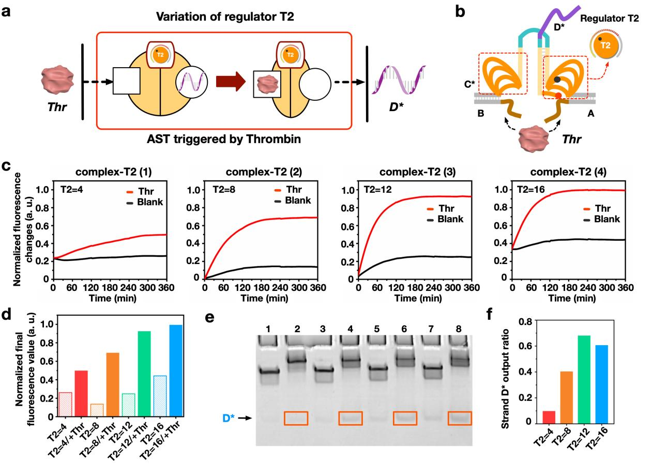
Supplementary Fig. 3 | Regulate the allosteric signal transduction by individually varying the loop lengths of regulator T2. (T1 = 3 nt, H = 11 nt). a, Illustrations and b, designs of the AST triggered by thrombin with different T2 lengths, respectively. c, Fluorescence results of AST triggered by thrombin with different T2 lengths of 4, 8, 12 and 16 nt for complex-T2 (1), (2), (3) and (4). [complex-T2] = 0.5 μM and [Thr] = 1.25 μM. d, Quantification of the final fluorescence values of AST triggered by thrombin with different T2 lengths. Native PAGE (12% acrylamide) results e, and analyzed using ImageJ f, of AST triggered by thrombin with different T2 lengths. Lane 1: complex-T2 (1), Lane 2: complex-T2 (1) + Thr, Lane 3: complex-T2 (2), Lane 4: complex-T2 (2) + Thr, Lane 5: complex-T2 (3), Lane 6: complex-T2 (3) + Thr, Lane 7: complex-T2 (4), Lane 8: complex-T2 (4) + Thr. [complex-T2] = 0.6 μM and [Thr] = 1.5 μM.

In our design, the length of the complementary region (H domain) between strands C and D is also an important factor that influences AST efficiency. We optimize the domain H of the DNA complex structure of the AST triggered by thrombin (Supplementary Fig. 4). The length of the H domain was used as 10 nt, 11 nt, 12 nt and 13 nt. In the results of the fluorescence experiments and PAGE experiments, better signal noise ratio of the released DNA product was obtained when the length of domain H was 12 nt. Therefore, we choose 12 nt as the optimal structure for the H domain in the following experiments.
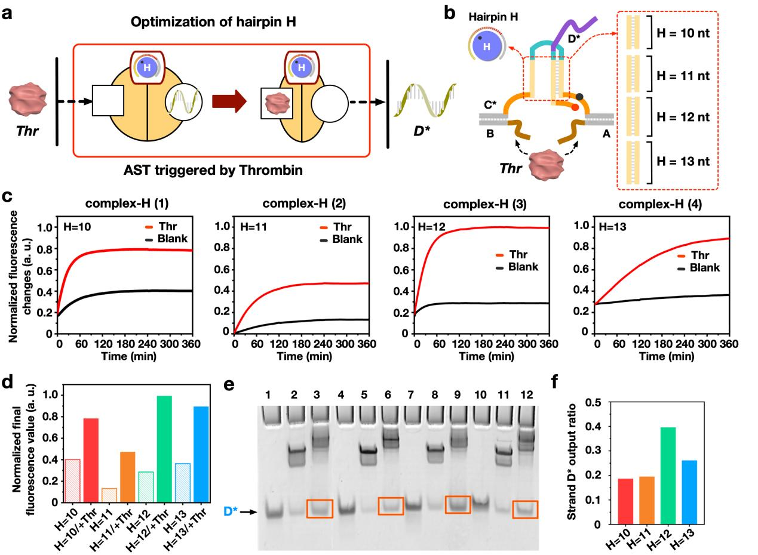
Supplementary Fig. 4 | The length variations of hairpin H to optimize the allosteric signal transduction. (T1 = 3 nt, T2 = 12 nt). a, Illustrations and b, designs of the AST triggered by thrombin with different H lengths, respectively. c, Fluorescence results of AST triggered by thrombin with different H lengths of 10, 11, 12 and 13 nt for complex-H (1), (2), (3), (4). [complex-H] = 0.5 μM and [Thr] = 1.25 μM. d, Quantification of the final fluorescence values of AST triggered by thrombin with different H lengths. Native PAGE (12% acrylamide) results e, and analyzed using ImageJ f, of AST triggered by thrombin with different H lengths. Lane 1: D2*, Lane 2: complex-H (1), Lane 3: complex-H (1) + Thr, Lane 4: D3*, Lane 5: complex-H (2), Lane 6: complex-H (2) + Thr, Lane 7: D4*, Lane 8: complex-H (3), Lane 9: complex-H (3) + Thr, Lane 10: D5*, Lane 11: complex-H (4), Lane 12: complex-H (4) + Thr. [complex-H] = 0.6 μM and [Thr] = 1.5 μM.

On the basis of the optimal structure described above, the optimal concentration of thrombin triggering were determined. As shown in supplementary Fig. 5a, we explored the optimal thrombin triggering concentration by changing the ratio of thrombin to DNA complex CDAB. Upon increasing thrombin concentration, the complex CDAB combined with more thrombin and formed CAB + Thr complex, and the band moved upward. There was an increasing ejection of strand D, reaching a peak value around 1:2.5. On the other hand, the reaction time of AST operations triggered by thrombin were determined by gel experiments. Supplementary Fig. 5b shows that the release efficiency can exceed 40% even if the reaction time is only five minutes (lane 3), demonstrating the fast efficiency of the allosteric signal transduction. As the time passes, the release of DNA D increases slowly and reaches its peak after about one hour.
On the basis of the optimization described above, we examined the influence of the overall concentration of the reaction system on the model (Supplementary Fig. 5c-5f). There were four reaction systems with concentrations of 0.05 μM, 0.1 μM, 0.2 μM, and 0.5 μM. As a result of the addition of thrombin at the four concentrations, significant changes were observed in fluorescence intensity. Additionally, the higher the reaction system concentration, the greater the fluorescence difference, so in the following fluorescence experiments, we selected a reaction system concentration of 0.5 μM or higher.
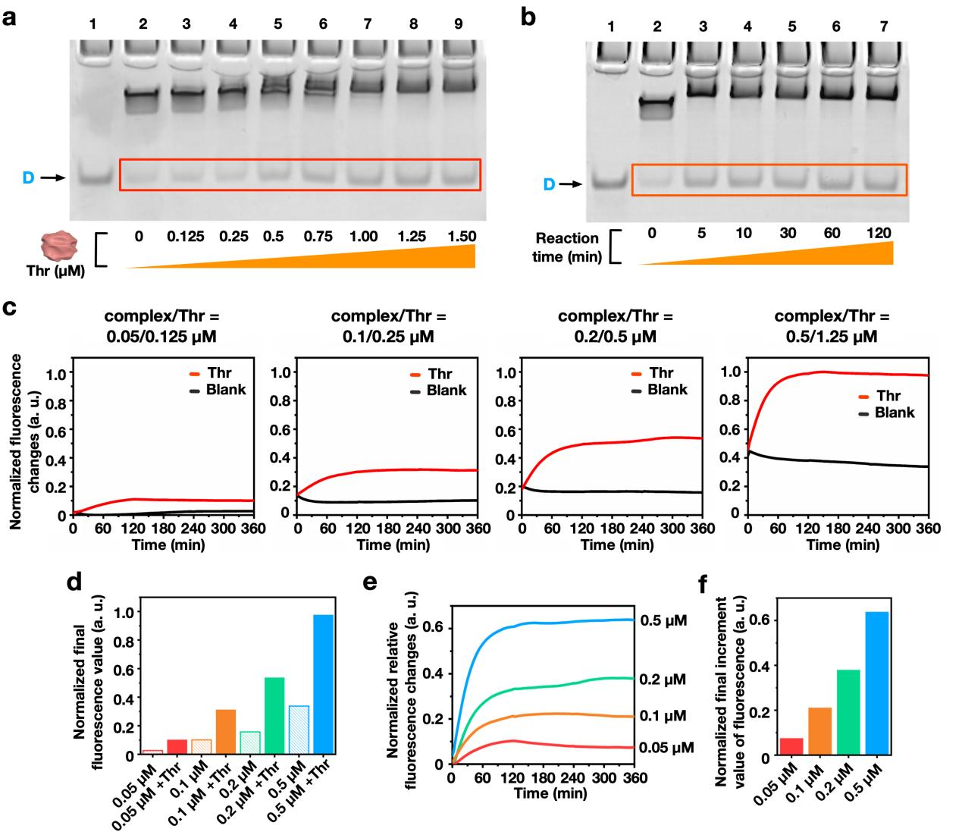
Supplementary Fig. 5 | The optimizations of the experimental conditions of the allosteric signal transduction. a, PAGE results of increasing thrombin concentrations to trigger AST. Lane 1: D, Lane 2: complex CDAB, Lanes 3-9: complex CDAB + [Thr] ([complex CDAB] = 0.5 μM, [Thr] as 0.125 μM, 0.25 μM, 0.5 μM, 0.75 μM, 1 μM, 1.25 μM, 1.5 μM, respectively). b, PAGE results of the reaction time of the AST operations triggered by thrombin. Lane 1: D, Lanes 2-7: CDAB + Thr (Reaction time = 0, 5 min, 10 min, 30 min, 60 min, 120 min, respectively). [complex CDAB] = 0.5 μM. [Thr] = 1.25 μM. c, Fluorescence results of the AST reaction systems with different concentrations of reactants. (1): [complex CDAB] = 0.05 μM, [Thr] = 0.125 μM; (2): [complex CDAB] = 0.1 μM, [Thr] = 0.25 μM; (3): [complex CDAB] = 0.2 μM, [Thr] = 0.5 μM; (4): [complex CDAB] = 0.5 μM, [Thr] = 1.25 μM. d, Histogram comparison of final fluorescence values of AST with different reactant concentrations. e, The relative fluorescence variations with different reactant concentrations at each time point for AST. f, Histogram of the final increment value of fluorescence results in (e).

S3. Designs and optimizations of the AST operations triggered by streptavidin
S3.1 Designs of the AST operations triggered by streptavidin
Based on the AST model mentioned above, the AST operations triggered by streptavidin was also designed. In the AST operations using streptavidin, the DNA complex was designed as: the domain H 11 nt, the domain T 13 nt, and the domain T2 12 nt. In addition, the binding sites that recognizes streptavidin on the DNA A and B strands was changed to biotin. The detailed design is shown in supplementary Fig. 6 and Table 4.
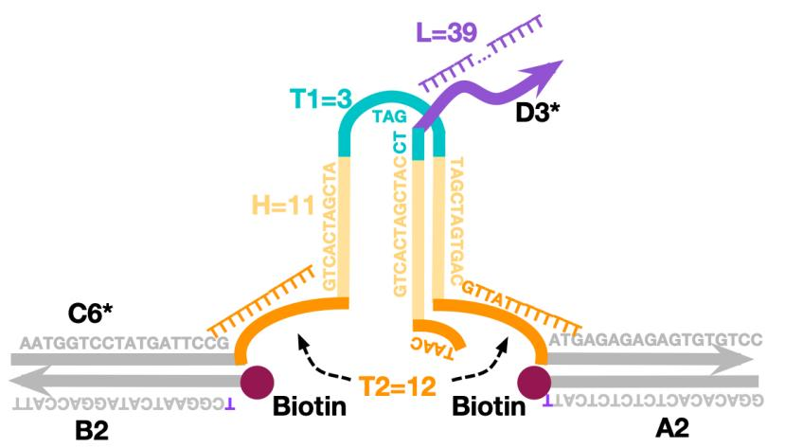

Supplementary Fig. 6 | Schematic diagram of AST operations triggered by streptavidin.

We performed NUPACK simulation for the AST operations triggered by streptavidin. In the initial state, although the strand C6* complementary domain H can hybridize to form an intra-hairpin, the thermodynamic state favors hybridization between the strand C6* and strand D3* due to the stable state produced by longer hybridization region with 18 nt (Supplementary Fig. 7a). Therefore, strand C6* preferentially hybridizes with strand D3*. To test the binding induced allosteric transduction, we firstly using DNA A5TB to simulate the protein triggering, where two ends of the strand C6* get close together as shown in supplementary Fig. 7b. In this state, domains (1) and (2) are adjacent to each other, thus results in a significant increase of the local concentrations of domains (1) and (2), to promote the release of strand D3*. The NUPACK simulation results verify our designs.
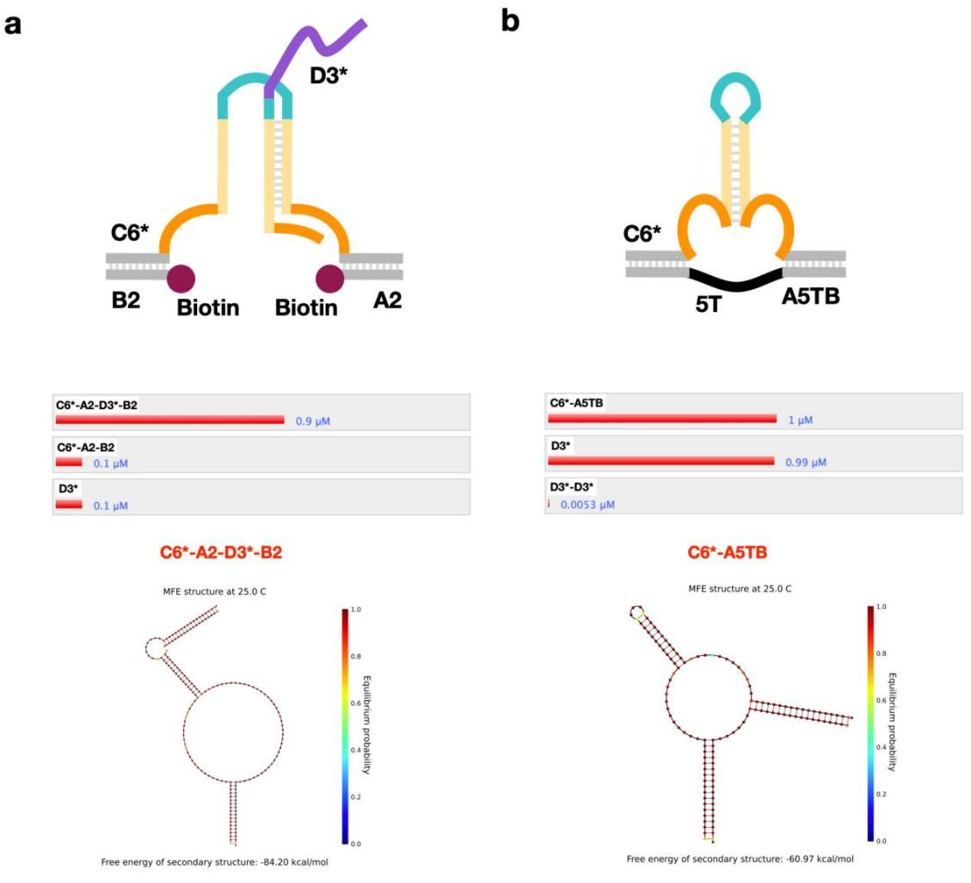
Supplementary Fig. 7 | NUPACK sequence simulation of the AST operations triggered by streptavidin. a, Schematic diagram and NUPACK simulation results of the assembly of strands C6*, D3*, A2 and B2 (at 25℃ and 1 μM concentration). b, Schematic diagram and NUPACK simulation results of the assembly of strands C6*, D3* and A5TB (at 25℃ and 1 μM concentration).

S3.2 Optimizations of the AST operations triggered by streptavidin
We explored the optimal structure of the streptavidin triggering AST operations by optimizing the lengths of regulator T2 as 4 nt, 8 nt, 12 nt, 16 nt, respectively (Supplementary Fig. 8a and 8b). Upon analysis of fluorescence experiments and PAGE experiments (Supplementary Fig. 8c-8f), better signal noise ratio of the released DNA product was obtained when T2 length was 12 nt. Therefore, we choose 12 nt as the optimal structure for the domain T2 in the following experiments.
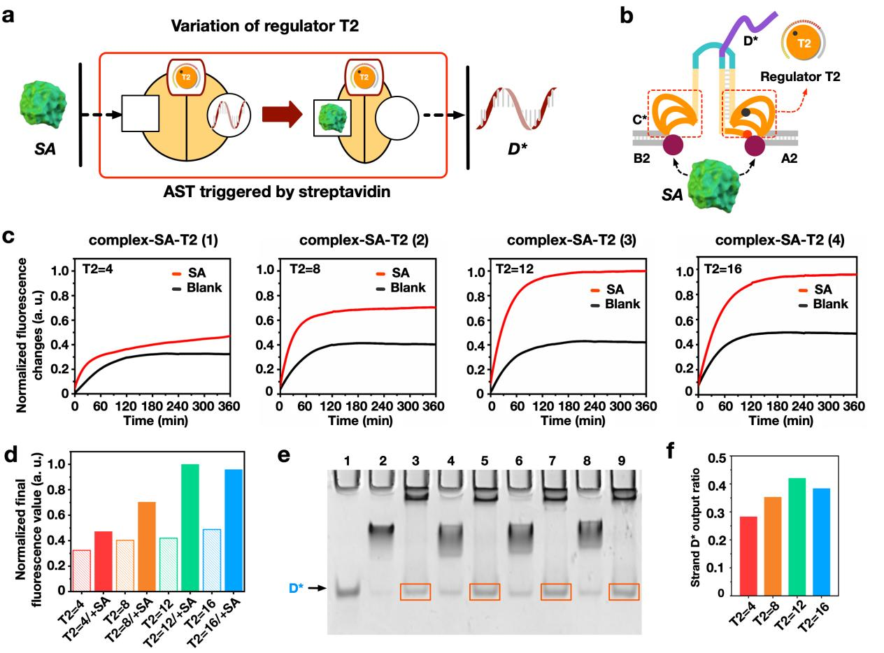
Supplementary Fig. 8 | Regulate the allosteric signal transduction triggered by streptavidin by individually varying the loop lengths of regulator T2. (T1 = 3 nt, H = 11 nt). a, Illustrations and b, designs of the AST operations with different T2 lengths, respectively. c, Fluorescence results of AST triggered by streptavidin with different T2 lengths of 4, 8, 12 and 16 nt for complex-SA-T2 (1), (2), (3) and (4). [complex-SA-T2] = 0.5 μM and [SA] = 1.25 μM. d, Quantification of the final fluorescence values of AST operations. e, Native PAGE results and f. analyzed using ImageJ Lane 1: complex-SA-T2 (1), Lane 2: complex-SA-T2 (1) + SA, Lane 3: complex-SA-T2 (2), Lane 4: complex-SA-T2 (2) + SA, Lane 5: complex-SA-T2 (3), Lane 6: complex-SA-T2 (3) + SA, Lane 7: complex-SA-T2 (4), Lane 8: complex-SA-T2 (4) + SA. [complex-SA-T2] = 0.6 μM and [SA] = 1.5 μM.
In our design, the length of the complementary region (H domain) between strands C and D is also an important factor that influences AST efficiency. We optimize the domain H of the DNA complex structure of the AST triggered by streptavidin (Supplementary Fig. 9). The length of the H domain was used as 10 nt, 11 nt, 12 nt and 13 nt. In the results of the fluorescence experiments and PAGE experiments, better signal noise ratio of the released DNA product was obtained when the length of domain H was 11 nt. Therefore, we choose 11 nt as the optimal structure for the H domain in the following experiments.
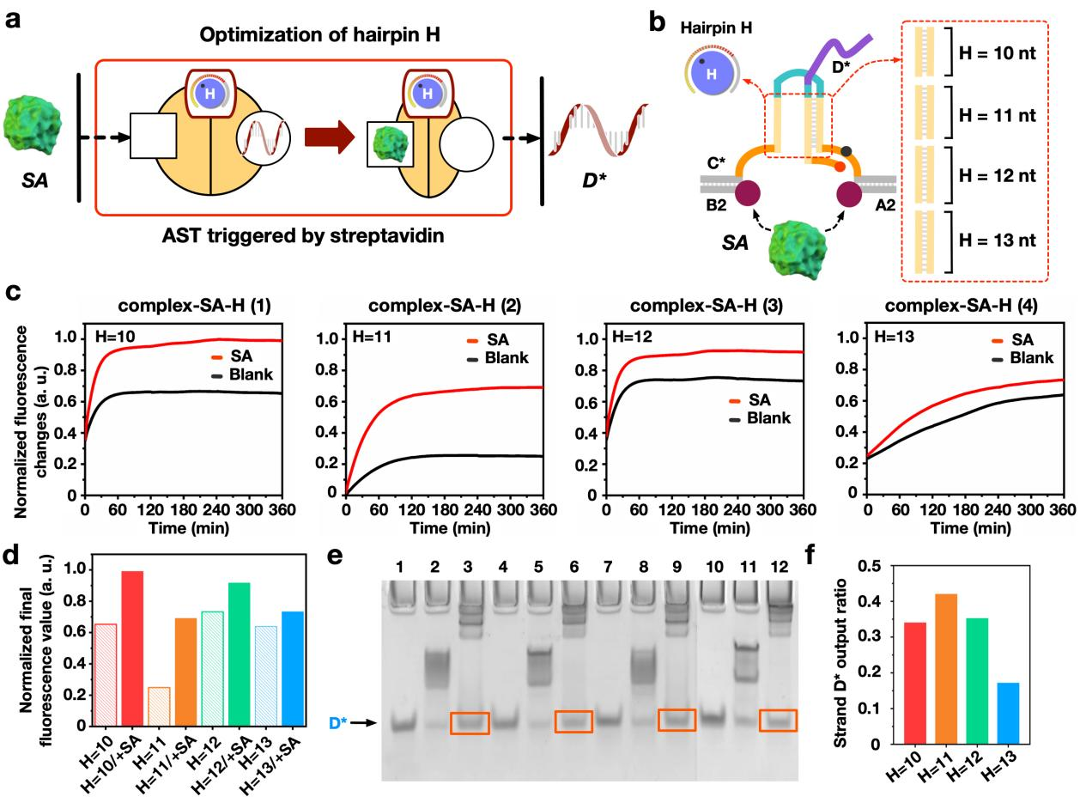
Supplementary Fig. 9 | The length variations of domain H to optimize the AST operations triggered by streptavidin. (T1=3 nt, T2=12 nt). a, Illustrations and b, designs of the AST triggered by streptavidin with different H lengths, respectively. c, Fluorescence results of AST triggered by streptavidin with different H lengths of 10, 11, 12 and 13 nt for complex-SA-H (1), (2), (3), (4). [complex-SA-H] = 0.5 μM and [Thr] = 1.25 μM. d, Quantification of the final fluorescence values of AST operations. e, Native PAGE results and f, analyzed using ImageJ Lane 1: D2*, Lane 2: complex-SA-H (1), Lane 3: complex-SA-H (1) + Thr, Lane 4: D3*, Lane 5: complex-SA-H (2), Lane 6: complex-SA-H (2) + Thr, Lane 7: D4*, Lane 8: complex-SA-H (3), Lane 9: complex-SA-H (3) + Thr, Lane 10: D5*, Lane 11: complex-SA-H (4), Lane 12: complex-SA-H (4) + Thr. [complex-SA-H] = 0.6 μM and [Thr] = 1.5 μM.

On the basis of the optimal structure described above, the optimal concentration of streptavidin triggering were determined. As shown in supplementary Fig. 10a, we explored the optimal streptavidin triggering concentration by changing the ratio of streptavidin to DNA complex C6*D3*A2B2. Upon increasing thrombin concentration, the complex C6*D3*A2B2 combined with more streptavidin and formed C6*A2B2 + SA, and the band moved upward. There was an increasing ejection of strand D, reaching a peak value around 1:3. On the other hand, the reaction time of AST operations triggered by streptavidin were determined by gel experiments. Supplementary Figure 10b shows the change of release efficiency over time, which proves the efficient and fast release of allosteric signal transduction.
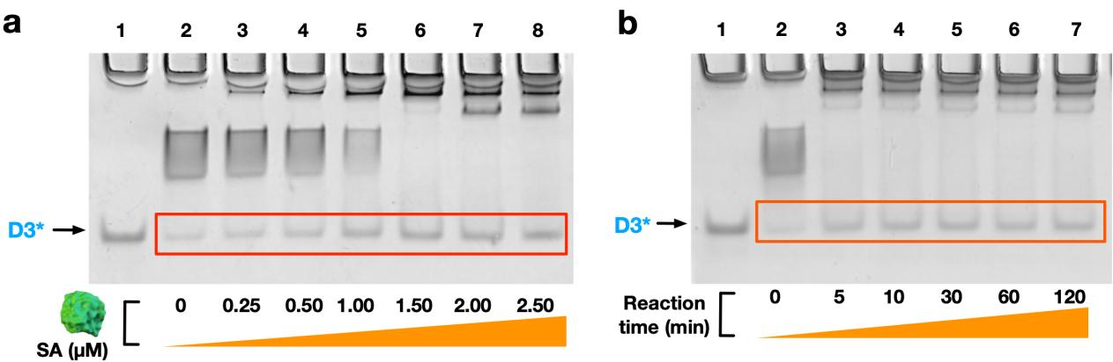
Supplementary Fig. 10 | The optimizations of the experimental conditions of the allosteric signal transduction triggered by streptavidin. a, PAGE results of increasing streptavidin concentrations to trigger AST. Lane 1: D3*, Lane 2: complex C6*D3*A2B2, Lanes 3-9: complex C6*D3*A2B2 + [SA] ([complex C6*D3*A2B2] = 0.5 μM, [SA] as 0.25 μM, 0.5 μM, 1 μM, 1.5 μM, 2 μM and 2.5 μM, respectively). b, PAGE results of the reaction time of the AST operations triggered by streptavidin. Lane 1: D3*, Lanes 2-7: C6*D3*A2B2 + SA (Reaction time = 0, 5 min, 10 min, 30 min, 60 min, 120 min, respectively). [complex C6*D3*A2B2] = 0.5 μM. [SA] = 1.5 μM.

After the completion of all optimization experiments, PAGE and fluorescence experiments were used to verify the optimal AST triggered by streptavidin (Supplementary Fig. 11). In PAGE analysis (supplementary Fig. 11c), after 2 hour of reaction, it can be seen in lane 5 that translator binds to streptavidin and releases D3* strand. In the fluorescence experiment, the fluorescence value of the translator was compared with that after adding 3 times streptavidin, and it could be seen that the fluorescence value was significantly increased within 2 hours after adding streptavidin to the translator (supplementary Fig. 11d).
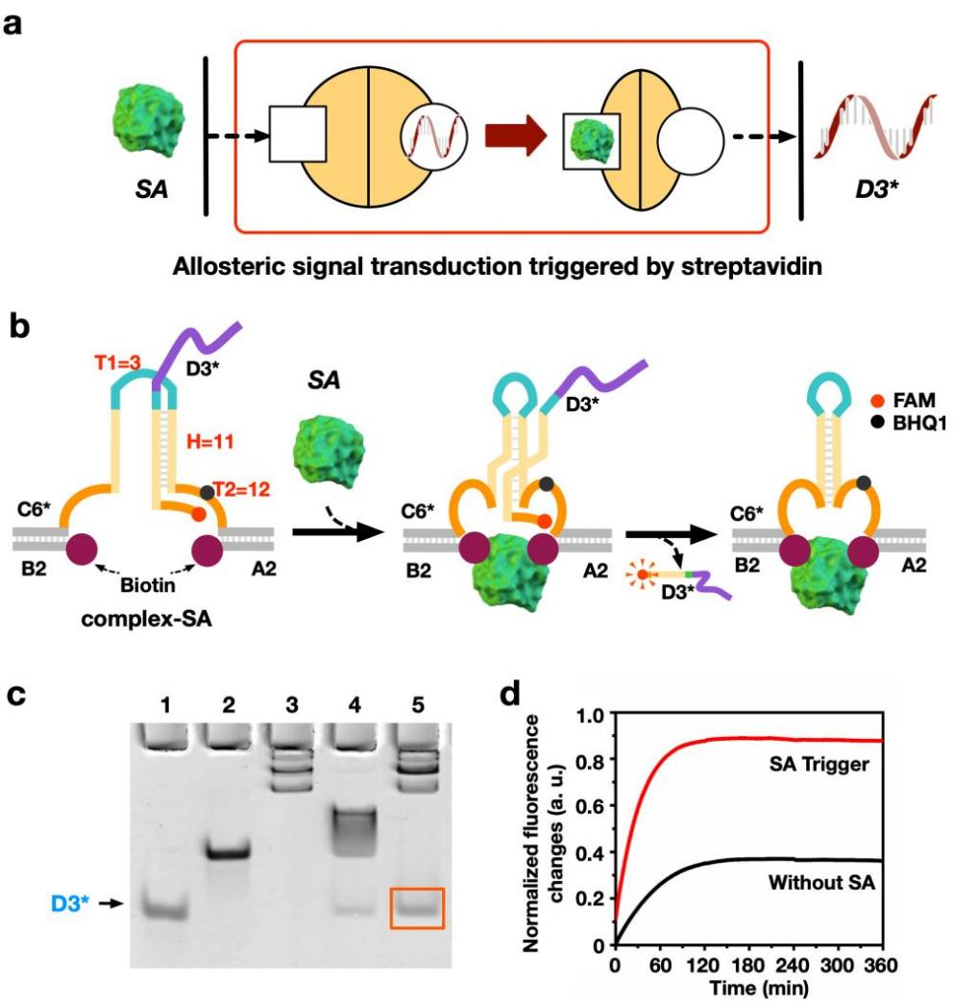
Supplementary Fig. 11 | Allosteric signal transduction triggered by streptavidin. a,b, Schematic illustration (a) and design (b) of a basic allosteric signal transduction triggered by streptavidin, respectively. c, PAGE gel analysis of the basic allosteric transduction system. Lane 1: D3*; Lane 2: C6*A2B2; Lane 3: C6*A2B2 + SA; Lane 4: C6*D3*A2B2; Lane 5: C6*D3*A2B2 + SA. d, Fluorescence output of the basic allosteric transduction system triggered by streptavidin. [DNA complex] = 0.5 µM, [SA] = 1.5 µM.

S4. Designs and results of the AST operations triggered by PDGF-BB
S4.1 Designs of the AST operations triggered by PDGF-BB
The AST operations triggered by PDGF-BB was designed using DNA complex-PDGF, CDA3B3 (Supplementary Fig. 13). The length of domain H was 12 nt, that of domain T1 was 3 nt, and that of domain T2 was 12 nt. In addition, aptamers sequences 35Apt that binds PDGF-BB were designed at the ends of DNA A3 and B3. The detailed design is shown in supplementary Fig. 13 and Table 5.
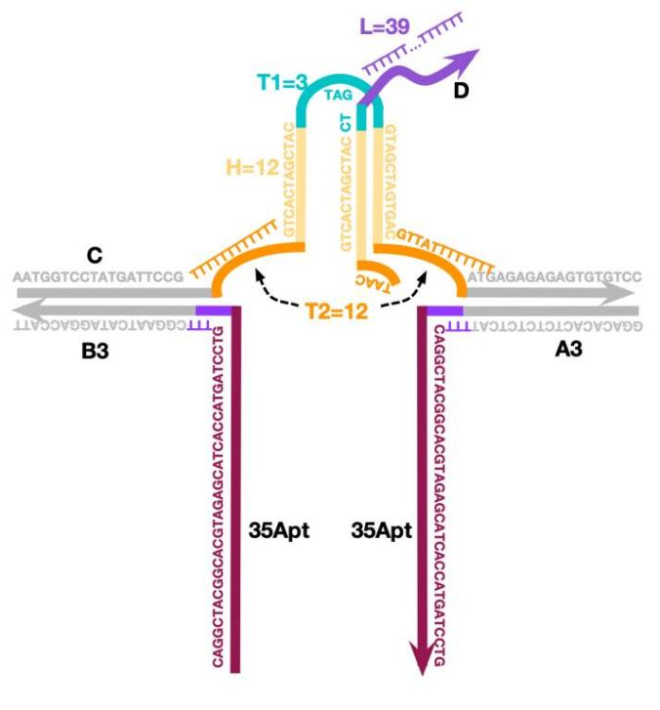
Supplementary Fig. 12 | Schematic diagram of AST operations triggered by PDGF-BB structure sequence.

We performed NUPACK simulation for the AST operations triggered by PDGF-BB. In the initial state, although the strand C complementary domain H can hybridize to form an intra-hairpin, the thermodynamic state favors hybridization between the strand C and strand D due to the stable state produced by longer hybridization region with 18 nt (Supplementary Fig. 14a). Therefore, strand C preferentially hybridizes with strand D. To test the binding induced allosteric transduction, we firstly using DNA A5TB to simulate the protein triggering, where two ends of the strand C get close together as shown in supplementary Fig. 14b. In this state, domains (1) and (2) are adjacent to each other, thus results in a significant increase of the local concentrations of domains (1) and (2), to promote the release of strand D. The NUPACK simulation results verify our designs.
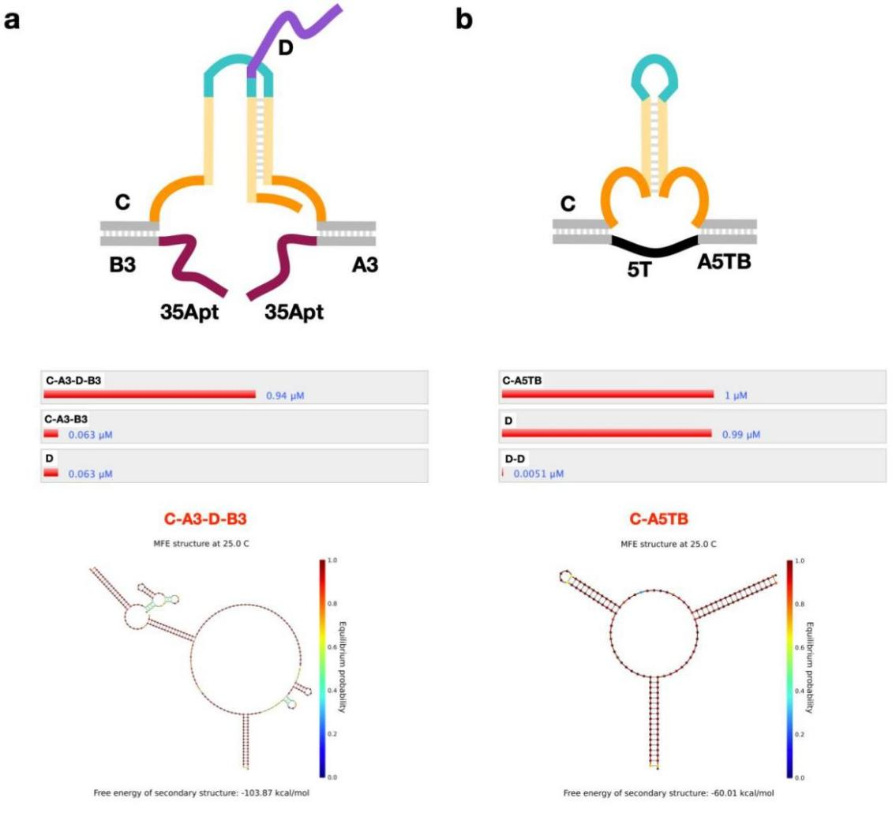
Supplementary Fig. 13 | NUPACK sequence simulation of the AST operations triggered by PDGF-BB. a, Schematic diagram and NUPACK simulation results of the assembly of strands C, D, A3 and B3 (at 25℃ and 1 μM concentration). b, Schematic diagram and NUPACK simulation results of the assembly of strands C, D and A5TB (at 25℃ and 1 μM concentration).

S4.2 Results of the AST operations triggered by PDGF-BB
The detailed mechanism of the AST triggered by PDGF-BB model is shown in supplementary Fig. 15a and 15b. With the increasing PDGF-BB, the released D strand gradually increased to the maximum peak (from lanes 2 to 5), and then the release decreased at the highest concentration of PDGF-BB as 1.8 μM (lane 6) (Supplementary Fig. 15b). This may be due to competition induced re-conjugation between PDGF-BB and the DNA aptamer, causing an oversaturation that interferes with the AST effects.
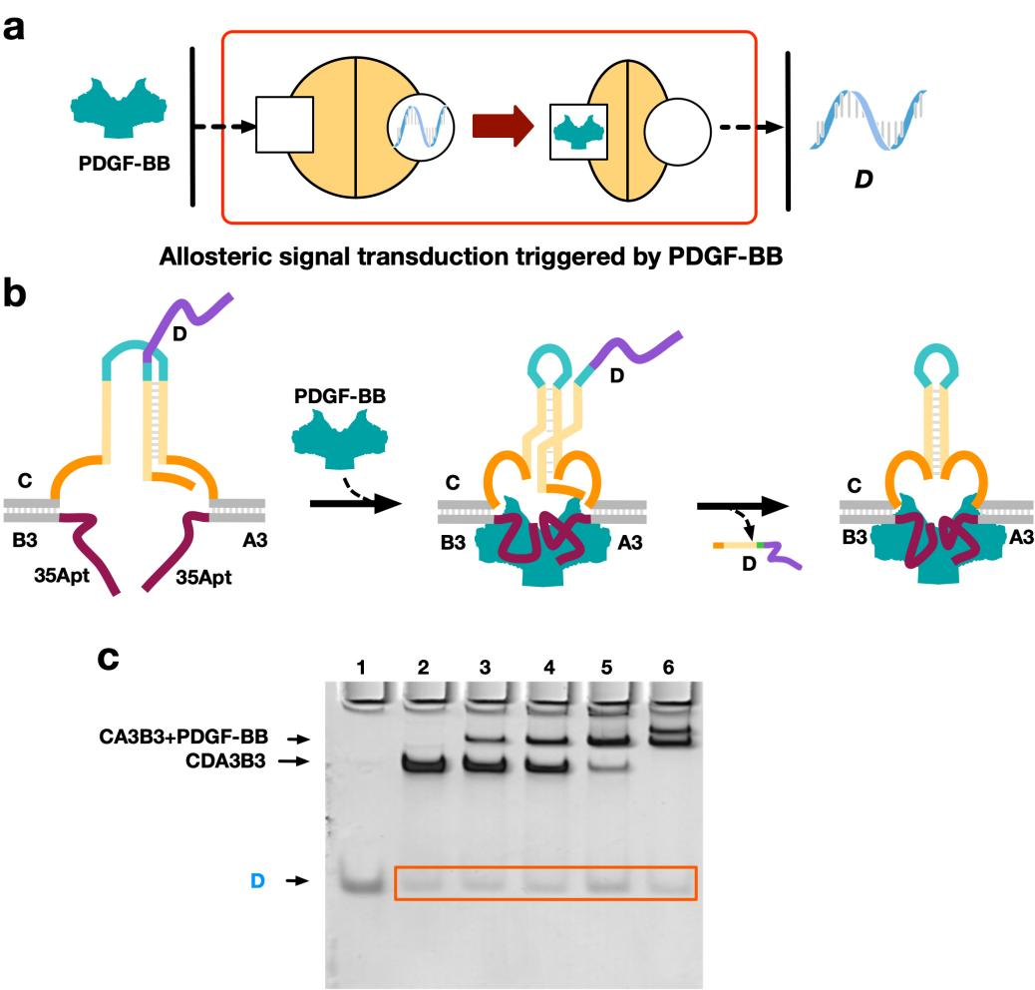
Supplementary Fig. 14 | The results of AST operations triggered by PDGF-BB. a, Schematic diagram of the AST operations triggered by PDGF-BB. b, Native PAGE analysis of the AST with different PDGF-BB concentrations. [complex-PDGF]=0.6 μM. Lanes 2-6 were added with PDGF-BB of 0, 0.3, 0.6, 1.2, and 1.8 μM, respectively.

S5. Triggering AST with saturated protein concentrations
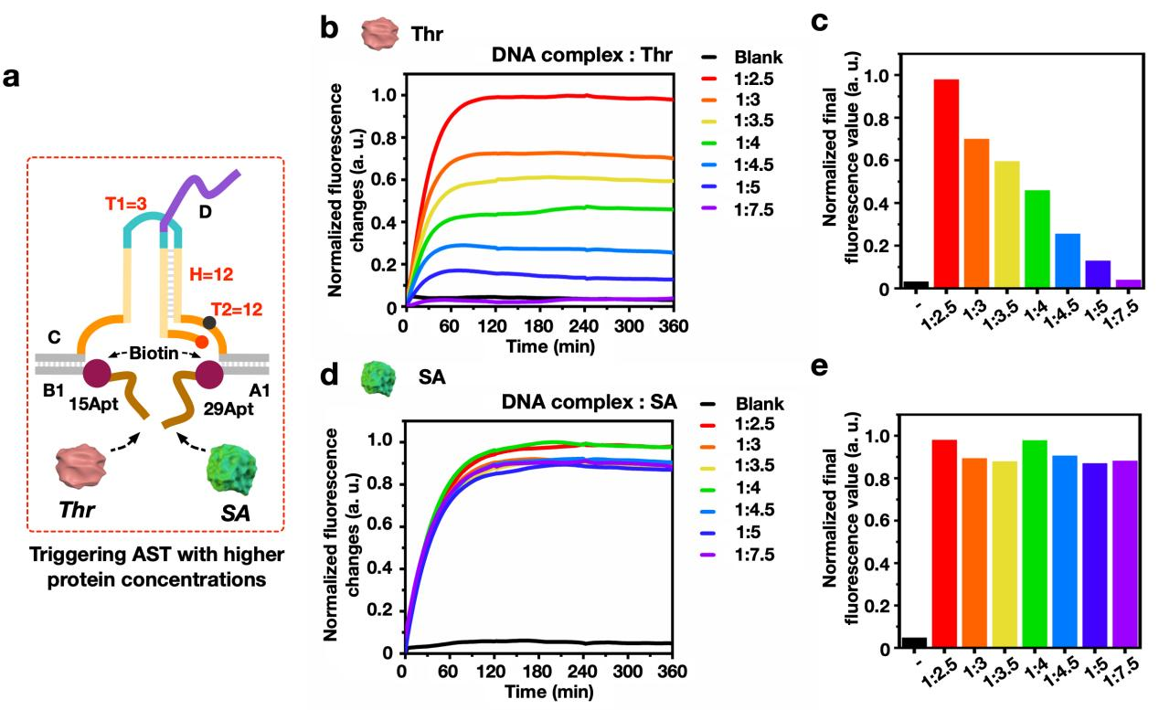
Supplementary Fig. 15 | Triggering AST with saturated protein concentrations of thrombin and streptavidin. a, Designs of trigger AST with saturated protein concentrations of thrombin and streptavidin. b, Fluorescence results of the AST triggered by saturated concentrations of thrombin. [complex-or] = 0.5 μM. [Thr] = 0, 1.25 μM, 1.5 μM, 1.75 μM, 2.0 μM, 2.25 μM, 2.5 μM, 3.75 μM. c, Histogram of the final increment value of fluorescence results of high concentrations of thrombin. d, Fluorescence results of the AST triggered by high concentrations streptavidin. [complex-or] = 0.5 μM. [SA] = 0, 1.25 μM, 1.5 μM, 1.75 μM, 2.0 μM, 2.25 μM, 2.5 μM, 3.75 μM. e, Histogram of the final increment value of fluorescence results using saturated concentrations of streptavidin.

S6. Designs and results of cooperative regulation of the allosteric signal transducer
According to the previous experimental results of the AST triggered by thrombin model structure optimization, we kept the domain H constant to 12 nt, and varied the length of regulator T1 and T2 to implement the cooperative regulation of allosteric signal transducers. The detailed design is shown in supplementary Fig. 16, 17 and Table 6. As shown in supplementary Fig. 18, fluorescence data results of all 9 kinds of CAST regulations.
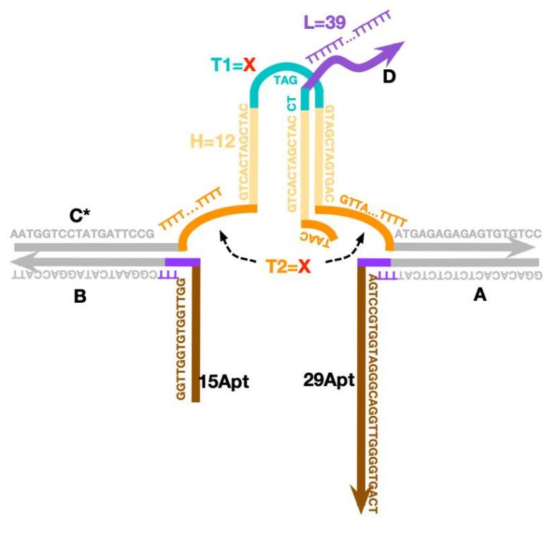
Supplementary Fig. 16 | Schematic diagram of the DNA complex used in CAST operations.
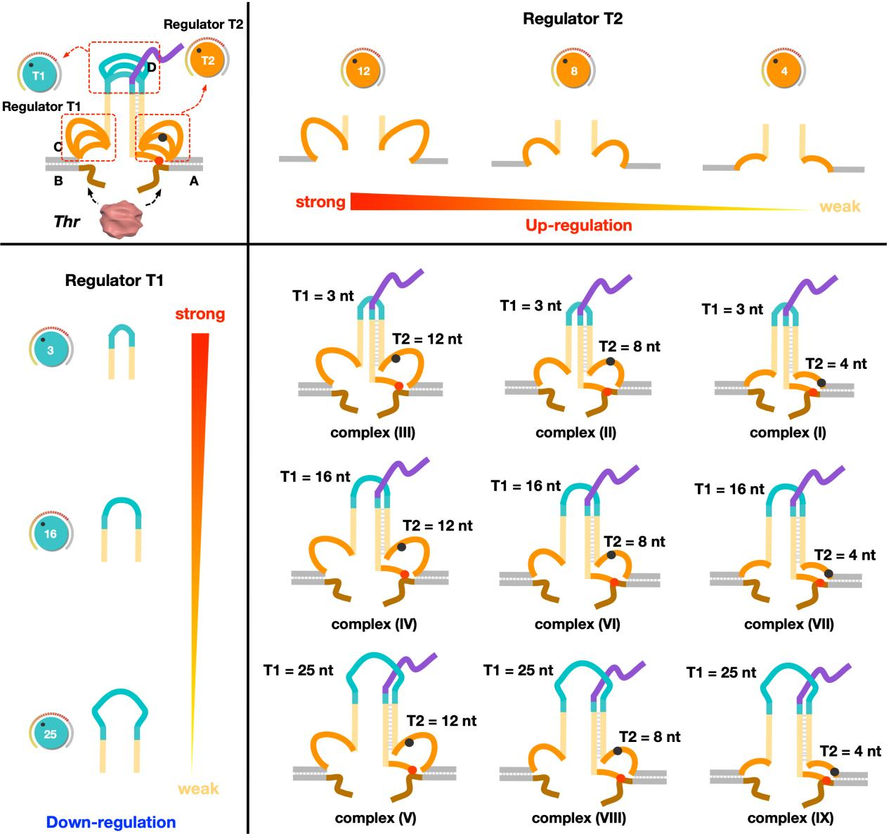

Supplementary Fig. 17 | Structural design of all 9 DNA complexes used in the cooperative regulations of the signal transduction.

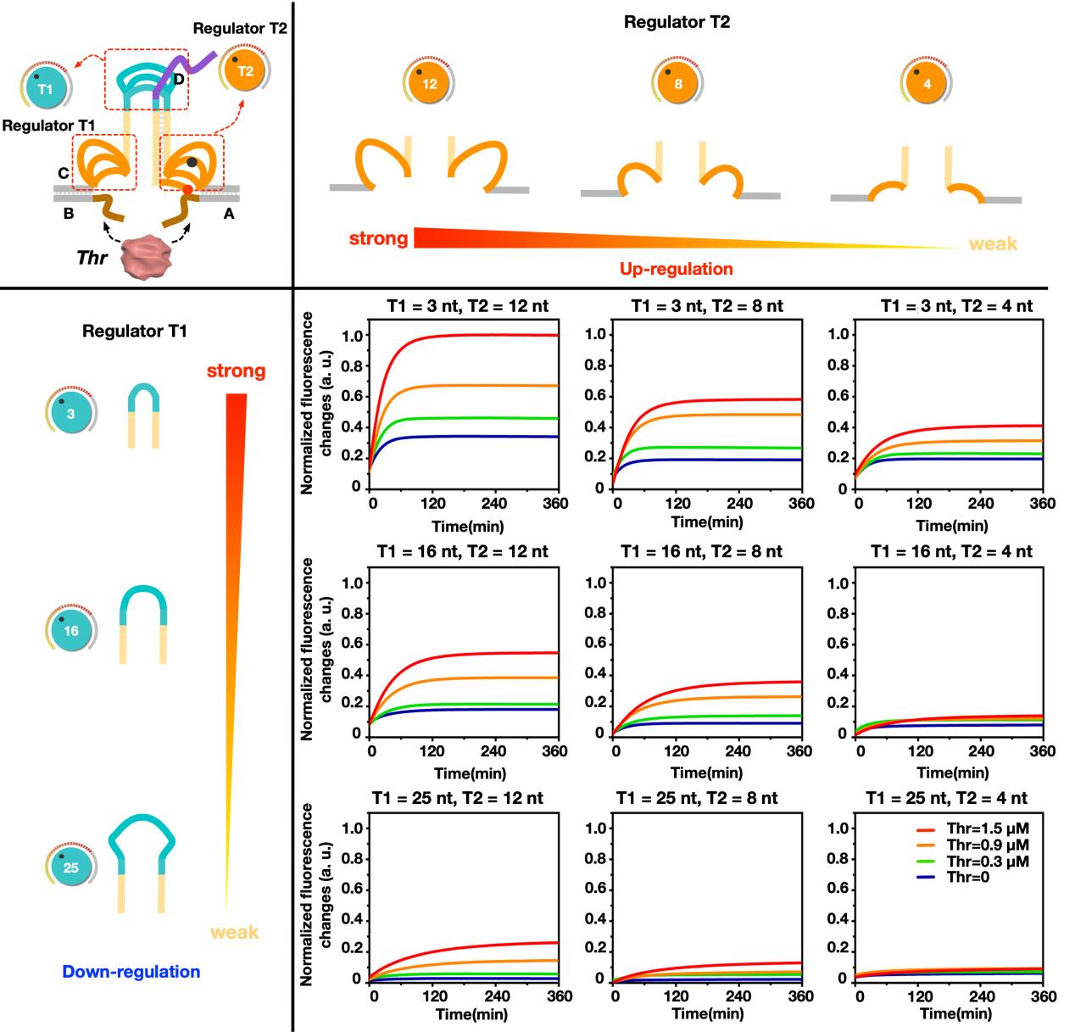
Supplementary Fig. 18 | Fluorescence data results of all 9 kinds of CAST regulations using regulators T1 and T2. [complex] = 0.6 μM. [Thr] = 0, 0.3 μM, 0.9 μM, 1.5 μM.

S7. Designs of the OR logic operations based on the CAST strategy
Based on the CAST model, we use two proteins of thrombin and streptavidin to implement OR gate operation. In the OR gate, the length of domain H was 12 nt, that of domain T1 was 3 nt, and that of domain T2 was 12 nt. In addition, two biotin modifications were designed at the ends of aptamer sequence and the detailed design is shown in supplementary Fig. 19 and Table 7.
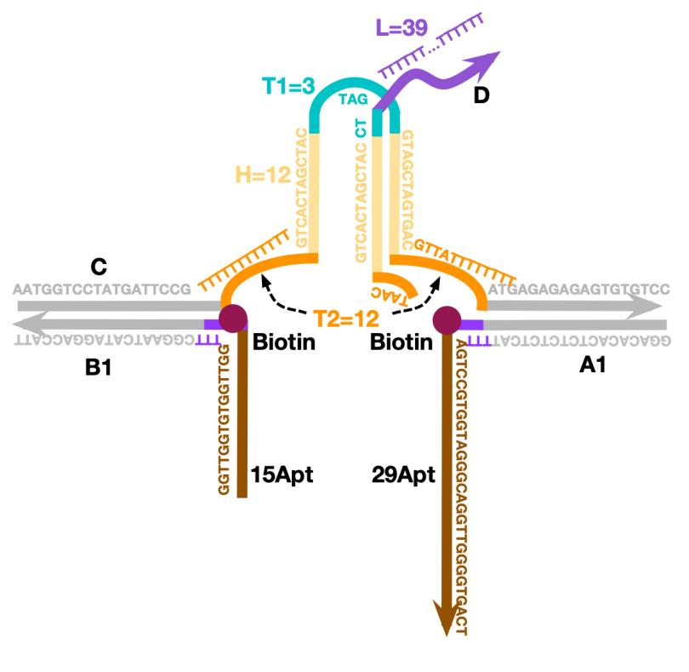
Supplementary Fig. 19 | Schematic diagram of OR gate DNA complex.

S8. Designs and optimizations of the AND logic operations based on CAST strategy
S8.1 Designs of the AND logic operations
In order to realize the design of AND logic gate, we developed a CAST DNA complex with two separated structures: B2C1 and A2C2D1 (Supplementary Fig. 20 and Table 8). DNA A2 and strand B2 respectively modified biotin for streptavidin recognition. Therefore, in the absence of protein input, the DNA complex-and stayed at the state as two separated structures (C1-B2 and C2-A2-D1), without releasing DNA D1. When any one of proteins: thrombin and streptavidin is introduced, two separated structures were still kept for not enough protein binding connection, and no allosteric transduction was performed to release DNA D1. Only in the presence of both proteins of thrombin and streptavidin, both ends of C1-B2 and C2-A2-D1 approach close to each other, thus prompting the release of DNA D1. NUPACK sequence simulation of AND logic gate complex is shown in supplementary Fig. 21.
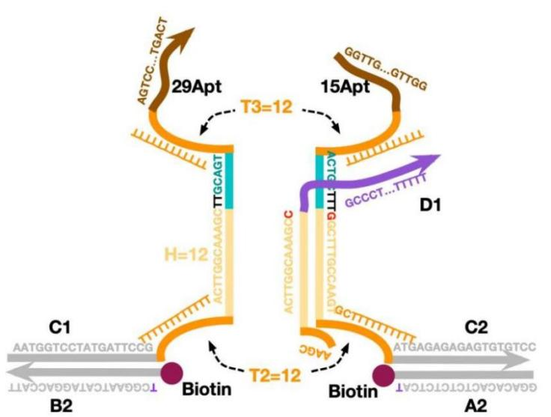
Supplementary Fig. 20 | Schematic diagram of AND gate DNA complex.

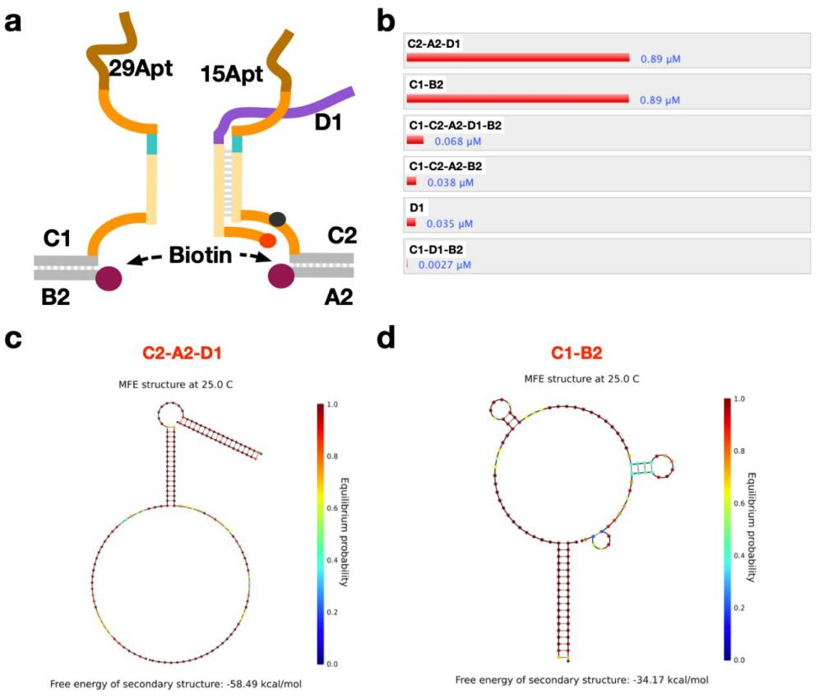
Supplementary Fig. 21 | NUPACK sequence simulation of AND logic gate complex. a, Schematic diagram of NUPACK simulation results of AND logic gate complex. b, NUPACK simulation results of four single strands of AND gate complex at 25 ℃ and 1 μM concentration. The secondary structure of c, C2-A2-D1 and d, C1-B2.

S8.2 Optimizations of the AND logic operations
To optimize the AND logic operation, we designed four kinds of DNA complex structures complex-and (1), (2), (3) and (4), and verified the operations by PAGE experiments (Supplementary Fig. 22 and see Table S8 for sequence design). Specifically, in complex-and (1), the length of domain H was 12 nt, that of domain T2 was 12 nt, and that of domain T3 was 12 nt; in complex-and (2), the length of domain H was 13 nt, that of domain T2 was 12 nt, and that of domain T3 was 12 nt; in complex-and (3), the length of domain H was 18 nt, that of domain T2 was 12 nt, and that of domain T3 was 12 nt, with DNA D1 hybridization length as 13 nt; in complex-and (4), the length of domain H was 17 nt, that of domain T2 was 12 nt, and that of domain T3 was 12 nt, with DNA D1 hybridization length as 12 nt. In the PAGE results, a significant release of DNA D can be found only in complex-and (4) as shown in supplementary Fig. 16. Therefore, we choose the structure of complex-and (4) in the AND logic operations.
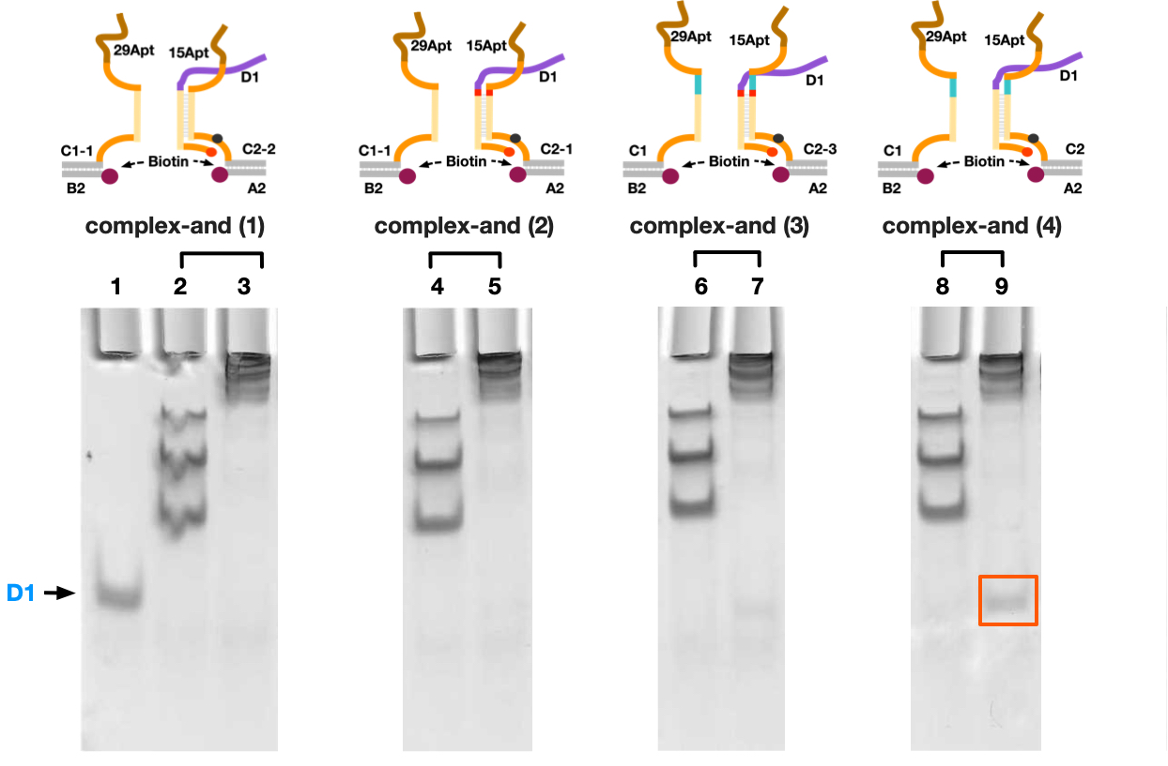
Supplementary Fig. 22 | Regulation of molecular translators by AND logic gate. Lane 1: D1, Lane 2: complex-and (1), Lane 3: complex-and (1) + Thr + SA, Lane 4: complex-and (2), Lane 5: complex-and (2) + Thr + SA, Lane 6: complex-and (3), Lane 7: complex-and (3) + Thr + SA, Lane 8: complex-and (4), Lane 9: complex-and (4) + Thr + SA.

S9. The cascading circuit based on the CAST strategy
To further explore the CAST strategy, switchable and cascading allosteric signal transductions has been constructed. In the switchable system, DNA S* and R* binding with the site of toehold 1 and 2 in complex (X) to displace DNA S and R, respectively, thus making complex (X) at “ON” state with dual biotin modifications. In this condition, the “ON” complex (X) can be triggered by streptavidin to release DNA P. In the cascading system, the thrombin is designed to triggered the upstream complex (XI) through the allosteric signal transduction to release of DNA S* (modified with biotin). Then, DNA S* binding with the site of toehold 1 in downstream complex (XII) to displace DNA S, thus making complex (XII) at “ON” state with dual biotin modifications. Only in this condition, the “ON” complex (XII) can be triggered by streptavidin to release DNA P. The sequence design and simulation are shown in supplementary Fig. 23, Fig. 24 and Table 9.
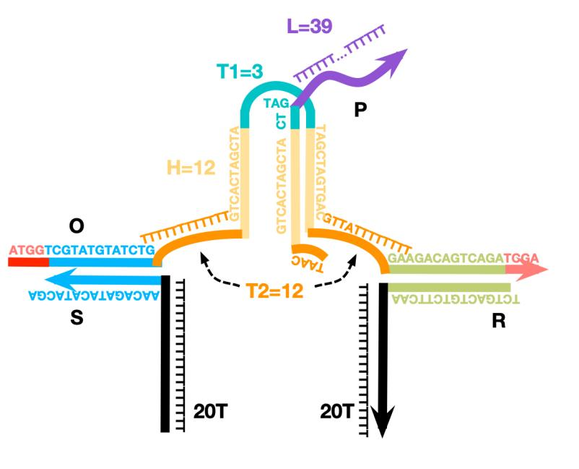
Supplementary Fig. 23 | Schematic diagram of DNA complex (X).
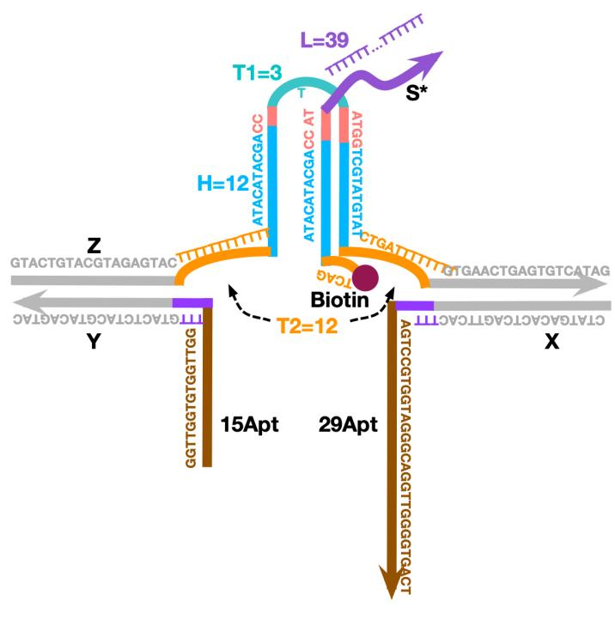
Supplementary Fig. 24 | Schematic diagram of DNA complex (XI).
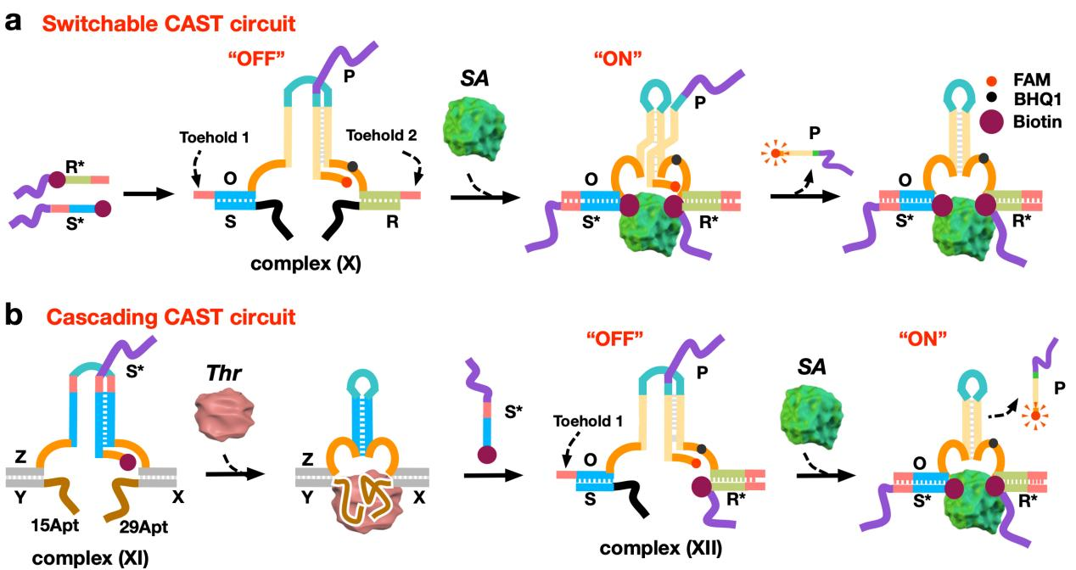
Supplementary Fig. 25 | Schematic diagram of switchable and cascade circuit. Schematic diagram of a, switchable AST circuit and b, cascading CAST circuit. Sequence of c, complex (X) d, complex (XI).

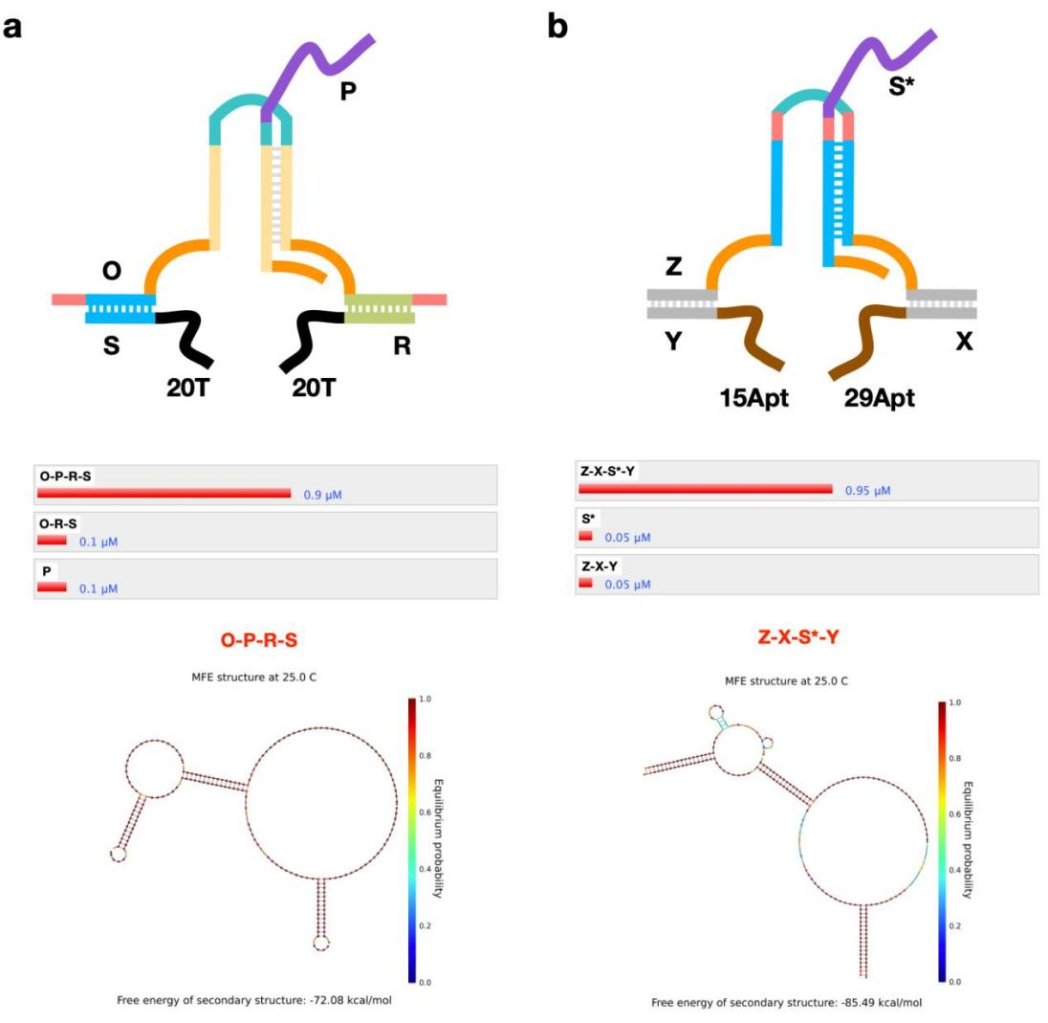
Supplementary Fig. 26 | NUPACK simulation results of the DNA complexes used in the switchable and cascade circuits. a, Schematic diagram and NUPACK simulation results of the assembly of complex (X) (at 25℃ and 1 μM concentration). b, Schematic diagram and NUPACK simulation results of the assembly of complex (XI) (at 25℃ and 1 μM concentration).

In order to realize cascaded control of CAST model, strands R* and S* are used as triggers, and a complete downstream translator structure is formed through strand displacement to complete downstream AST (supplementary Fig. 25). Complex (X) was incubated with diaplacement strands R* and S* for 1h, and streptavidin was added for 1h. Fluorescence analysis showed that only when both the diaplacement strand and streptavidin were present, strand P release was generated and the fluorescence signal was significantly enhanced (supplementary Fig. 25d and 25e).
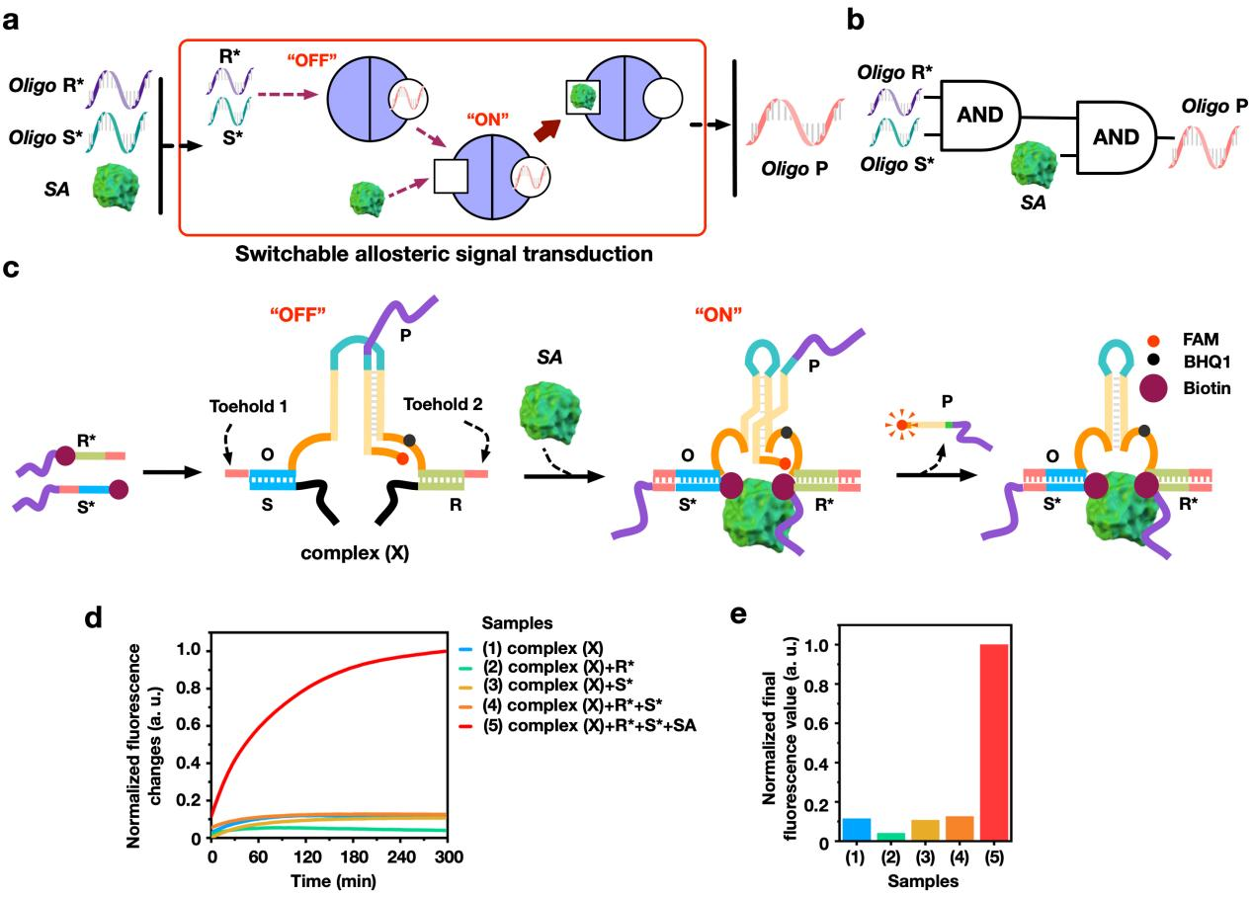
Supplementary Fig. 27 | Switchable AST circuit triggered by streptavidin. a, b, The illustrations and c, designs of switchable AST (using DNA complex (X), OPRS), respectively. d, Fluorescence results. [complex (X)] = 0.5 μM, R* = S* = 0.5 μM, [SA] = 1.5 μM. e, The final normalized fluorescence value of switchable AST.

S10. Using CAST strategy to regulate GFP gene expression
S10.1 Designs of the allosteric transducer to control GFP gene expression
We redesigned the strand D sequences with the GFP ASOs, called D_{GFP}, and so that the signal transduction induced allosteric release of DNA D_{GFP} could target at the GFP gene to regulate the gene expression in Hela cells. In the complex-G, the 3 'and 5' ends of DNA A and B are designed with thrombin aptamer sequences with the length of 29 nt and 15 nt, respectively, and the complementary domains of strand C are both 18 bp. The T1 domain of strand C is 3 nt, the T2 domains is 12 nt, and the H domain is 12 nt (Supplementary Fig. 26 and Table 10).
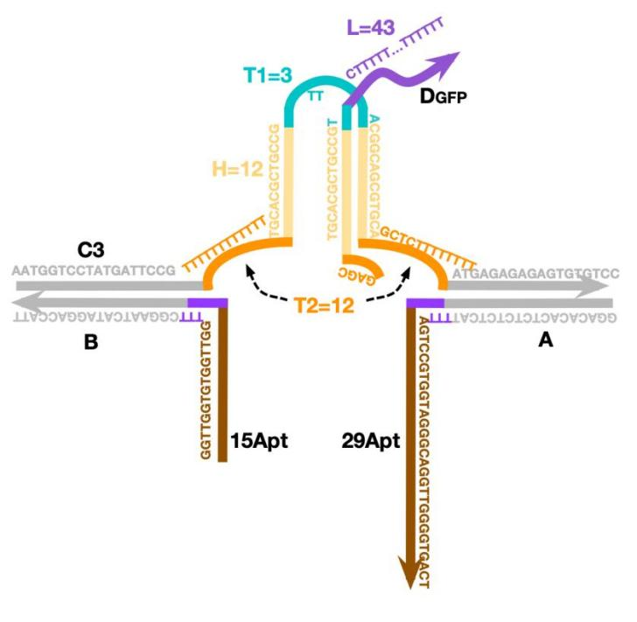
Supplementary Fig. 28 | Schematic diagram of DNA complex-G to control GFP gene expression.

We first tested whether complex-G could act in vitro. The results of PAGE experiment are shown in supplementary Fig. 27. Upon adding thrombin concentration, the complex-G (C3D_{GFP}AB) combined with thrombin and formed C3AB + Thr complex, and the band moved upward. At the same time, strand D_{GFP} is released from the basic structure.
After verifying that D_{GFP} could be released, flow cytometry assay and confocal assay were used to verify whether D_{GFP} could be released into Hela cells . We labeled single strand D_{GFP} with Cy5.5 and Cy5 fluorophore and performed flow cytometry and confocal experiments, respectively. Flow cytometry (Supplementary Fig. 27c and 27d) and confocal experiment (Supplementary Fig. 28) showed that the fluorescence intensity in cells decreased significantly when thrombin was added to the complex-G compared with the condition without triggering. All these results confirmed that the nucleic acid strand released by the molecular translator could be taken up by Hela cells.
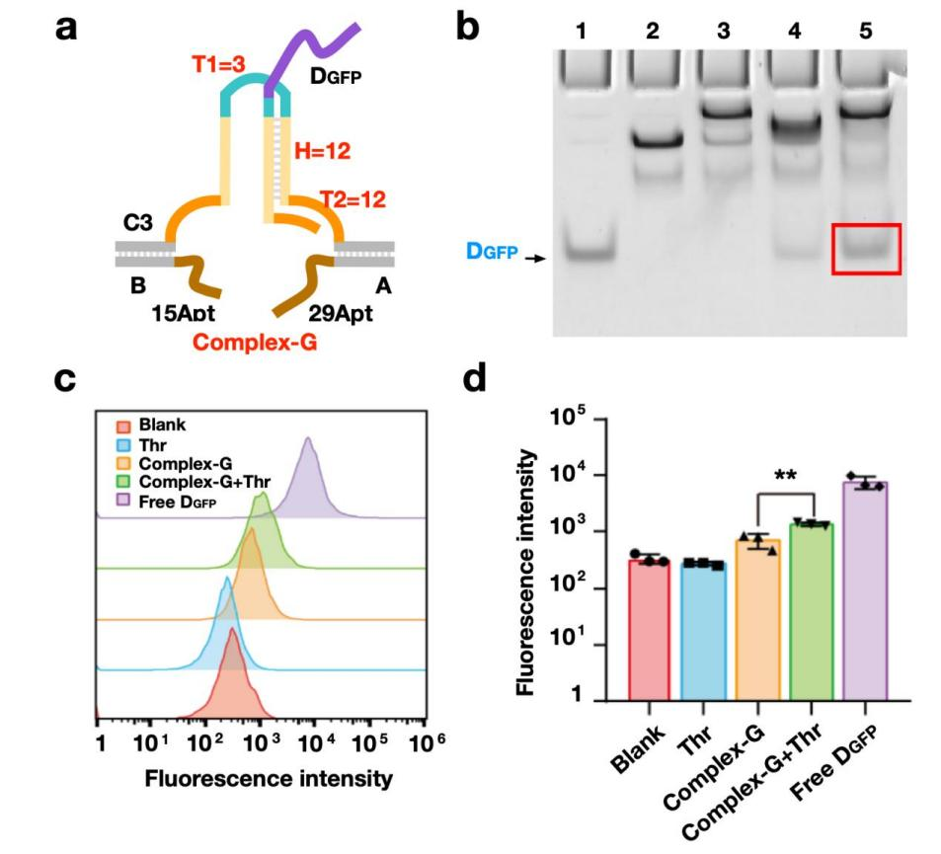
Supplementary Fig. 29 | PAGE and flow cytometry confirmed that AST regulates GFP gene expression. a, Design and b, PAGE results of the AST (using DNA Complex-G, C3D_{GFP}AB), respectively. Lane 1: D_{GFP}; Lane 2: C3AB; Lane 3: C3AB + Thr; Lane 4: Complex-G; Lane 5: Complex-G + Thr. c, d, Flow cytometry confirmed that the nucleic acid strands ejected from the molecular translator could be taken up by HeLa cells.
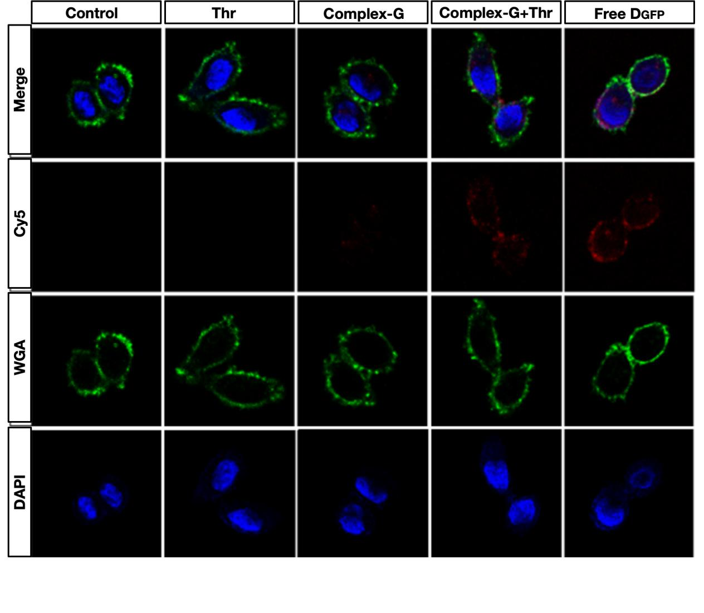
Supplementary Fig. 30 | Confocal experiments confirmed that the fluorescent Cy5-labeled nucleic acid strands could enter the interior of HeLa cells. Blue color is the nucleus; Green color is the cell membrane; The red color represents the Cy5-labeled strand D.

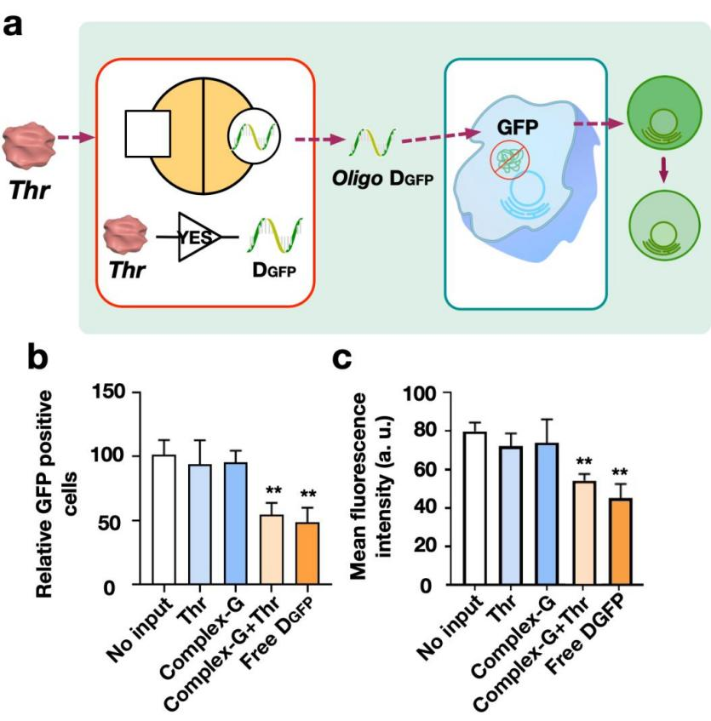
Supplementary Fig. 31 | Using AST to regulate GFP gene expression. a, Schematic illustration of the allosteric regulation of GFP gene expression via thrombin. b, Relative GFP positive cells results and c, mean fluorescence intensities of the allosteric regulations of GFP gene, respectively.

S10.2 Cooperative regulation allosteric transducer to regulate GFP gene expression
In the study, we investigated to use using CAST strategy to regulate GFP gene expression. Based on the previous cooperative regulation mechanism, we designed six kinds of allosteric DNA complexes as shown in supplementary Fig. 20 and Table 10. By varying the loop combinations of T1/T2, six kinds of DNA complexes were used in the experiments as: (i) C3-1D_{GFP}AB (T1 = 16 nt, T2 = 4 nt), (ii) C3-2D_{GFP}AB (T1 = 16 nt, T2 = 8 nt), (iii) C3-3D_{GFP}AB (T1 = 16 nt, T2 = 12 nt), (iv) C3-4D_{GFP}AB (T1 = 3 nt, T2 = 8 nt), (v) C3D_{GFP}AB (T1 = 3 nt, T2 = 12 nt) and (vi) C3-5D_{GFP}AB (T1 = 3 nt, T2 = 4 nt).
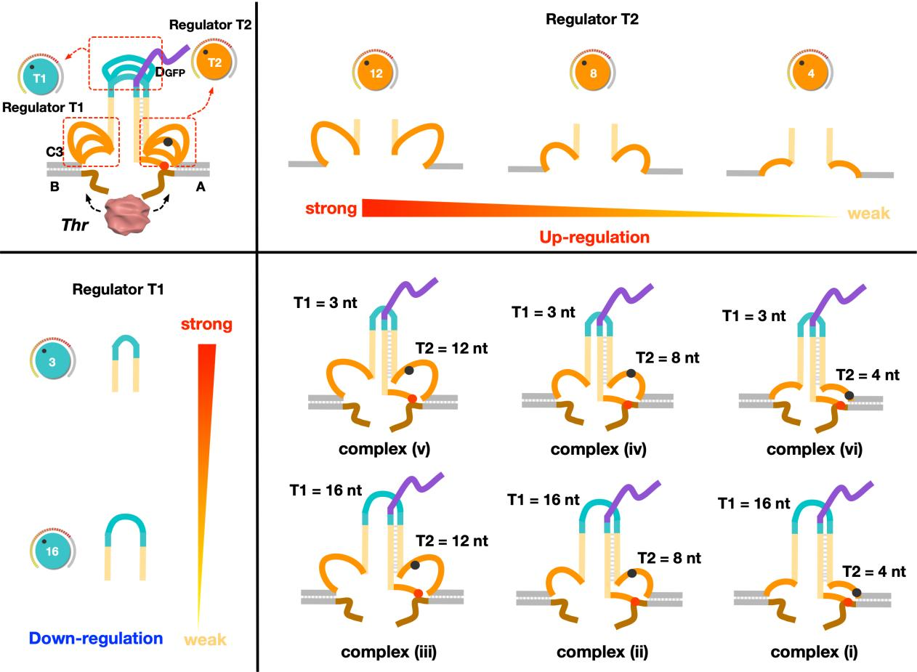
Supplementary Fig. 32 | Structural designs of all six kinds of cooperative regulations of DNA complexes to regulate GFP gene expression.

The PAGE experiments were used to verify the in vitro operations of CAST based gene regulation (Supplementary Fig. 21). In the gel results, it is clear to see that the releases of D_{GFP} can be found in the samples of thrombin triggered complexes (ii), (iii), (iv) and (v).
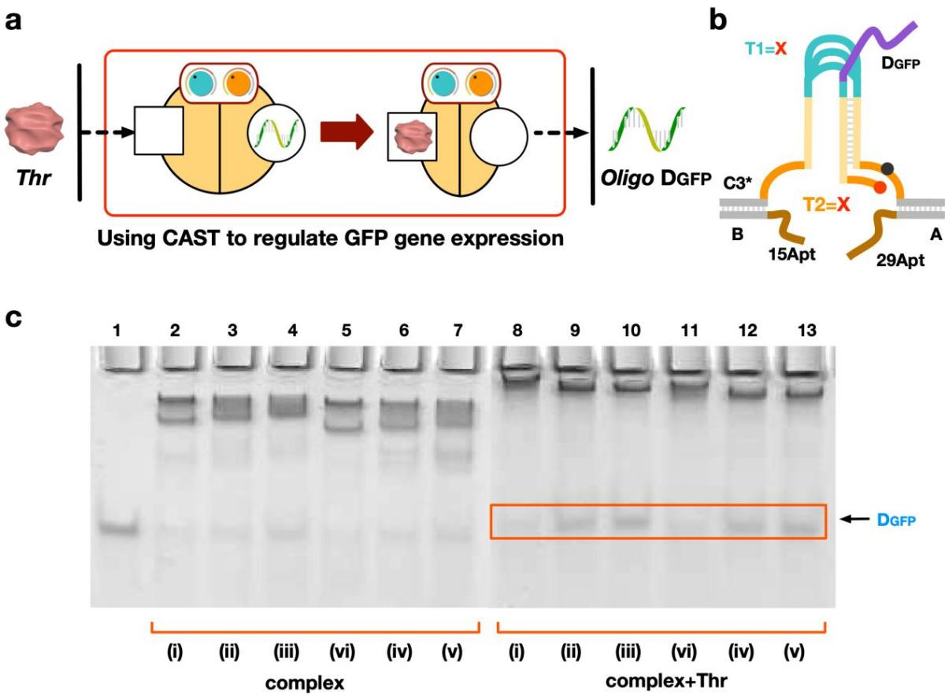

Supplementary Fig. 33 | Design and PAGE results of CAST regulation of GFP gene expression using CAST strategy. a,Schematic illustration and b, design of CAST regulations of GFP gene expression. c, PAGE results of CAST regulations of GFP gene expression. Lane 1: D_{GFP}; Lane 2: complex (i); Lane 3: complex (ii); Lane 4: complex (iii); Lane 5: complex (vi); Lane 6: complex (iv); Lane 7: complex (v); Lane 8: complex (i) + Thr; Lane 9: complex (ii) + Thr; Lane 10: complex (iii) + Thr; Lane 11: complex (vi) + Thr; Lane 12: complex (iv) + Thr; Lane 13: complex (v) + Thr. [complex] = 0.6 µM, [Thr] = 1.5 µM.

S11. Using CAST to regulate PLK1 gene expression
S11.1 Designs of the AST to regulate PLK1 gene expression
We developed a CAST based regulation of PLK1-specific ASOs to logically control PLK1 expression and influence the tumor cell proliferation. We firstly verified the released effect of the allosteric signal transduction of PLK1-specific ASOs (Table 11). As shown in supplementary Fig. 22, PLK1-specific ASOs is initially captured in the DNA complex-P. In the complex, the 3 'and 5' ends of DNA A and B are designed with thrombin aptamer sequences with the length of 29 nt and 15 nt, respectively, and the complementary domains of strand C are both 18 bp. And the length of domain T1 of strand C is 3 nt, that of domain T2 is 12 nt, and that of domain H is 12 nt.
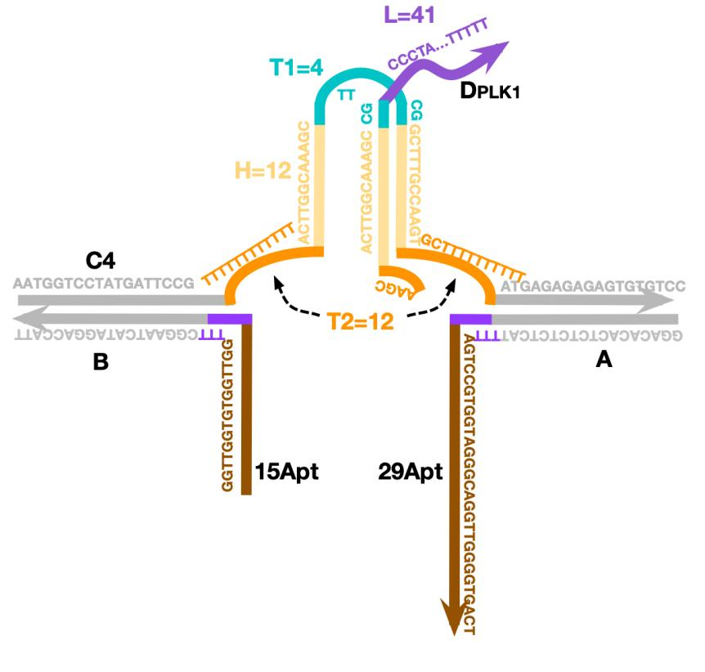
Supplementary Fig. 34 | Schematic diagram of DNA complex-P to control PLK1 gene expression.
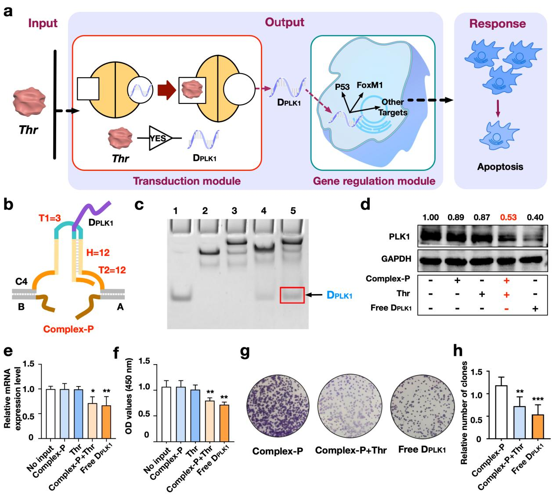
Supplementary Fig. 35 | Using allosteric “YES” gate to regulate PLK1 gene expression and influence cell proliferation. a, Schematics and b, design of the CAST “YES” gate regulations of PLK1 gene expression and tumor cell proliferations by using thrombin (using DNA Complex-P, C4D_{PLK1}AB), respectively. c, PAGE results of the “YES” gate. Lane 1: D_{PLK1}; Lane 2: C4AB; Lane 3: C4AB + Thr; Lane 4: Complex-P; Lane 5: Complex-P + Thr. d, Western results of PLK1 gene expression. e, Relative mRNA expression results (examined by RT-qPCR). f, OD values results. g, The cell proliferation assay results. h, Statistical results of relative clones numbers in cell proliferation assay.

S11.2 Two input logical operations to cooperatively regulates PLK1 gene based on CAST strategy
Based on the previous OR and AND logic operations, we developed the ASOs based CAST regulation of PLK1 gene expression. The DNA complex structural design is shown in supplementary Fig. 23, Fig. 24 and Table 11. PAGE results of two-input logic operations indicated the efficient release of specific PLK1 ASOs in vitro as show in supplementary Fig. 25.
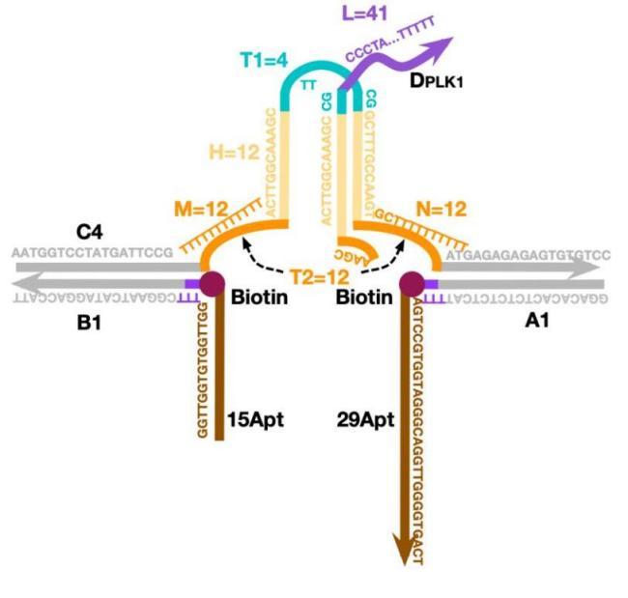
Supplementary Fig. 36 | Schematic diagram of DNA complex-OR to implement “OR” gate operations on PLK1 gene expression.

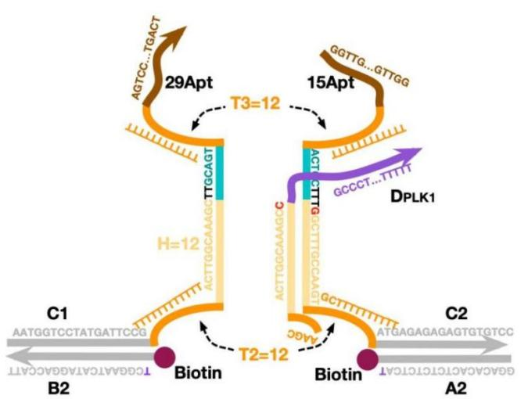

Supplementary Fig. 37 | Schematic diagram of DNA complex-AND to implement “AND” gate operations on PLK1 gene expression.

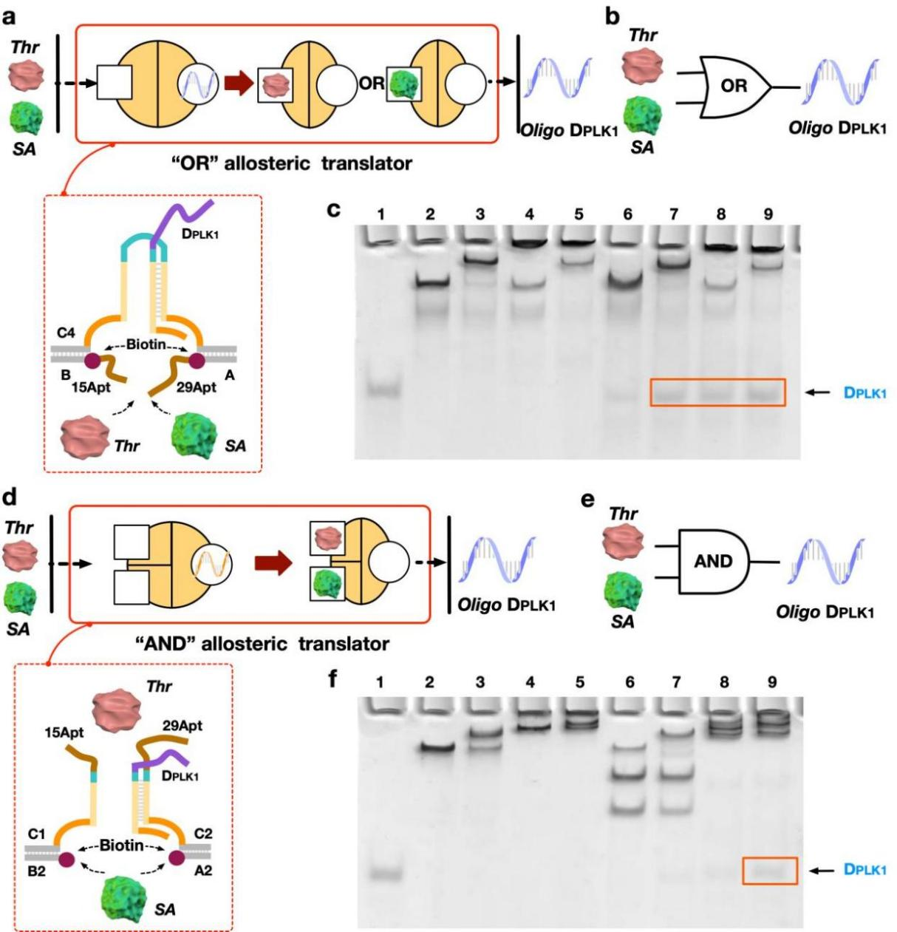
Supplementary Fig. 38 | PAGE results of two-input logic CAST operations to the release of specific PLK1 ASOs in vitro. a, Schematic illustration of the OR logic operations. b, Design and c, PAGE results of the OR logic operation, repectively. Lane 1: D_{PLK1}; Lane 2: C4AB; Lane 3: C4AB + Thr; Lane 4: C4AB + SA; Lane 5: C4AB + Thr + SA; Lane 6: complex-OR; Lane 7: complex-OR + Thr; Lane 8: complex-OR + SA; Lane 9: complex-OR + Thr + SA. d, e, Design and f, PAGE results of the AND logic operation, respectively. Lane 1: D_{PLK1}; Lane 2: C1B2 + C2A2; Lane 3: C1B2 + C2A2 + Thr; Lane 4: C1B2 + C2A2 + SA; Lane 5: C1B2 + C2A2 + Thr + SA; Lane 6: complex-AND; Lane 7: C2A2 + SA; Lane 5: C1B2 + C2A2 + Thr + SA; Lane 6: complex-AND; Lane 7: complex-AND + Thr; Lane 8: complex-AND + SA; Lane 9: complex-AND + Thr + SA. [DNA complex] = 0.6 µM, [Thr] = 1.5 µM, [SA] = 1.8 µM. It is worth noting that in order to fit the next cell experiment, the reactions of DNA complex and protein were incubated at 37℃.
Supplementary Tables
Table S1. DNA sequence of the basic allosteric signal transduction system
Name | Sequence | Modification
C | AATGGTCCTATGATTCCGTTTTTTTTTTTTGTCACTAGCTACTAGGTAGCTAGTGACGTTATTTTTTTTATGAGAGAGAGTGTGTCC | T-BHQ1  (Red base modification)
D | TAACGTCACTAGCTACCTTTTTTTTTTTTTTTTTTTTTTTTTTTTTTTTTTTTTTTT | 5’-FAM
A | GGACACACTCTCTCTCATTTTAGTCCGTGGTAGGGCAGGTTGGGGTGACT
B | GGTTGGTGTGGTTGGTTTCGGAATCATAGGACCATT

Table S2. DNA sequence of change the length of regulator T2
Name | Sequence | Modification
C1* | AATGGTCCTATGATTCCGTTTTGTCACTAGCTATAGTAGCTAGTGACGTTAATGAGAGAGAGTGTGTCC | T-BHQ1
C2* | AATGGTCCTATGATTCCGTTTTTTTTGTCACTAGCTATAGTAGCTAGTGACGTTATTTTATGAGAGAGAGTGTGTCC | T-BHQ1
C3* | AATGGTCCTATGATTCCGTTTTTTTTTTTTGTCACTAGCTATAGTAGCTAGTGACGTTATTTTTTTTATGAGAGAGAGTGTGTCC | T-BHQ1
C4* | AATGGTCCTATGATTCCGTTTTTTTTTTTTTTTTGTCACTAGCTATAGTAGCTAGTGACGTTATTTTTTTTTTTTATGAGAGAGAGTGTGTCC | T-BHQ1
D1* | TAACGTCACTAGCTACTTTTTTTTTTTTTTTTTTTTTTTTTTTTTTTTTTTTTTTT | 5’-FAM
A | GGACACACTCTCTCTCATTTTAGTCCGTGGTAGGGCAGGTTGGGGTGACT
B | GGTTGGTGTGGTTGGTTTCGGAATCATAGGACCATT
A2 | GGACACACTCTCTCTCAT | 3’-biotin
B2 | TCGGAATCATAGGACCATT | 5’-biotin

Table S3. DNA sequence of varying the length of hairpin H
Name | Sequence | Modification
C5* | AATGGTCCTATGATTCCGTTTTTTTTTTTTGTCACTAGCTTAGAGCTAGTGACGTTATTTTTTTTATGAGAGAGAGTGTGTCC | T-BHQ1
C6* | AATGGTCCTATGATTCCGTTTTTTTTTTTTGTCACTAGCTATAGTAGCTAGTGACGTTATTTTTTTTATGAGAGAGAGTGTGTCC | T-BHQ1
C7* | AATGGTCCTATGATTCCGTTTTTTTTTTTTGTCACTAGCTACTAGGTAGCTAGTGACGTTATTTTTTTTATGAGAGAGAGTGTGTCC | T-BHQ1
C8* | AATGGTCCTATGATTCCGTTTTTTTTTTTTGTCACTAGCTAGATAGTCTAGCTAGTGACGTTATTTTTTTTATGAGAGAGAGTGTGTCC | T-BHQ1
D2* | TAACGTCACTAGCTCTTTTTTTTTTTTTTTTTTTTTTTTTTTTTTTTTTTTTTTT | 5’-FAM
D3* | TAACGTCACTAGCTACTTTTTTTTTTTTTTTTTTTTTTTTTTTTTTTTTTTTTTTT | 5’-FAM
D4* | TAACGTCACTAGCTACCTTTTTTTTTTTTTTTTTTTTTTTTTTTTTTTTTTTTTTTT | 5’-FAM
D5* | TAACGTCACTAGCTAGACTTTTTTTTTTTTTTTTTTTTTTTTTTTTTTTTTTTTTTTT | 5’-FAM
A | GGACACACTCTCTCTCATTTTAGTCCGTGGTAGGGCAGGTTGGGGTGACT
B | GGTTGGTGTGGTTGGTTTCGGAATCATAGGACCATT
A2 | GGACACACTCTCTCTCAT | 3’-biotin
B2 | TCGGAATCATAGGACCATT | 5’-biotin

Table S4. DNA sequence of the AST triggered by streptavidin
Name | Sequence | Modification
C6* | AATGGTCCTATGATTCCGTTTTTTTTTTTTGTCACTAGCTATAGTAGCTAGTGACGTTATTTTTTTTATGAGAGAGAGTGTGTCC | T-BHQ1
D3* | TAACGTCACTAGCTACTTTTTTTTTTTTTTTTTTTTTTTTTTTTTTTTTTTTTTTT | 5’-FAM
A2 | GGACACACTCTCTCTCAT | 3’-biotin
B2 | TCGGAATCATAGGACCATT | 5’-biotin

Table S5. DNA sequence of the AST triggered by PDGF-BB
Name | Sequence | Modification
C | AATGGTCCTATGATTCCGTTTTTTTTTTTTGTCACTAGCTACTAGGTAGCTAGTGACGTTATTTTTTTTATGAGAGAGAGTGTGTCC | T-BHQ1
D | TAACGTCACTAGCTACCTTTTTTTTTTTTTTTTTTTTTTTTTTTTTTTTTTTTTTTT | 5’-FAM
A3 | GGACACACTCTCTCTCATTTTCAGGCTACGGCACGTAGAGCATCACCATGATCCTG
B3 | CAGGCTACGGCACGTAGAGCATCACCATGATCCTGTTTCGGAATCATAGGACCATT

Table S6. DNA sequences of CAST using regulators T1 and T2
Name | Sequence | Modification
C9* | AATGGTCCTATGATTCCGTTTTTTTTTTTTGTCACTAGCTACTAGGTAGCTAGTGACGTTATTTTTTTTATGAGAGAGAGTGTGTCC | T-BHQ1
C10* | AATGGTCCTATGATTCCGTTTTTTTTGTCACTAGCTACTAGGTAGCTAGTGACGTTATTTTATGAGAGAGAGTGTGTCC | T-BHQ1
C11* | AATGGTCCTATGATTCCGTTTTGTCACTAGCTACTAGGTAGCTAGTGACGTTAATGAGAGAGAGTGTGTCC | T-BHQ1
C12* | AATGGTCCTATGATTCCGTTTTTTTTTTTTGTCACTAGCTACTTTTTTTTTTTTTTAGGTAGCTAGTGACGTTATTTTTTTTATGAGAGAGAGTGTGTCC | T-BHQ1
C13* | AATGGTCCTATGATTCCGTTTTTTTTGTCACTAGCTACTTTTTTTTTTTTTTAGGTAGCTAGTGACGTTATTTTATGAGAGAGAGTGTGTCC | T-BHQ1
C14* | AATGGTCCTATGATTCCGTTTTGTCACTAGCTACTTTTTTTTTTTTTTAGGTAGCTAGTGACGTTAATGAGAGAGAGTGTGTCC | T-BHQ1
C15* | AATGGTCCTATGATTCCGTTTTTTTTTTTTGTCACTAGCTACTTTTTTTTTTTTTTTTTTTTTTTAGGTAGCTAGTGACGTTATTTTTTTTATGAGAGAGAGTGTGTCC | T-BHQ1
C16* | AATGGTCCTATGATTCCGTTTTTTTTGTCACTAGCTACTTTTTTTTTTTTTTTTTTTTTTTAGGTAGCTAGTGACGTTATTTTATGAGAGAGAGTGTGTCC | T-BHQ1
C17* | AATGGTCCTATGATTCCGTTTTGTCACTAGCTACTTTTTTTTTTTTTTTTTTTTTTTAGGTAGCTAGTGACGTTAATGAGAGAGAGTGTGTCC | T-BHQ1
D | TAACGTCACTAGCTACCTTTTTTTTTTTTTTTTTTTTTTTTTTTTTTTTTTTTTTTT | 5’-FAM
A | GGACACACTCTCTCTCATTTTAGTCCGTGGTAGGGCAGGTTGGGGTGACT
B | GGTTGGTGTGGTTGGTTTCGGAATCATAGGACCATT

Table S7. OR logic operations sequences
Name | Sequence | Modification
C | AATGGTCCTATGATTCCGTTTTTTTTTTTTGTCACTAGCTACTAGGTAGCTAGTGACGTTATTTTTTTTATGAGAGAGAGTGTGTCC | T-BHQ1
D | TAACGTCACTAGCTACCTTTTTTTTTTTTTTTTTTTTTTTTTTTTTTTTTTTTTTTT | 5’-FAM
A1 | GGACACACTCTCTCTCATTTTAGTCCGTGGTAGGGCAGGTTGGGGTGACT | T-biotin  (Red base modification)
B1 | GGTTGGTGTGGTTGGTTTCGGAATCATAGGACCATT | T-biotin

Table S8. AND logic operations sequences
Name | Sequence | Modification
C1-1 | AATGGTCCTATGATTCCGTTTTTTTTTTTTACTTGGCAAAGCTTTTTTTTTTTTAGTCCGTGGTAGGGCAGGTTGGGGTGACT
C2-1 | GGTTGGTGTGGTTGGTTTTTTTTTTTTCGGCTTTGCCAAGTGCTTTTTTTTTTATGAGAGAGAGTGTGTCC
C2-2 | GGTTGGTGTGGTTGGTTTTTTTTTTTTTGGCTTTGCCAAGTGCTTTTTTTTTTATGAGAGAGAGTGTGTCC
C1 | AATGGTCCTATGATTCCGTTTTTTTTTTTTACTTGGCAAAGCTTGCAGTTTTTTTTTTTTTAGTCCGTGGTAGGGCAGGTTGGGGTGACT
C2-3 | GGTTGGTGTGGTTGGTTTTTTTTTTTTACTGCTTCGGCTTTGCCAAGTGCTTTTTTTTTTATGAGAGAGAGTGTGTCC
C2 | GGTTGGTGTGGTTGGTTTTTTTTTTTTACTGCTTTGGCTTTGCCAAGTGCTTTTTTTTTTATGAGAGAGAGTGTGTCC
D1 | AAGCACTTGGCAAAGCCGCCCTATTCATTCTTCTTGATCCGGTTTTTTTTTTTTTTTTT | 5’-FAM
A2 | GGACACACTCTCTCTCAT | 3’-biotin
B2 | TCGGAATCATAGGACCATT | 5’-biotin

Table S9. Cascade circuit sequences
Name | Sequence | Modification
O | ATGGTCGTATGTATCTGTTTTTTTTTTTTGTCACTAGCTATAGTAGCTAGTGACGTTATTTTTTTTGAAGACAGTCAGATCGA | T-BHQ1
P | TAACGTCACTAGCTACTTTTTTTTTTTTTTTTTTTTTTTTTTTTTTTTTTTTTTTT | 5’-FAM
R | TCTGACTGTCTTCAATTTTTTTTTTTTTTTTTTTT
S | TTTTTTTTTTTTTTTTTTTTAACAGATACATACGA
R* | TCGATCTGACTGTCTTCTTTTTTTTTTTTTTTTTTTTTTTTTTTTTTT | T-biotin
S* | TCAGATACATACGACCATTTTTTTTTTTTTTTTTTTTTTTTTTTTTTT | 5’-biotin
Z | GTACTGTACGTAGAGTACTTTTTTTTTTTTATACATACGACCTATGGTCGTATGTATCTGATTTTTTTTGTGAACTGAGTGTCATAG
X | CTATGACACTCAGTTCACTTTAGTCCGTGGTAGGGCAGGTTGGGGTGACT
Y | GGTTGGTGTGGTTGGTTTGTACTCTACGTACAGTAC

Table S10. DNA sequences of CAST to regulate GFP gene expression
Name | Sequence | Modification
C3 | AATGGTCCTATGATTCCGTTTTTTTTTTTTTGCACGCTGCCGTTACGGCAGCGTGCAGCTCTTTTTTTTATGAGAGAGAGTGTGTCC
C3-1 | AATGGTCCTATGATTCCGTTTTTGCACGCTGCCGTTTTTTTTTTTTTTTACGGCAGCGTGCAGCTCATGAGAGAGAGTGTGTCC
C3-2 | AATGGTCCTATGATTCCGTTTTTTTTTGCACGCTGCCGTTTTTTTTTTTTTTTACGGCAGCGTGCAGCTCTTTTATGAGAGAGAGTGTGTCC
C3-3 | AATGGTCCTATGATTCCGTTTTTTTTTTTTTGCACGCTGCCGTTTTTTTTTTTTTTTACGGCAGCGTGCAGCTCTTTTTTTTATGAGAGAGAGTGTGTCC
C3-4 | AATGGTCCTATGATTCCGTTTTTTTTTGCACGCTGCCGTTACGGCAGCGTGCAGCTCTTTTATGAGAGAGAG TGTGTCC
C3-5 | AATGGTCCTATGATTCCGTTTTTGCACGCTGCCGTTACGGCAGCGTGCAGCTCATGAGAGAGAGTGTGTCC
D_{GFP} | GAGCTGCACGCTGCCGTCTTTTTTTTTTTTTTTTTTTTTTTTTTTTTTTTTTTTTTTTT
C3-1 | AATGGTCCTATGATTCCGTTTTTTTTTTTTTGCACGCTGCCGTTACGGCAGCGTGCAGCTCTTTTTTTTATGAGAGAGAGTGTGTCC | -BHQ1
D_{GFP}-1 | GAGCTGCACGCTGCCGTCTTTTTTTTTTTTTTTTTTTTTTTTTTTTTTTTTTTTTTTTT | 5’-FAM
A | GGACACACTCTCTCTCATTTTAGTCCGTGGTAGGGCAGGTTGGGGTGACT
B | GGTTGGTGTGGTTGGTTTCGGAATCATAGGACCATT

Table S11. DNA sequences of CAST to regulate PLK1 gene expression
Name | Sequence | Modification
C4 | AATGGTCCTATGATTCCGTTTTTTTTTTTTTACTTGGCAAAGCTTCGGCTTTGCCAAGTGCTTTTTTTTTTATGAGAGAGAGTGTGTCC
C1 | AATGGTCCTATGATTCCGTTTTTTTTTTTTACTTGGCAAAGCTTGCAGTTTTTTTTTTTTTAGTCCGTGGTAGGGCAGGTTGGGGTGACT
C2 | GGTTGGTGTGGTTGGTTTTTTTTTTTTACTGCTTTGGCTTTGCCAAGTGCTTTTTTTTTTATGAGAGAGAGTGTGTCC
D_{PLK1} | AAGCACTTGGCAAAGCCGCCCTATTCATTCTTCTTGATCCGGTTTTTTTTTTTTTTTTT
A | GGACACACTCTCTCTCATTTTAGTCCGTGGTAGGGCAGGTTGGGGTGACT
B | GGTTGGTGTGGTTGGTTTCGGAATCATAGGACCATT
A1 | GGACACACTCTCTCTCATTTTAGTCCGTGGTAGGGCAGGTTGGGGTGACT | -biotin
B1 | GGTTGGTGTGGTTGGTTTCGGAATCATAGGACCATT | -biotin
A2 | GGACACACTCTCTCTCAT | 3’-biotin
B2 | TCGGAATCATAGGACCATT | 5’-biotin

