Supplementary figures
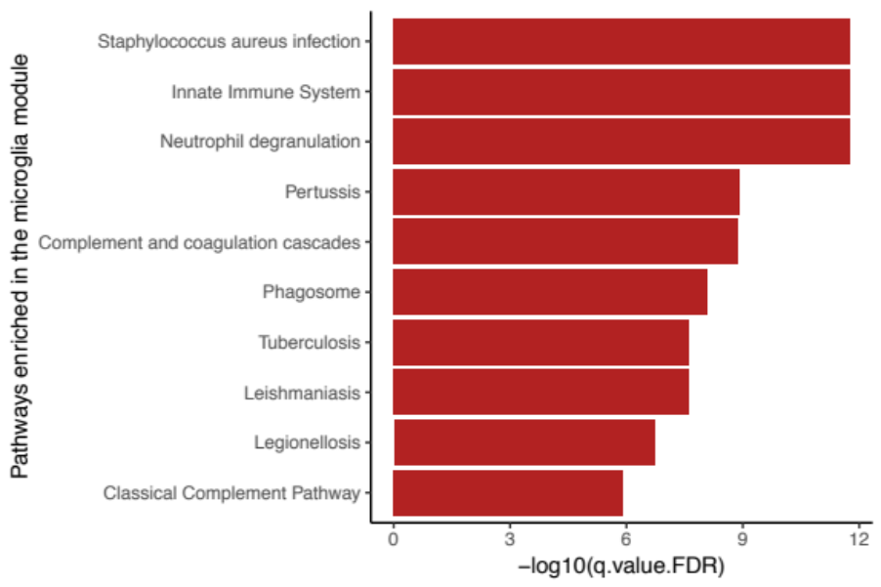
Figure 1. Top 10 enriched pathways of the two microglia modules combined.

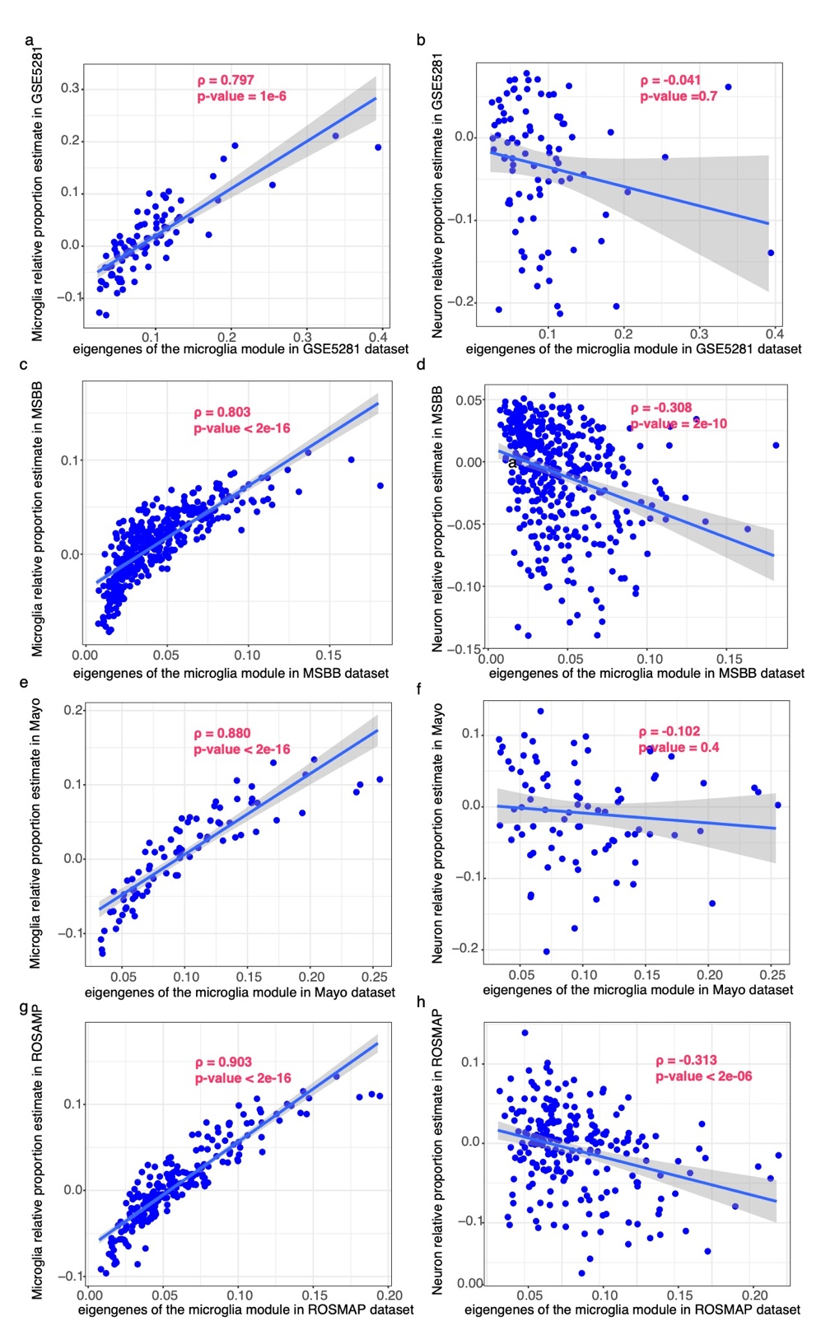
Figure 2. The Pearson correlation of the combined microglia module expression (eigengene values) with the estimated microglia cell proportions vs. with the estimated neuron cell proportions in GSE5281, MSBB, Mayo and ROSMAP datasets. a. Correlation with the estimated microglia cell proportions in GSE5281 dataset. b. Correlation with the estimated neuron cell proportions in GSE5281 dataset (control). c. Correlation with the estimated microglia cell proportions in MSBB dataset. d. Correlation with the estimated neuron cell proportions in MSBB dataset (control). e. Correlation with the estimated microglia cell proportions in Mayo dataset. f. with the estimated neuron cell proportions in Mayo dataset (control). g. Correlation with the estimated microglia cell proportions in ROSMAP dataset. h. Correlation with the estimated neuron cell proportions in ROSMAP dataset (control). Gray area indicates the area between the 95% confidence intervals.

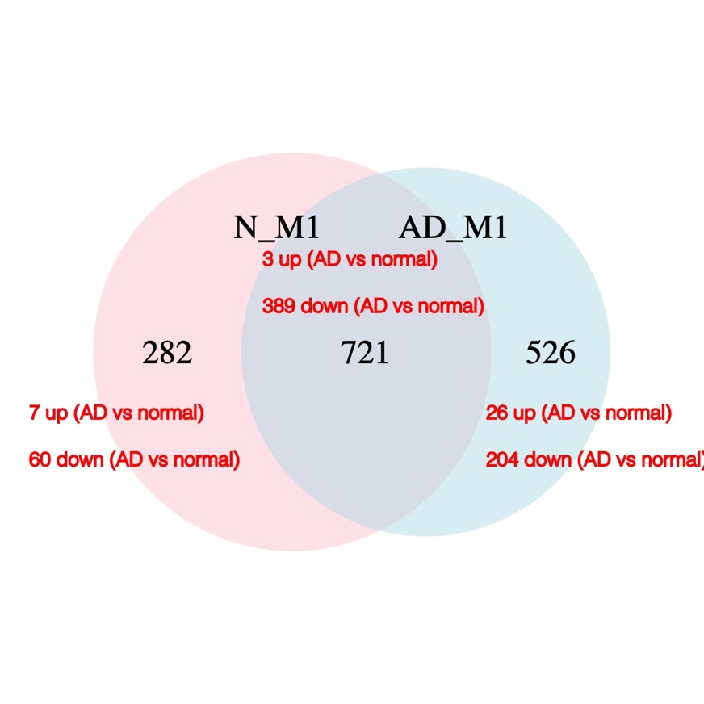
Figure 3. Overlapping of the neuron modules AD1 and N1, and the differentially expressed genes (in at least two datasets) in each compartment (red labels).

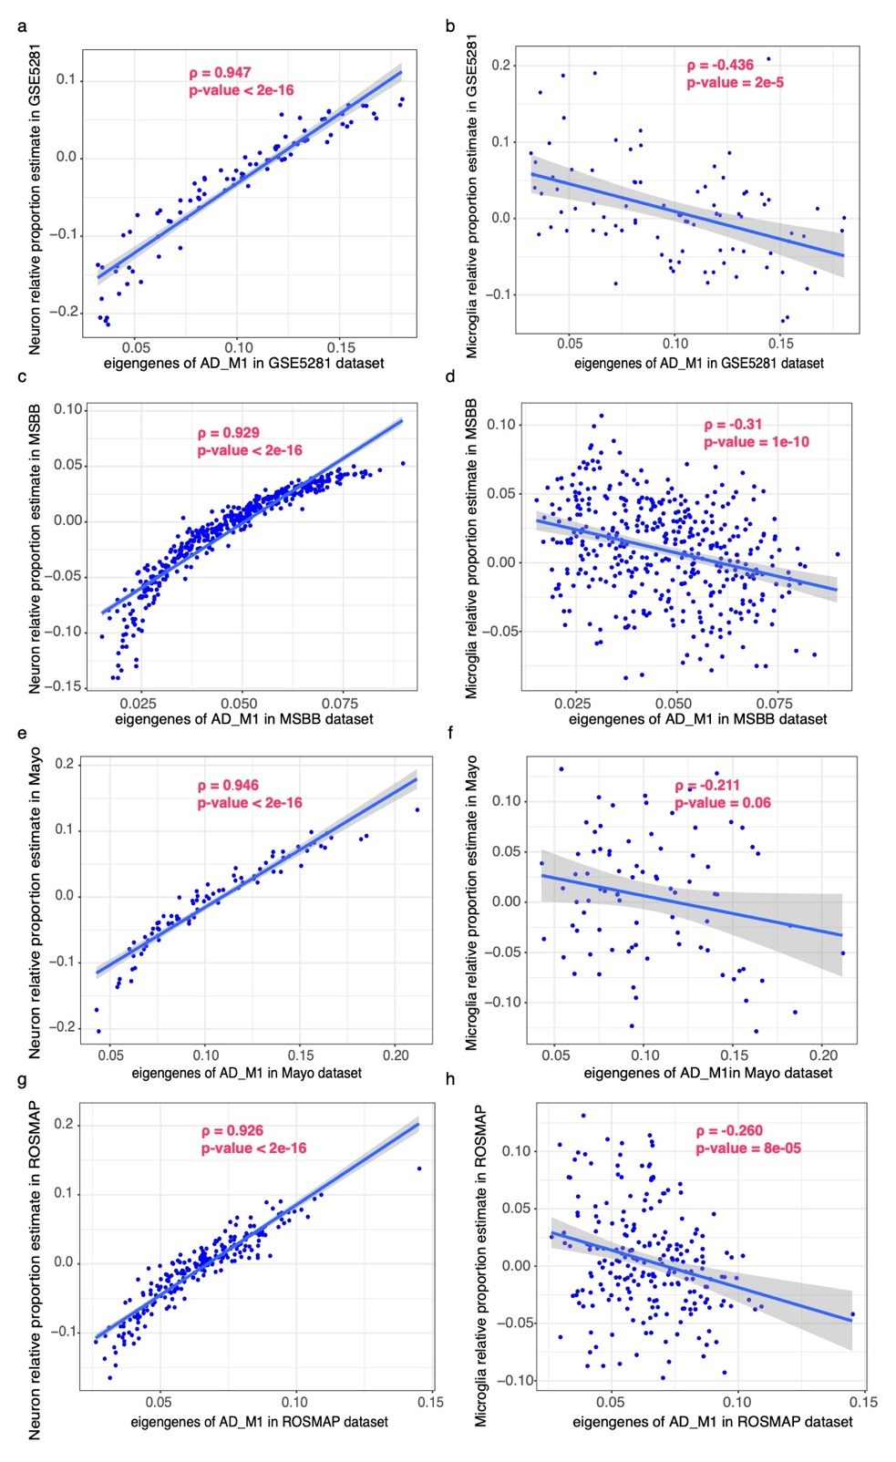
Figure 4. The Pearson correlation of neuron module AD1 expression (eigengene values) with the estimated neuron cell proportions vs. with the estimated microglia cell proportions in GSE5281, MSBB, Mayo and ROSMAP datasets. a. Correlation with the estimated neuron cell proportions in GSE5281 dataset. b. Correlation with the estimated microglia cell proportions in GSE5281 dataset (control). c. Correlation with the estimated neuron cell proportions in MSBB dataset. d. Correlation with the estimated microglia cell proportions in MSBB dataset (control). e. Correlation with the estimated neuron cell proportions in Mayo dataset. f. Correlation with the estimated microglia cell proportions in Mayo dataset (control). g. Correlation with the estimated microglia cell proportions in ROSMAP dataset. h. Correlation with the estimated microglia cell proportions in ROSMAP dataset (control). Gray area indicates the area between the 95% confidence intervals.
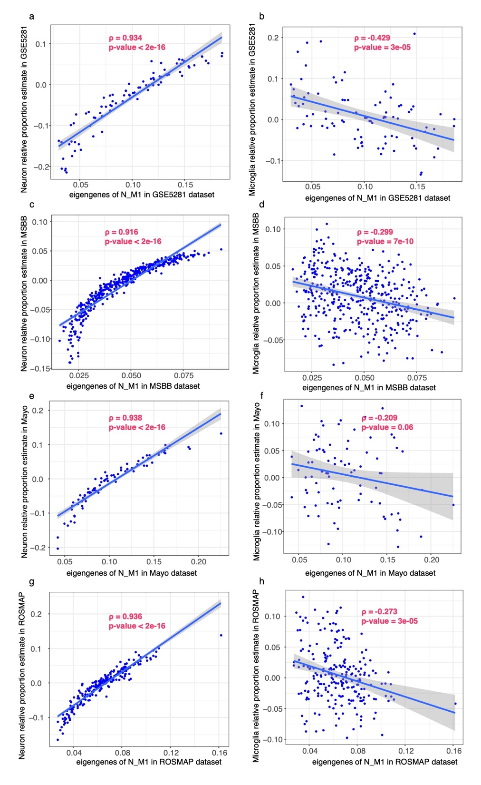
Figure 5. The Pearson correlation of the expression of neuron module N1 with the estimated neuron cell proportions vs. with the estimated microglia cell proportions in GSE5281, MSBB, Mayo and ROSMAP datasets. a. Correlation with the estimated neuron cell proportions in GSE5281 dataset. b. Correlation with the estimated microglia cell proportions in GSE5281 dataset (control). c. Correlation with the estimated neuron cell proportions in MSBB dataset. d. Correlation with the estimated microglia cell proportions in MSBB dataset (control). e. Correlation with the estimated neuron cell proportions in Mayo dataset. f. Correlation with the estimated microglia cell proportions in Mayo dataset (control). g. Correlation with the estimated neuron cell proportions in ROSMAP dataset. h. Correlation with the estimated microglia cell proportions in ROSMAP dataset. Gray area indicates the area between the 95% confidence intervals.

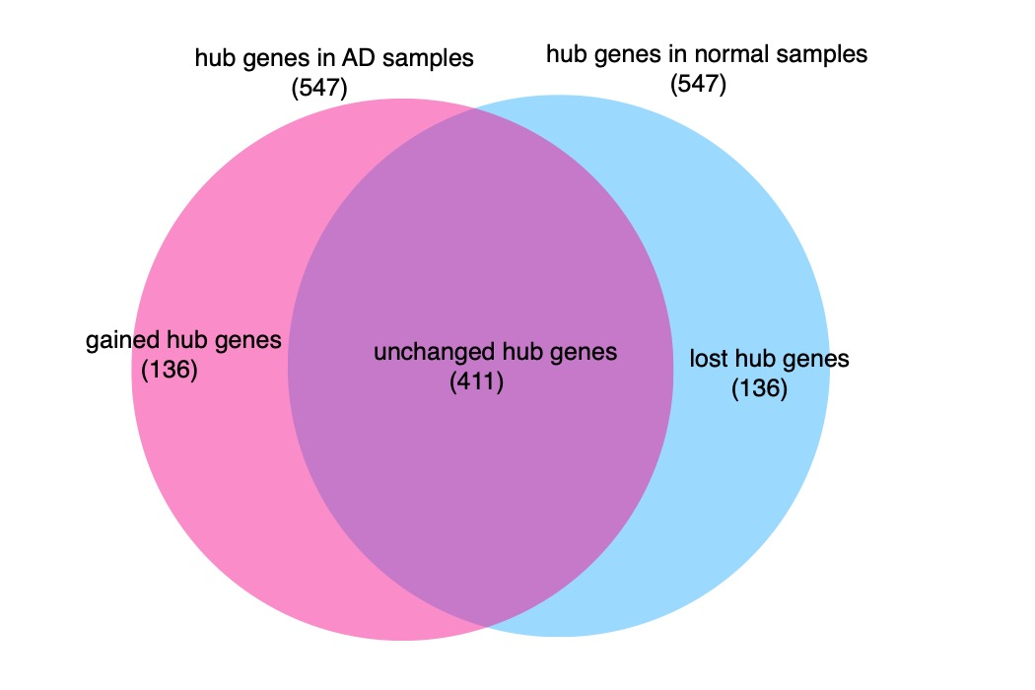
Figure 6. 547 hub genes from the frequent co-expression networks in AD vs. in normal samples (top 5 percentile connections in each group). The pink area denotes the gained hub genes in AD FGC network, the blue area denotes the lost hub genes in AD network but show up in normal network, and the purple area denotes the unchanged hub genes.

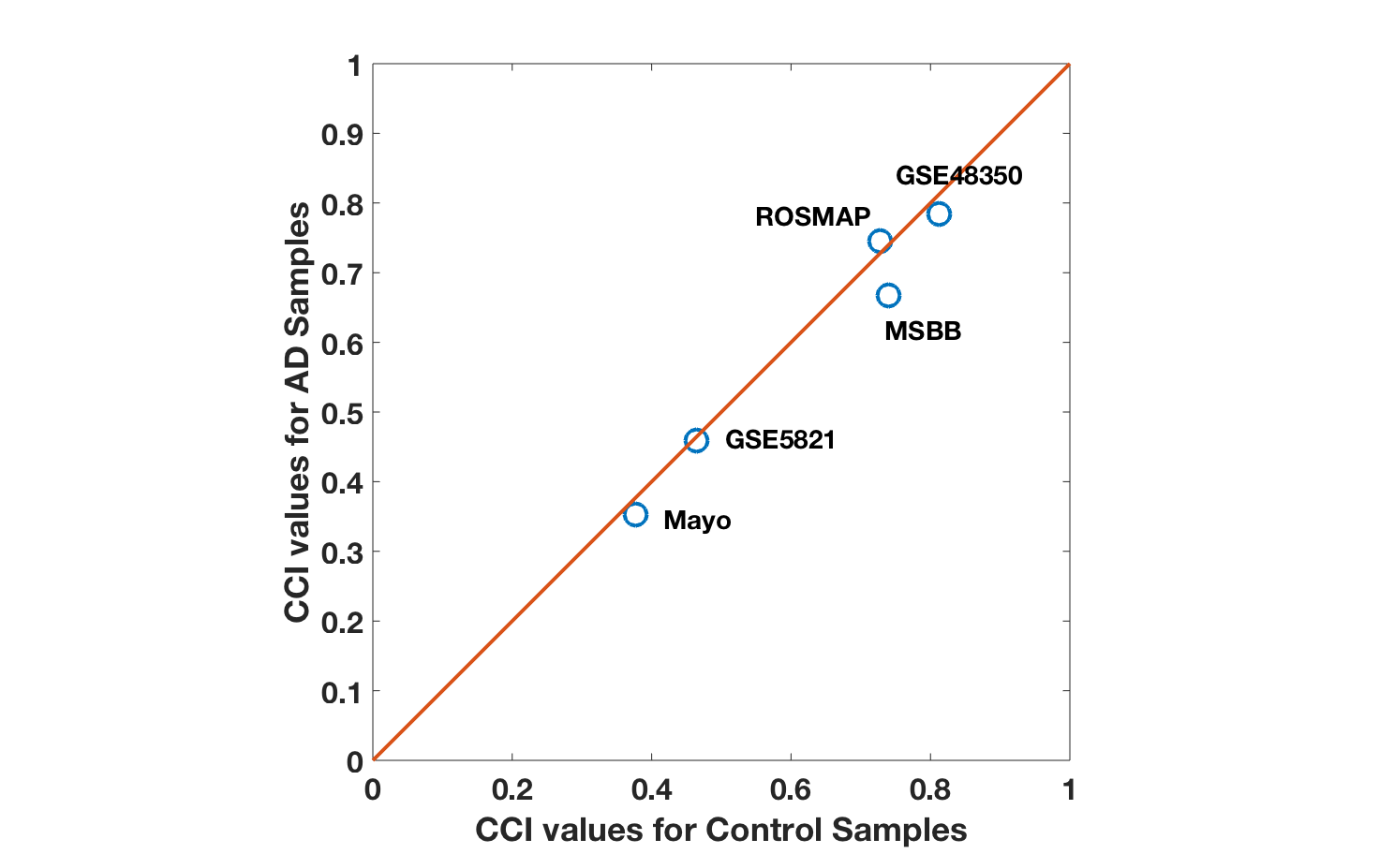

Figure 7 The scatterplot for the overall expression correlation (as measured by CCI) for the eight DAM genes from AD3/N6 microglia module across the five datasets. The alignment to the diagonal line indicates relatively unchanged correlation for this subset of genes.

Supplementary Table legends
Table 1. FGCN module genes from AD/Normal brain samples and the overlap (Jaccard index) between each pair of AD and normal FGCN modules. (sup-Table1.xlsx)
Table 2. DE and DC score summary for all AD/Normal FGCN modules. (sup-Table2.xlsx)
Table 3. Top 10 enriched GO/pathway terms of each AD/normal FGCN module. (sup-Table3.xlsx)
Table 4-5. Frequently down/up expressed genes (in at least two datasets) between AD and normal samples, merged for all five datasets. (sup-Table4-5.xlsx)
Table 6. Enrichment of gene markers in five major cell types in all AD/normal FGCN modules. (sup-Table6.xlsx)
Table 7. Enriched pathway/GO terms for overlapping genes of AD1 and N1. (sup-Table7-9.xlsx)
Table 8. Enriched pathway/GO terms in genes uniquely to AD1. (sup-Table7-9.xlsx)
Table 9. Enriched pathway/GO terms in genes uniquely to N1. (sup-Table7-9.xlsx)
Table 10. Enriched transcription factors and their targets for each FGCN modules. (sup-Table10.xlsx)
Table 11. Correlation of FGCN module eigengene with clinicopathological measurements in MSBB dataset. (sup-Table11.xlsx)
Table 12. Transcription factor BCL6/STAT3 targeted genes in AD_M1 and N_M1(sup-Table 12.xlsx).
Table 13. The overlap of AD3/N6 microglia module with two previously identified disease associated microglia modules (sup-Table13.xlsx).

