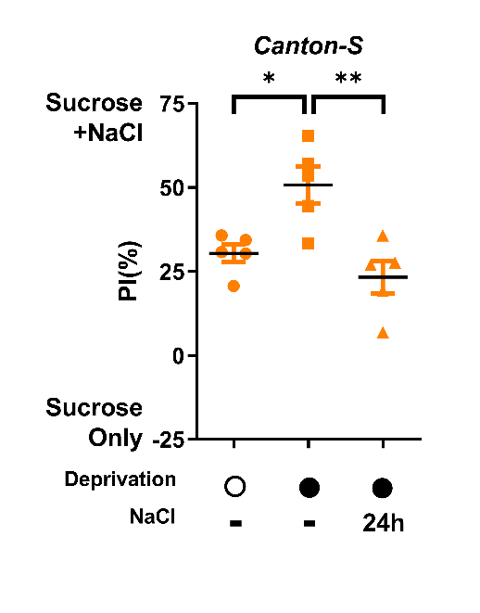

Extended Data Figure 1. Salt-deprived Canton-S (CS) flies display taste-independent preference for sodium.
Behavioral responses of 72-hour deprived control CS flies that had been fed 10mM NaCl for 24 hours prior to the two-choice task. **p<0.01, *p<0.05: one-way ANOVA with Tukey’s post-hoc test

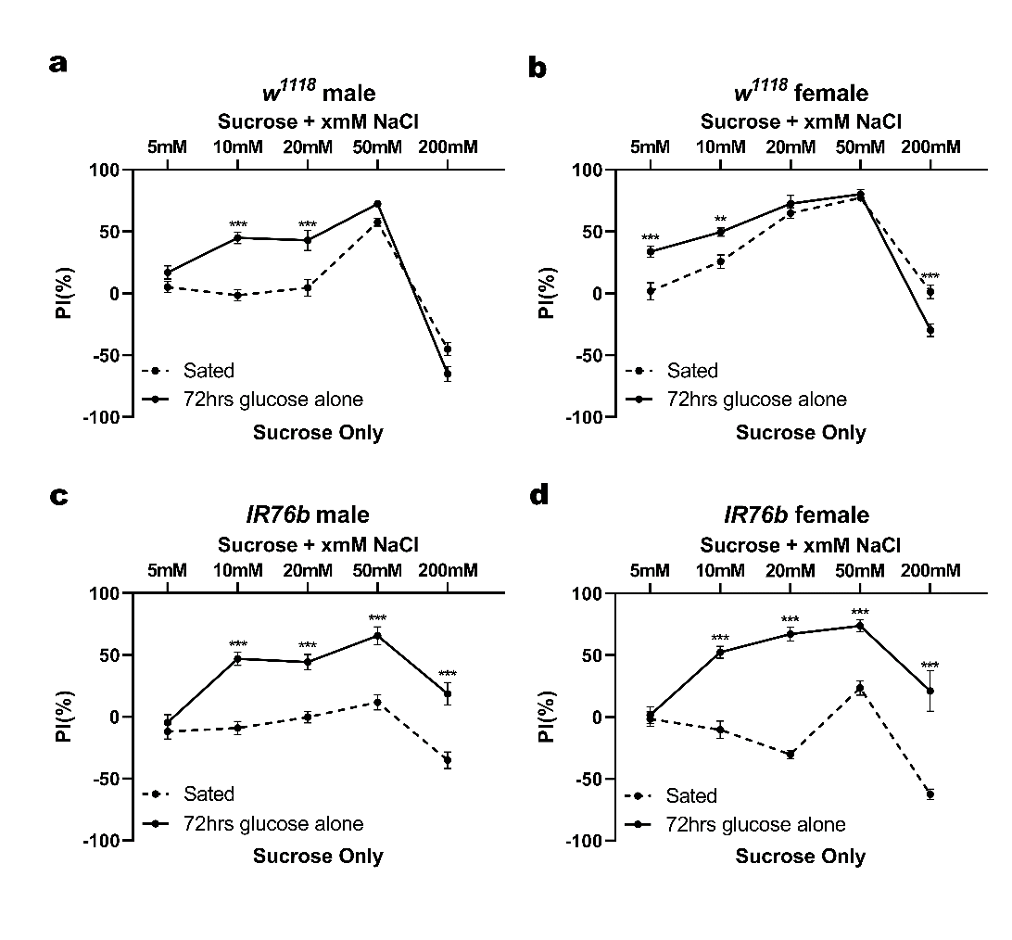

Extended Data Figure 2. Two-choice behavioral responses to various concentrations of NaCl in control, IR76b mutant male and female flies after 72 hours of salt deprivation.
a-d. Behavioral responses of control w¹¹¹⁸ male (a), female (c) flies and IR76b mutant male (b), female (d) flies in the two-choice assay after 72 hours of salt deprivation. Deprived and sated flies were given a choice between 20mM sucrose and 20mM sucrose with different NaCl concentrations (5mM, 10mM, 20mM, 50mM, 200mM).
All graphs in figure showed mean ± s.e.m. ***p<0.001, **p<0.01: two-way ANOVA with Bonferroni’s multiple comparisons test.

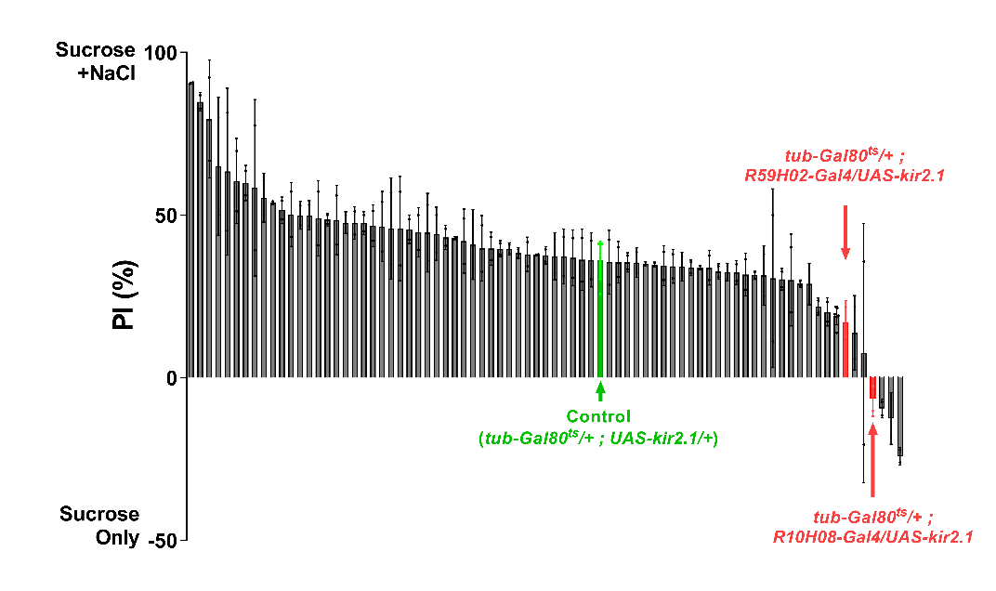

Extended Data Figure 3. A screen to identify cells that are required for the deprivation-induced NaCl preference
The result of a screen using Janelia GAL4 lines crossed with tub-GAL80^{ts}, UAS-kir2.1 for defects in the deprivation-induced preference for NaCl (10mM) after 72hours of salt deprivation.

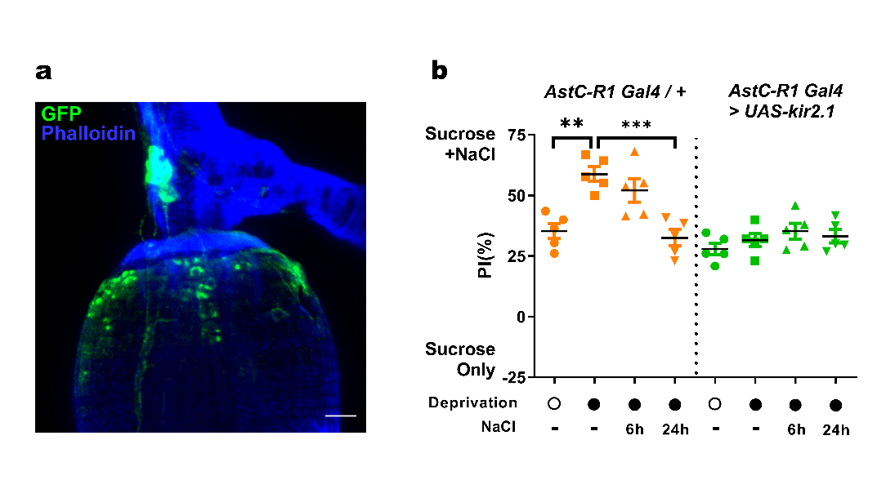

Extended Data Figure 4. Expression and function of AstC-R1+ enteric neuron on the proventriculus
- A confocal image of anterior enteric neurons (green) labeled by AstC-R1-GAL4 crossed to UAS-CD8::GFP, and counterstained with phalloidin (blue). Scale bars, 20μm
- Behavioral responses of AstC-R1-GAL4 crossed to tub-GAL80^{ts}, UAS-kir2.1 for inactivation of the anterior enteric neurons that were sated, 72-hour deprived, or refed with 10mM NaCl for 6 and 24 hours prior to the two-choice assay. ***p<0.001, **p<0.01: one-way ANOVA with Tukey’s post-hoc test.

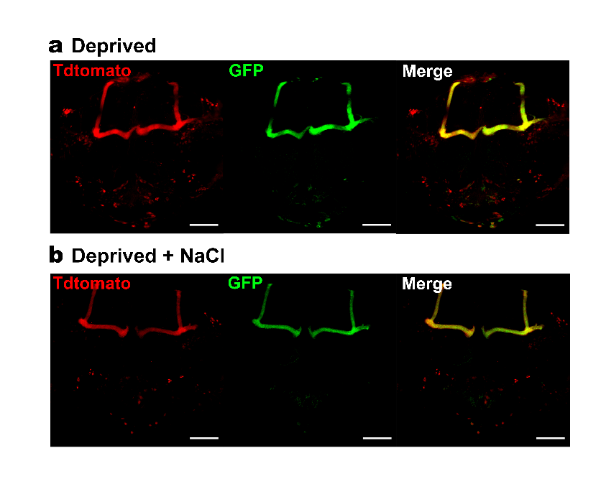

Extended Data Figure 5. AstC-R1+ brain neurons were not stimulated by NaCl ingestion
a-b. Representative images of AstC-R1+ neurons in the brains of flies carrying AstC-R1-GAL4, UAS-tdtomato and UAS-CaLexA that were deprived (a) and re-sated by 50mM NaCl intake b. Native tdtomato (red) and GFP (green) fluorescence signals were visualized. Scale bars, 50μm

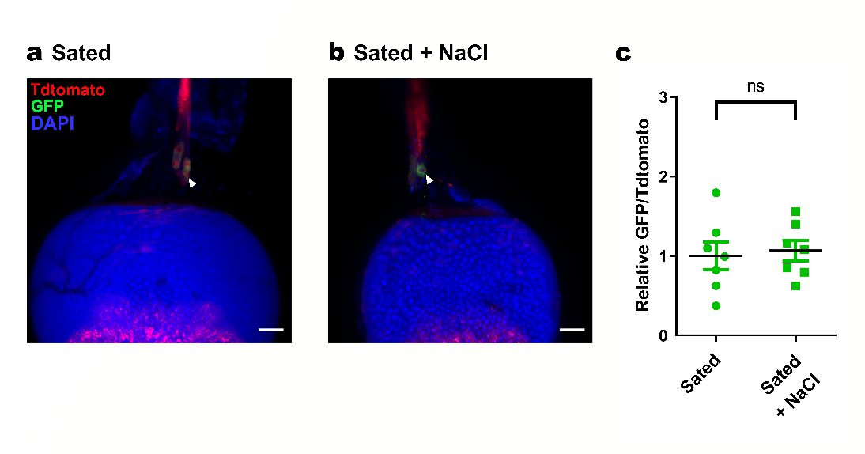

Extended Data Figure 6. Response of INSO neurons to sodium in sated flies.
a-c. Representative images of INSO neurons of flies carrying AstC-R1-Gal4, UAS-tdtomato and UAS-CaLexA, that had been fed normal fly food (a), fed normal food that was further added 50mM NaCl (b), the quantification (c) of CaLexA-derived native GFP fluorescence signals from INSO neurons. Native tdtomato (red) and GFP (green) fluorescence, counterstained with DAPI (blue) were shown. Scale bars, 20μm. ns: unpaired two-tailed t-test.

