Supplementary Information

Supplementary Table 1. Calculation of sugar puckering for each nucleotide at the catalytic core of the 8–17 DNA enzyme (DNAzyme).
Calculations were conducted based on the X-ray crystal structure (PDB ID: 5XM83¹). Five nucleotides (G2/G6/G9/C10/T11) with the North/East type conformation were selected, and were confirmed using the pseudorotation phase angle (P) value and puckering amplitude (ν_{max}) for each, as shown here. Relative activities were calculated based on Fig. 1d, and the activity of the unmodified 8–17 DNAzyme (Dz1) was set as 1.0. For locked nucleic acid (LNA) and 2′-O-methyl (2′-OMe) sugar puckering calculation, one representative was selected from the X-ray structure (PDB ID: 1HHW²: LNA-RNA hybrid; PDB ID: 1I7J³: dsRNA of 2′-OMe)
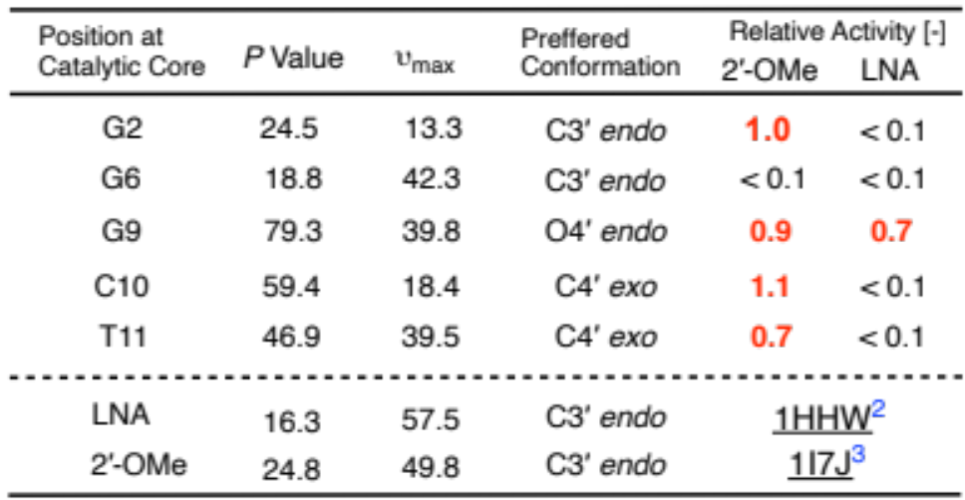

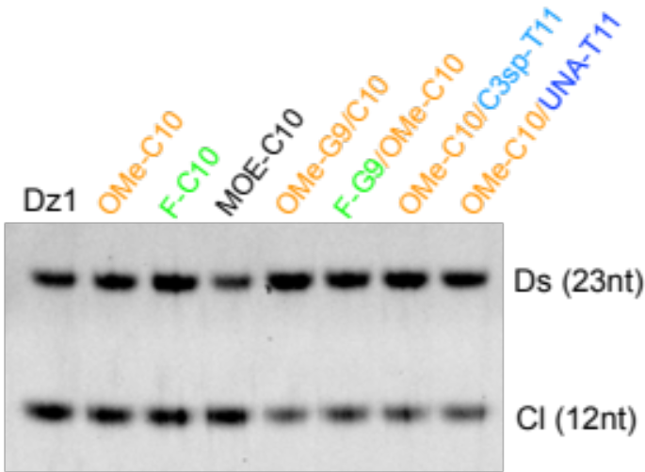
Supplementary Fig. 1. The differences between the 2′-modifications and the two-point modifications in the catalytic core.
The modifications at C10, using 2′-fluoro (F-C10) and 2′-O-methoxyethoxy (MOE-C10), exhibited the same activity as OMe-C10. In the case of two-point modifications (lane 5–8), the cleavage activity was retained but it decreased slightly from that of Dz1. Cleavage reaction conditions: 0.01 μM DNAzyme, 0.1 μM DNA substrate in 100 mM HEPES buffer (pH 7.3) with 0.25 mM Pb(OAc)₂, 400 mM KCl and 100 mM of NaCl. The solution was incubated for 10 min at 37 ℃.

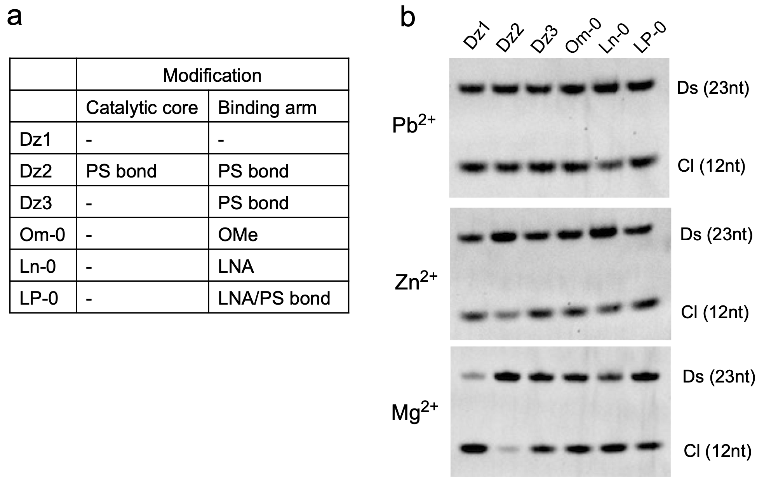
Supplementary Fig. 2. Effect of phosphorothioate (PS) and LNA/ 2′-OMe modifications in the binding arm of Dz1.
a) Modification pattern of assessed samples. Detailed sequences were summarized in Supplementary Table 2. b) Cleavage activity in the presence of divalent metal ions (Pb²⁺/Zn²⁺/Mg²⁺). A PS backbone for all nucleotides including the catalytic core (Dz2) decreased the activity under Zn²⁺ and Mg²⁺ conditions; however, a PS backbone only at the binding arm (Dz3) was tolerated, including further modified species, like those with LNA and PS modifications (LP-0). We chose LNA/PS as the modification pattern in the binding arm because of their expected high stability against nucleases, and PS modification at the catalytic core was not used for further investigations. The cleavage assay was conducted under the same conditions as those mentioned in Supplementary Fig. 1, except for divalent ion concentration and incubation time (Pb²⁺: 0.25 mM Pb(OAc)₂, 10 min; Zn²⁺: 2.5 mM ZnCl₂, 20 min; Mg²⁺: 2.5 mM MgCl₂, 60 min).

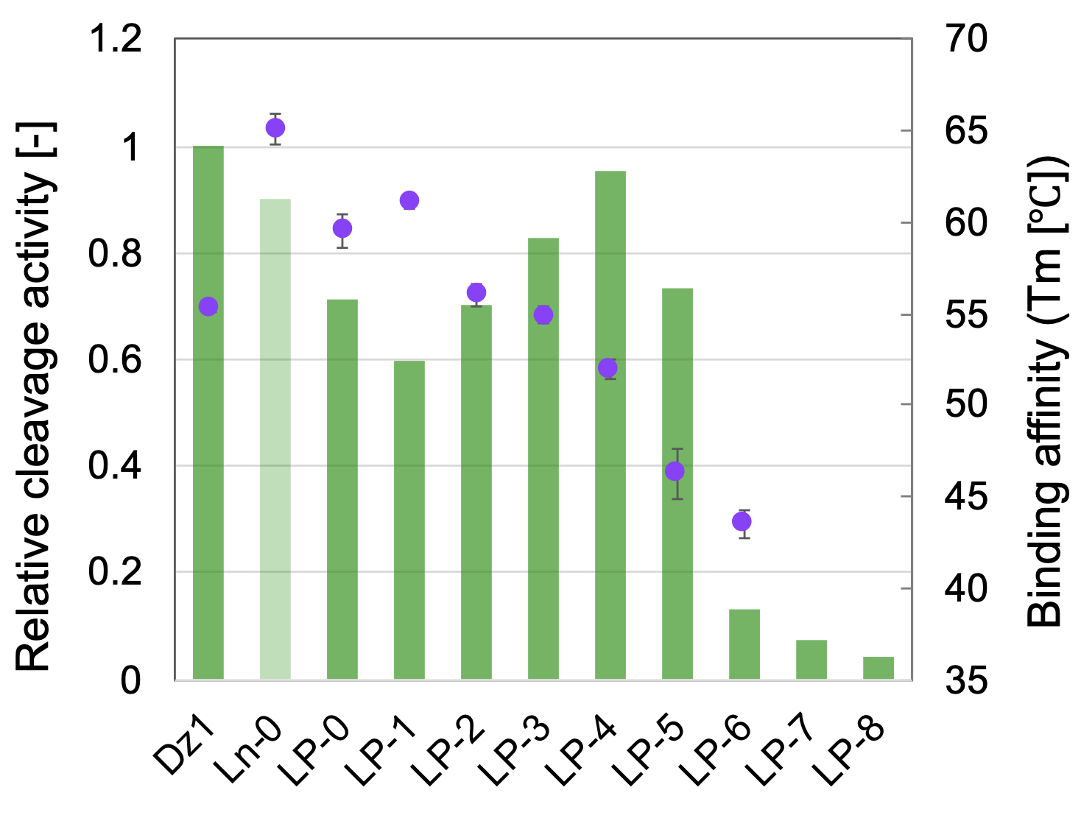
Supplementary Fig. 3. The connection between cleavage activity and binding affinity in case of the RNA substrates.
Effect of the modification and the length on the cleavage activity is shown for RNA substrates (green bar), and binding affinities (T_{m} values) were shown in purple circle. In the case of LNA modifications without PS (Ln-0), the cleavage activity was just a reference value because of its insufficient dissociation of duplexes. Cleavage reaction conditions: 0.025 μM DNAzyme, 0.1 μM RNA substrate in 100 mM HEPES buffer (pH 7.3) with 2.5 mM MgCl₂, 400 mM KCl and 100 mM of NaCl. The solution was incubated for 60 min at 37 ℃.

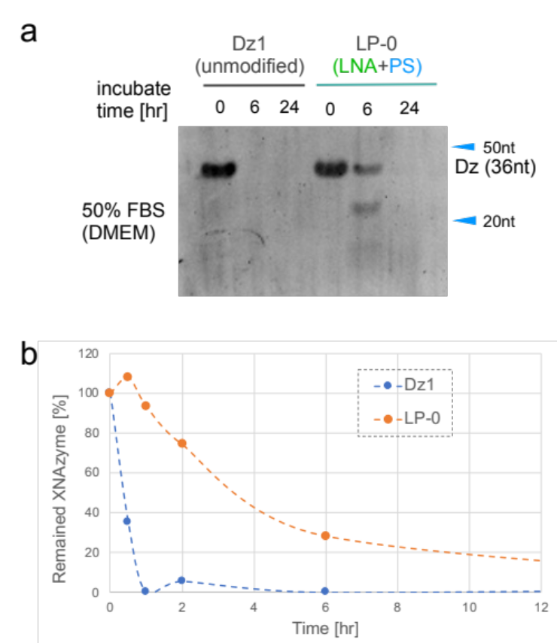
Supplementary Fig. 4. Expansion study of biostability in FBS.
a) The result of the biostability assays for Dz1 and LP-0. Incubation time was prolonged to 6 h or 24 h in 50% FBS and DMEM solution at 37 ℃. The samples were analyzed using urea-PAGE, followed by SYBR gold staining. b) The summary of time-dependent biostability in 50% PBS. The ratio of the remaining Dz1 and LP-0 was plotted. The data were combined with that of Fig. 2e and Supplementary Fig. 4a. Dz1 had decomposed completely in 1 h, whereas 30% of the LP-0 was remaining after 6 h.

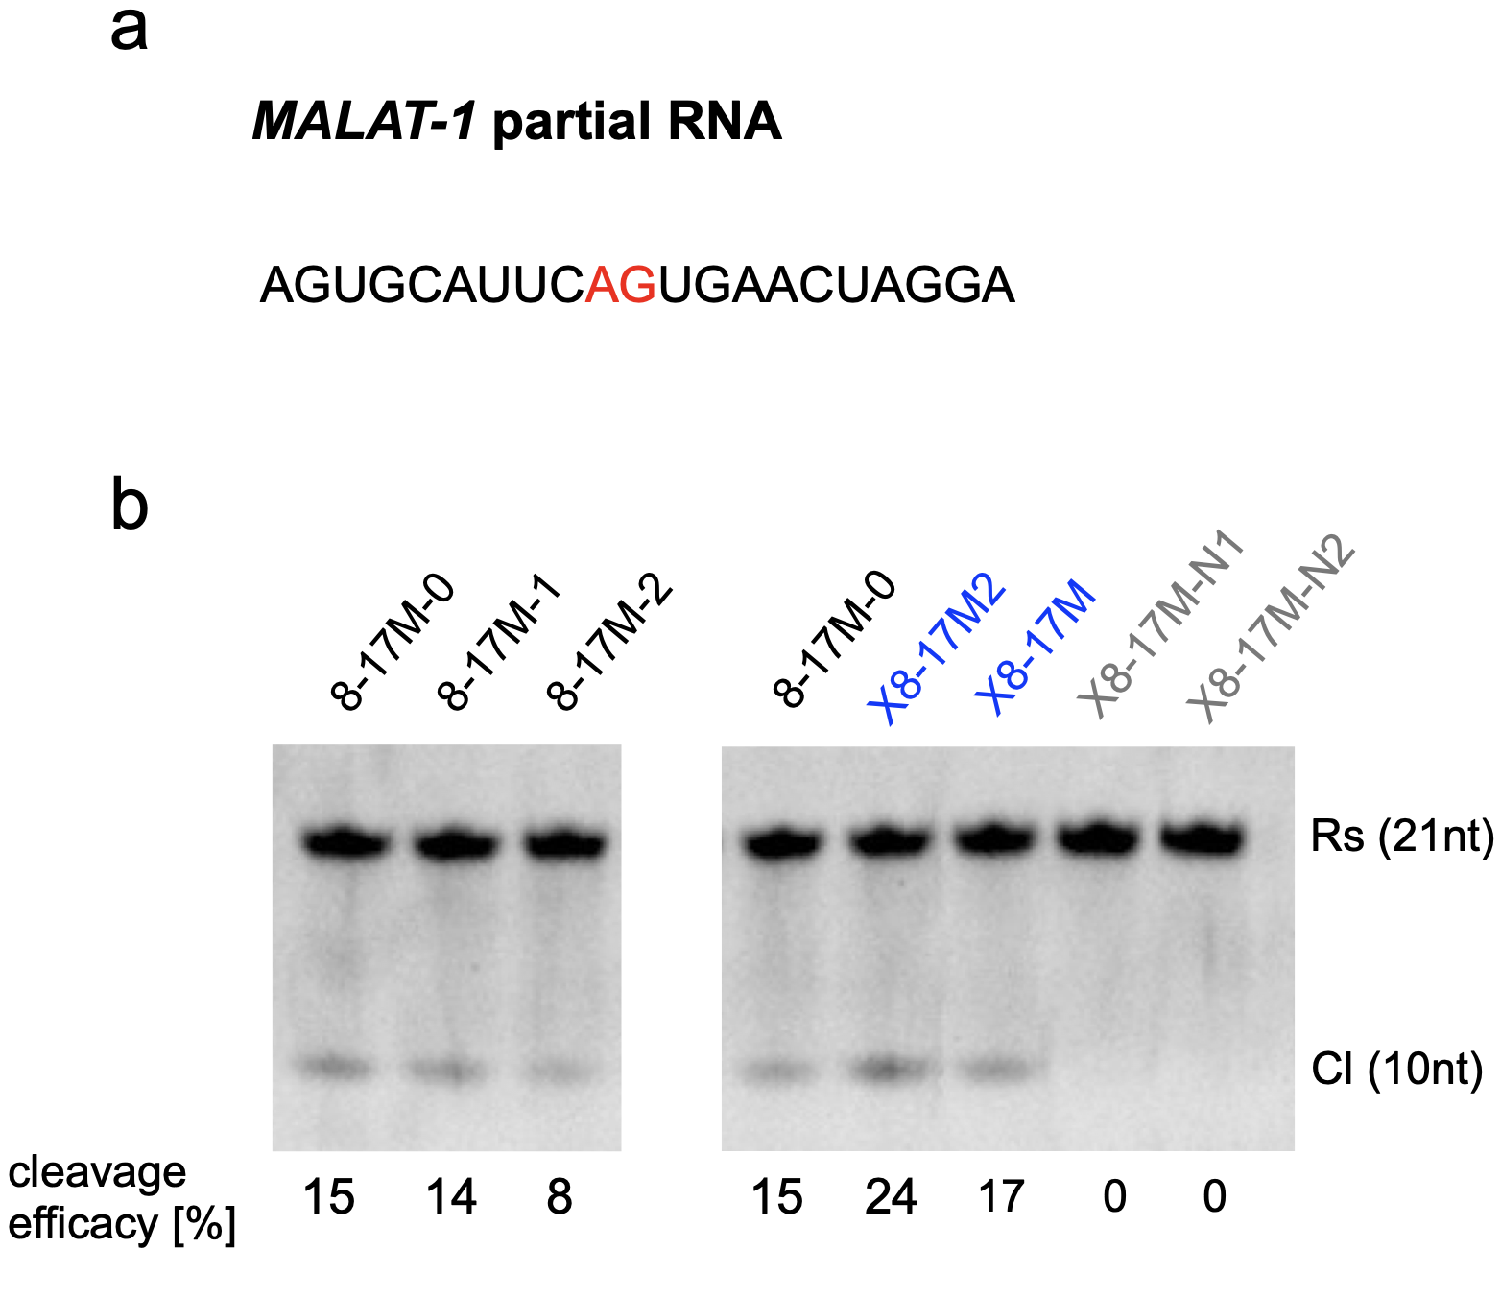
Supplementary Fig. 5. MALAT-1 cleavage assay using urea-PAGE.
a) MALAT-1 partial sequence was used for the assay (21 nucleotides). Fluorescein isothiocyanate (FITC) was conjugated to its 5′ end. Cleavage site is indicated in red. b) The result of the cleavage assay. The binding arm was modified with LNA and PS bonds, and its length shortened gradually from both ends (8–17M-0, 8–17M-1, 8–17M-2, sequences were shown in Supplementary Table 2). As a result, the length of 8–17M-0 was considered the most suitable for our design (left gel image, lane 1). We next modified OMe-C10 in the catalytic core (X8–17M2), and the design of the binding arm was changed (X8–17M, LNA and 2′-OMe was used). Both designs worked well for this sequence as well (right gel image lane 2, 3). Moreover, negative controls (X8–17M-N1, X8–17M-N2) did not show the cleavage activity. In other words, they have no DNAzyme-mediated cleavage activity. The cleavage assay was conducted under the same conditions as those mentioned in Supplementary Fig. 3.

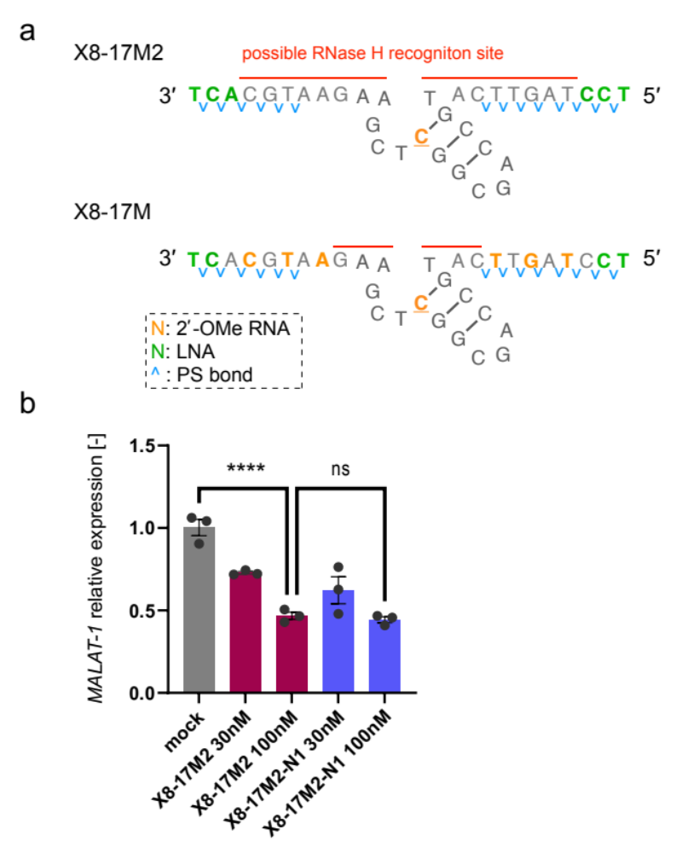
Supplementary Fig. 6. MALAT-1 knockdown assay of X8–17.
a) The binding arm of X8–17 was designed similar to the gapmer structure of ASOs (X8–17M2). As a reference, X8-17M used in Fig. 4 is also shown. X8-17M2 has enough length to recruit RNase H (red bar). b) The result of the knockdown assay using Hepa1c1c cells was the same as that in Fig. 4e. X8-17M2 and its negative control (X8-17M2-N1) showed comparable knockdown activity, which indicated that mainly RNase H-mediated knockdown (antisense effect) was observed. The results of the experiment were analyzed using a one-way analysis of variance and Dunnett′s test (ns, not significant, **** P<0.0001).

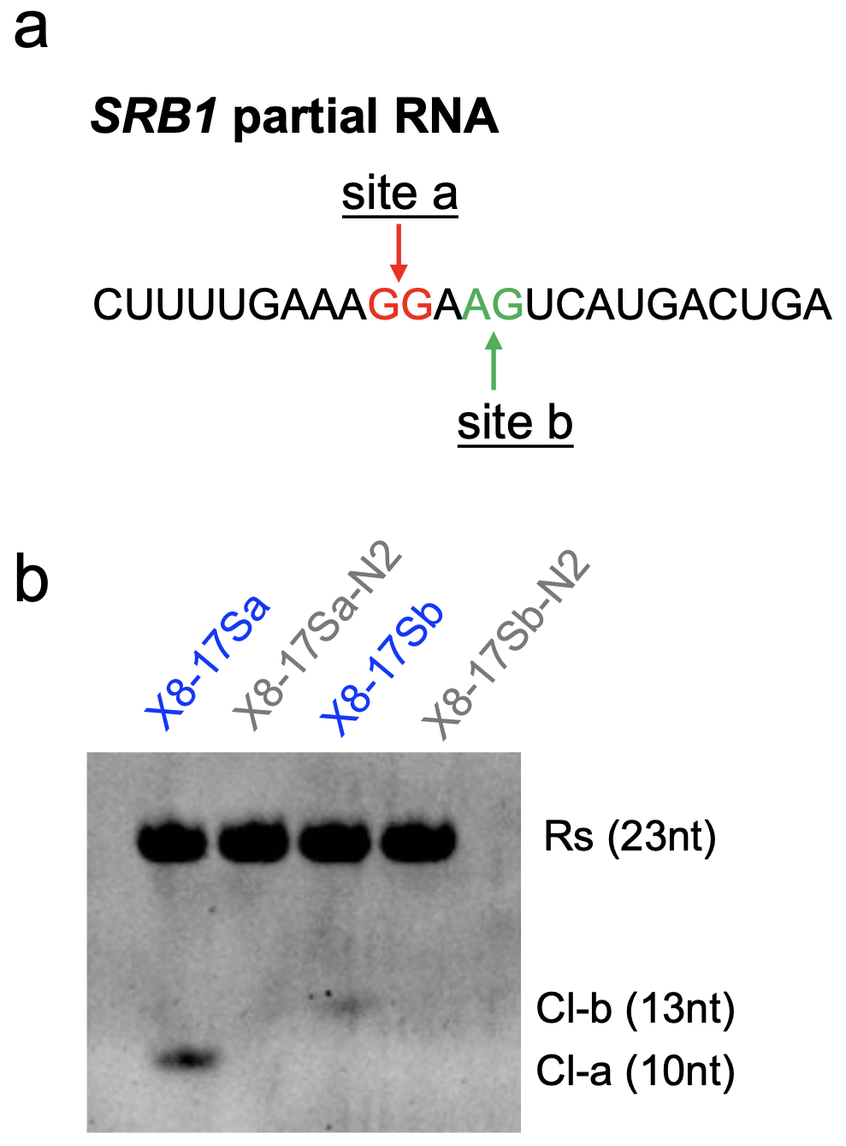
Supplementary Fig. 7. SRB1 cleavage assay analyzed using urea-PAGE.
a) SRB1 partial sequence (24 nucleotides) used for the assay is shown. FITC was conjugated to its 5′ end. Cleavage sites are shown in red and green. b) X8–17 cleavage assay results. X8–17Sa and X8–17Sb can cleave the substrate because the cleaved Cl-a and Cl-b were observed as expected. In the case of the negative controls (X8–17Sa-N2 and X8–17Sb-N2), cleaved products were not observed. The cleavage assay was conducted under the same condition as those mentioned in Supplementary Fig. 3.

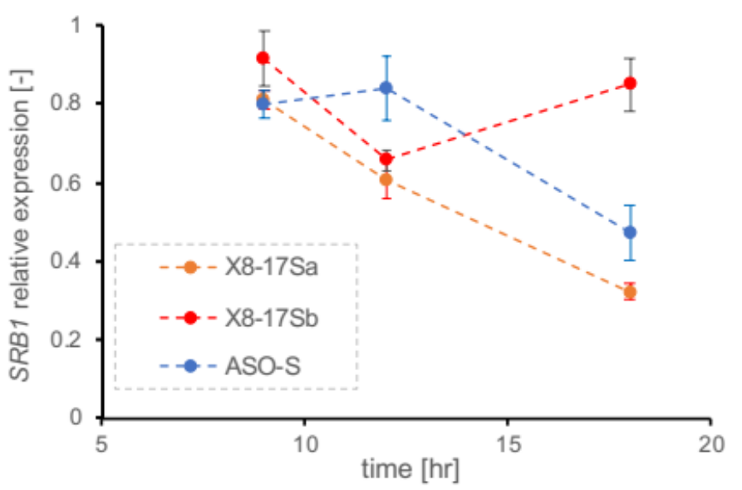
Supplementary Fig. 8. Time-dependent knockdown of SRB1 RNA in Hepa1c1c7 cells.
The relative expression of SRB1 was calculated via the ΔΔCt method with GAPDH as a housekeeping gene. X8–17s for SRB1 (X8–17Sa and X8–17Sb) and ASO targeting SRB1 (ASO-S) were assessed for their knockdown activity depending on the incubation time after transfection. The results for ASO-S (10 nM) and X8–17Sa and X8–17Sb (100 nM) are shown.

Supplementary Table 2. All DNAzymes and substrates (oligonucleotides) used in this study
Oligonucleotide Name | Sequence (5′–3′)
Numbering | tgtaacgcac–tgc-cag-cgg-ctc-gaa–atctctctcgt  1-3  4-6  10-12  7-9  13-15
Dz1 | tgtaacgcac–tgccagcggctcgaa–atctctctcgt
Dz2 | t^g^t^a^a^c^g^c^a^c^t^g^c^c^a^g^c^g^g^c^t^c^g^a^a^a^t^c^t^c^t^c^t^c^g^t
Dz3 | t^g^t^a^a^c^g^c^ac–tgccagcggctcgaa–at^c^t^c^t^c^t^c^g^t
DNA substrate (Ds) | (5′-FITC) acgagagagatGggtgcgttaca
RNA substrate  (Rs) | (5′-FITC) ACGAGAGAGAUGGGUGCGUUACA
DNA substrate for Tm assay | acgagagagatgggtgcgttaca
RNA substrate for Tm assay | ACGAGAGAGAUgGGUGCGUUACA
Catalytic Core Modification
OMe-G2 | tgtaacgcac–tG^{M}c-cag-cgg-ctc-gaa–atctctctcgt
OMe-G6 | tgtaacgcac–tgc-caG^{M}-cgg-ctc-gaa–atctctctcgt
OMe-G9 | tgtaacgcac–tgc-cag-cgG^{M}-ctc-gaa–atctctctcgt
OMe-C10 | tgtaacgcac–tgc-cag-cgg-C^{M}tc-gaa–atctctctcgt
OMe-T11 | tgtaacgcac–tgc-cag-cgg-cT^{M}c-gaa–atctctctcgt
LNA-G2 | tgtaacgcac–tG^{L}c-cag-cgg-ctc-gaa–atctctctcgt
LNA-G6 | tgtaacgcac–tgc-caG^{L}-cgg-ctc-gaa–atctctctcgt
LNA-G9 | tgtaacgcac–tgc-cag-cgG^{L}-ctc-gaa–atctctctcgt
LNA-C10 | tgtaacgcac–tgc-cag-cgg-5^{L}tc-gaa–atctctctcgt
LNA-T11 | tgtaacgcac–tgc-cag-cgg-cT^{L}c-gaa–atctctctcgt
UNA-C7 | tgtaacgcac–tgc-cag-C^{U}gg-ctc-gaa–atctctctcgt
UNA-T11 | tgtaacgcac–tgc-cag-cgg-cT^{U}c-gaa–atctctctcgt
C3sp-C7 | tgtaacgcac–tgc-cag-(sp)gg-ctc-gaa–atctctctcgt
C3sp-T11 | tgtaacgcac–tgc-cag-cgg-c(sp)c-gaa–atctctctcgt
F-C10 | tgtaacgcac–tgc-cag-cgg-C^{F}tc-gaa–atctctctcgt
MOE-C10 | tgtaacgcac–tgc-cag-cgg-5^{m}tc-gaa–atctctctcgt
OMe-G9/C10 | tgtaacgcac–tgc-cag-cgG^{M}-C^{M}tc-gaa–atctctctcgt
F-G9/OMe-C10 | tgtaacgcac–tgc-cag-cgG^{F}-C^{M}tc-gaa–atctctctcgt
OMe-C10/UNA-T11 | tgtaacgcac–tgc-cag-cgg-C^{M}T^{U}c-gaa–atctctctcgt
OMe-C10/C3sp-T11 | tgtaacgcac–tgc-cag-cgg-C^{M}(sp)c-gaa–atctctctcgt
Binding Arm Modification
Ln-0 | T^{L}G^{L}T^{L}aacgcac–tgccagcggctcgaa–atctctct5^{L}G^{L}T^{L}
LP-0 | T^{L}^G^{L}^T^{L}^a^a^c^g^c^ac–tgccagcggctcgaa–at^c^t^c^t^c^t^5^{L}^G^{L}^T^{L}
LP-1 | G^{L}^T^{L}^A^{L}^a^c^g^c^ac–tgccagcggctcgaa–at^c^t^c^t^c^T^{L}^5^{L}^G^{L}
LP-2 | T^{L}^A^{L}^A^{L}^c^g^c^ac–tgccagcggctcgaa–at^c^t^c^t^5^{L}^T^{L}^5^{L}
LP-3 | A^{L}^A^{L}^5^{L}^g^c^ac–tgccagcggctcgaa–at^c^t^c^T^{L}^5^{L}^T^{L}
LP-4 | A^{L}^5^{L}^G^{L}^c^ac–tgccagcggctcgaa–at^c^t^5^{L}^T^{L}^5^{L}
LP-5 | 5^{L}^G^{L}^5^{L}^ac–tgccagcggctcgaa–at^c^T^{L}^5^{L}^T^{L}
LP-6 | G^{L}^5^{L}^A^{L}c–tgccagcggctcgaa–at^5^{L}^T^{L}^5^{L}
LP-7 | 5^{L}^A^{L}5^{L}–tgccagcggctcgaa–aT^{L}^5^{L}^T^{L}
LP-8 | A^{L}5^{L}–T^{L}gccagcggctcgaa– A^{L}T^{L}^5^{L}
Om-0 | T^{M}G^{M}T^{M}aacgcac–tgccagcggctcgaa–atctctctC^{M}G^{M}T^{M}
mouse MALAT-1 targeting DNAzyme
X8-17M | T^{L}^5^{L}^c^T^{M}^a^G^{M}^t^T^{M}^catgccagcggC^{M}tcgaagA^{M}a^T^{M}^g^C^{M}^a^5^{L}^T^{L}
X8-17M-N1 | T^{L}^5^{L}^c^T^{M}^a^G^{M}^t^T^{M}^caaagctcggcgaccgtgA^{M}a^T^{M}^g^C^{M}^a^5^{L}^T^{L}
X8-17M-N2 | T^{L}^5^{L}^c^T^{M}^a^G^{M}^t^T^{M}^catgccaacggC^{M}ttgaagA^{M}a^T^{M}^g^C^{M}^a^5^{L}^T^{L}
X8-17M2 | T^{L}^5^{L}^5^{L}^t^a^g^t^t^catgccagcggC^{M}tcgaagaa^t^g^c^A^{L}^5^{L}^T^{L}
X8-17M2-N1 | T^{L}^5^{L}^5^{L}^t^a^g^t^t^caaagctcggcgaccgtgaa^t^g^c^A^{L}^5^{L}^T^{L}
8-17M-0 | T^{L}^5^{L}^5^{L}^t^a^g^t^t^catgccagcggctcgaagaa^t^g^c^A^{L}^5^{L}^T^{L}
8-17M-1 | 5^{L}^5^{L}^T^{L}^a^g^t^t^catgccagcggctcgaagaa^t^g^5^{L}^A^{L}^5^{L}
8-17M-2 | 5^{L}^T^{L}^A^{L}^g^t^t^catgccagcggctcgaagaa^t^G^{L}^5^{L}^A^{L}
ASO-M | 5^{L}^T^{L}^A^{L}^g^t^t^c^a^c^t^g^a^a^T^{L}^G^{L}^5^{L}
RNA substrate (Rs-M) | (5′-FITC) AGUGCAUUCAGUGAACUAGGA
mouse SRB1 targeting DNAzyme
X8-17Sa | G^{L}^T^{L}^c^A^{M}^t^G^{M}^a^C^{M}^tttgccagcggC^{M}tcgaatT^{M}t^C^{M}^a^A^{M}^a^A^{L}^G^{L}
X8-17Sa-N2 | G^{L}^T^{L}^c^A^{M}^t^G^{M}^a^C^{M}^tttgccaacggC^{M}ttgaatT^{M}t^C^{M}^a^A^{M}^a^A^{L}^G^{L}
X8-17Sb | T^{L}^5^{L}^a^G^{M}^t^C^{M}^a^T^{M}^gatgccagcggC^{M}tcgaatC^{M}c^T^{M}^t^T^{M}^c^A^{L}^A^{L}
X8-17Sb-N2 | T^{L}^5^{L}^a^G^{M}^t^C^{M}^a^T^{M}^gatgccaacggC^{M}ttgaatC^{M}c^T^{M}^t^T^{M}^c^A^{L}^A^{L}
ASO-S | G^{m}^5^{m}^T^{m}^T^{m}^5^{m}^a^g^t^5^a^t^g^a^5^t^T^{m}^5^{m}^5^{m}^T^{m}^T^{m}
RNA substrate (Rs-S) | (5′-FITC) CTTTTGAAAGGAAGTCATGACTGA
Lower cases denote DNA residues, Upper cases denote RNA residues. N^{L}: LNA; N^{M}: 2′-OMe RNA; N^{U}: UNA; sp: C3-spacer; N^{F}: 2′-F DNA; N^{m}: MOE RNA; “5” means 5-methyl cytidine; and “^” denotes phosphorothioate (PS) bonds. Red font indicates cleavage site for the substrate, or a critical mutation for X8–17.

Supplementary References
- Liu, H. et al. Crystal structure of an RNA-cleaving DNAzyme. Nat. Commun. 8, 2006 (2017).
- Adamiak, D. A., Rypniewski, W., Mileckl, R., J., Adamiak, R. W. The 1.19 $Å$ X-ray structure of 2′-O-Me(CGCGCG)2 duplex shows dehydrated RNA with 2-methyl-2,4-pentanediol in the minor groove. Nucleic Acids Res. 29, 4144–4153 (2001).
- Petersen, M., Bondensgaard, K., Wengel, J., Jacobsen J. P. Locked nucleic acid (LNA) recognition of RNA: NMR solution structures of LNA:RNA hybrids. J. Am. Chem. Soc. 124, 5974–5982 (2002).

