Supplementary Materials

Sustainable Solvent Recycling Strategy Toward Environmentally Viable Perovskite Solar Cells

Hee Jung Kim^{1†}, Oh Yeong Gong^{1†}, Young Ju Kim¹, Geon Woo Yoon¹, Gill Sang Han¹, Hyunjung Shin^{2, 3}, and Hyun Suk Jung^{1, 3,} *

¹School of Advanced Materials Science & Engineering, Sungkyunkwan University, 2066,
Seobu-ro, Jangan-gu, Suwon-si, Gyeonggi-do, 16419, Republic of Korea
²Department of Energy Science, Sungkyunkwan University (SKKU), Suwon, 16419, Republic of Korea
³SKKU Institute of Energy Science and Technology (SIEST), Sungkyunkwan University, Suwon 16419, Republic of Korea

† H.J.K and O.Y.G contributed equally to this work.
* Corresponding authors.
Correspondence: hsjung1@skku.edu (H. S. Jung)
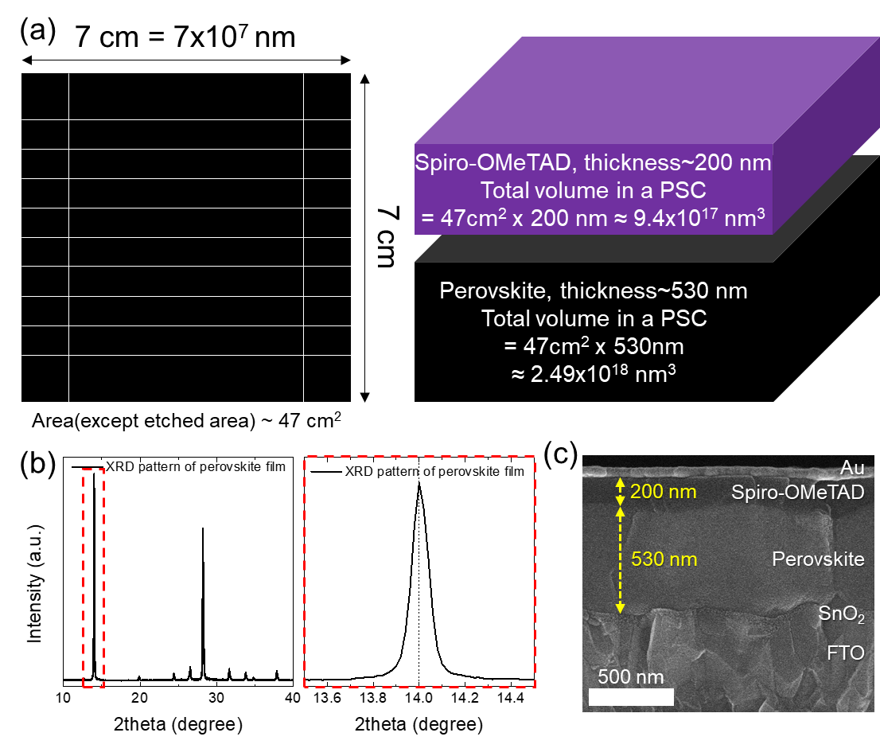
Supplementary Figure 1. Calculation of theoretical amount of each element in PSC-dissolved DMF. (a) Schematic structure of perovskite solar cell (PSC) which was used to dissolution process for theoretical calculation about the amount of each component in a PSC. (b) XRD pattern of the perovskite film and (c) cross-sectional SEM image of PSC. The theoretical amounts of each element dissolved from 7x7 cm² PSC was calculated by assuming the volume of each film. The total area of a PSC was 7x7 cm² and the actual area of perovskite film was calculated excluding the etched area (~ 2 cm²). The thickness of perovskite and spiro-OMeTAD films are 530 nm and 200 nm, respectively. The lattice parameter of a perovskite cubic crystal was calculated to be 0.632 nm by Bragg’s law from XRD pattern of perovskite film. As the result, the volume of the perovskite film was calculated to be 2.49 x 10¹⁸ nm³, the theoretical number of perovskite crystal was 9.86 x 10¹⁵ in the perovskite film. Then the amounts of each element were calculated by following ratio of the perovskite stoichiometric composition (in this study, FA_{0.90}Cs_{0.05}MA_{0.05}PbI_{2.85}Br_{0.15}). The calculated values are summarized in Supplementary Table 1 and 2.
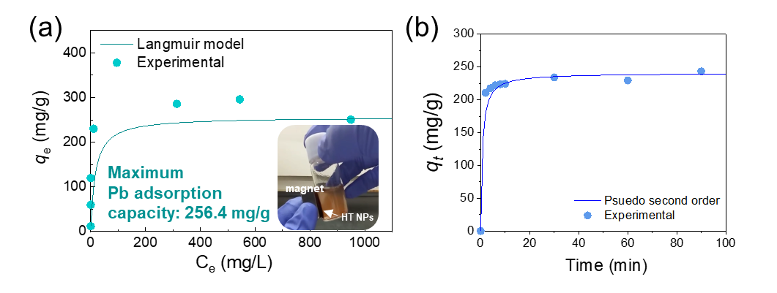

Supplementary Figure 2. (a) Langmuir sorption isotherm of Pb by hematite nanoparticles (HT NPs) under DMF solvents [Initial Pb concentrations: 10-1000 mg/L, hematite nanoparticles amounts: 1g/L, reaction time: 60 min] (inset: optical image of hematite nanoparticles attracted to Nd magnet.) and (b) Psuedo second order kinetics plot of Pb adsorption on hematite nanoparticles under DMF solvent. The hematite nanoparticles were prepared as an adsorbent for Pb removal, as reported in our previous work ¹. The hematite nanoparticles exhibited a high Pb adsorption capacity of 256.4 mg/g obtained from the Langmuir model in DMF solvent. The highly negatively charged surface enhances the electrostatic attraction with positively charged substances, and the conjugated gelatin on the surface provided a large active site, leading to capturing Pb with high adsorption capacity and fast kinetics ¹. In addition, the magnetism of the hematite nanoparticles enables to easily recollect the Pb adsorbents using a magnet (inset of Supplementary Fig. 2(a)).

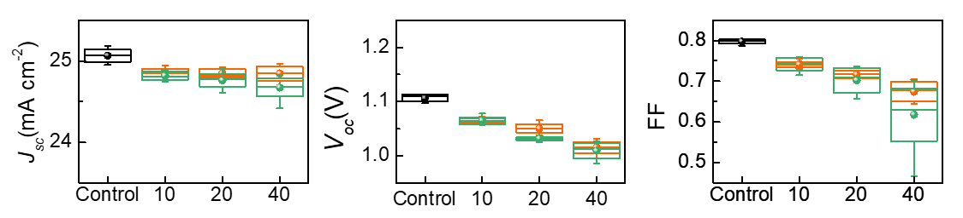

Supplementary Figure 3. Statistics for PV parameters of reproduced PSCs by using the recovered DMF solvents from the one-step dissolution processes. The number in X-axis means the dissolved number of PSCs into a DMF bath. Control PSCs were fabricated by using a pure DMF solvent.

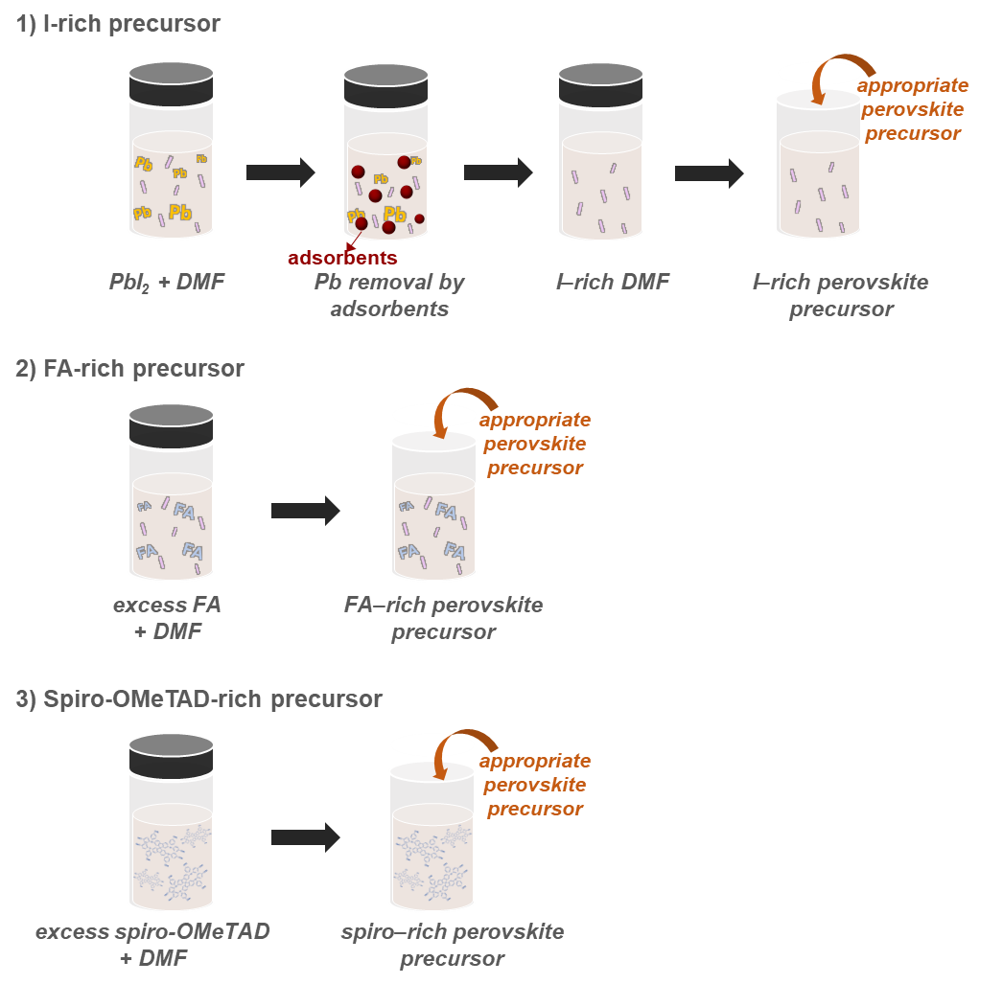

Supplementary Figure 4. Schematics of preparation of each component (i.e., I, FA, and spiro-OMeTAD) rich perovskite precursor. To confirm each component’s effects on the re-fabricated PSCs, perovskite precursors with excessive certain components were prepared. For the iodine-rich precursor, excessive PbI₂ was dissolved in DMF solvent, then only Pb ions were removed by using adsorbents (in this study, hematite nanoparticles). The FA-rich precursor was prepared by adding excess FAI without any post-treatment, due to the low effects of iodine on the PCE of re-fabricated PSCs (see Fig. 3(a) and Supplementary Fig. 5). Finally, the spiro-OMeTAD-rich precursor was also prepared by adding spiro-OMeTAD into perovskite precursor solution.
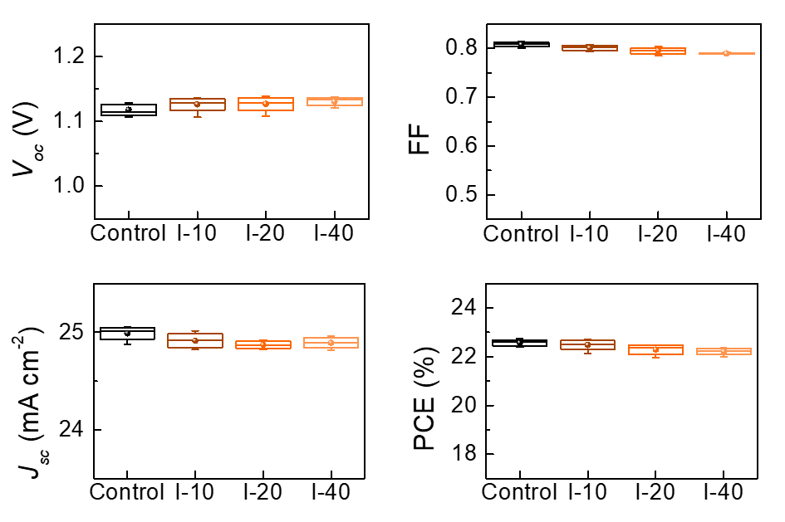
Supplementary Figure 5. Statistics for PV parameters of PSCs fabricated by using I-rich DMF solvents. Number in X-axis means the dissolved number of PSCs into a DMF bath. Each I-rich DMF solvent was prepared by adding a specific concentration of iodine into DMF which corresponding to the theoretical concentration of iodine according to the specific dissolved number of PSCs into DMF.

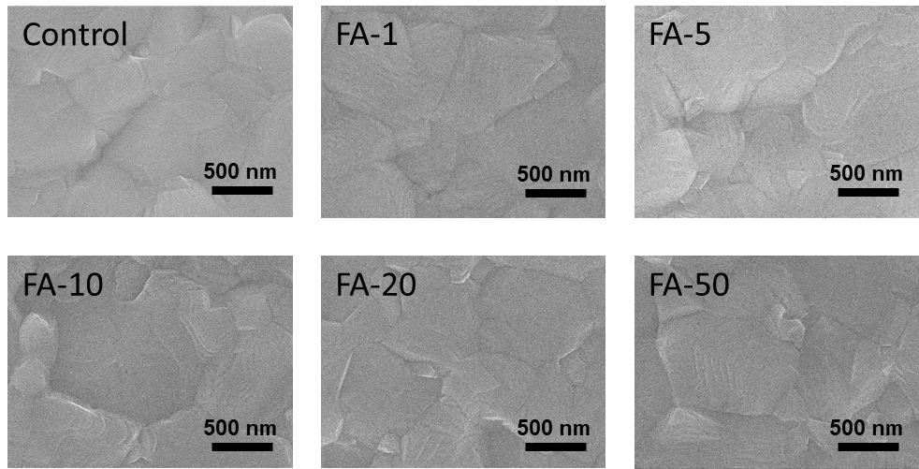

Supplementary Figure 6. Plan-view SEM images of perovskite films fabricated by using FA-rich DMF solvents. An added concentration of FA into a perovskite precursor solution is corresponding to the theoretical concentration of FA according to the specific dissolved number of PSCs into DMF.

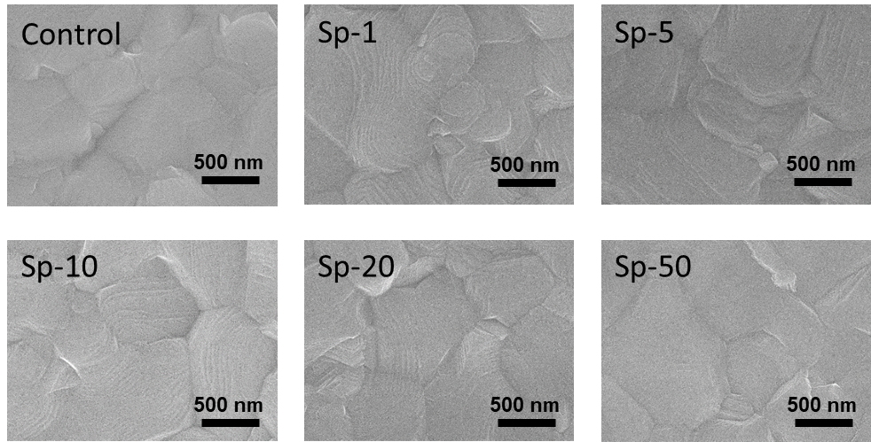

Supplementary Figure 7. Plan-view SEM images of perovskite films fabricated by using spiro-rich DMF solvents. An added concentration of spiro-OMeTAD into a perovskite precursor solution is corresponding to the theoretical concentration of spiro-OMeTAD according to the specific dissolved number of PSCs into DMF.

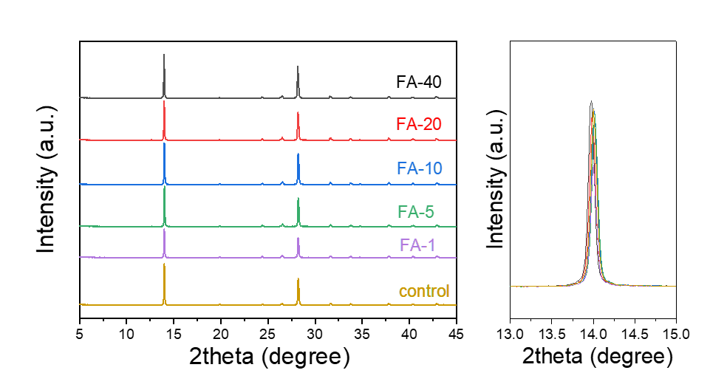
Supplementary Figure 8. XRD patterns of perovskite fabricated with different amounts excess FA accordance with the number dissolved PSC devices

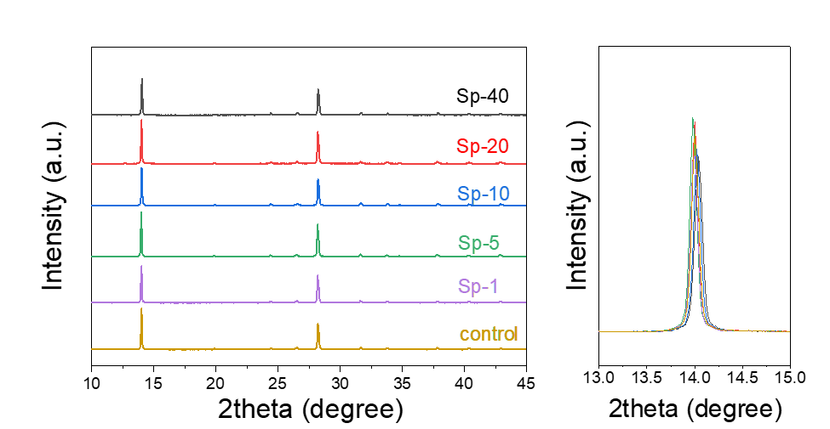
Supplementary Figure 9. XRD patterns of perovskite fabricated with different amounts excess spiro-OMeTAD accordance with the number dissolved PSC devices

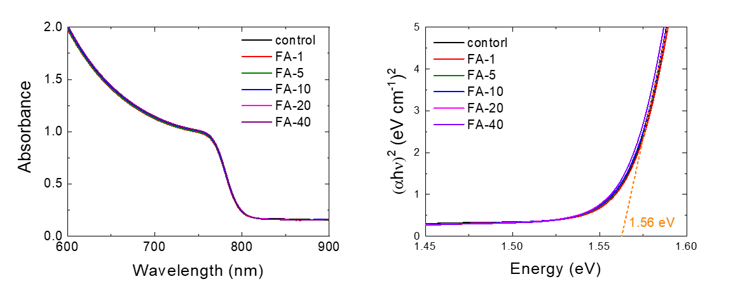
Supplementary Figure 10. (a) Ultraviolet (UV)-visible absorbance spectra and (b) Tauc plot of the perovskite films fabricated by using FA-rich DMF solvents.

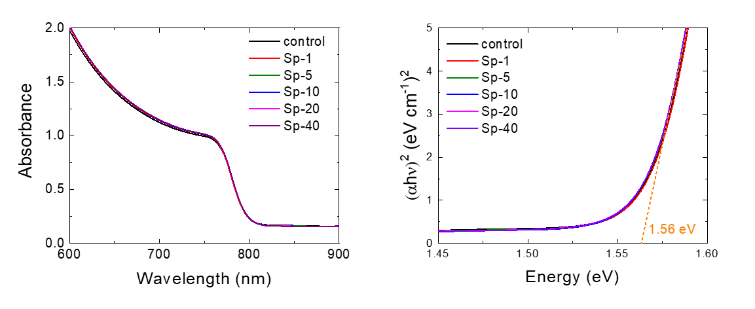

Supplementary Figure 11. (a) Ultraviolet (UV)-visible absorbance spectra and (b) Tauc plot of the perovskite films fabricated by using spiro-rich DMF solvents.
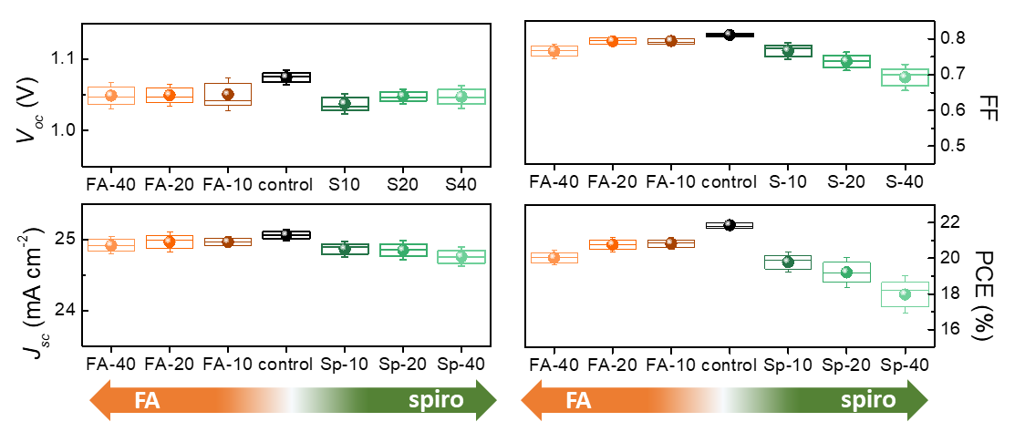
Supplementary Figure 12. Statistics for PV parameters of the PSCs by using FA-rich and spiro-rich DMF solvents. A Specific concentration of each material was added in a perovskite precursor solution, and that is corresponding to the theoretical concentration according to the dissolved number of PSCs into DMF solvent.

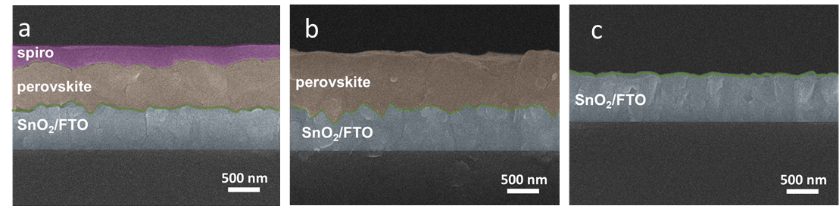

Supplementary Figure 13. Cross-sectional SEM images (a) PSC, (b) after dissolving the PSC in CB bath, and (c) after dissolving the PSC, which selectively dissolved in the CB bath, in DMF bath.
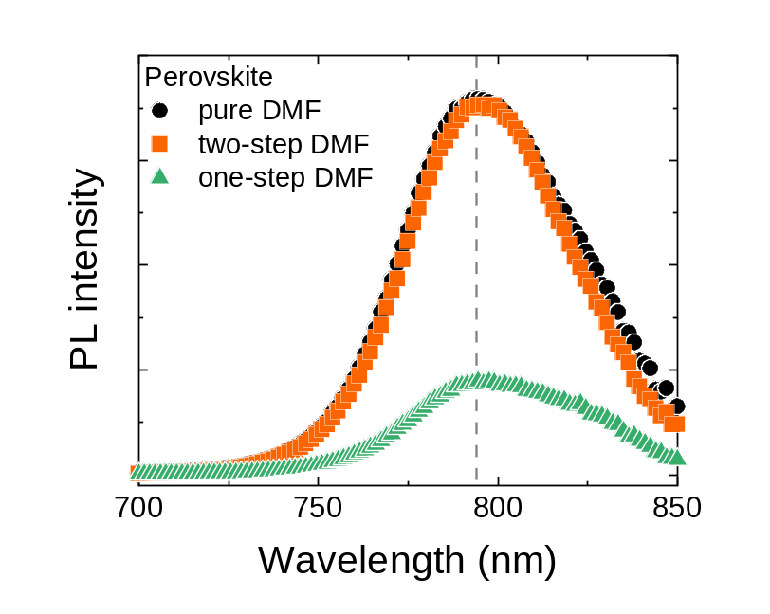

Supplementary Figure 14. Steady-state photoluminescence spectra of the perovskite films prepared by using control (pure DMF), produced by using the recovered DMF from two-step process (two-step DMF) and recovered DMF from one-step process (one-step DMF).

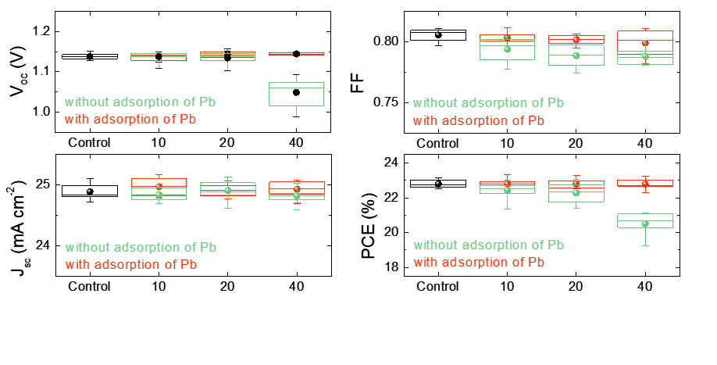
Supplementary Figure 15. Statistics for PV parameters of the PSCs prepared by using the recovered DMF solvents from the two-step dissolution process. The two different recovered DMF solvents with and without heavy metal adsorption processes were used. Control devices were fabricated by using a pure DMF solvent. Even though spiro-OMeTAD was not present in the two-step DMF, the PSCs fabricated with DMF recovered without heavy metal (especially Pb) adsorption exhibited a decrease in PCE as the concentration of Pb in DMF increased, corresponding to an increase in the number of PSCs dissolved in DMF. The effects of excess PbI₂ which exceeds the optimized concentration in perovskite precursor solutions, are well known as the origin for deteriorating PV performance in PSCs ²⁻⁴. However, no such negative effect was observed in PSCs fabricated with DMF which removed heavy metal ions by hematite nanoparticles adsorption, indicating the importance of heavy metal management.

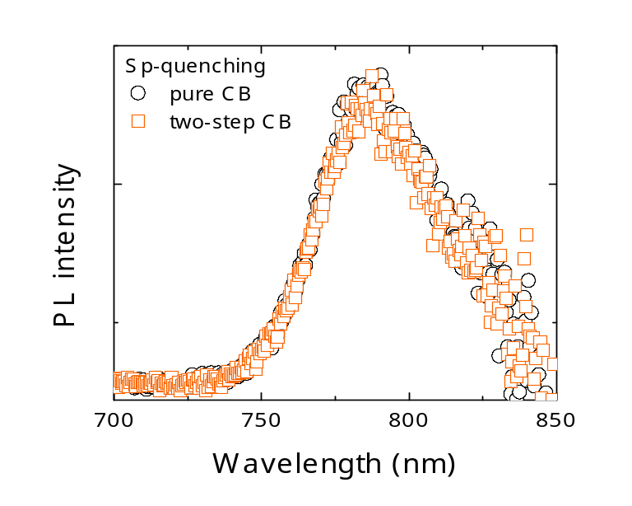
Figure S16. Steady-state photoluminescence spectra of the perovskite/spiro-OMeTAD films prepared by using pure CB (pure CB) and produced by using CB recovered from the two-step process (two-step CB).

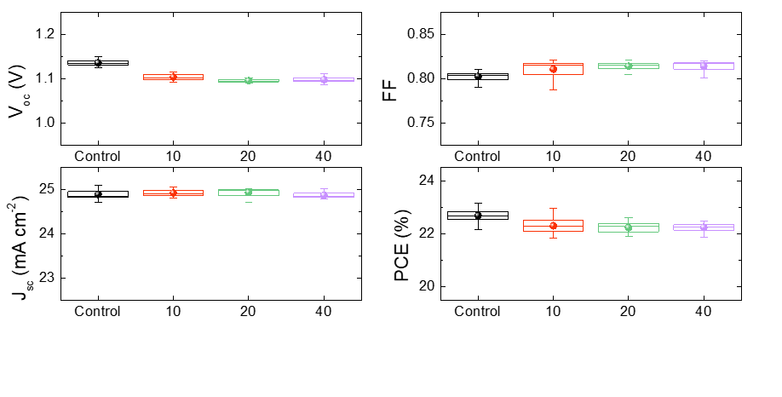
Supplementary Figure 17. Statistics of PV parameters of the PSCs prepared by using the recovered CB solvents from the two-step dissolution. The number in X-axis means the dissolved number of d-PSCs into the CB bath. Control devices were fabricated by using a pure CB solvent.

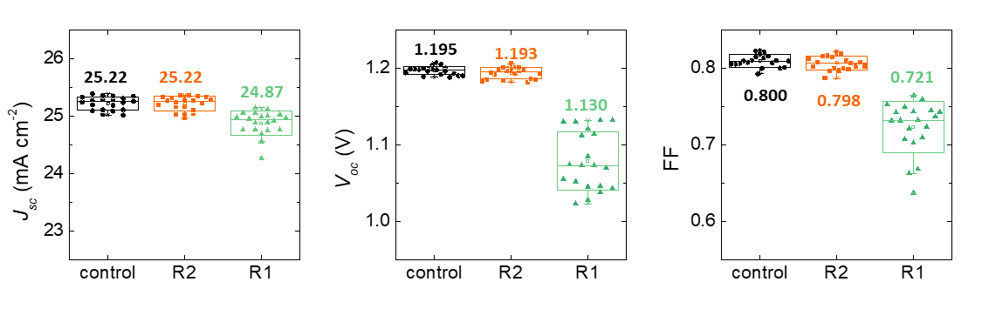
Supplementary Figure 18. Statistics of PV parameters of the PSCs prepared by using pure, two-step (R2), and one-step (R1) DMF solvents. Also, the recovered CB from the two-step dissolution process was used to fabricated R2 PSCs. The J-V curves and stabilized power output tracking for each best performing control, R2-, and R1-PSCs without encapsulation under continuous 1 sun illumination in ambient air.

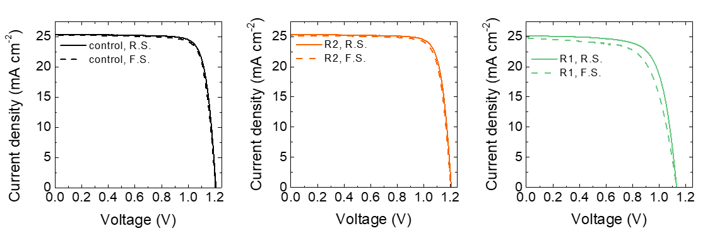
Supplementary Figure 19. Best J-V curves for PSCs prepared by using pure, two-step (R2), and one-step (R1) DMF solvents. Also, the recovered CB from the two-step dissolution process was used to fabricated R2 PSC.
Supplementary Table 1. Theoretical and experimental amounts/concentrations of each element from a PSC which dissolved into 50 ml of DMF solvent.

element | Amount / Concentration
element | mg |  |  | mM
element | Theoretical | Experimental | Error | Theoretical | Experimental | Error
Cs | 0.1088 | 0.0905 | 0.0183 | 0.0164 | 0.0136 | 0.0028
Pb | 3.3914 | 3.0085 | 0.3829 | 0.3274 | 0.2904 | 0.0370
I | 5.92 | 5.75 | 0.16 | 0.9330 | 0.9062 | 0.0268
Br | 0.20 | 0.94 | 0.74 | 0.0491 | 0.2353 | 0.1862

Supplementary Table 2. Theoretically calculated FA and spiro-OMeTAD concentrations according to the dissolved number of PSCs in 50 mL of DMF.

 | Dissolved number of PSCs in 50 mL of DMF
 | 1 | 5 | 10 | 20 | 40
MA (mM) | 0.0164 | 0.0818 | 0.1637 | 0.3274 | 0.6547
FA (mM) | 0.2946 | 1.4731 | 2.9462 | 5.8924 | 11.7848
Spiro-OMeTAD (mM) | 0.0156 | 0.0782 | 0.1565 | 0.3130 | 0.6259

Supplementary Table 3. PV parameters of the best control, R2, and R1 PSCs.

 | Scan direction | J_{sc}  (mA cm⁻²) | V_{oc}  (V) | FF  (-) | PCE  (%)
control | Reverse | 25.333 | 1.208 | 0.824 | 25.21
control | Forward | 25.327 | 1.205 | 0.819 | 24.99
R2  (two-step) | Reverse | 25.333 | 1.206 | 0.819 | 25.02
R2  (two-step) | Forward | 25.330 | 1.203 | 0.814 | 24.80
R1  (one-step) | Reverse | 25.114 | 1.130 | 0.721 | 20.47
R1  (one-step) | Forward | 24.757 | 1.130 | 0.668 | 18.69

Reference
1 Kim, H. J. et al. Synthesis and adsorption properties of gelatin-conjugated hematite (α-Fe2O3) nanoparticles for lead removal from wastewater. Journal of hazardous materials 416, 125696 (2021).
2 Park, B. W. et al. Understanding how excess lead iodide precursor improves halide perovskite solar cell performance. Nature Communications 9, doi:ARTN 330110.1038/s41467-018-05583-w (2018).
3 Tumen-Ulzii, G. et al. Detrimental Effect of Unreacted PbI2 on the Long-Term Stability of Perovskite Solar Cells. Advanced Materials 32, doi:ARTN 190503510.1002/adma.201905035 (2020).
4 Roose, B., Dey, K., Chiang, Y. H., Friend, R. H. & Stranks, S. D. Critical Assessment of the Use of Excess Lead Iodide in Lead Halide Perovskite Solar Cells. Journal of Physical Chemistry Letters 11, 6505-6512, doi:10.1021/acs.jpclett.0c01820 (2020).

