Supplementary Information:

Ultrafine-bubble-water-promoted nanoceramic decoration of metal powders
for additive manufacturing
Mingqi Dong¹, Weiwei Zhou^{1,} *, Suxia Guo¹, Naoyuki Nomura^{1,} ∗

¹Department of Materials Processing, Graduate School of Engineering, Tohoku University, Sendai, 980-8579, Japan

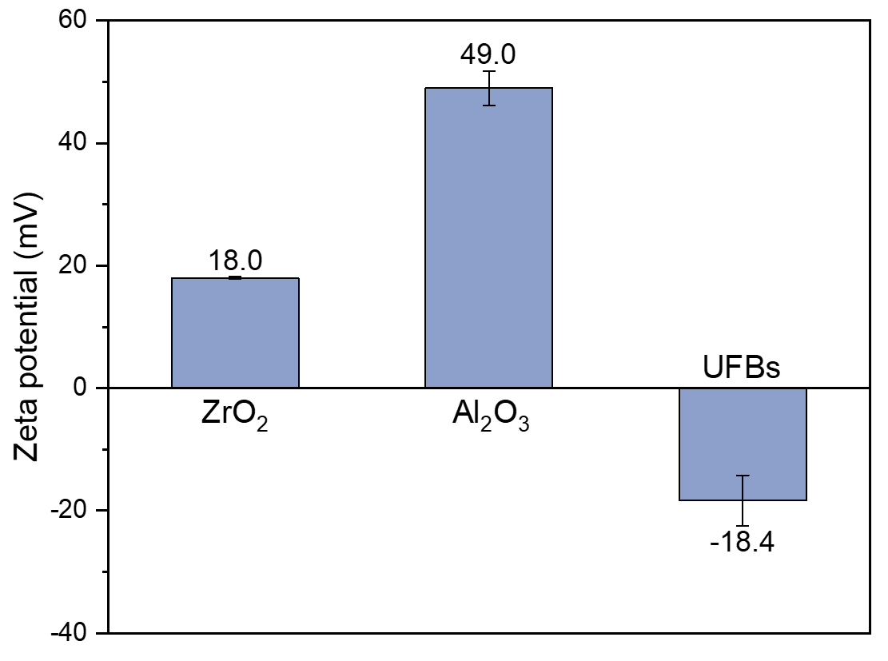
Fig. S1 Zeta potential of ZrO₂, Al₂O₃, and UFBs in water. The zeta potential of UFBs was measured using the as-prepared UFB water without dilution.

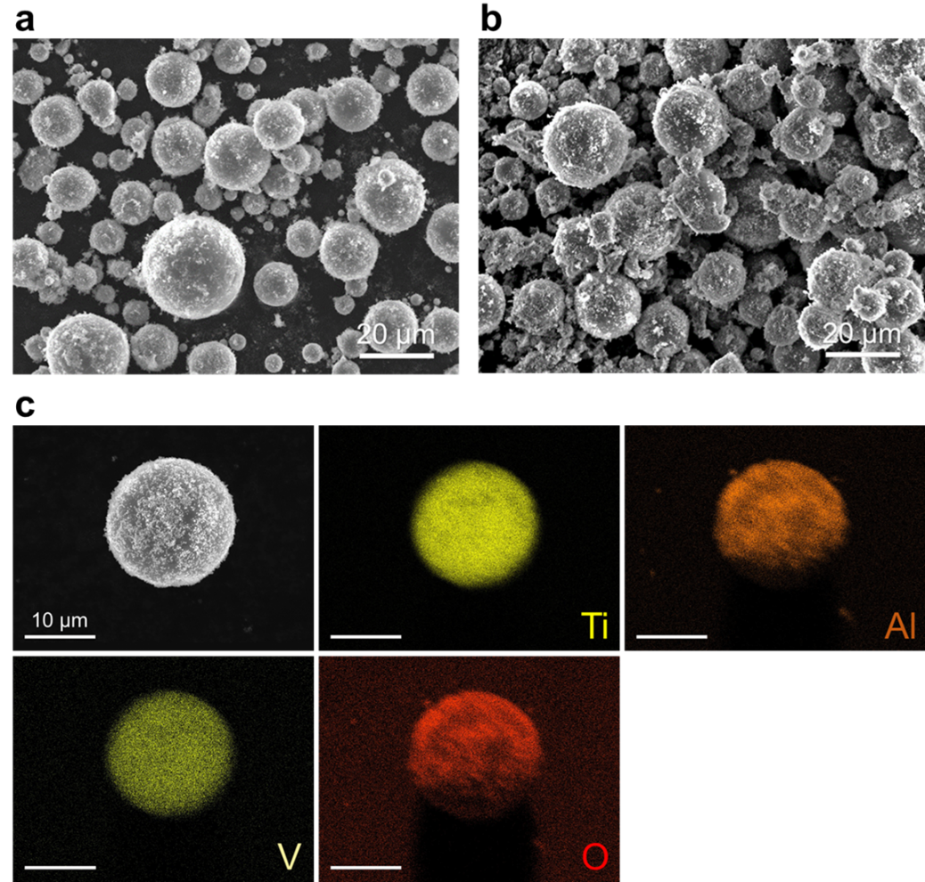
Fig. S2 Characterization of composite powders produced by UFBH. FESEM images of the (a) 5 wt%, (b) 10 wt% Al₂O₃/Ti64 powders produced by UFBH; (c) FESEM image and corresponding EDXS mappings of a 10 wt% Al₂O₃/Ti64 powder particle.

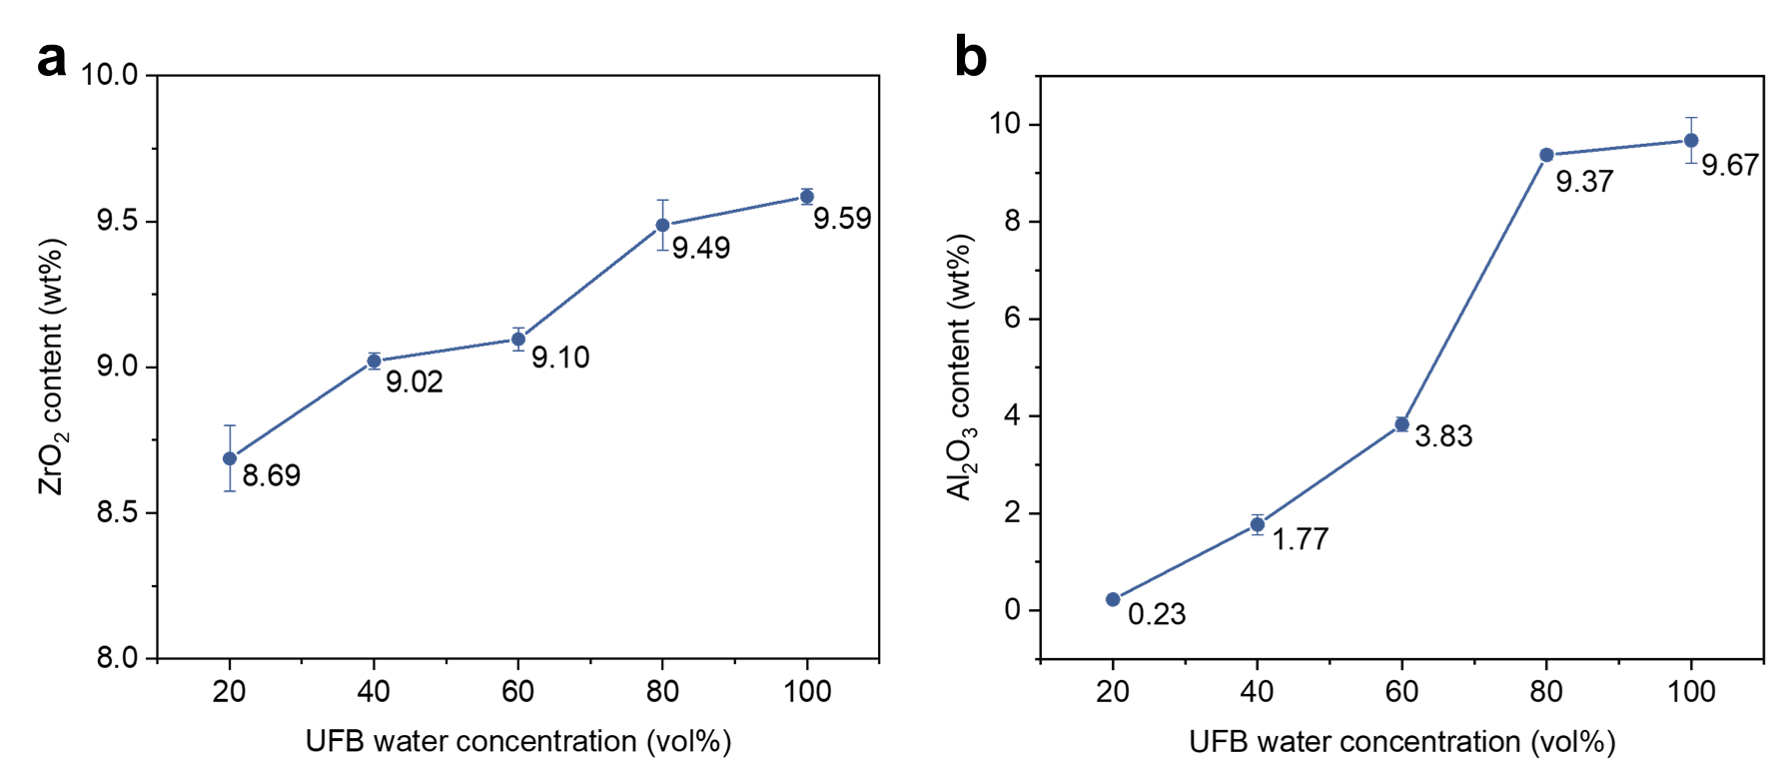
Fig. S3 (a) ZrO₂ or (b) Al₂O₃ content in the 10 wt% nanoparticles-added ZrO₂/Ti64 or Al₂O₃/Ti64 composite powders as a function of the UFB water concentration during the UFBH process. ZrO₂ or Al₂O₃ nanoparticles (1 g) were mixed with 9 g Ti64 powders using 500 ml of UFB water at different concentrations. In the case of 20% UFB water concentration, 100 ml of as-prepared UFB water and 400 ml of deionized water were mixed.

Supplementary Note 1: In-situ observation of UFBH process.
“Supplementary Movie 1.avi” and “Supplementary Movie 2.avi” are videos in-situ recording the heteroagglomeration process under high-resolution optical microscope. The ZrO₂/Ti64 powder suspension in “Supplementary Movie 1.avi” and “Supplementary Movie 2.avi” was prepared in deionized water and UFB water, respectively.

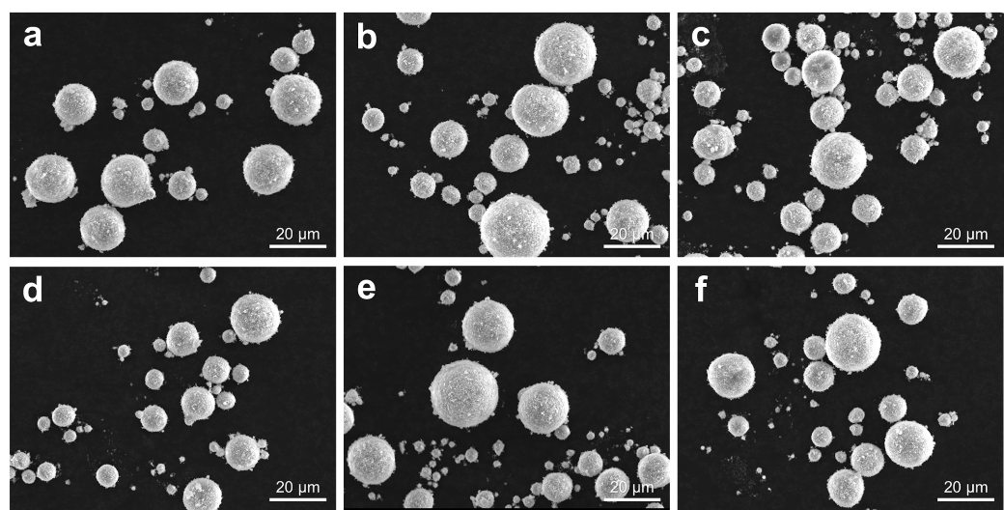
Fig. S4 FESEM images of the 5 wt% ZrO₂/Ti64 composite powders (a) before and (b-f) after L-PBF recoating cycles of (b) 1, (c) 2, (d) 3, (e) 4 and (f) 5. The recoating parameters were the same as those used for the actual L-PBF process. The observed particles were randomly taken from the powder beds at different recoating cycles.

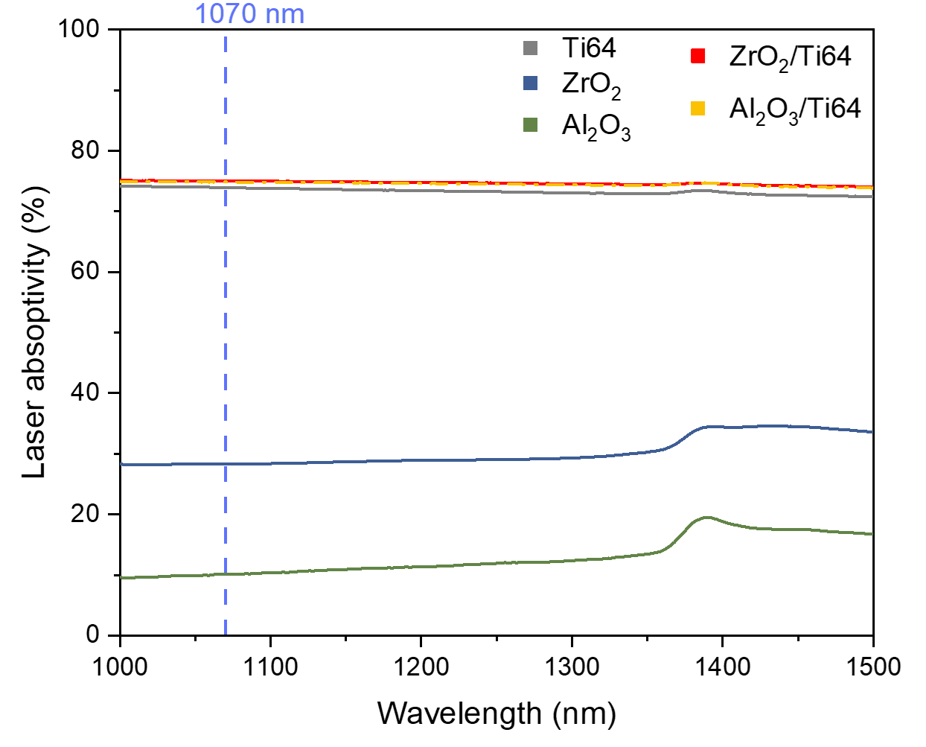
Fig. S5 Laser absorptivity of the Ti64, ZrO₂, Al₂O₃, 5 wt% ZrO₂/Ti64, and 5 wt% Al₂O₃/Ti64 powders as a function of laser wavelength in the range of 1000–1500 nm.

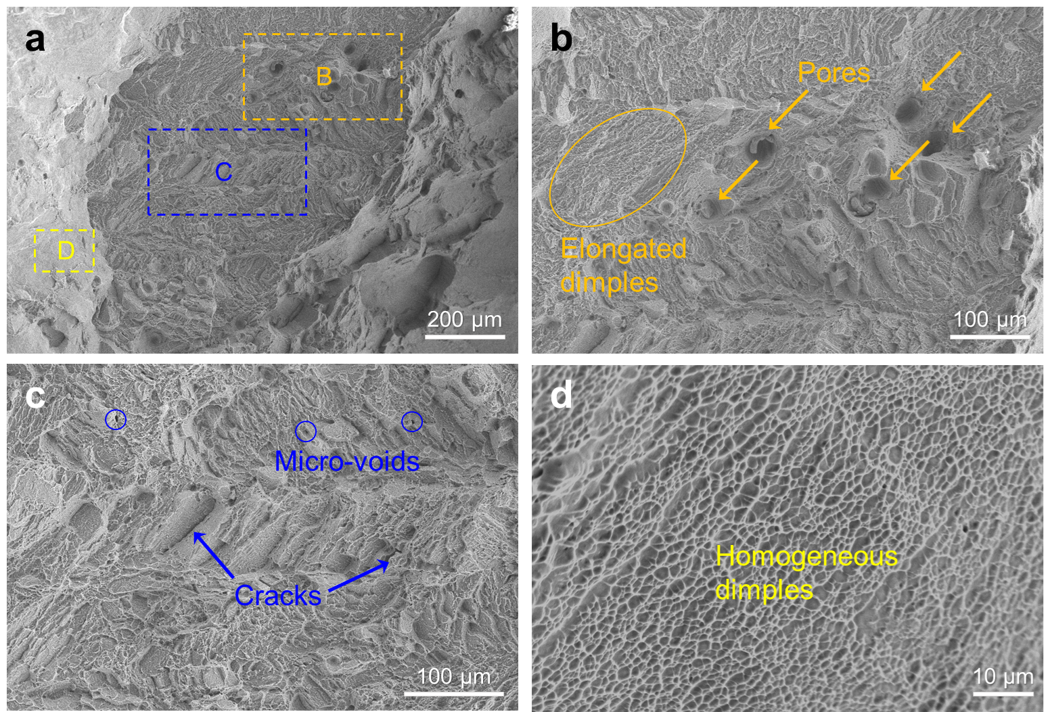
Fig. S6 Fracture surface morphologies of the 1 wt% ZrO₂/Ti64 build. (b), (c) and (d) Images taken from the orange, blue, and yellow rectangles in (a), respectively. Small quantities of typical AM defects such as micropores were distributed over the fracture surface. Since the fine dimples were dominantly detected on the fracture surface, it is concluded that the ZrO₂/Ti64 builds underwent a ductile fracture mode upon tensile loading.

∗ Corresponding authors. E-mail addresses: weiwei.zhou.c3@tohoku.ac.jp (W. Zhou), naoyuki.nomura.a2@tohoku.ac.jp (N. Nomura)

