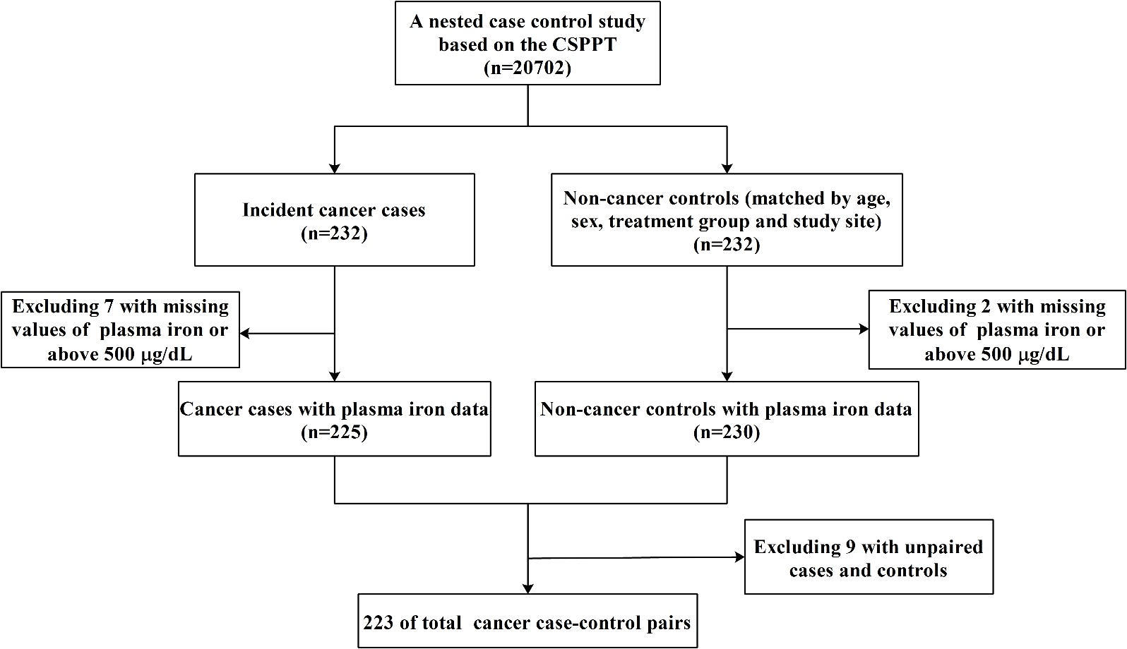
Supplemental Figure 1. Flow chart of the study participants using a nested case-control design.

