Supplementary Information

Spatiotemporally Controlled Drug Delivery via Photothermally Driven Conformational Change of Self-integrated Plasmonic Hybrid Nanogels

Seungki Lee¹, Subeen Kim³, Doyun Kim¹, Jieun You¹, Ji Soo Kim⁴, Hakchun Kim¹, Jungwon Park^{4,5}, Jihwan Song³*, and Inhee Choi^{1,2}*
*Corresponding authors: inheechoi1@uos.ac.kr; jsong@hanbat.ac.kr

Supplementary Text
Calculation of the photothermal conversion efficiency
The photothermal conversion efficiency (η) of the PHNs was calculated according to a previous report. The detailed method is as follows:
$η=\frac{hs\left(T_{max}-T_{Surr}\right)-Q_{Dis}}{I(1-{10}^{-Abs})}$ (1)
where h is the heat transfer coefficient, S is the surface area of the container, and the value of hs is obtained from Fig. 3g. The maximum steady temperature (T_{max}) of the solution of the A-PHN was 36.2℃ and the environmental temperature (T_{Sur}) was 25.3℃. The temperature change (T_{Max}-T_{Sur}) of the A-PHN solution was 10.9℃. The laser power I, was 0.2 W. The absorbance of A-PHNs at 532 nm was 1.0. Q_{Dis} expresses the heat dissipated from the light absorbed by the quartz sample cell itself, and it was measured independently to be 15 mW using a quartz cuvette cell containing pure water.
In order to gain hs, a dimensionless parameter θ is introduced as followed:
$θ=\frac{T-T_{Sur}}{T_{Max}-T_{Sur}}$ (2)
A sample system time constant can be calculated as (3).
$t=-τ_{s}\ln\left(θ\right)$ (3)
According to Fig. S12, τs was determined and calculated to be 203.20 s.
$hs=\frac{m_{D}C_{D}}{τ_{s}}$ (4)
Additionally, m was 0.2 g and C was 4.2 J/g℃. Thus, according to (4), hs was deduced to be 6.20 mW/℃ for A-PHN.
Therefore, substituting the values of each parameter in (1), the 532 nm laser heat conversion efficiency (η) of the A-PHNs was calculated to be 15.69%.
Table S1. Name and the molecular weight of the used linker molecules and nomenclatures of the PHNs synthesized with the linker molecules.
PHNs | Linker molecules | M.W. (g/mol)
M-PHN | N,N`-methylene bis(acrylamide) | 154.17
T-PHN | Tryptophan | 204.23
S-PHN | Sucrose | 342.3
P-PHN | Poly(ethylene glycol) diacrylate | 575.5
A-PHN | Alginic acid | M_{n}: 58,900
G-PHN | Gelatin | 50,000-100,000

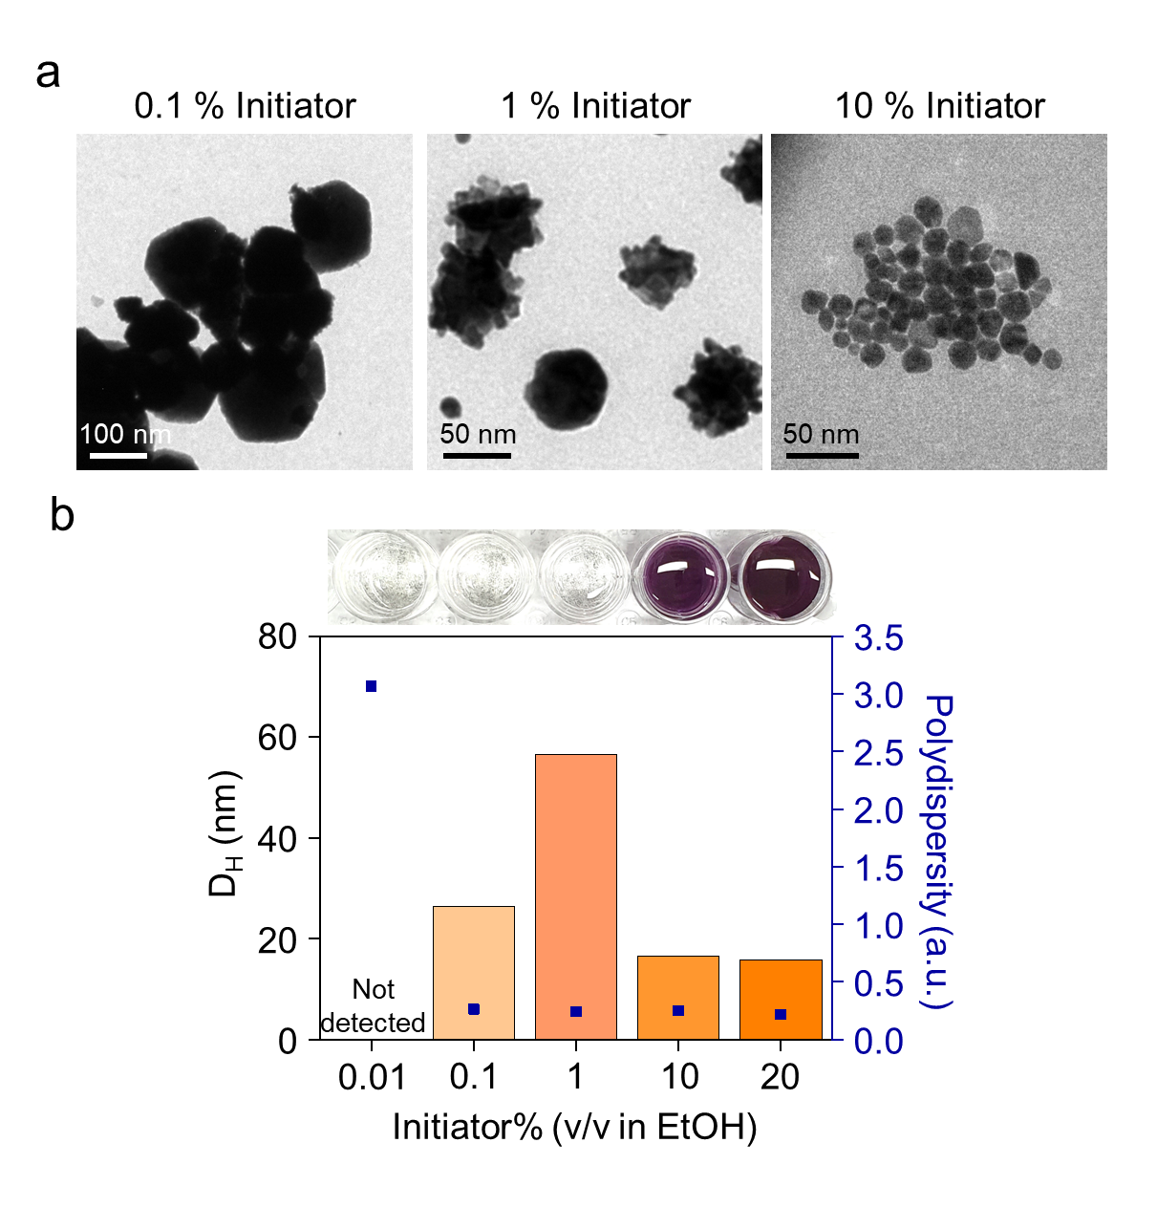
Fig. S1. Optimization of photoinitiator concentration for obtaining homogenous size distribution of gold nanoparticles (GNPs). (a) Transmission electron microscopy (TEM) images of GNPs according to the concentration. (b) Hydrodynamic diameters and polydispersity of the obtained GNPs. The photographs indicate the colloidal colors of GNPs formed through radical polymerization.
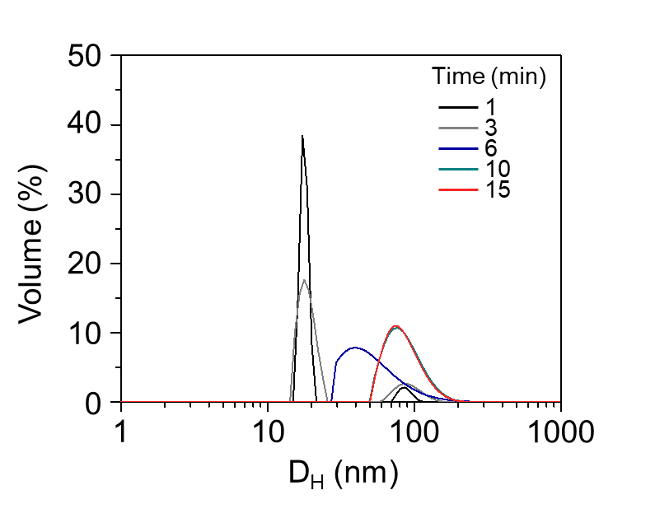
Fig. S2. Hydrodynamic diameter distribution of the N, N’-methylene bisacrylamide (MBA)-linked PHNs (M-PHNs) according to the reaction time between 1–15 min.
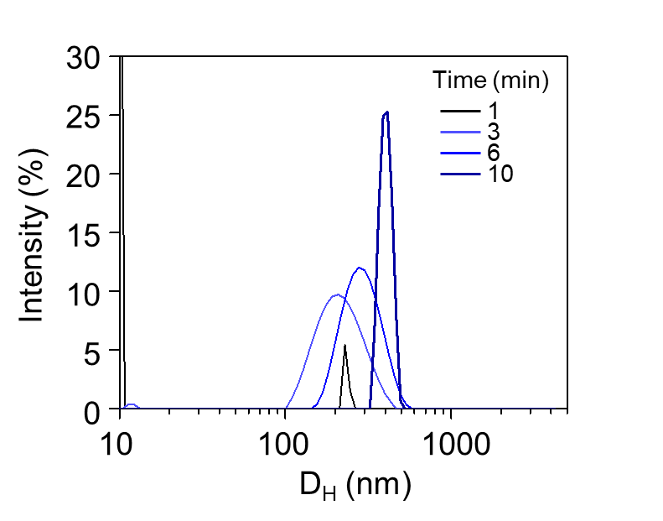
Fig. S3. Hydrodynamic diameters of poly (N-isopropyl acrylamide) (PNIPAM) nanogels without GNPs according to the reaction time.
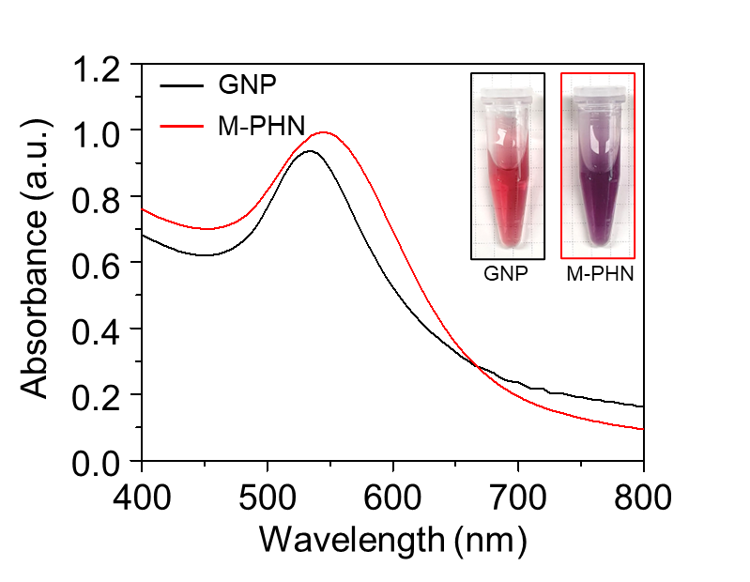
Fig. S4. Absorbance spectra of colloidal GNPs and M-PHNs. Insets display the colors of the colloidal solutions.
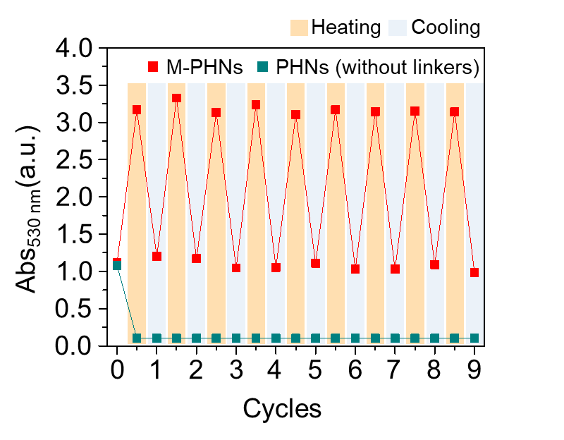
Fig. S5. Monitoring of the thermal stability of M-PHNs and PHNs during 10 cycles of the heating/cooling procedure.
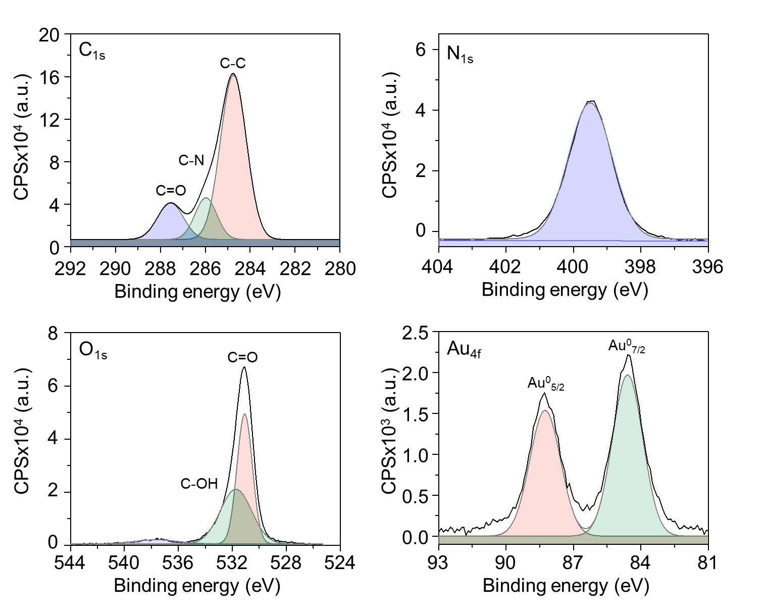
Fig. S6. Narrow scans of the XPS spectra focused on the selected elements of C, N, O, and Au.
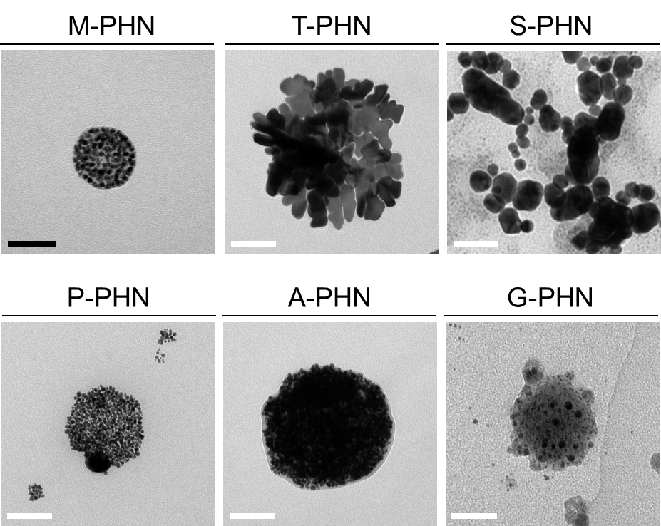
Fig. S7. TEM images of the PHNs with different linker molecules (i.e., MBA (M-PHN), tryptophan (T-PHN), sucrose (S-PHN), PEG-da (P-PHN), alginate (A-PHN), and gelatin (G-PHN)). The Black scale bar indicates 50 nm and the white scale bars represent 100 nm.
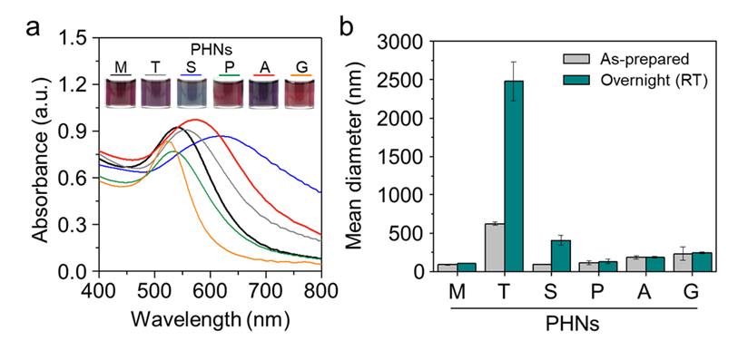
Fig. S8. Optical properties and colloidal stabilities of the PHNs synthesized with different linker molecules. (a) Absorbance spectra and photographs of the PHNs. (b) Mean diameters were measured from as-synthesized colloidal PHNs and the PHNs stored at RT (25℃) overnight.
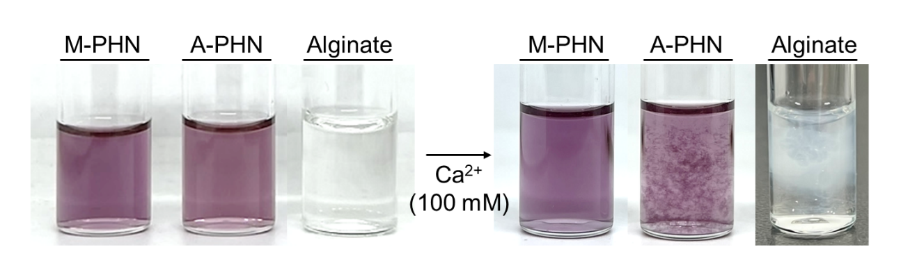
Fig. S9. Observation of the calcium ion-mediated gelation using M-PHN and A-PHN by adding 100 mM CaCl₂.
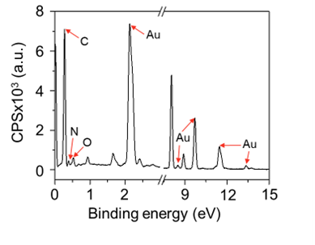
Fig. S10. Energy-dispersive X-ray spectroscopy of A-PHN from Fig. 2g.
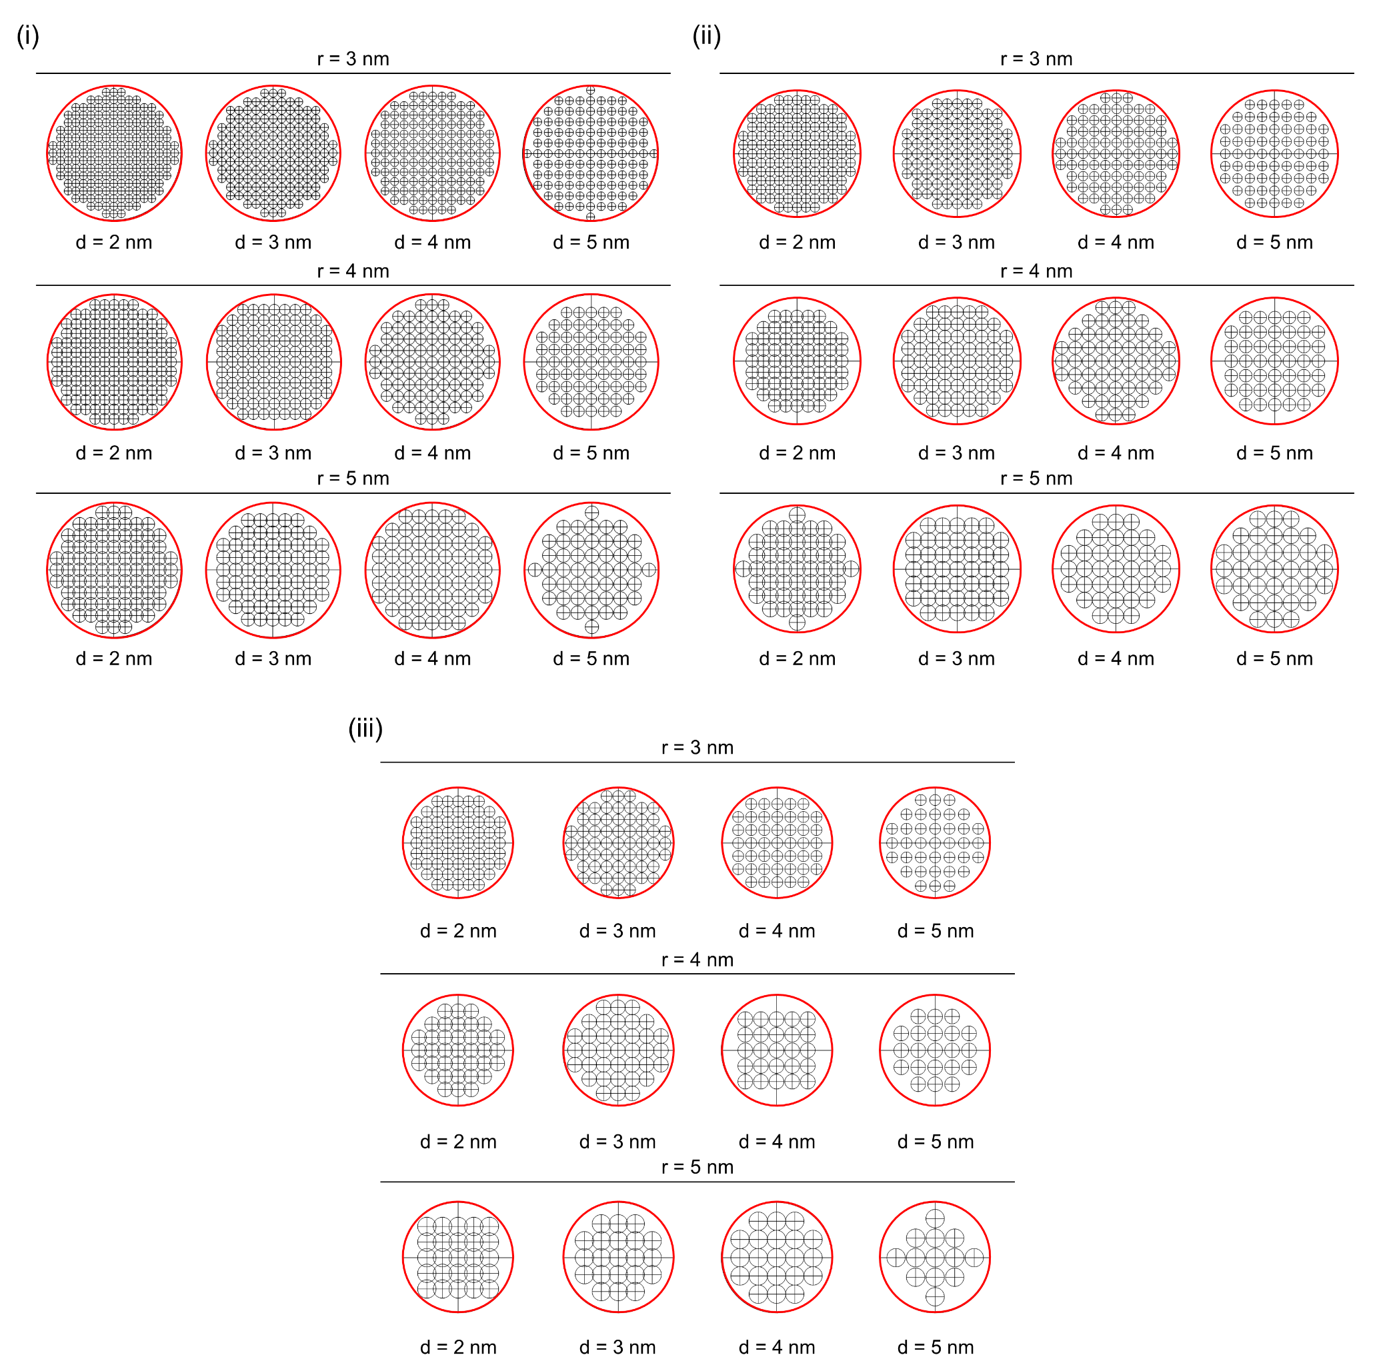
Fig. S11. Schematic image of the GNP structures used in the computation at different diameters of PHN (i) R=100 nm, (ii) R=80 nm, and (iii) R=60 nm, respectively. The red line indicates the boundary of the PHN.
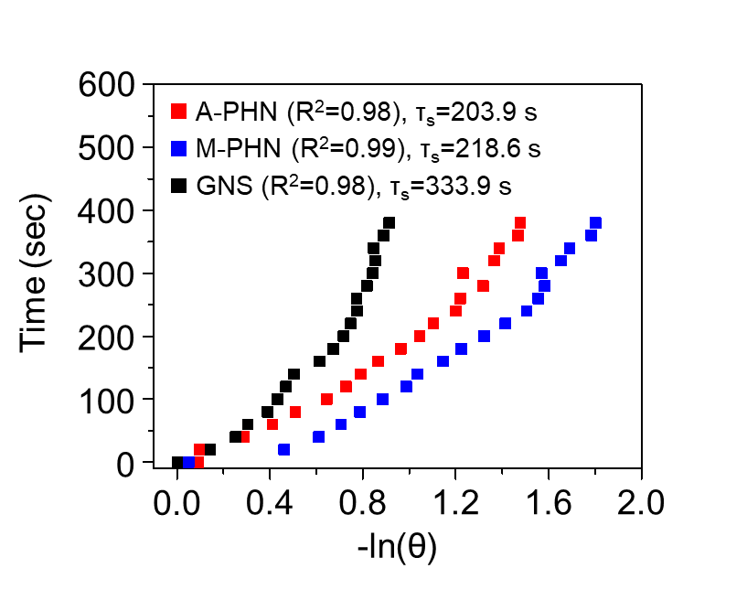
Fig. S12. Linear relationship of -ln(θ) versus time obtained from the cooling period of the thermal curve in Fig. 3g. A dimensionless driving force temperature, 𝜃 was obtained using the equation, 𝜃 = (𝑇−𝑇_{BKG})/(𝑇_{max}-𝑇_{BKG}), where 𝑇_{BKG} indicates the background temperature, and 𝑇_{max} represents the maximum temperature, respectively.
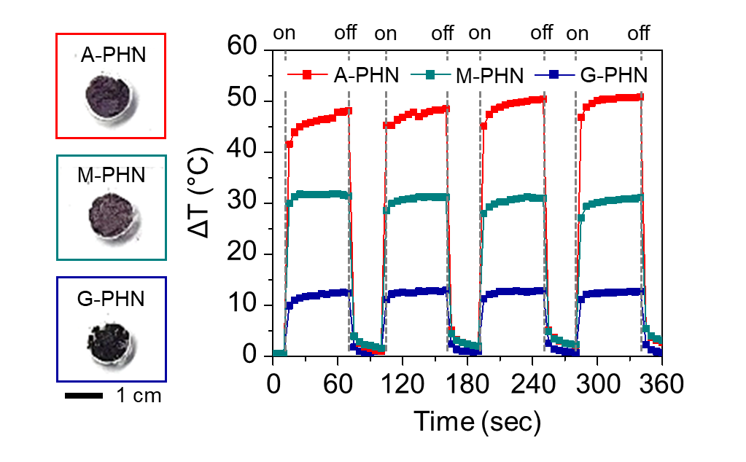
Fig. S13. Light-responsive heat generation of dehydrated PHNs under light illumination (532 nm, 0.8 W/cm²). Gray dash lines indicate the time points on/off the laser.
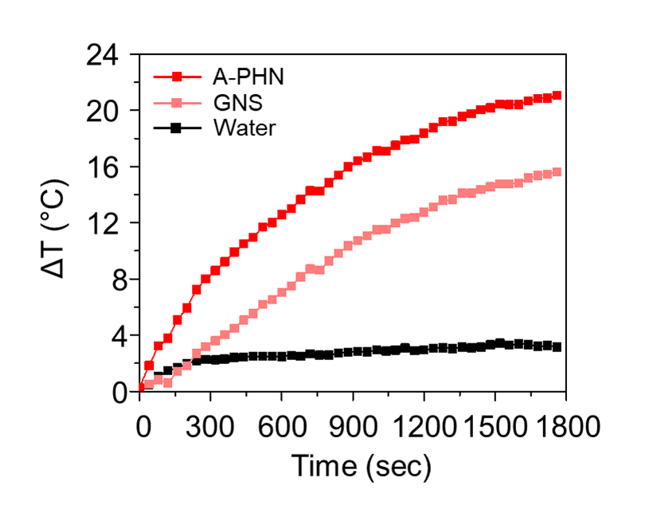
Fig. S14. Monitoring of the solution temperature under a commercial LED lamp (0.8 W/cm²).
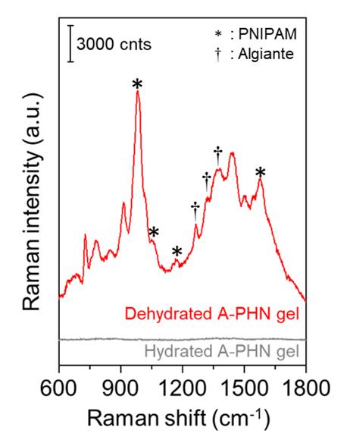
Fig. S15. In situ Raman spectra of A-PHN gels under 785-nm laser illumination (* indicate the hydrophobic moieties at PNIPAM nanogel, † represents the fingerprint peak from alginate). Each gel was prepared using Ca²⁺-induced gelation, and a dehydrated state was obtained by heating the solution over 40℃.
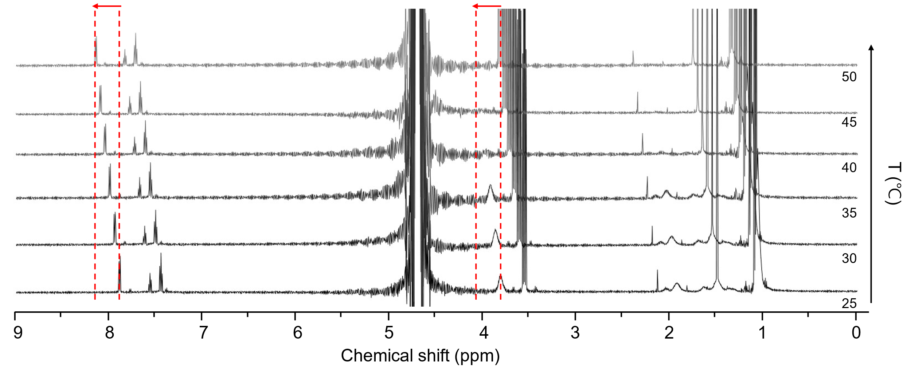
Fig. S16. Temperature-dependent ¹H-NMR (600 MHz) study of A-PHN dispersed in D₂O.
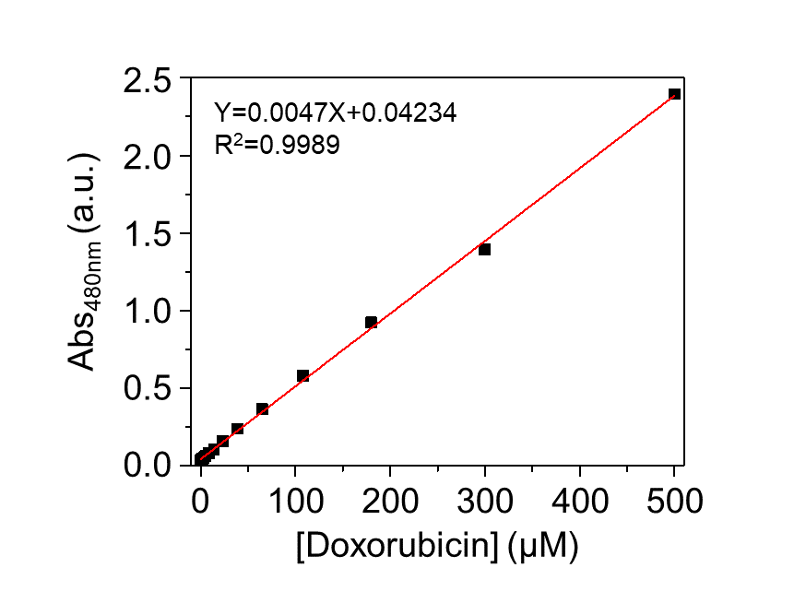
Fig. S17. Standard curve of doxorubicin by absorbance at 480 nm.
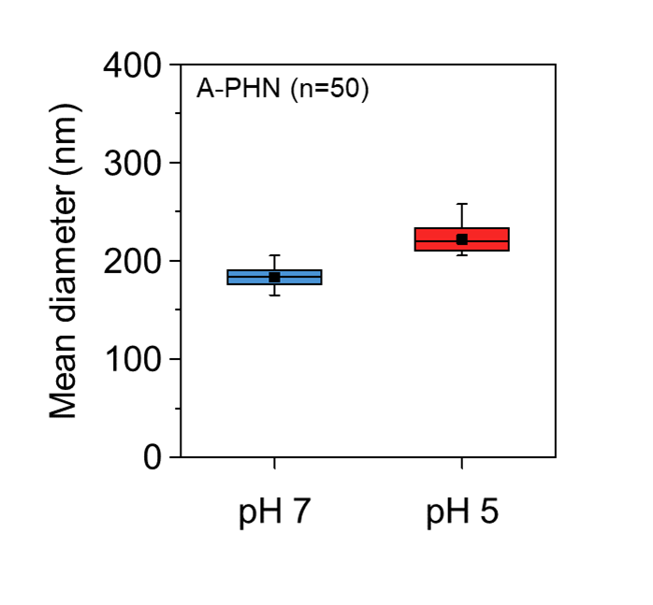
Fig. S18. Monitoring the mean diameters of A-PHN by changing the buffer pH conditions (n=50).
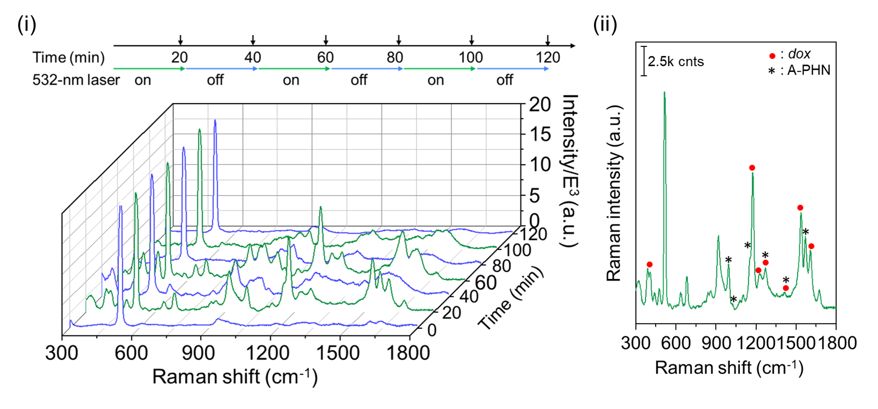
Fig. S19. Monitoring the Raman spectra of released dox under temporally controlled light modulation. (i) Time-coursed Raman spectra. (ii) Representative spectrum collected at every 20 min of 532 nm illumination. Raman spectra were obtained using the 785 nm laser with 1 s of exposure time (5 times accumulation each).
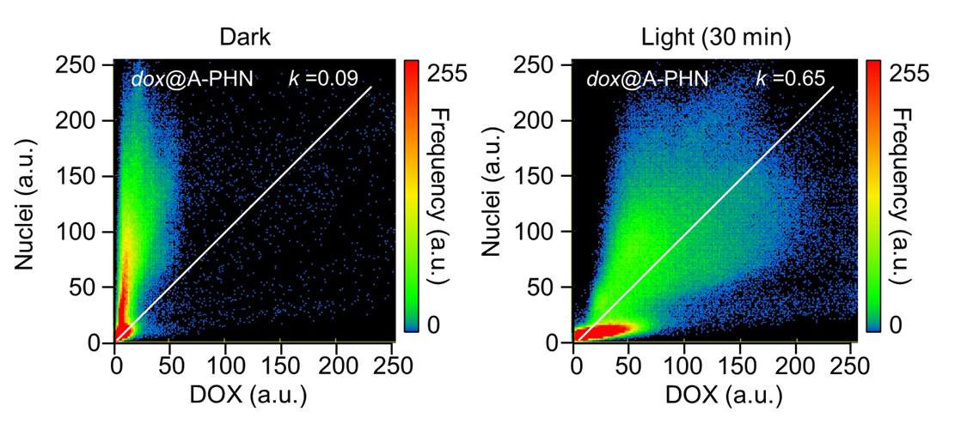
Fig. S20. Images of Pearson’s colocalization coefficient (k) plots for dox versus Hoechst from Fig. 5e (i).
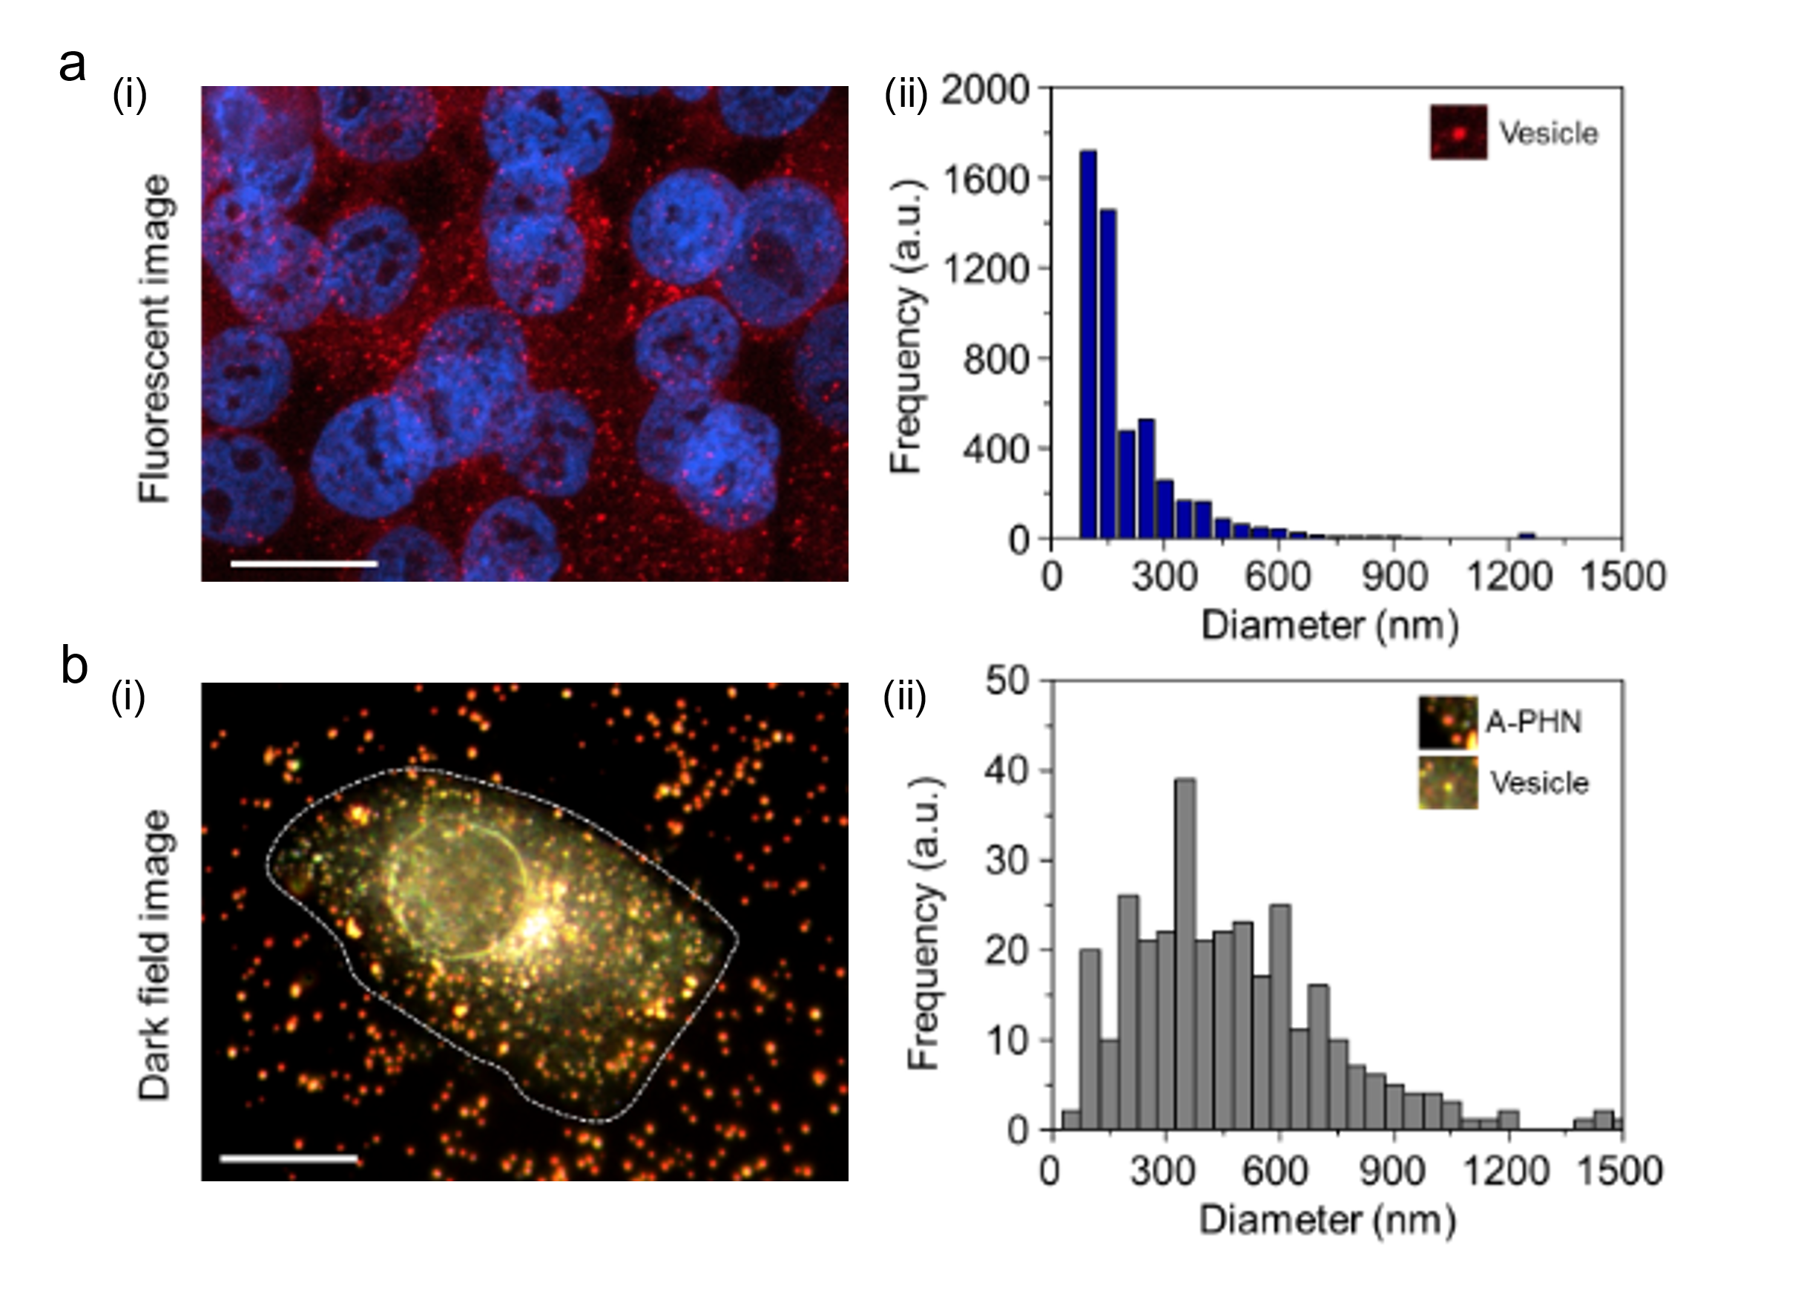
Fig. S21. Cellular internalization of A-PHNs into A375P cell. (a) Confocal microscopy analysis of endocytic vesicles. (i) Fluorescence image when stained with DND-99 (red) and Hoechst 33258 (blue). The scale bar is 20 µm. (ii) Frequency plots extracted from red dots from the fluorescent images. (b) Dark-field scattering microscopy results. (i) Scattering image of the representative single cell including A-PHN (i.e., orange scattering spots). The scale bar is 40 µm. (ii) Frequency plots from scattering spots. All distribution plots were obtained from ImageJ.
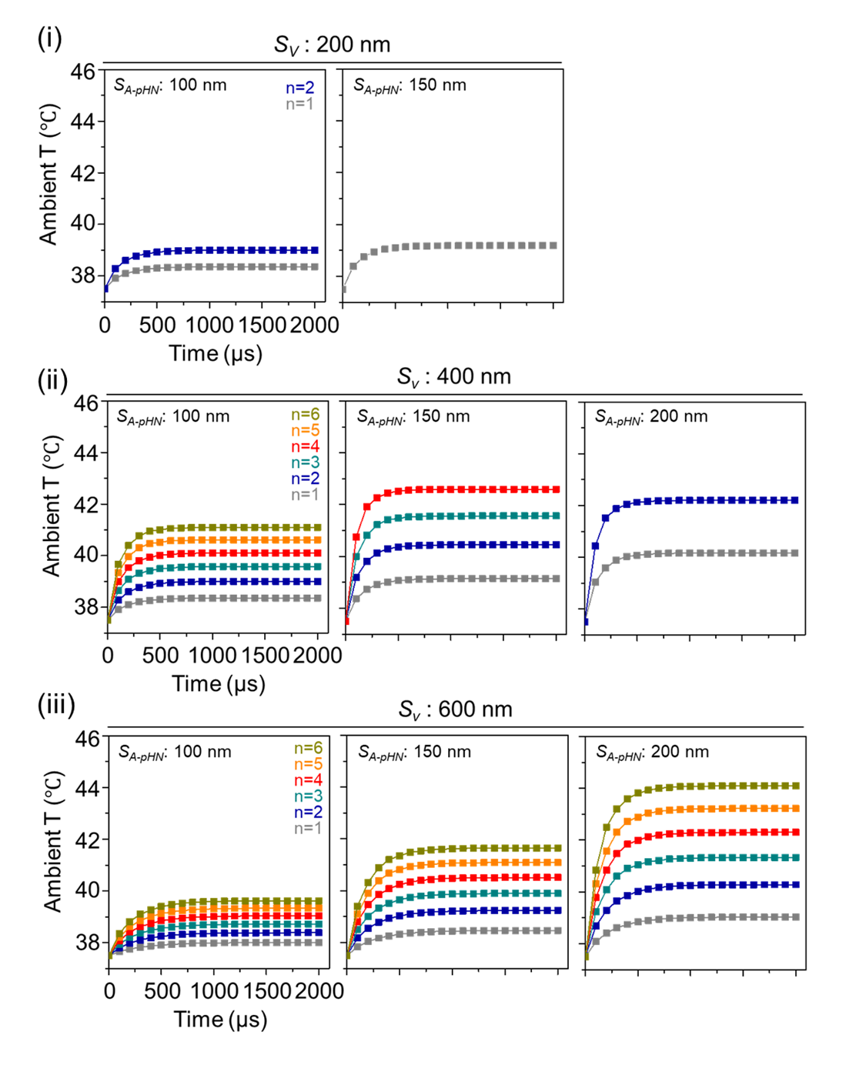
Fig. S22. Computational simulation results of heat generation from vesicles including A-PHN. Heat elevation profile using (i) S_{v}=200 nm, (ii) S_{v}=400 nm, and (iii) S_{v}=600 nm with different sizes (S_{A-PHN}) and numbers (n) of PHN.
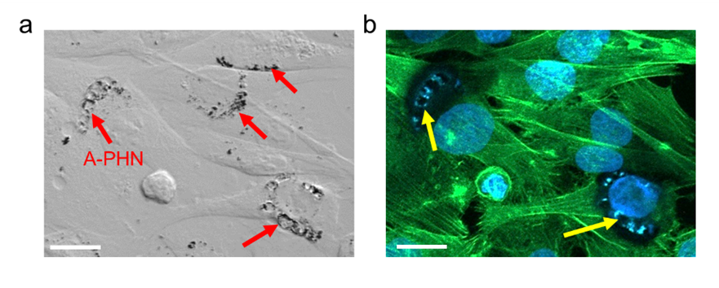
Fig. S23. Observation of the damage to the cytoskeleton by A-PHNs under exposure to 532 nm laser at 3.5 W/cm². Black dots indicate the A-PHN, the green color indicates F-actin, and blue indicates the nuclei. Scale bars are 20 µm. (a) Bright-field image after the laser illumination on the A-PHN. (b) Fluorescence image of the same area. Red arrows indicate A-PHN and yellow arrows indicate the damaged areas.
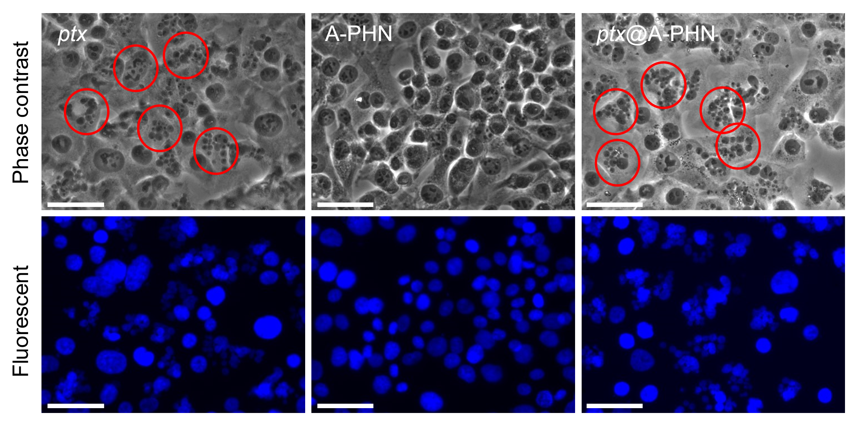
Fig. S24. Observation of nuclear fragments in A375P cells after treatment with ptx, A-PHN, and ptx@A-PHN (with light exposure), respectively. (Scale bar: 50 µm) Nuclei were stained with Hoechst. Red circles indicate the ptx-induced apoptotic nuclear fragmentations.

