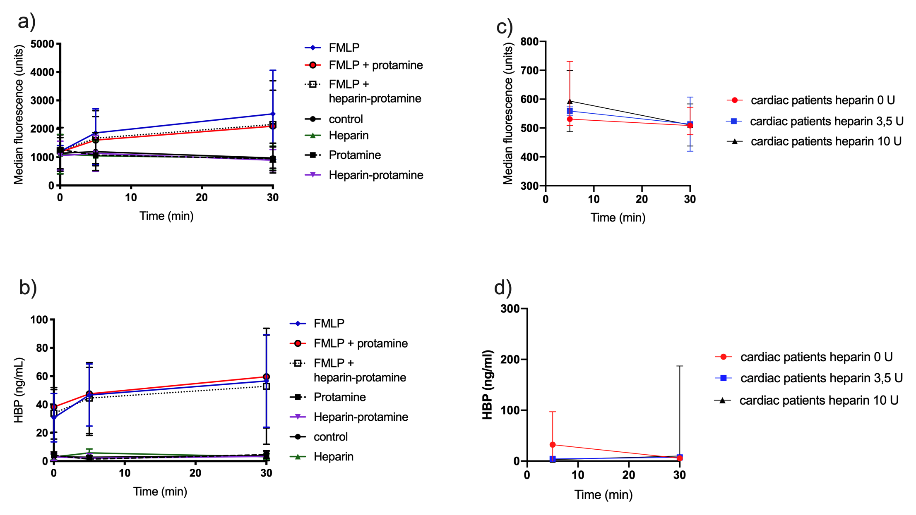

Supplementary figure 1 | In vitro stimulation of whole blood from healthy donors and patient samples: a) Neutrophil activation of healthy donors stimulated with N-Formyl-methionyl-leucyl-phenylalanine (FMLP) and additional factors (protamine or heparin-protamine complex); b) Neutrophils stimulated with FMLP showed higher heparin binding protein (HBP) release compared with neutrophils only stimulated with protamine or heparin-protamine complex; c and d) Samples taken from the additional patients before administration of heparin. The whole blood was stimulated with different concentrations of heparin ex vivo to account for the possible effects of surgical trauma. All graphs show median + interquartile range (IQR).

Supplementary Table 1| Effect of protamine and heparin-protamine on detection of HBP by ELISA.
HBP sample | Spike | HBP in unspiked sample  (ng/mL) | HBP remaining in spiked sample  (%)
1 | protamine | 169 | 80
2 | protamine | 32 | 82
3 | protamine | 7.7 | 60
4 | heparin-protamine | 126 | 97
5 | heparin-protamine | 44 | 100
6 | heparin-protamine | 6.1 | 103

Supplementary table 2 | Presentation of p values at different time points in all study groups

Sample | Reference group¹ | CABG² | Complex³
Sample 1-2 p value | - | 0.189 | 0.245
Sample 1-3 p value | - | 0.011 | 0.011
Sample 1-4 p value | - | 0.011 | 0.011
Sample 1-5 p value | - | 0.011 | 0.011
Sample 1-6 p value | - | 0.011 | 0.011
Sample 1-7 p value | 0.030 | 0.011 | 0.011
Sample 1-8 p value | - | 0.011 | 0.096
Sample 1-9 p value | - | 0.096 | 0.103
¹ Reference group (Wilcoxon signed rank test); ² CABG surgery (Wilcoxon signed rank test), ³ Complex surgery Wilcoxon signed rank test). Sample 1: at anaesthesia induction; Sample 2: 5 min before heparin; Sample 3: 5 min post heparin; Sample 4: 5 min after CPB start; Sample 5: Before ending CPB; Sample 6: 5 min post protamine: Sample 7: ICU arrival; Sample 8: 1 day post-surgery; Sample 8: 3-5 days post-surgery. CPB, cardiopulmonary bypass; ICU, intensive care unit.

Supplementary table 3 | Measurements of additional markers of inflammation and neutrophil activation.
Characteristic | CABG  (n=15) | Complex  (n=15)
At anesthesia (ng/mL)  MPO  IL8  IL6 | 0 (0-182.2)  0 (0-2.5)  0 (0-0) | 0 (0-119.2)  0 (0-0)  0 (0-0)
Before ending CPB (ng/mL)  MPO  IL8  IL6 | 5392.8 (3462.2-7695.0)  -  - | 8307.4 (4395.3-11412.2)  -  -
ICU arrival(ng/mL)  MPO  IL8  IL6 | 980.6 (191.40-1064.7)  0 (0-0)  41.8 (0-310.7) | 1994.1 (1095.6-3822.3)  0 (0-0)  295.5 (53.9-414.3)
1 day post-surgery (ng/mL)  MPO  IL8  IL6 | 119.20 (0-612.9)  0 (0-5.0)  1.57 (0-167.1) | 275.5 (24.6-723.2)  0 (0-2.9)  60.7 (13.1-161.3)
3-5 days post-surgery (ng/mL)  MPO  IL8  IL6 | 0 (0-455.4)  0 (0-6.2)  0 (0-5.8) | 371.3 (0-644.5)  0 (0-41.6)  50.4 (0-98.2)
Values expressed as median (IQR). CABG, Coronary bypass grafting; MPO, myeloperoxidase; IL, interleukin; CPB, cardiopulmonary bypass; ICU, intensive care unit.

