Extended Data Figures

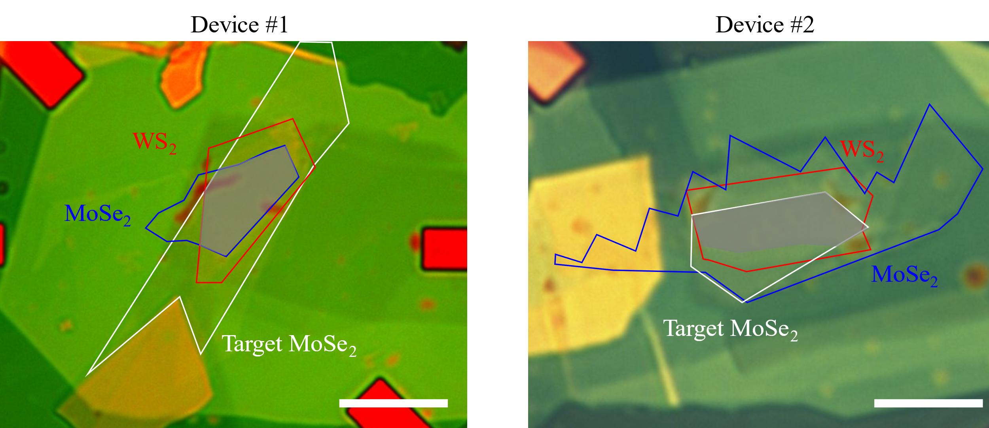

Extended Data Figure 1 | Optical image of device 1 and 2. The target MoSe₂ monolayer (white) and the moiré bilayer with monolayer MoSe₂ (blue) and WS₂ (red) are labeled and outlined. The effective area of the devices is shaded in grey. The scale bars are 10 μm.

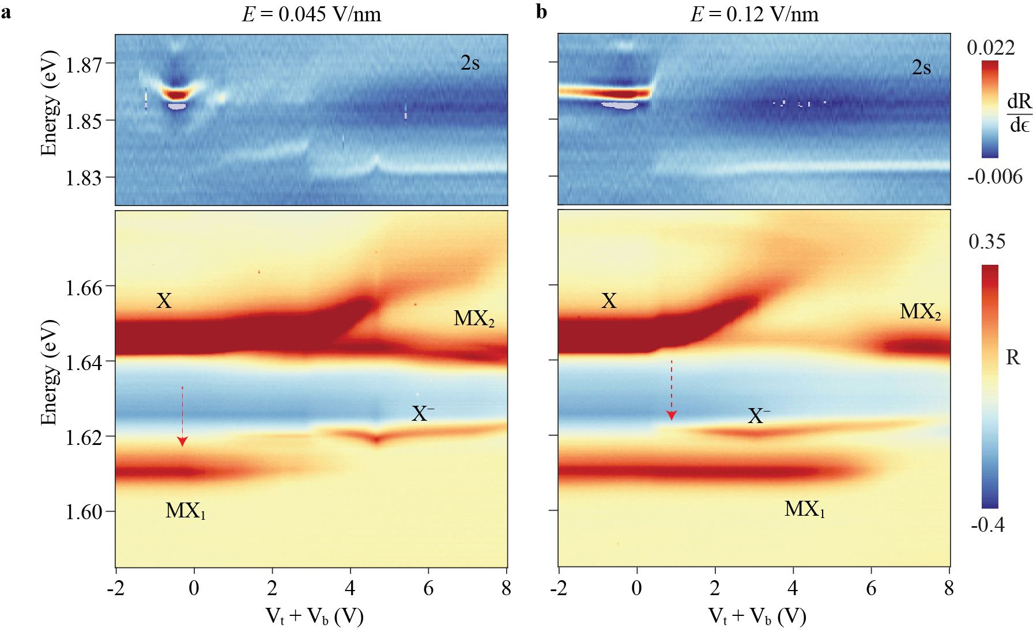

Extended Data Figure 2 | Gate dependent reflectance contrast spectrum (device 1). a,b, Gate voltage ($V_{t}+V_{b}$) dependent reflectance contrast spectrum at electric field 0.045 V/nm (a) and 0.12 V/nm (b). Five different exciton species can be identified: the fundamental moiré exciton MX₁, the excited moiré exciton MX₂, the neutral (X) and charged (X⁻) excitons of the target layer, and the 2s exciton of the sensor layer. The red dashed arrows denote the onset of electron doping in the device. The moiré (target) layer is first doped at low (high) electric field.

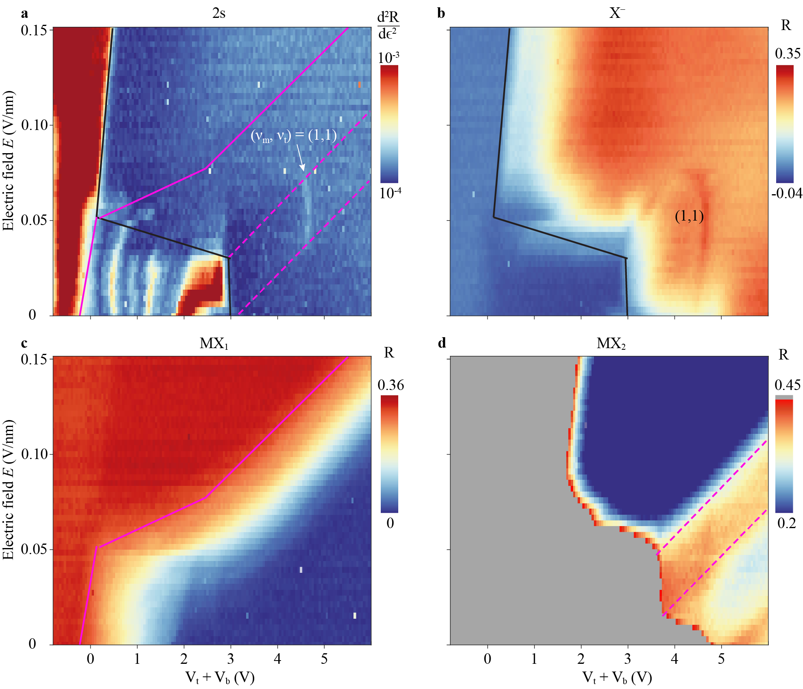

Extended Data Figure 3 | Electrostatics phase diagram (device 1). a-d, Electric-field ($E$) and gate ($V_{t}+V_{b}$) dependences of the spectral feature corresponding to the sensor 2s exciton (a), charged exciton X⁻ of the target layer (b), moiré exciton MX₁ (c) and MX₂ (d). The analysis of the reflectance contrast spectra is described in Methods. The X⁻ reflectance (b) determines the boundary between the doped (high) and neutral (low) target layer (black solid line). The MX₁ reflectance (c) determines the boundary between the doped (low) and neutral (high) moiré layer (pink solid line). The MX₂ reflectance (d) determines the boundaries of the $(ν_{m},ν_{t})=(1,ν_{t})$ region with enhanced contrast (pink dashed lines). These boundaries are included in a.

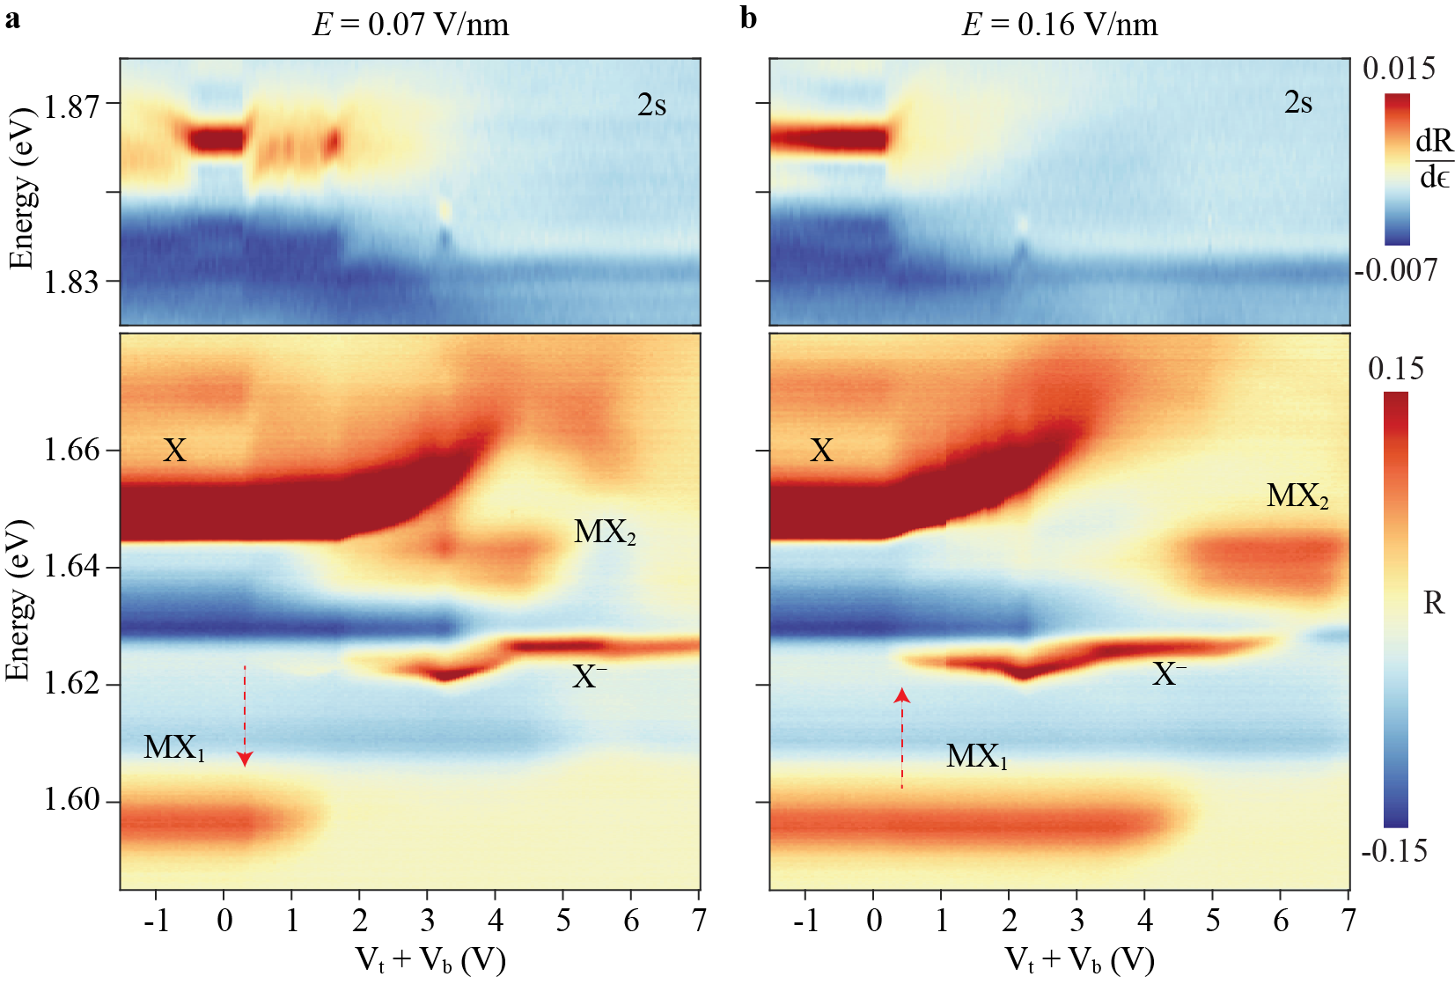

Extended Data Figure 4 | Gate dependent reflectance contrast spectrum (device 2). a,b, Gate voltage ($V_{t}+V_{b}$) dependent reflectance contrast spectrum at electric field 0.07 V/nm (a) and 0.16 V/nm (b). Similar to Extended Data Fig. 2, five different exciton species can be identified. The red dashed arrows denote the onset of electron doping in the device.

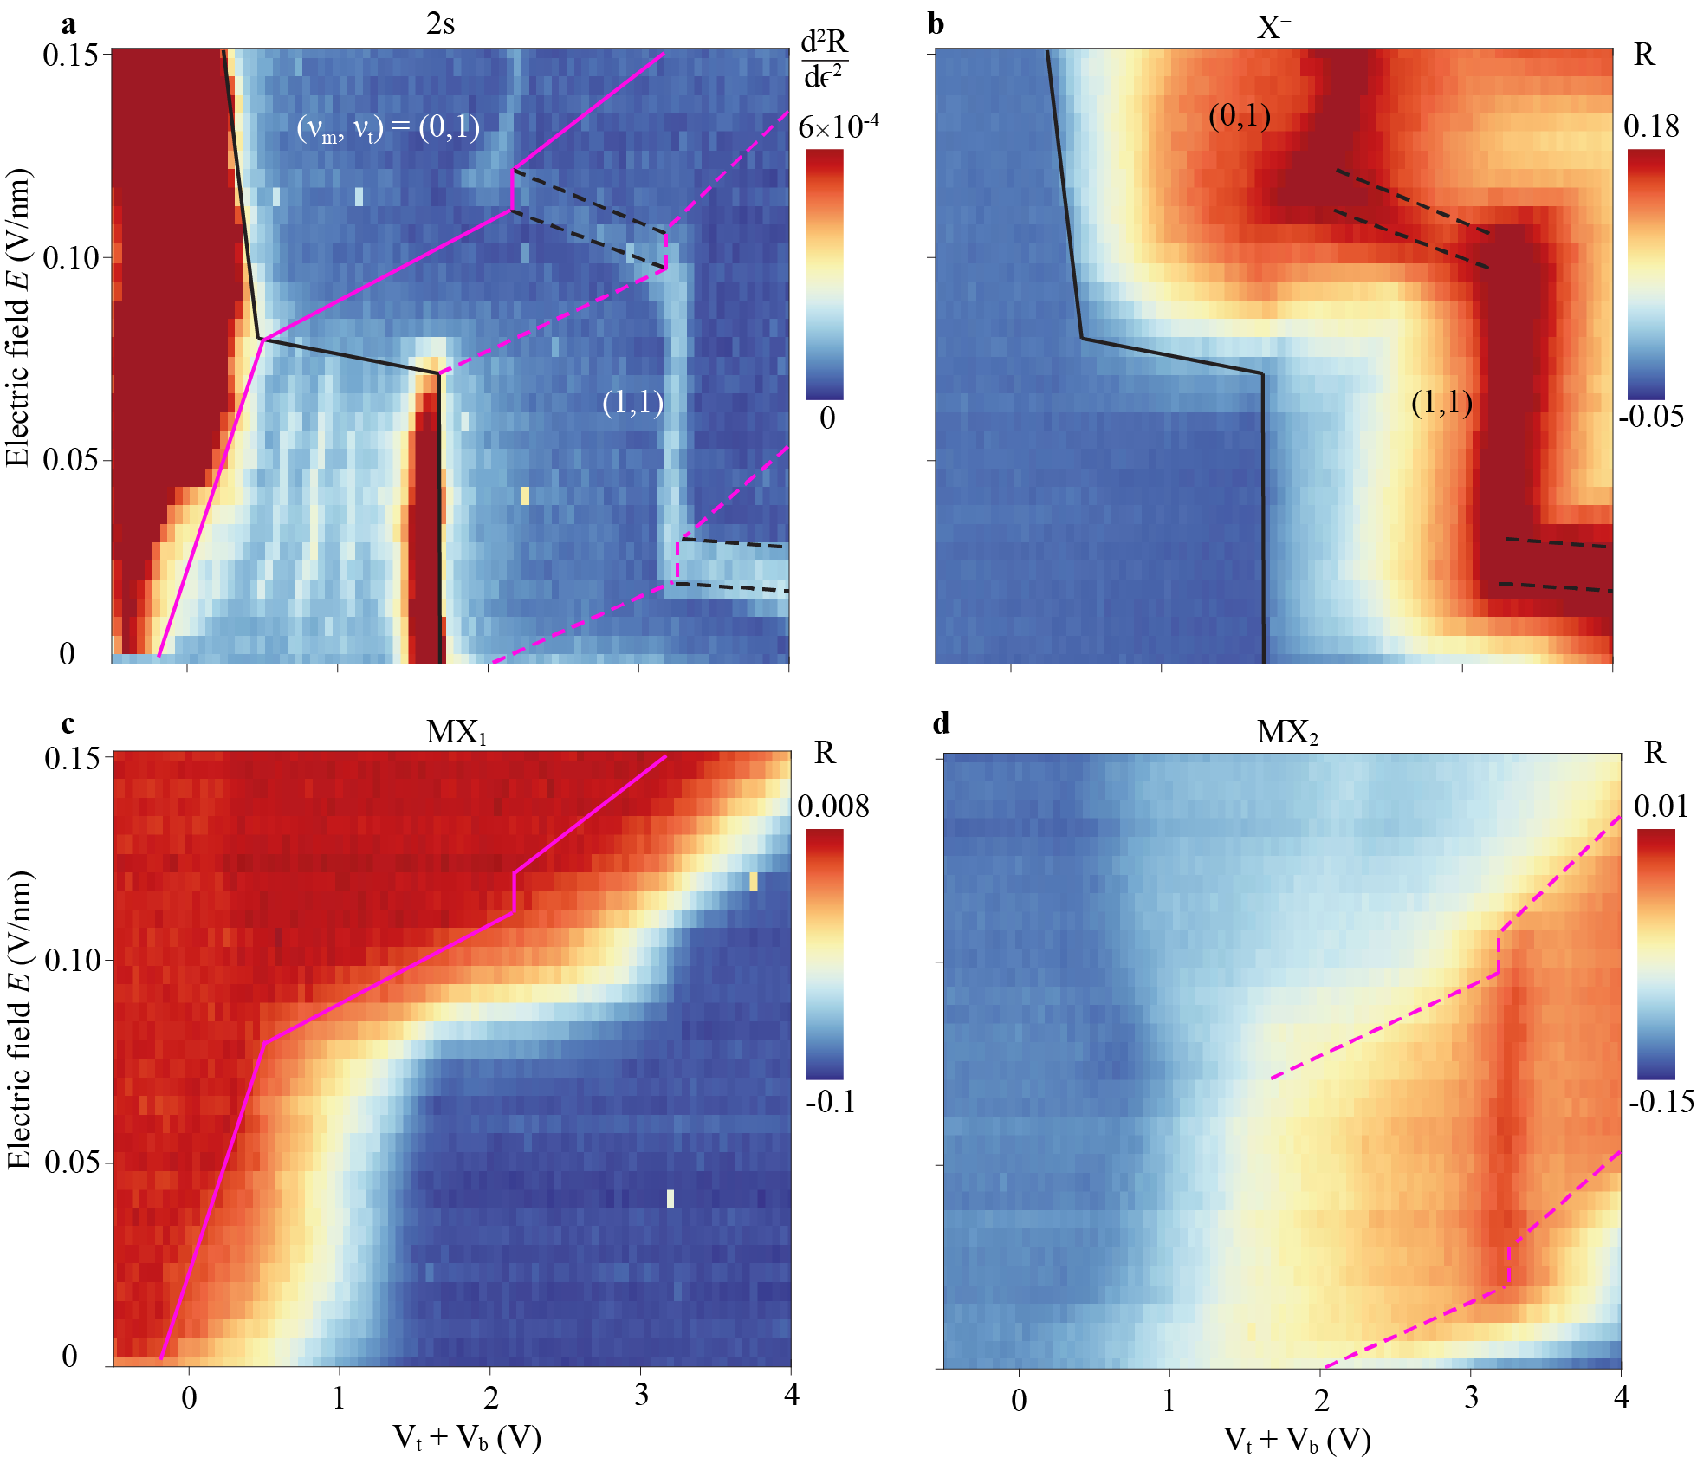

Extended Data Figure 5 | Electrostatics phase diagram (device 2). a-d, Electric-field ($E$) and gate ($V_{t}+V_{b}$) dependences of the spectral feature corresponding to the sensor 2s exciton (a), charged exciton X⁻ of the target layer (b), moiré exciton MX₁ (c) and MX₂ (d). The analysis of the reflectance contrast spectra is described in Methods. The X⁻ reflectance (b) determines the boundary between the doped (high) and neutral (low) target layer (black solid line). It also determines the boundaries (black dashed lines) of the $(ν_{m},ν_{t})=(ν_{m},1)$ region. The MX₁ reflectance (c) determines the boundary between the doped (low) and neutral (high) moiré layer (pink solid line). The MX₂ reflectance (d) determines the boundaries of the $(ν_{m},ν_{t})=(1,ν_{t})$ region with enhanced contrast (pink dashed lines). These boundaries are included in a.

