Supplementary Information

Treatments description:
Control: no amendment.
BS₁: 3 kDa (~1 nm)-filtered biogas slurry (BS) application.
BS₂₀: 300 kDa (~20 nm)-filtered BS application.
BS₂₂₀: 220 nm-filtered BS application.
BS₄₅₀: 450 nm-filtered BS application.

Table S1 Characteristics of the separated biogas slurry used in this study
 | Treatments | DRPª | P_{coll}^{b} | TP^{c} | TN^{d} | CODe | pH
 |  | (mg L^{–1}) |  |  | (g L^{–1})
Experiment 1 | BS₁ | 26.0 ± 0.32 | / | 30.6 ± 0.96 | 0.985 ± 0.042 | 0.87 ± 0.14 | 8.36 ± 0.02
 | BS₄₅₀ | 47.8 ± 1.71 | 23.6 ± 1.07 | 54.3 ± 1.26 | 1.17 ± 0.045 | 2.25 ± 0.45 | 8.29 ± 0.22
Experiment 2 | BS₁ | 52.8 ± 4.16 | / | 110 ± 4.74 | 0.971 ± 0.103 | 0.94 ± 0.13 | 8.64 ± 0.05
 | BS₂₀ | 67.0 ± 2.89 | 24.4 ± 0.87 | 135 ± 2.81 | 1.14 ± 0.425 | 2.54 ± 0.35 | 8.87 ± 0.07
 | BS₂₂₀ | 75.9 ± 2.11 | 28.6 ± 0.98 | 148 ± 1.56 | 1.16 ± 0.329 | 2.76 ± 0.29 | 8.70 ± 0.10
 | BS₄₅₀ | 72.3 ± 1.90 | 29.8 ± 1.41 | 146 ± 4.26 | 1.28 ± 0.354 | 3.01 ± 0.74 | 8.90 ± 0.13
ª DRP: dissolved reactive phosphorus.
^{b} P_{coll}: colloidal phosphorus.
^{c} TP: total phosphorus.
^{d} TN: total nitrogen.
^{e} COD: chemical oxygen demand.

Table S2 Concentration of colloidal Fe, Al in rhizosphere soil solution after BS-derived colloids application over time (n = 3)
Treatments | Al_{coll}ª |  |  |  |  | Fe_{coll}^{b}
 | (mg L^{–1}) |  |  |  |  | (mg L^{–1})
 | 0d | 5d | 15d | 25d | 45d | 0d | 5d | 15d | 25d | 45d
Control | 1.08 ± 0.04 | 1.10 ± 0.06 | 0.62 ± 0.12 | 0.44 ± 0.12 | 0.53 ± 0.08 | 0.21 ± 0.01 | 0.26 ± 0.04 | 0.14 ± 0.03 | 0.11 ± 0.02 | 0.14 ± 0.03
BS₁ | 1.52 ± 0.05 | 1.32 ± 0.22 | 0.80 ± 0.15 | 0.78 ± 0.06 | 0.82 ± 0.08 | 0.83 ± 0.02 | 0.80 ± 0.04 | 0.51 ± 0.07 | 0.48 ± 0.03 | 0.52 ± 0.04
BS₂₀ | 2.98 ± 0.15 | 2.05 ± 0.26 | 1.04 ± 0.17 | 1.08 ± 0.04 | 0.93 ± 0.14 | 1.87 ± 0.18 | 1.36 ± 0.05 | 0.69 ± 0.09 | 0.69 ± 0.02 | 0.56 ± 0.08
BS₂₂₀ | 3.03 ± 0.18 | 2.20 ± 0.29 | 1.32 ± 0.19 | 1.03 ± 0.18 | 1.07 ± 0.06 | 2.03 ± 0.25 | 1.37 ± 0.10 | 0.86 ± 0.09 | 0.63 ± 0.11 | 0.64 ± 0.03
BS₄₅₀ | 3.16 ± 0.13 | 2.41 ± 0.18 | 1.35 ± 0.08 | 1.14 ± 0.11 | 1.12 ± 0.12 | 2.10 ± 0.17 | 1.45 ± 0.09 | 0.88 ± 0.06 | 0.71 ± 0.06 | 0.72 ± 0.03

ª Al_{coll}: mobile colloidal aluminum.
^{b} Fe_{coll}: mobile colloidal iron.

Table S3 Rice biomass and total P content in soils with the application of BS with and without colloids (n=3)
Soil | Treatments | Biomass (g plant^{–1} DW) |  | P content (g kg^{–1})
 |  | Shoot | Root | Shoot | Root
Soil 1 | Control | 0.86 ± 0.06 | 0.16 ± 0.03 | 2.79 ± 0.14 | 1.60 ± 0.06
Silt loam | BS₁ | 1.05 ± 0.08 | 0.20 ± 0.03 | 2.92 ± 0.10 | 1.73 ± 0.05
 | BS₄₅₀ | 0.83 ± 0.03 | 0.13 ± 0.01 | 2.75 ± 0.08 | 1.58 ± 0.03
Soil 2 | Control | 0.30 ± 0.03 | 0.05 ± 0.01 | 2.28 ± 0.12 | 0.88 ± 0.22
Sandy loam | BS₁ | 0.87 ± 0.10 | 0.19 ± 0.03 | 2.44 ± 0.07 | 1.32 ± 0.05
 | BS₄₅₀ | 0.81 ± 0.06 | 0.17 ± 0.03 | 2.36 ± 0.17 | 1.27 ± 0.07

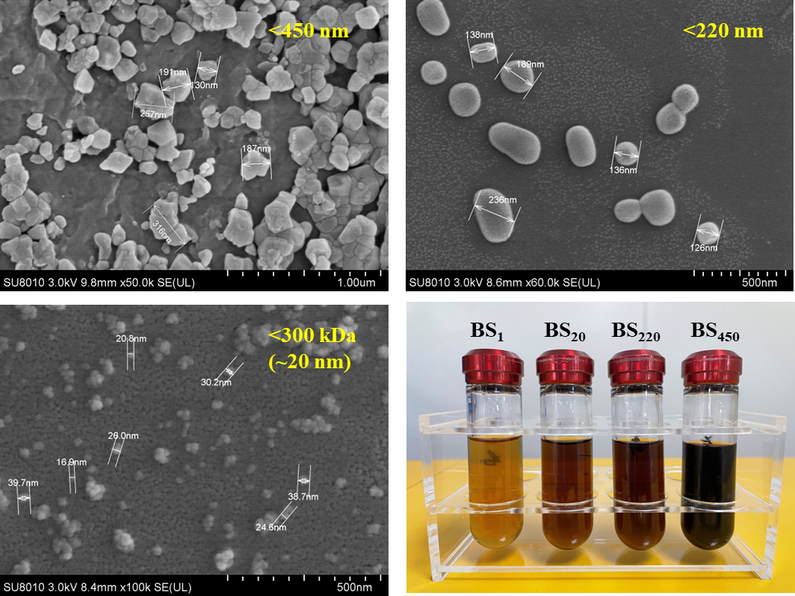
Fig. S1 Scanning electron micrographs (SEM) of BS-derived colloids
Methods: The 450 nm, 220 nm and 300 kDa (~20nm) filtered BS were collected and freeze-dried in a freeze-drying machine (FD-B10N-50), respectively, and then subjected to ion sputtering to make the surface of the sample conductive. After that, the surface morphology of the BS colloidal particles was observed by thermal field emission scanning electron microscope (SIRION-100, Netherlands).

Fig. S2 The calibration line between the enzyme activity and the gray value

Fig. S3 (A): Heat map of correlation between phosphatase and soil solution properties, (B): heat map of correlation between RBA_{coll} and phosphatase activity, other plant indexes based on Pearson correlation coefficients. P_{coll}, total colloidal phosphorus; SRP, soil solution dissolved reactive phosphorus; MRP_{coll}, colloidal molybdate reactive phosphorus; MUP_{coll}, colloidal molybdate unreactive phosphorus; Al_{coll}: mobile colloidal aluminium; Fe_{coll}: mobile colloidal iron; Shoot P, shoot P content; Root P, root P content; ACP, acid phosphatase average activity; ALP, alkaline phosphatase average activity; Hotspot_{ACP}, the hotspot areas of acid phosphatase; Hotspot_{ALP}, the hotspot areas of alkaline phosphatase. *correlation is significant at p < 0.05 (two-tailed); **correlation is significant at p < 0.01 (two-tailed)

Fig. S4 Concentration of pH, DOC (mg L⁻¹) and EC (mS cm⁻¹) in rhizosphere soil solution after BS-derived colloids application over time.

