Supplementary materials
Direct and indirect photodegradation of bisphenol-A in the presence of natural water components
Yao Han1·Lijun Li2·Lu Jin1·Rong Zhou¹·Yayu Li¹·Weiwen Jing^{1*}
(1 College of Chemical Engineering, Xinjiang Agricultural University, Xinjiang Uygur Autonomous Region,
Urumqi, 830052, China
2 Shenyang Center of China Geological Survey, Liaoning Province, Shenyang, 110034, China)
*Corresponding author phone/fax: +86-991-8762934; e-mail:479218061@qq.com

38 Pages, 11 Figures, 9 Tables

Chemicals
Photodegradation experiments
Comprehensive experiment design
Fig. S1 a---Distribution of different species of BPA as a function of pH
b---UV-vis absorption spectra of BPA (solid line) and spectral irradiance of the light source (dot line)
Fig. S2 UV-vis absorption spectra of BPA and different concentration HA (solid line) and the emission spectra of light source (dotted line)
Fig. S3 Effect of NH+ 4on the photodegration of BPA
Fig. S4 UV absorption spectra of BPA, NO- 3, NO- 2 and NH+ 4
Fig. S5 Photodegradation of BPA and AP (a), BPA, AP and BA (b) and AP, BA and BPA (c) in different systems
Fig. S6 Formation of H₂O₂ and ·OH in the UV/air, UV/Fe³⁺/air and UV/Fe²⁺/air systems
(C_{BPA}=10 mg L⁻¹, C_{Fe}³⁺ or C_{Fe}²⁺ = 1.0 mM, pH=4± 0.1)
Fig. S7 Effect of chloride ion on BPA photodegradation
Fig. S8 Formation of H₂O₂ and ·OH under different Cl⁻ concentrations
Fig. S9 Comparison between the predicted value and the real value of the model
Fig.S10 Mass spectra of BPA photolysis products (GC-MS)
Fig. S11 MS spectra of BPA and photodegradation products(UHPLC-Q-Orbitrap-MS/MS)
Table S1 Specific water quality parameters of natural water sample
Table S2 Factors and concentration levels in central combination test
Table S3 Shielding factors of different concentrations of HA on BPA photodegradation
Table S4 Steady concentration of photogenerated ·OH in the different systems (C_{AP}=0.11 mM)
Table S5 BBD experimental design and response value
Table S6 Analysis of variance (ANOVA) test and Estimated coefficients of significance for the
response function Y
Table S7 The photodegradation kinetics parameters and quench experiments of BPA in pure water (PW) and natural water (NW)
Table S8 GC-MS analysis results for photodegradation intermediates and product of BPA in pure water (Ⅰ), nitrate-containing solution (NO- 3, Ⅱ; NO-- 2, Ⅲ；NO- 3+NO-- 2, Ⅳ), HA-containing solution (Ⅴ), Cl⁻- containing solution (Ⅵ) and Cl⁻-HA- containing solution (Ⅶ)
Table S9 UHPLC-Q-Orbitrap-MS/MS analysis results for photodegradation intermediates and product of bisphenol A in in pure water (Ⅰ), nitrate-containing solution (NO- 3, Ⅱ; NO-- 2, Ⅲ；NO- 3+NO-- 2, Ⅳ), Cl⁻- containing solution (Ⅴ) and Cl⁻-HA- containing solution (Ⅵ), NO- 3-Cl⁻-HA- containing solution(Ⅶ)

Chemicals
All chemicals were analytical-reagent grade at least. The analytical standard of BPA (>99.8%), humic acid (HA, ≥90%), p-benzoquinone (BQ, 99%, O₂·⁻ quencher), 4-benzoyl benzoic acid (CBBP), and Sulfadiazine (SAs) were purchased from Aladdin Biochemical Technology Co., Ltd. (Shanghai, China). Benzoic acid (BA, Cl· and Cl₂^{-·} probe) standard, H₂O₂ (1000 mg L⁻¹, ·OH sensitizer) and acetophenone (AP, ·OH probe) were supplied from Dr. Ehrenstofer GmbH (Augsburg, Germany), North Weiye Metrology Technology Research Institute (Beijing, China) and Macleans Biochemical Technology Co., Ltd. (Shanghai, China), respectively. Isopropanol (IPA, ·OH quencher), sodium azide (NaN₃, ¹O₂ and ·OH quencher), sorbic acid (SA, the excited triplet states quencher), NaNO₃, NaNO₂, NaClO, t-butanol (TB, ·OH and RHS quencher), NH₄HCO₃, CH₂Cl₂ and Na₂SO₄, HClO₄ (70%) and NaOH were all purchased by Fuchen Chemical Reagent Factory (Tianjin, China). N,O-bis (trimethylsilyl) trifluoroacetamide (BSTFA) and HPLC grade methanol were obtained from Sigma-Aldrich Trading Co., Ltd. (Bellefonte, USA). Ultra-pure water was prepared with an ultrafilter from Tang’s Corning Technology Development Co., Ltd. China. All stock solutions were made up and diluted in ultra-pure water and stored in a refrigerator. The complete dissolution of BPA in water at room temperature was assisted by ultrasound and tested by high performance liquid chromatography (HPLC).
Photodegradation experiments
The photolysis reactions were conducted in a temperature controlled WATTCAS Parallel light Reactor (WP-TEC-1020) with 275-280 nm COB-LED cooled and filtered ultraviolet light source. Photochemical experiments were performed in a capped cylindrical quartz photolysis tube (16 mm i.d., containing 20 mL of solution). The incident light intensity impacting on the solutions was 7.97 mW cm⁻². The reaction temperature was maintained at 30 ± 1 °C by cold water. Unless noted otherwise, all experiments were performed under air condition and pHs were fixed at 7.0 ± 0.05 by adjusting the solutions with NaOH and HClO₄. Except the initial concentration experiment, the initial concentration of BPA was generally 10 mg L⁻¹. Dark control experiments were conducted in high-pure water. At given reaction time intervals, samples were taken out and analyzed by HPLC. Each experiment was conducted in triplicate with relative errors less than 10%.
The natural water samples were spiked with the test compound and different concentrations of nitrate, HA, iron and chloride and irradiated to evaluation the effect of natural matrix on BPA photodegradation. Surface waters were collected at three locations in Xinjiang Uygur Autonomous Region, China in September 2021: I. 41°35'15.72''N, 86°14'26.52''E (reservoir water); II. 41°34'18.80''N, 86°14'31.88''E (river water); III. 41°44'58.92''N, 86°7'24.96''E (river water). Samples were collected in 3-L amber glass bottles and transported to the laboratory. Samples were filtered immediately (0.45 μm) and stored at 4 °C until analyzed.

Identification of Photodegradation Products
The possible photodegradation products of BPA were identified via triple quadrupole tandem GC-MS (7890-7000D, Agilent) and Ultimate 3000 UHPLC - Q Exactive Orbitrap highresolution liquid chromatography-mass spectrometry (UHPLC-Q-Orbitrap-MS/MS, Thermo Scientifific) equipped with the heated electrospray ionization (HESI) source.
GC-MS: The sample solutions were extracted using CH₂Cl₂ (20 mL×3) and then desiccated by Na₂SO₄. After filtration, the extracts were steamed to nearly dry with a rotary evaporation instrument and then derivatized with 50 μL BSTFA at 40 °C for 20 min. Then, these silylated mixtures were determined by GC-MS. A HP-5 MS capillary column (30 m × 0.25 mm × 0.25 μm) was used with ultrapure helium as the carrier gas at a flow rate of 1 mL·min⁻¹. The facility was operated at the positive electron ionization of 70 eV. The injection, detector and EI source temperatures were all set at 250 ℃. The injection volume was 1.0 μL with the split ratio 20:1. The column temperature program was: the initial temperature was 40 °C for 5 min and increased to 280 °C at 6 °C·min⁻¹ with 10 min holding. The information of BPA photodegradation products was acquired in the full-scan mode of m/z 50 to 600 and the solvent delay time was adjusted to 2 min.
UHPLC-Q-Orbitrap-MS/MS: The reaction solution was analyzed by UHPLC-Q-Orbitrap-MS/MS after 30 min UV light irradiation . All mathematically possible formulas for each ion were calculated with a mass tolerance of ±10 ppm. Chromatographic separation was conducted using an UltiMate 3000 HPLC (Thermo Scientific, U.S.A.) with gradient elution of water and acetonitrile as the mobile phase at a flow rate of 0.6 mL min⁻¹. Elution started with 90% water and reduced linearly to 10% in 15 min with 10 min holding and then back to 90% in another 5 min. The injection volume was 50 μL. MS analysis for photoproducts identification was performed in negative ionization mode. The HESI-source parameters were set as follows: spray voltage, 3.2 kV; capillary temperature, 300 °C; sheath gas, 40 mL min⁻¹; probe heater temperature, 350 °C; Auxiliary gas rate, 10 mL min⁻¹; S-lens, 50%; NCE, 40, 60 and 80. The full-scan mode of m/z 50 to 600. The structures and formulas of the photolysis products were detected based on precise m/z analysis using Xcalibur 2.0 software .
Data calculation and evaluation
- Second-order rate constant measurement
The second-order rate constant k _{BPA,·OH,} k_{BPA, Cl·}, k_{BPA, Cl2}^{·-} was determined using a competition kinetics method. according to equation (S1):
(S1)
where, BPA_{t}, BPA₀, AP_{t} and AP₀ are the concentrations of BPA and AP at time t and 0, respectively. k_{·OH, AP} is the second-order reaction rate of the reaction between AP and ·OH (k_{AP,·OH}= 5.9×10⁹ M⁻¹ s⁻¹, Kelly et al., 2012). In this method, experiments were conducted with solutions involving AP (a reference compound, 0.1 mM), BPA (10 mg L⁻¹) and H₂O₂ (photosensitizer, 0.5 mM) dissolved in pure water. ln(BPA_{t}/BPA₀) and ln(AP_{t}/AP₀) were obtained through the slope of the line resulting from plotting the rates of loss of BPA and AP against time. The amount of BPA and AP remaining in each solution after exposure to the UV irradiation was measured by HPLC.
- Steady-state concentrations [·OH]ss
The steady-state photogenerated ·OH concentration [·OH]_{ss} was estimated using AP-containing solution (0.1 mM) by equation (S2):
(S2)
where, [AP] is the equilibrium concentration of AP (mM). k_{obs, AP} is pseudo first-order rate constant for AP degradation and k_{·OH, AP} is second-order rate constant for AP and ·OH.
- The specific contribution of different ROS
Quenching experiments were employed with the radical inhibitors IPA (100 mM), NaN₃ (100 mg L⁻¹), SA (20 mg L⁻¹), BQ (100 mg L⁻¹) and TB (20 mM) to the reaction solutions respectively (Armbrust et al., 2000; Avila et al., 2006; Boreen et al., 2008; Zhang et al., 2018; Zhao et al., 2019). The contribution ratios of ·OH, ¹O₂, O₂·⁻, BPA* and RHS were calculated by following equations:
(S3)
(S4)
(S5)
(S6)
(S7)
Where, R_{·OH}、R¹O₂、RO₂^{.-}、R_{BPA*} and R_{RHS} represent the contribution ratios of the self-sensitized photolysis mediated by ·OH, ¹O_{2,} O₂·⁻ , BPA* and RHS in BPA photodegradation, respectively. k_{IPA}, k_{NaN3,} k_{BQ}, k_{SA} and k_{TB} are the photolysis rate constants of BPA in pure water and with the presence of IPA, NaN₃, BQ, SA and TB, respectively.
- The shielding coefficient ∑Sλ of HA for BPA photolysis
The shielding coefficient of HA for BPA photolysis is calculated as follows (Zeng et al., 2012):

(S8)
(S9)
Where, S_{λ} represents optical shielding coefficient of HA to BPA at wavelength λ, ∑S_{λ} represents the total shielding coefficient of HA to BPA in the range of BPA UV absorption wavelength; ɑ_{λ} (cm⁻¹) is absorbance of HA at wavelength λ, ε_{λ} is molar absorption of BPA at wavelength λ and L is optical path (cm).
Comprehensive experiment design
In order to study the multivariate interactions of factors on the photodegradation of BPA, a four-factor (Cl⁻, NO- 3, Fe(III) and HA) with 3 concentration levels and 5 replicates of the center point was employed (Table S2) to probe the multivariate effects by Design-Expert 8.0 software according to the principle of Box-Behnken design (BBD) method which is based on the response surface methodology (RSM) (Box and Wilson, 1951; Li et al., 2018). Multiple linear regression and analysis of variance are used to analyze and establish the mathematical model, which is represented by the following equation:
(S10)
Where Y is the observed pseudo-first order photodegradation rate constants of BPA, considering as the response function. X_{i} and X_{j} are independent variables. β₀ is intercept (constant term); β_{i} and β_{ii} are linear and squared coefficients of the first and second terms, respectively. β_{ij} is interaction coefficient for different factors and ε is a random error.

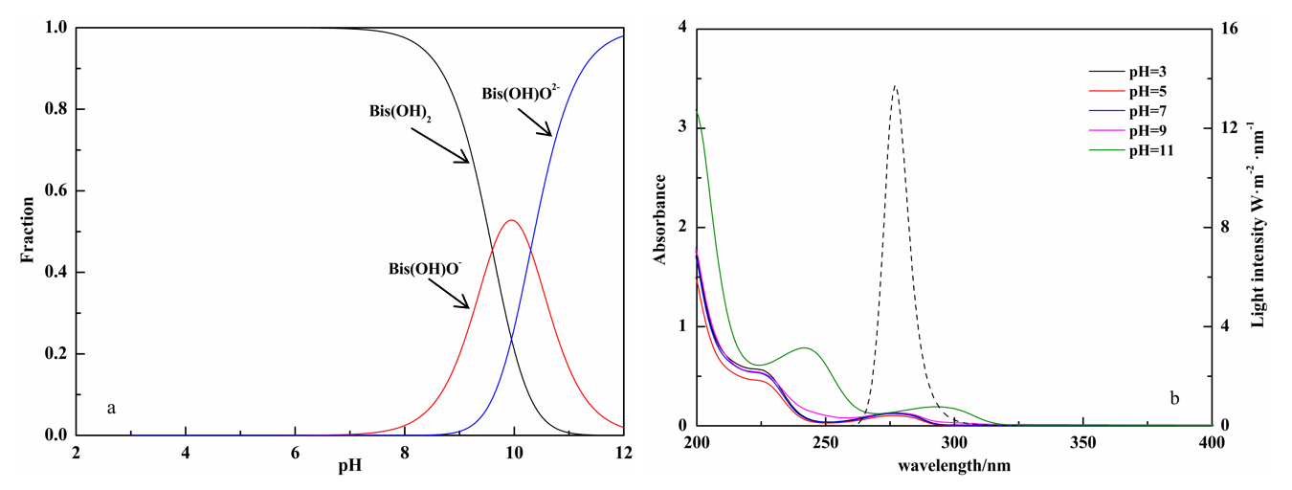
Fig. S1 a---Distribution of different species of BPA as a function of pH
b---UV-vis absorption spectra of BPA (solid line) and spectral irradiance of the light source (dot line)

Fig. S2 UV-vis absorption spectra of BPA and different concentration HA (solid line) and
the emission spectra of light source (dotted line)

Fig. S3 Effect of NH+ 4on the photodegration of BPA

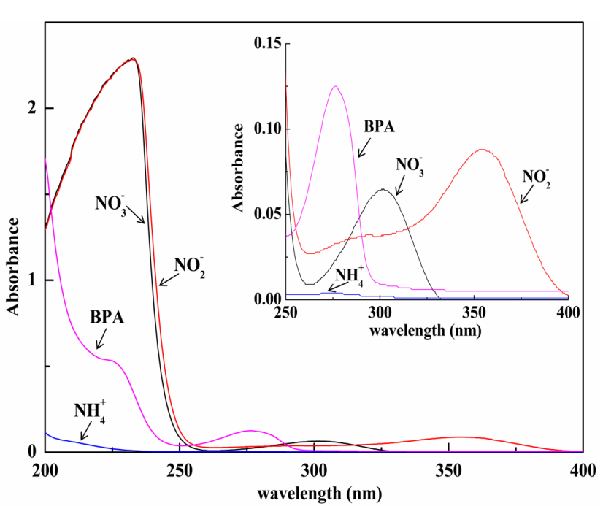
Fig. S4 UV absorption spectra of BPA, NO- 3, NO- 2 and NH+ 4

Fig. S5 Photodegradation of BPA and AP (a), BPA, AP and BA (b) and AP, BA and BPA (c) in different systems
a--Competitive hydroxyl radicals oxidation of BPA versus the reference compound AP (acetophenone) in UV/H₂O₂ system experiment procedures. The reactions were carried out in Quartz vessel. The initial solution contained: 0.11 mmol·L⁻¹ acetophenone and BPA (10 mg L⁻¹) at pH=7 ± 0.1 (adjusted by HClO₄ and NaOH). The reaction was initiated by addition of 0.5 mM H₂O₂ to the vessel. Samples (0.5 mL) were withdrawn.
b--Photodegradation of AP, BA (reference compound) and BPA (target compound) in the presence of the Cl· sensitizer NaClO at pH=7 ± 0.1 (adjusted by HClO₄ and NaOH). Initial conditions: AP concentration: 0.11 mM; NaClO concentration: 5 mg L⁻¹; BA: 10 mg L⁻¹; BPA: 10 mg L⁻¹.
c--Photodegradation of AP, BA (reference compound) and BPA (target compound) in the presence of the Cl₂⁻· sensitizer NaClO and Cl⁻ at pH=7 ± 0.1. Initial conditions: AP concentration: 0.11 mM; NaClO concentration: 5 mg L⁻¹; BA: 10 mg L⁻¹; BPA: 10 mg L⁻¹; Cl⁻: 0.2 M.

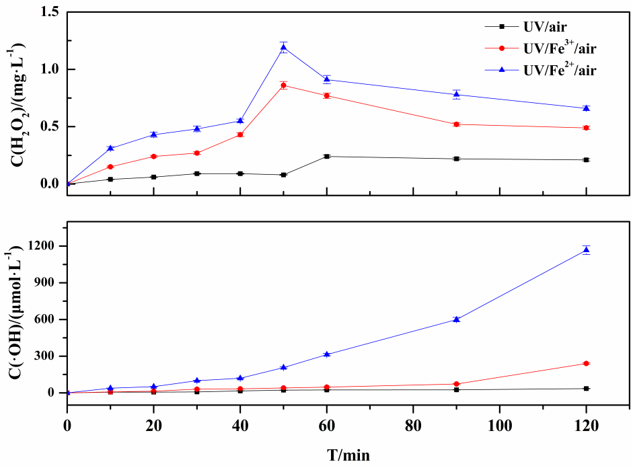
Fig. S6 Formation of H₂O₂ and ·OH in the UV/air, UV/Fe³⁺/air and UV/Fe²⁺/air systems
(C_{BPA}=10 mg L⁻¹, C_{Fe}³⁺ or C_{Fe}²⁺ = 1.0 mM, pH=4 ± 0.1)

Fig. S7 Effect of chloride ion on BPA photodegradation

Fig. S8 Formation of H₂O₂ and ·OH under different Cl⁻ concentrations

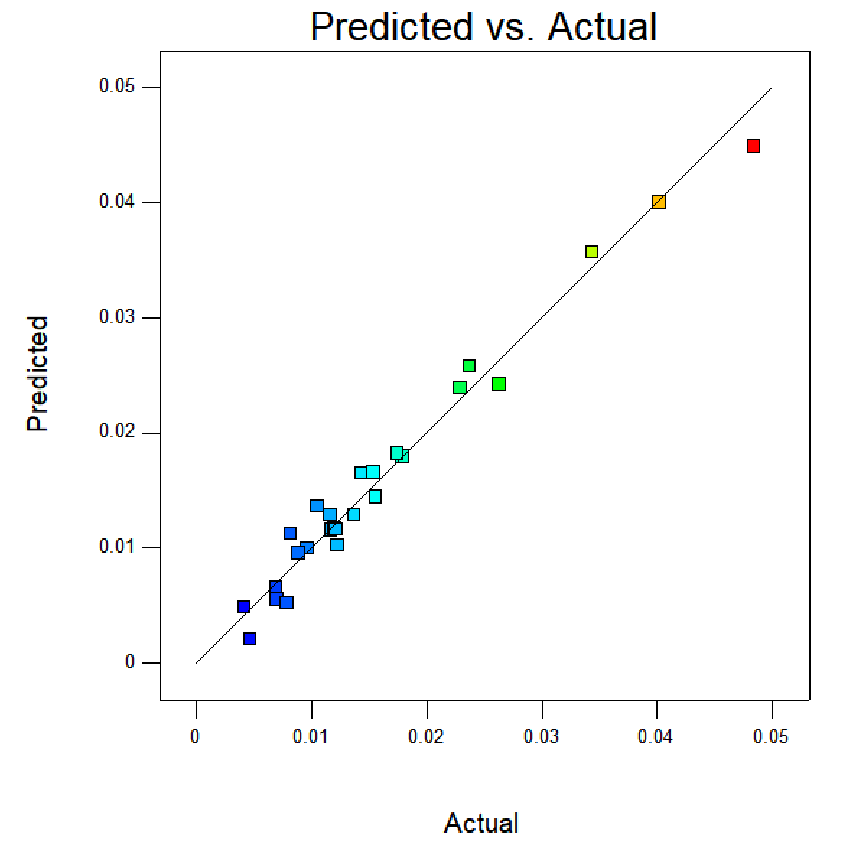
Fig. S9 Comparison between the predicted value and the real value of the model

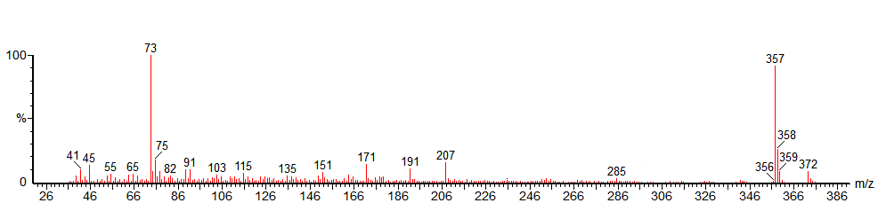
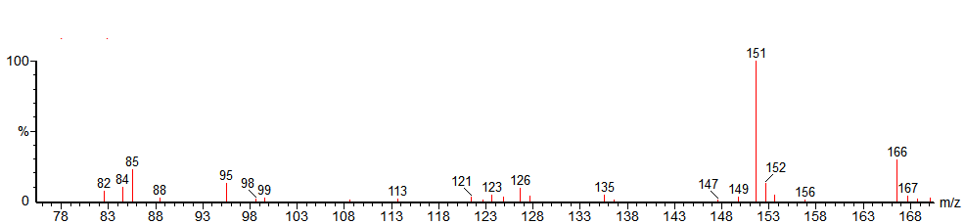
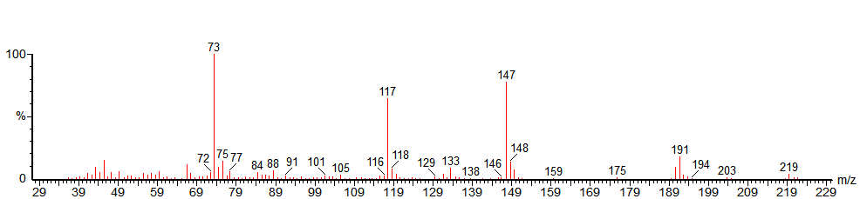
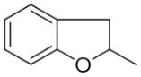
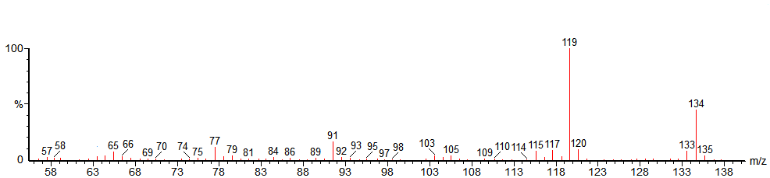
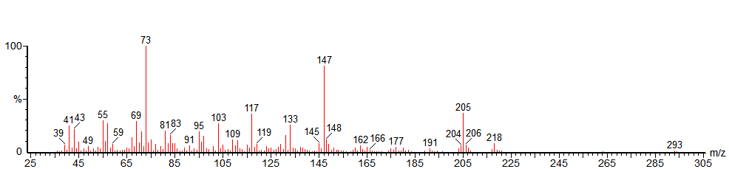

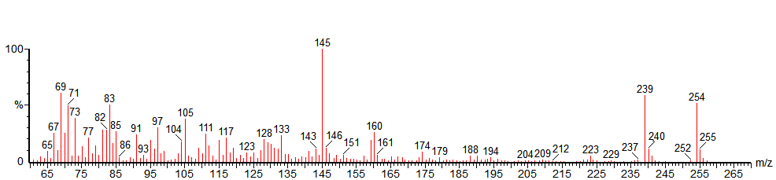
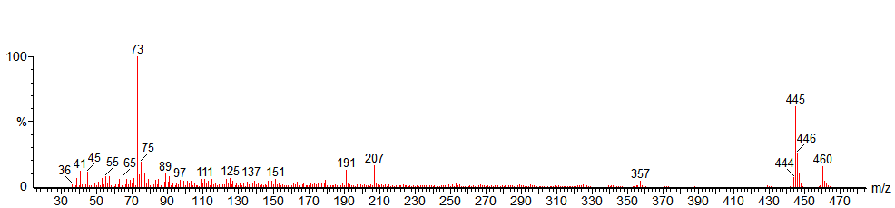
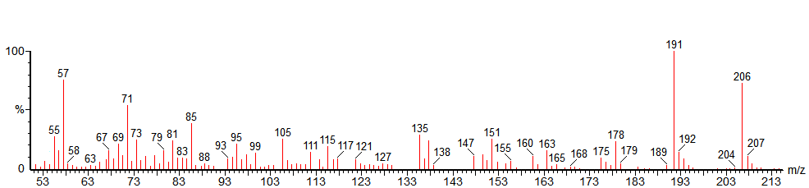
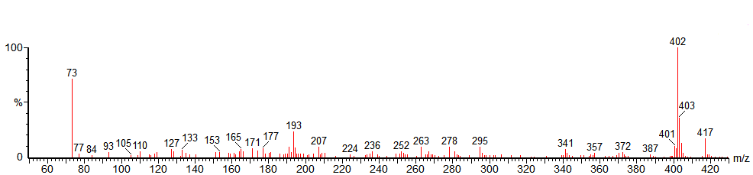
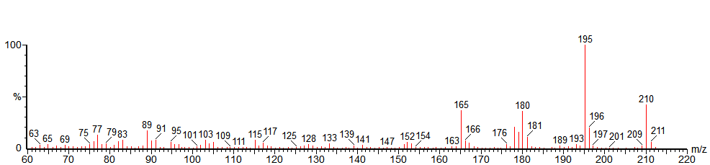
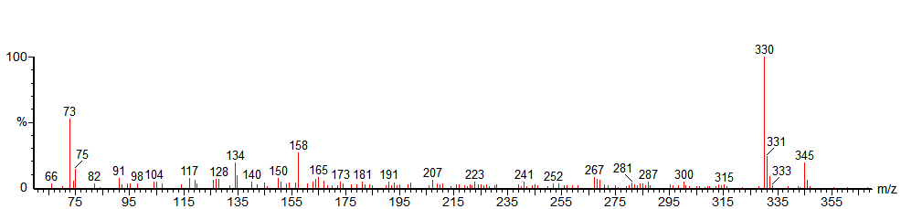

or
or
Fig. S10 MS spectra of BPA photolysis products (GC-MS)

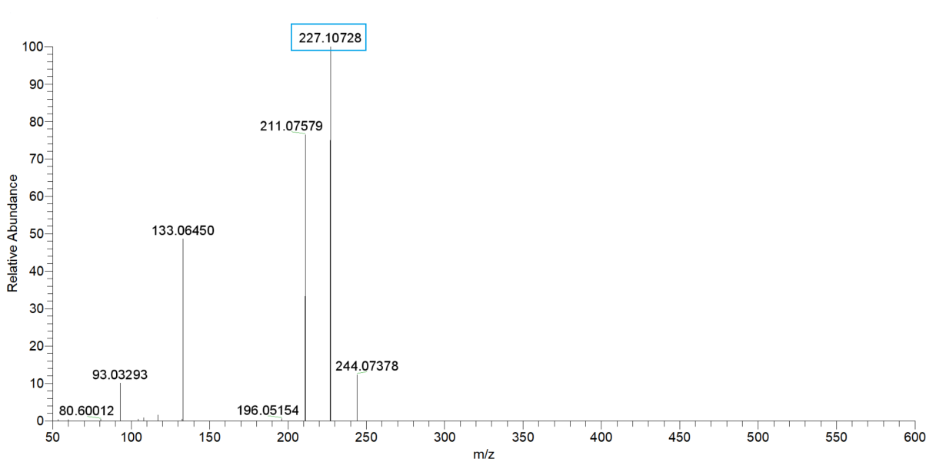
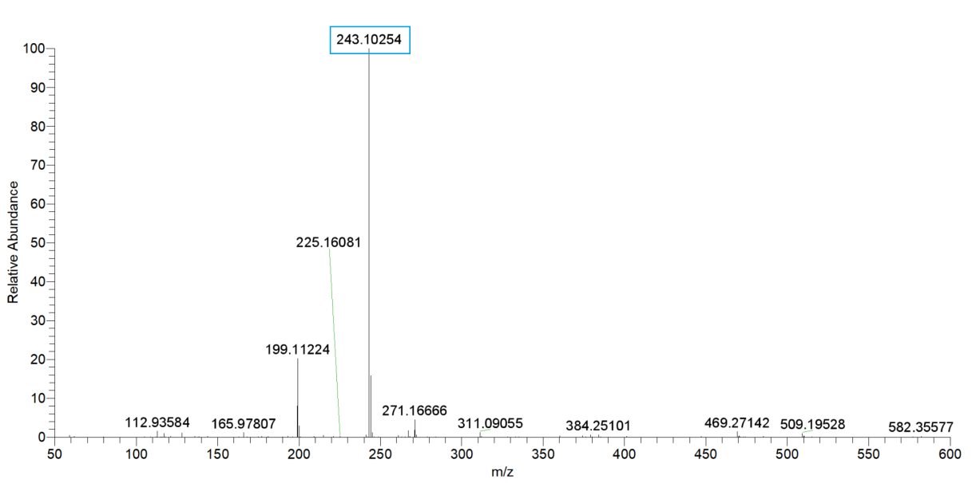
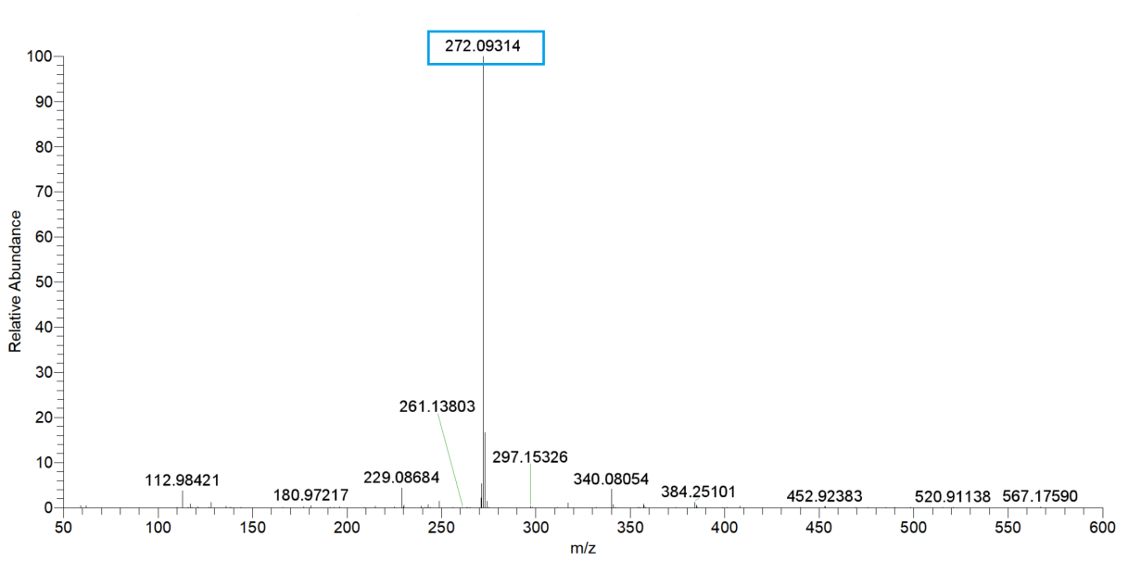

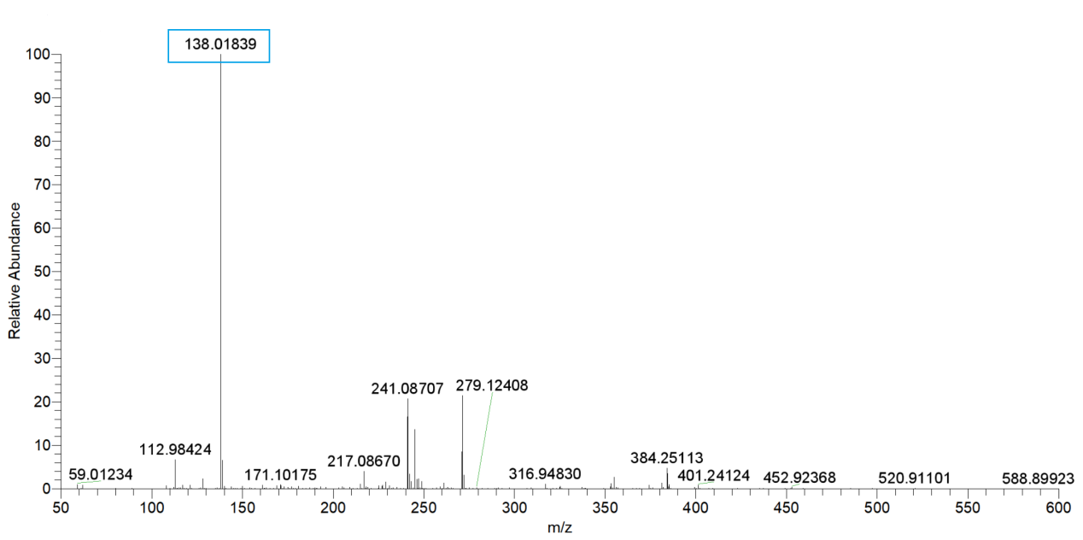
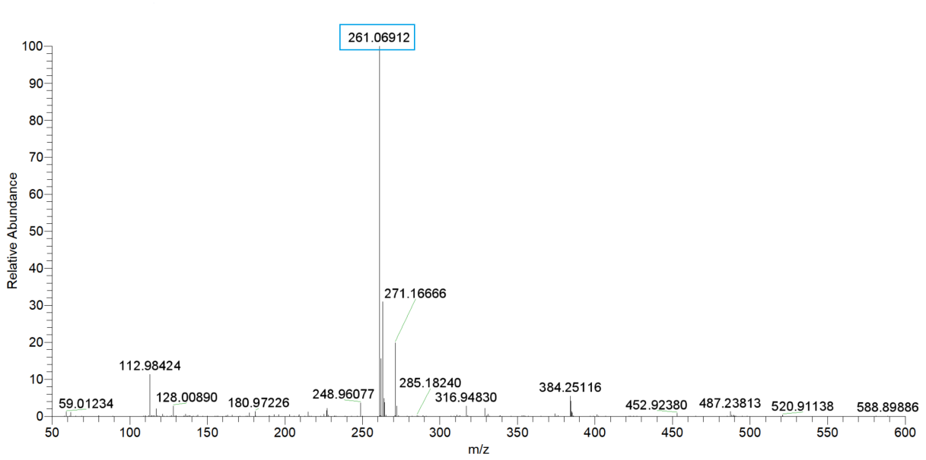
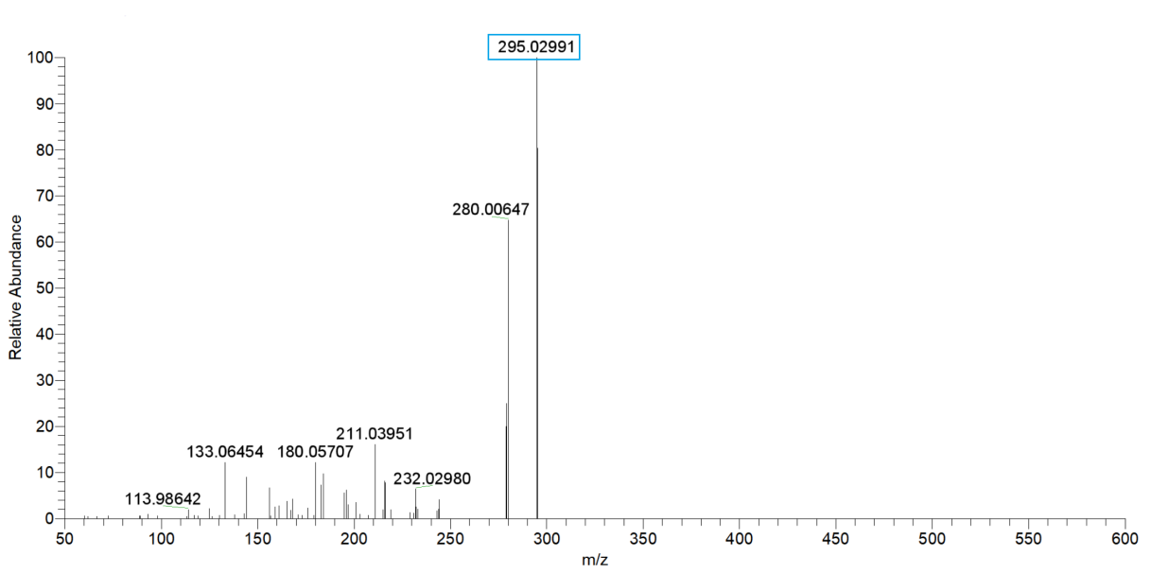
or
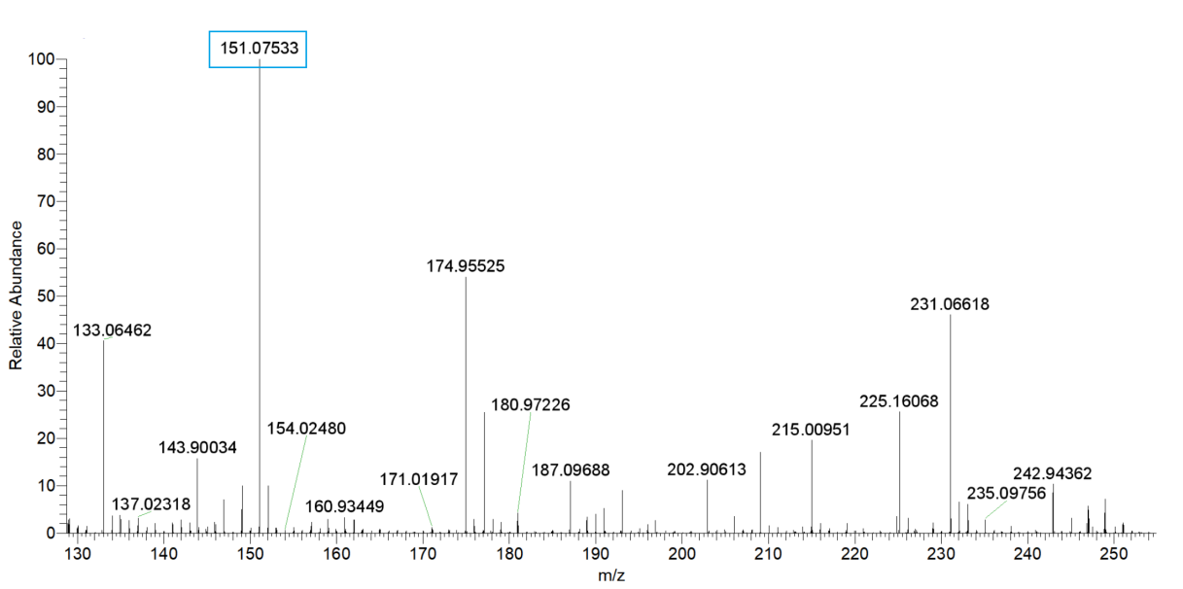
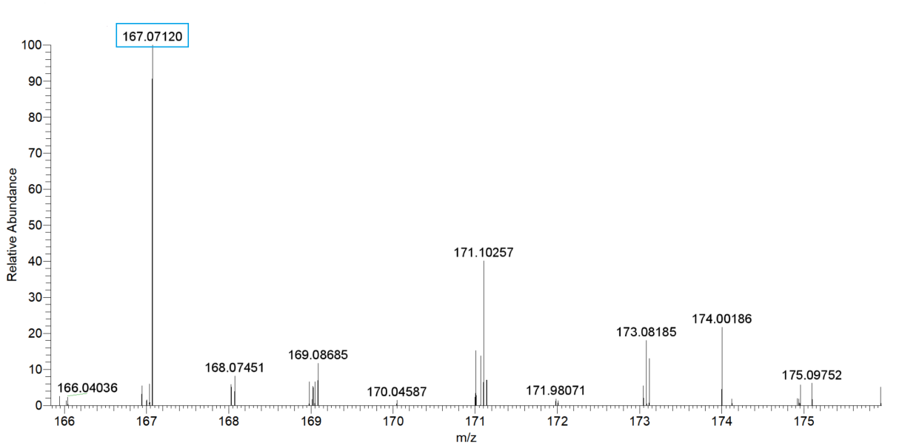
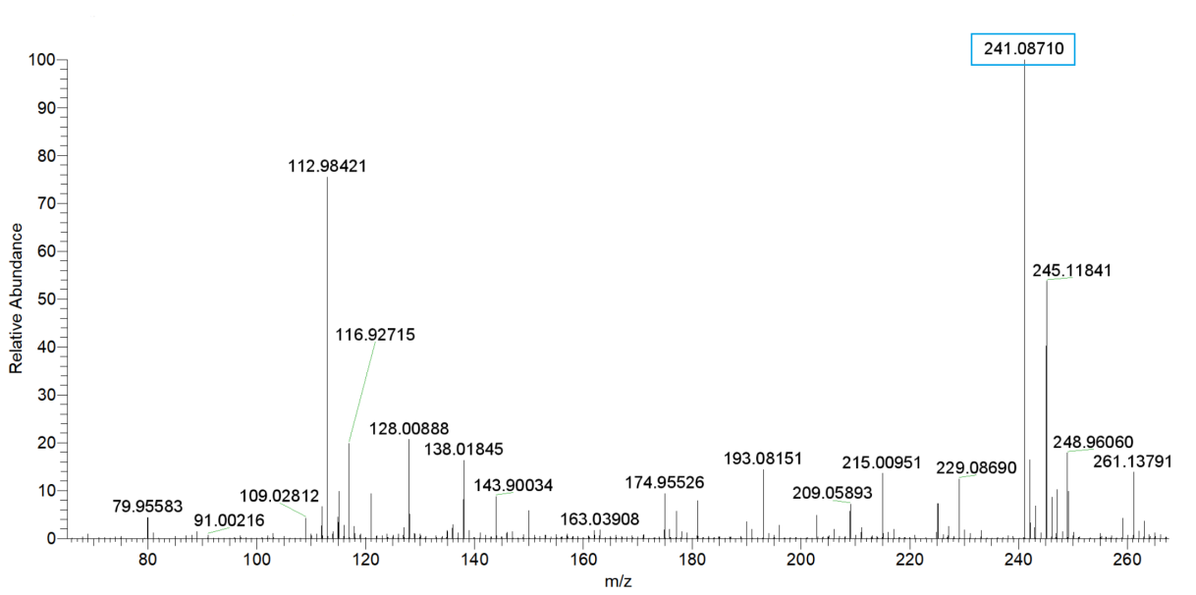
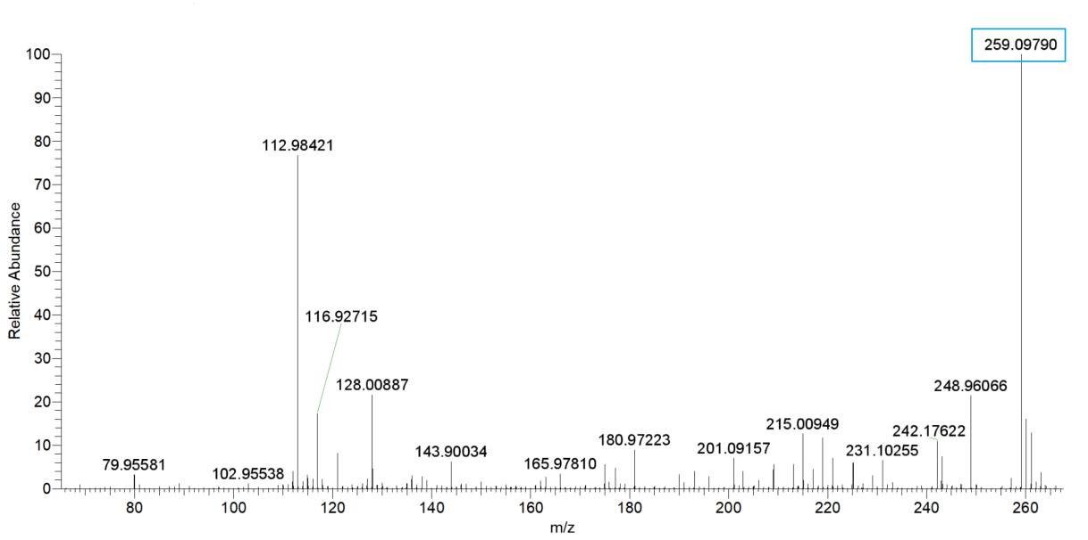
or
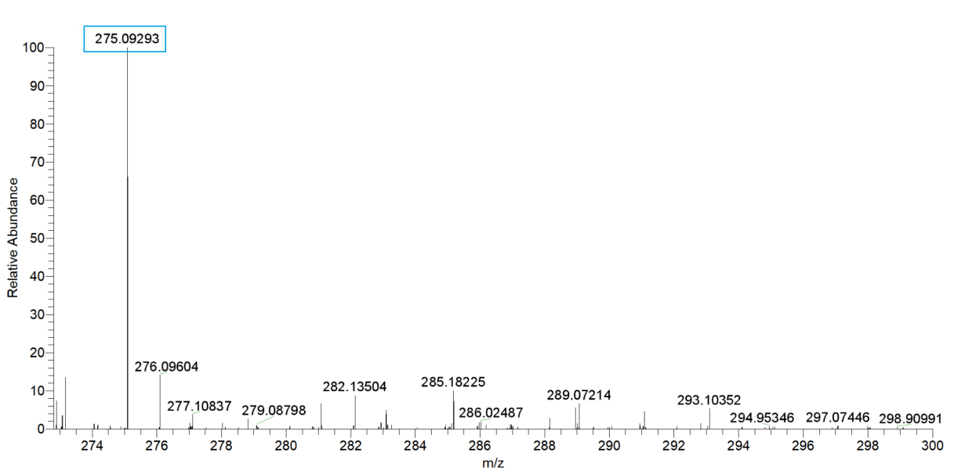
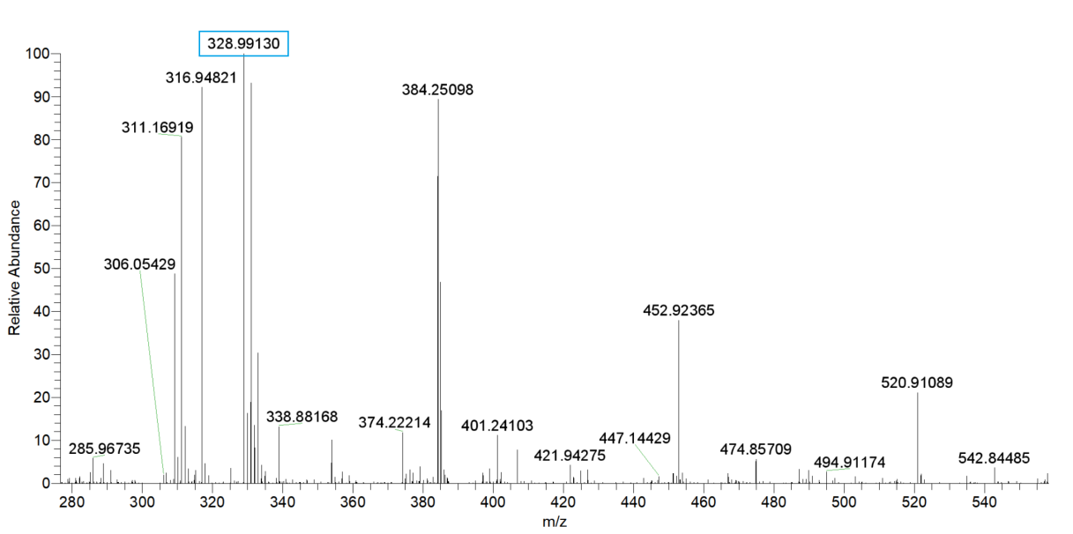

Fig. S11 MS spectra of BPA and photodegradation products(UHPLC-Q-Orbitrap-MS/MS)

Table S1 Specific water quality parameters of natural water sample
 | Sample I | Sample II | Sample III
NO₃⁻ (mg L⁻¹) | 0.07 | 0.11 | 2.10
Br⁻ ( mg L⁻¹) | 0.029 | 0.03 | 0.35
Cl⁻ ( mg L⁻¹) | 104 | 7.38 | 156.07
Fe³⁺ (mM) | 0.00541 | 0.00983 | 0.03
pH | 8.01 | 8.15 | 8.34
EC (μs cm⁻¹) | 725.8 | 307 | 1143
COD (mg L⁻¹) | 24 | 15.1 | 161.2
BOD₅ (mg L⁻¹) | <0.5 | <0.5 | 15
DO (mg L⁻¹) | 8.85 | 10.26 | 8.10
TOC (mg C L⁻¹) | 12.6 | 10.4 | 51.3

Table S2 Factors and concentration levels in central combination test
Symbol | Factors | Concentration levels
Symbol | Factors | -1 | 0 | 1
X₁ | NO- 3 (mM) | 0 | 0.5 | 1
X₂ | HA (mg L⁻¹) | 0 | 11.2 | 22.3
X₃ | Fe³⁺ (mM) | 0 | 0.5 | 1.0
X₄ | Cl⁻ (mg L⁻¹) | 0 | 50.0 | 100.0

Table S3 Shielding factors of different concentrations of HA on BPA photodegradation
HA (mg C L⁻¹) | k_{obs} (min⁻¹) | ΣS_{λ} | k₀ΣS_{λ} (min⁻¹) | k_{a} (min⁻¹)
0 | 0.02127 | -- | -- | 0.02127
1.00 | -- | 0.835 | 0.01776 | 0.01557
11.2 | -- | 0.468 | 0.00996 | 0.00896
22.3 | -- | 0.280 | 0.00595 | 0.00498
Note: k_{obs} and k_{a} represent the degradation rate constant of BPA in the absence and presence of HA, respectively. ΣS_{λ} represents the total shielding coefficient and k₀ΣS_{λ} indicates the theoretical rate constant.

Table S4 Steady concentration of photogenerated ·OH in the different systems
(C_{AP} = 0.11 mM)
systems | pH=4 | pH=7
Pure water (PW) | 4.1 × 10⁻¹⁵ | 9.1 × 10⁻¹⁵
PW+NO- 3 (1 mM) | - | 3.1 × 10⁻¹⁵
PW+NO- 2 (1 mM) | - | 1.9 × 10⁻¹⁵
PW+Fe³⁺ (1 mM) | 3.0 × 10⁻¹⁴ | -
PW+Fe²⁺ (1 mM) | 3.8 × 10⁻¹⁴ | -

Table S5 BBD experimental design and response value
No. | X₁: NO₃⁻ | X₂: HA | X₃: Fe³⁺ | X₄: Cl⁻ | k (min⁻¹)
1 | 0 | -1 | -1 | 0 | 0.01431
2 | 0 | 0 | 0 | 0 | 0.01367
3 | 0 | 1 | 1 | 0 | 0.00789
4 | -1 | 0 | 0 | -1 | 0.01789
5 | 0 | 0 | 0 | 0 | 0.01367
6 | 1 | 1 | 0 | 0 | 0.00963
7 | 1 | 0 | 1 | 0 | 0.01745
8 | -1 | 0 | 1 | 0 | 0.01539
9 | 0 | 0 | 0 | 0 | 0.01367
10 | -1 | 0 | -1 | 0 | 0.01228
11 | 0 | 0 | 1 | -1 | 0.02291
12 | 0 | 1 | 0 | -1 | 0.00415
13 | 1 | 0 | 0 | -1 | 0.01168
14 | 0 | 0 | -1 | -1 | 0.00697
15 | 0 | 1 | 0 | 1 | 0.01557
16 | 0 | -1 | 0 | 1 | 0.02626
17 | 0 | -1 | 0 | -1 | 0.04021
18 | 0 | 0 | 1 | 1 | 0.0105
19 | -1 | -1 | 0 | 0 | 0.03436
20 | 0 | 1 | -1 | 0 | 0.00818
21 | 0 | -1 | 1 | 0 | 0.0484
22 | -1 | 0 | 0 | 1 | 0.01199
23 | 0 | 0 | -1 | 1 | 0.00887
24 | 0 | 0 | 0 | 0 | 0.01165
25 | 1 | 0 | 0 | 1 | 0.01210
26 | 1 | 0 | -1 | 0 | 0.00465
27 | 1 | -1 | 0 | 0 | 0.02373
28 | -1 | 1 | 0 | 0 | 0.00692
29 | 0 | 0 | 0 | 0 | 0.01165

Table S6 Analysis of variance (ANOVA) test and estimated coefficients of significance
for the response function Y
Source | Sum of squares | Freedom | Mean square sum | F value | P value | Significance
Model | 2.916E-003 | 14 | 2.083E-004 | 38.01 | < 0.0001 | significant
X₁ | 3.198E-005 | 1 | 3.198E-005 | 5.84 | 0.0299 | *
X₂ | 1.517E-003 | 1 | 1.517E-003 | 276.89 | < 0.0001 | **
X₃ | 3.772E-004 | 1 | 3.772E-004 | 68.84 | < 0.0001 | **
X₄ | 2.858E-005 | 1 | 2.858E-005 | 5.22 | 0.0385 | *
X₁X₂ | 4.449E-005 | 1 | 4.449E-005 | 8.12 | 0.0129 | *
X₁X₃ | 2.347E-005 | 1 | 2.347E-005 | 4.28 | 0.0574
X₁X₄ | 9.986E-006 | 1 | 9.986E-006 | 1.82 | 0.1985
X₂X₃ | 2.955E-004 | 1 | 2.955E-004 | 53.93 | < 0.0001 | **
X₂X₄ | 1.609E-004 | 1 | 1.609E-004 | 29.37 | < 0.0001 | **
X₃X₄ | 5.119E-005 | 1 | 5.119E-005 | 9.34 | 0.0085 | *
X₁² | 1.738E-006 | 1 | 1.738E-006 | 0.32 | 0.5822
X₂² | 3.339E-004 | 1 | 3.339E-004 | 60.94 | < 0.0001 | **
X₃² | 1.972E-006 | 1 | 1.972E-006 | 0.36 | 0.5581
X₄² | 4.809E-006 | 1 | 4.809E-006 | 0.88 | 0.3647
Residual | 7.671E-005 | 14 | 5.479E-006
Lack of fit | 7.181E-005 | 10 | 7.181E-006 | 5.87 | 0.0514 | Not significant
Pure error | 4.896E-006 | 4 | 1.224E-006
Cor total | 2.993E-003 | 28
Note：*0.0001<P<0.05 is significant, **P<0.0001 is very significant.

Table S7 The photodegradation kinetics parameters and quench experiments of BPA
in pure water (PW) and natural water (NW)
Sample | Quencher | Kinetic equations | k (min⁻¹) | t_{1/2}  (min) | Contribution  (%) | R²
PW | - | ln(C_{t}/C₀) = -0.02145t+0.01198 | 0.02145 | 32.3 | - | 0.9727
NW-I | NW (Without quenching agent) | ln(C_{t}/C₀) = -0.01294t-0.1464 | 0.01294 | 53.6 | - | 0.9674
NW-I | IPA | ln(C_{t}/C₀) = -0.00986t-0.01507 | 0.00986 | 70.3 | 23.8(·OH) | 0.8991
NW-I | NaN₃ | ln(C_{t}/C₀) = -0.00799t-0.11779 | 0.00799 | 86.8 | 14.5(¹O₂) | 0.9345
NW-I | SA | ln(C_{t}/C₀) = -0.00454t-0.04752 | 0.00454 | 152.7 | 50.5(³DOM*) | 0.9313
NW-I | TB | ln(C_{t}/C₀) = -0.00705t-0.02139 | 0.00705 | 98.3 | 21.7(RHS) | 0.9824
NW-II | NW (Without quenching agent) | ln(C_{t}/C₀) = -0.00993t+0.11689 | 0.00993 | 69.8 | - | 0.9522
NW-II | IPA | ln(C_{t}/C₀) = -0.00628t-0.12344 | 0.00628 | 110.4 | 36.8(·OH) | 0.8569
NW-II | NaN₃ | ln(C_{t}/C₀) = -0.00508t+0.09415 | 0.00508 | 136.45 | 12.1(¹O₂) | 0.8795
NW-II | SA | ln(C_{t}/C₀) = -0.00350t-0.05000 | 0.00350 | 198.0 | 52.7(³DOM*) | 0.9624
NW-II | TB | ln(C_{t}/C₀) = -0.00600t+0.03667 | 0.00600 | 115.52 | 2.8(RHS) | 0.9880
NW-III | NW (Without quenching agent) | ln(C_{t}/C₀) = -0.00869t-0.07341 | 0.00869 | 79.8 | - | 0.9670
NW-III | IPA | ln(C_{t}/C₀) = -0.00721t-0.04557 | 0.00721 | 96.1 | 17.2(·OH) | 0.9773
NW-III | NaN₃ | ln(C_{t}/C₀) = -0.00643t+0.03552 | 0.00643 | 107.8 | 9.0(¹O₂) | 0.9791
NW-III | SA | ln(C_{t}/C₀) = -0.00428t-0.02383 | 0.00428 | 162.0 | 41.7(³DOM*) | 0.8835
NW-III | TB | ln(C_{t}/C₀) = -0.00373t-0.02048 | 0.00373 | 185.8 | 40.0(RHS) | 0.9874

Table S8 GC-MS analysis results for photodegradation intermediates and product of BPA in pure water (Ⅰ), nitrate-containing solution (NO- 3, Ⅱ; NO-- 2, Ⅲ；NO- 3+NO-- 2, Ⅳ), HA-containing solution (Ⅴ), Cl⁻- containing solution (Ⅵ) and Cl⁻-HA- containing solution (Ⅶ)
Number | Compound | Retention time  (min) | Detected ions  (m/z) | System |  |  |  |  |  |  |  |  |  | Possible byproducts
 |  |  |  | Ⅰ |  | Ⅱ | Ⅲ |  | Ⅳ | Ⅴ |  | Ⅵ | Ⅶ | Possible byproducts
1 | Bisphenol A | 36.32 | 372[M⁺]，357，207，191，73 | Yes | Yes |  |  | Yes | Yes |  | Yes | Yes | Yes
2 | Phenol | 13.83 | 166[M⁺]，151，77 | Yes | Yes |  |  | Yes | Yes |  | No | Yes | Yes
3 | Lactic acid | 14.44 | 219[M⁺-CH₃]，191, 147, 117, 73 | Yes | Yes |  |  | Yes | Yes |  | Yes | Yes | Yes
4 | 2-methyl-2,3-dihydro-Benzofuran | 15.89 | 134[M⁺], 191, 91 | Yes | Yes |  |  | No | No |  | Yes | Yes | Yes | 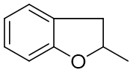
5 | Glycerol | 19.30 | 293[M⁺-CH₃]，218，205，147，117，73 | Yes | Yes |  |  | Yes | Yes | Yes |  | Yes | Yes | 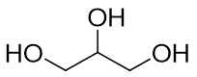
6 | p-isopropylphenol | 20.13 | 208[M+]，193，135，73 | Yes | Yes |  |  | Yes | Yes | Yes |  | Yes | Yes | 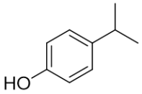
7 | Hydroquinone | 22.31 | 254[M⁺]，239，73 | Yes | Yes |  |  | Yes | Yes | Yes |  | Yes | Yes
8 | BPA catechol | 37.88 | 460[M⁺]，445，357，207，191，73 | Yes | Yes |  |  | Yes | Yes | Yes |  | Yes | Yes
9 | p-isopropenylphenol | 21.55 | 206[M⁺]，191，151，115，73 | Yes | Yes |  |  | Yes | Yes | No |  | No | Yes
10 | Nitrobisphenol A | 41.10 | 417[M⁺]，402，207，73 | No | Yes |  |  | Yes | Yes | No |  | No | No
11 | p-nitrophenol | 28.61 | 211/210[M⁺]，196/195，181/180，166/165，77 | No | Yes |  |  | No | Yes | No |  | No | No
12 | 4-(2-(4-nitrophenoxy)propan-2-yl)phenol | 38.36 | 345[M⁺]，330，207，73 | No | Yes |  |  | Yes | Yes | No |  | No | No
13 | Monochloro BPA | 39.01 | 406[M⁺]，391，207，73 | No | No |  |  | No | No | No |  | No | Yes
14 | Dichloro-BPA | 41.95 | 440[M⁺]，425，355，207，73 | No | No |  |  | No | No | No |  | No | Yes
15 | Dichloro-4-isopropylphenol | 24.75 | 276[M⁺]，261，246，233,147,117，73 | No | No |  |  | No | No | No |  | No | Yes

Table S9 UHPLC-Q-Orbitrap-MS/MS analysis results for photodegradation intermediates and product of bisphenol A in in pure water (Ⅰ), nitrate-containing solution (NO- 3, Ⅱ; NO-- 2, Ⅲ；NO- 3+NO-- 2, Ⅳ), Cl⁻- containing solution (Ⅴ) and Cl⁻-HA- containing solution (Ⅵ), NO- 3-Cl⁻-HA- containing solution(Ⅶ)
No. | [M-H]⁻ |  | △(ppm) | 体系 |  |  |  |  |  |  | Proposed Structure
No. | Theoretical | Observed | △(ppm) | Ⅰ | Ⅱ | Ⅲ | Ⅳ | Ⅴ | Ⅵ | Ⅶ | Proposed Structure
1 | 227.10666 | 227.10728 | 2.75 | Yes | Yes | Yes | Yes | Yes | Yes | Yes | 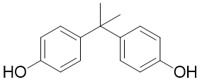
8 | 243.10157 | 243.10254 | 3.99 | Yes | Yes | Yes | Yes | Yes | Yes | Yes
16 | 151.07536 | 151.07533 | -0.17 | Yes | Yes | Yes | Yes | Yes | Yes | Yes
17 | 167.07027 | 167.07120 | 5.57 | Yes | Yes | Yes | Yes | Yes | No | No
18 | 241.08592 | 241.08710 | 4.89 | Yes | Yes | Yes | Yes | Yes | Yes | Yes
19 | 259.09700 | 259.09790 | 0.47 | Yes | Yes | Yes | Yes | Yes | Yes | Yes
20 | 275.09140 | 275.09293 | 5.56 | Yes | Yes | Yes | Yes | Yes | Yes | Yes
10 | 272.09173 | 272.09314 | 5.17 | No | Yes | Yes | Yes | No | No | Yes
11 | 138.01875 | 138.01839 | -1.30 | No | Yes | Yes | Yes | No | No | Yes
13 | 261.06768 | 261.06912 | 5.52 | No | No | No | No | No | Yes | Yes
14 | 295.02871 | 295.02991 | 4.07 | No | No | No | No | No | Yes | Yes
21 | 328.98974 | 328.99130 | 4.74 | No | No | No | No | No | Yes | Yes

References
Armbrust, K.L., 2000. Pesticide hydroxyl radical rate constants: Measurements and estimates of their importance in aquatic environments. Environ. Toxicol. Chem. 19 (9), 2175-2180.
Avila, L.A., Massey, J.H., Senseman, S.A., Armbrust, K.L., Lancaster, S.R., Mccauley, G.N., Chandler, J.M., 2006. Imazethapyr aqueous photolysis, reaction quantum yield, and hydroxyl radical rate constant. J. Agri. Food Chem. 54 (7), 2635-2639.
Boreen, A.L., Edhlund, B.L., Cotner, J.B., mcneill, K., 2008. Indirect photodegradation of dissolved free amino acids: The contribution of singlet oxygen and the differential reactivity of DOM from various sources. Environ. Sci. Technol. 42 (15), 5492-5498.
Box, G.E.P., Wilson, K.B., 1951. On the experimental attainment of optimum multifactorial conditions. J. Royal. Statis. Socie: Series B (Method). 13 (1), 1-45.
Kelly, M.M., Arnold, W.A., 2012. Direct and indirect photolysis of the phytoestrogens genistein and daidzein. Environ. Sci. Technol. 46 (10), 5396-5403.
Li, Y.J., Liu, X.L., Zhang, B.J., Zhao, Q., Ning, P., Tian, S., 2018. Aquatic photochemistry of sulfamethazine: multivariate effects of main water constituents and mechanisms. Environ. Sci. Proc. Imp. 20 (3), 513-522.
Zeng, C., Ji, Y.F., Zhou, L., Zhang, Y., Yang, X., 2012. The role of dissolved organic matters in the aquatic photodegradation of atenolol. J. Hazard. Mater. 239-240, 340-347.
Zhang, X.D., Liu, Z.C., Kong, Q.Q., Liu, G.G., Lv, W.Y., Li, F.H., Lin, X.X., 2018. Aquatic photodegradation of clofibric acid under simulated sunlight irradiation: kinetics and mechanism analysis. Rsc Adv. 8 (49), 27796-27804.
Zhao, Q., Fang, Q., Liu, H.Y., Li, Y.J., Cui, H.S., Zhang, B.J., Tian S.L. 2019. Halide-specific enhancement of photodegradation for sulfadiazine in estuarine waters: roles of halogen radicals and main water constituents. Water Res, 160, 209-216.

