Supplementary Appendix
Contents
Supplementary Figure 1. The locations of air pollutants monitoring stations and hospitals in Henan, China 02
Supplementary Figure 2. Association between O₃ single- and dual-pollution model (every 10 µg/m³ increase) and AMI hospitalization at single-day lag 03
Supplementary Figure 3. Percentage of O₃ concentration interval in Henan Province during the study period (A) and average O₃ concentration per month from 2016-2021 in different cities (B) 04
Supplementary Figure 4. The estimated annual preventable AMI hospitalizations (A) and annual savable hospitalization costs (B) if the historical O₃ concentration could be reduced to a relatively low level 05
Supplementary Table 1. Coordinates of each hospital in the study area 06
Supplementary Table 2. Coordinates of each city air monitoring station in the study area 07
Supplementary Table 3. Spearman’s correlation coefficients between daily air pollutants (O₃: 8h) and meteorological data in Henan, 2016–2021 08
Supplementary Table 4. RR (95% CI) of AMI hospitalizations at different lag days with O₃ (every 10 µg/m³ increase) in different subgroups 09
Supplementary Table 5. Comparison of the AMI hospitalizations, O3 concentration and mean temperature in cold and warm seasons 10
Supplementary Table 6. Comparison of the AMI hospitalizations, O3 concentration, average temperature and sunshine duration in warm seasons 11
Supplementary Table 7. Results of sensitivity analyses by changing degree of freedom for long-term trend and seasonality 12

Supplementary Figure 1. The locations of air pollutants monitoring stations and hospitals in Henan, China.
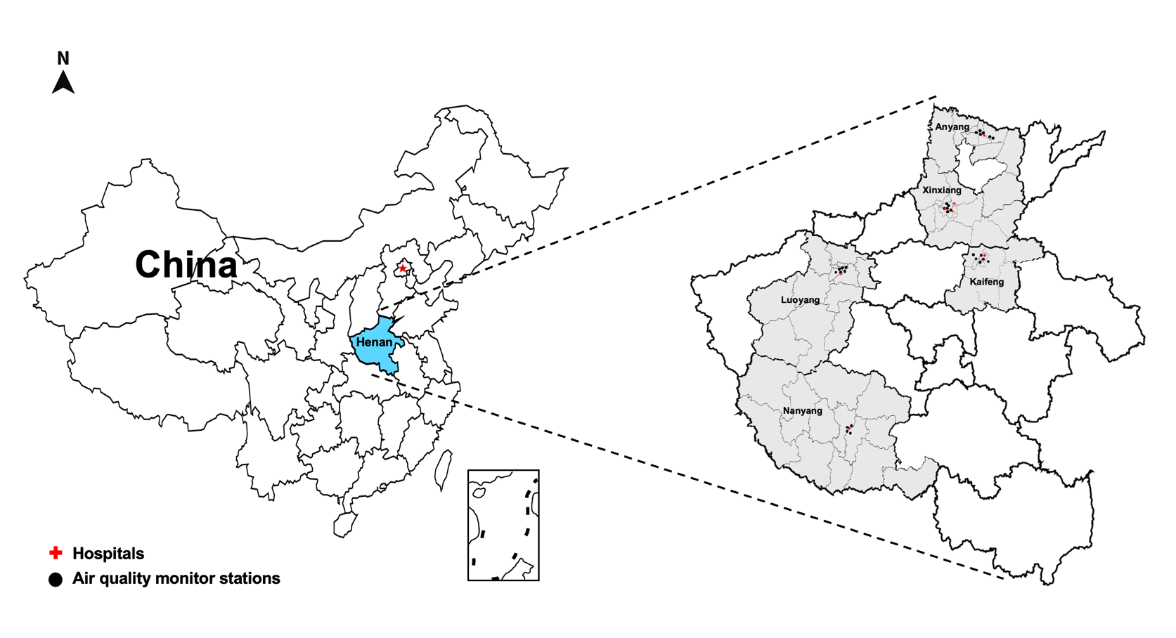
Supplementary Figure 2. Percentage of O₃ concentration interval in Henan Province during the study period (A) and average O₃ concentration per month from 2016-2021 in different cities (B)
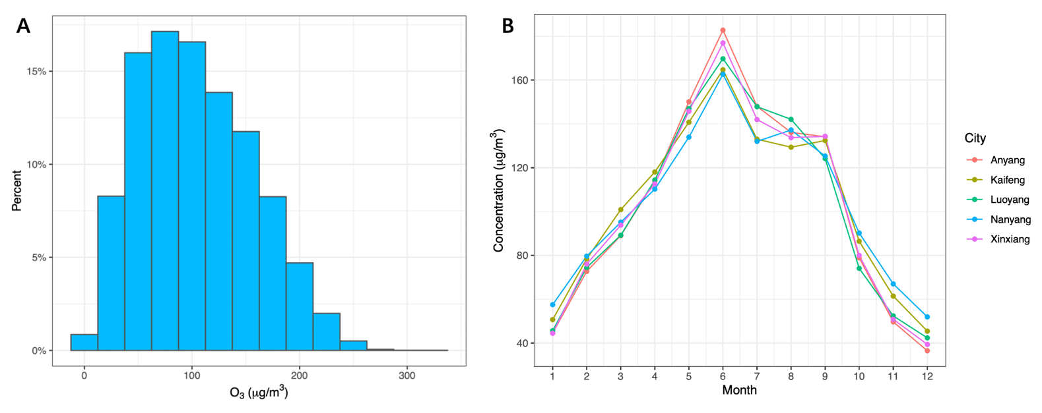

Note: O₃: ozone.
Supplementary Figure 3. Association between O₃ single-/dual-pollution model (every 10 µg/m³ increase) and AMI hospitalization at single-day lag

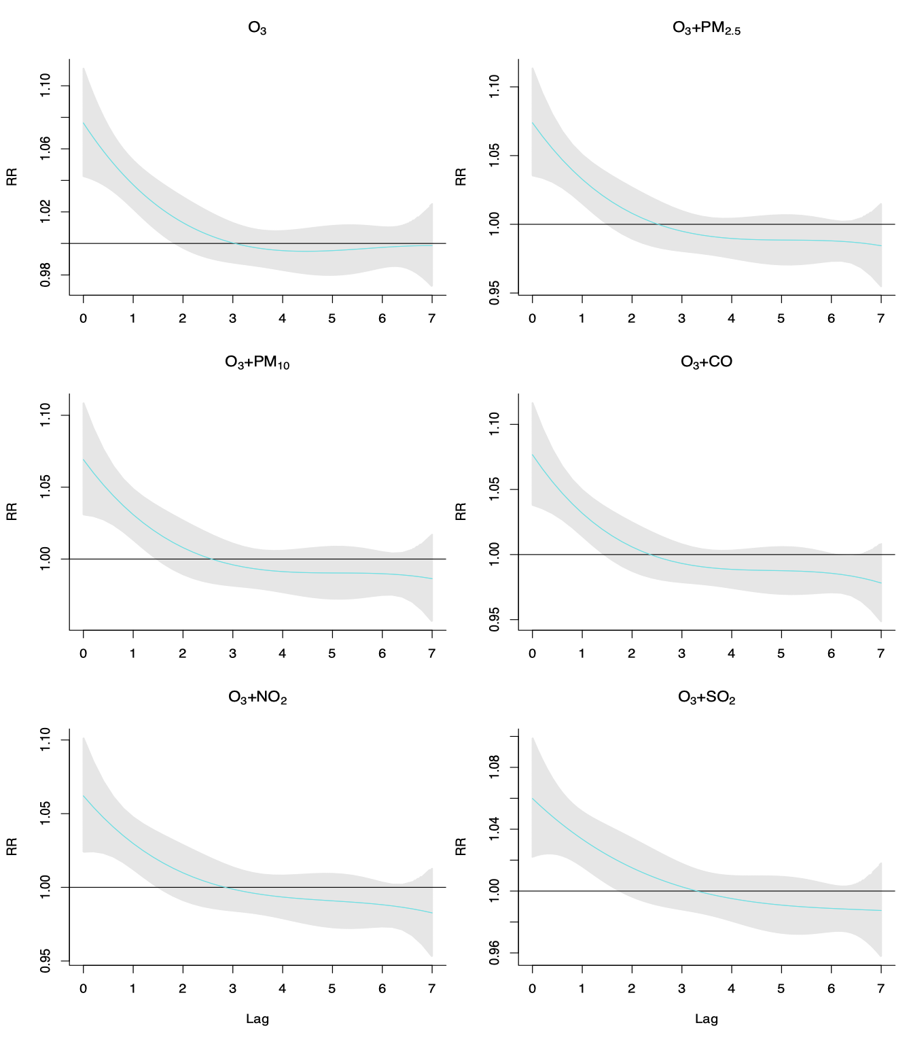

Note: PM_{2.5}: particulate matter with aerodynamic matter ≤2.5 μm; PM₁₀: particulate matter with aerodynamic matter ≤10 μm; CO: carbon monoxide; NO₂ : nitrogen dioxide; SO₂ : sulfur dioxide; O₃ : ozone; Gray area: 95% confidence interval.
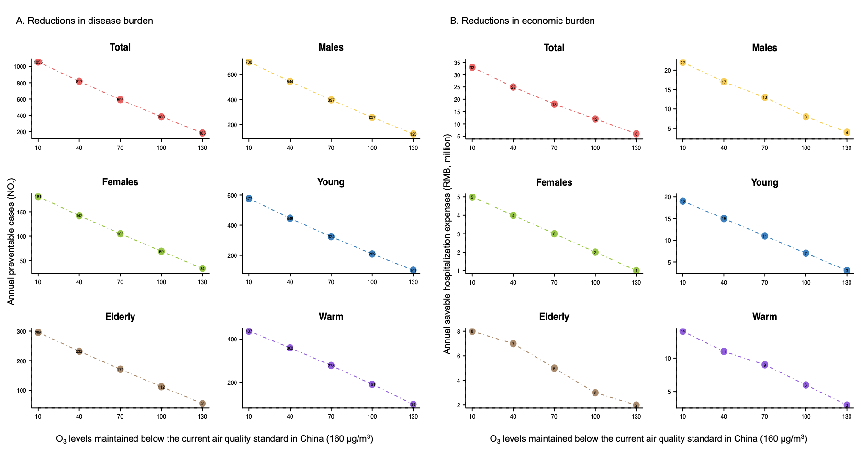
Supplementary Figure 4. The estimated annual preventable AMI hospitalizations (A) and annual savable hospitalization costs (B) if the historical O₃ concentration could be reduced to a relatively low level

Note: young: 15–64 years; elderly: 65+ years; Warm: May to September.

Supplementary Table 1. Coordinates of each hospital in the study area

City | Hospital Name | Longitude, N | Latitude, E
Xinxiang | The First Affiliated Hospital of Xinxiang Medical University | 114.059 | 35.408
Xinxiang | The Third Affiliated Hospital of Xinxiang Medical University | 113.925 | 35.281
Xinxiang | The Affiliated People's Hospital of Xinxiang Medical University | 113.869 | 35.306
Nanyang | Nanyang Central Hospital | 112.529 | 33.008
Anyang | Anyang First People's Hospital | 114.412 | 36.076
Kaifeng | Hospital of Traditional Chinese Medicine Affiliated to Henan University | 114.368 | 34.805
Luoyang | The First Affiliated Hospital of Henan University of Science and Technology | 112.427 | 34.599

Supplementary Table 2. Coordinates of each city air monitoring station in the study area

City | City code | Station code | Longitude, N | Latitude, E
Xinxiang | 410700 | 2389A | 113.836 | 35.310
Xinxiang | 410700 | 2390A | 113.884 | 35.272
Xinxiang | 410700 | 2391A | 113.883 | 35.303
Xinxiang | 410700 | 3054A | 113.919 | 35.285
Xinxiang | 410700 | 3476A | 113.914 | 35.333
Xinxiang | 410700 | 3689A | 113.900 | 35.372
Nanyang | 411300 | 2403A | 112.519 | 32.992
Nanyang | 411300 | 2404A | 112.522 | 33.012
Nanyang | 411300 | 2406A | 112.557 | 33.027
Nanyang | 411300 | 2407A | 112.550 | 32.968
Anyang | 410500 | 1818A | 114.484 | 36.062
Anyang | 410500 | 1819A | 114.355 | 36.102
Anyang | 410500 | 1820A | 114.358 | 36.087
Anyang | 410500 | 3141A | 114.392 | 36.088
Anyang | 410500 | 3669A | 114.471 | 36.064
Anyang | 410500 | 3703A | 114.292 | 36.095
Kaifeng | 410200 | 1824A | 114.339 | 34.778
Kaifeng | 410200 | 1826A | 114.289 | 34.797
Kaifeng | 410200 | 3147A | 114.344 | 34.811
Kaifeng | 410200 | 3210A | 114.364 | 34.796
Kaifeng | 410200 | 3473A | 114.249 | 34.831
Kaifeng | 410200 | 3592A | 114.464 | 34.756
Luoyang | 410300 | 1812A | 112.394 | 34.651
Luoyang | 410300 | 1814A | 112.466 | 34.687
Luoyang | 410300 | 1815A | 112.494 | 34.689
Luoyang | 410300 | 1817A | 112.428 | 34.626
Luoyang | 410300 | 3341A | 112.495 | 34.633
Luoyang | 410300 | 3636A | 112.439 | 34.678

Supplementary Table 3. Spearman’s correlation coefficients between daily air pollutants (O₃: 8h) and meteorological data in Henan, 2016–2021

 | PM_{2.5} | PM₁₀ | CO | NO₂ | SO₂ | O₃ | Temperature | Sunshine Duration
PM_{2.5} | 1.00*
PM₁₀ | 0.88* | 1.00*
CO | 0.73* | 0.68* | 1.00*
NO₂ | 0.67* | 0.69* | 0.65* | 1.00*
SO₂ | 0.46* | 0.53* | 0.67* | 0.60* | 1.00*
O₃ | -0.42* | -0.33* | -0.35* | -0.43* | -0.21* | 1.00*
Temperature | -0.52* | -0.43* | -0.40* | -0.49* | -0.32* | 0.78* | 1.00*
Sunshine Duration | -0.26* | -0.12* | -0.21* | -0.09* | 0.03* | 0.54* | 0.34* | 1.00*

Note: PM_{2.5} : particulate matter with aerodynamic matter ≤2.5 μm; PM₁₀ : particulate matter with aerodynamic matter ≤10 μm; CO : carbon monoxide; NO₂ : nitrogen dioxide; SO₂ : sulfur dioxide; O₃ : ozone; *：p<0.001.

Supplementary Table 4. RR (95% CI) of AMI hospitalizations at different lag days with O₃ (every 10 µg/m³ increase) in different subgroups.
 | Males | Females | Young | Elderly | Warm | Cold | LSD | SSD
 | RR (95%CI) | RR (95%CI) | RR (95%CI) | RR (95%CI) | RR (95%CI) | RR (95%CI) | RR (95%CI) | RR (95%CI)
Lag0 | 1.073 (1.031-1.117) | 1.066 (1.010-1.126) | 1.094 (1.052-1.139) | 1.054 (1.010-1.101) | 1.095 (1.049-1.143) | 1.069 (0.989-1.156) | 1.144 (1.057-1.237) | 1.060 (0.989-1.136)
Lag1 | 1.034 (1.014-1.054) | 1.029 (1.003-1.055) | 1.042 (1.023-1.062) | 1.031 (1.010-1.052) | 1.053 (1.033-1.072) | 1.027 (0.991-1.065) | 1.046 (1.007-1.085) | 1.028 (0.994-1.064)
Lag2 | 1.010 (0.989-1.031) | 1.006 (0.979-1.034) | 1.011 (0.992-1.032) | 1.015 (0.993-1.037) | 1.025 (1.005-1.044) | 0.998 (0.963-1.035) | 1.004 (0.967-1.043) | 1.015 (0.977-1.054)
Lag3 | 0.997 (0.981-1.013) | 0.995 (0.973-1.017) | 0.997 (0.981-1.013) | 1.005 (0.988-1.022) | 1.007 (0.992-1.023) | 0.981 (0.936-1.028) | 0.996 (0.965-1.027) | 1.013 (0.982-1.044)
Lag4 | 0.992 (0.976-1.008) | 0.992 (0.970-1.013) | 0.993 (0.978-1.009) | 0.999 (0.982-1.016) | 0.999 (0.983-1.014) | 0.976 (0.932-1.021) | 1.003 (0.972-1.034) | 1.015 (0.984-1.047)
Lag5 | 0.990 (0.970-1.010) | 0.994 (0.968-1.022) | 0.996 (0.977-1.016) | 0.994 (0.973-1.016) | 0.995 (0.976-1.015) | 0.982 (0.950-1.014) | 1.007 (0.97-1.045) | 1.015 (0.977-1.055)
Lag6 | 0.988 (0.972-1.005) | 1.000 (0.978-1.023) | 1.003 (0.987-1.019) | 0.991 (0.974-1.008) | 0.995 (0.979-1.011) | 0.999 (0.964-1.035) | 0.992 (0.96-1.026) | 1.007 (0.974-1.040)
Lag7 | 0.984 (0.951-1.018) | 1.007 (0.962-1.054) | 1.009 (0.976-1.043) | 0.986 (0.952-1.022) | 0.996 (0.965-1.029) | 1.028 (0.947-1.116) | 0.943 (0.887-1.002) | 0.982 (0.923-1.046)
Lag01 | 1.109 (1.056-1.166) | 1.097 (1.026-1.174) | 1.141 (1.086-1.198) | 1.087 (1.031-1.146) | 1.153 (1.093-1.216) | 1.099 (0.986-1.224) | 1.196 (1.081-1.322) | 1.090 (1.001-1.187)
Lag02 | 1.120 (1.063-1.181) | 1.104 (1.028-1.185) | 1.154 (1.095-1.215) | 1.103 (1.043-1.167) | 1.181 (1.117-1.248) | 1.097 (0.979-1.228) | 1.201 (1.077-1.339) | 1.107 (1.009-1.213)
Lag03 | 1.117 (1.057-1.180) | 1.098 (1.019-1.183) | 1.150 (1.089-1.214) | 1.109 (1.045-1.176) | 1.190 (1.124-1.259) | 1.076 (0.957-1.209) | 1.196 (1.065-1.342) | 1.121 (1.015-1.237)
Lag04 | 1.108 (1.047-1.172) | 1.088 (1.008-1.175) | 1.142 (1.080-1.207) | 1.107 (1.042-1.176) | 1.188 (1.122-1.257) | 1.050 (0.925-1.192) | 1.199 (1.063-1.353) | 1.138 (1.026-1.261)
Lag05 | 1.096 (1.033-1.163) | 1.082 (0.998-1.174) | 1.138 (1.072-1.207) | 1.101 (1.033-1.174) | 1.182 (1.113-1.256) | 1.031 (0.902-1.178) | 1.207 (1.061-1.374) | 1.155 (1.034-1.291)
Lag06 | 1.084 (1.018-1.153) | 1.083 (0.994-1.179) | 1.141 (1.072-1.214) | 1.091 (1.020-1.167) | 1.176 (1.104-1.254) | 1.029 (0.911-1.163) | 1.198 (1.045-1.374) | 1.163 (1.033-1.309)
Lag07 | 1.066 (1.004-1.132) | 1.090 (1.004-1.184) | 1.151 (1.084-1.223) | 1.076 (1.008-1.149) | 1.172 (1.102-1.247) | 1.058 (0.946-1.183) | 1.13 (0.986-1.295) | 1.142 (1.015-1.286)

Note: Warm: May to September; Cold: from November to March; LSD: Long Sunshine Duration (sunshine duration > 6h); SSD: Short Sunshine Duration (sunshine duration ≤ 6h); Both LSD and SSD are warm season sunshine durations; Bold: p<0.05.

Supplementary Table 5. Comparison of the AMI hospitalizations, O₃ concentration and mean temperature in cold and warm seasons

 | Mean ± SD | Min | 25th | 50th | 75th | Max
Cold
AMI | 12.01±4.79 | 1.00 | 9.00 | 11.00 | 14.00 | 36.00
O₃ (µg/m³) | 56.15±26.06 | 4.00 | 37.00 | 54.00 | 72.00 | 160.00
Mean temperature (°C) | 4.60±4.77 | -10.20 | 1.20 | 4.10 | 7.60 | 19.60
Sunshine duration (h) | 4.62±3.32 | 0.00 | 1.12 | 5.04 | 7.64 | 10.88
Warm
AMI | 11.07±4.39 | 1.00 | 8.00 | 11.00 | 14.00 | 31.00
O₃ (µg/m³) | 143.77±43.56 | 26.00 | 112.00 | 144.00 | 174.00 | 316.00
Mean temperature (°C) | 25.26±3.65 | 13.10 | 22.80 | 25.70 | 28.00 | 34.60
Sunshine duration (h) | 6.33±3.66 | 0.00 | 3.27 | 6.72 | 9.64 | 13.18

Note: Warm: May to September; Cold: from November to March (next year); O₃: ozone.

Supplementary Table 6. Comparison of the AMI hospitalizations, O₃ concentration, average temperature and sunshine duration in warm seasons

 | Mean ± SD | Min | 25th | 50th | 75th | Max
LSD
AMI | 10.24±3.73 | 2.00 | 8.00 | 10.00 | 12.00 | 24.00
O₃ (µg/m³) | 165.20±36.40 | 64.00 | 140.00 | 165.00 | 190.00 | 316.00
Average temperature (℃) | 26.53±3.28 | 16.20 | 24.40 | 26.90 | 28.90 | 34.60
Sunshine duration (h) | 9.52±1.78 | 6.10 | 8.00 | 9.70 | 11.00 | 13.50
SSD
AMI | 9.93±3.86 | 1.00 | 7.00 | 10.00 | 12.75 | 24.00
O₃ (µg/m³) | 120.20±37.78 | 26.00 | 93.00 | 120.00 | 146.00 | 253.00
Average temperature (℃) | 23.83±3.56 | 13.10 | 21.40 | 24.30 | 26.43 | 33.90
Sunshine duration (h) | 2.37±1.95 | 0.00 | 0.50 | 2.10 | 4.10 | 6.00

Note: LSD: Long Sunshine Duration (sunshine duration > 6h); SSD: Short Sunshine Duration (sunshine duration ≤ 6h); O₃: ozone.

Supplementary Table 7. Results of sensitivity analyses by changing degree of freedom for long-term trend and seasonality

 | Temp | Total | Males | Females | Young | Elderly | Warm | Cold
df=3 | 5 | 1.121(1.073-1.172) | 1.128(1.074-1.185) | 1.102(1.021-1.189) | 1.137(1.075-1.201) | 1.102(1.037-1.170) | 1.183(1.118-1.253) | 1.117(0.989-1.261)
df=4 | 5 | 1.128(1.079-1.180) | 1.132(1.078-1.190) | 1.117(1.034-1.206) | 1.142(1.080-1.207) | 1.111(1.046-1.180) | 1.188(1.120-1.260) | 1.120(0.988-1.268)
df=5 | 5 | 1.103(1.082-1.185) | 1.139(1.083-1.196) | 1.115(1.032-1.205) | 1.149(1.086-1.216) | 1.111(1.045-1.181) | 1.191(1.122-1.264) | 1.118(0.986-1.268)
df=6 | 5 | 1.103(1.080-1.184) | 1.139(1.083-1.198) | 1.108(1.025-1.199) | 1.154(1.090-1.222) | 1.102(1.036-1.173) | 1.194(1.123-1.269) | 1.122(0.989-1.274)
df=7 | 5 | 1.103(1.079-1.183) | 1.138(1.081-1.197) | 1.108(1.024-1.200) | 1.147(1.082-1.215) | 1.108(1.041-1.179) | 1.197(1.126-1.272) | 1.124(0.989-1.277)

Note: Df: degree of freedom; Young: 15–64 years; Elderly: 65+ years; Warm: May to September; Cold: from November to March (next year).

