Supplementary Material

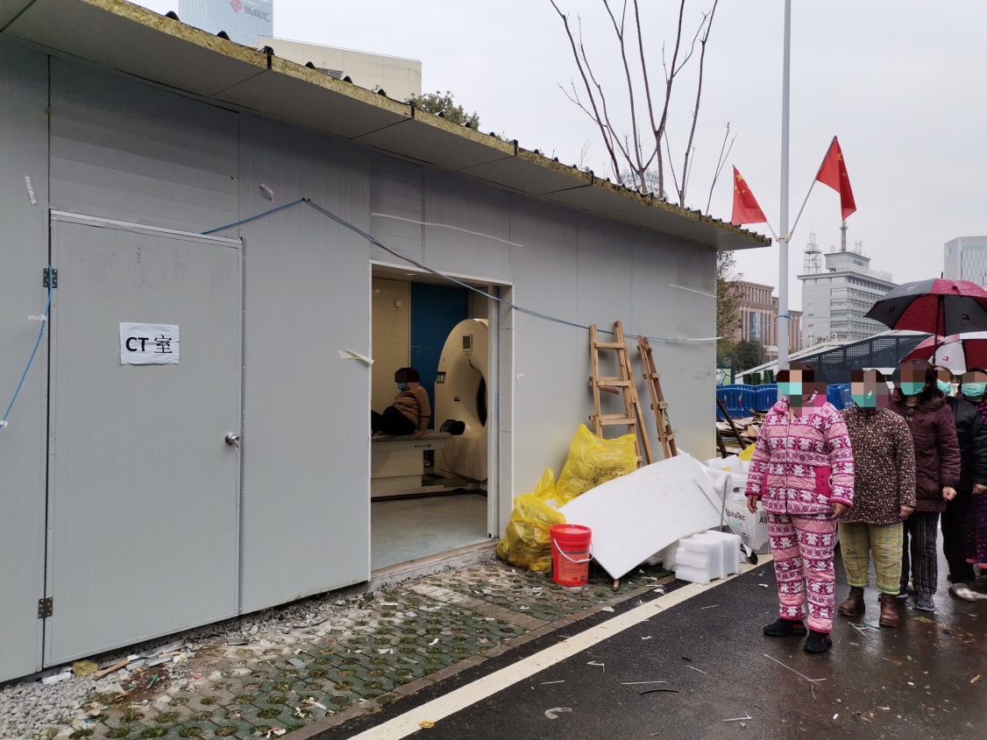
Supplementary Figure 1 Temporarily constructed relocatable CT cabin.

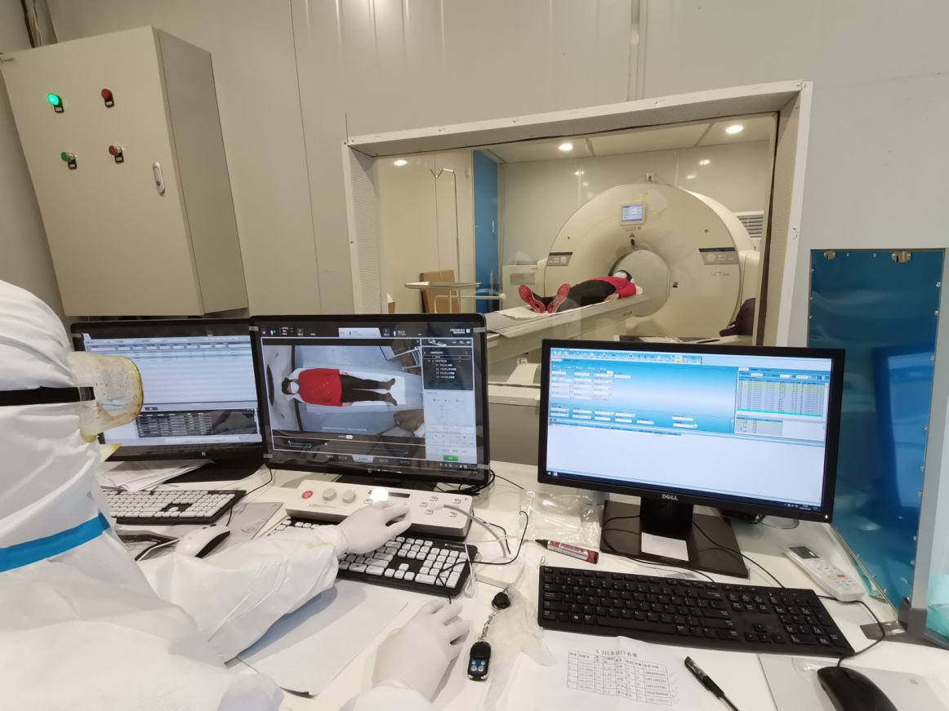
Supplementary Figure 2 Relocatable CT cabin at work

