Supplementary information

Domain Imaging Processing
Images are taken using a Kerr microscope.
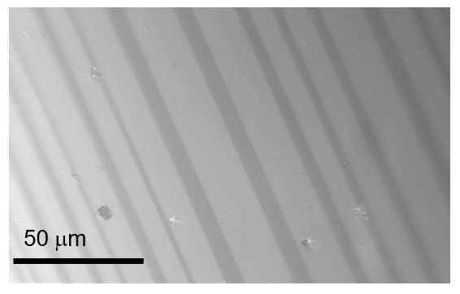
Raw images are enhanced by subtracting a background at a saturating field to enhance the difference in light levels due to Kerr rotation.
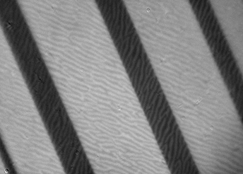
The contrast is enhanced further by applying a filter convolve.

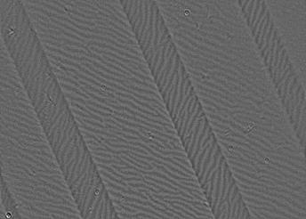
Finally the images presented are obtained by applying a threshold that collapses the greyscale image into a black and white one.
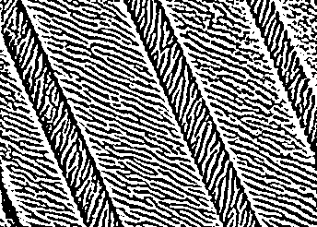

Fourier analysis
From the above thresholded images, a 2D fourier transform is performed using the numpy 2DFFT package in python.
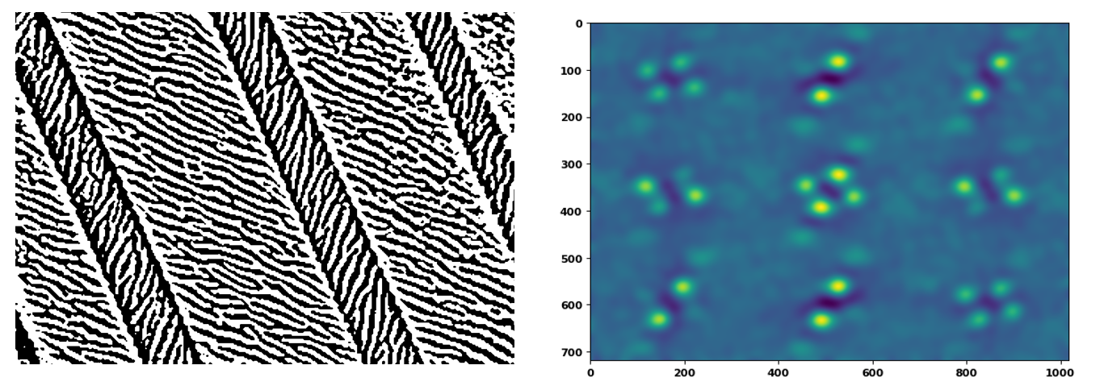
This produces information about the periodicity of the domain patterns as discussed in the main paper. As the domains are oriented along preferred directions there are poles that represent the periodicity associated with those domains. To find the orientation between these we use the skimage package alongside the Houghs circles function to fit a circle to these poles, giving us the pixel location of the centre of the pole. From this, we can extract the angular difference by treating each location as a vector quantity.
