Exhibits
Exhibit 1. Overview of findings for selection of coding questions used to assess IIS statutes and administrative codes across all 50 states, the District of Columbia, Philadelphia, and New York City.
Section A: Consent required for birth records (birth), pediatric vaccination records (ped), and adult vaccination records (adult) to be included in IIS
Consent | Mandated  (no opt-out) |  |  |  |  |  |  | Implied  (with opt-out) |  |  |  |  |  |  |  |  | Expressed  (written) |  |  |  |  |  |  |  |  | Expressed  (written or verbal) |  |  |  |  |  |  | Not mentioned
Record | Birth |  | Ped |  |  | Adult |  | Birth |  |  |  | Ped | Adult |  |  |  | Birth |  |  |  | Ped |  | Adult |  |  | Birth | Ped |  |  | Adult |  |  | Birth |  | Ped |  |  | Adult
Jurisdictions  Number (%) | 14  (26) |  | 15  (28) |  |  | 9  (17) |  | 7  (13) |  |  |  | 28  (53) | 29  (55) |  |  |  | 2  (4) |  |  |  | 2  (4) |  | 4  (7) |  |  | 1  (2) | 1  (2) |  |  | 3  (6) |  |  | 29  (55) |  | 7  (13) |  |  | 8  (15)
Section B: Provider types required to report vaccinations for children (child) and adults (adult)
Provider |  | At least 1 Provider type |  |  |  |  | All vaccine providers |  |  |  |  |  |  |  |  | Pharmacists only |  |  |  |  |  | Medicaid / Public / VFC only |  |  |  |  |  |  | Otherª |  |  |  |  | Not mentioned
Patient Age |  | Child |  | Adult |  |  | Child |  |  |  | Adult |  |  |  |  | Child |  |  | Adult |  |  | Child |  |  | Adult |  |  |  | Child |  | Adult |  |  | Child |  |  | Adult
Jurisdictions  Number (%) |  | 44  (83) |  | 38  (72) |  |  | 30  (57) |  |  |  | 20  (38) |  |  |  |  | 6  (11) |  |  | 7  (13) |  |  | 0  (0) |  |  | 1  (2) |  |  |  | 8  (15) |  | 10  (19) |  |  | 9  (17) |  |  | 15  (28)
Section C: School and/or childcare utilization of IIS
 |  | Accept IIS as proof of vaccination record |  |  |  |  |  |  |  |  |  |  |  | At least 1 staff member has read access |  |  |  |  |  |  |  |  |  |  |  |  |  | At least 1 staff member has edit permission
Utilization |  | Yes |  |  | No |  |  |  | Not mentioned |  |  |  |  | Yes |  |  |  |  |  | No |  |  |  | Not mentioned |  |  |  | Yes |  |  |  | No |  |  |  | Not mentioned
Jurisdictions Number (%) |  | 43  (81) |  |  | 1  (2) |  |  |  | 9  (17) |  |  |  |  | 44  (83) |  |  |  |  |  | 4  (7) |  |  |  | 5  (10) |  |  |  | 22  (41) |  |  |  | 13  (25) |  |  |  | 18  (34)
Section D: Mandatory demographic elements included in IIS
Demographic Element |  | Date of Birth |  |  |  |  |  |  |  | Sex |  |  |  |  |  |  |  | Race |  |  |  |  |  |  |  | Ethnicity |  |  |  |  |  |  | Birthplace
Jurisdictions  Number (%) |  | 27  (51) |  |  |  |  |  |  |  | 25  (47) |  |  |  |  |  |  |  | 13  (25) |  |  |  |  |  |  |  | 9  (17) |  |  |  |  |  |  | 15  (28)
Section E: Patient allowed direct access to records through digital portal or application
Access |  | Yes |  |  |  |  |  |  |  |  |  |  |  |  | Adult records only |  |  |  |  |  |  |  |  |  |  |  |  | No
Jurisdictions Number (%) |  | 18  (34) |  |  |  |  |  |  |  |  |  |  |  |  | 3  (6) |  |  |  |  |  |  |  |  |  |  |  |  | 32^{b}  (60)
ª Laws may require specific provider type(s) to report such as optometrists, student health clinics, dentists, midwives, VFC, etc. depending on state and patient age.​
^{b} As of publication, NJ allowed access to COVID-19 vaccination records only.

Exhibit 2. Comparison of previous and current legal epidemiology studies of immunization information systems and immunization registries across the United States.
Section A: Sources of information & population age vaccination records studied
Study | Current Study  (2022) |  |  |  |  |  | Martin et al.  (2015) |  |  |  |  |  |  |  | Hedden et al.  (2012) |  |  |  |  |  |  |  | Horlick et al.  (2001) |  |  |  |  |  |  |  | Gostin and Lazzarini  (1995)
Primary Source | WestlawNext® legal database, July 2021 |  |  |  |  |  | WestLaw legal database, Oct-Nov 2011 |  |  |  |  |  |  |  | Legal databases, 2010-2011 |  |  |  |  |  |  |  | Survey and Phone Interviews, 1997-1998, 2000 |  |  |  |  |  |  |  | Not reported
Secondary Sources | Public health department websites |  |  |  |  |  | Survey of immunization program managers.  Phone interviewsª |  |  |  |  |  |  |  | Library records of statues and regulations |  |  |  |  |  |  |  | Legislation, administrative rules, and immunization registry policies |  |  |  |  |  |  |  | Not reported
Focus population | Pediatric and Adult |  |  |  |  |  | Pediatric and Adult |  |  |  |  |  |  |  | Pediatric |  |  |  |  |  |  |  | Pediatric |  |  |  |  |  |  |  | Pediatric
Jurisdictions included | 53 |  |  |  |  |  | 53^{b} |  |  |  |  |  |  |  | 56^{c} |  |  |  |  |  |  |  | 51^{d} |  |  |  |  |  |  |  | 52e
Section B: Change in ages included in IIS
Reporting ages | No age restrictions (all ages) |  |  |  |  |  |  |  |  |  |  |  |  |  |  |  |  | Pediatric only (0-18)
Study | 2022 |  | 2015 |  |  | 2012 |  |  |  |  | 2001 |  |  | 1995 |  |  |  | 2022 |  |  |  | 2015 |  |  |  |  | 2012 |  |  |  | 2001 |  |  |  | 1995
Jurisdictions  Number (%) | 52  (98) |  | 51  (96) |  |  |  |  |  |  |  |  |  |  |  |  |  |  | 1  (2) |  |  |  | 2  (4) |  |  |  |  | 47  (84) |  |  |  | 36  (71) |  |  |  | 16  (31)
Section C: Change in consent required for pediatric vaccination reporting
Consent | Mandated  (no opt-out) |  |  |  |  |  |  | Implied  (with opt-out) |  |  |  |  |  |  |  | Expressed  (written) |  |  |  |  |  |  |  | Expressed  (written or verbal) |  |  |  |  |  |  |  | Not mentioned
Study | 2022 | 2015 |  |  | 2001 |  |  | 2022 |  | 2015 |  | 2001 |  |  |  | 2022 | 2015 |  |  | 2001 |  |  |  | 2022 |  | 2015 |  | 2001 |  |  |  | 2022 | 2015 |  |  | 2001
Jurisdictions  Number (%) | 15  (28) | 12  (23) |  |  | 12  (24) |  |  | 27  (51) |  | 38  (72) |  | 23  (44) |  |  |  | 2  (4) | 2  (4) |  |  | 12  (24) |  |  |  | 1  (2) |  | 1  (2) |  | 2  (4) |  |  |  | 8  (15) |  |  |  | 2  (4)
Section D: Change in mandated pediatric vaccination reporting requirements
Reporting | At least 1 provider required
Study | 2022 |  |  |  |  | 2015 |  |  |  |  |  |  |  | 2012 |  |  |  |  |  |  | 2001 |  |  |  |  |  |  |  |  | 1995^{f}
Jurisdictions Number (%) | 44  (83) |  |  |  |  | 31  (58) |  |  |  |  |  |  |  | 26  (46) |  |  |  |  |  |  | 12  (24) |  |  |  |  |  |  |  |  | 12  (63)
Section E: Change in age restrictions for mandated reporting by at least 1 provider
Reporting age restrictions | No age restrictions  (all ages) |  |  |  |  |  |  |  | Adult subset^{g} |  |  |  |  |  |  |  |  |  | Pediatric  (all under 19) |  |  |  |  |  |  |  |  |  | Pediatric subset^{g}
Study | 2022 |  |  | 2015 |  |  |  |  | 2022 |  |  |  | 2015 |  |  |  |  |  | 2022 |  |  |  |  |  | 2015 |  |  |  | 2022 |  |  |  |  | 2015
Jurisdictions  Number (%) | 36  (68) |  |  | 14  (26) |  |  |  |  | 2  (4) |  |  |  | 3  (6) |  |  |  |  |  | 6  (11) |  |  |  |  |  | 12  (23) |  |  |  | 2  (4) |  |  |  |  | 2  (4)
ª Phone interviews conducted with relevant individuals including immunization program and IIS managers, CDC public health advisors, etc.
^{b} Compared to current study - Excludes NH. Includes San Antonio, TX.
^{c} Compared to current study - Includes San Antonio and Houston, TX and Chicago, IL.
^{d} Compared to current study - Excludes NYC and PHI.
^{e} Compared to current study - Excludes NYC and PHI. Includes Puerto Rico.
^{f} Mandated reporting to immunization registry. An additional 11 states required reporting to local health department.
^{g} Subset of adult and pediatric age groups indicate that some jurisdictions require reporting for only a portion of the age group.

Exhibit 3. School and childcare read and write/edit access to IIS.
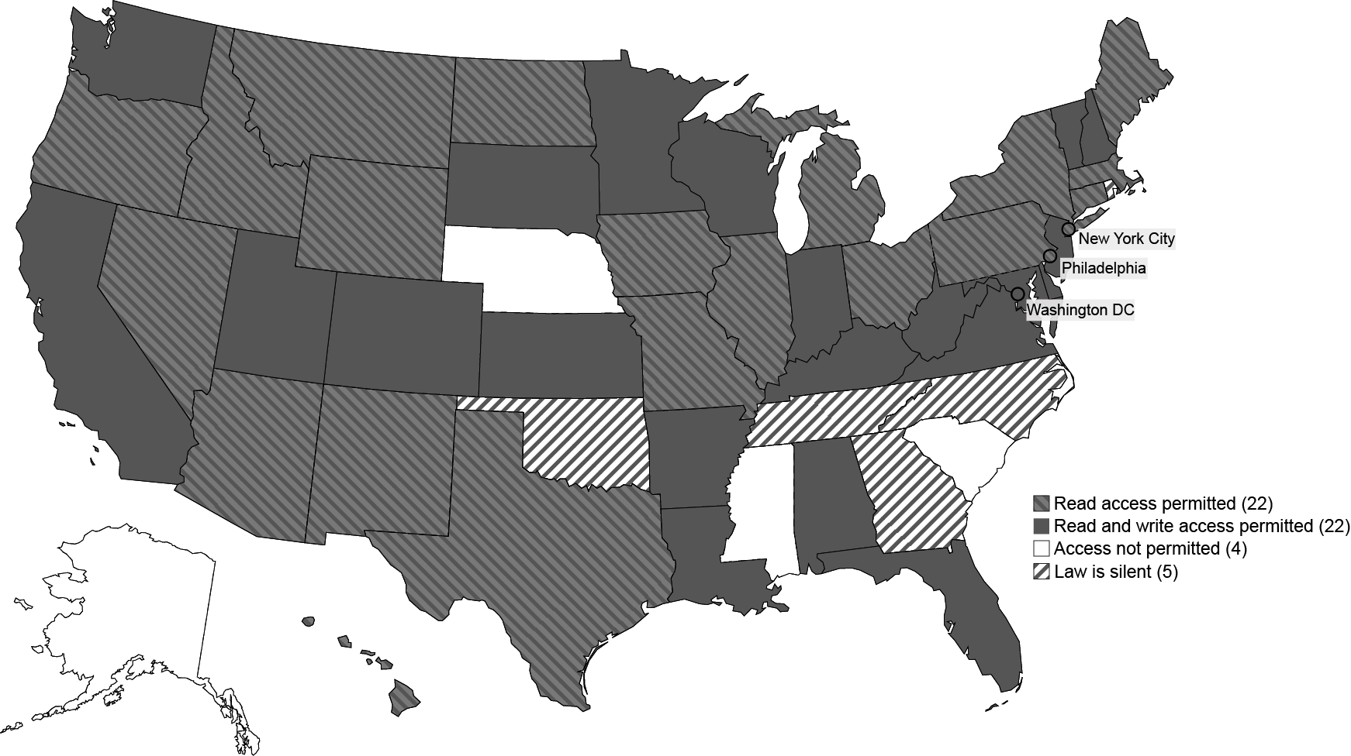
Notes: Read access permitted indicates that at least 1 school or childcare staff member is permitted access to view records in the IIS. Read and write access permitted indicates that at least 1 school or childcare staff member is permitted access to view and or edit records in the IIS. Access not permitted indicates that provisions in the law prohibit or omit school and childcare staff members from direct IIS access. Law is silent indicates that school or childcare access to IIS records was not addressed in the law.

Exhibit 4. IIS demographic data reporting requirements.
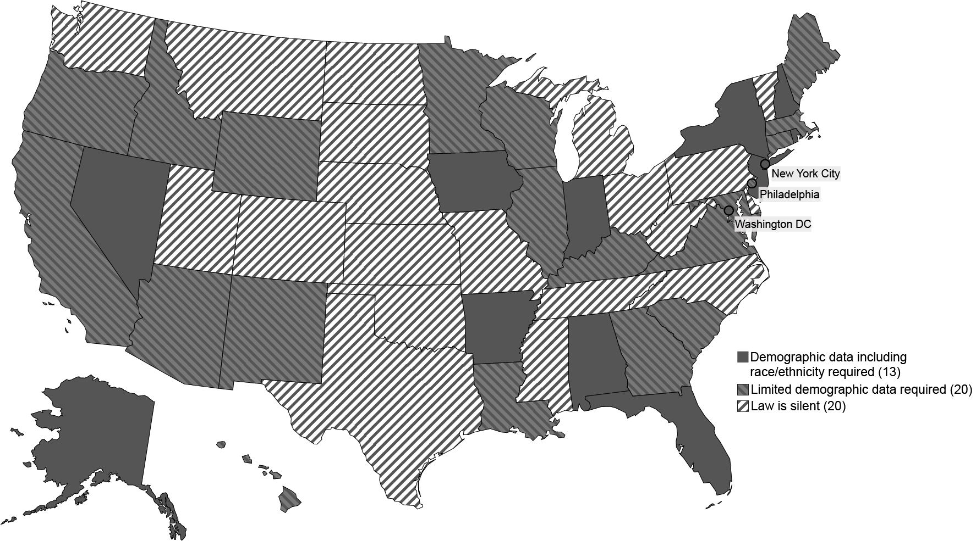
Notes: Limited demographic data indicates that demographic data was mentioned in the law but may not have specified which aspects of demographic data is required for reporting or may be limited to date of birth and address. Jurisdictions that specified reporting of additional demographic data, specifically race and/or ethnicity, are considered separately. Law is silent indicates that collection or reporting of demographic data was not addressed in the law.

EXHIBIT 1 (table)
Caption: Overview of findings for selection of coding questions used to assess IIS statutes and administrative codes across all 50 states, the District of Columbia, Philadelphia, and New York City.
Source/Notes: SOURCE: Authors’ analysis, evaluation, and organization of IIS laws identified using the methods described in the “Study Design” section.

EXHIBIT 2 (table)
Caption: Comparison of previous and current legal epidemiology studies of immunization information systems and immunization registries across the United States.
Source/Notes: SOURCE: Authors’ analysis, evaluation, and organization of IIS laws identified using the methods described in the “Study Design” section.

EXHIBIT 3 (figure)
Caption: School and childcare read and write/edit access to IIS.
Source/Notes: SOURCE: Authors’ legal analysis and evaluation of IIS laws by jurisdiction. NOTES: Read access permitted indicates that at least 1 school or childcare staff member is permitted access to view records in the IIS. Read and write access permitted indicates that at least 1 school or childcare staff member is permitted access to view and or edit records in the IIS. Access not permitted indicates that provisions in the law prohibit or omit school and childcare staff members from direct IIS access. Law is silent indicates that school or childcare access to IIS records was not addressed in the law.

EXHIBIT 4 (figure)
Caption: IIS demographic data reporting requirements.
Source/Notes: SOURCE: Authors’ legal analysis and evaluation of IIS laws by jurisdiction. NOTES: Limited demographic data indicates that demographic data was mentioned in the law but may not have specified which aspects of demographic data is required for reporting or may be limited to date of birth and address. Jurisdictions that specified reporting of additional demographic data, specifically race and/or ethnicity, are considered separately. Law is silent indicates that collection or reporting of demographic data was not addressed in the law.

