Supplementary information
Recommendations for robust renovation strategies of Swiss residential buildings
Table of contents:
1. Analyzed buildings’ structure and energy performance 1
2. Description of uncertain parameters 2
3. The resulting renovation options for conventional and bio-based materials 3
4. Initial energy consumption and LCA, LCCA and insulation thickness of the renovated solutions for gas and heat pump heating systems 5

Analyzed buildings’ structure and energy performance
Existing state of the analyzed buildings can be seen in Table 1.
Table 1 – existing state of analyzed buildings
Building | 1 | 2 | 3 | 4 | 5 | 6
Year of construction | 1911 | 1939 | 1960 | 1970 | 1972 | 1988
Construction period | Before 1919 | 1919-1945 | 1946-1960 | 1961-1970 | 1971-1980 | 1981-1990
Heated floor area, m² | 1563 | 2445 | 1475 | 2811 | 1446 | 5215
Exterior walls structure | Stone, not insulated, U = 1.60 W/(m²K) | Hollow brick, not insulated, U-value – 1.22 W/(m²K) | Hollow brick, not insulated, U-value – 0.65 W/(m²K) | Reinforced concrete, not renovated, U-value – 1.53 W/(m²K) | Double brick wall, 4 cm of mineral wool, U-value – 0.55 W/(m²K) | Reinforced concrete, 8 cm of mineral wool, U-value – 0.43 W/(m²K)
Roof structure | Wooden beams, 10 cm rockwool, U = 0.98 W/(m²K) | Hollow brick, not insulated, U-value – 1.02 W/(m²K) | Reinforced concrete. 10 cm rockwool, U-value – 0.31 W/(m²K) | Reinforced concrete, 10 cm EPS, U-value – 0.36 W/(m²K) | Reinforced concrete, 6 cm mineral wool, U-value – 0.50 W/(m²K) | Reinforced concrete, 10 cm EPS, U-value – 0.47 W/(m²K)
Ground slab structure | Concrete, not insulated, U = 2.80 W/(m²K) | Hollow brick, not insulated, U-value – 0.98 W/(m²K) | Hollow brick, not insulated, U-value – 1.06 W/(m²K) | Reinforced concrete, not insulated, U-value – 2.14 W/(m²K) | Reinforced concrete, not insulated, U-value – 1.53 W/(m²K) | Reinforced concrete, not insulated, U-value – 2.18 W/(m²K)
Storeboxes |  | Hollow brick, not insulated, U-value – 2.66 W/(m²K) | Hollow brick, 10 cm, U-value – 3.50 W/(m²K) | Reinforced concrete, not insulated, U-value – 4.00 W/(m²K) | Brick, not insulated, U-value – 0.99 W/(m²K) | Concrete slab, 6 cm mineral wool, U-value – 0.49 W/(m²K)
Windows | Double glazing with PVC frame, U-value 1.60 W/m²,K | Double glazing, PVC frame. U-value 1.94 W/m²,K | Double glazing, wooden frame, U-value 2.95 W/m²,K | Double glazing, PVC frame, U-value 2.33 W/m²,K | Double glazing with low-E layer, PVC frame, U-value 1.70 W/m²,K | Double glazing, PVC frame, U-value 2.70 W/m²,K
Heating demand, deterministic, SIA 380/1, kWh/m²,a | 141 | 94 | 110 | 109 | 91 | 88

Description of uncertain parameters
The description of the uncertain parameters including range and distribution type can be seen in Table 2.
Table 2: Description of uncertain parameters
Model parameter |  | Parameters | Moments | Distribution | Source
Embodied LCEI ${(m}_{production})$ and investment costs ($C_{investment})$
Embodied impact gas boiler [kgCO₂eq.] |  | [2246, 3370] |  | uniform | (Wernet, G., Bauer, C., Steubing, B., Reinhard, J., Moreno-Ruiz, E., and Weidema, 2016)
Embodied impact wood pellets boiler [kgCO₂eq.] |  | [915.9, 1375] |  | uniform
Embodied impact heat pump [kgCO₂eq.] |  | [4600, 5520] |  | uniform
Cost gas boiler [CHF/ERA] |  | [30.1, 45.2] |  | uniform | (SIA 480, 2016; WWF, 2015)
Cost wood pellets boiler [CHF/ERA] |  | [37.7, 56.5] |  | uniform | (SIA 480, 2016; WWF, 2015)
Cost heat pump [CHF/ERA] |  | [40.7, 61] |  | uniform | (SIA 480, 2016; WWF, 2015)
Embodied impact components [%] |  | [-30,30] |  | uniform | (Chen et al., 2010; Säynäjoki et al., 2017)
Investment cost components [%] |  | [-20, 20] |  | uniform | (SIA 480, 2016)
Operational environmental and cost inputs
Thermal energy generation - $k_{op.}$ [kgCO2-eq./kWh] | Gas | [0.248, 0.249] |  | uniform | (Chen et al., 2010; Säynäjoki et al., 2017)
Thermal energy generation - $k_{op.}$ [kgCO2-eq./kWh] | Wood pellets | [0.038, 0.048] |  | uniform | (Chen et al., 2010; Säynäjoki et al., 2017)
Thermal energy generation - $k_{op.}$ [kgCO2-eq./kWh] | Heat pump | [0.036, 0.039] |  | uniform | (Chen et al., 2010; Säynäjoki et al., 2017)
Operational cost for heating [CHF/kWh] $m_{op}$ | Gas | [0.101, 0.111, 0.127] |  | triangular | (Toczé, 2018; WWF, 2015)
Operational cost for heating [CHF/kWh] $m_{op}$ | Wood pellets | [0.095, 0.107, 0.13] |  | triangular | (Toczé, 2018; WWF, 2015)
Operational cost for heating [CHF/kWh] $m_{op}$ | Heat pump | [0.064, 0.079, 0.093] |  | triangular | (Toczé, 2018; WWF, 2015)
Inflation rate $r$ [%] |  | [0.5,2] |  | uniform | (State Secretariat for economic Affairs (SECO), 2019)
Discount rate (real) $d_{nominal}$ [%] |  | [2.5,4.5] |  | uniform | (SIA 480, 2016)
Components reference service life $RSL$ [years]
Exterior wall [years] |  |  | [40.6, 11.6] | lognormal | (Lasvaux et al., 2019)
Roof [years] |  |  | [30.4, 9.6] | lognormal | (Lasvaux et al., 2019)
Slab [years] |  |  | [33.7, 14.2] | lognormal | (Lasvaux et al., 2019)
Wall against unheated surface [years] |  |  | [40.6, 11.6] | lognormal | (Lasvaux et al., 2019)
Windows [years] |  |  | [27.5, 12.2] | lognormal | (Lasvaux et al., 2019)
Oil boiler [years] |  |  | [19.4, 3.1] | lognormal | (Lasvaux et al., 2019)
Gas boiler [years] |  |  | [18.8, 3.3] | lognormal | (Lasvaux et al., 2019)
Wood pellets boiler [years] |  |  | [18.3, 2.8] | lognormal | (Lasvaux et al., 2019)
Heat pump [years] |  |  | [17.1, 6.4] | lognormal | (Lasvaux et al., 2019)
Electric boiler [years] |  |  | [19.8, 5] | lognormal | (Lasvaux et al., 2019)
Slab against unheated surface [years] |  |  | [33.7, 14.2] | lognormal | (Lasvaux et al., 2019)
Roof against unheated surface [years] |  |  | [30.4, 9.6] | lognormal | (Lasvaux et al., 2019)
System performance
Existing windows U-value $U_{ex}$ [W/m²*K] |  |  | [2.9, 0.58] | lognormal | Assumption, (Fernandes et al., 2019)
Existing exterior wall degradation $d_{i}$ [%] |  |  | [10, 3] | gumbel | Assumption (Domínguez-Muñoz et al., 2009)
Existing roof insulation degradation $d_{i}$ [%] |  |  | [20, 5] | lognormal | Assumption (Domínguez-Muñoz et al., 2009)
Thermal bridge renovation $φ$ [%] |  |  | [18, 5] | gaussian | Assumption
Efficiency loss of the existing system [%] |  | [0.15, 0.25] |  | uniform | Assumption (European comission directorate-general for energy, 2016)
Efficiency loss of a new system [%] $PF$ |  |  | [0.15, 0.05] | gaussian | Dependent on the heating system, shown in SI1
Existing slab against unheated surf., degradation [%] $d_{i}$ |  |  | [10, 5] | lognormal | Assumption (Gharehbaghi et al., 2020)
User-oriented parameters
Operating temperature inside $T_{in}$ [°C] |  | [20,23] |  | uniform | (Khoury et al., 2018)
Building occupation schedule $t_{occ}$ [h/day] |  | [8, 16] |  | uniform | +/- 4 hours to the suggested 12 h value by (SIA 380/1, 2016)
Airflow $q_{vent}$ [m³h/m²] |  | [0.7, 1] |  | uniform | (Khoury et al., 2018)

The resulting renovation options for conventional and bio-based materials
The renovation solutions for the median values considering conventional and bio-based materials can be seen in Table 3 and Table 4.
Table 3: Optimal renovation solutions considering conventional materials
Building, year | Heating system | Windows | Exterior wall | Roof | Ground floor | Storebox (box above window with blinds) | LCCA, CHF/m²,a | LCA kgCO₂eq/m²,a
1, 1911 | Gas | Current | Hagatherm 2cm Multipor 8cm | Cellulose fibre 21cm | Rockwool 11cm | - | 6.57 | 22.38
1, 1911 | Wood pellets | Current | Hagatherm 2cm Multipor 8cm | Cellulose fibre 16.5cm | Rockwool 11cm | - | 7.19 | 3.99
1, 1911 | Heat pump | Current | Hagatherm 2cm Multipor 8cm | Cellulose fibre 21cm | Rockwool 8cm | - | 5.17 | 10.90
2, 1939 | Gas | Current | Current | Glasswool 12 cm | Rockwool 8 cm | Glasswool  10 cm | 6.64 | 19.44
2, 1939 | Wood pellets | Current | Current | Glasswool 12 cm | Rockwool 8 cm | Glasswool 11 cm | 6.02 | 6.41
2, 1939 | Heat pump | Current | Current | Glasswool 12 cm | Rockwool 8 cm | Glasswool 12 cm | 6.14 | 19.41
3, 1960 | Gas | Wooden frame with double glazing | Wood fibre 10 cm | Current | Rockwool  8 cm | Glasswool 5 cm | 13.16 | 33.45
3, 1960 | Wood pellets | Current | Current | Current | Rockwool 11 cm | Glasswool 4 cm | 5.56 | 6.99
3, 1960 | Heat pump | Current | Current | Current | Rockwool 8 cm | Glasswool 7 cm | 6.82 | 19.58
4, 1970 | Gas | Wooden frame with double glazing | Wood fibre 10 cm | Glasswool 7 cm | Current | Glasswool 10 cm | 9.40 | 21.36
4, 1970 | Wood pellets | Current | Wood fibre 10 cm | Glasswool 7 cm | Current | Glasswool 10 cm | 10.74 | 7.71
4, 1970 | Heat pump | Current | 10 cm wood fibre | Glasswool 7 cm | Current | Glasswool 10 cm | 9.10 | 12.56
5, 1972 | Gas | Current | Wood fibre 9.4 cm | Glasswool 23 cm | Rockwool 10 cm | Glasswool 7 cm | 11.14 | 23.73
5, 1972 | Wood pellets | Current | Wood fibre 4.2 cm | Current | Rockwool 10 cm | Glasswool 7 cm | 9.03 | 6.61
5, 1972 | Heat pump | Current | Current | Glasswool 16.1 cm | Rockwool 6.9 cm | Glasswool 12.7 cm | 7.43 | 22.40
6, 1988 | Gas | Wooden frame with double glazing | Wood fibre 7 cm | Current | Rockwool 10 cm | Glasswool 5 cm | 8.35 | 19.10
6, 1988 | Wood pellets | Current | Wood fibre 7 cm | Current | Rockwool 7 cm | Glasswool 5 cm | 6.08 | 6.30
6, 1988 | Heat pump | Current | Current | Rockwool 5 cm | Rockwool 7 cm | Glasswool 8 cm | 4.64 | 12.28

Table 4: Optimal renovation solutions considering bio-based materials
Building, year | Heating system | Windows | Exterior wall | Roof | Ground floor | Storebox (box above window with blinds) | LCCA, CHF/m²,a | LCA kgCO₂eq/m²,a
1, 1911 | Gas | Current | Straw bale 70 cm | Straw bale 70 cm | EPS 20 cm | - | 6.54 | 13.84
1, 1911 | Wood pellets | Current | Straw bale 70 cm | Straw bale 70 cm | EPS 10 cm | - | 5.08 | 1.89
1, 1911 | Heat pump | Current | Straw bale 70 cm | Straw bale 70 cm | Hempcrete 38 cm | - | 4.72 | 2.72
2, 1939 | Gas | Wooden frame with double glazing | Straw bale 70 cm | Straw bale 70 cm | Hempcrete 38 cm | Straw bale 70 cm | 4.61 | 7.32
2, 1939 | Wood pellets | Current | Straw bale 70 cm | Straw bale 70 cm | Hempcrete 38 cm | Straw bale 70 cm | 5.91 | 1.08
2, 1939 | Heat pump | Current | Straw bale 70 cm | Straw bale 70 cm | Hempcrete 38 cm | Straw bale 70 cm | 4.69 | 1.61
3, 1960 | Gas | Current | Straw bale 70 cm | Straw bale 70 cm | Hempcrete 38 cm | Hemp mat 22 cm | 7.73 | 20.55
3, 1960 | Wood pellets | Current | Straw bale 70 cm | Straw bale 70 cm | Hempcrete 38 cm | Straw bale 70 cm | 4.26 | 1.21
3, 1960 | Heat pump | Current | Straw bale 70 cm | Straw bale 70 cm | Hempcrete 38 cm | Hempcrete 8 cm | 5.37 | 1.66
4, 1970 | Gas | Current | Straw bale 70 cm | Straw bale 70 cm | EPS 20 cm | Wood fibre 6 cm | 4.49 | 7.97
4, 1970 | Wood pellets | Current | Hemp mat 12 cm | Straw bale 70 cm | Hempcrete 38 cm | Straw bale 70 cm | 5.53 | 2.41
4, 1970 | Heat pump | Current | Straw bale 70 cm | Straw bale 70 cm | EPS 15 cm | Wood fibre 10 cm | 3.85 | 2.95
5, 1972 | Gas | Current | Hemp mat 18 cm | Hemp mat 18 cm | EPS 10 cm | Straw bale 70 cm | 6.31 | 14.73
5, 1972 | Wood pellets | Current | Straw bale 20 cm | Straw bale 70 cm | EPS 15 cm | Straw bale 70 cm | 7.16 | 2.99
5, 1972 | Heat pump | Current | Straw bale 70 cm | Hemp mat 22 cm | EPS 10 cm | Straw bale 70 cm | 8.64 | 3.24
6, 1988 | Gas | Current | Straw bale 70 cm | Straw bale 48 cm | EPS 20 cm | Straw bale 20 cm | 9.59 | 15.77
6, 1988 | Wood pellets | Current | Straw bale 70 cm | Straw bale 70 cm | Hempcrete 38 cm | Wood fibre 12 cm | 4.96 | 1.34
6, 1988 | Heat pump | Current | Straw bale 48 cm | Straw bale 70 cm | Hempcrete 20 cm | Hemp mat 6 cm | 3.96 | 1.85

Initial energy consumption and LCA, LCCA and insulation thickness of the renovated solutions for gas and heat pump heating systems
In the following figures, the results for the LCA, LCCA and insulation thickness for the gas boiler and heat pump are shown.
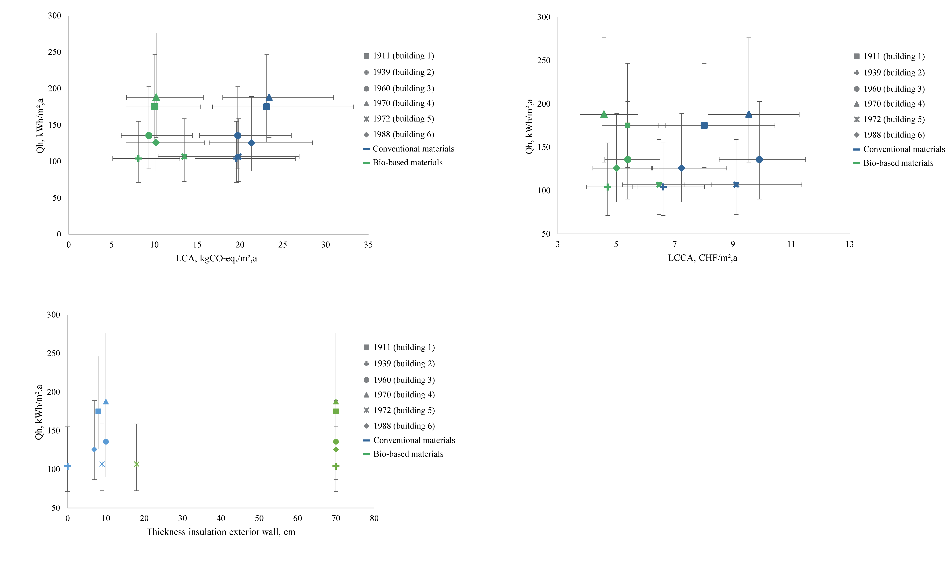
Figure 1: Initial energy consumption and renovated results of LCA considering bio-based and conventional materials for gas boiler

Figure 2: Initial energy consumption and renovated results of LCCA considering bio-based and conventional materials for gas boiler

Figure 3: Initial energy consumption and thickness of thermal insulation after renovation considering bio-based and conventional materials for gas boiler

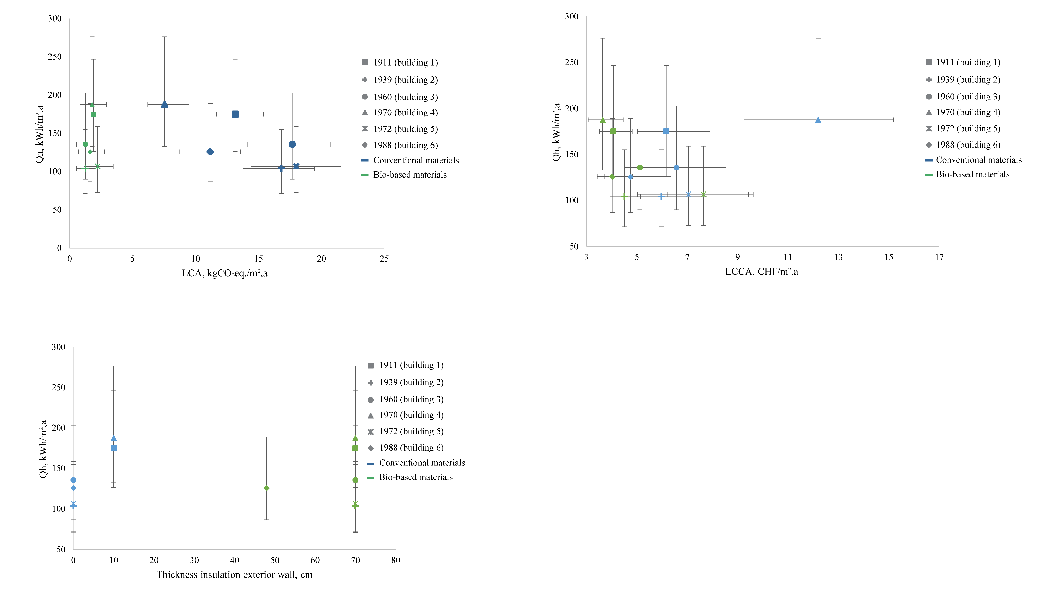
Figure 4: Initial energy consumption and renovated results of LCA considering bio-based and conventional materials for heat pump

Figure 5: Initial energy consumption and renovated results of LCCA considering bio-based and conventional materials for heat pump

Figure 6: Initial energy consumption and thickness of thermal insulation after renovation considering bio-based and conventional materials for heat pump

