Table 4.0: The average result of each parameter for condition of raw coconut husks with limestone and raw coconut husks.

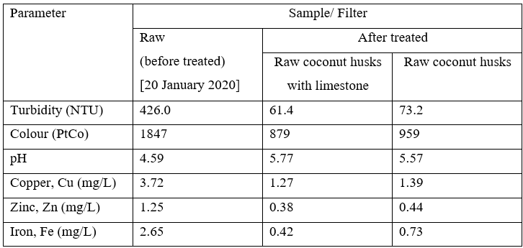

Table 4.1: The average result of each parameter for condition of raw sugarcane bagasse with limestone and raw sugarcane bagasse.
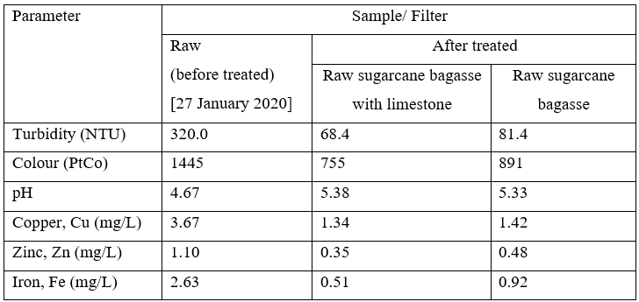

Table 4.2: The average result and percentage removal of turbidity for condition of raw coconut husks with limestone, raw coconut husks, raw sugarcane bagasse with limestone and raw coconut husks.

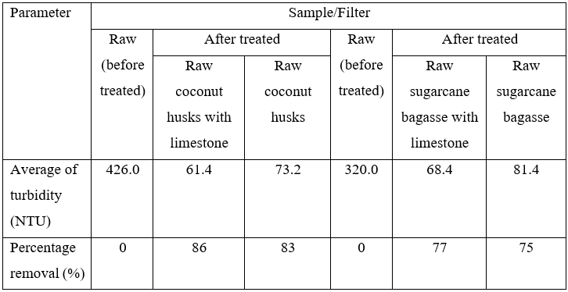

Table 4.3: The average result and percentage removal of colour for condition of raw coconut husks with limestone, raw coconut husks, raw sugarcane bagasse with limestone and raw coconut husks.

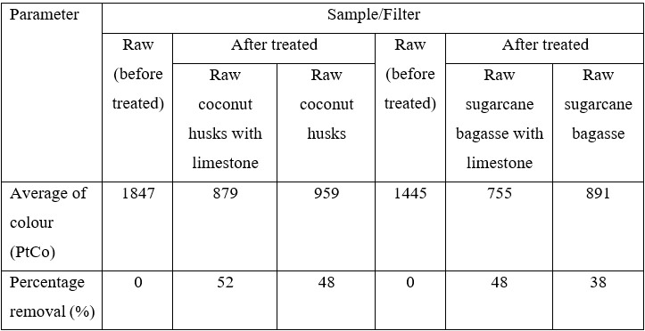

Table 4.4: The average result and percentage removal of pH for condition of raw coconut husks with limestone, raw coconut husks, raw sugarcane bagasse with limestone and raw coconut husks.
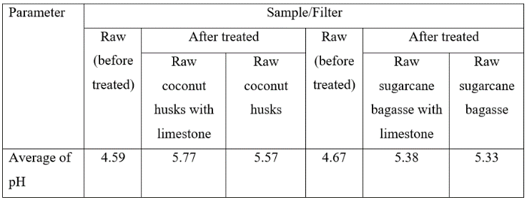

Table 4.5: The average result and percentage removal of Copper for condition of raw coconut husks with limestone, raw coconut husks, raw sugarcane bagasse with limestone and raw coconut husks.

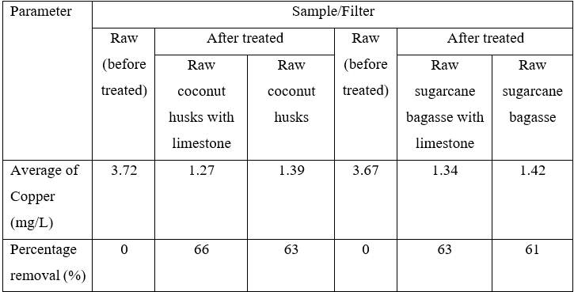

Table 4.6: The average result and percentage removal of Zinc (Zn) for condition of raw coconut husks with limestone, raw coconut husks, raw sugarcane bagasse with limestone and raw coconut husks.

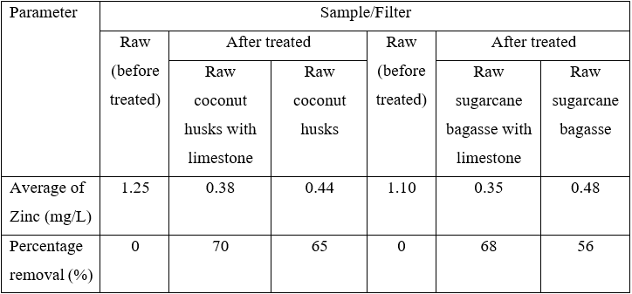

Table 4.7: The average result and percentage removal of Iron (Fe) for condition of raw coconut husks with limestone, raw coconut husks, raw sugarcane bagasse with limestone and raw coconut husks.

