Supporting Information
Spidroin-Inspired Hierarchical Structure Binder Achieves Highly Integrated Silicon-Based Electrodes
Pengzhou Mu^{1, 2}, Shu Zhang¹, Huanrui Zhang^{1, *}, Jiedong Li¹, Zhi Liu¹, Shanmu Dong¹, Guanglei Cui^{1, *}

These authors contributed equally: Pengzhou Mu, Shu Zhang
¹ Qingdao Industrial Energy Storage Research Institute, Qingdao Institute of Bioenergy and Bioprocess Technology, Chinese Academy of Sciences, Qingdao 266101, P. R. China.
² University of Chinese Academy of Sciences, Beijing 100190, P.R. China.
*e-mail: E-mail: zhanghr@qibebt.ac.cn, cuigl@qibebt.ac.cn

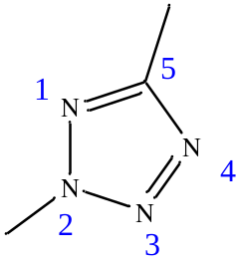
Figure S1. ¹H NMR spectrum of PPB
As shown in Figure S1, the chemical shift located at 4.2 ppm was assigned to the C_{d}–H covalently bonding to N-2 position of tetrazole ring. ¹

Figure S2. ¹³C NMR spectrum of PPB
As illustrated in Figure S2, the chemical shift located at 162 ppm was assigned to the C_{d} in 5 position of tetrazole ring. ¹

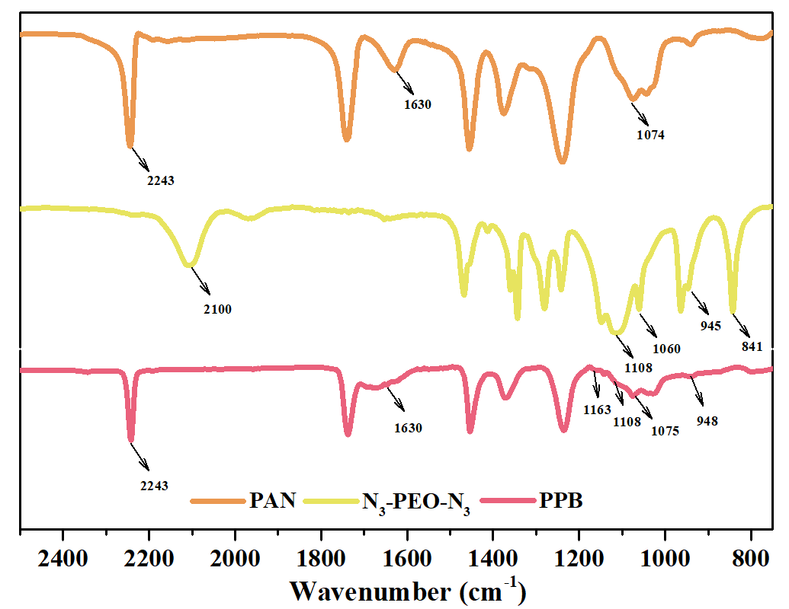
Figure S3. FTIR spectra of PAN, N₃-PEG-N₃ and PPB.
In FTIR spectra (Figure S3), after reaction, the −CN group in PAN located at 2243cm⁻¹ apparently decreases, while the stretching vibration absorption peak of azide groups at 2100 cm⁻¹ disappears (Figure S3), suggesting that the −CN group in the PAN and −N₃ groups in the N₃−PEO−N₃ have undergone chemical evolution.^{1,2} In addition, a peak at 1163cm⁻¹ corresponds to C−N on tetrazole units.

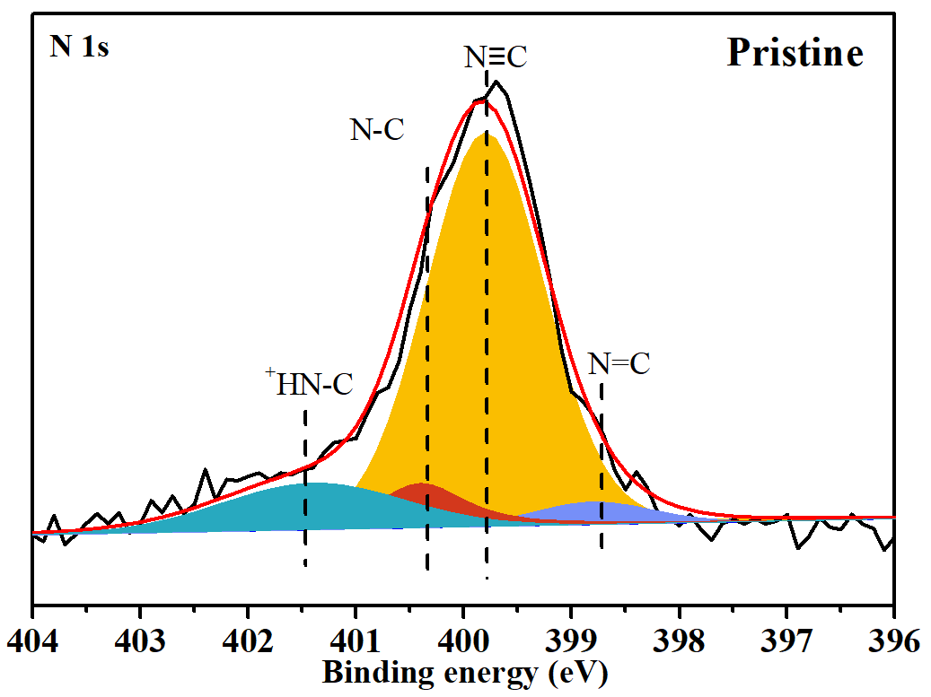
Figure S4. N 1s XPS spectra for the AOB binder based pristine Si anode.
The prepared AOB binder based pristine Si electrode was characterized by XPS. The peak at 398.7 eV, 400.4 eV, and 399.8 eV were attributed to N=C, N−C and C≡N in PPB, respectively. In addition, the peak at 401.5 eV was assigned to the ⁺HN−C reflecting the hydrogen bonding between PPB with PAA.

Figure S5. Typical SEM image of (a) PAB-N binder film morphology. AOB binder film morphologies when diluted in mixed solvents (b) Water: NMP=1:10 (v/v), (c) Water: NMP=1:5 (v/v) and (d) Water: NMP=1:10 (v/v). (e) Typical SEM image of PAB-N binder film morphology.
All the polymer binders were stirred and dissolved in the corresponding co-solvent at room temperature, and the obtained solution was then dropped onto monocrystalline Si piece. After drying at 120 °C for 12 hours under vacuum, the sample surface was then sprayed the gold.

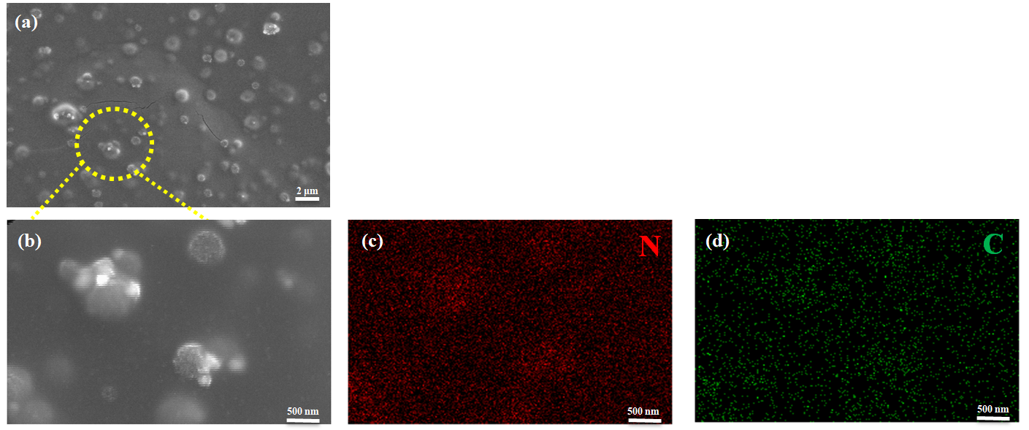
Figure S6. Typical SEM images of (a) the AOB binder diluted in mixed solvents (NMP: water =5:1), and (b) the corresponding selected area amplification image and (c) N and (d) C element mapping images.
In Figure S6, high-resolution SEM imaging presents submicron-sized irregular spherical domains, and SEM element mapping demonstrates that there are much more N elements distributed in the cluster domains than the rest of the film, while C elements are relatively uniform in the AOB binder.

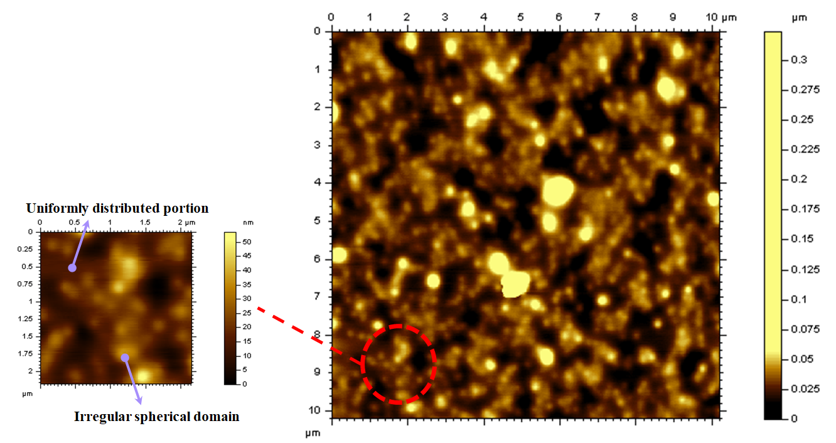
Figure S7. Top-viewed AFM height sensor images of AOB binder film.
As shown in Figure S7, top-viewed AFM height sensor images show the condensed structure of AOB binder films, which contains submicron-sized spherical domains and uniform spherical clusters-free region.

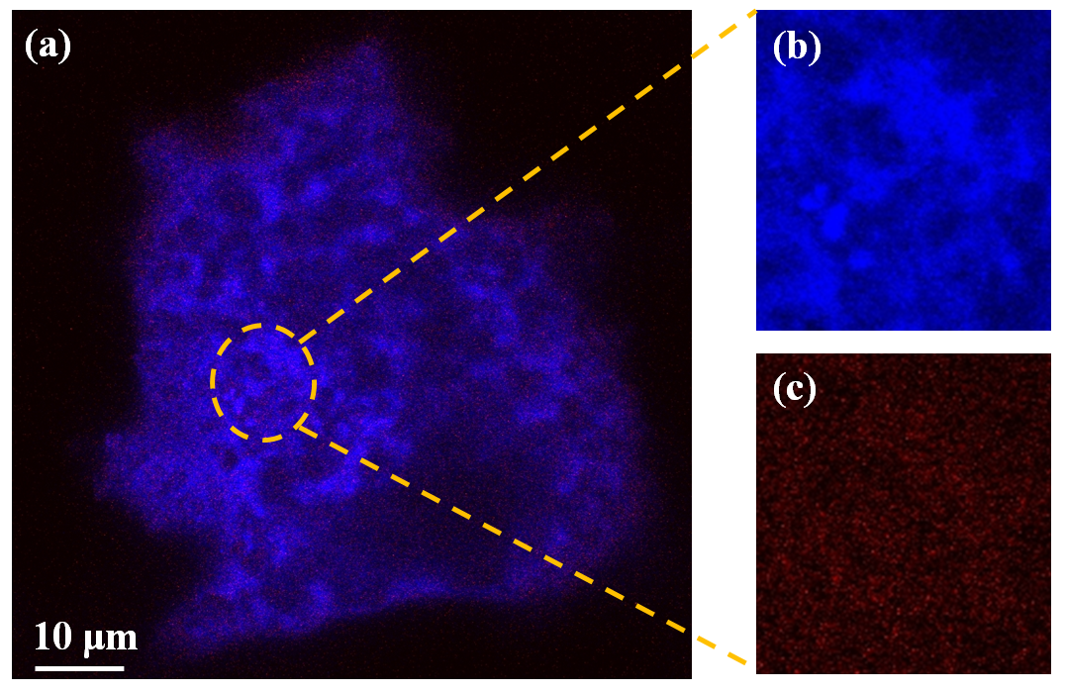
Figure S8. CLSM images of (a) AOB binder film, and of (b-c) the corresponding enlarged film regions excited with 495 nm and 545 nm representing PPB and PAA, respectively.
As displayed in Figure S8a, PPB (excited with 495 nm) and (PAA excited with 545 nm) present blue and red, respectively (Figure S8a). It is evident that CLSM images show the apparently distinct distribution of PAA and PPB in the AOB binder film; PAA is uniformly distributed in the whole film (Figure S8c), while the PPB exists more in the submicron-sized irregular spherical domains (Figure S8b).

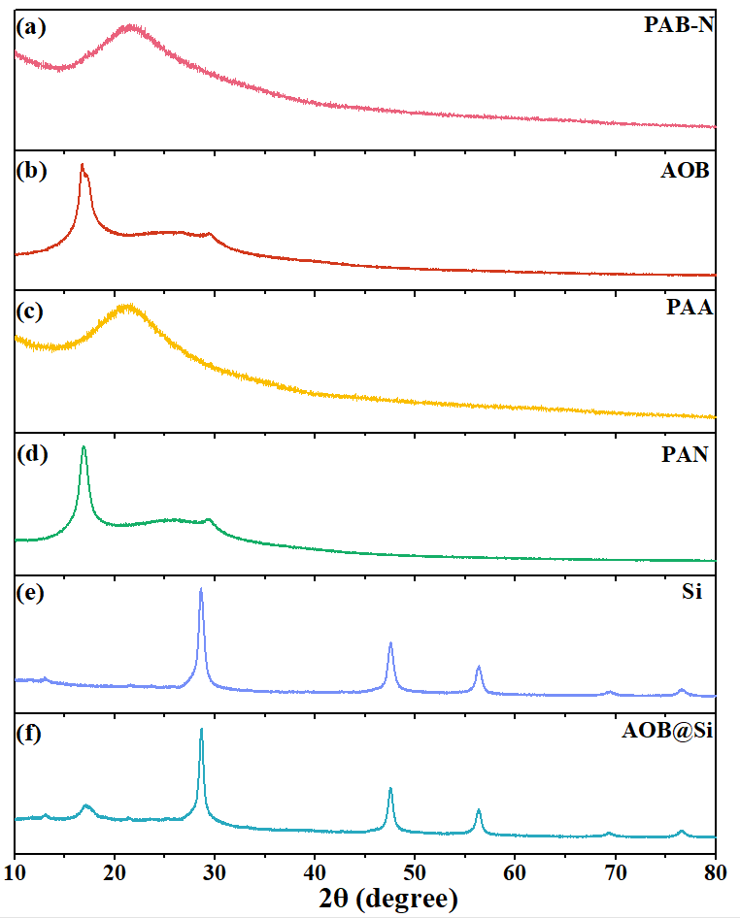
Figure S9. XRD patterns of (a) PAB-N binder film, (b) AOB binder film, (c) PAA powder, (d) PAN powder, (e) Si nanoparticles and (f) Si electrode with AOB binder (denoted as AOB@Si).
As shown in Figure S9, XRD patterns of PAA powder, PAN powder, PAB-N binder film, AOB binder film, Si nanoparticles and AOB@Si were plotted. Apparently, the PAB-N film is amorphous, while both the AOB binder film and the Si electrode with AOB binder show one same strong peak with d spacing of 5.32 Å (2θ=16.68°), which is similar to that of PAN polymer. These findings prove that the aqueous-oil binary mixing process can induce the generation of crystalline zone in the AOB binder film, and that the spidroin-like hierarchical structure binder with amorphous and crystallization domains is constructed.
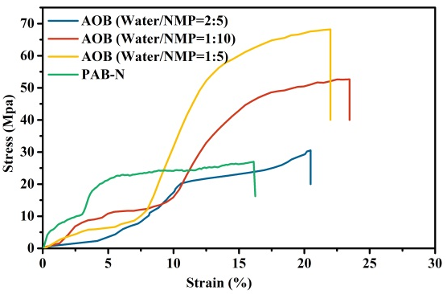
Figure S10. Stress-strain curves of PAB-N and AOB polymer membranes prepared with different solvent systems.
As shown in Figure S10, the water/NMP ratio of 1/5 renders a maximum tensile strength of 68 MPa and a relatively high elongation at break (22.1%), which was chosen as the optimum one for following research.

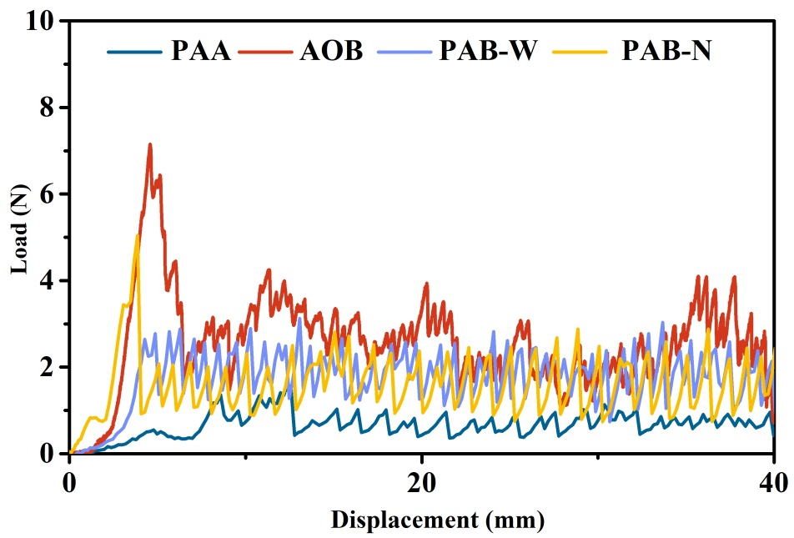
Figure S11. Peeling force-displacement curves of Si anodes with PAB-W and PAB-N binders.
In a 180° peeling test for Si electrodes, the average peel strengths of the PAB-N and PAB-W binders based Si electrodes were 1.53 N and 1.68, respectively, which were lower than that (2.56 N) of AOB based Si electrode. The enhanced electrode peeling strength proves the significance of hierarchical structure design.
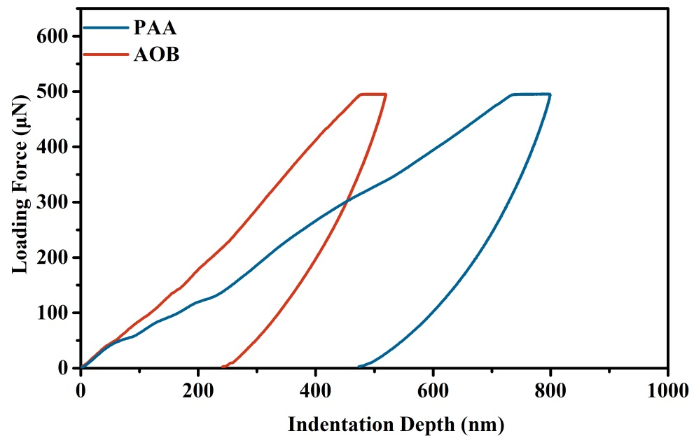
Figure S12. Comparison of load-indentation depth curves of electrodes with PAA and AOB binders.

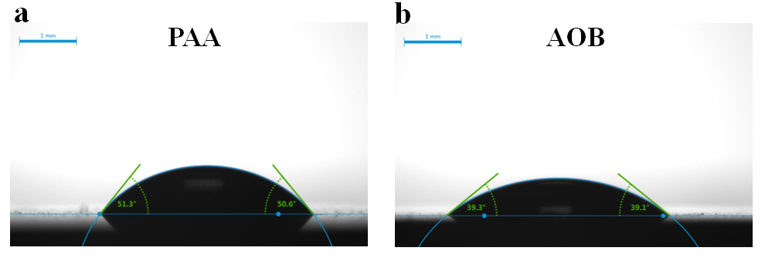
Figure S13. Contact angles of 1 wt% (a) PAA- and (b) AOB binder-based solutions on monocrystalline Si.
The contact angles of the AOB and PAA binder solutions onto the surface of the monocrystalline silicon were 39.1° and 50.6° after standing for 120 s, respectively, indicating that the wettability of the AOB binder solution is higher than the PAA binder solution. The higher wettability helps prevent stress concentration at the interface between binder and Si anode from forming a large number of defects.

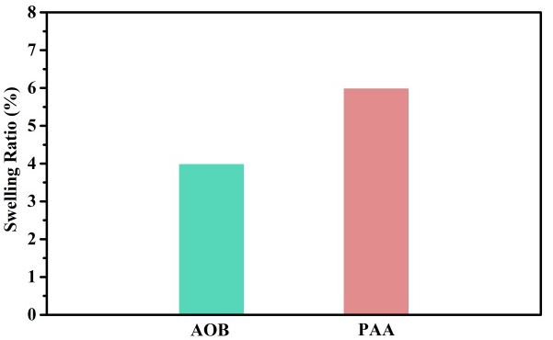
Figure S14. Swelling ratios of AOB and PAA binder films in electrolyte at room temperature.
As presented in Figure S14, the AOB binder polymer film shows a lower swelling ratio (4% vs. 6%) of electrolytes than the PAA counterpart at room temperature.

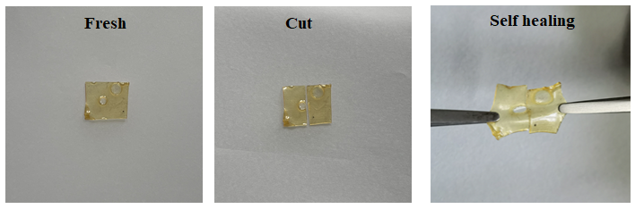
Figure S15. Photos image of self-healing test of AOB binder films.
We cut the AOB binder film into two pieces and kept them together in the presence of electrolyte for about 12 h at room temperature. It is evident that the AOB binder film is obviously recovered, which proves the self-healing ability of AOB binder.

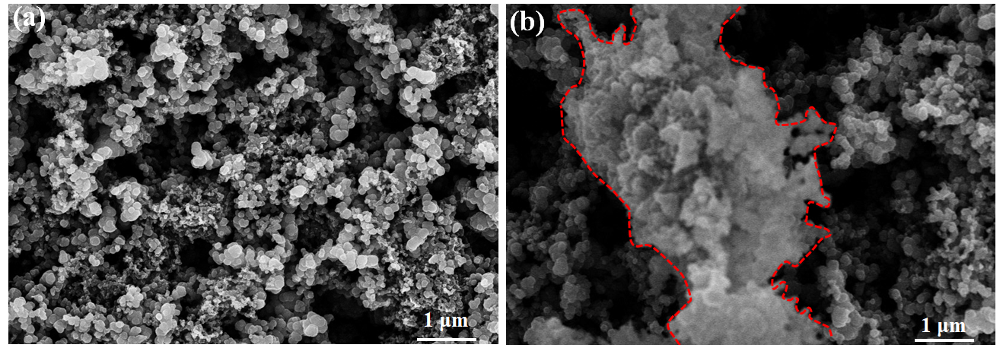
Figure S16. Typical SEM images of (a) PAB-N binder based Si electrode, (b) PAB-W binder based Si electrode.
In Figure S16, the PAB-N binder renders relatively even surface of Si electrode, while PAB-W binder incurs large cluster and obvious cracks.
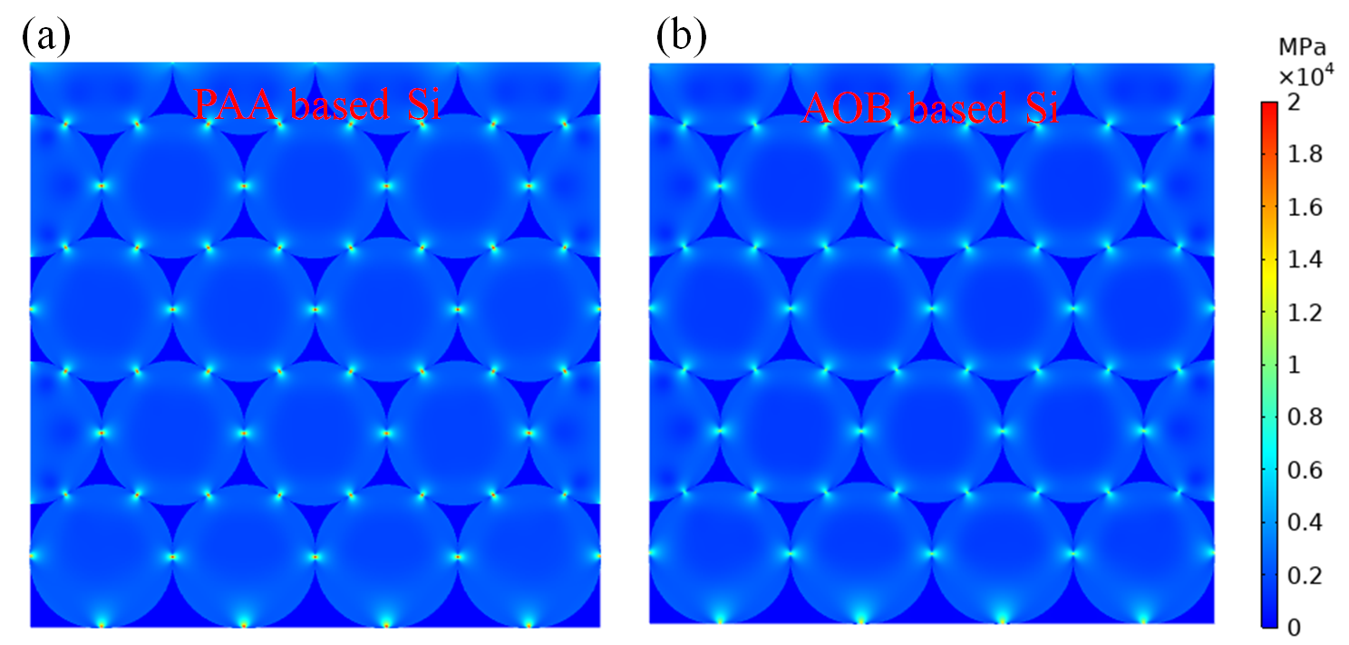
Figure S17. Stress distribution on Si particles in the presence of (a) PAA binder and (b) AOB binder at Li₁₅Si₄ states.
Finite element simulation was carried out to understand the effect of binder mechanical properties on stress distribution after lithiation of Si anode. As shown in Figure S17, the Mises stress between adjacent Si particles in the presence of PAA binder is much higher than that (~2000 vs. ~800 MPa) of AOB binder.
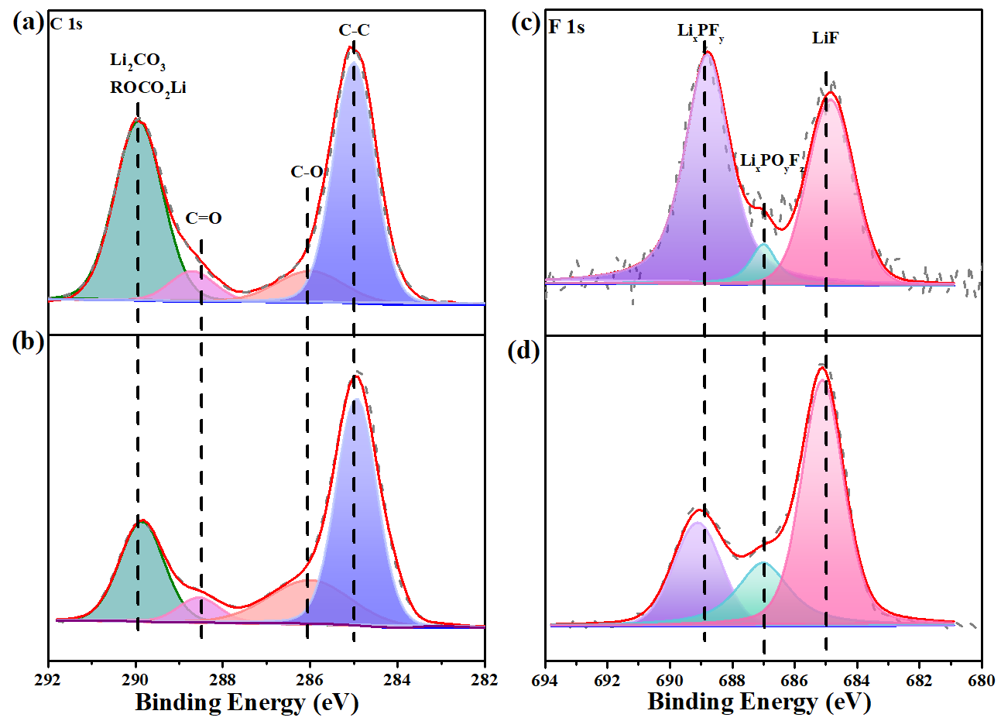
Figure S18. XPS spectra for the Si anode after cycling. C 1s XPS spectra of (a) PAA- and (b) AOB binder based Si electrode, and F 1s XPS spectra of (c) PAA- and (d) AOB binder-based Si electrode.
As shown in Figure S18, both of electrodes show peaks at 288.5 and 289.6 eV associated with ROCO₂Li /Li₂CO₃ and C=O in the C 1s XPS spectra, while in the F 1s spectra, there are three typical peaks, LiF (685 eV), Li_{x}PO_{y}F_{z} (687 eV) and Li_{x}PF_{y} (689 eV).
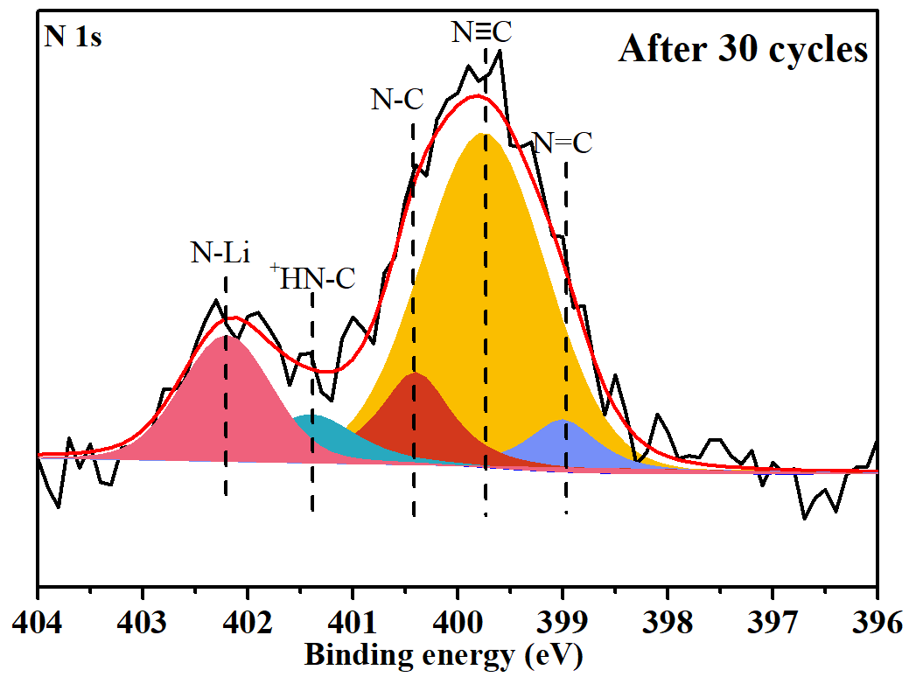
Figure S19. N 1s XPS spectra for the AOB binder based Si anode after 30 cycles.
Compared with the N 1s XPS spectra for pristine Si anode with AOB binder (Figure S4), the N 1s spectrum of the AOB based anode surface after 30 cycles shows a strong N–Li peak (Figure S19), corresponding to lithiation of tetrazole structure, which is beneficial to transport lithium ions.

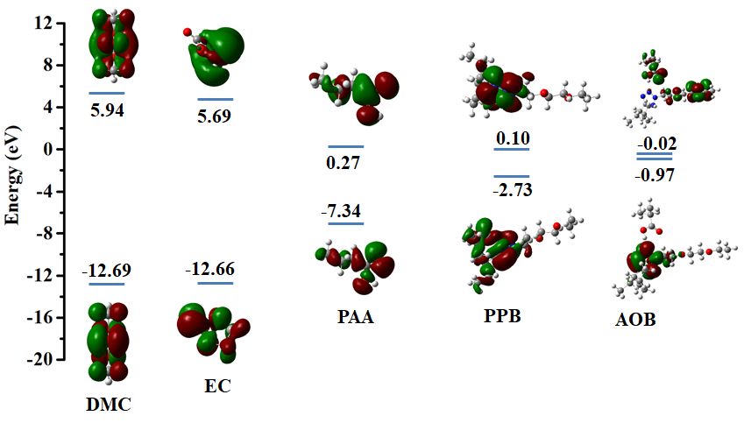
Figure S20. HOMO−LUMO energy level comparison between the electrolyte solvents, PAA, PPB and AOB binder.
Density functional theory (DFT) calculations were performed to investigate whether AOB binder tends to participate in SEI formation. As shown in Figure S20, AOB binder has the lower-lying LUMO level (−0.97 eV) than those of PAA, PPB, DMC and EC. This finding demonstrates that AOB binder would be subjected to be reduced prior to the electrolyte and participate in the formation of polymer-reinforced SEI.
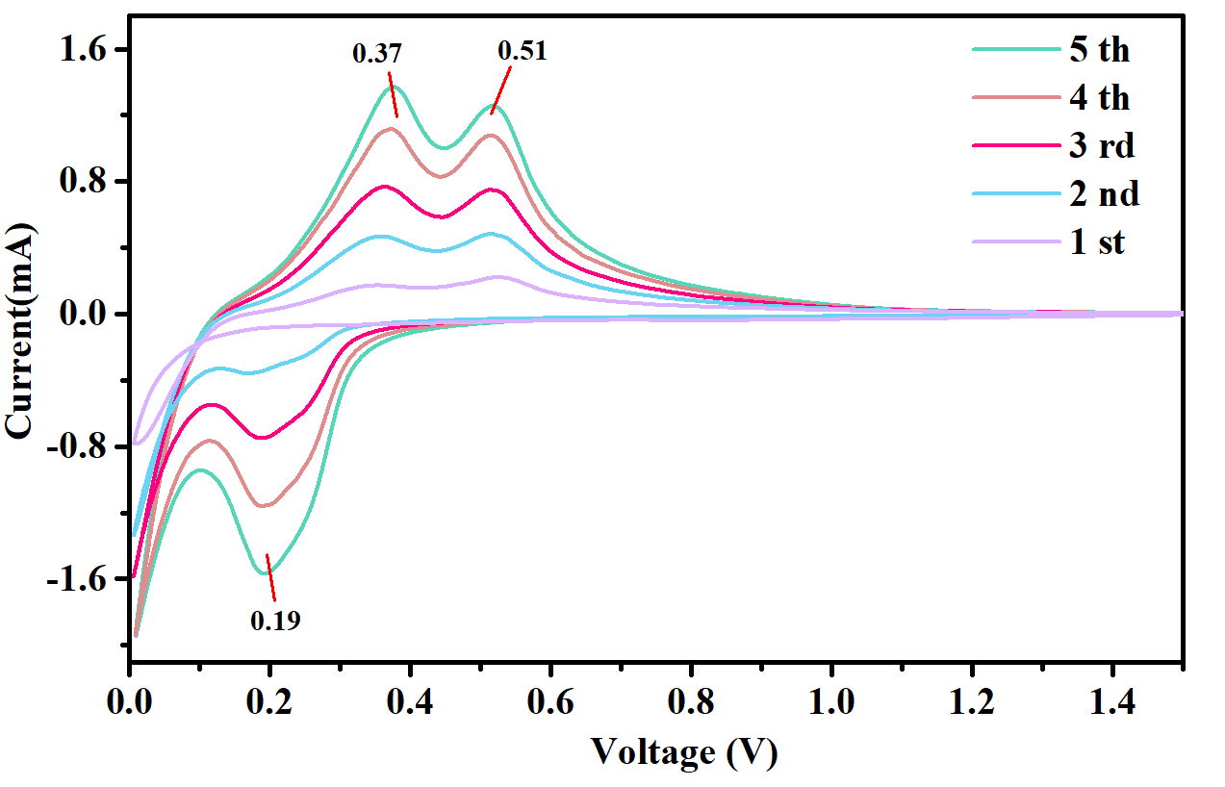
Figure S21. CV curves of the AOB based Si electrode at 0.5 mV s⁻¹.
In the cyclic voltammetry (CV) analysis of Si/Li half-cells with AOB binder, two broad peaks around ~0.37 and ~0.51 V correspond to the delithiation process of Li-Si phases.
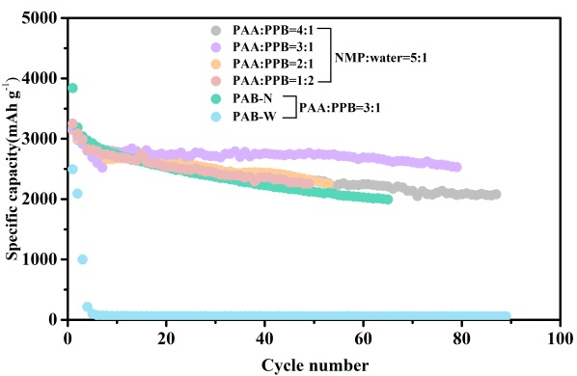
Figure S22. Capacity retention of the varied binder based Si/Li batteries at a voltage range of 0.005-1.5 V.

As shown in Figure S22, AOB binder with a PPB/PAA weight ratio of 3:1 shows a maximum capacity retention (2529 mAh g⁻¹), and thus was selected as the optimal research model. Additionally, compared with PAB-N and PAB-W, the enhanced cycle performance of AOB binder should be attributable to its enhanced mechanical and adhesion abilities, proving design rationality of AOB binder.

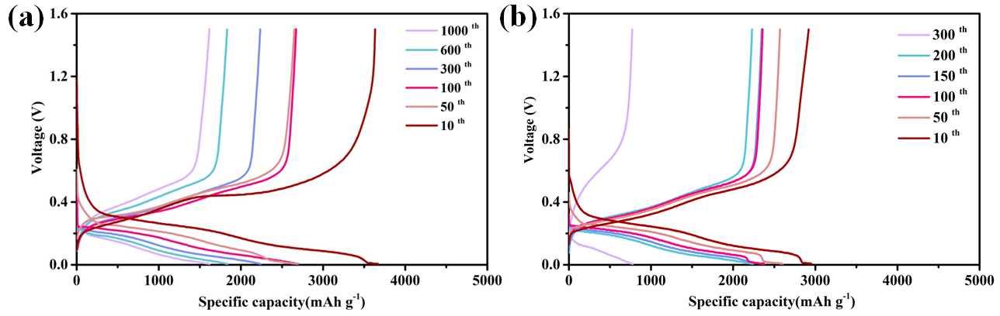
Figure S23. Voltage profiles of (a) PAA and (b) AOB based Si/Li half cells.

Apparently, in comparison with traditional PAA binder, AOB binder renders decreased battery polarization during cycling in Si/Li half cells.

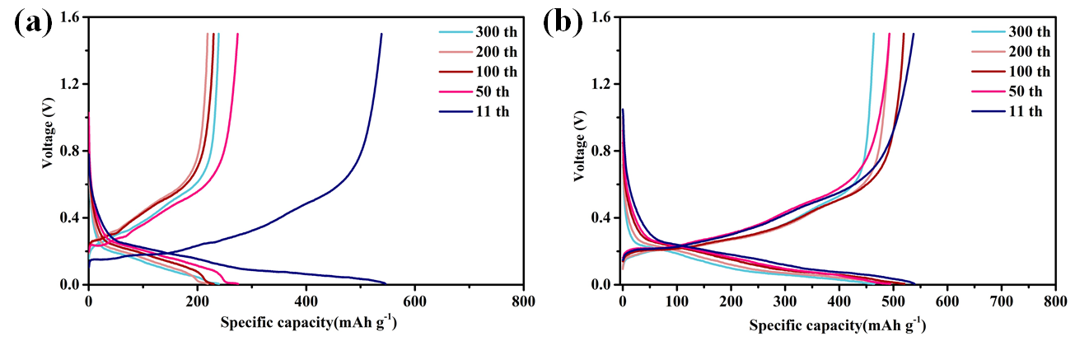
Figure S24. Voltage profiles of (a) PAA and (b) AOB based S600/Li half cells.

Apparently, in comparison with traditional PAA binder, AOB binder renders decreased battery polarization during cycling in S600/Li half cells.

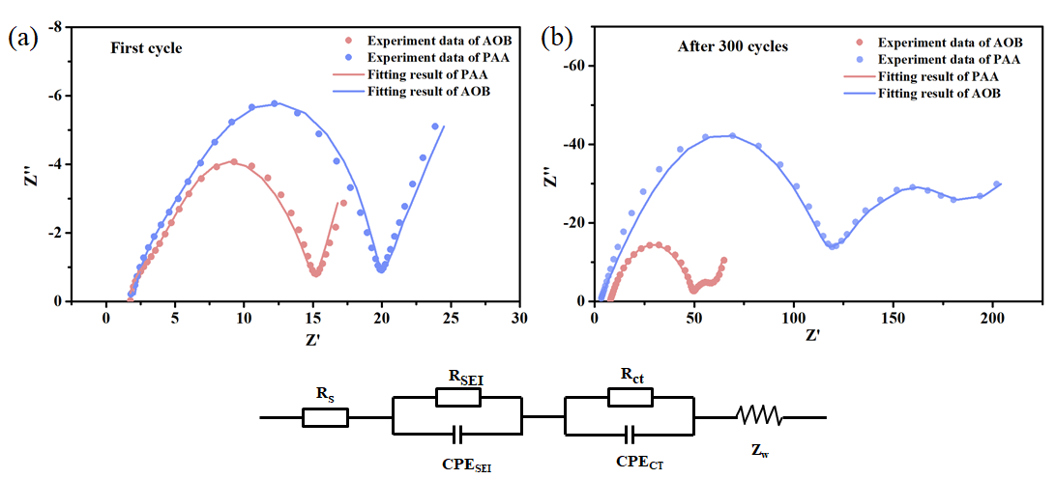
Figure S25. Nyquist plots of AOB and PAA binder based Si electrodes tested after 1 cycle (a) and 300 cycles (b). The dots and lines represent experimental data and fitted data, respectively.

Table S1 Impedance parameters of the Si electrodes with PAA and AOB binder calculated from equivalent circuit fitting.
 | After first cycle |  | After 300 cycles
 | PAA | AOB | PAA | AOB
R_{s} (Ω) | 2.1 | 1.8 | 3.2 | 2.1
R_{CT} (Ω) | 2.3 | 2.0 | 120.2 | 49.5
R_{SEI} (Ω) | 15.4 | 11.3 | 62.3 | 12.2
EIS measurements of PAA binder- and AOB binder-based Si electrode were conducted to investigate the SEI film. The Nyquist plots are fitted using an equivalent circuit model, include R_{s} (solution resistance), R_{ct} (charge transfer resistance), R_{SEI} (SEI film resistance), CPE (constant phase elements) and Z_{w} (Warburg impedance),³ and corresponding results are shown in Table S1. After pristine cycle, the R_{ct}, R_{s} and R_{SEI} values of AOB binder based electrodes after the first cycle are slightly lower than those of the PAA-based electrode (Figure S25a). However, the R_{ct} (120.2 Ω) and R_{SEI}, (62.3 Ω) of PAA based electrode apparently raise after 300 cycles (Figure S25b), indicating that the severe side reactions occurred at SEI, which would lead to a thick SEI film. It is worth noting that the R_{SEI} and Rct of AOB binder based electrode only increased to 49.5 Ω and 12.2 Ω after 300 cycles, respectively. Above results demonstrated that the AOB binder can effectively prevent excessive growth of SEI films in silicon-based electrode, which is inseparable from the stable SEI brought by its excellent mechanical, adhesion and self-healing abilities.

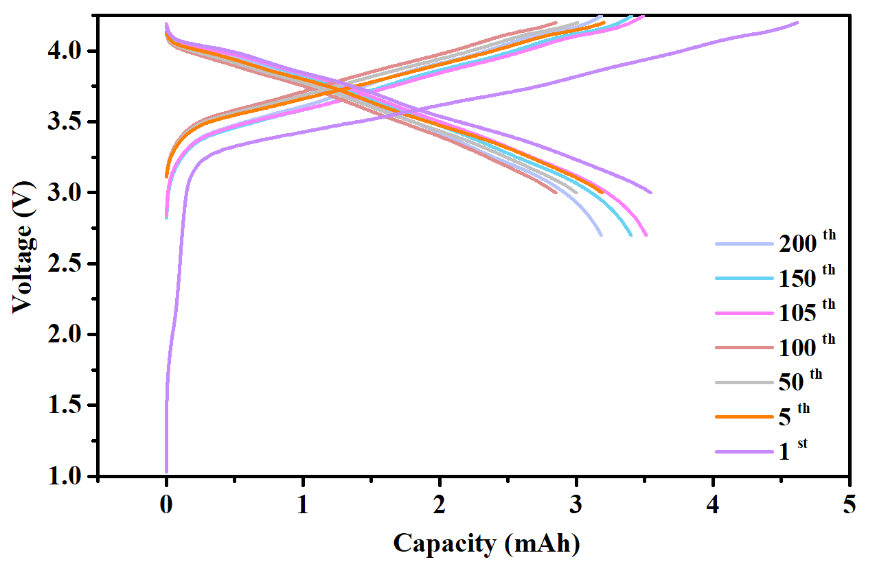
Figure S26. Voltage profiles of AOB binder based NCM811/S600 full cell.
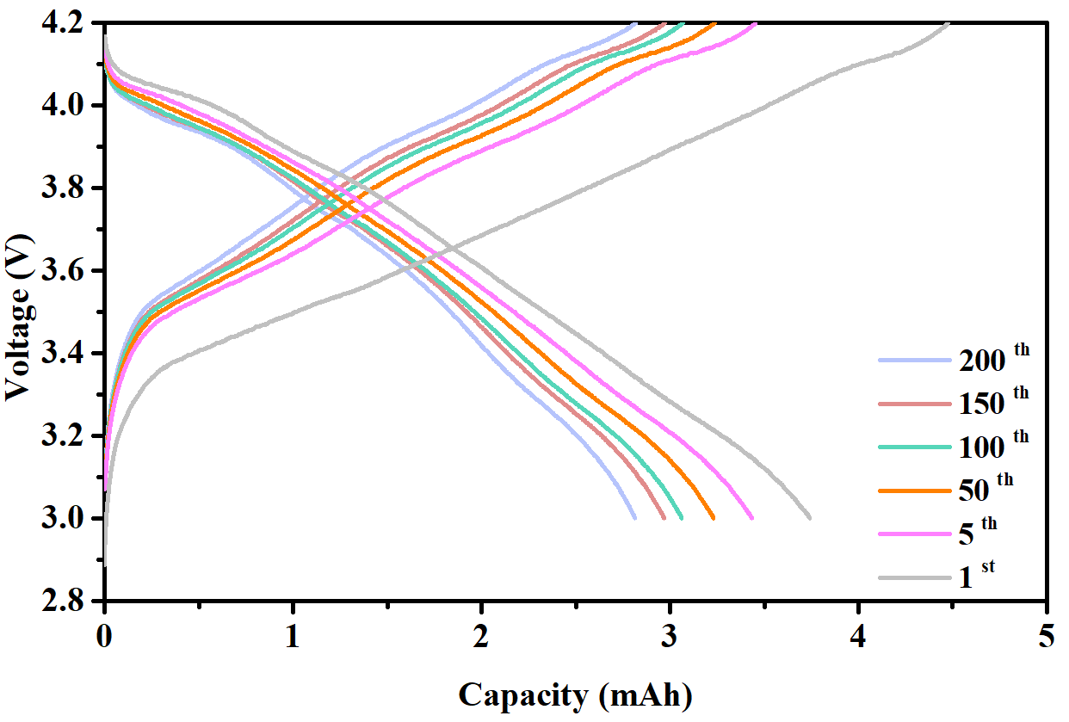
Figure S27. Voltage profiles of AOB binder based NCM811/Si full cell.

Components of the soft package cell
 | Paremeter | Value |  | Paremeter | Value
Cathode | Component | 94% NCM811, 3% PVDF, 3% Super P | Anode | Component | 90% S600, 7% AOB binder, 3% Super P
Cathode | Specific capacity | 190 mAh/g | Anode | Specific capacity | 600 mAh/g
Cathode | Active material loading (each side) | 16 mg/cm² | Anode | Active material loading (each side) | 5.5 mg/cm²
Cathode | Number of stacks | 12 (double side) | Anode | Number of stacks | 13 (double side)
Cathode | Size | 58 mm * 78 mm | Anode | Size | 60 mm * 80 mm
N/P | 1.15
Electrolyte | Commercially available 1M LiPF₆ in EC/DMC/FEC (4.5/4.5/1, v/v/v)
Table S2 Components of NCM811/S600 soft package cell.

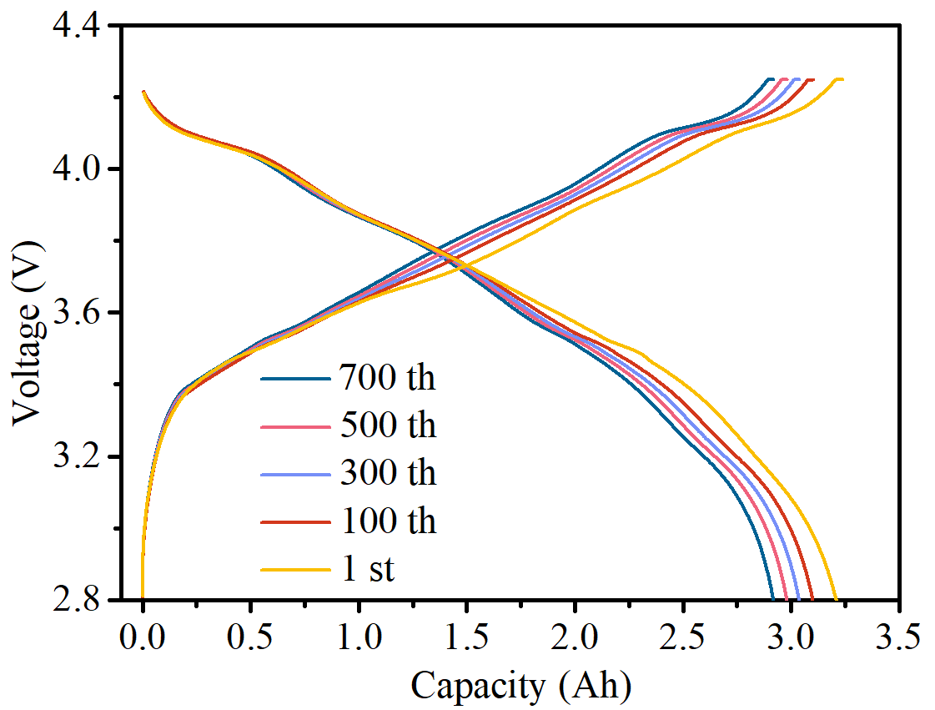
Figure S28. Voltage profiles of AOB based NCM811/S600 full soft package cell.

Table S3 Electrochemical properties comparison between our work and previous reported Si anode based batteries.
 | Binder | The particle size of Si | Remaining capacity |  | Rate performance | Ref.
Li/Si half cells | Catechol-functionalized chitosan cross-linked by glutaraldehyde | <100 nm | 2144 mAh g⁻¹ after 100 cycles |  | ———— | ⁴
Li/Si half cells | Poly(ether-thioureas) | ———— | 900 mAh g⁻¹ after 200 cycles at 1 C |  | 1594 mAh g⁻¹ at 1 C | ⁵
Li/Si half cells | Poly-glutamic acid/polyacrylic acid | ~50 nm | 2000 mAh g⁻¹ after 300 cycles at 0.1 C |  | 1359 mAh g⁻¹ at 1 C | ⁶
Li/Si half cells | Poly(acrylamide-co-2-(dimethylamino)ethyl acrylate | ~100 nm | 2747 mAh g⁻¹ after 100 cycles at 1 A g⁻¹ |  | 1446 mAh g⁻¹ at 8 A g⁻¹ | ⁷
Li/Si half cells | Starch/ polyvinyl alcohol | ~100 nm | 1011 mAh g⁻¹ after 300 cycles at 1 A g⁻¹ |  | 1283 mAh g⁻¹ at 4 A g⁻¹ | ⁸
Li/Si half cells | Peach gum/epichlorohydrin | ~100 nm | 2060 mAh g⁻¹ after 200 cycles at 2 A g⁻¹ |  | 895 mAh g⁻¹ at 8 A g⁻¹ | ⁹
Li/Si half cells | PAA | ~50 nm | 1500 mA h g⁻¹ after 500 cycles at 1 A g⁻¹ |  | 1550 mA h g⁻¹ at 6 A g⁻¹ | ¹⁰
Li/Si half cells | PVA-g-PAA | 30–80 nm | 1315.8 mA h g⁻¹ after 1000 cycles at 0.4 A g⁻¹ |  | 1525.5 mAh g⁻¹ at 10 A g⁻¹ | ¹¹
Li/Si half cells | PANI | 60 nm | 1420 mA h g⁻¹ after 1000 cycles at 1 A g⁻¹ |  | 1100 mAh g⁻¹ at 3A g⁻¹ | ¹²
Li/Si half cells | PEG grafted PFP | ———— | 605 mA h g⁻¹ after 1000 cycles at 0.3 C |  | 800 mAh g⁻¹ at 2 C | ¹³
Li/Si half cells | AOB binder | ~200 nm | 1617 mAh g⁻¹ after 1000 cycles at 0.4 C |  | 1350 mAh g⁻¹ at 2 C | Our work
Soft package full cells | Binder | Cathode |  | Anode | Remaining capacity | Ref.
Soft package full cells | Lithiated polyacrylic acid (P-LiPAA)/Nafion (P-LiNF) | LiNi_{0.5}Co_{0.2}Mn_{0.3}O₂ (NCM523) |  | Si | 0.03 Ah after 140 cycles at 0.2 C | ¹⁴
Soft package full cells | Guar gum-g-polyacrylamide | NCM523 |  | Si | 0.8 Ah after 70 cycles at 0.2 C | ¹⁵
Soft package full cells | Tannic acid (TA)/poly(acrylic acidco-2-hydroxyethyl acrylate) (PAH) | NCM523 |  | Si-C (500 mAh/g) | 1.58Ah after 700 cycles at 1C | ¹⁶
Soft package full cells | CMC/PAA | LiNi_{0.8}Co_{0.1}Mn_{0.1}O₂ (NCM811) |  | Si-C | ~0.8 Ah after 500 cycles at 0.5C | ¹⁷
Soft package full cells | PAA | NCM523 |  | Si-C | 1.5 Ah after 200 cycles at 1C | ¹⁸
Soft package full cells | Poly(furfuryl alcohol)/polyvinyl alcohol | NCM523 |  | Si | 0.5 Ah after 35 cycles at 0.5 C | ¹⁹
Soft package full cells | CMC/SBR | NCM523 |  | Si-C | 1.86 Ah after 150 cycles at 1C | ²⁰
Soft package full cells | Alginate/Carboxymethyl chitosan | LiNi_{0.6}Co_{0.2}Mn_{0.2}O₂(NCM622) |  | Si-C | 0.035 Ah after 500 cycles at 1C | ²¹
Soft package full cells | PAA-Li | NCA |  | SiOx/C | 1.8 Ah after 100 cycles at 0.2 C | ²²
Soft package full cells | AOB binder | NCM811 |  | Si-C(600 mAh/g) | 2.92 Ah after 700 cycles at 1C | Our work

1 Liao, X. et al. High strength in combination with high toughness in robust and sustainable polymeric materials. Science 366, 1376-1379 (2019).
2 Yoon, J. H. et al. Expandable crosslinked polymer coatings on silicon nanoparticle anode toward high-rate and long-cycle-life lithium-ion battery. Appl. Surf. Sci. 571, 151294 (2022).
3 Zhao, J. et al. Inorganic crosslinked supramolecular binder with fast Self-Healing for high performance silicon based anodes in lithium-ion batteries. J. Colloid Interface Sci. 625, 373-382 (2022).
4 Cao, P.-F. et al. Rational design of a multifunctional binder for high-capacity silicon-based anodes. ACS Energy Lett. 4, 1171-1180 (2019).
5 Chen, H. et al. A mechanically robust self-healing binder for silicon anode in lithium ion batteries. Nano Energy 81,105654 (2021).
6 Guo, M.-J. et al. A dual force cross-linked γ-PGA-PAA binder enhancing the cycle stability of silicon-based anodes for lithium-ion batteries. Electrochim. Acta 425, 140704 (2022).
7 Jin, B. et al. A self‐healable polyelectrolyte binder for highly stabilized sulfur, silicon, and silicon oxides electrodes. Adv. Funct. Mater. 31, 2104433 (2021).
8 Li, J. et al. A novel multi-functional binder based on double dynamic bonds for silicon anode of lithium-ion batteries. Electrochim. Acta 425, 140620 (2022).
9 Li, Z. et al. A robust network binder via localized linking by small molecules for high-areal-capacity silicon anodes in lithium-ion batteries. Nano Energy 79, 105430 (2021).
10 Jung, C. H., Kim, K. H. & Hong, S. H. Stable silicon anode for lithium-ion batteries through covalent bond formation with a binder via esterification. ACS Appl. Mater. Interfaces 11, 26753-26763 (2019).
11 He, J. & Zhang, L. Polyvinyl alcohol grafted poly (acrylic acid) as water-soluble binder with enhanced adhesion capability and electrochemical performances for Si anode. J. Alloys Compd. 763, 228-240 (2018).
12 Wu, H. et al. Stable Li-ion battery anodes by in-situ polymerization of conducting hydrogel to conformally coat silicon nanoparticles. Nat. Commun. 4, 1943 (2013).
13 Yuca, N. et al. Highly efficient poly(fluorene phenylene) copolymer as a new class of binder for high-capacity silicon anode in lithium-ion batteries. Int. J. Energy Res. 42, 1148-1157 (2018).
14 Li, Z. et al. Silicon anode with high initial coulombic efficiency by modulated trifunctional binder for high‐areal‐capacity lithium‐ion batteries. Adv. Energy Mater. 10, 1903110 (2020).
15 Li, Z. et al. An ion‐conductive grafted polymeric binder with practical loading for silicon anode with high interfacial stability in lithium‐ion batteries. Adv. Energy Mater. 12, 2201197 (2022).
16 Hu, L. et al. Gradient H-bonding binder enables stable high-areal-capacity Si-based anodes in pouch cells. Adv. Mater. 33, 2104416 (2021).
17 Bai, M. et al. Encasing prelithiated silicon species in the graphite scaffold: an enabling anode design for the highly reversible, energy-dense cell model. ACS Appl. Mater. Interfaces 12, 47490-47502 (2020).
18 Han, X. et al. On the interface design of Si and multilayer graphene for a high-performance Li-ion battery anode. ACS Appl. Mater. Interfaces 12, 44840-44849 (2020).
19 Liu, T. et al. Interweaving 3D network binder for high-areal-capacity Si anode through combined hard and soft polymers. Adv. Energy Mater. 9, 1802645 (2019).
20 Zhao, L. et al. Compact Si/C anodes fabricated by simultaneously regulating the size and oxidation degree of Si for Li-ion batteries. J. Mater. Chem. A 7, 24356-24365 (2019).
21 Qi, C. et al. Suitable thickness of carbon coating layers for silicon anode. Carbon 186, 530-538 (2022).
22 Song, J. et al. Suppressed volume variation of optimized SiO_{x}/C anodes with PAA-based binders for advanced lithium-ion pouch cells. Solid State Ion 343, 115070 (2019).

