Supplementary Information for
Intrinsic Instability of Rhombohedral (Hf, Zr)O₂ Phases and Endurance Crisis of Hf-based Ferroelectric Devices
Jinchen Wei^{1,2}, Guanghua Xu¹, Menglin Huang^{1,3}, Yu-Ning Wu^{2,*}, Wenwu Li^{2,4,*}, Hongjun Xiang³, and Shiyou Chen^{1,2,3*}
¹School of Microelectronics, Fudan University, Shanghai, China, chensy@fudan.edu.cn
²Key Lab of Polar Materials and Devices (MOE) and Department of Electronics, East China Normal University, Shanghai, China,
³Key Laboratory of Computational Physical Sciences (MOE), Fudan University, Shanghai, China
⁴Shanghai Frontiers Science Research Base of Intelligent Optoelectronics and Perception, Institute of Optoelectronics, Department of Materials Science, Fudan University, Shanghai, China,
*Email: ynwu@phy.ecnu.edu.cn or liwenwu@fudan.edu.cn or chensy@fudan.edu.cn

- Additional explanation for structures of rhombohedral HfO₂
The structures of both R3 and R3m HfO₂ have three-fold rotation symmetry with the [111] direction as the rotation axis. As shown in Fig. S1, there exist three equivalent Hf atoms (marked as Hf1) and two groups of equivalent O atoms (marked as O1 and O2), which are all off-diagonal and are three-fold rotationally symmetric around the [111] direction of R3 and R3m HfO₂, respectively. Besides, there are one Hf atom (marked as Hf2) and two nonequivalent O atoms (marked as O3 and O4) sitting in the rotation axis.
The disordered atomic distribution of Hf and Zr atoms in Hf_{0.5}Zr_{0.5}O₂ (HZO) alloy leads to the loss of symmetry of all the O atoms. In principle, we need to calculate the formation energy for each defect. However, to save the computation cost, we arranged the 96 O vacancies of the supercells into 4 groups according to the equivalent O positions of HfO₂ (O1 to O4) and selected 10 prototypes of O vacancies for each group to calculate their formation energies.
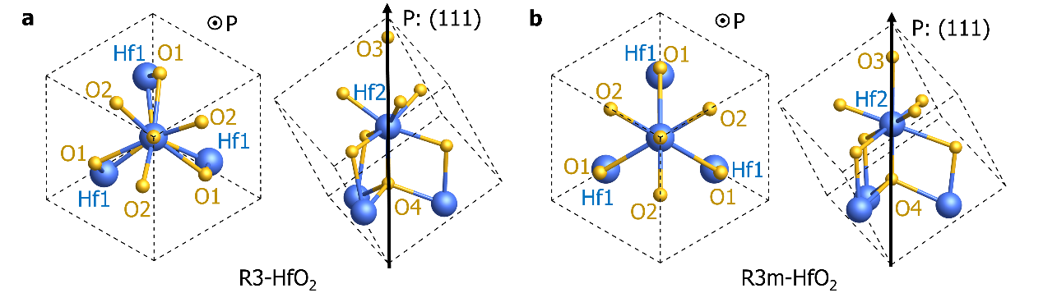
Fig. S1 | Primitive cells of r-phases HfO₂. The [111] direction (also the direction of polarization) points out of the plane and upward for a R3 and b R3m phases.

- Transition levels of intrinsic O defects in rhombohedral Hf_{0.5}Zr_{0.5}O₂
Corresponding to the formation energies of O defects in Fig. 2, the transition energy levels of O vacancies (${\text{V}}_{\text{O}}$) and O interstitials (${\text{O}}_{\text{i}}$) in R3, R3m and strained-R3m HZO are summarized in Fig. S2. Obviously, ${\text{V}}_{\text{O}}$s in all r-phase are all donors whose transition levels are close to CBM. In case the Fermi level is close to middle of the gap, they are usually in positive charge state such as ${\text{V}}_{\text{O}}^{\text{2+}}$, and can capture the electrons from conduction band. On the other hand, ${\text{O}}_{\text{i}}$s, which are mostly acceptors, tends to exist as negatively charged ${\text{O}}_{\text{i}}^{\text{2-}}$ that can capture holes from valence band. Interestingly, for the vacancies from four nonequivalent O groups, the four types of ${\text{V}}_{\text{O}}\text{s}$ in R3m phase have similar transition levels, whereas those in R3 and strained-R3m HZO exhibit obvious difference. Particularly, different from other O vacancies, ${\text{V}}_{\text{O4}}$ in R3 phase and ${\text{V}}_{\text{O3}}$in strained-R3m HZO do not have transition levels involving neutral state.
Fig. S2 | Transition levels of O-related defects. a R3 phase of Hf_{0.5}Zr_{0.5}O₂, b R3m phase of Hf_{0.5}Zr_{0.5}O₂ and c strained-R3m phase of Hf_{0.5}Zr_{0.5}O₂.

- X-Ray powder diffraction simulation for phase identification
X-Ray diffraction (XRD) is a widely-used experimental tools to identify the phase of HZO in the synthesized thin film. On the LSMO substrate, the film with XRD (111) diffraction peak slightly above 30° is believed to contain Pca2₁ HZO, while the diffraction peak between 26° and 28° indicates the existence of R3m HZO. In Fig. S3, we show the simulation results of X-Ray powder diffraction patterns of HfO₂ and HZO with different space groups using LDA, PBE and PBEsol exchange-correlation functionals. The results reveal that three functionals provide consistent XRD patterns for different crystal phases. The Pca2₁ HZO indeed has a characteristic (111) peak at around 30.5° and strained-R3m HZO has a diffraction peak ranged from 25° and 27°, which fits well with the experimental results. Furthermore, the (111) peak of P2₁/m HZO is at around 25°, which is consistent with the experimental facts by Nukala et al. Such agreement confirms the phase transformation from strained-R3m HZO to strained-P2₁/m HZO that is induced by defects.
Fig. S3 | X-Ray powder diffraction simulation for each phase of HfO₂ and Hf_{0.5}Zr_{0.5}O₂ (HZO). a The comparison of typical X-ray diffraction peak positions of calculated HfO₂ (in solid mark) and HZO (in hollow mark) with different spatial symmetry in LDA, PBE and PBE solid (PBEsol) functional. The powder diffraction pattern of HZO in different phases in b LDA, c PBE and d PBEsol functional.
We also simulate the strain effect on the XRD patterns for Pca2₁ and R3m HZO. As shown in Fig. S4, as the compressive in-plane strain in (111) plane increases from 0% to 4%, the (111) peaks shift towards the left for both Pca2₁ and R3m HZO. It means that the observed (111) peak below 30° cannot certainly prove the existence of R3m HZO. For instance, Pca2₁ HZO with 3% of compressive in-plane strain may also has the (111) peak at around 29°. In order to confirm the space group of HZO in synthesized film, further experimental structural characterization is required.
Fig. S4 | XRD patterns of Pca2₁ and R3m HZO with compressive strains up to 4%. The powder diffraction patterns of a Pca2₁ and b R3m HZO are simulated under different degrees of compressive strain applied to the plane that is perpendicular to (111) direction. The structures are optimized with PBEsol functional. The arrows illustrate the shift trend of the (111) peaks with strain increasing from 0% to 4%.

- Strain-induced phase transition of ferroelectric-paraelectric Hf_{0.5}Zr_{0.5}O₂
Fig. S5 plots the lattice constant along c direction and the polarization as functions of the compressive in-plane strain for R3 and Pca2₁ HZO. For R3 phase, as shown in Fig. S5a, lattice constant along c direction increases linearly as strain increases from 0% to 3%, and starts to increase more steeply as the strain gets above 3%. Meanwhile, the polarization slightly increases as strain increases from 0% to 3%, and plunges significantly for strains higher than 3%. It indicates the occurrence of the phase transforms to another phase, which is determined as the strained-R3m HZO. Similar behavior can be observed for Pca2₁ HZO. It transforms to P2₁/m HZO as the compressive strain reaches above 4%, and the polarization disappears. For both cases, the compressive strain causes the ferroelectric phases to transform to phases with low or no polarization, weakening the ferroelectricity of film.
Fig. S5 | Illustration of strain-induced phase transition of ferroelectric-paraelectric Hf_{0.5}Zr_{0.5}O₂ (HZO). Change of the lattice parameters in c direction and polarization under different compressive strains for a R3m phase and b Pca2₁ phase HZO. Different background colors illustrate the different phases with significantly different c values.

