Supplementary Tables and Figures

Supplementary table 1: Basic characteristics of TPO gene polymorphisms of this study
 | SNP | Position | Consequence | Ref. allele | Other allele | MAF | O(HET) | E(HET) | P
 | rs4490233 | 1372933 | Upstream gene | A | G | 0.30 | 0.42 | 0.42 | 0.616
 | rs13423589 | 1373270 | Upstream gene | T | G | 0.15 | 0.26 | 0.26 | 0.695
 | rs4927602 | 1374288 | non-coding transcript exon,non-coding transcript | A | G | 0.46 | 0.46 | 0.49 | <0.001
 | rs9326161 | 1375171 | intron,non-coding transcript | T | C | 0.05 | 0.10 | 0.10 | 0.774
 | rs4076290 | 1375197 | intron,non-coding transcript | A | G | 0.49 | 0.48 | 0.49 | 0.011
 | rs11897977 | 1380953 | intron,non-coding transcript | G | A | 0.11 | 0.20 | 0.20 | 0.174
 | rs10153889 | 1393643 | intron,non-coding transcript | G | A | 0.05 | 0.10 | 0.10 | 0.886
 | rs10190521 | 1394200 | intron,non-coding transcript | A | G | 0.02 | 0.04 | 0.04 | 0.282
 | rs1996207 | 1394528 | intron,non-coding transcript | A | G | 0.37 | 0.46 | 0.46 | 0.403
 | rs938326 | 1398009 | intron,non-coding transcript | T | C | 0.48 | 0.49 | 0.49 | 0.061
 | rs11211644 | 1400723 | intron,non-coding transcript | T | C | 0.40 | 0.46 | 0.48 | 0.012
 | rs17091595 | 1402077 | intron,non-coding transcript | T | G | 0.00 | 0.000 | 0.000 | NA
 | rs1546588 | 1403306 | intron,non-coding transcript | T | C | 0.06 | 0.12 | 0.12 | 0.634
 | rs11675342 | 1403856 | intron,non-coding transcript | T | C | 0.43 | 0.48 | 0.49 | 0.119
 | rs11675434 | 1404043 | intron,non-coding transcript | T | C | 0.38 | 0.46 | 0.47 | 0.019
 | rs13400534 | 1408111 | intron,non-coding transcript | T | C | 0.49 | 0.49 | 0.49 | 0.105
 | rs11682968 | 1408458 | intron,non-coding transcript | T | C | 0.49 | 0.49 | 0.49 | 0.122
 | rs2071402 | 1413427 | upstream_gene | A | G | 0.41 | 0.47 | 0.48 | 0.068
 | rs2071403 | 1413472 | 5_prime_UTR | G | G | 0.45 | 0.74 | 0.49 | NA
 | rs10193983 | 1419511 | intron | A | G | 0.11 | 0.12 | 0.20 | 0.603
 | rs1967512 | 1419728 | intron | C | T | 0.30 | 0.41 | 0.42 | 0.053
 | rs2048726 | 1422574 | intron | T | G | 0.38 | 0.46 | 0.47 | 0.002
 | rs2276702 | 1422849 | intron | G | G | 0.36 | 0.45 | 0.46 | 0.004
 | rs9678469 | 1423335 | intron | A | G | 0.14 | 0.24 | 0.24 | 0.055
 | rs10519477 | 1427818 | intron | T | C | 0.20 | 0.32 | 0.32 | 0.250
 | rs4927606 | 1431524 | intron | T | C | 0.24 | 0.36 | 0.36 | 0.339
 | rs1514684 | 1437406 | intron | A | G | 0.23 | 0.36 | 0.36 | 0.456
 | rs9751407 | 1437777 | intron | G | A | 0.12 | 0.21 | 0.21 | 0.064
 | rs11891272 | 1438198 | intron | T | C | 0.02 | 0.04 | 0.04 | 0.001
 | rs7602332 | 1446194 | intron | C | A | 0.12 | 0.21 | 0.21 | 0.076
 | rs10204515 | 1447925 | intron | C | T | 0.43 | 0.49 | 0.49 | 0.583
 | rs4927608 | 1449756 | intron | G | A | 0.43 | 0.49 | 0.49 | 0.616
 | rs2070882 | 1454229 | intron | T | C | 0.44 | 0.48 | 0.49 | 0.103
 | rs6706775 | 1455689 | intron | T | C | 0.41 | 0.48 | 0.48 | 0.483
 | rs4927611 | 1456232 | missense | T | G | 0.36 | 0.46 | 0.46 | 0.619
 | rs4927612 | 1456368 | intron | G | A | 0.36 | 0.46 | 0.46 | 0.658
 | rs11694726 | 1456448 | intron | T | C | 0.07 | 0.13 | 0.13 | <0.001
 | rs4927616 | 1459113 | intron | C | T | 0.04 | 0.09 | 0.09 | 0.286
 | rs6732480 | 1459640 | intron | C | T | 0.41 | 0.48 | 0.48 | 0.503
 | rs6723319 | 1463438 | intron | G | A | 0.14 | 0.23 | 0.24 | <0.001
 | rs11211654 | 1470359 | intron | A | G | 0.07 | 0.14 | 0.14 | 0.002
 | rs13431646 | 1472441 | intron | T | C | 0.04 | 0.09 | 0.09 | 0.213
 | rs10201842 | 1473219 | intron | T | G | 0.44 | 0.48 | 0.49 | 0.007
 | rs6588678 | 1479168 | intron | G | A | 0.34 | 0.44 | 0.45 | 0.155
 | rs10196514 | 1490601 | intron | A | G | 0.06 | 0.11 | 0.11 | 0.010
 | rs2048722 | 1492028 | intron | G | A | 0.46 | 0.49 | 0.49 | 0.334
 | rs1126797 | 1494031 | missense | T | C | 0.34 | 0.45 | 0.45 | 0.800
 | rs10189329 | 1494059 | intron | A | G | 0.06 | 0.11 | 0.11 | 0.010
 | rs13430369 | 1494742 | intron | G | T | 0.05 | 0.001 | 0.004 | 1.000
 | rs2276704 | 1495956 | intron | T | C | 0.26 | 0.39 | 0.39 | 0.535
 | rs13431173 | 1496098 | missense | G | A | 0.10 | 0.001 | 0.001 | 1.000
 | rs732609 | 1496155 | missense | C | A | 0.40 | 0.48 | 0.48 | 0.537
 | rs13431282 | 1496202 | splice_region,intron | C | A | 0.00 | 0.001 | 0.001 | 1.000
 | rs3755551 | 1498985 | intron | T | C | 0.26 | 0.39 | 0.39 | 0.525
 | rs938330 | 1502370 | intron | C | T | 0.32 | 0.43 | 0.43 | 0.222
 | rs4927621 | 1504913 | intron | G | A | 0.44 | 0.49 | 0.49 | 0.513
 | rs12465127 | 1512593 | intron | A | G | 0.44 | 0.48 | 0.49 | 0.053
 | rs4927624 | 1512908 | intron | C | T | 0.49 | 0.50 | 0.49 | 0.704
 | rs13398180 | 1513015 | intron | T | C | 0.20 | 0.33 | 0.32 | 0.062
 | rs11896517 | 1514340 | intron | C | T | 0.10 | 0.19 | 0.19 | 0.497
 | rs17732233 | 1515292 | intron | T | C | 0.26 | 0.38 | 0.39 | 0.151
 | rs1126799 | 1516904 | missense | C | T | 0.49 | 0.50 | 0.49 | 0.858
 | rs2048727 | 1519979 | intron | A | G | 0.34 | 0.43 | 0.45 | 0.052
 | rs4927625 | 1521757 | intron | G | A | 0.46 | 0.49 | 0.49 | 0.684
 | rs6605278 | 1543458 | downstream_gene | T | C | 0.15 | 0.25 | 0.25 | 0.147
SNP=Single Nucleotide polymorphism, Ref. allele=Reference allele is the minor allele, MAF=Minor allele frequency, NA=Not applicable, O(HET)=Observed heterozygosity, E(HET)=Expected heterozygosity, P=Hardy-Weinberg P-value.

Supplementary table 2: Association between TPO gene SNPs and positive TPOAb in cross-sectional stage with PLINK software
SNP | POSITION | BETA | estimate | P-value*
rs4490233 | 1372933 | 0.462679 | 0.617985 | 0.527554
rs4076290 | 1375197 | 0.126581 | 0.202013 | 0.901555
rs938326 | 1398009 | 0.962324 | 0.952656 | 0.112455
rs13400534 | 1408111 | 0.853388 | 0.929905 | 0.147206
rs2071402 | 1413427 | 0.020968 | 0.182147 | 0.959141
rs1967512 | 1419728 | 0.48687 | 0.625322 | 0.506079
rs10204515 | 1447925 | 0.018906 | 0.108151 | 0.99073
rs2070882 | 1454229 | 0.726521 | 0.808758 | 0.253008
rs2048722 | 1492028 | 0.561866 | 0.686262 | 0.434706
rs4927621 | 1504913 | 0.827343 | 0.884128 | 0.183899
rs4927624 | 1512908 | 0.545616 | 0.633837 | 0.486458
rs1126799 | 1516904 | 0.726462 | 0.79895 | 0.271103
* The significant p-value in this analysis is 1-(1-p) ¹³

Supplementary table 3: Association between TPO gene SNPs and TPOAb seroconversion in longitudinal stage with PLINK software
SNP | POSITION | BETA | estimate | P-value*
rs4490233 | 1372933 | 0.005476 | 0.058744 | 0.962183
rs4076290 | 1375197 | 0.009728 | 0.329289 | 0.529422
rs938326 | 1398009 | 0.011361 | 0.504967 | 0.450864
rs13400534 | 1408111 | 0.032162 | 0.748248 | 0.233934
rs2071402 | 1413427 | 0.258328 | 0.994405 | 0.534522
rs1967512 | 1419728 | 0.006472 | 0.131622 | 0.91719
rs10204515 | 1447925 | 0.011736 | 0.540328 | 0.445689
rs2070882 | 1454229 | 0.010472 | 0.397981 | 0.52162
rs2048722 | 1492028 | 0.011955 | 0.542216 | 0.42835
rs4927621 | 1504913 | 0.06343 | 0.92012 | 0.163109
rs4927624 | 1512908 | 0.017513 | 0.717574 | 0.308804
rs1126799 | 1516904 | 0.009579 | 0.228404 | 0.582095
* The significant p-value in this analysis is 1-(1-p) ¹³

Supplementary figure 1: Flowchart of the entrance of SNPs in each analysis.

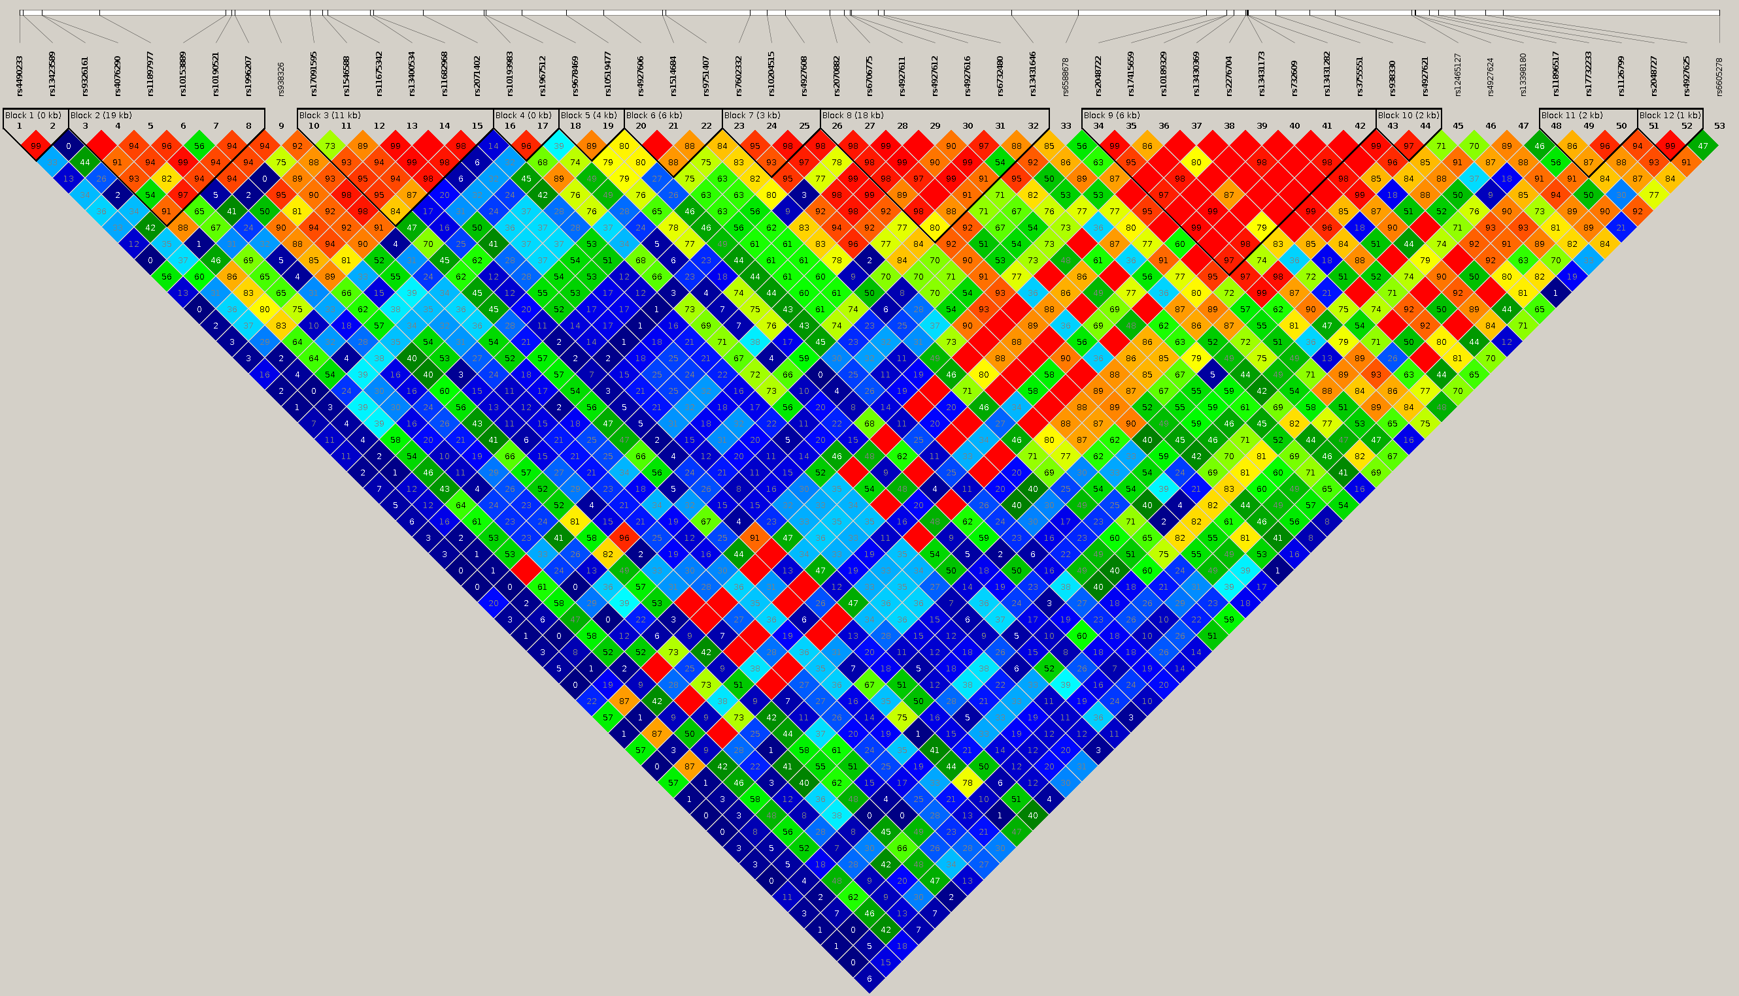
Supplementary figure 2: Linkage Disequilibrium (LD) heatmap; To find commonly used LD polymorphisms (in this triangular representation, the relationship between polymorphisms is studied one by one, and dark red squares represent polymorphisms that are in high correlation with each other) between 53 SNPs of TPO gene .

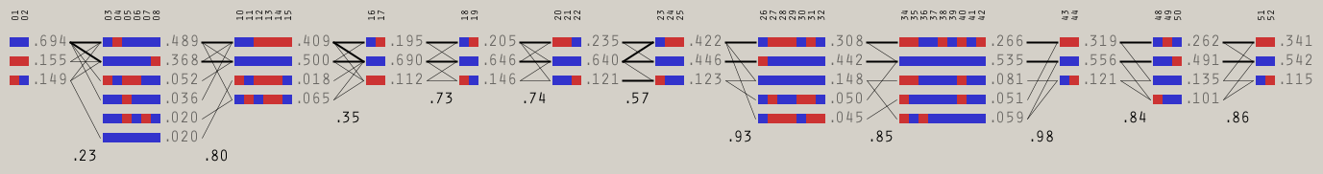
Supplementary figure 3: The diagram of 52 selective polymorphisms in TPO gene and displaying polymorphisms with higher LD in 12 blocks.

