Supplementary Information
Fine Resolution Analysis of bacterial communities associated with Neochloris oleoabundans culture and insights into terpenes as contamination control agents
Denisse Tatiana Molina-Aulestia¹, Júlio César de Carvalho¹, Gilberto Vinícius de Melo Pereira¹, Alexander da Silva Vale¹, Dão Pedro de Carvalho², Vanete Thomaz Soccol¹, Carlos Ricardo Soccol¹

¹ Bioprocess Engineering and Biotechnology Department, Federal University of Paraná Curitiba, PR 81531-980, Brazil
² Federal Institute of Education, Science and Technology of Paraná (IFPR), Londrina, PR, Brazil

Figure caption
Fig S1. Alpha rarefaction curves observed OTUs (operational taxonomic units). A. Initial culture metagenomic B. 12 Months (MC) to control.
Fig S2. Maximum-likelihood tree based on 16S rRNA gene sequences showing the phylogenetic relationships of Aureimonas isolated from Neochloris oleoabundans UTEX 1185. Bootstrap values (%) based on 1000 replications are shown at branch points. The substitution model used was Kimura 2-parameter model. Bar = 0.10% sequence divergence.
Fig S3. Maximum-likelihood tree based on 16S rRNA gene sequences showing the phylogenetic relationships of Bacillus isolated from Neochloris oleoabundans UTEX 1185. Bootstrap values (%) based on 1000 replications are shown at branch points. The substitution model used was Kimura 2-parameter model. Bar = 0.020% sequence divergence.
Fig S4. Maximum-likelihood tree based on 16S rRNA gene sequences showing the phylogenetic relationships of Brevundimonas isolated from Neochloris oleoabundans UTEX 1185. Bootstrap values (%) based on 1000 replications are shown at branch points. The substitution model used was Tamura 3-parameter model. Bar = 0.10% sequence divergence
Fig S5. Maximum-likelihood tree based on 16S rRNA gene sequences showing the phylogenetic relationships of Exiguobacterium isolated from Neochloris oleoabundans UTEX 1185. Bootstrap values (%) based on 1000 replications are shown at branch points. The substitution model used was Tamura-Nei model. Bar = 0.020% sequence divergence.
Fig S6. Maximum-likelihood tree based on 16S rRNA gene sequences showing the phylogenetic relationships of Microbacterium isolated from Neochloris oleoabundans UTEX 1185. Bootstrap values (%) based on 1000 replications are shown at branch points. The substitution model used was Tamura 3-parameter model. Bar = 0.020% sequence divergence.
Fig S7. Maximum-likelihood tree based on 16S rRNA gene sequences showing the phylogenetic relationships of Pseudomonas isolated from Neochloris oleoabundans UTEX 1185. Bootstrap values (%) based on 1000 replications are shown at branch points. The substitution model used was Kimura 2-parameter model. Bar = 0.010% sequence divergence.
Fig S8. Maximum-likelihood tree based on 16S rRNA gene sequences showing the phylogenetic relationships of Shinella isolated from Neochloris oleoabundans UTEX 1185. Bootstrap values (%) based on 1000 replications are shown at branch points. The substitution model used was Kimura 2-parameter model. Bar = 0.010% sequence divergence.

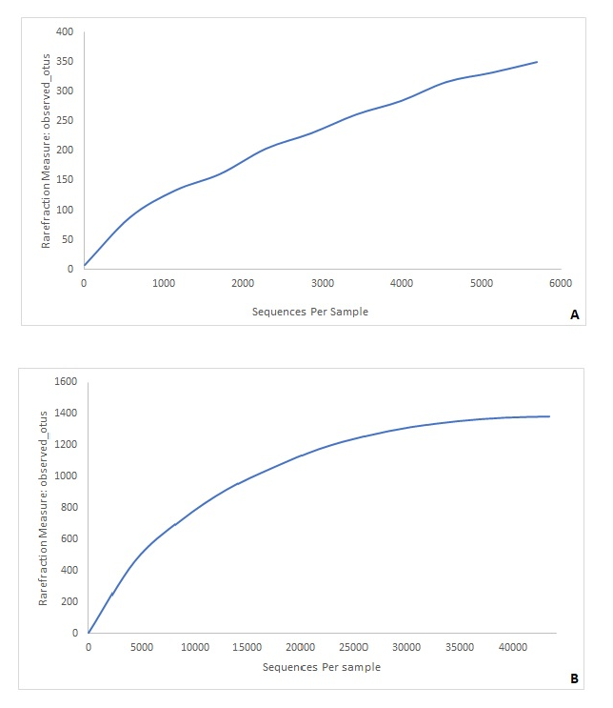
Fig S1. Alpha rarefaction curves observed OTUs (operational taxonomic units). A. Initial culture metagenomic B. 12 Months (MC) to control.

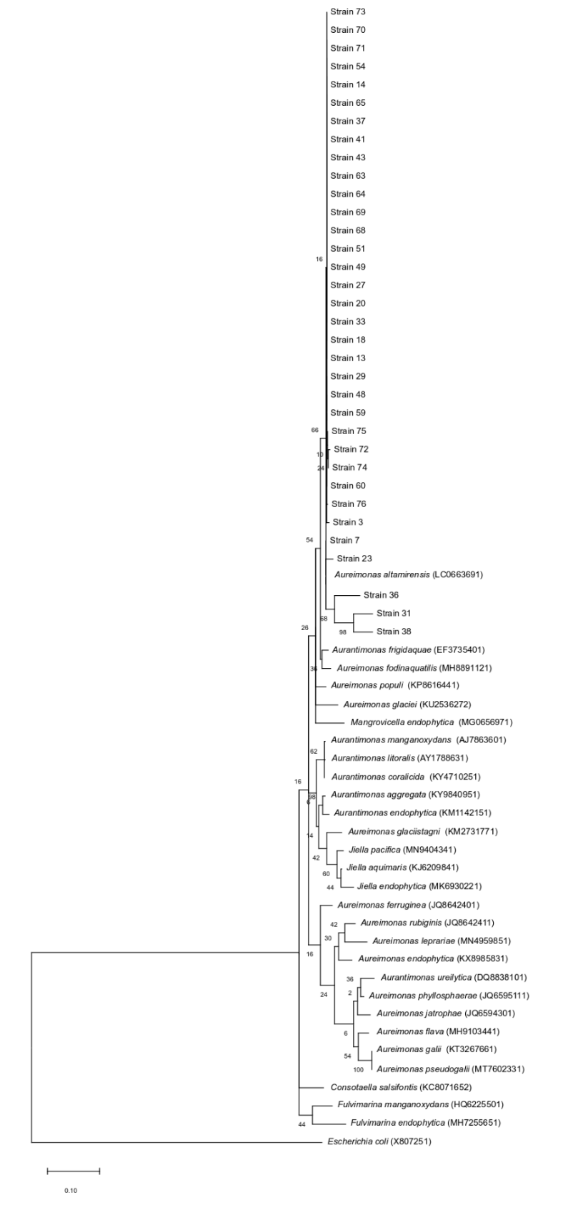

Fig S2. Maximum-likelihood tree based on 16S rRNA gene sequences showing the phylogenetic relationships of Aureimonas isolated from Neochloris oleoabundans UTEX 1185. Bootstrap values (%) based on 1000 replications are shown at branch points. The substitution model used was Kimura 2-parameter model. Bar = 0.10% sequence divergence.

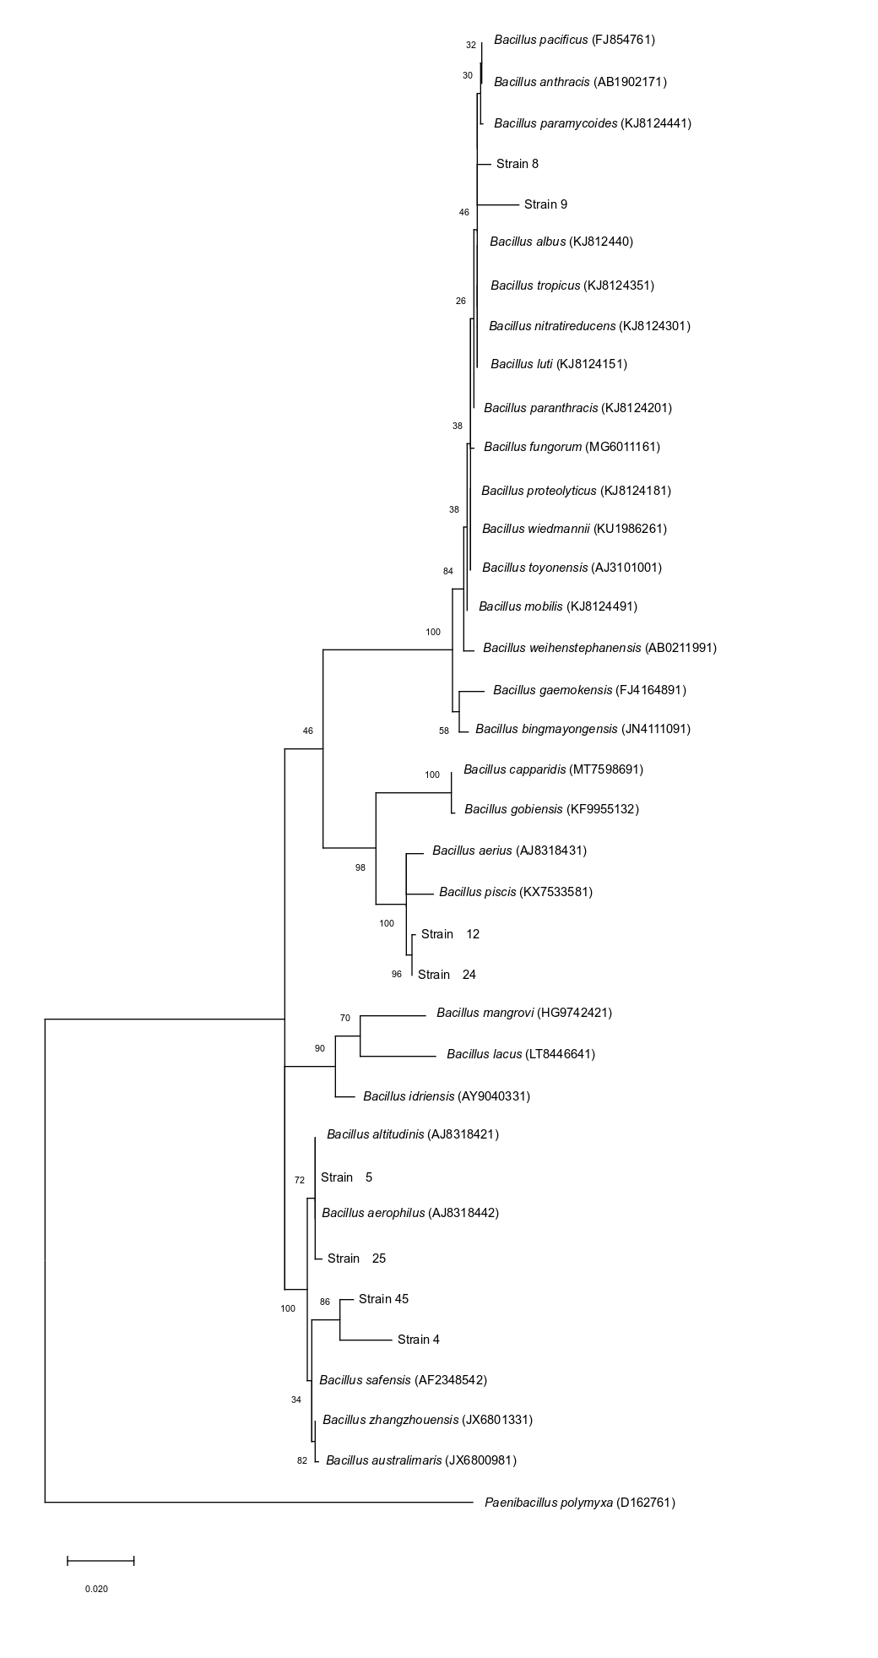

Fig S3. Maximum-likelihood tree based on 16S rRNA gene sequences showing the phylogenetic relationships of Bacillus isolated from Neochloris oleoabundans UTEX 1185. Bootstrap values (%) based on 1000 replications are shown at branch points. The substitution model used was Kimura 2-parameter model. Bar = 0.020% sequence divergence.
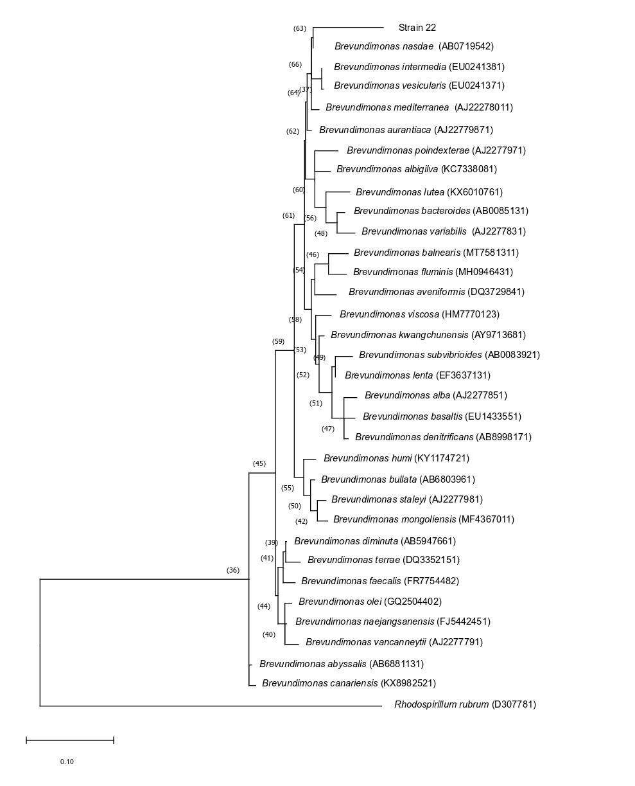
Fig S4. Maximum-likelihood tree based on 16S rRNA gene sequences showing the phylogenetic relationships of Brevundimonas isolated from Neochloris oleoabundans UTEX 1185. Bootstrap values (%) based on 1000 replications are shown at branch points. The substitution model used was Tamura 3-parameter model. Bar = 0.10% sequence divergence.

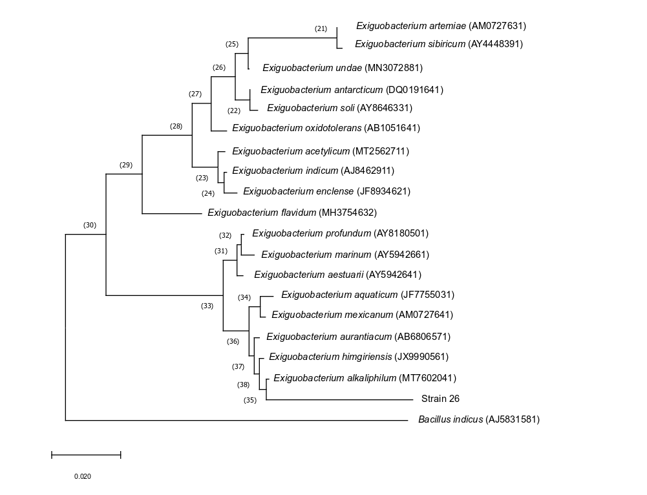
Fig S5. Maximum-likelihood tree based on 16S rRNA gene sequences showing the phylogenetic relationships of Exiguobacterium isolated from Neochloris oleoabundans UTEX 1185. Bootstrap values (%) based on 1000 replications are shown at branch points. The substitution model used was Tamura-Nei model. Bar = 0.020% sequence divergence.

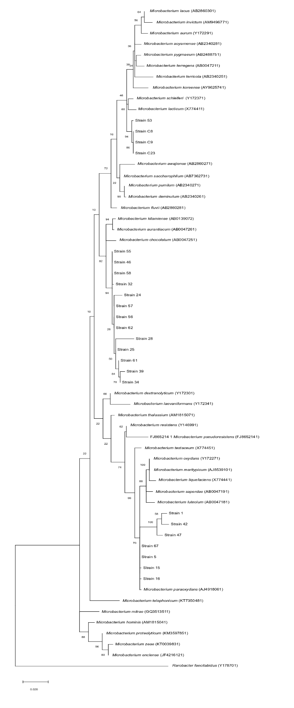

Fig S6. Maximum-likelihood tree based on 16S rRNA gene sequences showing the phylogenetic relationships of Microbacterium isolated from Neochloris oleoabundans UTEX 1185. Bootstrap values (%) based on 1000 replications are shown at branch points. The substitution model used was Tamura 3-parameter model. Bar = 0.020% sequence divergence.
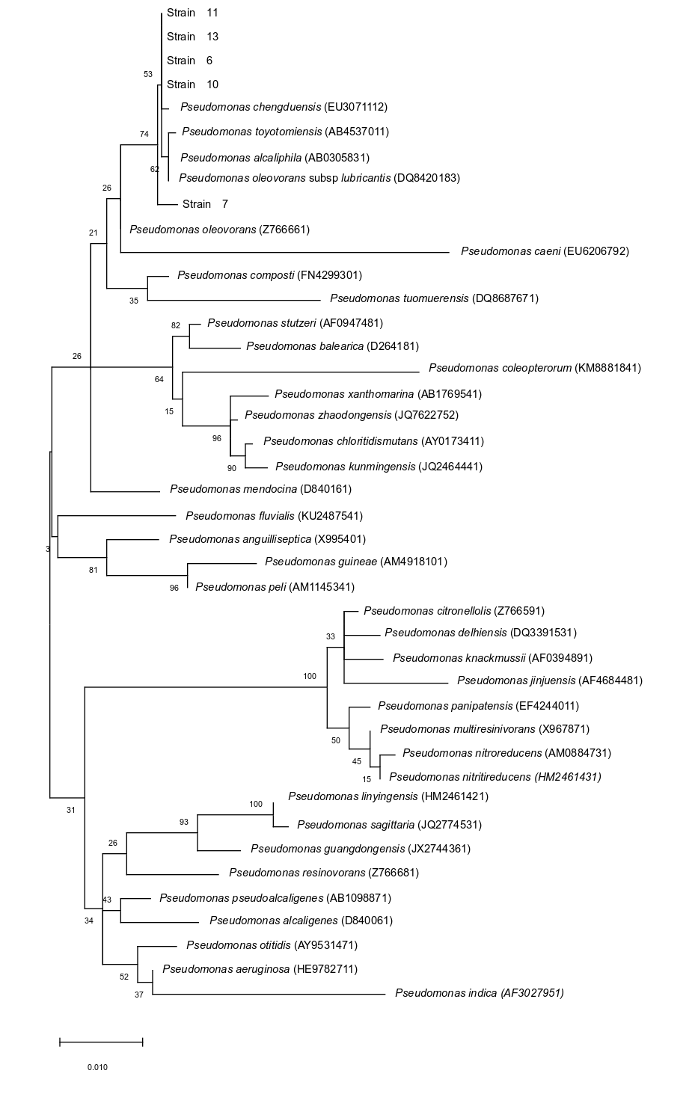

Fig S7. Maximum-likelihood tree based on 16S rRNA gene sequences showing the phylogenetic relationships of Pseudomonas isolated from Neochloris oleoabundans UTEX 1185. Bootstrap values (%) based on 1000 replications are shown at branch points. The substitution model used was Kimura 2-parameter model. Bar = 0.010% sequence divergence.
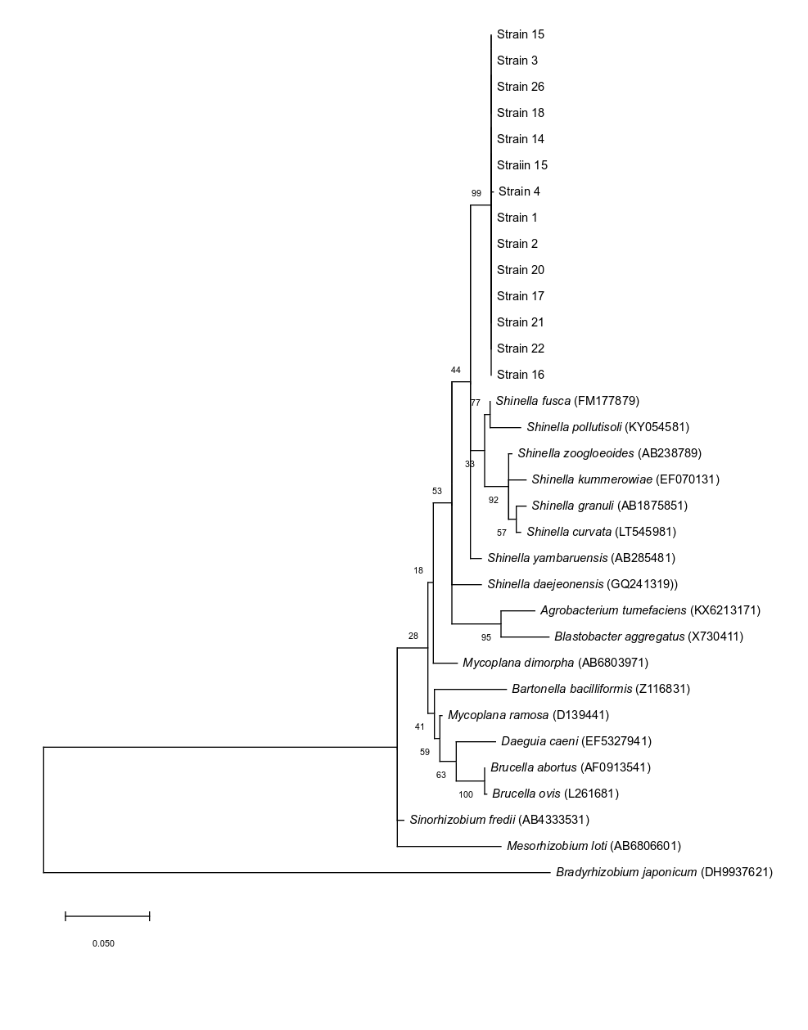
Fig S8. Maximum-likelihood tree based on 16S rRNA gene sequences showing the phylogenetic relationships of Shinella isolated from Neochloris oleoabundans UTEX 1185. Bootstrap values (%) based on 1000 replications are shown at branch points. The substitution model used was Kimura 2-parameter model. Bar = 0.010% sequence divergence.

Tables

Table S1. Bacterial community diversity by Illumina high-throughput sequencing on initial culture Family frequency. Microorganisms with a prevalence lower than 5% (others).

Table S2. Bacterial community diversity by Illumina high-throughput sequencing on 12 months to controlling (MC). Family frequency. Microorganisms with a prevalence lower than 5% (others).

Table S3. Bacterial community diversity by Illumina high-throughput sequencing on initial culture. Genera frequency. Microorganisms with a prevalence lower than 5% (others).

Table S4. Bacterial community diversity by Illumina high-throughput sequencing on 12 months to controlling (MC). Family frequency. Microorganisms with a prevalence lower than 5% (others).

Table S1. Bacterial community diversity by Illumina high-throughput sequencing on initial culture Family frequency. Microorganisms with a prevalence lower than 5% (others).

Microorganism (Initial Culture)
Balneolaceae
Chthoniobacteraceae
Pedosphaeraceae
Weeksellaceae
0319-6A21
Acetobacteraceae
Actinopolysporaceae
Alcanivoracaceae
Alicyclobacillaceae
Alteromonadaceae
Armatimonadaceae
Beijerinckiaceae
Chitinophagaceae
Conexibacteraceae
Cryomorphaceae
Cyclobacteriaceae
Desulfobacteraceae
Flavobacteriaceae
Frankiaceae
Gemmataceae
Gemmatimonadaceae
Geodermatophilaceae
Haliangiaceae
Hydrogenophilaceae
Hyphomicrobiaceae
Hyphomonadaceae
Idiomarinaceae
Isosphaeraceae
Koribacteraceae
Ktedonobacteraceae
Lactobacillaceae
Leuconostocaceae
Methylocystaceae
Micromonosporaceae
Mycobacteriaceae
Nitrospiraceae
Oxalobacteraceae
Paenibacillaceae
Patulibacteraceae
Pirellulaceae
Piscirickettsiaceae
Solibacteraceae
Microorganism (Initial Culture)
Solirubrobacteraceae
Streptococcaceae
Streptomycetaceae
Syntrophobacteraceae
Thermomonosporaceae

Table S2. Bacterial community diversity by Illumina high-throughput sequencing on 12 months to controlling (MC). Family frequency. Microorganisms with a prevalence lower than 5% (others).

Microorganism (MC)
Other
OPB35

Table S3. Bacterial community diversity by Illumina high-throughput sequencing on initial culture. Genera frequency. Microorganisms with a prevalence lower than 5% (others).

Microorganisms (Initial Culture)
Candidatus koribacter
Solibacteraceae
Actinomycetales
Actinopolyspora
Frankiaceae
Geodermatophilus
Catellatospora
Dactylosporangium
Pilimelia
Pseudonocardia
Actinoallomurus
Fluviicola
Flavobacterium
Chryseobacterium
Balneolaceae
Sediminibacterium
Alicyclobacillus
Ammoniphilus
Cohnella
Paenibacillus
Lactobacillus
Pediococcus
Streptophyta
Leuconostoc
Lactococcus
Gemmatimonas
Nitrospirales
Nitrospira
Mycoplana
Phenylobacterium
Pedomicrobium
Aminobacter
Chelativorans
Hyphomonas
Oceanicaulis
Rhodobaca
Gluconobacter
Azospirillum
Inquilinus
Kaistobacter
Microorganisms (Initial Culture)
Janthinobacterium
Desulfosarcina
Myxococcales
Haliangiaceae
Marinobacter
Idiomarina
Erwinia
Alcanivorax
Methylophaga
Dokdonella
Luteibacter
Pedosphaera
Candidatus Koribacter
Leuconostocaceae
Fructobacillus
Rhodoplanes
Sphingopyxis
Sphingomonas
Streptomyces
Devosia

Table S4. Bacterial community diversity by Illumina high-throughput sequencing on 12 months to controlling (MC). Genera frequency. Microorganisms with a prevalence lower than 5% (others).

Microorganism (MC)
Other

