Figure supplementary legend
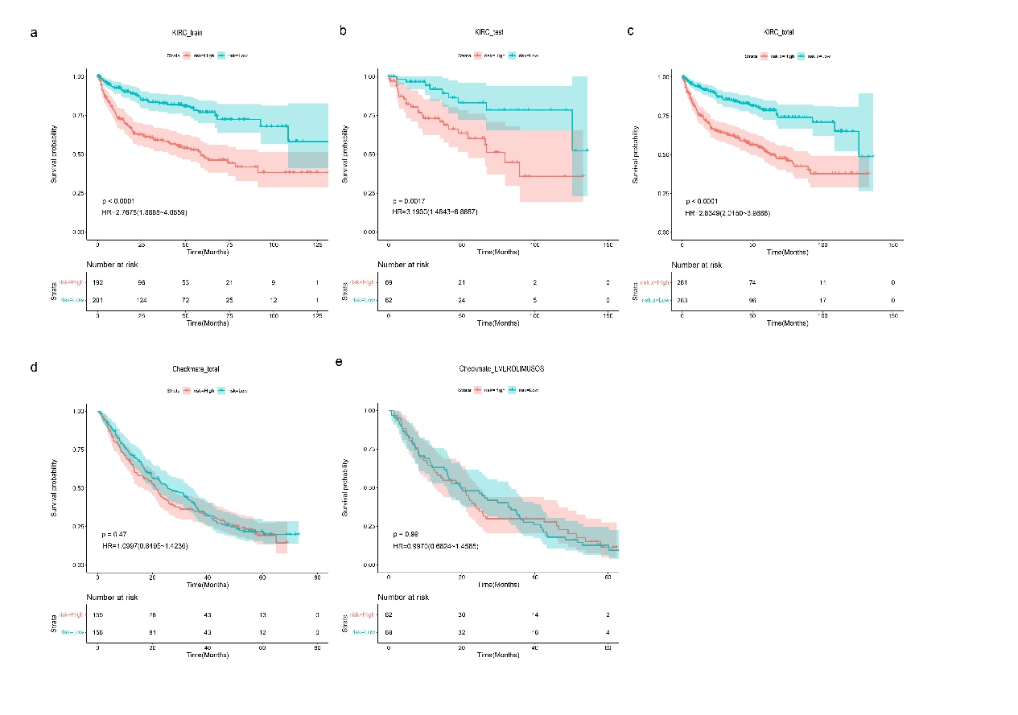
Figure S1. K-M analysis of different-risk groups. (a-c) K-M analysis of PFS of different-risk groups in TCGA-KIRC train, test, total cohort. (d-e) K-M analysis of different-risk groups of OS in Checkmate-total and everolimus cohort.
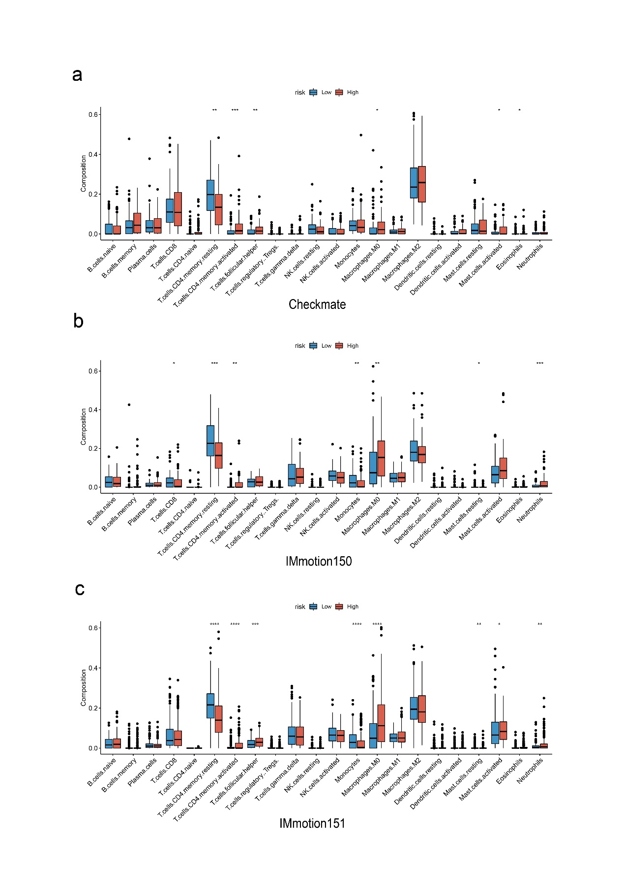

Figure S2. TME cell composition and fraction of individual immune cell types in three Immune-related cohorts. (a)CheckMate-025. (b)IMmotion150. (c)IMmotion151.

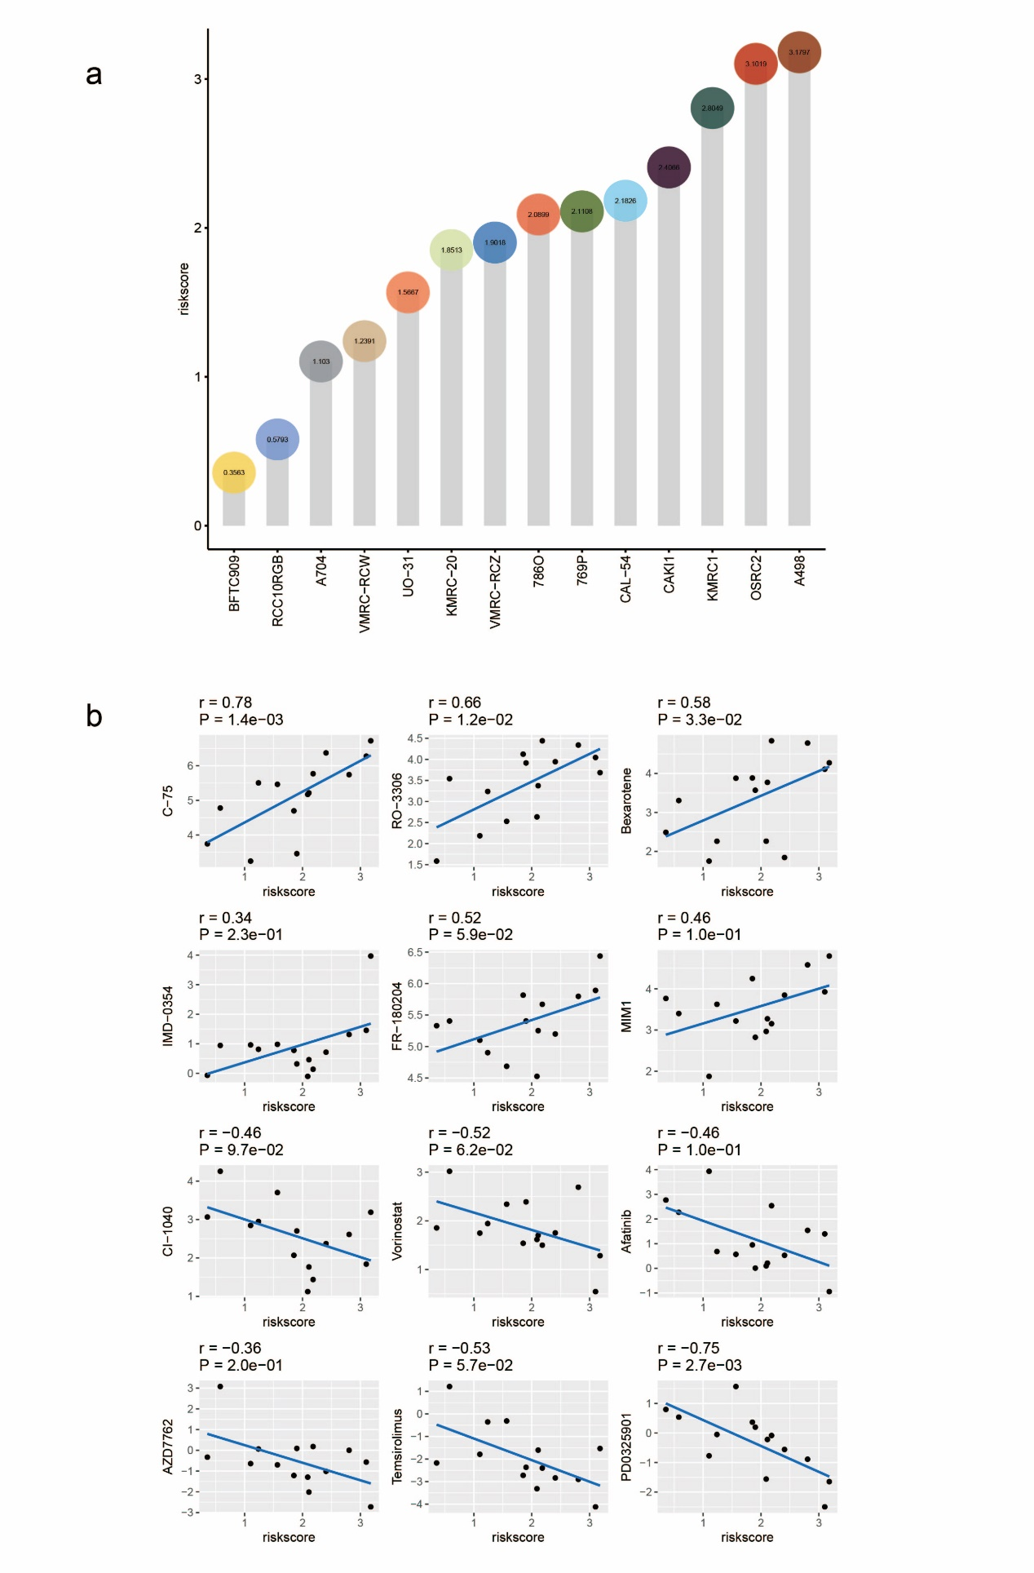
Figure S3. The risk score of ccRCC cell lines through CCLE and drug sensitivity data in GDSC. (a) A498 had the highest risk score while BFTC-909 had the lowest risk score. (b) The risk score had positive correlation with IC50 of C-75 while was negatively correlated with IC50 of PD0325901.

