Supporting Information
for
Generating Circularly Polarized Light from Clustering‐Triggered Emission Using Solid Phase Molecular Self-Assembly
Peilong Liao, Shihao Zang, Tongyue Wu, Hongjun Jin, Wenkai Wang，Jianbin Huang, Yun Yan*

Content
Part 1. Characterizations 1
Part 2. The CTE characteristics of α-poly-L-lysine(PLL) aqueous solution 3
Part 3. The CTE characteristics of PLL-OL aqueous solutions 4
Part 4. The composition and structure characterization of PLL-OL film 6
Part 5. Supplementary for the humidity responsive CTE-based CPL 9
Part 6. Supplementary for the Color tunable CPL through FRET 11

Part 1. Characterizations
X-ray diffraction (XRD) measurements were performed using a Rigaku Dmax-2400 diffractometer with Cu Kα radiation. The solid samples were placed on clean glass slides for small-angle range tests. Small angle X-ray scattering (SAXS) and wide angle X-ray scattering (WAXS) measurements were performed using ganesha small angle x-ray scattering system of SAXSLAB company with Cu Kα radiation. TGA experiments were carried out under nitrogen flow on TA Instrument Q600 SDT at a heating rate of 10 °C/min. Elemental Analysis (EA) of the PLL-NaOA film were carried out on Vario EL elemental analyzer with 0.1% accuracy for C, H and N. The fluorescence spectrum, fluorescence lifetime, and quantum yield of liquid samples were all given by the Edinburgh Instruments Limited FLS980 steady-state transient fluorescence / phosphorescence spectrometer (77-500K). Liquid samples can be directly measured in a quartz cell. UV-Vis spectrum were given by Shimadzu UV-1800 spectrometer. The TEM photos of the samples were taken on a JEM-2100F transmission electron microscope. The acceleration voltage was 200 kV. Film samples were prepared by resin-embedded sections. The dynamic light scattering(DLS) spectrum were given by Brookhaven's Nano DLS highly sensitive particle size analyzer. The sample was filtered through a 450 nm filter before test, and the experimental results are processed by volume distribution. CD spectra were recorded by a JASCO J-1500 spectrometer at range of 250-700 nm with scanning speed of 200 nm/min, response time of 1 s, and bandwidth of 3 nm. CPL spectra were recorded by CPL-200 spectrometer at range of 400-700 nm with the HT of the Excitation light source of 600-800 V, scanning speed of 100 nm/min, response time of 2 s. The g value is calculated after reasonable smoothing and baseline correction. The XPS spectrum was given by AXIS Supra X-ray Photoelectron Spectrometer. And the FT-IR spectrums were given by NICOLET IS50 Fourier transform infrared spectrometer through attenuated total reflection(ATR).

Part 2. The CTE characteristics of α-poly-L-lysine(PLL) aqueous solution
PLL is a typical CTE luminescent material with characteristic concentration- dependent luminescence, wave-dependent luminescence and silence in CPL, which is attributed to its heterogeneous micelle aggregation structure in solution. (Figure S1 and Figure S2 respectively support this conclusion in terms of fluorescence properties and aggregate structure)
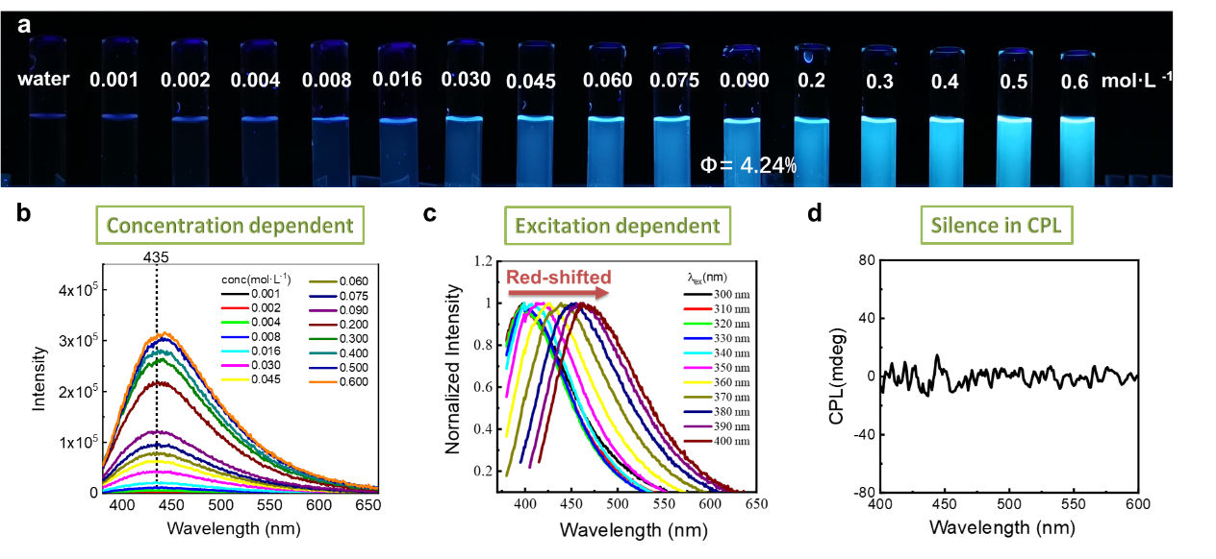
Figure S1. The Flourescence properties of PLL aqueous solutions. a Photographs taken under 365 nm UV light and b emission spectra (λ_{ex} = 365 nm) of PLL aqueous solutions at different concentrations. c Emission spectra of PLL (0.1 M) at different excitation wavelength. d CPL spectra (λ_{ex} = 350 nm) of PLL (0.1 M) aqueous solutions.

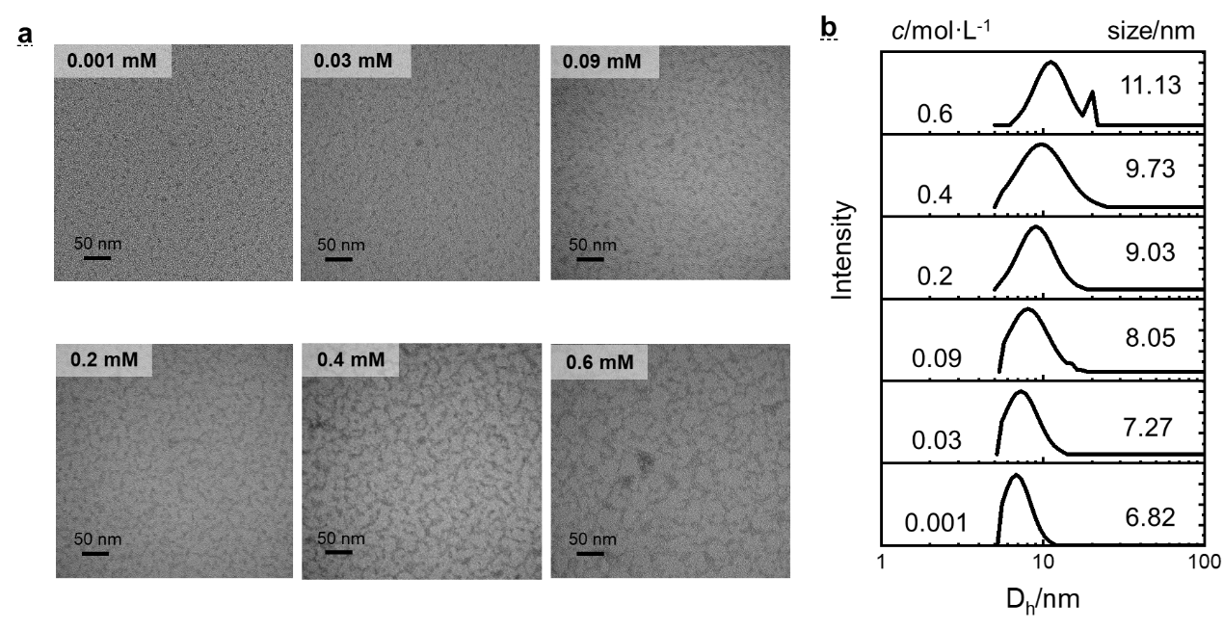
Figure S2. The aggregate structure of PLL aqueous solutions. a TEM and b DLS spectra of 0.001-0.6 M PLL aqueous solutions

Part 3. The CTE characteristics of PLL-OL aqueous solutions
PLL-OL aqueous solutions at the ratio of Lys:OL=1:1 showed typical CTE luminescent material with characteristic concentration- dependent luminescence and wave- dependent luminescence, which is attributed to its heterogeneous vesicles aggregation structure in solution. (Figure S 3 and Figure S 4 respectively support this conclusion in terms of fluorescence properties and aggregate structure)

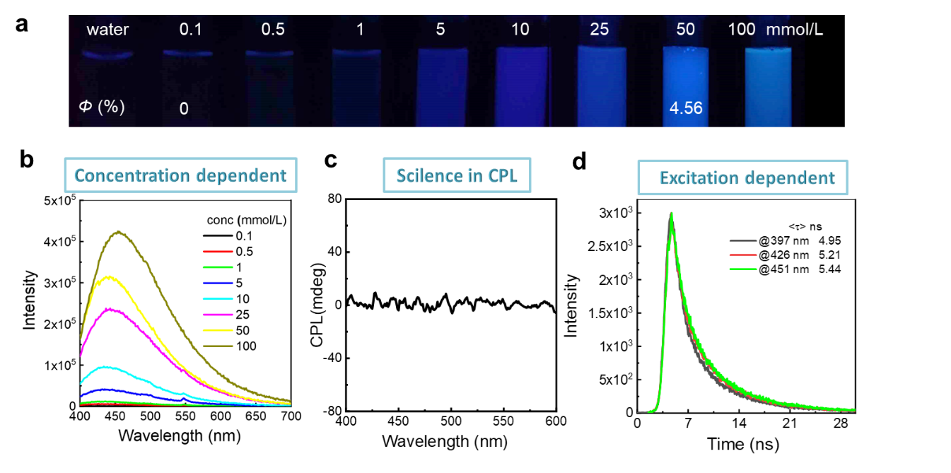
Figure S3. The fluorescence properties of PLL-OL aqueous solutions. a Photographs taken under 365 nm UV light and b emission spectra (λ_{ex} = 365 nm) of PLL-NaOL aqueous solutions at different concentrations(Lys:OL=1:1). c CPL spectra (λex = 350 nm) of PLL (50 mM, 1:1) aqueous solutions.. d Lifetimes of PLL-NaOL (50 mM, 1:1) aqueous solutions monitored at 397(λex = 310 nm), 426(λex = 360 nm) and 451 nm (λex = 390 nm).

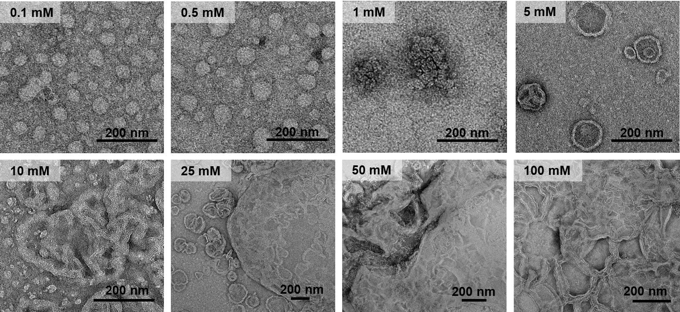
Figure S4. TEM photos of PLL-OL aqueous solutions taken at different concentrations. (Lys:OL=1:1)

Part 4. The composition and structure characterization of PLL-OL film
Table S1. Table of Elemental Analysis of PLL-OL film
Element | N | C | H
Experimental result | 5.12 | 68.61 | 11.31
Theoretical result | 5.12 | 68.70 | 11.48
Final result | (C₆H₁₄N₂O) ₁·(C₁₈H₃₄O₂)_{1.405}·(H₂O)_{1.267}

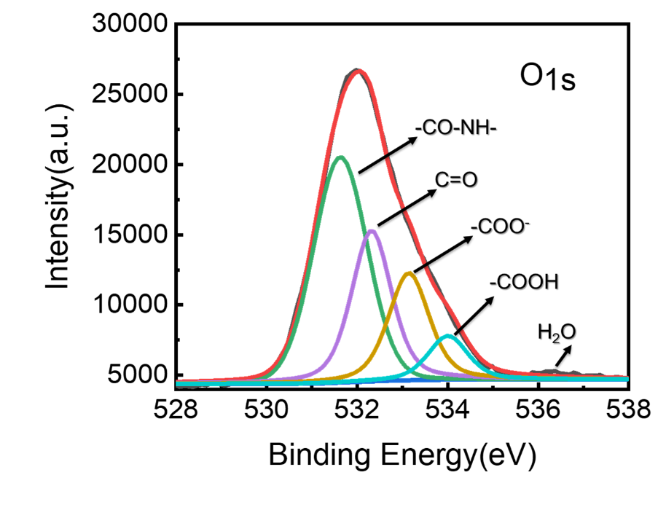
Figure S5. High-resolution XPS spectra (O 1s) of PLL-OL film. The four deconvoluted peaks at 531.62, 532.31, 533.14, and 534.00 eV can be attributed to the binding energies of O 1s of CO-NH, C=O, COO⁻, and COOH, respectively. Their peak areas are 24649.43, 14267.39, 10351.61 and 4129.85, as the ratio of the two fitted peaks areas of COOH(534.00 eV) and COO-(533.14 eV) is 0.4:1.
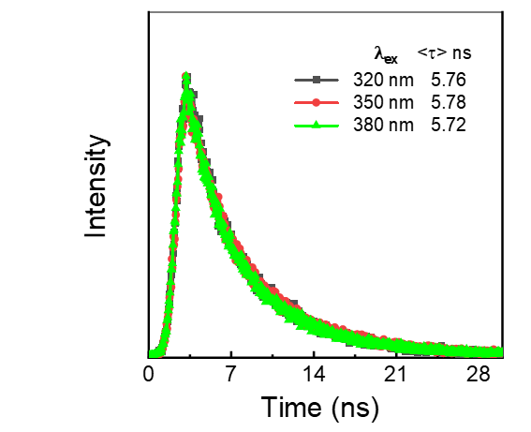
Figure S6. Lifetimes of PLL-NaOL film monitored at 462 nm with different excitation wavelength.
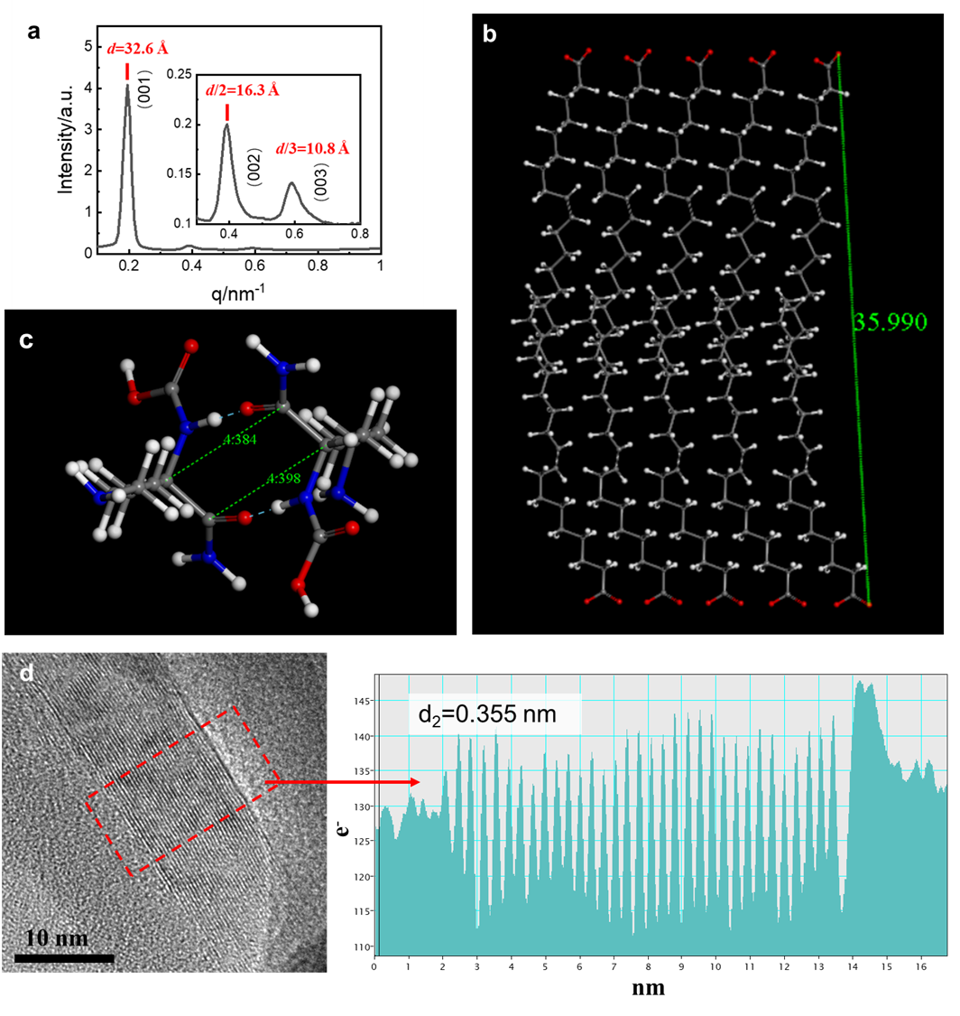
Figure S7. Structure characterization of PLL-OL film. a WAXS patterns of PLL-OL film. The molecular simulation of b oleate bilayer and c eight-membered ring hydrogen bond between amides. d TEM contrast analysis spectra shows that the interval between light and dark stripes is 0.355 nm

Part 5. Supplementary for the humidity responsive CTE-based CPL
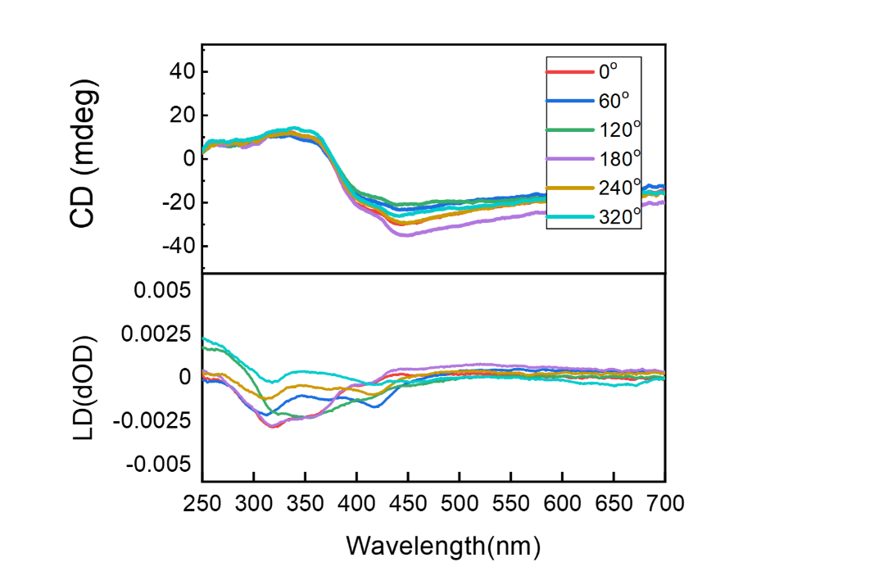
Figure S8. The CD and LD spectras of PLL-OL film measured with different angles.

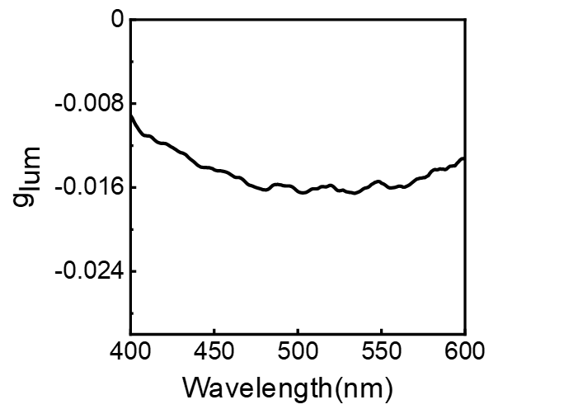
Figure S9. The g_{lum} of PLL-OL film.

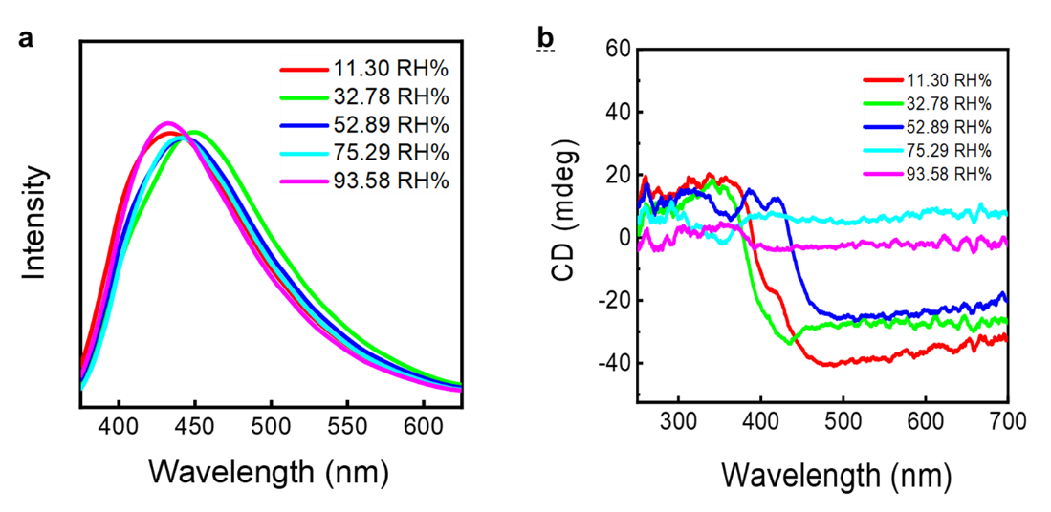
Figure S10. The emission and CD spectra of PLL-OL films under different relative humidity. a Emission spectra; b CD spectra.

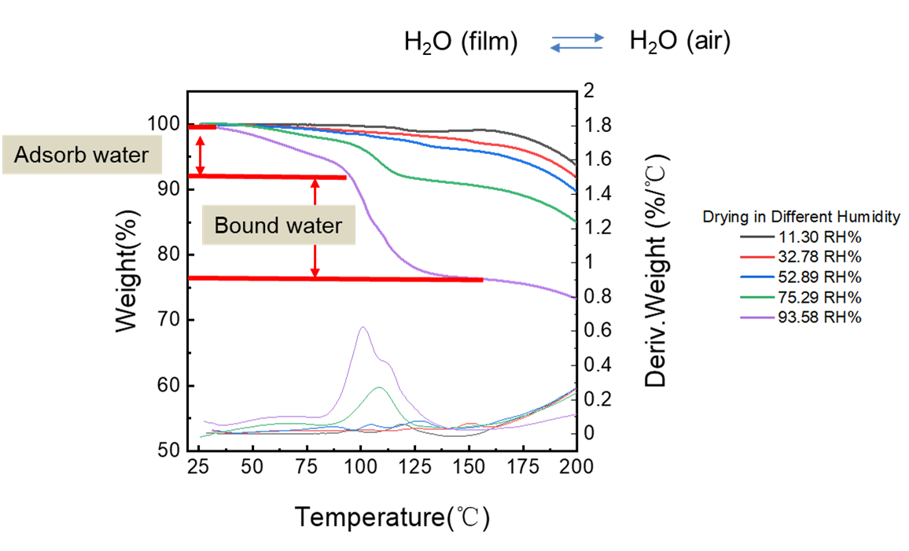
Figure S11. TGA spectra of PLL-OL films under different relative humidity. The absorbed water will gradually evaporate with the increase of temperature, while the bound water will break the bond above 100℃ and form an obvious peak on the TGA

Table S2. Table of assembly structure and the water content of the film changes with humidity
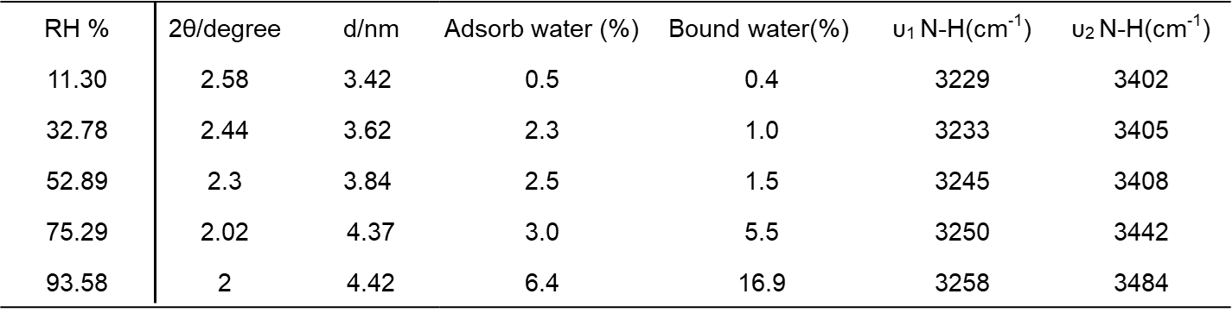

Part 6. Supplementary for the Color tunable CPL through FRET
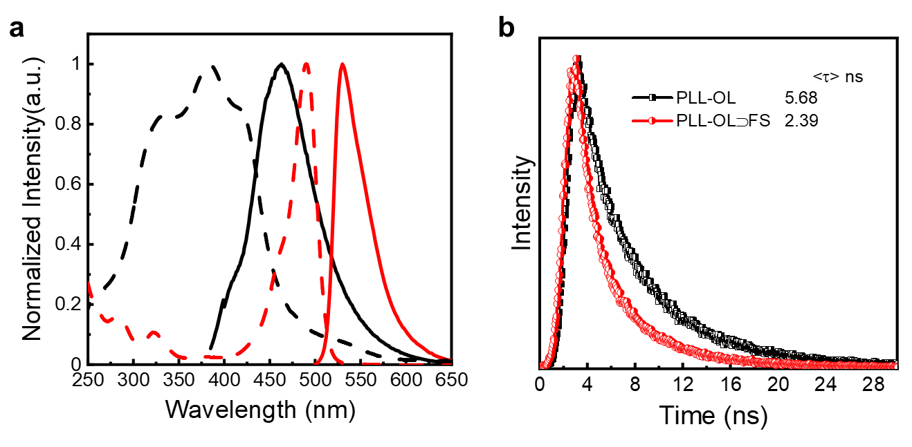
Figure S12. The FRET from PLL to FS. a Normalized absorption (dashed line) and emission (solid line) spectra of PLL-OL film (black lines) and FS aqueous solution (red lines, 10⁻⁴ M). b Lifetimes of PLL-OL film (black) and PLL-OL⊃FS film (0.87 wt% FS, red) at RT.

Table S3. Florescence lifetime, energy transfer efficiency and absolute quantum yield of the PLL-OL⊃FS film with different FS weight content
FS weight content | Fluorescence lifetime(ns) | Energy transfer efficiency(%) | Absolute quantum yield(%)
0 wt% | 5.68 |  | 5.56
0.01111 wt% | 4.38 | 22.9 | 7.89
0.1697 wt% | 3.33 | 41.4 | 13.7
0.2727 wt% | 2.49 | 56.2 | 19.2
0.4286 wt% | 2.42 | 57.4 | 20.8
0.8727 wt% | 2.39 | 57.9 | 21.9
1.091 wt% | 2.4 | 57.7 | 19.5

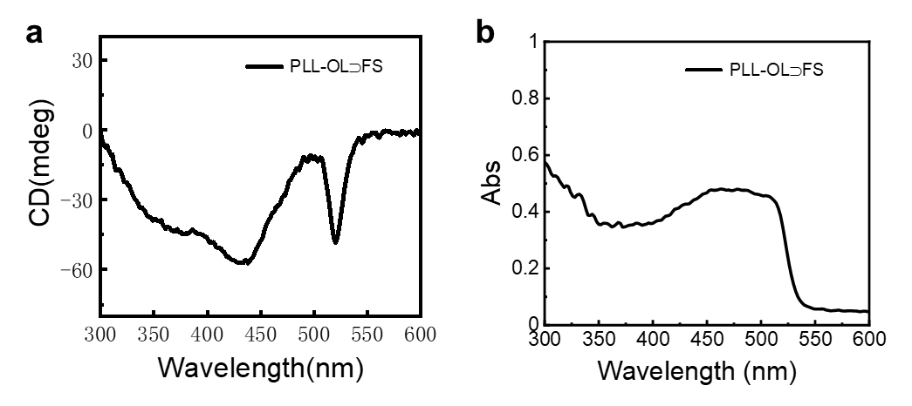
Figure S13. The CD and UV spectra of PLL-OL⊃FS film (0.87 wt% FS). a CD spectra. b UV spectra.

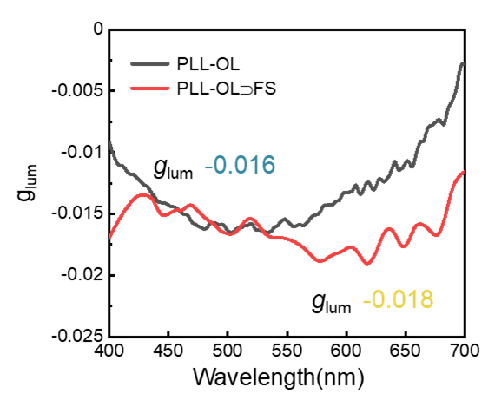
Figure S14. The g_{lum} value of PLL-OL film and PLL-OL⊃FS film (0.87 wt% FS).

