Additional Material

Diagnostic potential of myocardial early systolic lengthening for patients with suspected non-ST-segment elevation acute coronary syndrome

Wanwei Zhang¹, Qizhe Cai¹, Mingming Lin¹, Runyu Tian¹, Shan Jin¹, Yunyun Qin^{1,*},
Xiuzhang Lu^{1,*}

¹ Department of Ultrasound Medicine, Beijing Chao Yang Hospital, Capital Medical University, Beijing, 100020, China.

*Corresponding authors:
Yunyun Qin, MD PhD:
Department of Ultrasound Medicine, Beijing Chao Yang Hospital, Capital Medical University, Beijing, 100020, China.
Email: yun_23@126.com
Xiuzhang Lu, MD PhD:
Department of Ultrasound Medicine, Beijing Chao Yang Hospital, Capital Medical University, Beijing, 100020, China.
Email: echolxz @163.com

Supplemental Fig.1. Flowchart of the study population
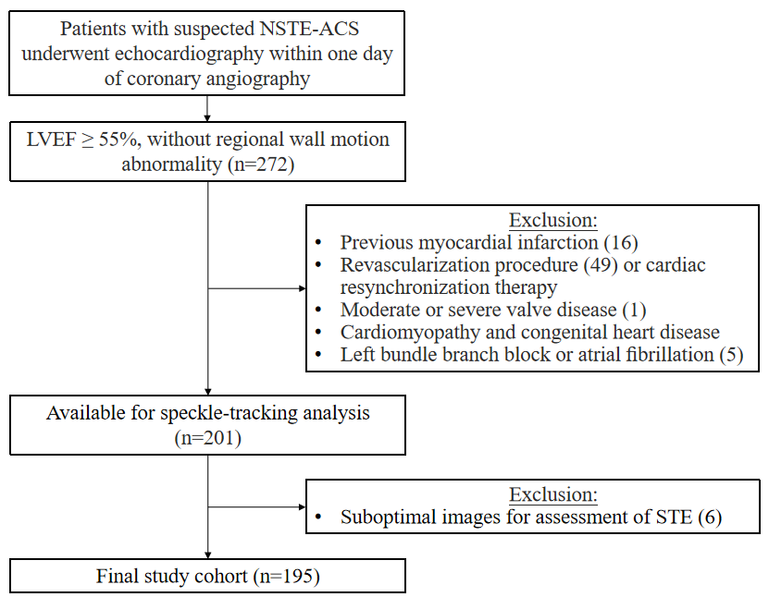

Supplemental Table 1. Spearman’s correlations between myocardial deformational parameters
Spearman’s correlations | GLS  rho | P | PSI  rho | P
DESL | 0.17 | =0.021 | 0.39 | <0.001
ESI | 0.20 | =0.005 | 0.49 | <0.001
DESL, duration of early systolic lengthening; ESI, early systolic index; GLS, global longitudinal strain; PSI, post-systolic index

Supplemental Table 2. ROC curve results to predict significant coronary branch stenosis

Variable | Territory perfusd by |  | AUC | P | Cut-off | Sen | Spe
Variable | Non-significant stenotic coronary | Significant stenotic coronary
LAD territories | n=71 | n=94
TLS, % | -19.10 ± 3.00 | -18.50 ± 3.10 | 0.55 | 0.310 | - | - | -
PSI, % | 1.92 (0.65, 3.87) | 2.57 (0.86, 7.44) | 0.58 | 0.076 | - | - | -
DESL, ms | 6.30 (2.40, 12.60) | 8.90 (5.4, 14.80) * | 0.60 | 0.024 | 6.00 | 70% | 49%
ESI, % | 0.40 (0.08, 1.23) | 1.08 (0.35, 2.33) * | 0.64 | 0.001 | 0.34 | 76% | 49%
LCX territories | n=114 | n=51
TLS, % | -16.50 ± 2.60 | -15.50 ± 2.90* | 0.60 | 0.040 | -15.44 | 51% | 70%
PSI, % | 1.49 (0.46, 3.29) | 2.22 (0.64, 9.94) | 0.59 | 0.075 | - | - | -
DESL, ms | 5.00 (0.00, 11.20) | 8.60 (5.00, 15.80) * | 0.64 | 0.002 | 6.80 | 69% | 61%
ESI, % | 0.27 (0.00, 1.21) | 0.92 (0.12, 2.84) * | 0.65 | 0.001 | 0.34 | 75% | 53%
RCA territories | n=111 | n=54
TLS, % | -17.90 ± 3.00 | -17.40 ± 3.00 | 0.58 | 0.102 | - | - | -
PSI, % | 1.35 (0.42, 2.89) | 2.11 (0.74, 5.08) * | 0.61 | 0.024 | 1.38 | 69% | 51%
DESL, ms | 10.60 (4.00, 16.50) | 14.20 (8.9, 21.20) * | 0.62 | 0.007 | 7.30 | 83% | 38%
ESI, % | 0.94 (0.15, 2.29) | 1.32 (0.58, 3.34) * | 0.63 | 0.004 | 0.22 | 93% | 30%
ROC, receiver operating characteristic curve; AUC, area under the curve; Sen, sensitivity; Spe, specificity; LAD, left anterior descending artery; TLS, territorial longitudinal strain; PSI, post-systolic index; DESL, duration of early systolic lengthening; ESI, early systolic index; LCX, left circumflex coronary artery; RCA, right coronary artery
*P<0.05 vs. territory perfused by non-significant stenotic coronary

