Supplemental material
Genome-wide association study of lipids in Greenlandic Inuit shows independent PCSK9 association and reveals a unique genetic architecture

Supplementary Figures

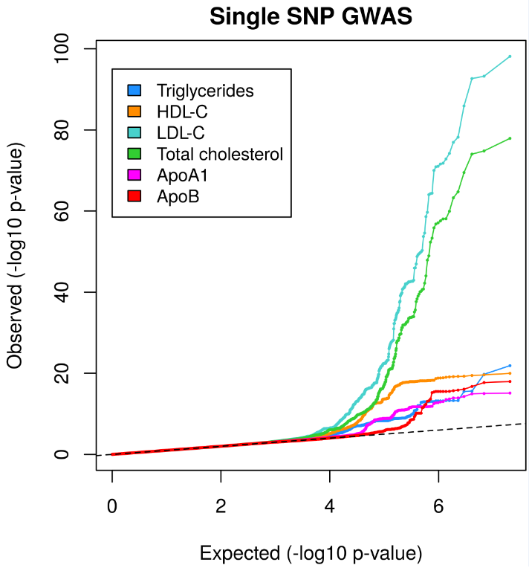
Supplementary Figure 1. QQ-plots for each of the genome-wide association analyses of the six lipid traits.

A) B)
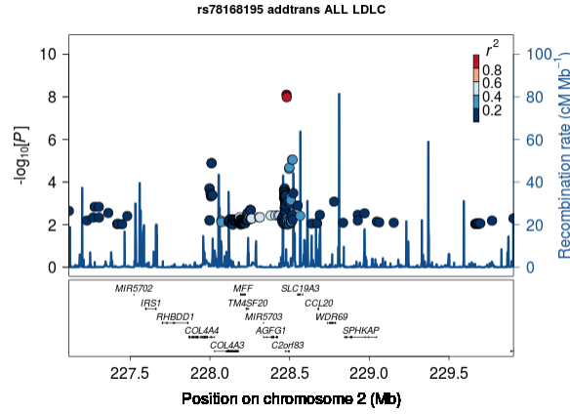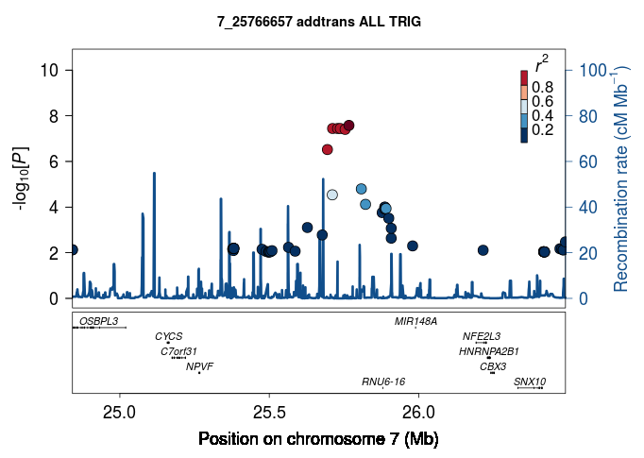
Supplementary Figure 2. Locus zoom of the potentially novel association signals for A) LDL-cholesterol at chromosome 2 (lead variant rs78168195), and for B) triglycerides at chromosome 7 (lead variant rs148015058).

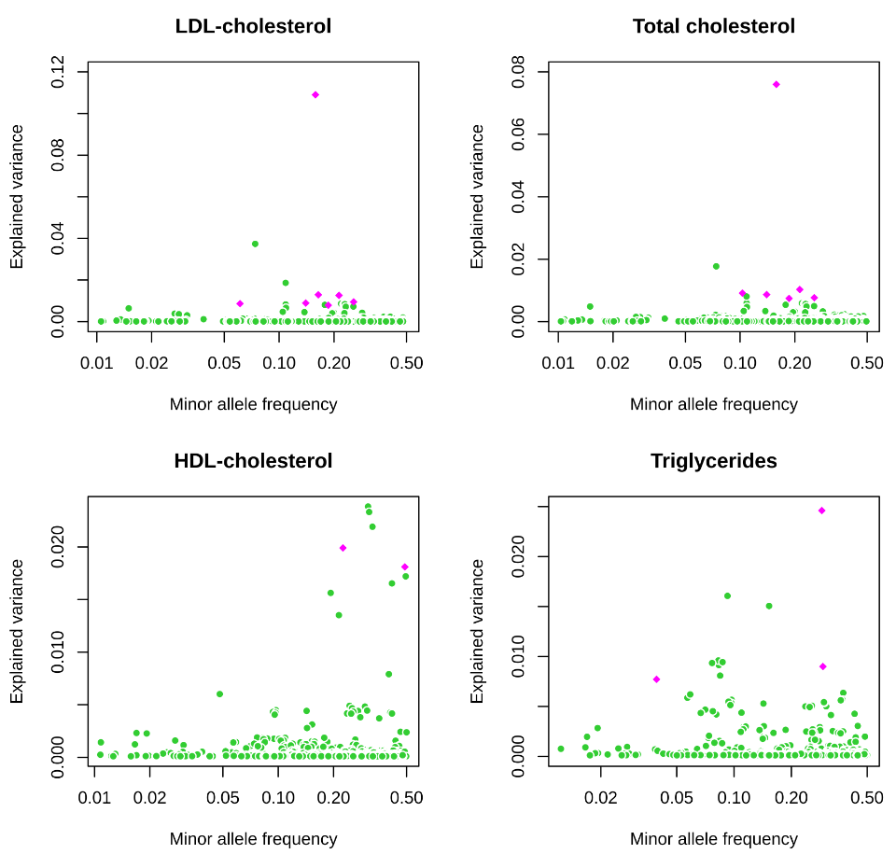
Supplementary Figure 3. Explained variance plotted against allele frequencies for variants with MAF>1% associated with each of the six lipid traits at p<5x10⁻⁸. Lead variants of the association signals identified in Greenlanders (pink diamonds), and variants associated with the lipid traits in Europeans (green circles) (1).

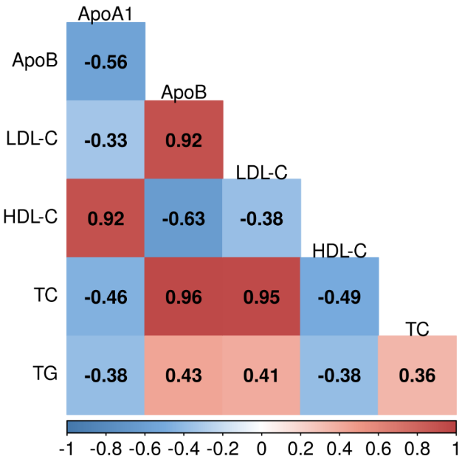
Supplementary Figure 4. Spearman’s correlation coefficients between the genetic risk scores for each of the six lipid traits. ApoA1, apolipoprotein A1; apoB, apolipoprotein B; HDL-C, HDL-cholesterol; LDL-C, LDL-cholesterol, TC, total cholesterol; TG, triglycerides.

Supplementary Tables

 | ICD8  (Greenland) | ICD9  (UKBB) | ICD10  (Greenland+UKBB) | ICPC2  (Greenland) | Self-reported  (UKBB)
Myocardial Infarction | 41009, 41099, 41109, 41199, 41209, 41299 | 410, 411, 412, 42979 | I21, I22, I23, I241, I252 | K74, K75, K76 | 1075
Ischaemic stroke | 43309, 43399, 43409, 43499, 43601, 43609, 43690, 43699 | 434, 436 | I63, I64 | K89, K90, K91 | 1583
Supplementary Table 1. The definition of cardiovascular disease outcomes is based on diagnosis codes according to previously reported categories (2). ICD, International Statistical Classification of Diseases and Related Health Problems; ICPC, International Classification of Primary Care; Self-reported: UK Biobank specific codes for self-reported diseases.

The Classification of Operations and Treatments in Greenland  (Greenland) | NOMESCO Classification of Surgical Procedures  (Greenland) | OPCS-4  (UKBB) | Baseline medical history  (UKBB)
30009, 30019, 30029, 30039, 30049, 30059, 30069, 30079, 30089, 30099, 30109, 30119, 30120, 30129, 30139, 30149, 30159, 30169, 30179, 30189, 30199, 30200, 30240, 30241, 30245, 30280, 86011, 86012, 86013, 86020, 86111, 86112, 86113, 86211, 86212, 86213, 86311, 86312, 86313, 86611, 86612, 86613, 86711, 86712, 86713, 86811, 86812, 86813, 86911, 86912, 86913, 86920, 87011, 87012, 87013 | KFNC, KFNC, KFNC, KFNC, KFNC, KFNA, KFNW96, KFNG, KNFG, KFNG12, KNFG, KNFG, KPA | K40, K41, K42, K43, K44, K45, K46, K49, K50, K553, K75, K76, L29, L303, L311, L313, L314, L318, L319 | 1069, 1070, 1095, 1105
Supplementary Table 2. The Classification of Operations and Treatments and The Nordic Medico-Statistical Committee (NOMESCO) Classification of Surgical Procedures were used to classify revascularization procedures for Greenlanders, and Classification of Interventions and Procedures (OPCS-4) and baseline medical history were used to classify revascularization procedures for Europeans from the UK Biobank.

Phenotype | All |  | Males |  | Females
Phenotype | Median (25-75th percentile) | N | Median (25-75th percentile) | N | Median (25-75th percentile) | N
Age (years) | 43 (33-54) | 4493 | 44 (34-55) | 1880 | 43 (33-53) | 2613
LDL-cholesterol (mmol/L) | 3.6 (2.9-4.3) | 3808 | 3.6 (2.9-4.4) | 1658 | 3.5 (2.9-4.3) | 2150
HDL-cholesterol (mmol/L) | 1.6 (1.3-1.9) | 4472 | 1.5 (1.2-1.89) | 1871 | 1.66 (1.4-2) | 2601
Total cholesterol (mmol/L) | 5.8 (5.1-6.6) | 4341 | 5.8 (5.1-6.6) | 1811 | 5.8 (5.1-6.675) | 2530
Triglycerides (mmol/L) | 1.0 (0.75-1.39) | 3969 | 0.98 (0.73-1.42) | 1737 | 1.02 (0.76-1.37) | 2232
ApoA1 (g/L) | 1.71 (1.55-1.95) | 1196 | 1.66 (1.48-1.87) | 511 | 1.77 (1.61-1.98) | 685
ApoB (g/L) | 0.89 (0.76-1.05) | 1196 | 0.89 (0.76-1.06) | 511 | 0.90 (0.77-1.04) | 685
Use of lipid lowering drugs (%) | 3.0 | 2770 | 3.3 | 1227 | 2.8 | 1543
HbA1c (%) | 5.8 (5.5-6.1) | 4446 | 5.8 (5.5-6.1) | 1869 | 5.7 (5.4-6) | 2577
Fasting plasma glucose (mmol/L) | 5.6 (5.2-6) | 3556 | 5.7 (5.3-6.1) | 1530 | 5.5 (5.2-5.9) | 2026
2-h plasma glucose (mmol/L) | 5.4 (4.3-6.7) | 3321 | 5.0 (4.0-6.4) | 1438 | 5.7 (4.7-7.1) | 1883
Fasting serum insulin (pmol/L) | 38 (25-56) | 3554 | 33 (22-50) | 1531 | 41 (28-60) | 2023
2-h serum insulin (pmol/L) | 108 (47-210) | 3322 | 61 (30-136) | 1439 | 146 (76-247) | 1883
Use of glucose lowering drugs (%) | 1.4 | 2781 | 1.3 | 1232 | 1.4 | 1549
Systolic blood pressure (mm Hg) | 76 (69-84) | 3983 | 78 (70-86) | 1694 | 74 (68-82) | 2289
Diastolic blood pressure (mm Hg) | 122 (111-134) | 3983 | 127 (116-138) | 1694 | 119 (110-130) | 2289
Use of antihypertensive drugs (%) | 10.2 | 2822.0 | 9.0 | 1241.0 | 11.1 | 1581
BMI (kg/m²) | 25.3 (22.4-29.0) | 4446 | 25.0 (22.4-28.5) | 1858 | 25.5 (22.4-29.5) | 2588
Supplementary Table 3. Participants Characteristics.

Locus | Variant ID | Chr:pos  (effect allele) | type of variant (Nearest gene) | Lipid trait | N | β_{SD} (SE) | p-value | PVE (%)
1 | rs78168195 | 2:228480653 (G) | Intron (C2orf83) | LDL-cholesterol | 3809 | 0.27 (0.05) | 7.9x10⁻⁹ | 0.87
 |  |  |  | Total cholesterol | 4342 | 0.22 (0.04) | 3.4x10⁻⁷ | 0.59
 |  |  |  | ApoB | 1197 | 0.20 (0.09) | 0.027 | 0.41
2 | rs148015058 | 7:25766657 (T) | Intergenic (NPVF) | Triglycerides | 3970 | 0.35 (0.06) | 2.6x10⁻⁸ | 0.77
3 | rs4927191 | 1:55491702 (C) | Intergenic (PCSK9) | LDL-cholesterol | 3809 | -0.23 (0.03) | 1.2x10⁻¹² | 1.29
 |  |  |  | Total cholesterol | 4342 | -0.17 (0.03) | 2.3x10⁻⁹ | 0.83
 |  |  |  | ApoB | 1197 | -0.20 (0.05) | 1.5x10⁻⁴ | 1.17
 |  |  |  | HDL-cholesterol | 4473 | 0.08 (0.03) | 0.0082 | 0.15
4 | rs312029 | 2:21461730 (C) | Intergenic (APOB) | Total cholesterol | 4341 | -0.19 (0.03) | 6.2x10⁻¹⁰ | 0.87
 |  |  |  | LDL-cholesterol | 3808 | -0.20 (0.03) | 5.6x10⁻⁹ | 0.89
 |  |  |  | Triglycerides | 3969 | -0.12 (0.03) | 5.5x10⁻⁴ | 0.30
 |  |  |  | ApoB | 1196 | -0.18 (0.07) | 0.0060 | 0.62
5 | rs2169387 | 8:9181395 (A) | Intergenic (PPP1R3B) | Total cholesterol | 4342 | -0.15 (0.03) | 1.5x10⁻⁸ | 0.74
 |  |  |  | LDL-cholesterol | 3809 | -0.17 (0.03) | 3.5x10⁻⁸ | 0.79
 |  |  |  | HDL-cholesterol | 4473 | -0.06 (0.03) | 0.025 | 0.11
6 | rs287 | 8:19815556 (G) | Intron (LPL) | Triglycerides | 3970 | -0.16 (0.03) | 3.3x10⁻⁹ | 0.90
 |  |  |  | HDL-cholesterol | 4473 | 0.08 (0.02) | 4.6x10⁻⁴ | 0.27
7 | rs2519093 | 9:136141870 (T) | Intron (ABO) | LDL-cholesterol | 3809 | 0.16 (0.03) | 1.0x10⁻⁹ | 0.95
 |  |  |  | Total cholesterol | 4342 | 0.14 (0.02) | 1.2x10⁻⁸ | 0.77
 |  |  |  | ApoB | 1197 | 0.12 (0.05) | 0.016 | 0.49
8 | rs66505542 | 11:116623213 (TA) | Intron (BUD13) | Triglycerides | 3970 | 0.25 (0.03) | 1.3x10⁻²² | 2.46
 |  |  |  | LDL-cholesterol | 3809 | 0.14 (0.03) | 9.7x10⁻⁸ | 0.77
 |  |  |  | Total cholesterol | 4342 | 0.12 (0.02) | 1.4x10⁻⁷ | 0.64
 |  |  |  | HDL-cholesterol | 4473 | -0.12 (0.02) | 1.5x10⁻⁷ | 0.64
 |  |  |  | ApoB | 1197 | 0.15 (0.05) | 0.0016 | 0.84
 |  |  |  | ApoA1 | 1197 | -0.13 (0.05) | 0.0045 | 0.66
9 | rs8045855 | 16:57000696 (A) | Intron (CETP) | HDL-cholesterol | 4473 | -0.20 (0.02) | 6.7x10⁻²⁰ | 1.81
 |  |  |  | LDL-cholesterol | 3809 | -0.11 (0.02) | 6.8x10⁻⁶ | 0.54
 |  |  |  | ApoA1 | 1197 | -0.18 (0.04) | 3.5x10⁻⁵ | 1.45
 |  |  |  | Triglycerides | 3970 | -0.07 (0.02) | 0.0023 | 0.24
10 | rs730882082 | 19:11215991 (A) | Missense (LDLR) | LDL-cholesterol | 3809 | 0.66 (0.03) | 7.2x10⁻⁹⁹ | 10.90
 |  |  |  | Total cholesterol | 4342 | 0.55 (0.03) | 1.2x10⁻⁷⁸ | 7.60
 |  |  |  | ApoB | 1197 | 0.52 (0.06) | 2.0x10⁻¹⁸ | 6.18
 |  |  |  | HDL-cholesterol | 4473 | -0.12 (0.03) | 7.8x10⁻⁵ | 0.35
 |  |  |  | ApoA1 | 1197 | -0.12 (0.06) | 0.047 | 0.33
11 | rs429358 | 19:45411941 (C) | Missense (APOE) | LDL-cholesterol | 3809 | 0.20 (0.03) | 2.8x10⁻¹² | 1.26
 |  |  |  | Total cholesterol | 4342 | 0.17 (0.03) | 2.6x10⁻¹¹ | 1.03
 |  |  |  | HDL-cholesterol | 4473 | -0.13 (0.03) | 7.3x10⁻⁷ | 0.57
 |  |  |  | ApoB | 1197 | 0.24 (0.05) | 1.3x10⁻⁶ | 1.92
 |  |  |  | Triglycerides | 3970 | 0.11 (0.03) | 1.9x10⁻⁴ | 0.36
Supplementary Table 4. All lipid association signals (p<0.05) for the 11 loci with a genome-wide significant association signal. Loci number 1 and 2 are potentially novel and the remaining loci have been associated with lipid levels previously (3, 4).

 |  |  |  |  |  | Greenlanders |  |  |  |  |  | UK Biobank
 |  |  | MAF (%) |  |  | LDL-cholesterol |  |  | Total cholesterol |  |  | LDL-cholesterol |  | Total cholesterol
# | rsID | posHg19 | GR | EU | EA | β_{SD} (SE) | p-value | PVE (%) | β_{SD} (SE) | p-value | PVE (%) | β_{SD} (SE) | p-value | β_{SD} (SE) | p-value
1 | rs4927191 | 1:55491702T>C | 16.4 | 27.3 | 19.7 | -0.23 (0.03) | 1.2x10⁻¹² | 1.29 | -0.17 (0.03) | 2.3x10⁻⁹ | 0.83 | -0.031 (0.0025) | 2.0x10⁻³⁷ | -0.028 (0.0025) | 5.1x10⁻³⁰
2 | rs4609471 | 1:55493584C>A | 15.1 | 20.7 | 12.8 | -0.23 (0.03) | 2.7x10⁻¹² | 1.30 | -0.17 (0.03) | 8.9x10⁻⁹ | 0.76 | -0.031 (0.0027) | 6.6x10⁻³² | -0.027 (0.0027) | 6.1x10⁻²⁵
3 | rs12117661 | 1:55487346C>G | 15.6 | 22.9 | 13.1 | -0.22 (0.03) | 6.5x10⁻¹² | 1.25 | -0.17 (0.03) | 1.1x10⁻⁸ | 0.74 | -0.030 (0.0025) | 2.8x10⁻³³ | -0.027 (0.0025) | 3.4x10⁻²⁶
4 | rs34232196 | 1:55489542C>T | 15.6 | 22.8 | 12.7 | -0.22 (0.03) | 6.8x10⁻¹² | 1.25 | -0.16 (0.03) | 1.5x10⁻⁸ | 0.72 | -0.030 (0.0025) | 1.1x10⁻³² | -0.026 (0.0025) | 1.0x10⁻²⁵
5 | rs17111483 | 1:55485098T>C | 10.2 | 9.5 | 20.7 | -0.26 (0.04) | 7.8x10⁻¹² | 1.25 | -0.22 (0.03) | 2.8x10⁻¹⁰ | 0.91 | -0.031 (0.0036) | 6.0x10⁻¹⁸ | -0.030 (0.0036) | 4.8x10⁻¹⁶
6 | rs4500361 | 1:55490861T>C | 15.8 | 22.8 | 12.6 | -0.22 (0.03) | 5.1x10⁻¹¹ | 1.30 | -0.17 (0.03) | 5.2x10⁻⁹ | 0.84 | -0.029 (0.0025) | 8.6x10⁻³² | -0.026 (0.0025) | 6.5x10⁻²⁵
7 | rs200159426 | 1:55491780A>G | 16.3 | 24.7 | 19.4 | -0.22 (0.03) | 5.6x10⁻¹¹ | 1.27 | -0.17 (0.03) | 2.0x10⁻⁸ | 0.82 | -0.031 (0.0025) | 2.6x10⁻³⁷ | -0.028 (0.0025) | 6.8x10⁻³⁰
8 | rs187607506 | 1:55491915C>T | 15.7 | 21.3 | 10.8 | -0.22 (0.03) | 1.3x10⁻¹⁰ | 1.19 | -0.17 (0.03) | 2.0x10⁻⁸ | 0.79 | -0.030 (0.0026) | 1.4x10⁻³⁰ | -0.026 (0.0026) | 9.3x10⁻²⁴

Supplementary Table 5. Variants associated with LDL-cholesterol at p<1x10⁻⁹ from the independent PCSK9 association signal. The minor allele frequencies in non-Finnish Europeans (EU) and East-Asians (EA) were obtained from the gnomAD data set v.2. The European association studies were based on 459,227 individuals from the UK Biobank and were conditioned on the PCSK9 loss-of-function variant (rs11591147).

# | rsID | Tibial nerve |  | Visceral adipose |  | Lung |  | Whole Blood |  | Tibial artery |  | Subcutaneous adipose
 |  | NES | p-value | NES | p-value | NES | p-value | NES | p-value | NES | p-value | NES | p-value
1 | rs4927191 | -0.73 | 8.1x10⁻⁵² | -0.47 | 2.3x10⁻¹⁴ | -0.26 | 3.7x10⁻¹⁶ | -0.18 | 2.9x10⁻¹¹ | -0.22 | 4.4x10⁻⁶ | -0.19 | 1.1x10⁻⁴
2 | rs4609471 | -0.79 | 1.3x10⁻⁵⁴ | -0.45 | 8.8x10⁻¹² | -0.28 | 3.0x10⁻¹⁷ | -0.19 | 6.6x10⁻¹¹ | - | NS | - | NS
3 | rs12117661 | -0.82 | 2.3x10⁻⁶¹ | -0.46 | 1.2x10⁻¹² | -0.29 | 4.0x10⁻¹⁹ | -0.19 | 8.3x10⁻¹¹ | -0.21 | 2.4x10⁻⁵ | -0.21 | 7.9x10⁻⁵
4 | rs34232196 | -0.83 | 3.7x10⁻⁶² | -0.46 | 1.4x10⁻¹² | -0.30 | 5.4x10⁻²⁰ | -0.19 | 7.3x10⁻¹¹ | -0.22 | 1.8x10⁻⁵ | -0.20 | 9.5x10⁻⁵
5 | rs17111483 | -0.37 | 1.9x10⁻⁶ | -0.46 | 1.3x10⁻⁷ | - | NS | - | NS | - | NS | - | NS
6 | rs4500361 | -0.83 | 2.5x10⁻⁶⁴ | -0.44 | 1.6x10⁻¹¹ | -0.30 | 4.4x10⁻²⁰ | -0.18 | 4.0x10⁻¹⁰ | NS | NS | -0.22 | 2.7x10⁻⁵
7 | rs200159426 | NA | NA | NA | NA | NA | NA | NA | NA | NA | NA | NA | NA
8 | rs187607506 | NA | NA | NA | NA | NA | NA | NA | NA | NA | NA | NA | NA
Supplementary Table 6. Association between the variants from the association signal near PCSK9 and PCSK9 expression across tissues with a p<2.0x10⁻⁴ for at least one of the variants in the GTEx portal (5). The variants are ordered according to their significance in the LDL-association signal. NA, not available; NES, normalized effect size; NS, not significant.

Association signals near PCKS9 |  | Greenlanders |  |  |  |  |  |  |  | Europeans (UK biobank)
 |  | Myocardial infarction |  | Ischaemic stroke |  | Revascularization procedures |  | Any CVD |  | Myocardial infarction |  | Ischaemic stroke |  | Revascularization procedures |  | Any CVD
# | rsID | HR (95% CI) | p-value | HR (95% CI) | p-value | HR (95% CI) | p-value | HR (95% CI) | p-value | HR (95% CI) | p-value | HR (95% CI) | p-value | HR (95% CI) | p-value | HR (95% CI) | p-value
1 | rs4927191 | 0.74 (0.52, 1.06) | 0.102 | 0.78 (0.61, 1.01) | 0.063 | 1.03 (0.71, 1.48) | 0.888 | 0.85 (0.70, 1.03) | 0.097 | 0.97 (0.95, 1.00) | 0.024 | 1.00 (0.96, 1.05) | 0.880 | 0.96 (0.93, 0.98) | 2.80x10⁻⁴ | 0.97 (0.96, 0.99) | 0.0038
2 | rs4609471 | 0.78 (0.54, 1.13) | 0.190 | 0.77 (0.59, 1.01) | 0.057 | 1.05 (0.72, 1.52) | 0.805 | 0.86 (0.70, 1.05) | 0.131 | 0.99 (0.96, 1.01) | 0.347 | 1.01 (0.96, 1.06) | 0.755 | 0.96 (0.93, 0.99) | 0.0024 | 0.98 (0.96, 1.00) | 0.035
3 | rs12117661 | 0.75 (0.52, 1.08) | 0.127 | 0.79 (0.61, 1.02) | 0.070 | 1.00 (0.69, 1.46) | 0.993 | 0.85 (0.70, 1.04) | 0.107 | 0.98 (0.95, 1.00) | 0.053 | 1.01 (0.97, 1.05) | 0.730 | 0.96 (0.93, 0.98) | 3.10x10⁻⁴ | 0.97 (0.96, 0.99) | 0.0047
4 | rs34232196 | 0.75 (0.52, 1.09) | 0.130 | 0.78 (0.60, 1.01) | 0.057 | 1.00 (0.69, 1.46) | 0.985 | 0.84 (0.69, 1.03) | 0.094 | 0.98 (0.95, 1.00) | 0.047 | 1.00 (0.96, 1.05) | 0.840 | 0.96 (0.93, 0.98) | 3.40x10⁻⁴ | 0.97 (0.95, 0.99) | 0.0044
5 | rs17111483 | 0.66 (0.41, 1.06) | 0.086 | 0.90 (0.67, 1.20) | 0.464 | 1.26 (0.83, 1.92) | 0.275 | 0.92 (0.73, 1.16) | 0.506 | 0.98 (0.95, 1.02) | 0.304 | 0.98 (0.92, 1.04) | 0.470 | 0.98 (0.94, 1.01) | 0.185 | 0.99 (0.96, 1.02) | 0.390
6 | rs4500361 | 0.80 (0.55, 1.17) | 0.249 | 0.79 (0.60, 1.03) | 0.082 | 0.91 (0.61, 1.36) | 0.649 | 0.86 (0.70, 1.06) | 0.152 | 0.98 (0.95, 1.00) | 0.055 | 1.01 (0.96, 1.05) | 0.750 | 0.96 (0.94, 0.98) | 6.10x10⁻⁴ | 0.97 (0.96, 0.99) | 0.0069
7 | rs200159426 | 0.80 (0.55, 1.16) | 0.234 | 0.81 (0.62, 1.05) | 0.116 | 0.99 (0.67, 1.46) | 0.966 | 0.88 (0.72, 1.08) | 0.213 | 0.97 (0.95, 1.00) | 0.022 | 1.00 (0.96, 1.04) | 0.975 | 0.96 (0.93, 0.98) | 2.00x10⁻⁴ | 0.97 (0.95, 0.99) | 0.0032
8 | rs187607506 | 0.81 (0.56, 1.18) | 0.276 | 0.79 (0.61, 1.04) | 0.094 | 1.00 (0.67, 1.48) | 0.992 | 0.88 (0.71, 1.08) | 0.216 | 0.98 (0.95, 1.00) | 0.062 | 0.99 (0.95, 1.04) | 0.731 | 0.96 (0.94, 0.98) | 0.0012 | 0.97 (0.96, 0.99) | 0.0089
Supplementary Table 7. Association between the variants from the association signal near PCSK9 (p<10⁻⁹) and different CVD outcomes in Greenlanders and in Europeans from the UK Biobank, analyzed using a model adjusted for age, sex, and the first 10 principal components. The analyses in Europeans were conditioned on the PCSK9 loss-of-function variant (rs11591147) (6). CVD, cardiovascular disease; HR, hazard ratio.

 | N | β_{SD} (SE) | p-value
Lipid profile
LDL-cholesterol (mmol/L) | 3809 | -0.22 (0.03) | 6.5x10⁻¹²
Total cholesterol (mmol/L) | 4342 | -0.17 (0.03) | 1.1x10⁻⁸
Triglycerides (mmol/L) | 3970 | -0.02 (0.03) | 0.657
HDL-cholesterol (mmol/L) | 4473 | 0.08 (0.03) | 0.0064
Apolipoprotein B (g/L) | 1197 | -0.19 (0.05) | 4.1x10⁻⁴
Apolipoprotein A1 (g/L) | 1197 | 0.03 (0.05) | 0.573
Glucose homeostasis
HbA1C (%) | 4447 | -0.03 (0.02) | 0.315
Fasting plasma glucose (mmol/L) | 3557 | 0.02 (0.03) | 0.443
2h plasma glucose (mmol/L) | 3322 | 0.03 (0.03) | 0.397
Fasting serum insulin (pmol/L) | 3555 | -0.004 (0.03) | 0.915
2h serum insulin (pmol/L) | 3323 | 0.04 (0.04) | 0.263
Fasting serum C-peptide (mmol/L)) | 3555 | -0.02 (0.03) | 0.461
2h serum C-peptide (mmol/L) | 3323 | 0.01 (0.03) | 0.736
Systolic blood pressure (mm Hg) | 3984 | -0.02 (0.03) | 0.506
Diastolic blood pressure (mm Hg) | 3984 | -0.02 (0.03) | 0.585
Anthropometrics
BMI (kg/m²) | 4447 | -0.02 (0.03) | 0.439
Weight (kg) | 4453 | -0.03 (0.03) | 0.292
Waist (cm) | 4420 | -0.01 (0.03) | 0.803
Waist-hip ratio | 4417 | -0.04 (0.03) | 0.178
Supplementary Table 8. Associations between the potential causal variant in the PCSK9 association signal (rs12117661) and lipid levels, measures of glucose homeostasis, and anthropometrics.

 |  | Myocardial infarction |  | Ischaemic stroke |  | Revascularization procedures |  | Any CVD
Locus | variant ID | HR (95% CI) | p-value | HR (95% CI) | p-value | HR (95% CI) | p-value | HR (95% CI) | p-value
1 | rs78168195 | 1.07 (0.63, 1.80) | 0.806 | 1.07 (0.74, 1.53) | 0.731 | 1.42 (0.84, 2.38) | 0.188 | 1.15 (0.87, 1.53) | 0.325
2 | rs148015058 | 1.15 (0.66, 1.98) | 0.622 | 1.20 (0.77, 1.87) | 0.425 | 1.08 (0.56, 2.07) | 0.815 | 1.16 (0.83, 1.63) | 0.386
3 | rs4927191 | 0.74 (0.52, 1.06) | 0.102 | 0.78 (0.61, 1.01) | 0.063 | 1.03 (0.71, 1.48) | 0.888 | 0.85 (0.70, 1.03) | 0.097
4 | rs312029 | 0.79 (0.53, 1.18) | 0.253 | 0.83 (0.63, 1.09) | 0.186 | 0.58 (0.35, 0.98) | 0.042 | 0.81 (0.65, 1.02) | 0.072
5 | rs2169387 | 0.83 (0.58, 1.18) | 0.293 | 1.22 (0.99, 1.50) | 0.063 | 0.87 (0.59, 1.29) | 0.481 | 1.10 (0.92, 1.30) | 0.301
6 | rs287 | 0.89 (0.67, 1.17) | 0.399 | 0.97 (0.80, 1.18) | 0.747 | 1.00 (0.73, 1.35) | 0.980 | 0.94 (0.81, 1.10) | 0.445
7 | rs2519093 | 1.16 (0.87, 1.55) | 0.308 | 0.91 (0.74, 1.11) | 0.351 | 1.15 (0.83, 1.60) | 0.395 | 1.00 (0.85, 1.17) | 0.996
8 | rs187850276 | 0.96 (0.71, 1.30) | 0.798 | 1.04 (0.85, 1.26) | 0.733 | 0.91 (0.65, 1.29) | 0.609 | 1.04 (0.89, 1.23) | 0.600
9 | rs8045855 | 1.09 (0.83, 1.42) | 0.535 | 1.07 (0.90, 1.28) | 0.444 | 1.02 (0.76, 1.38) | 0.882 | 1.05 (0.91, 1.21) | 0.507
10 | rs730882082 | 1.39 (0.99, 1.95) | 0.060 | 1.12 (0.89, 1.42) | 0.334 | 1.73 (1.21, 2.48) | 0.0026 | 1.25 (1.03, 1.50) | 0.022
11 | rs429358 | 0.93 (0.68, 1.27) | 0.646 | 0.92 (0.74, 1.14) | 0.427 | 1.22 (0.89, 1.68) | 0.217 | 0.97 (0.82, 1.15) | 0.740
Supplementary Table 9. Association analysis of lead variants of the 11 association signals and different cardiovascular outcomes in a Cox-regression model adjusted for age, sex, and the first 10 principal components. CVD, cardiovascular disease; HR, hazard ratio; IS, ischemic stroke; MI, myocardial infarction; RP, revascularization procedures.

 |  |  | PVE (%)
 |  |  | GRS |  | Age |  | BMI
GRS/Trait | Beta (SE) | p-value | model 1 | model 2 | model 1 | model 2 | model 1 | model 2
Triglycerides | 0.64 (0.07) | 4.5x10⁻²² | 2.35 | 1.92 | 0.02 | 0.12 | 12.3 | 12.0
Total cholesterol | 0.91 (0.04) | 3.0x10⁻¹²³ | 12.2 | 9.98 | 11.9 | 10.9 | 2.25 | 3.01
LDL-cholesterol | 0.88 (0.03) | 6.2x10⁻¹⁴⁸ | 16.3 | 13.7 | 6.44 | 5.91 | 5.93 | 5.86
HDL-cholesterol | 0.43 (0.05) | 1.8x10⁻¹⁵ | 1.42 | 1.31 | 6.27 | 3.41 | 14.2 | 11.6
Apolipoprotein A1 | 0.27 (0.11) | 0.012 | 0.53 | 0.73 | 1.82 | 0.87 | 5.48 | 4.69
Apolipoprotein B | 0.91 (0.07) | 1.4x10⁻³² | 11.3 | 10.8 | 0.26 | 0.74 | 6.05 | 6.29
Supplementary Table 11. Effect size and p-value for association analyses adjusted for age, sex, BMI, and the first 10 principal components, and partial variance explained (PVE) for each genetic risk score (GRS), age, and BMI adjusted for age, sex, BMI, and the first 10 principal components (model 1), or the first 10 principal components (model 2).

References
1. Liu DJ, Peloso GM, Yu H, Butterworth AS, Wang X, Mahajan A, et al. Exome-wide association study of plasma lipids in > 300,000 individuals. Nature Genet. 2017;49(12):1758-+.
2. Trinder M, Francis GA, Brunham LR. Association of Monogenic vs Polygenic Hypercholesterolemia With Risk of Atherosclerotic Cardiovascular Disease. JAMA Cardiol. 2020;5(4):390-9.
3. Dube JB, Wang J, Cao HN, McIntyre AD, Johansen CT, Hopkins SE, et al. Common Low-Density Lipoprotein Receptor p.G116S Variant Has a Large Effect on Plasma Low-Density Lipoprotein Cholesterol in Circumpolar Inuit Populations. Circ-Cardiovasc Genet. 2015;8(1):100-U90.
4. Surakka I, Horikoshi M, Magi R, Sarin AP, Mahajan A, Lagou V, et al. The impact of low-frequency and rare variants on lipid levels. Nature Genet. 2015;47(6):589-97.
5. GTEx Consortium. The Genotype-Tissue Expression (GTEx) pilot analysis: Multitissue gene regulation in humans. Science. 2015;348(6235):648-60.
6. Bycroft C, Freeman C, Petkova D, Band G, Elliott LT, Sharp K, et al. The UK Biobank resource with deep phenotyping and genomic data. Nature. 2018;562(7726):203-9.

