Elevated n-6/n-3 polyunsaturated fatty acid ratio in erythrocyte membranes of obese patients interacts with intestinal flora to promote cognitive impairment
Tong Zhao¹, Hongying Huang¹, Jinchen Li¹, Jingyi Shen¹, Cui Zhou¹, Rong Xiao¹ and Weiwei Ma^{1*}
¹ School of Public Health, Beijing Key Laboratory of Environmental Toxicology, Capital Medical University, Beijing, 100069, People’s Republic of China.
* Corresponding author: Weiwei Ma, School of Public Health, Beijing Key Laboratory of Environmental Toxicology, Capital Medical University, Beijing, 100069, People’s Republic of China, Tel +86-10-83911651, Fax +86-10-83911651, Email weiweima@ccmu.edu.cn.

Supplementary Fig S1 Basic information of two groups of intestinal flora
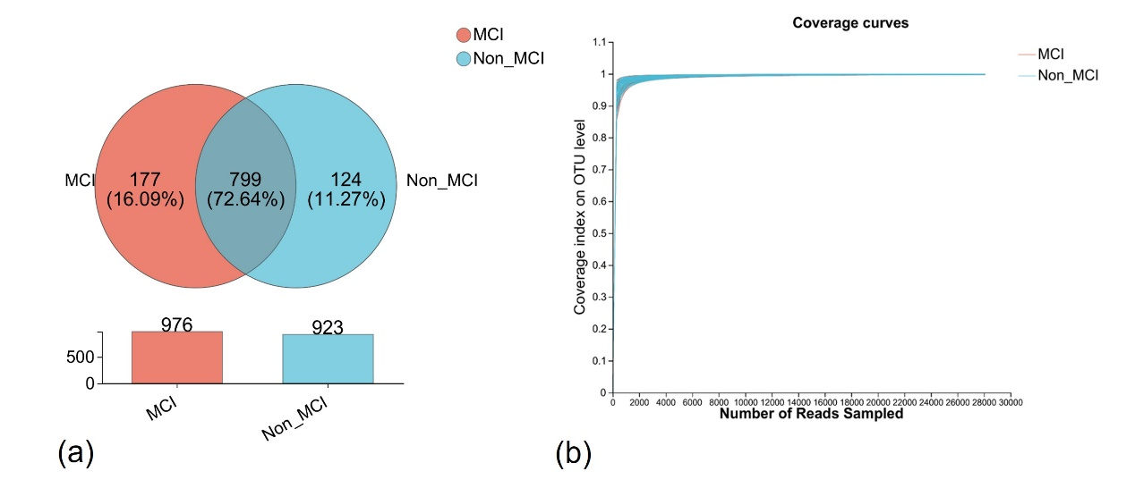
Legend (a) The common and unique species in the two groups of samples were compared, and the similarity and overlap of species composition in the samples were more intuitively expressed. (b) Select the OTU level with 97% similarity, use mothur to calculate the coverage index under random sampling, and use R language tools to make graphs. MCI: obesity with cognitive impairment group; Non_MCI: obese but cognitively normal group; OTU, operational taxonomic units.

