Supplementary Material
Article title: The Design of a MOOC on Health Behaviors: A Practical Blueprint for the Instructional Design of MOOCs
Journal name: Discover Education
Author names: Andre Matthias Müller, Claire Tan, Charlene Goh & Raymond Boon Tar Lim
Affiliation: Saw Swee Hock School of Public Health, National University of Singapore
E-mail address of the corresponding author: ephamm@nus.edu.sg

Additional table: Key aspects identified, related guiding principles and comprehensive list of principles implementation. Screenshots showcasing implementation of guiding principles provided below this table.
Key aspects to address | Guiding principles | Implementation in current MOOC
Key aspects to address | Guiding principles | Target areas identified  (based on guiding principles) | Practical features incorporated to address target area
Learner backgrounds: Managing cognitive load of learners from diverse backgrounds who are unfamiliar with the topic, have moderate English-language proficiency and moderate digital literacy. | Provide learning environments, materials and tasks that limit cognitive load and facilitate cognitive processing. | To prevent extraneous cognitive processing, important learning elements that belong together should not be separated in the learning environment | - Essential content/elements were provided in the same space with no external links (see Screenshot 1 below)  - Text or spoken words were aligned with visuals (see Screenshot 2 below)
 |  | To reduce cognitive load and allow learners to consolidate their learning, the learning environment/flow should be logical and not complex | - 7 core topics were provided to scaffold learning (macro-level), with each of the 7 sections/weeks being further logically segmented to focus on various aspects of the topic (meso-level). Within segments, learning units provided Information in bite-sized chunks that flowed logically (micro-level) (see Screenshot 3 below)  - Basic concepts/ideas that were necessary to progress need to be introduced early on to avoid extraneous processing later on.
 |  | To facilitate cognitive processing of new concepts, learning materials should not overload the information entry channel (audio, visual). Ideally, two channels of information should be combined (visual and audio) to aid active building of mental models. | - Key concepts were explained in videos, with a text or graphic provided to consolidate learning (see Screenshot 4 below)  - Graphics were accompanied with spoken words instead of on-screen text (see Screenshot 5 below)
 |  | To keep learners focused on achieving desired learning outcomes and avoid additional processing, learning materials should minimise extraneous content and features | - Materials were made bite-sized and uncluttered (i.e., short videos, uncluttered graphics, brief texts) and directly related to learning outcomes (see Screenshot 6 below)  - Important content was communicated at the start of each section and brief summaries of key learning points were provided at the end (see Screenshot 7 below)  - Optional material that provided depth of coverage for the topic was signposted towards the end of sections and segments (see Screenshot 8 below)
 |  | To reduce cognitive load, language of instruction should not be overly complex | - Basic English language was used in the videos, graphics and texts (Text and scripts were drafted, edited to improve readability and then again reviewed prior to upload).  - Technical depth, jargon and numerical references were minimized as much as possible
 |  | To reduce extraneous cognitive processing, learning materials should be consistent | - A single style guide was utilized throughout the course – headlines and fonts were formatted similarly across sections, and paragraph lengths were kept consistently short
Learner motivations: Catering to learners with vastly different motivations to join our MOOC and enable them to gain what they need or want. | Support learners in achieving their goals by enabling them to control what and how they want to learn. | To allow for easy navigation to desired content, naming conventions should reflect what can be learned or experienced | - Descriptive names were used for all sections, segments and units (names of learning elements within units often contain the actual activity such as Immersive task) (see Screenshot 9 below)
 |  | To afford learners autonomy during the learning process, content overviews should be provided, detailing the topics and materials available for access | - A welcome message was included at the start of the course, outlining key learning objectives and the 7 core topics and when they will be covered during the course (see Screenshot 10 below)  - Brief messages were emailed to learners detailing the questions that will be addressed in the relevant sessions. These questions were also posted at the start of each session. (see Screenshot 11 below)  - A content brief was incorporated in the introductory videos of each section to highlight the section’s learning objectives and activities (see Screenshot 12 below)
 |  | To allow learners to decide how they want to learn, varied learning materials and activities that address the same topic should be provided and signposted | - Each learning element has descriptive name and clearly highlights what kind of a learning activity it is (e.g., self-reflection, immersive activity, summary, research insights)
 |  | To afford learners the option to delve deeper into a topic, additional and optional learning materials should be provided | - Additional learning materials, such as references and web links, were signposted in various sections (see Screenshot 13 below)
Higher-order learning: Enabling higher-order learning to facilitate the acquisition of complex cognitive competencies. | Provide various authentic and personally relatable opportunities to practice and actively learn. | To improve engagement with a topic and facilitate higher-order learning, opportunities for active learning and practice should be provided | - Commonly, videos and/or texts were provided prior to introducing increasingly more active learning materials (scaffolding from transmission to more challenging active learning tasks).  - Various Immersive and self-reflection activities were provided, such as behavioral analyses and intervention development, assessment of own and others health behaviors, evaluations of existing strategies and environments etc.  - Multiple-choice questions were application related.  - Movement breaks were conducted to highlight how health behaviors could be promoted. (see Screenshot 14 below)
Connecting and instructor presence: Facilitating social connectedness and demonstrating instructor presence while considering the capacity of instructors. | Create a learning atmosphere that resembles human interaction and provide multiple opportunities to connect without overburdening instructors. | To prevent feelings of disconnectedness during the learning journey, platforms should be made available for interactions and learners should be encouraged to interact | - Learners were encouraged to introduce themselves and reveal some personal information in discussion forums. We post guiding questions to prompt the sharing of personal information (e.g., hobbies, opinions) and personal experiences (e.g., current health behaviours) (see Screenshot 15 below)  - Learners were encouraged to learn and engage with their peers by sharing in the discussion forums and through a peer assessment for a project (see Screenshot 16 below)
 |  | To show instructor presence and demonstrate humanness, content should not be presented in an impersonal and transactional manner, and instructors need to be personable and responsive | - Videos and texts were crafted with first- and second-person references (i.e., use of ‘I’, ‘we’, ‘you’) and conversational language (e.g., “Let’s have a look at…”) (see Screenshot 17 below)  - Instructors introduced themselves to learners through a short personal sharing in an introductory video (see Screenshot 18 below)  - Instructors replied to learners’ posts on discussion forums in a personable manner (see Screenshot 19 below)

No | Practical features incorporated to address target area | Screenshot
1 | Essential content/elements were provided in the same space with no external links | 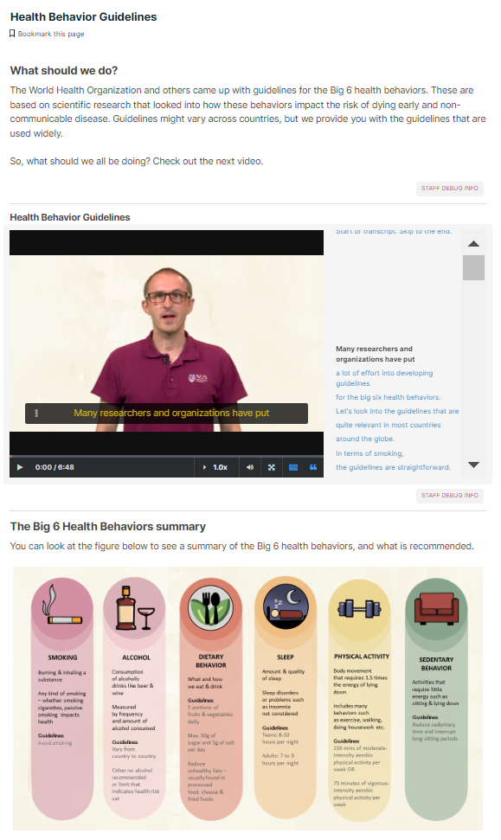
2 | Text or spoken words were aligned with visuals | 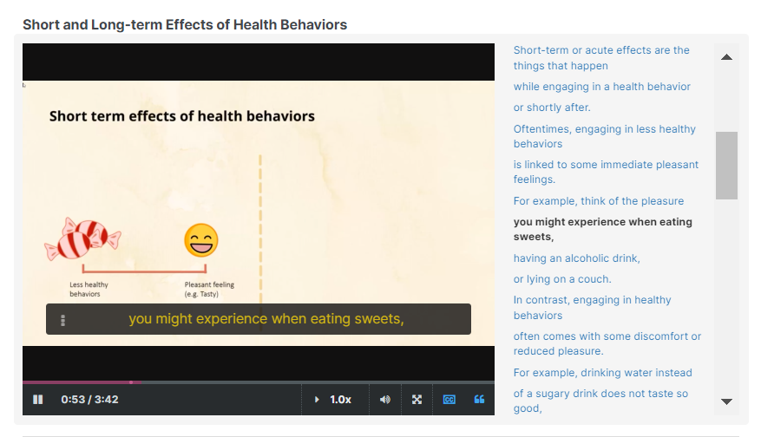
3 | 7 core topics were provided to scaffold learning (macro-level), with each of the 7 sections/weeks being further logically segmented to focus on various aspects of the topic (meso-level). Within segments, learning units provided Information in bite-sized chunks that flowed logically (micro-level) | 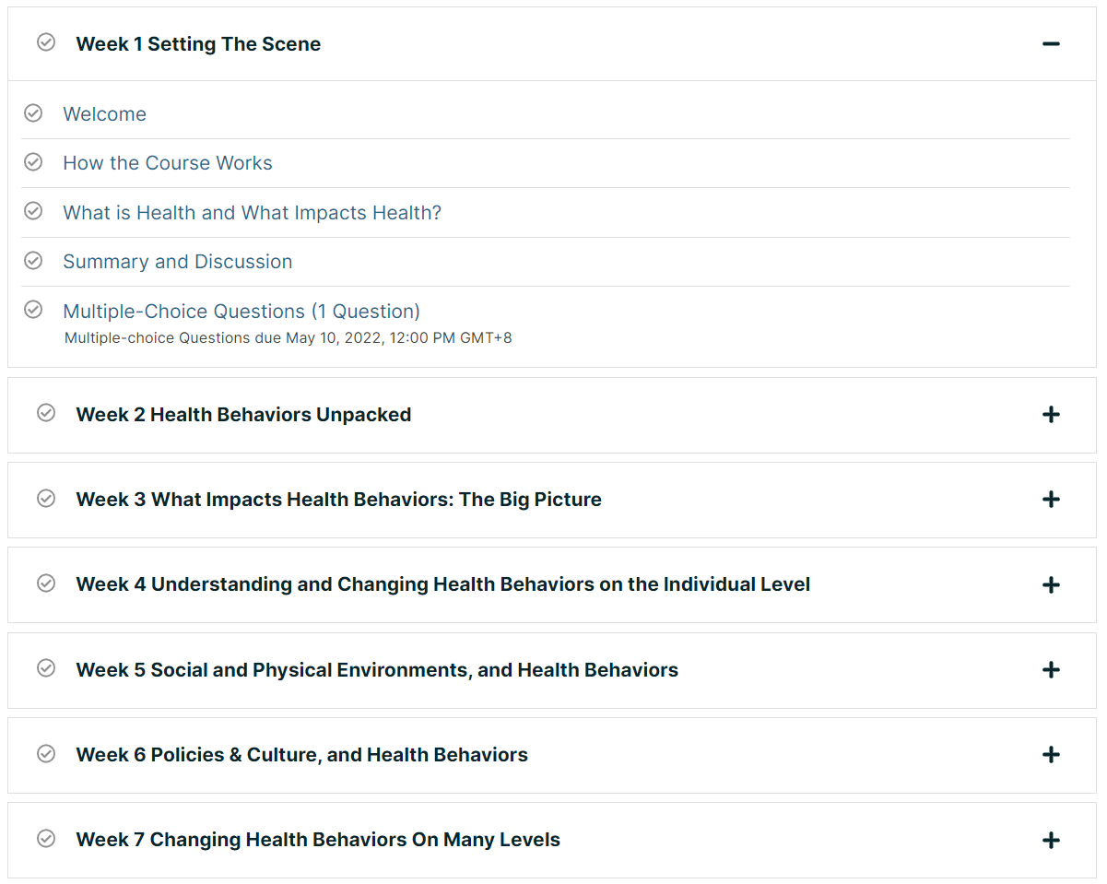
4 | Key concepts were explained in videos, with a text or graphic provided to consolidate learning | 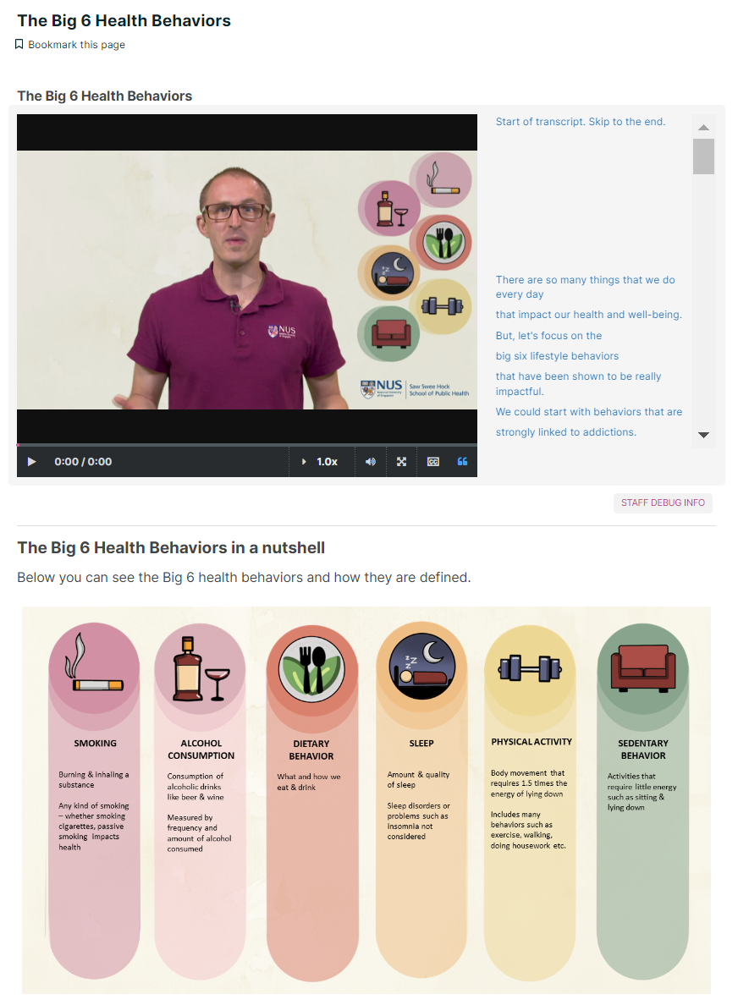
5 | Graphics were accompanied with spoken words instead of on-screen text | 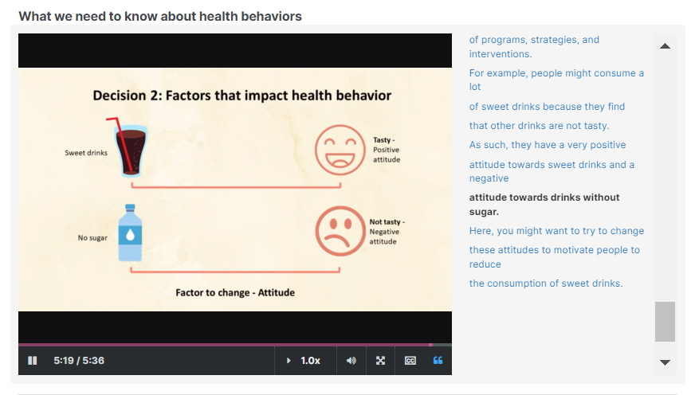
6 | Materials were made bite-sized and uncluttered (i.e., short videos, uncluttered graphics, brief texts) and directly related to learning outcomes (Screenshot 6) | 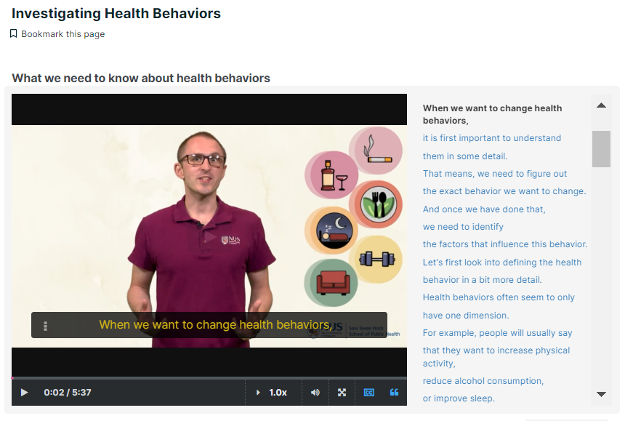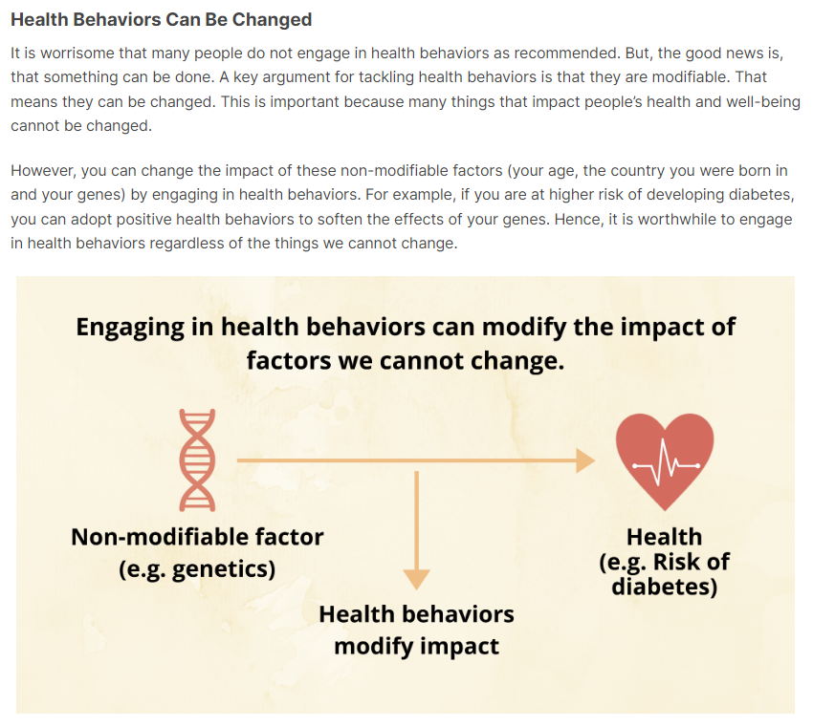
7 | Important content was communicated at the start of each section and brief summaries of key learning points were provided at the end (Screenshot 7) | 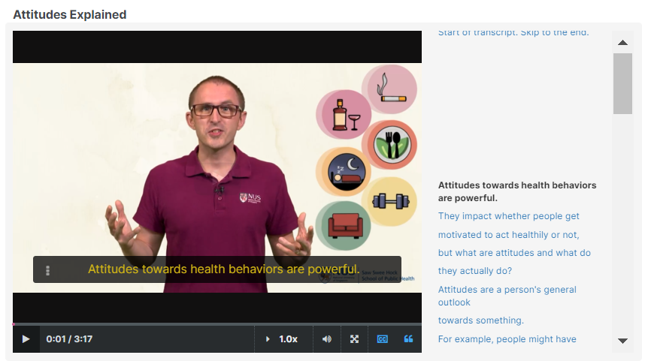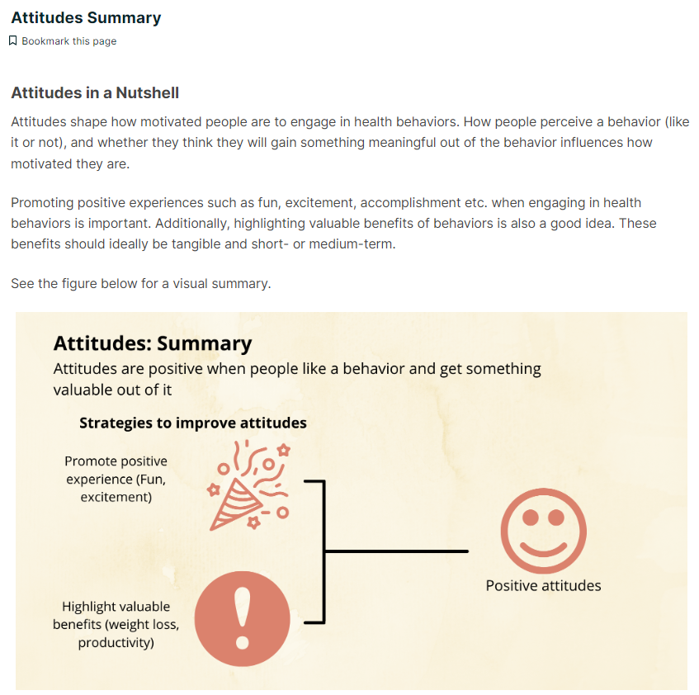
8 | Optional material that provided depth of coverage for the topic was signposted towards the end of sections and segments | 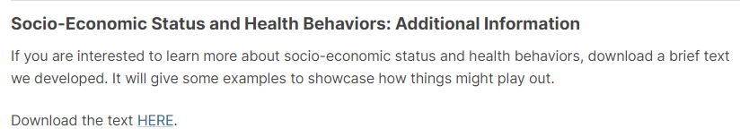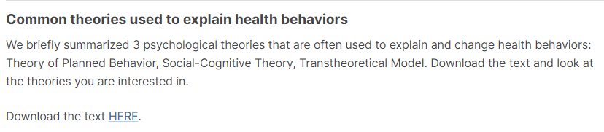
9 | Descriptive names were used for all sections, segments and units (names of learning elements within units often contain the actual activity such as Immersive task) | 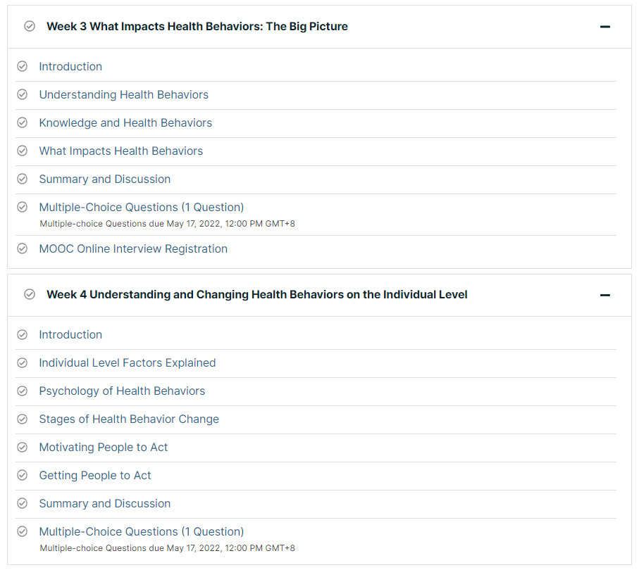
10 | A welcome message was included at the start of the course, outlining key learning objectives and the 7 core topics and when they will be covered during the course | 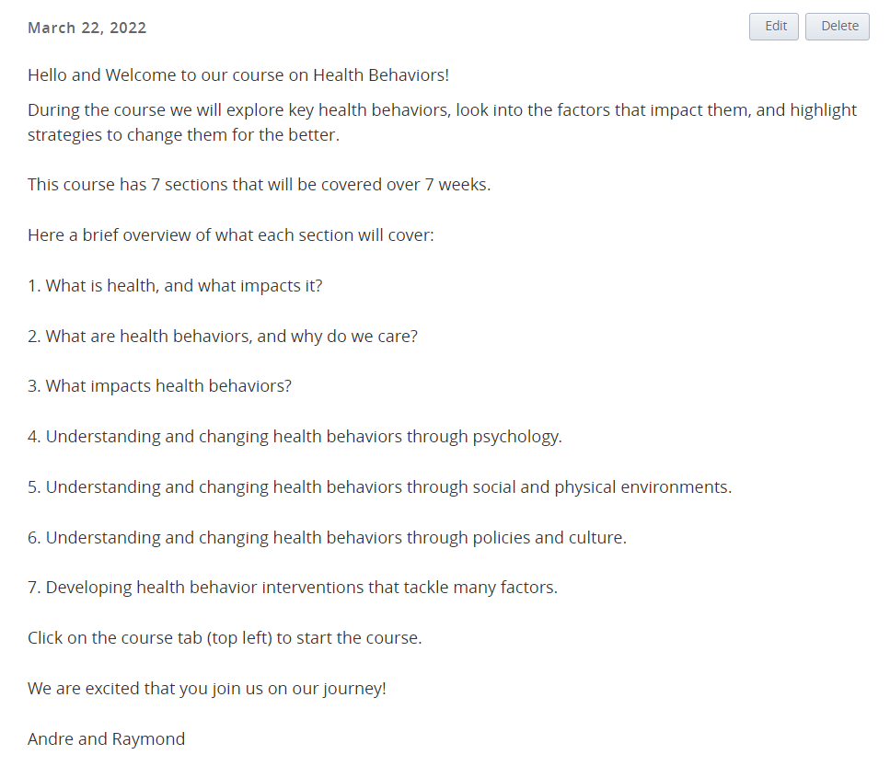
11 | Brief messages were emailed to learners detailing the questions that will be addressed in the relevant sessions. These questions were also posted at the start of each session. | 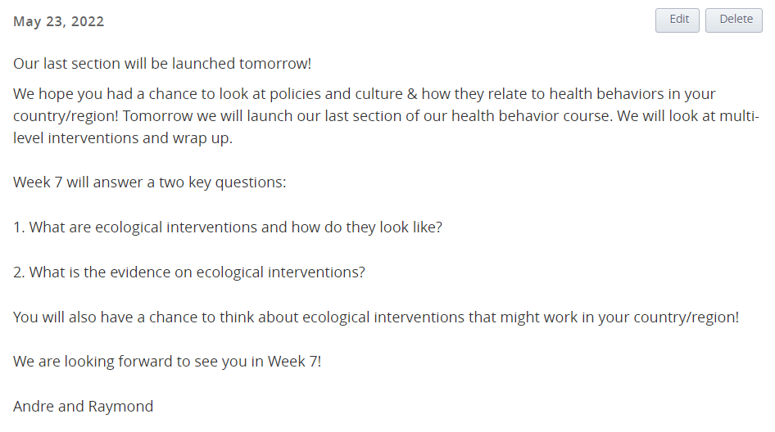
12 | A content brief was incorporated in the introductory videos of each section to highlight the section’s learning objectives and activities | 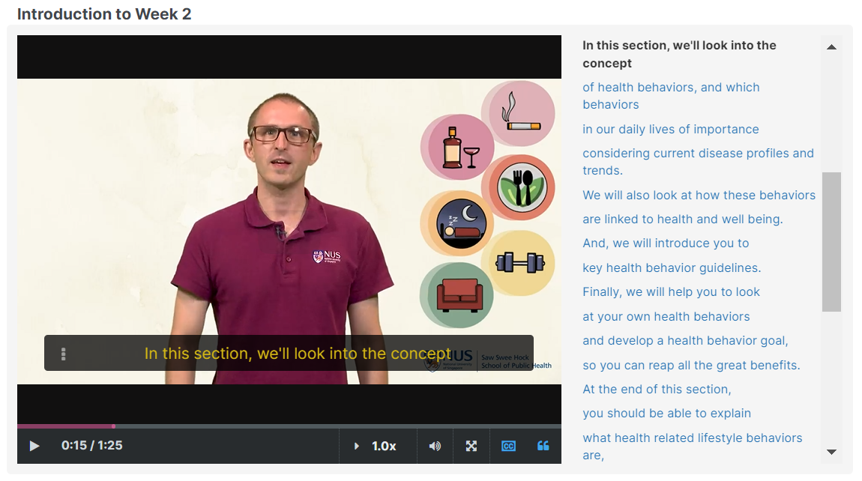
13 | Additional learning materials, such as references and web links, were signposted in various sections | 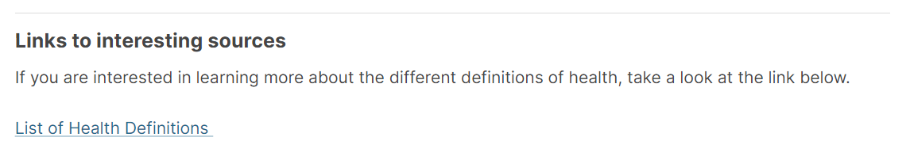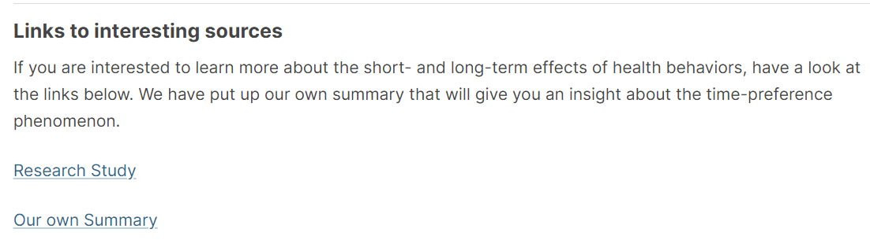
14 | Various Immersive and self-reflection activities were provided, such as behavioral analyses and intervention development, assessment of own and others health behaviors, evaluations of existing strategies and environments etc.  Movement breaks were conducted to highlight how health behaviors could be promoted. | 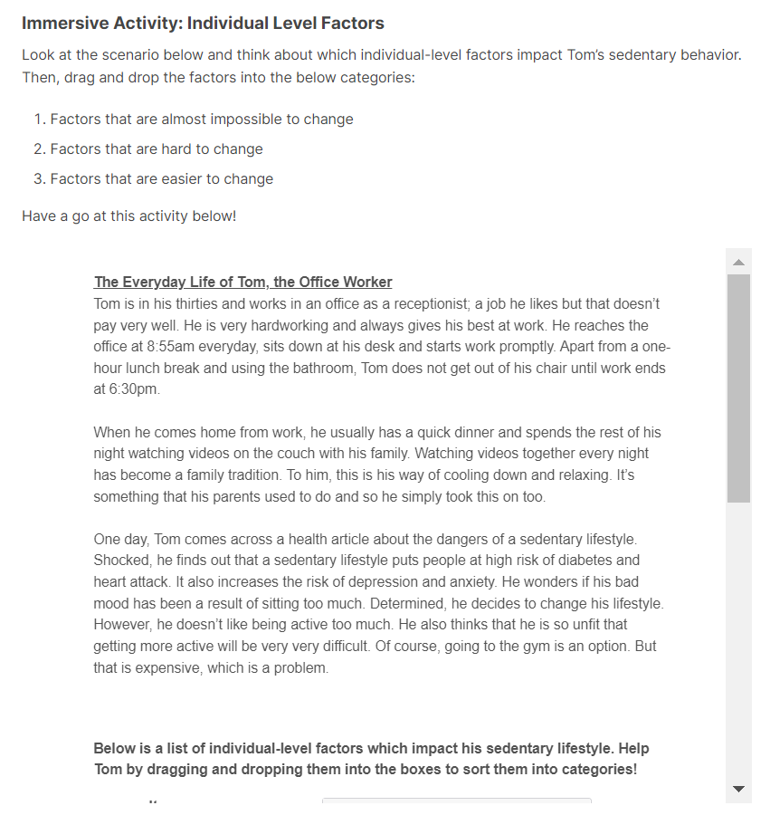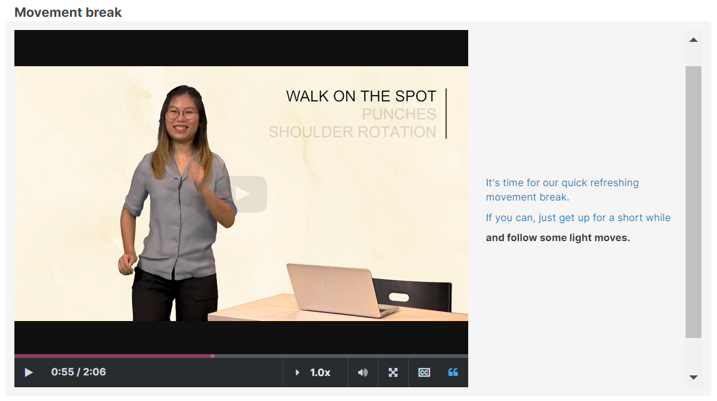  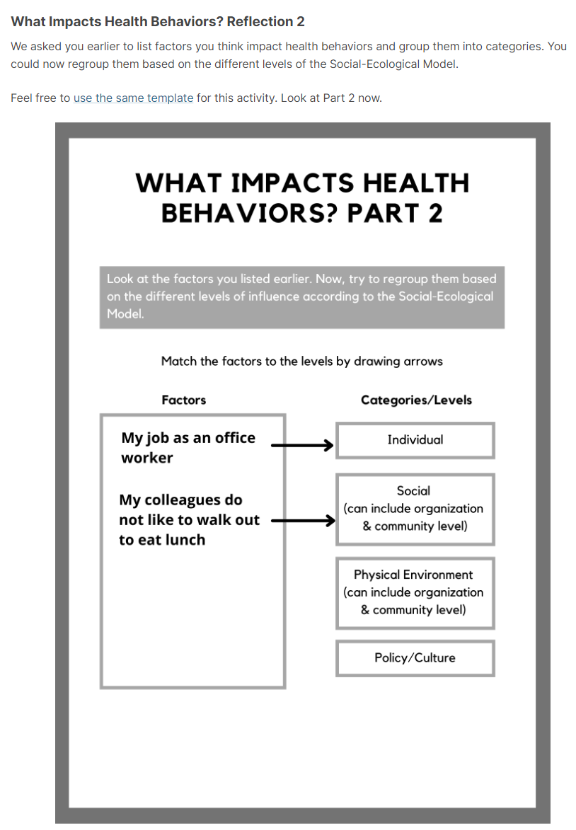
15 | Learners were encouraged to introduce themselves and reveal some personal information in discussion forums. We post guiding questions to prompt the sharing of personal information (e.g., hobbies, opinions) and personal experiences (e.g., current health behaviours) | 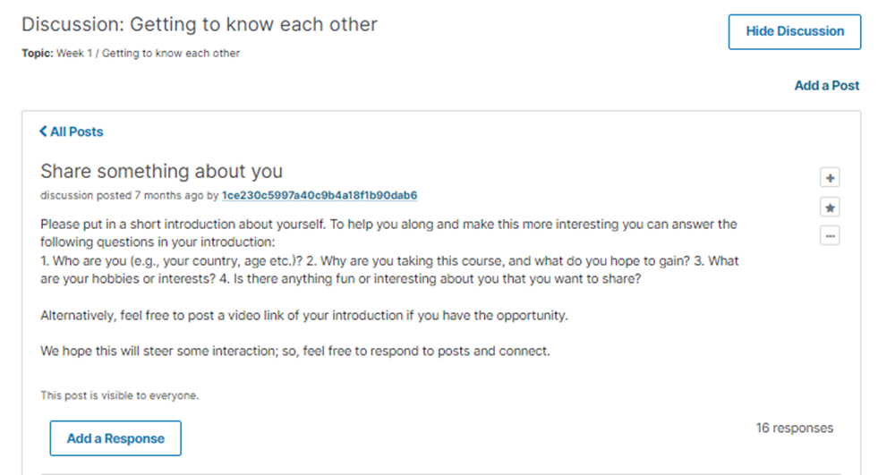
16 | Learners were encouraged to learn and engage with their peers by sharing in the discussion forums and through a peer assessment for a project | 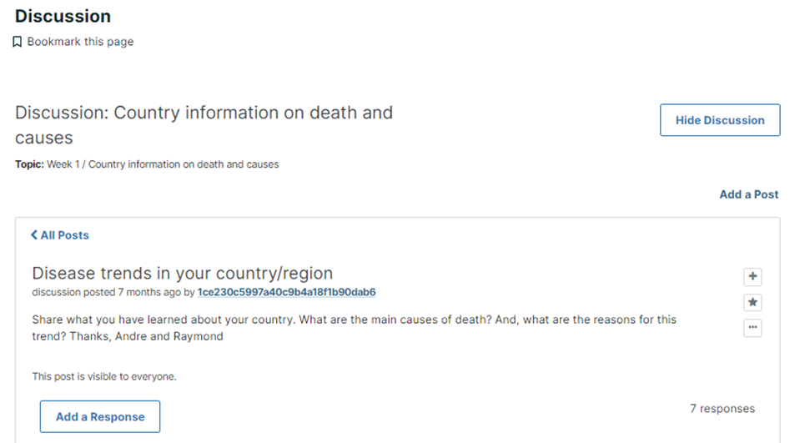
17 | Videos and texts were crafted with first- and second-person references (i.e., use of ‘I’, ‘we’, ‘you’) and conversational language (e.g., “Let’s have a look at…”) | 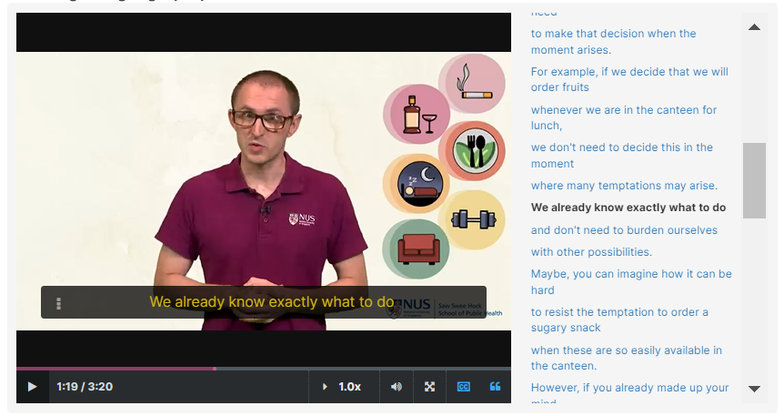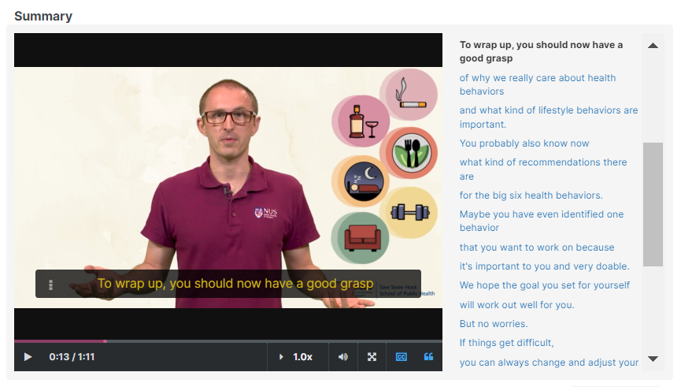
18 | Instructors introduced themselves to learners through a short personal sharing in an introductory video |   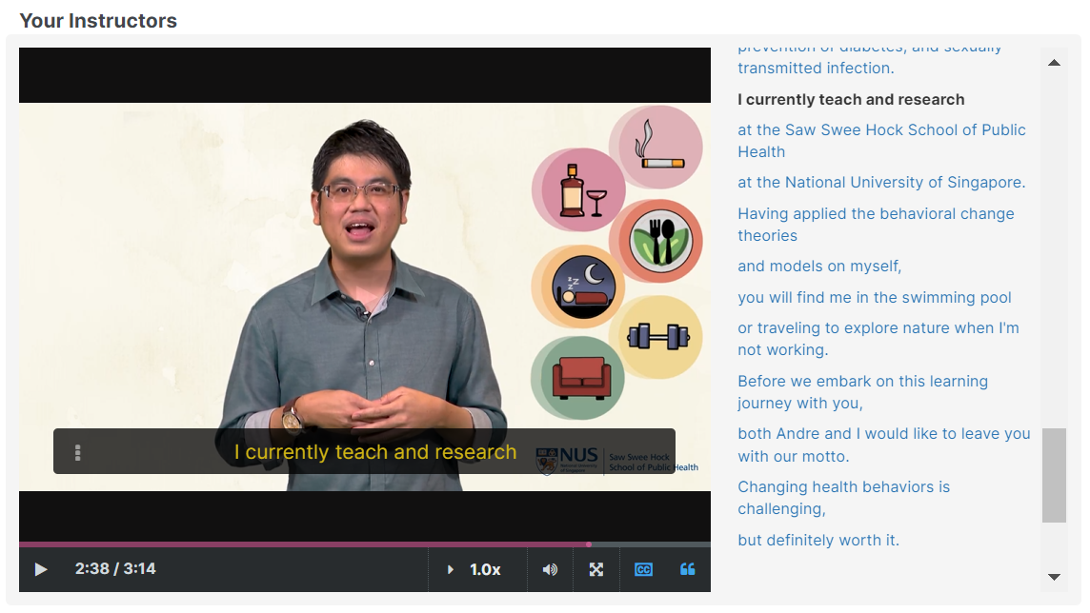
19 | Instructors replied to learners’ posts on discussion forums in a personable manner | 