Shcbp1 deficiency dampens chondrocyte viability and cartilage ECM homeostasis via disturbing coordination of Akt and Erk signal pathways
MengYao Sun, Jidong Yan, Xinyu Huo, Weikun Hou, Yitong Zhao, Litao Wu, Sijia Mi, Huang Huang, Yaqi Lyu, Yongsong Cai, Fujun Zhang, Xudong Yang, Wenhua Zhu, Liesu Meng, Jian Sun, Shemin Lu*

This Supplementary Materials file includes:
Fig. S1 to S5 (Pages 2-9)
Materials and Methods (Pages 10-14)
References (Pages 15)

Figure S1
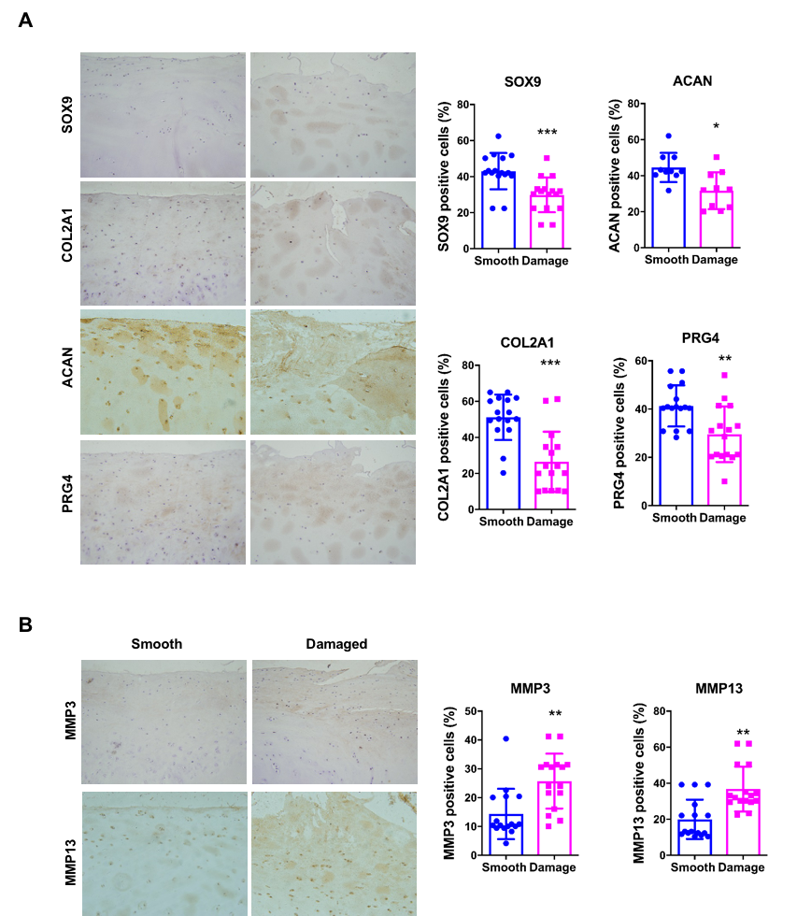

Figure S1. Shcbp1 expression is decreased in OA cartilage. (A) Immunostaining for detection of COL2A1 and COL10A1, ACAN and SOX9 in human OA smooth and OA damaged cartilage samples. (Scale bars 50 μm.) Quantification of cells for positively stained COL2A1 and COL10A1, ACAN and SOX9 (n=16/group). (B) Immunostaining for detection of MMP3 and MMP13 in human OA smooth and OA damaged cartilage samples. (Scale bars 50 μm.) Quantification of cells for positively stained MMP3 and MMP13 (n=16/group). Data are expressed as means ± SD in each bar graph. *p < 0.05, **p < 0.01, ***p < 0.001.

Figure S2
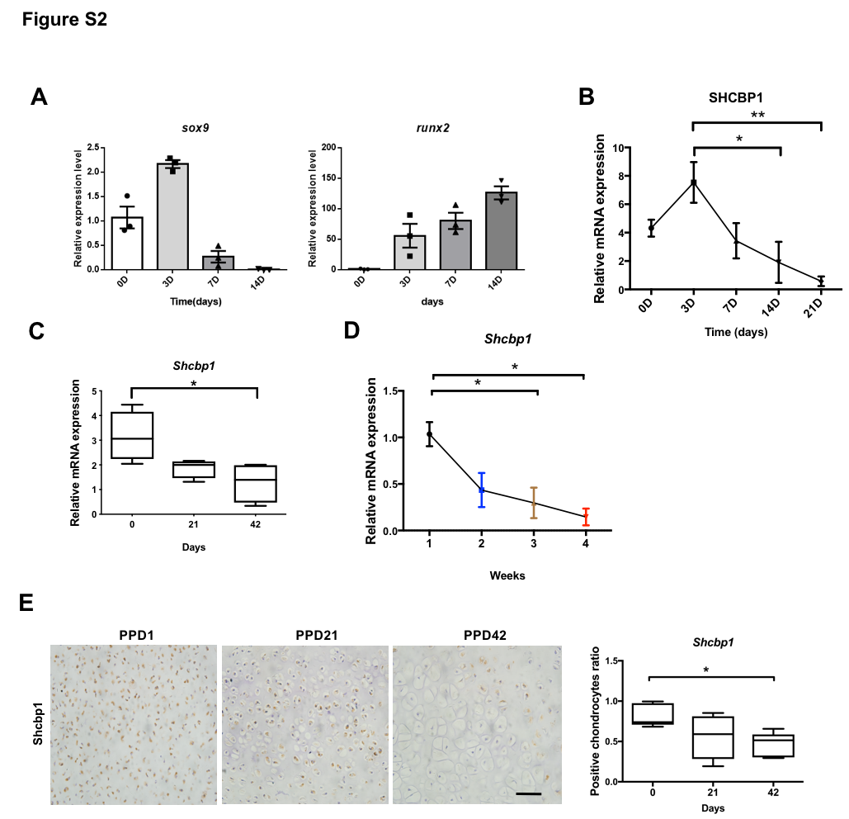

Figure S2. Shcbp1 is downregulated during chondrocyte differentiation and cartilage development. (A) The mRNA expression of Sox9 and Runx2 was observed by RT-qPCR in murine ATDC5 line stimulated with ITS. (B) The mRNA expression of Shcbp1 was observed by RT-qPCR in murine ATDC5 line stimulated with ITS. (C) The mRNA expression of Shcbp1 was observed by RT-qPCR in the knee joint cartilage of wild-type rats at postnatal day 1, 21 and 42. (D) The mRNA expression of Shcbp1 was detected by RT-qPCR in rats’ model of bone matrix gelatin induced endochondral ossification. (E) Immunohistochemistry for detection of Shcbp1 in the knee joint cartilage of wild-type mice at postnatal day 1, 21 and 42. (Scale bars 50 μm.) Ratio of Shcbp1-positive chondrocyte numbers to total number of chondrocytes.

Figure S3
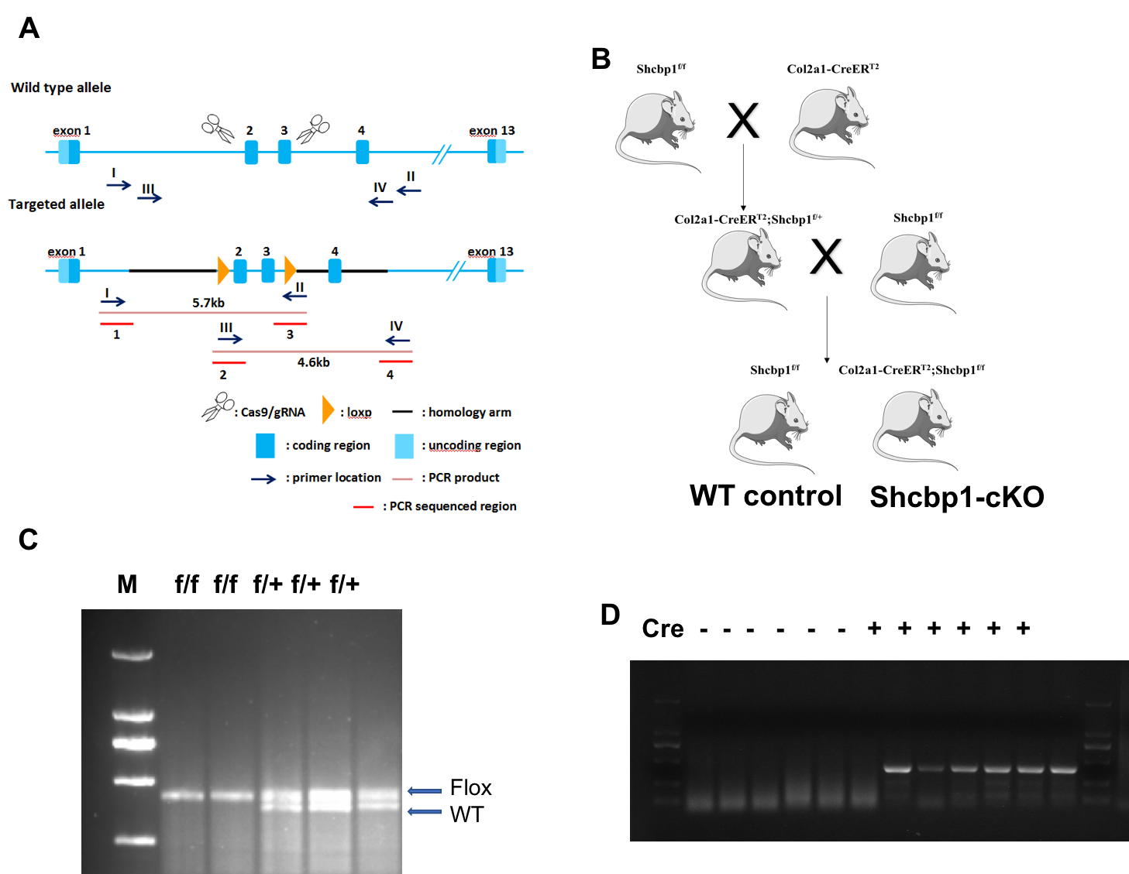

Figure S3. Genotyping of the chondrocyte specific Shcbp1 knockout mice. (A) Schematic of Shcbp1 knockout strategy. (B) Schematic of mouse breeding strategy to generate Col2a1-CreER^{T2};Shcbp1^{f/f} mice. (C) Genomic DNA PCR detection of Shcbp1^{f/f} floxed allele. (D) Col2a1-CreER^{T2} transgenic allele.

Figure S4
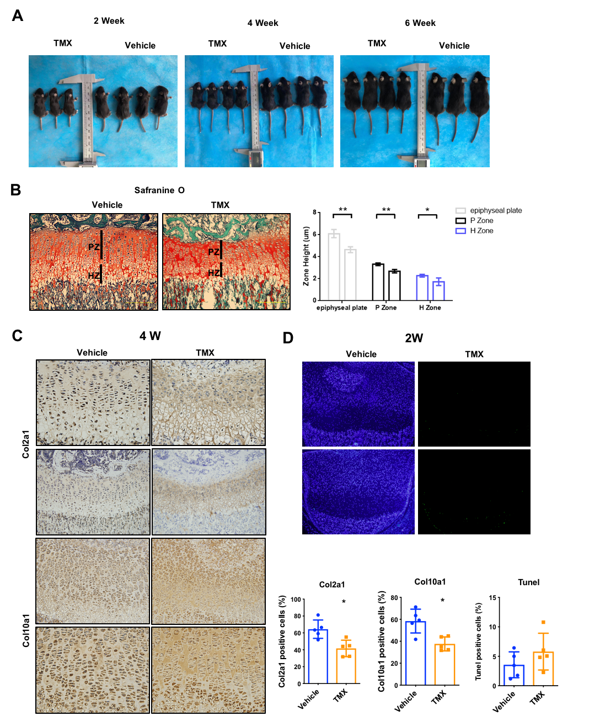
Figure S4. Postnatal deletion of Shcbp1 causes skeletal retardation and delayed ossification and differentiation. (A) Col2a1-CreER^{T2};Shcbp1^{f/f} mice were injected with tamoxifen (TMX) or corn oil as a vehicle control for 3 days. Mice were harvested at one, three and five weeks later. Images showed that two, four and six-week-old littermates from vehicle and TMX groups. (B) Safranin O–Fast Green staining of the growth plate after TMX or vehicle treatment. (Scale bars 50 μm) The mice from TMX group showed reduced cellularity in chondrocyte proliferating and hypertrophic zones of growth plate and a shortened growth plate when compared to the mice from vehicle gourps. The bar graph is a quantification of the data in the images. (C) Immunohistochemistry for detection of Col2a1 and Col10a1 in tibial cartilage of four-week-old littermates from vehicle and TMX groups. (Scale bar, 100 mm.) Quantification of cells positively stained for Col2a1 and Col10a1. (D) TUNEL assay for detection of TUNEL-positive cells in tibial cartilage of two-week-old littermates from vehicle and TMX groups. The number of TUNEL-positive cells were quantitatively analyzed, respectively (n = 4/group). Data are expressed as means ± SD in each bar graph. *p < 0.05, **p < 0.01, ***p < 0.001.

Figure S5
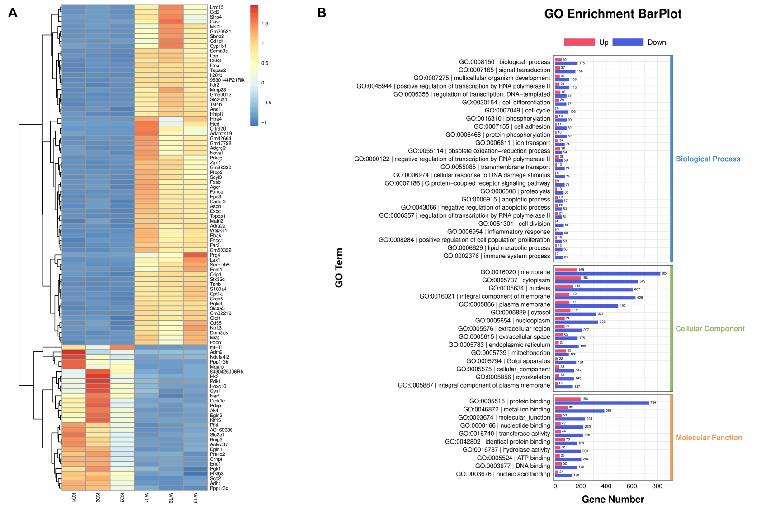
Figure S5. Shcbp1 deficiency dampens chondrocyte viability and ECM homeostasis via Erk and Akt signal pathways. (A) RNA-Seq analysis showing representative genes that were differentially expressed between Shcbp1^{f/f} (control) and Col2a1-CreER^{T2};Shcbp1^{f/f} conditional knockout (cKO) mice articular cartilage. (B) GO terms with the most significant p values for biological processes, molecular function and cellular component.

MATERIALS AND METHODS
Mice
Shcbp1^{f/f} and Col2a1-CreER^{T2} mice were fed standard rodent chow and water ad libitum in the SPF animal house of Xi’an Jiaotong University Biomedical Center. The experiment had been approved by the Institutional Animal Ethics Committee of the University (Permission ID: XJ2006Y039; Xi’an Jiao Tong University, Xi’an, China). Both Shcbp1^{f/f} and Col2a1-CreER^{T2} mice were C57BL/6J background. To generate Col2a1-CreER^{T2};Shcbp1^{f/f} mice, Shcbp1^{f/f} mice were mated with Col2a1-CreER^{T2} mice to obtain Col2a1-CreER^{T2};Shcbp1^{f/+} mice, which were then mated with Shcbp1^{f/f} mice. Genotyping was performed after extracting genomic DNA form tail snips using a DNeasy blood and tissue kit (Qiagen, Valencia, CA, catalog no. 9504). PCR were performed to detect Cre and floxed Shcbp1 alleles using corresponding primer sets with standard conditions (Cre: 94℃ for 5 minutes, 94℃ for 30 seconds, 60℃ for 30 seconds, and 72℃ for 30 seconds for 35 cycles, and 72℃ for 5 minutes; Shcbp1^{fl/fl}: 94℃ for 5 minutes, 94℃ for 30 seconds, 60℃ for 30 seconds, and 72℃ for 30 seconds for 35 cycles, and 72℃ for 5 minutes and 10℃ forever ). The sequence of PCR primers for genotyping Shcbp^{f/f} mice are as follows: a forward primer, 5’-GTTCAAATCCCAGCAACCACAT-3’, and a reverse primer, 5’-CAGCAGGTCGCACTTACACA-3’. The 376-bp PCR product was detected in WT mice, and the 415-bp PCR product was detected in homozygous mice. In Hete mice (Shcbp^{f/+}), both 376-bp and 415-bp product was detected. The Cre transgene was detected by PCR using the primers 5’-CAC TGC GGG CTC TAC TTC AT-3’(forward) and 5’ -ACC AGC AGC ACT TTT GGA AG-3’(reverse) to amplify a 358-bp DNA product.
Human cartilage information
The details of the 16 OA patients are list in the table S1 as below.
Table S1. The details information of OA patients.
Diagnosis | Gender | Age
Osteoarthritis (left knee) | Female | 76y
Osteoarthritis (left knee) | Male | 62y
Osteoarthritis (left knee) | Male | 62y
Osteoarthritis (right knee) | Female | 67y
Osteoarthritis (right knee) | Female | 68y
Osteoarthritis (left and right knee) | Female | 58y
Osteoarthritis (left and right knee) | Male | 66y
Osteoarthritis (left and right knee) | Male | 69y
Osteoarthritis (right knee) | Female | 66y
Osteoarthritis (right knee) | Female | 64y
Osteoarthritis (right knee) | Female | 76y
Osteoarthritis (left knee) | Male | 65y
Osteoarthritis (left knee) | Male | 71y
Osteoarthritis (left and right knee) | Female | 62y
Osteoarthritis (right knee) | Female | 62y

Rats and bone matrix gelatin induced endochondral ossification (BMD-ECO) model
Sprague-Dawley (SD) rats purchased from the Animal Centre of the Fourth Military Medical University, China and Dark Agouti (DA) rats originated from the Section of Medical Inflammation Research, Lund University, Sweden were bred and kept in a climate controlled environment, housed in polystyrene cages containing wood shavings, and fed standard rodent chow and water ad libitum in the SPF animal house of Department of Genetics and Molecular Biology, Xi’an Jiaotong University College of Medicine. The experiment had been approved by the Institutional Animal Ethics Committee of the University.
The bone matrix gelatin (BMG) was prepared from bone of DA rats as previously described. DA rats at age of 3 months were killed by lethal dose of aether. Diaphyseal shafts of femur and tibia were collected and dissected free of muscles. After exactly removed bone marrow, bones were cut into chips about the size of 1 cm. Liquid nitrogen was used to freeze the bone shafts in this procedure to avoid possible denaturation of proteins. After lipid of bones was removed by chloroform/methanol, the bonewas demineralized in 0.6M HCL and BMG was extracted successively with the solution of 2.0 M CaCl2, 0.5Methylenediamine tetra acetic acid (EDTA), 0.8MLiCl and water (55℃) to remove soluble proteins. Then, the bone chips were prepared by vacuum freeze-drying and stored in 20℃. Twenty DA rats received the syngeneic BMG implantation in supraspinatus and rhomboid muscles. Each rat can be planted in six pieces of BMG with the size of 1 cm. After 1, 2, 3, and 4 week of implantation, the generated cartilaginous tissues were harvested from five rats of each time point, respectively. The partial tissue was subjected to histological examination to observe the chondrogenesis and the other was used for RT-qPCR to detect the expression of Shcbp1[1].
Real-time quantitative PCR
Total RNA was isolated from cartilage or primary chondrocytes using TRIzol reagent (Invitrogen), and first-strand complementary DNA was synthesized using Superscript III reverse transcriptase (Invitrogen). Real-time PCR was performed on Agilent realtime PCR detection system (Agilent tech. USA) with SYBR Premix - FastStart Unversal SYBR Green Master (Rox), (Roche, Indianapolis, IN, USA). The relative gene expression is normalized by GAPDH. Real-time PCR oligonucleotide primers for mouse chondrocyte specific or related genes were designed using Universal Probe Library System software.
Histology and immunohistochemistry
IHC staining was performed with the standard streptavidin peroxidase complex method. Human cartilage or murine knee joints were fixed in 4% paraformaldehyde for 24h before decalcification in 10% w/v EDTA for 4 weeks prior to paraffin embedding. The paraffin blocks were sectioned at a thickness of 4μm and serial sections were stained with Safranin-O or H&E staining. For immunohistochemistry staining, cartilage tissue sections (4μm) were stained with primary Abs (SHCBP1, SOX9, ACAN, PRG4, COL2A1, COL10A1, MMP3 and MMP13) overnight at 4°C, incubated with biotin-labeled secondary antibody and developed with a horseradish peroxidase–labeled streptavidin reagent, and then stained for 3 min with 3,3′-diaminobenzidine (Histostain-plus kit; Zhongshan Golden Bridge Biotechnology, Beijing, China). Sections were lightly counterstained with hematoxylin and mounted with neutral balsam. The primary antibody was replaced with 1 × PBS as a negative control.
Cells
Mouse primary chondrocytes were harvested from the knee joints of 5-day-old Shcbp1^{f/f} and Col2a1-CreER^{T2};Shcbp1^{f/f} mice and digested the joints with 2.5% collagenase (BioFroxx). Chondrocytes were seeded in 12-well plates at a density of 5 × 10⁵ cells per well. After 5 days of culture, the cells were treated with 4-hydroxytamoxifen (1 µM) for 48 hours.
ATDC5, the murine chondrogenic precursor cell line was purchased from the European Collection of Cell Cultures (ECACC) (Salisbury, UK). ATDC5 cells were cultured and maintained in Dulbecco’s modified Eagle medium and Ham’s F-12 medium (DMEM/F-12) (HyClone, Logan, Utah, USA) supplemented with 5% fetal bovine serum (FBS) (HyClone, Logan, Utah, USA) at 37℃ in a humidified atmosphere of 5% CO2 in air. For induction of chondrogenesis, cells were plated as 10 µl/droplet in 24-well plate at concentration of 1 x 10⁷ cells/ml (micromass culture) for 1 h and then refreshed with DMEM/F12 medium containing different concentration of FBS, 10 µg /ml insulin, 5 µg/ml transferring, and 50 nM Se for 21 days as described previously [2].

References
1. Zhong, N., et al., MicroRNA-337 is associated with chondrogenesis through regulating TGFBR2 expression. Osteoarthritis Cartilage, 2012. 20(6): p. 593-602.
2. Woods, A.M., et al., Immune modulation of collagen-induced arthritis by intranasal cytokine gene delivery: a model for the therapy of rheumatoid arthritis. Arthritis Rheum, 2005. 52(12): p. 3761-71.

