Supplementary Information
Table S1 Relative levels of identified metabolites in A549 and A549/CR cells using GC-MS.
No | Compound | m/z | RT (min) | Fragmentation ion (m/z) | TMS | A549 | A549/CR
 | Alcohols
1 | Glycerol | 205 | 11.45 | 103, 117, 205, 218 | 3 | 3.40 ± 0.44 | 3.69 ± 0.50
2 | myo-inositol | 305 | 29.15 | 191, 217, 305, 318 | 6 | 6.93 ± 0.65 | 6.64 ± 1.96
 | Amino acids
3 | β-alanine | 102 | 9.34 | 102, 117, 176, 218 | 2 | 0.90 ± 0.14 | 1.19 ± 0.20*
 |  | 174 | 15.33 | 100, 174, 248, 290 | 3
4 | α-Alanine | 116 | 7.16 | 100, 116, 190, 218 | 2 | 5.51 ± 0.44 | 11.06 ± 1.77*
5 | Aspartic acid | 232 | 17.62 | 100, 202, 218, 232 | 3 | 5.78 ± 0.78 | 10.51 ± 1.87*
6 | Cysteine | 220 | 18.41 | 100, 115, 218, 220 | 3 | 0.42 ± 0.17 | 0.34 ± 0.23*
7 | Glutamic acid | 246 | 19.98 | 128, 156, 246, 348 | 3 | 34.45 ± 1.92 | 70.23 ± 6.36*
8 | Glycine | 102 | 7.63 | 86, 102, 176, 204 | 2 | 24.63 ± 1.81 | 47.24 ± 4.47*
 |  | 174 | 12.22 | 86, 174, 248, 276 | 3
9 | Isoleucine | 158 | 11.91 | 100, 158, 218, 232 | 2 | 2.32 ± 0.15 | 4.53 ± 0.42*
10 | Lysine | 174 | 26.27 | 128, 174, 230, 317 | 4 | 0.12 ± 0.02 | 0.18 ± 0.06*
11 | Ornithine | 142 | 24.20 | 142, 174, 200, 420 | 4 | 1.18 ± 0.26 | 4.85 ± 0.78*
12 | Proline | 142 | 12.00 | 100, 142, 216, 259 | 2 | 34.82 ± 5.41 | 50.54 ± 4.50*
13 | Pyroglutamic acid | 156 | 17.55 | 84, 156, 230, 258 | 2 | 0.80 ± 0.12 | 2.20 ± 0.47*
14 | Serine | 204 | 13.65 | 100, 188, 204, 218 | 3 | 1.06 ± 0.09 | 1.27 ± 0.40
15 | Threonine | 218 | 14.28 | 101, 117, 218, 291 | 3 | 0.25 ± 0.03 | 0.30 ± 0.11
16 | Tyrosine | 179 | 25.55 | 179, 208, 219, 310 | 2 | 0.37 ± 0.04 | 0.68 ± 0.10*
17 | Valine | 144 | 9.92 | 100, 144, 218, 246 | 2 | 3.98 ± 0.30 | 8.46 ± 0.89*
 | Organic acids
18 | Aminomalonic acid | 218 | 16.36 | 133, 174, 218, 320 | 3 | 1.04 ± 0.49 | 3.84 ± 0.50*
19 | Lactic acid | 117 | 6.18 | 117, 133, 191, 219 | 2 | 18.06 ± 1.85 | 36.75 ± 5.05*
20 | Malic acid | 233 | 16.86 | 101, 133, 233, 245 | 3 | 0.91 ± 0.05 | 0.31 ± 0.06*
21 | Succinic acid | 247 | 12.49 | 116, 129, 172, 247 | 2 | 0.03 ± 0.01 | 0.14 ± 0.02*
 | Purines
22 | Adenine | 264 | 25.14 | 84, 192, 264, 279 | 2 | 0.17 ± 0.05 | 0.61 ± 0.11*
23 | Guanine | 352 | 29.75 | 238, 264, 352, 367 | 3 | 0.96 ± 0.11 | 1.17 ± 0.26*
24 | Hypoxanthine | 265 | 23.92 | 193, 206, 265, 280 | 2 | 4.14 ± 0.36 | 9.17 ± 1.49*
 | Pyrimidines
25 | Uracil | 241 | 13.04 | 99, 113, 241, 255 | 2 | 2.46 ± 0.31 | 3.51 ± 0.76*
26 | Uridine | 217 | 34.49 | 103, 169, 217, 259 | 3 | 0.32 ± 0.04 | 0.14 ± 0.02*
 | Sugars
27 | Glucose | 204 | 27.35 | 103, 191, 204, 217 | 5 | 0.30 ± 0.03 | 0.03 ± 0.01*
28 | Glucose-6-phosphate | 387 | 33.22 | 204, 299, 357, 387 | 6 | 1.23 ± 0.12 | 0.73 ± 0.13*
29 | Glyceric acid | 189 | 12.88 | 103, 133, 189, 292 | 3 | 0.10 ± 0.02 | 0.08 ± 0.01
 |  |  | 33.51
 |  |  | 33.68
30 | Glycerol-3-phosphate | 299 | 23.07 | 299, 315, 357, 445 | 4 | 0.20 ± 0.08 | 0.23 ± 0.03*
31 | Ribose | 217 | 20.65 | 133, 191, 204, 217 | 4 | 0.61 ± 0.06 | 0.48 ± 0.17*
 |  |  | 20.97
 | Others
32 | Creatinine | 115 | 18.30 | 100, 115, 314, 329 | 3 | 0.70 ± 0.09 | 0.53 ± 0.09*
33 | Putrescine | 174 | 22.46 | 86, 174, 200, 214 | 4 | 0.16 ± 0.05 | 0.55 ± 0.08*

Each level is normalized by IS and total protein content to indicate the mean ± standard deviation (SD) (n = 15, five biological and three experimental replicates). For simplicity, ‘×10e4’ was omitted from the levels of the identified metabolites. A significant difference in the level of metabolites between A549 and A549/CR is indicated using the asterisk (*) by the Mann-Whitney test (p < 0.05). RT: retention time; TMS: trimethylsilylation; MEOX: methoxylamine hydrochloride; ND: not detected.
Table S2 Relative levels of the identified intact lipid species in A549 and A549/CR cells using nanoESI-MS.
No. | Lipid species | Ion species | m/z |  | A549 |  | A549/CR
 | Positive ion mode
 | Phosphatidylcholine (PC)
1 | PC 16:0/16:1 | [M + H]⁺ | 732 |  |  | 14.71 ± 1.41 | 12.04 ± 1.35*
2 | PC 16:0/16:0 | [M + H]⁺ | 734 |  |  | 5.41 ± 0.49 | 6.64 ± 0.68*
3 | PC 16:1/18:1 | [M + H]⁺ | 758 |  |  | 10.93 ± 1.10 | 9.67 ± 0.68*
4 | PC 16:0/18:1 | [M + H]⁺ | 760 |  |  | 25.19 ± 2.38 | 33.70 ± 3.13*
5 | PC 18:2/18:2 | [M + H]⁺ | 780 |  |  | 1.54 ± 0.20 | 1.95 ± 0.37*
6 | PC 16:0/20:4 | [M + H]⁺ | 782 |  |  | 7.03 ± 0.88 | 10.53 ± 1.44*
7 | PC 18:3/18:4 | [M + Na]⁺ | 798 |  |  | 1.72 ± 0.26 | 2.08 ± 0.49
8 | PC 16:0/22:6 | [M + H]⁺ | 806 |  |  | 1.88 ± 0.37 | 2.50 ± 0.42*
9 | PC 18:1/20:4 | [M + H]⁺ | 808 |  |  | 4.78 ± 0.77 | 6.68 ± 1.11*
10 | PC 18:0/20:4 | [M + H]⁺ | 810 |  |  | 3.83 ± 0.52 | 5.23 ± 0.49*
11 | PC 18:0/20:3 | [M + H]⁺ | 812 |  |  | 1.47 ± 0.29 | 1.44 ± 0.22
12 | PC 18:1/22:5 | [M + H]⁺ | 834 |  |  | 1.23 ± 0.10 | 1.43 ± 0.19*
13 | PC 18:0/22:5 | [M + H]⁺ | 836 |  |  | 0.90 ± 0.15 | 1.41 ± 0.23*
14 | PC 18:3/22:1 | [M + H]⁺ | 838 |  |  | 0.43 ± 0.08 | 0.72 ± 0.19*
 | Lyso-PC
15 | Lyso-PC 18:1 | [M + H]⁺ | 522 |  |  | 2.84 ± 0.63 | 3.02 ± 0.49
 | Phosphatidylethanolamine (PE)
16 | PE 18:0/18:2 | [M + H]⁺ | 744 |  |  | 3.11 ± 0.21 | 3.97 ± 0.32*
17 | PE 16:1/20:3 | [M + Na]⁺ | 762 |  |  | 5.70 ± 0.69 | 7.41 ± 0.49*
 | Plasmenyl-PE
18 | Plasmenyl-PE 18:0/16:0 | [M + H]⁺ | 704 |  |  | 2.86 ± 0.27 | 3.38 ± 0.29*
19 | Plasmenyl-PE 16:0/22:6 | [M + H]⁺ | 748 |  |  | 1.25 ± 0.12 | 1.39 ± 0.13*
20 | Plasmenyl-PE 16:0/22:5 | [M + Na]⁺ | 772 |  |  | 1.20 ± 0.13 | 1.78 ± 0.13*
 | Negative ion mode
 | Ceramide (Cer)
21 | Cer d18:1/16:0 | [M − H]⁻ | 536 |  |  | 4.21 ± 0.67 | 5.71 ± 0.92*
22 | Cer d18:1/18:0 | [M − H]⁻ | 564 |  |  | 5.92 ± 0.88 | 7.66 ± 1.12*
 | Phosphatidylethnolamine (PE)
23 | PE 16:0/18:1 | [M − H]⁻ | 716 |  |  | 1.94 ± 0.15 | 2.14 ± 0.14*
24 | PE 16:0/20:4 | [M − H]⁻ | 738 |  |  | 0.83 ± 0.08 | 0.90 ± 0.06*
25 | PE 18:1/18:1 | [M − H]⁻ | 742 |  |  | 2.51 ± 0.24 | 2.80 ± 0.17*
26 | PE 18:0/18:1 | [M − H]⁻ | 744 |  |  | 1.91 ± 0.16 | 2.84 ± 0.16*
27 | PE 18:1/20:4 | [M − H]⁻ | 764 |  |  | 2.18 ± 0.25 | 2.91 ± 0.22*
28 | PE 18:0/20:4 | [M − H]⁻ | 766 |  |  | 3.71 ± 0.37 | 4.58 ± 0.31*
29 | PE 18:0/20:3 | [M − H]⁻ | 768 |  |  | 0.72 ± 0.07 | 0.62 ± 0.05*
 | Plasmenyl-PE
30 | Plasmenyl-PE 16:0/20:4 | [M − H]⁻ | 722 |  |  | 1.50 ± 0.13 | 8.77 ± 0.81*
31 | Plasmenyl-PE 18:0/20:4 | [M − H]⁻ | 750 |  |  | 2.09 ± 0.16 | 5.18 ± 0.37*
 | Phosphatidylglycerol (PG)
32 | PG 16:0/16:0 | [M − H]⁻ | 721 |  |  | 3.48 ± 0.30 | 9.29 ± 1.21*
33 | PG 16:1/18:1 | [M − H]⁻ | 745 |  |  | 1.58 ± 0.10 | 1.65 ± 0.12
34 | PG 16:0/18:1 | [M − H]⁻ | 747 |  |  | 5.97 ± 0.64 | 7.03 ± 0.76*
35 | PG 16:0/18:0 | [M − H]⁻ | 749 |  |  | 1.75 ± 0.14 | 4.92 ± 0.47*
 | Phosphatidylserine (PS)
36 | PS 16:0/16:1 | [M − H]⁻ | 732 |  |  | 1.02 ± 0.13 | 0.87 ± 0.09*
37 | PS 16:1/18:1 | [M − H]⁻ | 758 |  |  | 2.46 ± 0.30 | 2.32 ± 0.28
38 | PS 16:1/18:0 | [M − H]⁻ | 760 |  |  | 7.90 ± 1.05 | 9.51 ± 0.72*
39 | PS 18:1/18:2 | [M − H]⁻ | 784 |  |  | 1.18 ± 0.18 | 1.49 ± 0.17*
40 | PS 18:1/18:1 | [M − H]⁻ | 786 |  |  | 6.02 ± 0.70 | 7.75 ± 0.76*
41 | PS 18:0/18:1 | [M − H]⁻ | 788 |  |  | 9.04 ± 1.30 | 13.11 ± 0.65*
42 | PS 18:1/20:4 | [M − H]⁻ | 808 |  |  | 0.91 ± 0.15 | 2.50 ± 0.34*
43 | PS 18:0/20:4 | [M − H]⁻ | 810 |  |  | 1.54 ± 0.26 | 2.66 ± 0.17*
44 | PS 18:1/22:1 | [M − H]⁻ | 842 |  |  | 1.04 ± 0.13 | 1.10 ± 0.07
 | Phosphatidylinositol (PI)
45 | PI 16:1/18:1 | [M − H]⁻ | 833 |  |  | 2.09 ± 0.19 | 1.50 ± 0.15*
46 | PI 16:0/18:1 | [M − H]⁻ | 835 |  |  | 1.85 ± 0.15 | 1.58 ± 0.11*
47 | PI 16:0/20:4 | [M − H]⁻ | 857 |  |  | 1.12 ± 0.11 | 1.57 ± 0.10*
48 | PI 18:1/18:1 | [M − H]⁻ | 861 |  |  | 4.30 ± 0.52 | 2.81 ± 0.22*
49 | PI 18:0/18:1 | [M − H]⁻ | 863 |  |  | 2.54 ± 0.22 | 2.35 ± 0.20*
50 | PI 18:1/20:4 | [M − H]⁻ | 883 |  |  | 3.55 ± 0.45 | 3.73 ± 0.33
51 | PI 18:0/20:4 | [M − H]⁻ | 885 |  |  | 11.26 ± 1.24 | 20.25 ± 1.44*
52 | PI 18:0/20:3 | [M − H]⁻ | 887 |  |  | 5.38 ± 0.66 | 6.55 ± 0.56*
53 | PI 18:0/20:2 | [M − H]⁻ | 889 |  |  | 1.83 ± 0.22 | 1.13 ± 0.12*
54 | PI 18:0/22:5 | [M − H]⁻ | 911 |  |  | 1.54 ± 0.16 | 2.13 ± 0.24*

Each value is normalized by IS and total protein content to represent the mean ± SD. For simplicity, ‘×10e4’ were omitted from the values of identified intact lipid species. A significant difference in the level of intact lipid species between A549 and A549/CR is indicated using the asterisk (*) by the Mann-Whitney test (p < 0.05).

Table S3 List of lipid pathway analysis related to A549 and A549/CR cells using LIPEA.
No. | Pathway name | Pathway lipids  (number) | Converted lipids  (number) | Converted lipids  (%) | p-value
1 | Glycerophospholipid metabolism | 26 | 4 | 40 | 0.020
2 | Glycosylphosphatidylinositol (GPI)-anchor biosynthesis | 3 | 2 | 20 | 0.024
3 | Autophagy - other | 3 | 2 | 20 | 0.024
4 | Autophagy - animal | 4 | 2 | 20 | 0.048
5 | Leishmaniasis | 4 | 2 | 20 | 0.048

The p-values were evaluated by Fisher’s exact test with Bonferroni correction. The percentage of converted lipids represents the percentage of total lipids related to each pathway.

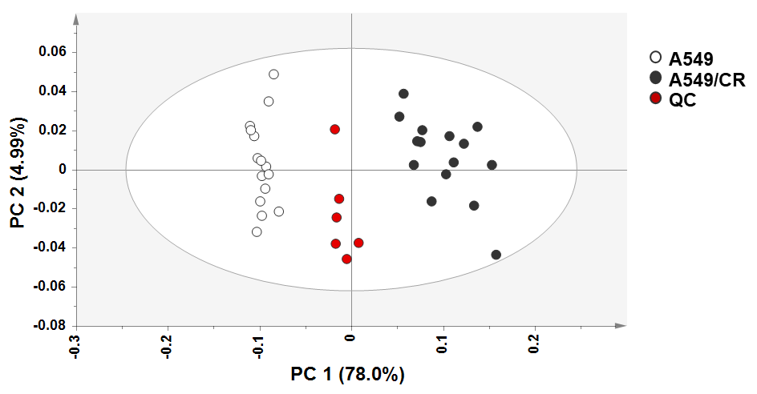
Figure S1. PCA-derived score plot of A549 and A549/CR cells with quality control (QC) samples. QCs were prepared by pooling equal volumes of each sample.

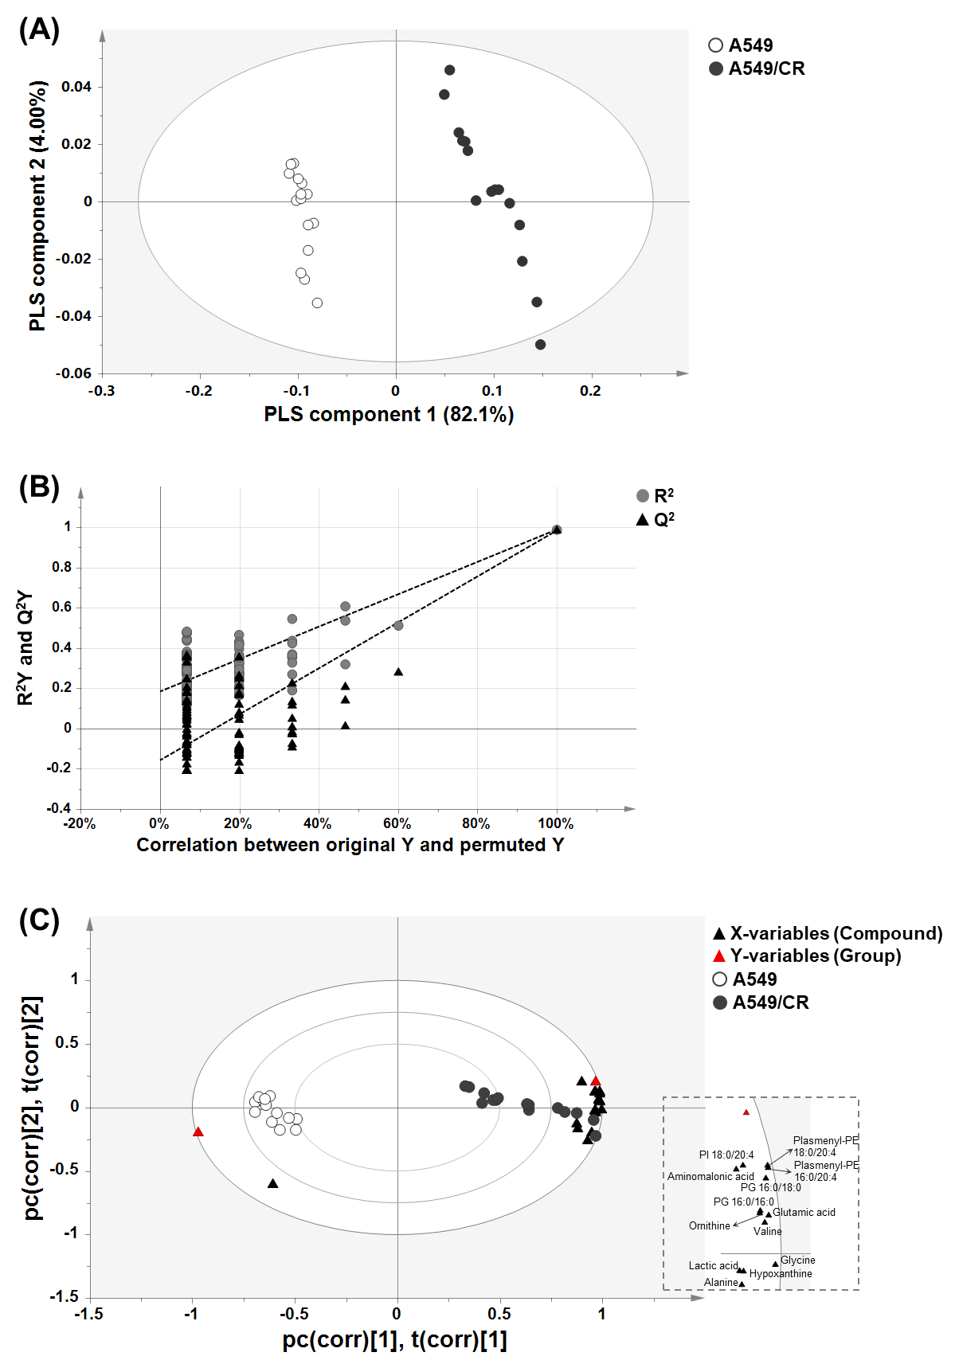
Figure S2. PLS-DA-derived score plot (A), diagram of permutation test (B), and PLS-DA biplot (C) of A549 and A549/CR cells. PLS-DA-biplot demonstrate the correlation of compounds identified in A549 and A549/CR cells (X-variables) and the group information (Y-variables).

