Supplementary Information

Tailoring Growth of MOF199 on Hierarchical Surface of Bamboo and Its Antibacterial Property
Minglei Su ª, Rong Zhang ª*, Jingpeng Li ^{b}, Xiaobei Jin ª, Xiaofeng Zhang ª, Daochun Qin ª*
ª Key Laboratory of National Forestry and Grassland Administration/Beijing for Bamboo & Rattan Science and Technology, International Center for Bamboo and Rattan, Beijing, 100102, China
^{b} Key Laboratory of High Efficient Processing of Bamboo of Zhejiang Province, China National Bamboo Research Center, Hangzhou, 310012, PR China

* Corresponding author: E-mail address: zhangrong@icbr.ac.cn (Rong Zhang); qindc@icbr.ac.cn (Daochun Qin)

1. Experimental section
1. 1. Preparation of MOF199
2.44 g of copper nitrate trihydrate and 1.16 g of BTC were dissolved in DMSO (10 g) at 20 ℃, then 4 ml MOF199 precursor solution was added in 200 ml methanol, and stirred for 2 h. After that the solution was collected and centrifuged to obtain MOF199 crystals. Finally, the obtained MOF199 were dried in vacuum at room temperature for 24 h.
1.2. Preparation of MOF199 coated bamboo by deposition method
The MOF199 coated bamboo was prepared by deposition method according to our previous report (Su et al., 2019). The MOF199 precursor solution was prepared by dissolving copper (II) nitrate trihydrate (2.44g) and 1,3,5-benzenetricarboxylic acid (1.16g) in DMSO (10g) kept at 20℃. Place the bamboo in a conical flask and add 200ml methanol, then dripped 4ml MOF199 precursor solution and stirring 5min. The reaction solution was placed in a vacuum drying dish for 8min, then samples were taken out and left in the air for 8min. Repeat these two steps 8 times and then leave the samples in the solution overnight. Finally, washed with acetone and ethanol, dried in vacuum for 24h.
1.3. Bonding strength test
The bonding strength between MOF199 and bamboo substrates were examined by ultrasonic treatment. The as-prepared MOF199/DCB sample in this article and MOF199 coated bamboo by deposition method were selected for adhesion experiments. The two kinds of bamboo were placed in water and treated with ultrasound for 20 min, ultrasonic frequency 80 KHz, followed by SEM-EDS to observe the remaining MOF199 on the surface.

2. Results
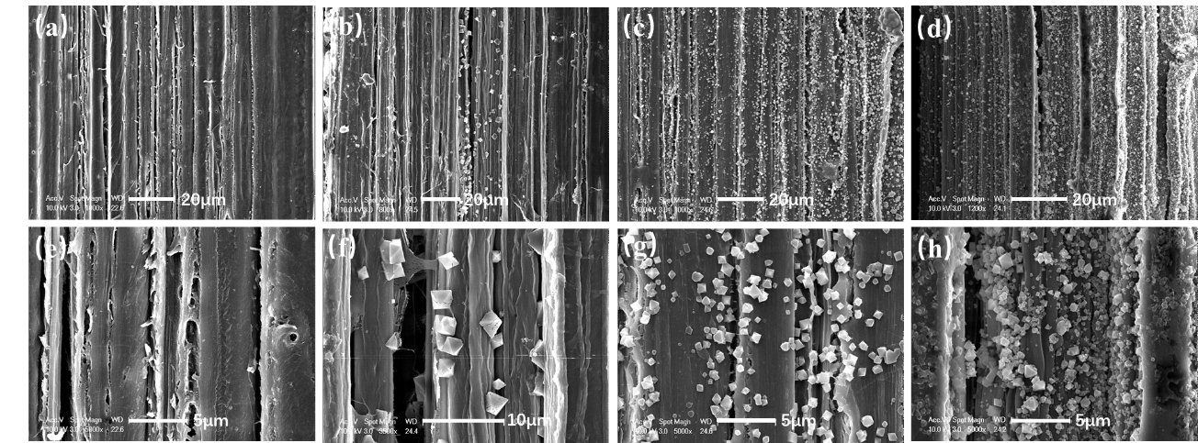
Fig. S1 SEM images of bamboo fiber in MOF199/B (a, e), MOF199/DB (b, f), MOF199/CB (c, g) and MOF199/DCB (d, h).

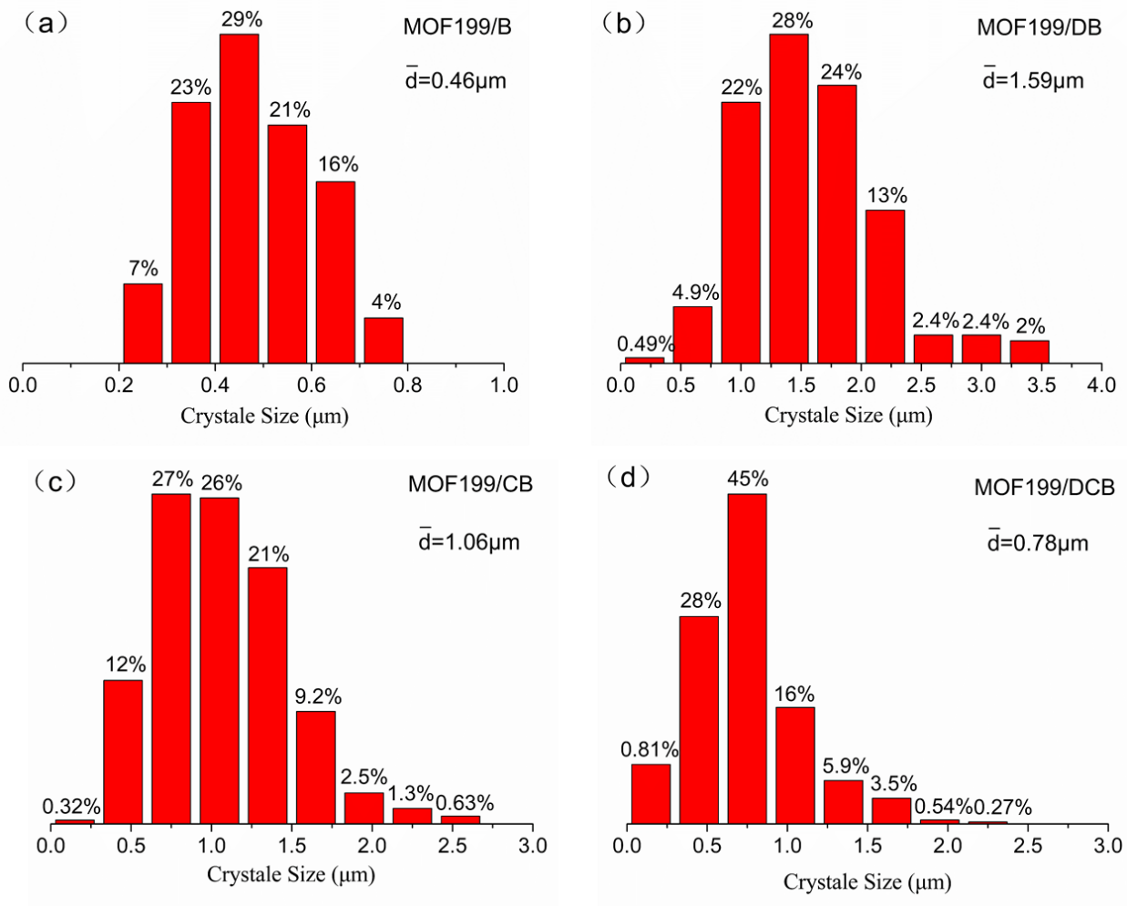
Fig. S2 Size distributions of MOF199 crystal on MOF199/B (a), MOF199/DB (b), MOF199/CB (c) and MOF199/DCB (d) surface.

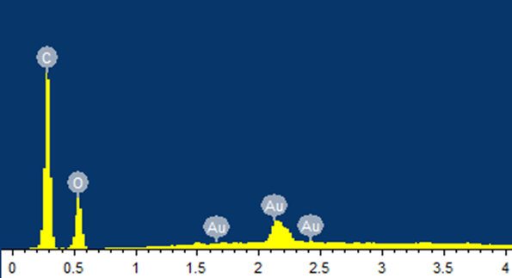
Fig. S3 EDS images of the natural bamboo.

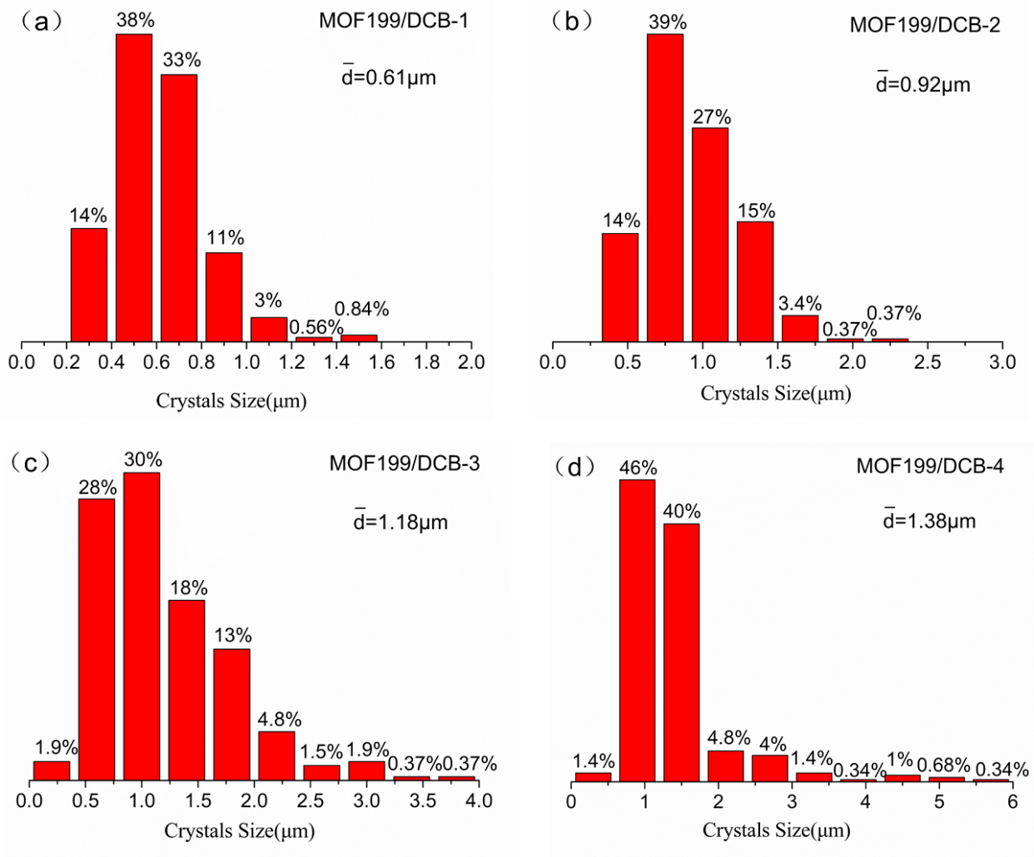
Fig. S4 Size distributions of MOF199 crystal on MOF199/DCB-1 (a), MOF199/DCB-2 (b), MOF199/DCB-3 (c) and MOF199/DCB-4 (d) surface.

Fig. S5 XRD images of simulated MOF199, natural bamboo, rMOF199/DCB, MOF199/DCB-1, MOF199/DCB-2, MOF199/DCB-3, MOF199/DCB-4.
Fig. S6 FTIR images of MOF199, DCB, rMOF199/DCB, MOF199/DCB-1, MOF199/DCB-2, MOF199/DCB-3, MOF199/DCB-4.

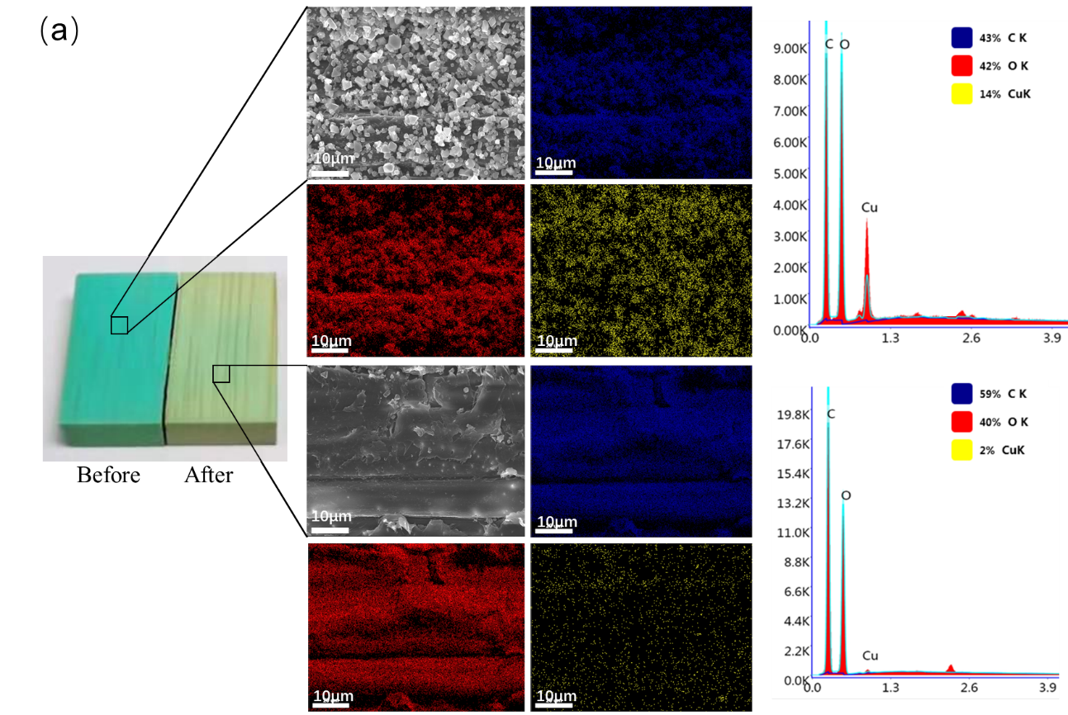
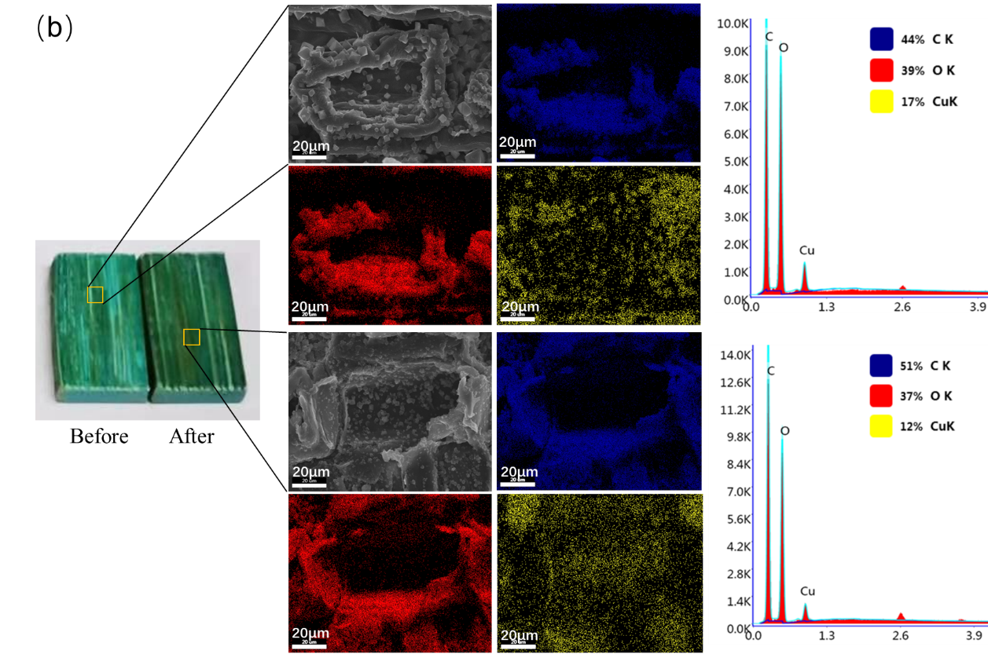
Fig. S7 SEM-EDS images of (a) MOF199/Bamboo prepared by deposition method and (b) MOF199/DCB sample before and after the ultrasonic test.

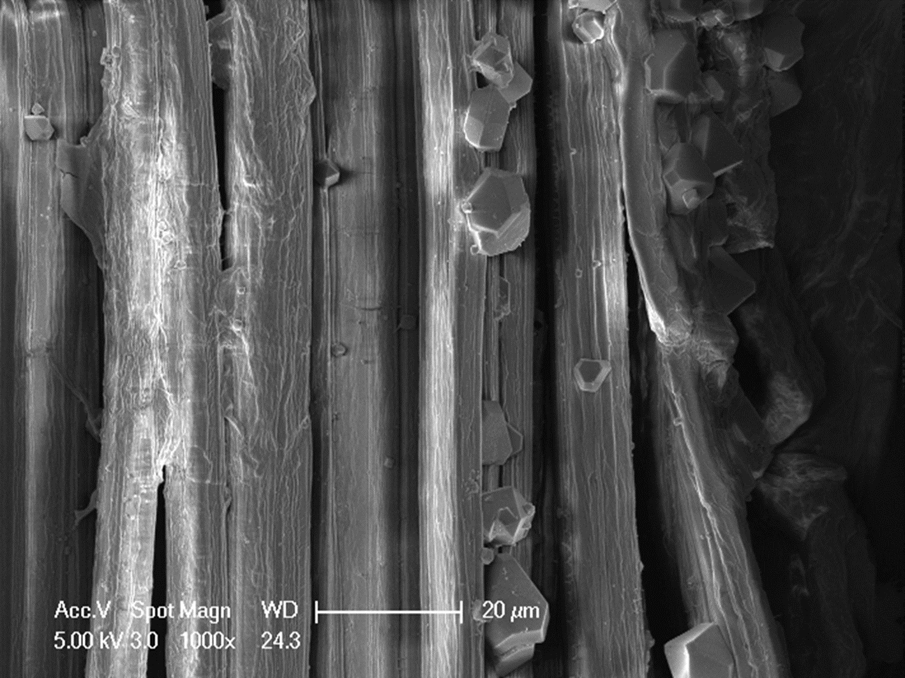
Fig. S8 SEM images of fiber in rMOF199/DCB. The MOF199 obtained from exchanged order of immersion show a truncated octahedral morphology.

Table S1. EDS analyses of MOF199/DCB-1, MOF199/DCB-2, MOF199/DCB-3 and MOF199/DCB-4.
Samples | C | O | Cu
MOF199/DCB-1 | 53.8 | 43.5 | 2.7
MOF199/DCB-2 | 53.8 | 43.0 | 3.1
MOF199/DCB-3 | 55.2 | 38.9 | 5.5
MOF199/DCB-4 | 57.6 | 35.9 | 6.5

References
Su M, Zhang R, Li H, Jin X, Li J, Yue X, Qin D (2019) In situ deposition of MOF199 onto hierarchical structures of bamboo and wood and their antibacterial properties. RSC Adv 9:40277-40285. https://doi.org/10.1039/c9ra07046j

