Supplementary A: Sample calculations for the G2SFCA score
Consider, for example, a census tract $c$ that consists of three block groups BG1, BG2, and BG3 and three vaccine providers F1, F2, and F3 provided in Figure A.1. Using the mobility data, suppose that we calculate the threshold distance in season $s$ for rural providers $d_{s}^{r}$ = 15 miles and the threshold distance for urban providers $d_{s}^{u}$ = 13 miles. Observe that provider F1 is in the catchment zone of block group 1, provider F2 is in the catchment zones of block groups 1 and 2, and provider F3 is outside of the catchment zones of all block groups.

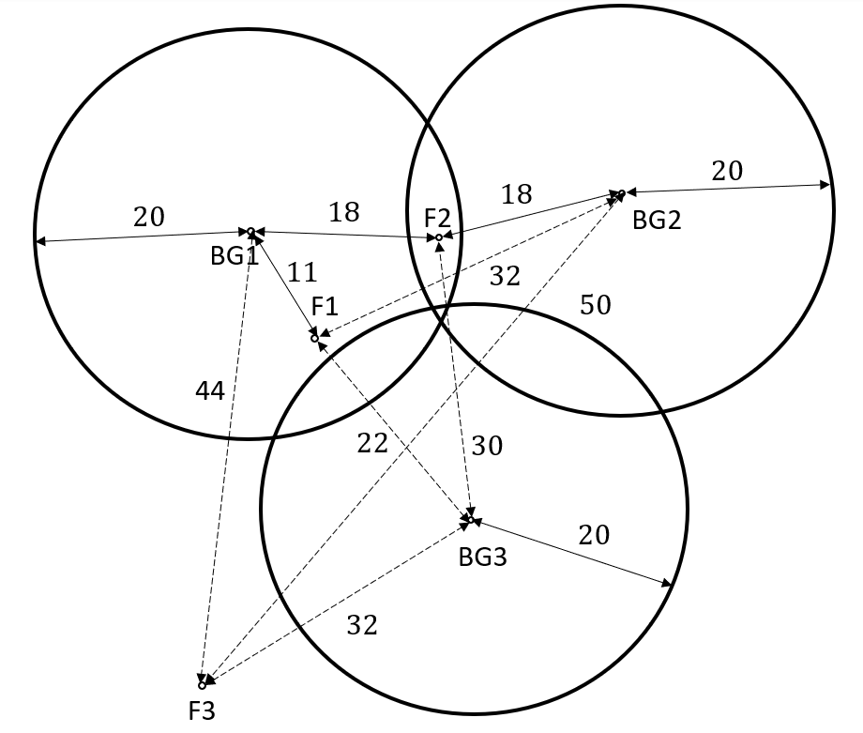
Figure A.1: G2SFCA accessibility calculations example. The points labeled BG1, BG2, and BG3 represent the centroid location for block groups 1, 2, and 3, respectively. The points labeled F1, F2, and F3 represent the location of vaccination providers 1, 2, and 3, respectively. The threshold travel time of block groups is 20 minutes. Travel time between centroid locations of block groups and providers within the corresponding catchment zones are marked with solid arrows. Travel time between centroid locations of block groups and providers outside of catchment zones are marked with dashed arrows.

Let’s now assume that the populations for BG1, BG2 and BG3 are 400, 500, and 1,000, respectively. The first step is to calculate the weighted supply-to-demand ratio $R_{f}$ for each vaccination provider F1, F2, and F3:

$$R_{F1}=\frac{C_{F1}}{P_{BG1}G\left(11,20\right)}=\frac{32}{\left(400\right)\left(0.64325\right)}=0.12437$$

$$R_{F2}=\frac{C_{F2}}{P_{BG1}G\left(18,20\right)+P_{BG2}G\left(18,20\right)}=\frac{32}{\left(400\right)\left(0.15362\right)+\left(500\right)\left(0.15362\right)}=0.23145$$

Where
$G\left(11,20\right)=\frac{e^{-\frac{1}{2}×{\left({11}/{20}\right)}^{2}}-e^{-\frac{1}{2}}}{1-e^{-\frac{1}{2}}} =0.64325$; $G\left(18,20\right)=\frac{e^{-\frac{1}{2}×{\left({18}/{20}\right)}^{2}}-e^{-\frac{1}{2}}}{1-e^{-\frac{1}{2}}} =0.15362$
and

$$G\left(22,20\right)=G\left(30,20\right)=G\left(32,20\right)=G\left(44,20\right)=G\left(50,20\right)=0$$

Then, we calculate the accessibility of each block group as:

$$A_{BG1}=R_{F1}G\left(11,20\right)+R_{F2}G\left(18,20\right)=(0.12437)(0.64325)+(0.23145)(0.15362)=0.11556$$
$$A_{BG2}=R_{F2}G\left(18,20\right)=(0.23145)(0.15362)=0.03556$$
$$A_{BG3}=0$$

Finally, the accessibility of this census tract is calculated as:

$$A_{c}=A_{BG1}\left(\frac{{A_{BG1}P}_{BG1}+{A_{BG2}P}_{BG2}+{A_{BG1}P}_{BG3}}{P_{BG1}+P_{BG2}+P_{BG3}}\right)=\frac{\left(0.11556\right)\left(400\right)+\left(0.03556\right)\left(500\right)+0(1000)}{400+500+1000}=0.03369$$

To calculate this score, a threshold distance or travel time, $d_{0},$needs to be defined. For testing purposes, we do not utilize USDAs nor our threshold distances for this $d_{0}$ value as this will introduce bias towards the respective method. Therefore, we vary this threshold by travel time between 20 minutes and 90 minutes with 10 minutes increments and calculate the accessibility score for each time. The travel time by car from the internal points of block groups to vaccine providers is obtained from the OSRM.

Supplementary B: Geographic distribution of low-access census tracts across seasons
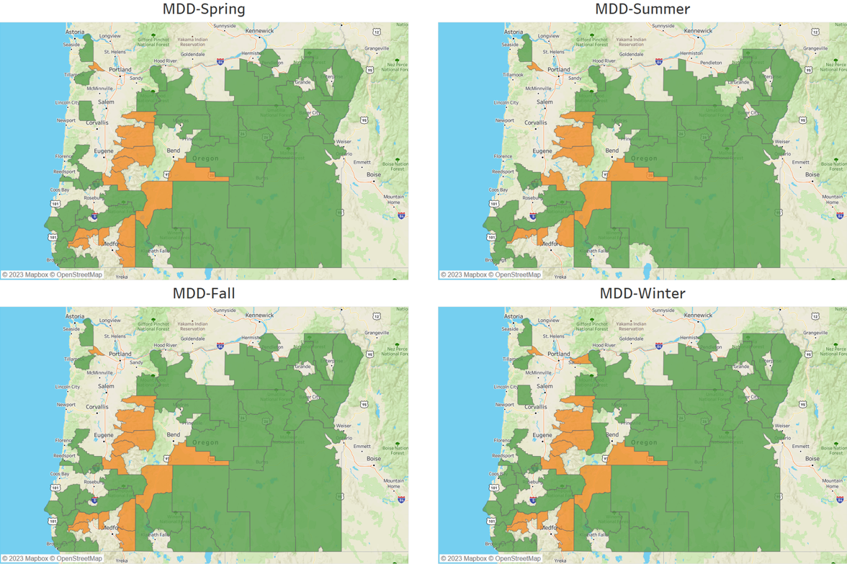
Figure B.1: Rural and Urban Distribution Comparison of Low-Access Census Tracts for MDD Definition. The green represents the rural low-access census tracts, and the orange represents the urban low-access census tracts.
Supplementary C: Additional numerical results around low access metrics for different seasons and across rural and urban areas.
Table C.1: G2SFCA Score of Low-access census tracts G2SFCA accessibility score is calculated using travel time thresholds ranging from 20 – 90 minutes. A lower score indicates lower accessibility with scores across all of Oregon ranging from 0 to 1.02. The bolded scores represent a value that is lower than the corresponding mean or median value in the USDA column. Otherwise, the mean and median G2SFCA score of USDA is bolded. IQR = Interquartile Range. The “MDD” columns are the G2SFCA score statistics among those identified by the threshold for the corresponding season. The “All” row represents the corresponding scores of all low census tracts identified by the corresponding definition. The “Rural” and “Urban” rows represent the corresponding scores of the rural and urban low census tracts, respectively.
Threshold Time - $d_{0}$ | Type | MDD-Spring |  |  | MDD-Summer |  |  | MDD-Fall |  |  | MDD-Winter |  |  | USDA
Threshold Time - $d_{0}$ | Type | Mean | Median | IQR | Mean | Median | IQR | Mean | Median | IQR | Mean | Median | IQR | Mean | Median | IQR
20 | All | 0.072 | 0.000 | 0.123 | 0.055 | 0.000 | 0.029 | 0.072 | 0.000 | 0.123 | 0.084 | 0.000 | 0.161 | 0.239 | 0.244 | 0.229
20 | Rural | 0.092 | 0.000 | 0.197 | 0.069 | 0.000 | 0.123 | 0.092 | 0.000 | 0.197 | 0.105 | 0.000 | 0.197 | 0.030 | 0.000 | 0.023
20 | Urban | 0.004 | 0.000 | 0.000 | 0.005 | 0.000 | 0.001 | 0.004 | 0.000 | 0.000 | 0.011 | 0.000 | 0.003 | 0.254 | 0.254 | 0.203
30 | All | 0.079 | 0.001 | 0.151 | 0.065 | 0.001 | 0.120 | 0.079 | 0.001 | 0.151 | 0.097 | 0.004 | 0.187 | 0.259 | 0.255 | 0.240
30 | Rural | 0.097 | 0.005 | 0.200 | 0.077 | 0.004 | 0.151 | 0.097 | 0.005 | 0.200 | 0.118 | 0.023 | 0.216 | 0.081 | 0.004 | 0.116
30 | Urban | 0.018 | 0.000 | 0.015 | 0.023 | 0.000 | 0.023 | 0.018 | 0.000 | 0.015 | 0.025 | 0.000 | 0.027 | 0.278 | 0.271 | 0.221
40 | All | 0.087 | 0.026 | 0.160 | 0.076 | 0.026 | 0.120 | 0.087 | 0.026 | 0.160 | 0.103 | 0.039 | 0.170 | 0.274 | 0.291 | 0.234
40 | Rural | 0.104 | 0.041 | 0.202 | 0.089 | 0.036 | 0.160 | 0.104 | 0.041 | 0.202 | 0.123 | 0.045 | 0.215 | 0.078 | 0.039 | 0.079
40 | Urban | 0.026 | 0.001 | 0.036 | 0.032 | 0.006 | 0.055 | 0.026 | 0.001 | 0.036 | 0.033 | 0.001 | 0.066 | 0.293 | 0.302 | 0.219
50 | All | 0.101 | 0.051 | 0.165 | 0.095 | 0.051 | 0.145 | 0.101 | 0.051 | 0.165 | 0.118 | 0.062 | 0.187 | 0.288 | 0.316 | 0.218
50 | Rural | 0.122 | 0.079 | 0.196 | 0.112 | 0.068 | 0.165 | 0.122 | 0.079 | 0.196 | 0.142 | 0.097 | 0.194 | 0.100 | 0.045 | 0.089
50 | Urban | 0.029 | 0.006 | 0.048 | 0.035 | 0.011 | 0.058 | 0.029 | 0.006 | 0.048 | 0.038 | 0.011 | 0.059 | 0.305 | 0.325 | 0.195
60 | All | 0.112 | 0.073 | 0.178 | 0.105 | 0.073 | 0.169 | 0.112 | 0.073 | 0.178 | 0.130 | 0.092 | 0.187 | 0.298 | 0.328 | 0.194
60 | Rural | 0.134 | 0.104 | 0.217 | 0.123 | 0.093 | 0.179 | 0.134 | 0.104 | 0.217 | 0.153 | 0.109 | 0.207 | 0.105 | 0.082 | 0.083
60 | Urban | 0.038 | 0.013 | 0.051 | 0.043 | 0.013 | 0.065 | 0.038 | 0.013 | 0.051 | 0.048 | 0.020 | 0.074 | 0.313 | 0.333 | 0.172
70 | All | 0.122 | 0.090 | 0.170 | 0.115 | 0.090 | 0.160 | 0.122 | 0.090 | 0.170 | 0.142 | 0.112 | 0.181 | 0.306 | 0.333 | 0.163
70 | Rural | 0.143 | 0.118 | 0.186 | 0.132 | 0.109 | 0.160 | 0.143 | 0.118 | 0.186 | 0.164 | 0.139 | 0.219 | 0.117 | 0.088 | 0.122
70 | Urban | 0.052 | 0.016 | 0.091 | 0.054 | 0.016 | 0.101 | 0.052 | 0.016 | 0.091 | 0.065 | 0.020 | 0.109 | 0.319 | 0.336 | 0.141
80 | All | 0.132 | 0.117 | 0.148 | 0.124 | 0.112 | 0.155 | 0.132 | 0.117 | 0.148 | 0.153 | 0.132 | 0.168 | 0.313 | 0.342 | 0.131
80 | Rural | 0.150 | 0.135 | 0.174 | 0.139 | 0.119 | 0.156 | 0.150 | 0.135 | 0.174 | 0.174 | 0.148 | 0.200 | 0.134 | 0.099 | 0.140
80 | Urban | 0.069 | 0.031 | 0.117 | 0.068 | 0.031 | 0.126 | 0.069 | 0.031 | 0.117 | 0.081 | 0.038 | 0.140 | 0.325 | 0.345 | 0.110
90 | All | 0.141 | 0.139 | 0.146 | 0.133 | 0.127 | 0.132 | 0.141 | 0.139 | 0.146 | 0.162 | 0.162 | 0.162 | 0.320 | 0.348 | 0.105
90 | Rural | 0.155 | 0.151 | 0.150 | 0.146 | 0.139 | 0.139 | 0.155 | 0.151 | 0.150 | 0.179 | 0.165 | 0.166 | 0.153 | 0.108 | 0.147
90 | Urban | 0.092 | 0.073 | 0.136 | 0.090 | 0.073 | 0.134 | 0.092 | 0.073 | 0.136 | 0.103 | 0.087 | 0.142 | 0.330 | 0.351 | 0.081
Table C.2: Population-to-facility ratio of Low-access census tracts. Population-to-facility ratio is calculated using travel time thresholds ranging from 20 – 90 minutes. A higher value indicates one available facility needs to serve more people (i.e., lower accessibility amongst those populations). The bolded ratios represent a value that is higher than the corresponding mean or median value in the USDA column. A bolded value in the USDA column indicates a higher population-to-facility ratio among those low-access census tracts identified by the adapted USDA definition. Otherwise, the mean and median population-to-facility ratio of USDA is bolded. IQR = Interquartile Range. The “MDD” columns are the population-to-facility ratio statistics among those identified by the threshold for the corresponding season. The “All” row represents the corresponding ratios of all low census tracts identified by the corresponding definitions. The “Rural” and “Urban” rows represent the corresponding ratios of the rural and urban low census tracts, respectively.
Threshold Time - $d_{0}$ | Type | MDD-Spring |  |  | MDD-Summer |  |  | MDD-Fall |  |  | MDD-Winter |  |  | USDA
Threshold Time - $d_{0}$ | Type | Mean | Median | IQR | Mean | Median | IQR | Mean | Median | IQR | Mean | Median | IQR | Mean | Median | IQR
20 | All | 3313 | 4954 | 4147 | 3465 | 4954 | 3885 | 3313 | 4954 | 4147 | 3258 | 4954 | 4464 | 725 | 50 | 238
20 | Rural | 3087 | 4954 | 4369 | 3352 | 4954 | 3885 | 3087 | 4954 | 4369 | 3085 | 4954 | 4583 | 3788 | 4954 | 3539
20 | Urban | 4080 | 4954 | 0 | 3862 | 4954 | 1033 | 4080 | 4954 | 0 | 3790 | 4954 | 1515 | 522 | 44 | 149
30 | All | 2839 | 4954 | 4636 | 2892 | 4954 | 4627 | 2839 | 4954 | 4636 | 2643 | 3007 | 4663 | 461 | 23 | 65
30 | Rural | 2621 | 1435 | 4637 | 2793 | 3205 | 4627 | 2621 | 1435 | 4637 | 2287 | 667 | 4742 | 2715 | 1455 | 4323
30 | Urban | 3582 | 4954 | 3099 | 3239 | 4954 | 4266 | 3582 | 4954 | 3099 | 3744 | 4954 | 1515 | 312 | 20 | 40
40 | All | 847 | 535 | 1346 | 871 | 703 | 1304 | 847 | 535 | 1346 | 1238 | 441 | 2877 | 121 | 14 | 30
40 | Rural | 821 | 478 | 1329 | 857 | 535 | 1270 | 821 | 478 | 1329 | 1079 | 332 | 2880 | 820 | 485 | 1392
40 | Urban | 933 | 1203 | 1385 | 920 | 1203 | 1470 | 933 | 1203 | 1385 | 1729 | 2222 | 2829 | 74 | 13 | 20
50 | All | 583 | 316 | 1164 | 510 | 354 | 916 | 583 | 316 | 1164 | 568 | 271 | 1359 | 74 | 10 | 20
50 | Rural | 558 | 282 | 1150 | 494 | 316 | 897 | 558 | 282 | 1150 | 477 | 233 | 596 | 481 | 397 | 895
50 | Urban | 670 | 600 | 1168 | 567 | 600 | 954 | 670 | 600 | 1168 | 849 | 1129 | 1313 | 47 | 10 | 15
60 | All | 1011 | 163 | 3163 | 1108 | 166 | 3161 | 1011 | 163 | 3163 | 1421 | 150 | 1691 | 133 | 7 | 15
60 | Rural | 911 | 163 | 875 | 1060 | 166 | 3159 | 911 | 163 | 875 | 1224 | 149 | 290 | 900 | 181 | 429
60 | Urban | 1348 | 189 | 3212 | 1276 | 189 | 3190 | 1348 | 189 | 3212 | 2030 | 826 | 5083 | 83 | 7 | 10
70 | All | 682 | 127 | 911 | 399 | 141 | 990 | 682 | 127 | 911 | 537 | 126 | 933 | 89 | 6 | 11
70 | Rural | 586 | 127 | 358 | 389 | 141 | 895 | 586 | 127 | 358 | 444 | 122 | 302 | 551 | 132 | 202
70 | Urban | 1009 | 117 | 2429 | 432 | 117 | 1033 | 1009 | 117 | 2429 | 822 | 226 | 1884 | 59 | 6 | 9
80 | All | 339 | 89 | 331 | 395 | 107 | 581 | 339 | 89 | 331 | 350 | 78 | 265 | 63 | 5 | 9
80 | Rural | 355 | 115 | 389 | 410 | 126 | 565 | 355 | 115 | 389 | 303 | 94 | 196 | 528 | 108 | 208
80 | Urban | 285 | 41 | 74 | 344 | 41 | 359 | 285 | 41 | 74 | 495 | 75 | 1179 | 33 | 5 | 6
90 | All | 232 | 63 | 212 | 267 | 67 | 293 | 232 | 63 | 212 | 280 | 72 | 147 | 29 | 4 | 9
90 | Rural | 253 | 69 | 206 | 289 | 80 | 325 | 253 | 69 | 206 | 237 | 73 | 118 | 185 | 71 | 137
90 | Urban | 161 | 30 | 70 | 189 | 30 | 104 | 161 | 30 | 70 | 414 | 66 | 543 | 19 | 4 | 5

Table C.3: Socioeconomic Status. For the poverty, no-high-school diploma, unemployment, and uninsured rates, a higher percentage reflects a lower socioeconomic status. For per capita income, a lower value indicates a lower socioeconomic status. The bolded values indicate a lower socioeconomic status in that metric relative to the corresponding mean or median value in the USDA column. A bolded value in the USDA column indicates a lower socioeconomic status within those low-access census tracts identified by the adapted USDA definition. Otherwise, the mean and median income of USDA is bolded. The “All” row represents the corresponding metric of all the low census tracts identified by the corresponding definition. The “Rural” and “Urban” rows represent the corresponding metric of the rural and urban low census tracts, respectively.
Socioeconomic Status | Type | MDD-Spring |  |  | MDD-Summer |  |  | MDD-Fall |  |  | MDD-Winter |  |  |  | USDA
Socioeconomic Status | Type | Mean | Median | IQR | Mean | Median | IQR | Mean | Median | IQR | Mean | Median | IQR | Mean |  | Mean | IQR
Poverty Rate | All | 15.2% | 13.9% | 7.0% | 15.5% | 13.9% | 7.0% | 15.2% | 13.9% | 7.0% | 15.1% | 13.7% | 7.6% | 10.6% |  | 9.7% | 8.0%
Poverty Rate | Rural | 16.0% | 14.1% | 7.2% | 16.1% | 13.9% | 6.6% | 16.0% | 14.1% | 7.2% | 14.1% | 13.2% | 8.2% | 15.6% |  | 14.2% | 6.7%
Poverty Rate | Urban | 12.7% | 12.4% | 9.0% | 13.2% | 13.6% | 9.3% | 12.7% | 12.4% | 9.0% | 18.2% | 15.5% | 6.7% | 10.2% |  | 9.4% | 7.3%
No High School Diploma | All | 9.4% | 8.8% | 4.8% | 9.2% | 8.7% | 4.3% | 9.4% | 8.8% | 4.8% | 9.3% | 8.8% | 4.6% | 8.2% |  | 7.6% | 6.8%
No High School Diploma | Rural | 9.9% | 9.2% | 4.8% | 9.6% | 9.0% | 4.2% | 9.9% | 9.2% | 4.8% | 9.1% | 8.8% | 4.7% | 10.6% |  | 10.3% | 3.1%
No High School Diploma | Urban | 7.8% | 7.9% | 5.8% | 7.7% | 7.9% | 4.2% | 7.8% | 7.9% | 5.8% | 9.9% | 9.1% | 3.4% | 8.0% |  | 7.5% | 6.5%
Unemployment rate | All | 8.4% | 7.0% | 4.2% | 8.4% | 7.0% | 4.3% | 8.4% | 7.0% | 4.2% | 8.2% | 6.8% | 4.5% | 5.5% |  | 4.9% | 3.6%
Unemployment rate | Rural | 7.9% | 6.7% | 3.8% | 8.2% | 6.7% | 4.3% | 7.9% | 6.7% | 3.8% | 7.1% | 5.7% | 4.4% | 7.7% |  | 6.7% | 5.2%
Unemployment rate | Urban | 10.1% | 8.8% | 2.2% | 8.9% | 8.4% | 2.6% | 10.1% | 8.8% | 2.2% | 11.8% | 8.8% | 6.0% | 5.3% |  | 4.9% | 3.6%
Uninsured Rate | All | 7.1% | 6.5% | 3.1% | 7.2% | 6.5% | 2.6% | 7.1% | 6.5% | 3.1% | 6.9% | 6.5% | 2.7% | 6.1% |  | 5.7% | 4.1%
Uninsured Rate | Rural | 7.4% | 6.7% | 3.1% | 7.3% | 6.7% | 2.3% | 7.4% | 6.7% | 3.1% | 6.7% | 6.4% | 2.1% | 7.7% |  | 6.9% | 3.0%
Uninsured Rate | Urban | 6.2% | 5.8% | 2.3% | 6.9% | 6.3% | 2.8% | 6.2% | 5.8% | 2.3% | 7.5% | 7.4% | 3.6% | 6.0% |  | 5.5% | 4.3%
Per capita | All | 28261 | 26869 | 6392 | 27996 | 27227 | 6547 | 28261 | 26869 | 6392 | 28848 | 27552 | 6916 | 36172 |  | 34047 | 13859
Per capita | Rural | 26410 | 26597 | 4908 | 26293 | 26869 | 5106 | 26410 | 26597 | 4908 | 29711 | 27592 | 6962 | 26000 |  | 26837 | 5231
Per capita | Urban | 34557 | 32211 | 14085 | 33957 | 32211 | 9704 | 34557 | 32211 | 14085 | 26189 | 25442 | 9445 | 36845 |  | 34699 | 13686

Table C.4: COVID-19 Community Vulnerability Index (CCVI) of Low-access census tracts. CCVI represents the aggregated score and T1 to T7 represents the scores of each of the individual 7 themes: (1) Socioeconomic status, (2) Minority status and language, (3) Household and transportation, (4) Epidemiological factors, (5) Healthcare system factors, (6) High-risk environments, and (7) Population density. A higher value reflects a higher vulnerability. The bolded values indicate a higher vulnerability in each metric to the corresponding mean or median value in the USDA column. A bolded value in the USDA column indicates a higher vulnerability within those low-access census tracts identified by the adapted USDA definition. The “All” row represents the corresponding metric of all low census tracts identified by the corresponding definition. The “Rural” and “Urban” rows represent the corresponding metric of rural and urban low census tracts, respectively.
CCVI and Sub Themes | Type | MDD-Spring |  |  | MDD-Summer |  |  | MDD-Fall |  |  | MDD-Winter |  |  | USDA
CCVI and Sub Themes | Type | Mean | Median | IQR | Mean | Median | IQR | Mean | Median | IQR | Mean | Median | IQR | Mean | Median | IQR
CCVI | All | 0.346 | 0.324 | 0.170 | 0.352 | 0.331 | 0.197 | 0.346 | 0.324 | 0.170 | 0.346 | 0.331 | 0.197 | 0.391 | 0.393 | 0.141
CCVI | Rural | 0.336 | 0.292 | 0.153 | 0.346 | 0.306 | 0.167 | 0.336 | 0.292 | 0.153 | 0.325 | 0.316 | 0.163 | 0.322 | 0.288 | 0.155
CCVI | Urban | 0.380 | 0.393 | 0.046 | 0.371 | 0.390 | 0.043 | 0.380 | 0.393 | 0.046 | 0.409 | 0.409 | 0.138 | 0.395 | 0.393 | 0.141
T1 | All | 0.529 | 0.551 | 0.137 | 0.528 | 0.551 | 0.156 | 0.529 | 0.551 | 0.137 | 0.526 | 0.540 | 0.134 | 0.450 | 0.505 | 0.280
T1 | Rural | 0.527 | 0.528 | 0.150 | 0.529 | 0.534 | 0.164 | 0.527 | 0.528 | 0.150 | 0.517 | 0.528 | 0.132 | 0.545 | 0.528 | 0.142
T1 | Urban | 0.534 | 0.585 | 0.092 | 0.521 | 0.585 | 0.153 | 0.534 | 0.585 | 0.092 | 0.556 | 0.587 | 0.271 | 0.444 | 0.505 | 0.280
T2 | All | 0.530 | 0.413 | 0.316 | 0.548 | 0.468 | 0.336 | 0.530 | 0.413 | 0.316 | 0.524 | 0.413 | 0.310 | 0.688 | 0.663 | 0.273
T2 | Rural | 0.512 | 0.401 | 0.325 | 0.531 | 0.401 | 0.368 | 0.512 | 0.401 | 0.325 | 0.497 | 0.389 | 0.262 | 0.481 | 0.399 | 0.347
T2 | Urban | 0.590 | 0.593 | 0.138 | 0.610 | 0.593 | 0.115 | 0.590 | 0.593 | 0.138 | 0.606 | 0.628 | 0.257 | 0.702 | 0.677 | 0.273
T3 | All | 0.639 | 0.695 | 0.233 | 0.641 | 0.695 | 0.233 | 0.639 | 0.695 | 0.233 | 0.622 | 0.695 | 0.284 | 0.457 | 0.457 | 0.336
T3 | Rural | 0.678 | 0.700 | 0.167 | 0.683 | 0.733 | 0.160 | 0.678 | 0.700 | 0.167 | 0.640 | 0.695 | 0.207 | 0.726 | 0.761 | 0.099
T3 | Urban | 0.507 | 0.565 | 0.129 | 0.539 | 0.611 | 0.378 | 0.507 | 0.565 | 0.129 | 0.564 | 0.570 | 0.356 | 0.439 | 0.457 | 0.280
T4 | All | 0.436 | 0.492 | 0.417 | 0.432 | 0.451 | 0.417 | 0.436 | 0.492 | 0.417 | 0.442 | 0.492 | 0.425 | 0.175 | 0.110 | 0.125
T4 | Rural | 0.478 | 0.494 | 0.391 | 0.484 | 0.494 | 0.344 | 0.478 | 0.494 | 0.391 | 0.467 | 0.494 | 0.425 | 0.479 | 0.494 | 0.284
T4 | Urban | 0.290 | 0.227 | 0.165 | 0.247 | 0.227 | 0.157 | 0.290 | 0.227 | 0.165 | 0.364 | 0.244 | 0.406 | 0.154 | 0.110 | 0.125
T5 | All | 0.251 | 0.206 | 0.182 | 0.262 | 0.214 | 0.195 | 0.251 | 0.206 | 0.182 | 0.246 | 0.206 | 0.181 | 0.339 | 0.319 | 0.145
T5 | Rural | 0.247 | 0.187 | 0.195 | 0.254 | 0.187 | 0.197 | 0.247 | 0.187 | 0.195 | 0.225 | 0.166 | 0.184 | 0.228 | 0.206 | 0.123
T5 | Urban | 0.264 | 0.244 | 0.134 | 0.290 | 0.282 | 0.098 | 0.264 | 0.244 | 0.134 | 0.311 | 0.268 | 0.170 | 0.346 | 0.319 | 0.145
T6 | All | 0.327 | 0.339 | 0.242 | 0.328 | 0.339 | 0.242 | 0.327 | 0.339 | 0.242 | 0.327 | 0.339 | 0.284 | 0.343 | 0.351 | 0.112
T6 | Rural | 0.316 | 0.339 | 0.277 | 0.321 | 0.339 | 0.284 | 0.316 | 0.339 | 0.277 | 0.305 | 0.339 | 0.266 | 0.319 | 0.339 | 0.219
T6 | Urban | 0.364 | 0.351 | 0.157 | 0.354 | 0.351 | 0.138 | 0.364 | 0.351 | 0.157 | 0.392 | 0.381 | 0.187 | 0.344 | 0.351 | 0.112
T7 | All | 0.314 | 0.223 | 0.401 | 0.302 | 0.212 | 0.383 | 0.314 | 0.223 | 0.401 | 0.335 | 0.223 | 0.425 | 0.731 | 0.768 | 0.287
T7 | Rural | 0.229 | 0.211 | 0.212 | 0.216 | 0.202 | 0.228 | 0.229 | 0.211 | 0.212 | 0.303 | 0.223 | 0.348 | 0.158 | 0.191 | 0.174
T7 | Urban | 0.603 | 0.622 | 0.114 | 0.603 | 0.622 | 0.113 | 0.603 | 0.622 | 0.114 | 0.436 | 0.550 | 0.397 | 0.769 | 0.784 | 0.287

