Supporting information for
Highly Active, Ultra-Low Loading Single-Atom Iron Catalysts for Catalytic Transfer Hydrogenation
Zhidong An, ^{a, ∇} Piaoping Yang, ^{b, ∇} Delong Duan, ^{c, ∇} Jiang Li, ^{a, *}, Tong Wan, ª Yue Kong, ª Stavros Caratzoulas, ^{b} Shuting Xiang, ^{d} Jiaxing Liu, ª Lei Huang, ª Anatoly I. Frenkel, ^{d} Yuan-Ye Jiang, ^{e} Ran Long, ^{c, *} Zhenxing Li, ^{a, *}, and Dionisios G. Vlachos ^{b, *}
- College of New Energy and Materials, China University of Petroleum (Beijing), Beijing 102249, China.
- Department of Chemical and Biomolecular Engineering and Catalysis Center for Energy Innovation, University of Delaware, 221 Academy St., Newark, Delaware, 19716, United States.
- School of Chemistry and Materials Science, Frontiers Science Center for Planetary Exploration and Emerging Technologies, and National Synchrotron Radiation Laboratory, University of Science and Technology of China, Hefei, Anhui, 230026, China.
- Department of Materials Science and Chemical Engineering Stony Brook University, Stony Brook, New York, 11794, USA; Chemistry Division Brookhaven National Laboratory Upton, New York, 11973, USA.
- School of Chemistry and Chemical Engineering, Qufu Normal University, Qufu 273165, China.
Corresponding authors: lijiang@cup.edu.cn (Jiang Li), longran@ustc.edu.cn (Ran Long), lizx@cup.edu.cn (Zhenxing Li), vlachos@udel.edu. (Dionisios G. Vlachos).
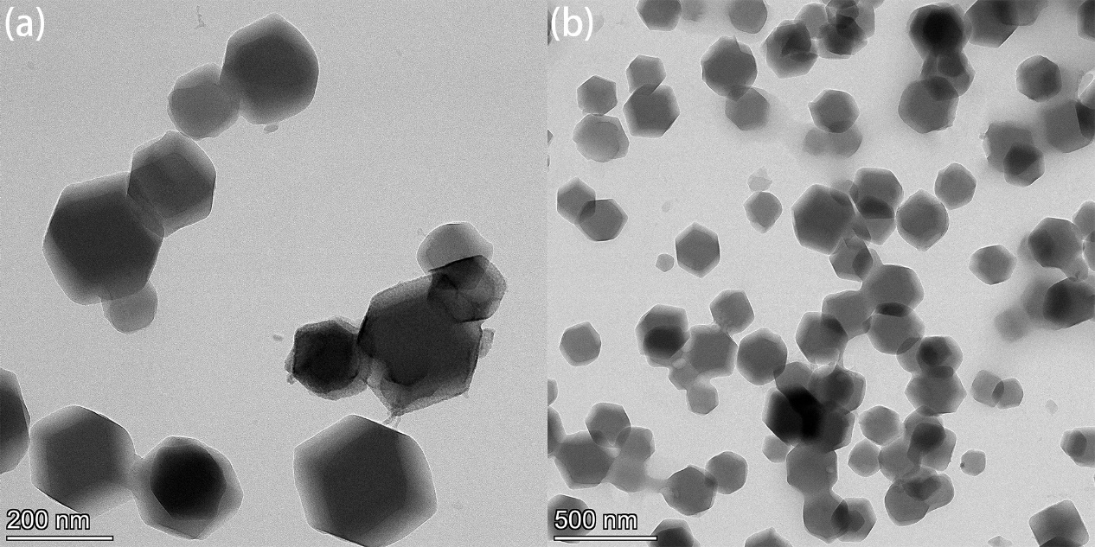
Figure S1. TEM images of ZIF-8 precursor.

Figure S2. XRD pattern of ZIF-derived iron catalysts prepared at different pyrolysis temperatures.

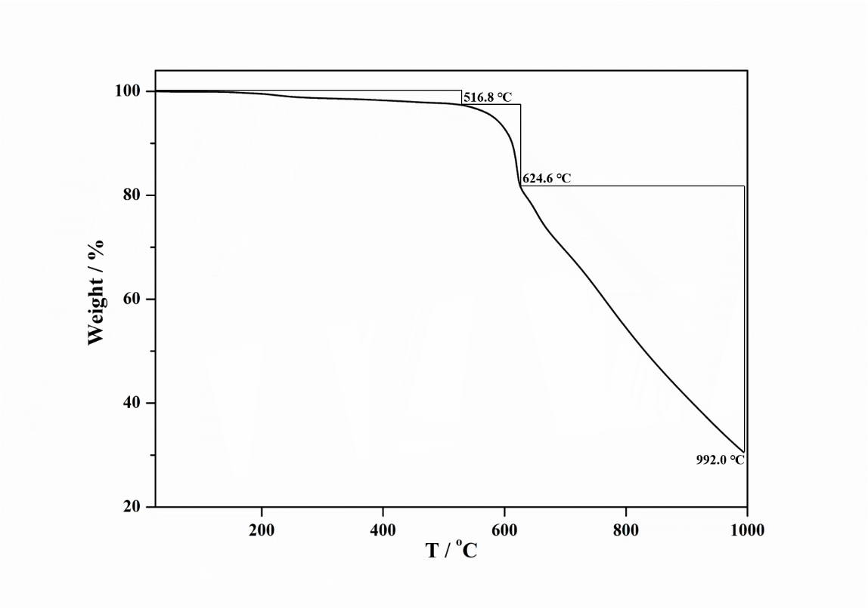
Figure S3. TGA data for Fe-ZIF-8 precursor.

Figure S4. N₂ adsorption isotherms of various MOF-derived catalysts.

Figure S5. NH₃-TPD (a) and CO₂-TPD (b) patterns of Fe-ZIF-8-800, ZIF-8-800, and Fe-MOF-5-800 catalysts.

Figure S6. O 1s XPS spectra of various MOF-derived catalysts.

Figure S7. C 1s XPS spectra of various MOF-derived catalysts.

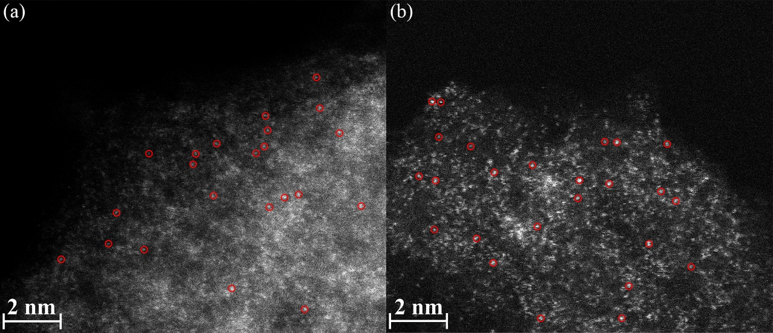
Figure S8. Two representative aberration corrected HAADF-STEM images of Fe-ZIF-8-800 catalyst.

Figure S9. Fe K-edge (a) and Zn K-edge (b) normalized X-ray absorption near-edge structure (XANES) spectra of the Fe-MOF-5-800 catalyst. Fourier transform of Fe K-edge (c) and Zn K-edge (d) EXAFS spectra of the Fe-MOF-5-800 catalyst. (e, f) EXAFS fitting of the Fe-MOF-5-800. (g) Wavelet transform of Fe K-edge and Zn K-edge EXAFS for Fe-MOF-5-800.

Figure S10. EXAFS fitting of the Fe-ZIF-8-800 using Fe(II)-N₄C₁₂ moiety. The results are similar to that using Fe(I)-N₃C₁₀ (Figure 2e), suggesting that the local structures of the Fe-N_{x} sites in Fe-ZIF-8-800 can be described well by both two porphyrin-based moieties.

Figure S11. (a–b) Experimental Fe K-edge XANES spectra of Fe-ZIF-8-800 and theoretical spectra of the porphyrin-based Fe-N_{x}C_{y} moieties. (c–d) Experimental Zn K-edge XANES spectra of ZIF-8-800 and theoretical spectra of the porphyrin-based Zn-N_{x}C_{y} moieties. Latin numerals in brackets indicate the formal oxidation states of the metal atoms.
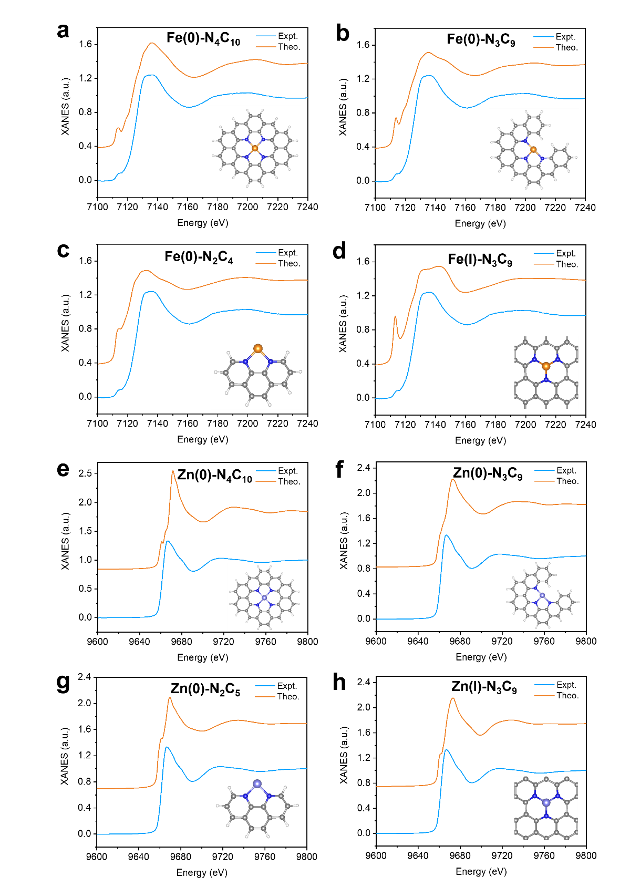
Figure S12. (a–d) Experimental Fe K-edge XANES spectra of Fe-ZIF-8-800 and theoretical spectra of the Fe-N_{x}C_{y} moieties involving pyridinic N coordination. (e–h) Experimental Zn K-edge XANES spectra of ZIF-8-800 and theoretical spectra of the Zn-N_{x}C_{y} moieties involving pyridinic N coordination. Latin numerals in brackets indicate the formal oxidation states of the metal atoms.
Figure S13. Time courses for the CTH of FF over Fe-ZIF-8-800 and Fe-phen/C-800 catalysts at 80 (a), 120 (b), and 160 ºC (c) (squares: conversion, circles: yield). Reaction conditions: 0.5 mmol FF, 3 mL solvent, 50 mg catalyst.

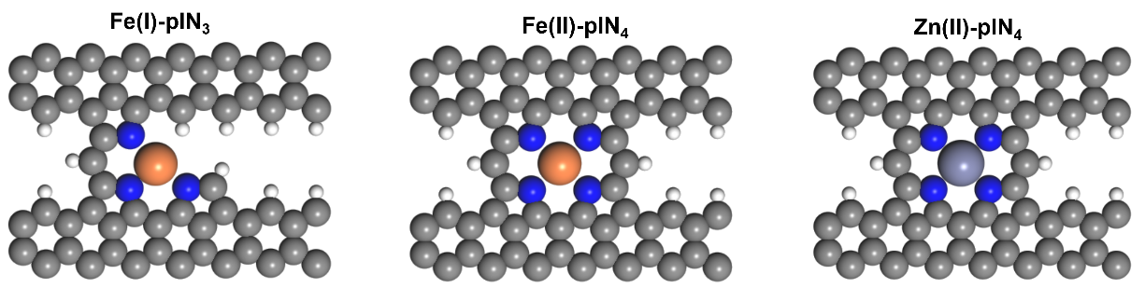
Figure S14. Fe(I)-plN₃, Fe(II)-plN₄, and Zn(II)-plN₄ models. The grey, blue, white, orange, and light purple spheres represent carbon (C), nitrogen (N), hydrogen (H), iron (Fe), and zinc (Zn), respectively.

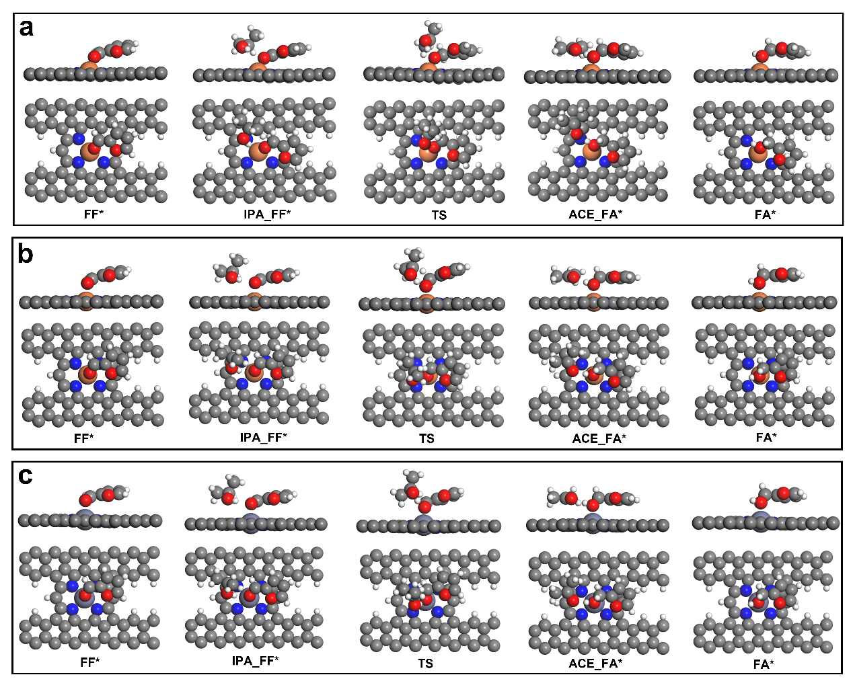
Figure S15. Optimized geometries (side and top views) of intermediates and transition states on P1 pathway for Fe(I)-plN₃ (a), Fe(II)-plN₄ (b), and Zn(II)-plN₄ (c).

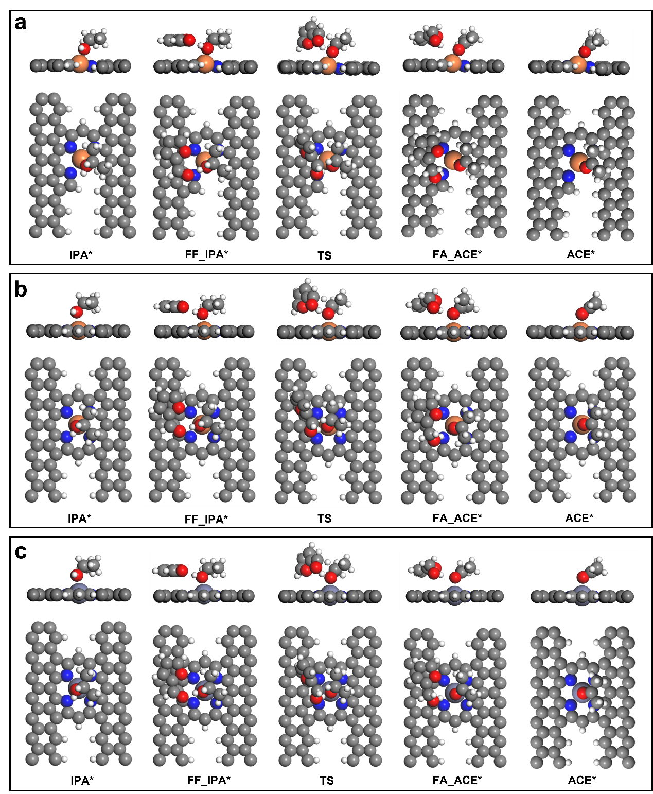
Figure S16. Optimized geometries (side and top views) of intermediates and transition states on P2 pathway for Fe(I)-plN₃ (a), Fe(II)-plN₄ (b), and Zn(II)-plN₄ (c).

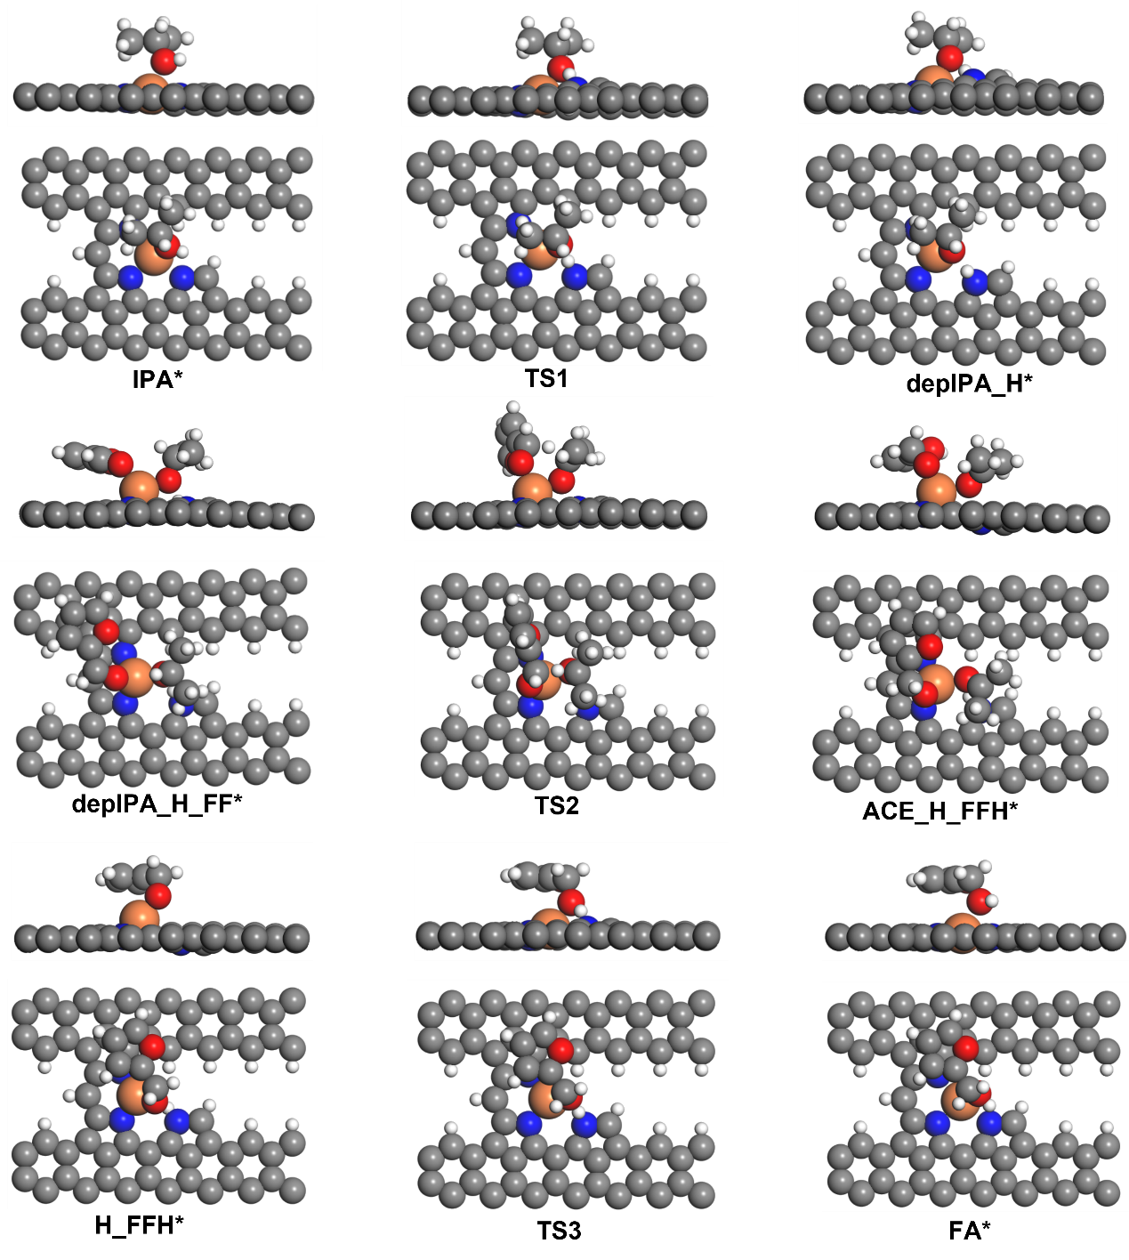
Figure S17. Optimized geometries (side and top views) of intermediates and transition states on P3 pathway for Fe(I)-plN₃.

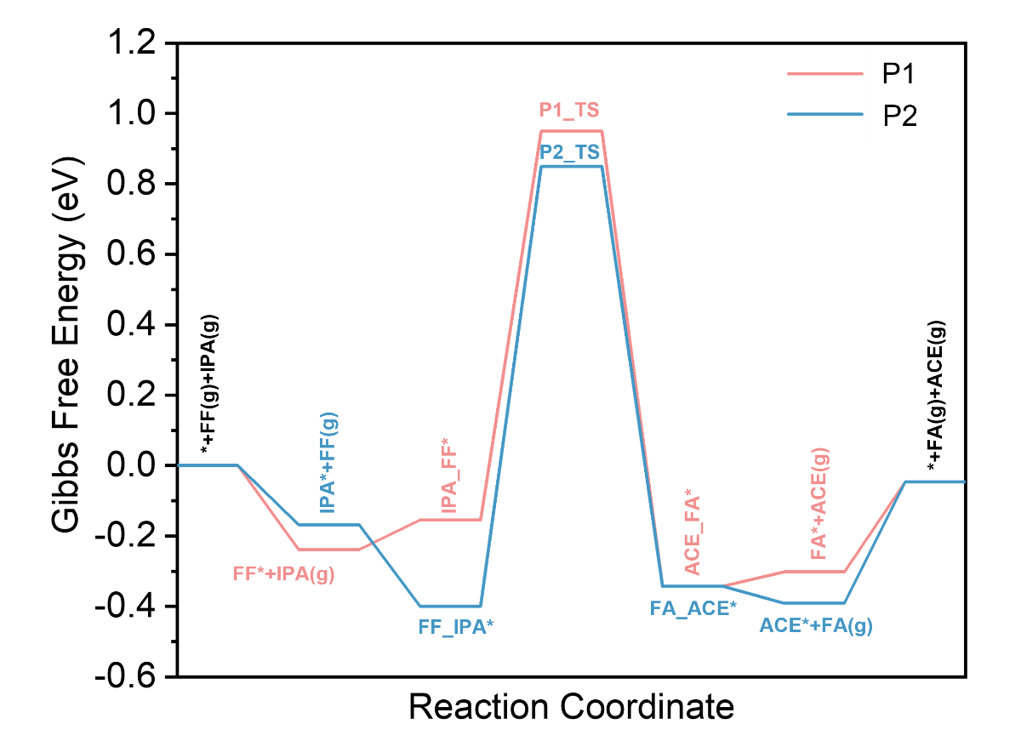
Figure S18. Gibbs free energy profiles along the P1 and P2 pathways for Fe(I)-plN₃ at 393 K.

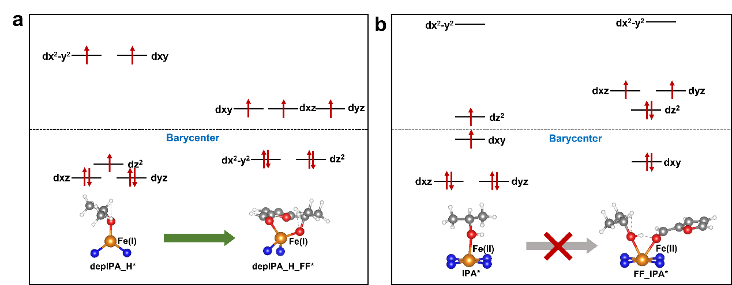
Figure S19. Crystal field splitting diagrams for various configurations of Fe(I) complexes (a) and Fe(II) complexes (b). depIPA_H*, depIPA_H_FF*, IPA*, FF_IPA* denote the trigonal, tetrahedral, square pyramidal, and “ridge-tent” configurations, respectively.

Figure S20. The adsorption geometries (side view) and corresponding adsorption energies of -OH groups in HMF and isopropanol at Fe(I)-plN₃.

Figure S21. (a) Recyclability tests of Fe-ZIF-8-800 catalyst. Reaction conditions: 0.5 mmol FF, 3 mL isopropanol solvent, 120 ℃, 15 min, 50 mg Fe-ZIF-8-800 catalyst for the first run, and then reused for 4 runs. To recover the activity of Fe-ZIF-8-800 catalyst, re-calcination of the reused catalyst is proceeded by adding 1 wt% Fe(NO₃)₃ (the Fe dosage is only 0.14 wt%). (b) XRD pattern of used and fresh Fe-ZIF-8-800 catalysts.

Figure S22. Fe K-edge (a) and Zn K-edge (c) normalized XANES spectra of fresh and used Fe-ZIF-8-800 catalysts. Fourier transform of Fe K-edge (b) and Zn K-edge (d) EXAFS spectra of fresh and used Fe-ZIF-8-800 catalysts.

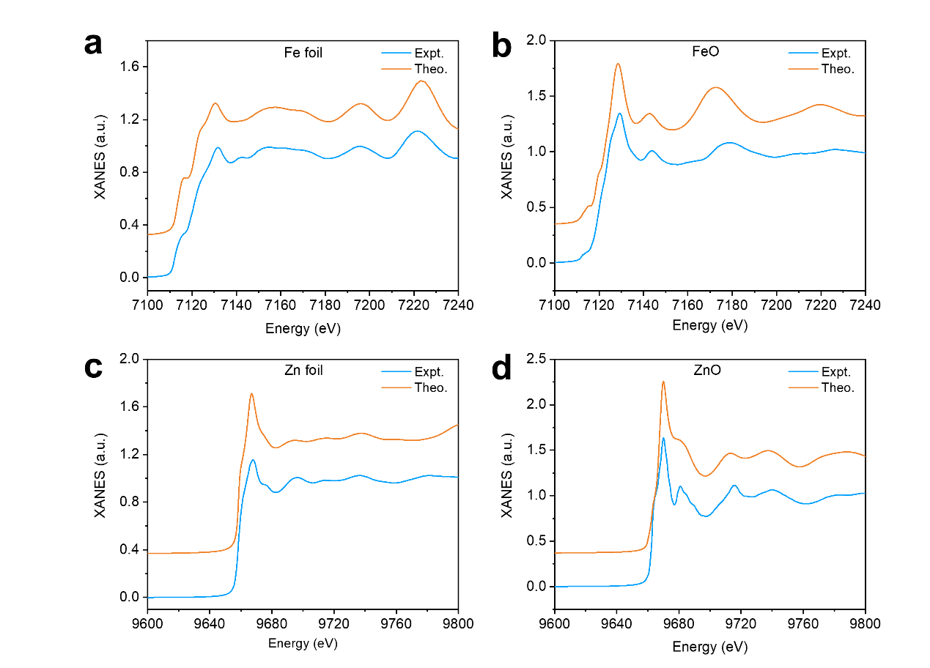
Figure S23. Experimental and computed Fe K-edge XANES spectra of Fe foil (a) and FeO (b); and Zn K-edge XANES spectra of Zn foil (c) and ZnO (d).
Figure S24. A representative GC spectrum. Reaction condition: 0.5 mmol FF, 3 mL isopropanol solvent, 50 mg Fe-ZIF-8-800 catalyst (0.13mol% Fe), 80 ºC, 3 h.

Table S1. Contents of Fe and Zn in various MOF-derived catalysts.
Entry | Catalyst | Fe Content [%] | Zn Content [%]
1 | Fe-ZIF-8-800 | 0.073 | 28.60
2 | Fe-MOF-5-800 | 5.73 | 63.24
3 | ZIF-8 | – | 30.81
4 | ZIF-8-800 | – | 20.79
5 | Fe-ZIF-8 | 0.037 | 30.48
6 | Fe-MOF-5 | 0.33 | N.D.
7 | Fe-ZIF-8-400 | N.D. | 30.95
8 | Fe-ZIF-8-600 | N.D. | 33.29
9 | Fe-ZIF-8-1000 | N.D. | 1.41
N.D.=not determined.

Table S2. Contents of N, C and H in Fe-ZIF-8-800 catalyst.
Catalyst | N  [wt%] | C  [wt%] | H  [wt%]
Fe-ZIF-8-800 | 21.98 | 46.34 | 2.374

Table S3. Intensity ratio of D-band to G-band in Raman spectra of various MOF-derived catalysts.
Catalyst | I_{D}/I_{G} | Peak Intensity
Catalyst | I_{D}/I_{G} | D peak | G peak
Fe-ZIF-8-800 | 2.01 | 7.66 | 3.82
Fe-ZIF-8-1000 | 1.6 | 7.43 | 4.64
Fe-MOF-5-800 | 1.03 | 5.71 | 5.55
ZIF-8-800 | 1.38 | 15.03 | 10.89

Table S4. N₂ adsorption/desorption data of various catalysts.
Catalyst | BET Surface Area  (m²/g) | Pore Size  (nm) | Pore Volume  (cm³/g)
Fe-ZIF-8 | 1315 | 9.62 | 0.05
Fe-ZIF-8-400 | 1280 | 7.53 | 0.07
Fe-ZIF-8-600 | 766 | 5.00 | 0.07
Fe-ZIF-8-800 | 403 | 9.75 | 0.07
Fe-ZIF-8-1000 | 991 | 7.83 | 0.05
ZIF-8-800 | 580 | 6.64 | 0.07
Fe-MOF-5-800 | 798 | 7.74 | 1.09

Table S5. N speciation (at. %) from XPS analysis for various ZIF-derived catalysts.
Sample | pyridnic N  398.6 eV | pyrrolic N  400.5 eV | graphitic N  401.2 eV
Fe-ZIF-8-400 | 93.3 | 6.7 | 0
Fe-ZIF-8-600 | 90.4 | 9.6 | 0
Fe-ZIF-8-800 | 81.1 | 13.1 | 5.8
ZIF-8-800 | 72.8 | 18.5 | 8.7

Table S6. O speciation (at. %) from XPS analysis for various MOF-derived catalysts.
Sample | lattice oxygen | bridging hydroxyls | physically adsorbed water | total O  (at. %)
Fe-ZIF-8-400 | 1.3 | 6.0 | 4.1 | 11.4
Fe-ZIF-8-600 | 1.1 | 5.1 | 6.4 | 12.7
Fe-ZIF-8-800 | 0 | 11.7 | 8.0 | 19.7
Fe-ZIF-8-1000 | 0 | 11.5 | 9.9 | 21.4
Fe-MOF-5-800 | 6.4 | 4.1 | 2.5 | 13.0
ZIF-8-800 | 4.2 | 5.3 | 3.9 | 13.3

Table S7. C speciation (at. %) from XPS analysis for various MOF-derived catalysts.
Sample | C–C/C–H | C–N/C–O | C=O/C=N | O–C=O | total C  (at. %)
Fe-ZIF-8-400 | 46.6 | 15.9 | 0 | 3.0 | 65.5
Fe-ZIF-8-600 | 45.5 | 14.8 | 0 | 3.8 | 64.1
Fe-ZIF-8-800 | 50.1 | 16.3 | 0 | 8.3 | 74.8
Fe-ZIF-8-1000 | 53.2 | 15.7 | 0 | 8.1 | 77.1
Fe-MOF-5-800 | 49.5 | 9.9 | 0 | 2.8 | 62.2
ZIF-8-800 | 55.0 | 9.3 | 4.9 | 6.4 | 75.7

Table S8. Fitting results of Fe K-edge EXAFS data.
CN, the coordination numbers; R, the bonding distance; σ², the Debye-Waller factor.
Sample | Scattering Path | CN | R(Å) | σ² (Å)
Fe-ZIF-8-800 | Fe-N | 3.70 +/– 0.56 | 1.96 +/– 0.02 | 0.00090
Used Fe-ZIF-8-800 | Fe-N | 4.56 +/– 0.58 | 2.00 +/– 0.10 | 0.00593
Fe-MOF-5-800 | Fe-O | 4.78 +/– 1.22 | 2.05 +/– 0.09 | 0.00123
Fe-MOF-5-800 | Fe-Fe | 4.69 +/– 2.33 | 2.47 +/– 0.06 | 0.01600
Fe₂O₃ | Fe-O | 6.00 (fixed) | 1.94 +/– 0.01 | 0.01087
Fe₂O₃ | Fe-Fe | 1.00 (fixed) | 2.70 +/– 0.05 | 0.01270
Fe₂O₃ | Fe-Fe | 3.00 (fixed) | 2.96 +/– 0.01 | 0.00677
Fe₂O₃ | Fe-Fe | 3.00 (fixed) | 3.45 +/– 0.09 | 0.00274
FeO | Fe-O | 6.00 (fixed) | 2.11 +/– 0.06 | 0.01557
FeO | Fe-Fe | 12.00 (fixed) | 3.07 +/– 0.01 | 0.01394
Fe foil | Fe-Fe | 8.00 (fixed) | 2.47 +/– 0.02 | 0.00467
Fe foil | Fe-Fe | 6.00 (fixed) | 2.85 +/– 0.02 | 0.00540

Table S9. Fitting results of Zn K-edge EXAFS data.
Sample | Scattering Path | CN | R(Å) | σ² (Å)
Fe-ZIF-8-800 | Zn-N | 3.89 +/– 0.32 | 1.97 +/– 0.01 | 0.00748
Used Fe-ZIF-8-800 | Zn-N | 4.07 +/– 0.41 | 1.98 +/– 0.01 | 0.00890
Fe-MOF-5-800 | Zn-O | 4.63 +/– 0.52 | 1.98 +/– 0.17 | 0.00435
Fe-MOF-5-800 | Zn-Zn | 6.21 +/– 2.63 | 3.22 +/– 0.07 | 0.00876
ZIF-8-800 | Zn-N | 4.10 +/– 0.38 | 1.98 +/– 0.01 | 0.00946
ZnO | Zn-O | 4.00 (fixed) | 1.97 +/– 0.00 | 0.00498
ZnO | Zn-Zn | 12.00 (fixed) | 3.23 +/– 0.02 | 0.00974
Zn foil | Zn-Zn | 12.00(fixed) | 2.65 +/– 0.01 | 0.01249

Table S10. Catalytic transfer hydrogenation of FF over various catalysts.ª
Entry | Catalyst | T  [ºC] | t  [h] | Conv.  [%] | Yield  [%] | Sel.  [%] | Yield of solvent-derived products
1 | – | 120 | 6 | 9.3 | 1.1 | 12.1 | 1.1 | < 0.1
2 | Fe-ZIF-8-800 | 120 | 6 | 99.6 | 96.5 | 96.9 | 156.0 | 2.1
3 | Fe-phen/C-800 | 120 | 6 | 51.5 | 44.0 | 85.4 | 87.9 | 0.3
4 | Fe-MOF-5-800 | 120 | 6 | 11.4 | 3.3 | 28.9 | 139.4 | 0
5 | ZIF-8-800 | 120 | 6 | 22.1 | 12.0 | 54.3 | 33.7 | 0.4
6 | Fe-ZnO-NH₃-800^{b} | 120 | 6 | 4.3 | 1.2 | 27.9 | 2.3 | 0
7 | Fe(acac)₃-ZIF-8-800^{c} | 120 | 6 | 95.0 | 74.0 | 77.9 | 112.1 | 4.8
8 | Fe-ZIF-8 | 120 | 6 | 23.1 | 13.0 | 56.3 | 54.2 | 0.6
9 | ZIF-8 | 120 | 6 | 14.8 | 5.7 | 38.5 | 22.7 | 0
10 | Fe-ZIF-8-400 | 120 | 6 | 4.8 | 2.2 | 45.8 | 3.14 | 0
11 | Fe-ZIF-8-600 | 120 | 6 | 82.0 | 79.6 | 97.1 | 82.1 | 1.8
12 | Fe-ZIF-8-900 | 120 | 6 | 98.5 | 87.0 | 88.3 | 125.7 | 2.8
13 | Fe-ZIF-8-1000 | 120 | 6 | 61.8 | 50.1 | 81.1 | 110.3 | 1.6
14 | Fe-ZIF-8-800 | 120 | 1 | 99.5 | 93.1 | 93.5 | 103.8 | 2.7
15^{d} | Fe-ZIF-8-800 | 80 | 3 | 96.6 | 90.1 | 93.3 | 103.8 | 3.6
16 | Pd/C | 120 | 1 | 14.8 | 0.6 | 4.1 | 5.8 | 0
17 | Pt/C | 120 | 1 | 16.3 | 0.7 | 4.3 | 3.5 | 0
18 | Ru/C | 120 | 1 | 36.9 | 27.7 | 75.1 | 4.0 | 0
ªReaction condition: 0.5 mmol FF, 3 mL isopropanol solvent, 50 mg catalyst (0.13mol% Fe). ^{b}Calcination of Fe-ZnO precursor under NH₃ at 800 ºC. The dosage of Fe in Fe-ZnO precursor is the same as Fe-ZIF-8-800 catalyst. ^{c}The synthesis method is the same as Li’s paper [S1] except pyrolysis at 800 ºC. ^{d}Iron loading is 0.3 wt% (0.54 mol% Fe).
The catalytic performance of various MOF-derived catalysts is summarized in Table S10. The formation of acetone (dehydrogenation product of isopropanol solvent) and of (E)-4-(furan-2-yl)but-3-en-2-one (coupling products of FF and acetone) illustrates solvent conversion and side reaction, respectively. Trace FA is observed in the blank test (entry 1). We also tried Li’s method [S1] to prepare Fe SA catalysts using Fe(acac)₃ as Fe precursors. The performance is inferior to our Fe SA catalyst although the Fe loading is much higher (2.16 wt%, ca. 30 times higher than our Fe-ZIF-8-800 catalyst) in their work. Control experiments using noble metal catalysts such as Pd, Pt, and Ru are inferior to ZIF-derived catalysts (entries 16–18).

Table S11. Screening of H donor for the CTH of FF over Fe-ZIF-8-800 catalyst.ª
Entry | H-Donor | Conversion  [%] | Yield  [%] | Selectivity  [%]
1 | MeOH | 28.8 | 13.4 | 47.1
2 | EtOH | 42.1 | 33.7 | 80.0
3 | 1-PrOH | 60.0 | 29.4 | 49.1
4 | 2-PrOH | 100 | 93.4 | 93.4
5 | 2-BuOH | 96.2 | 89.1 | 92.7
6 | Cyclohexanol | 49.3 | 25.7 | 52.1
ªReaction conditions: 0.5 mmol FF, 3 mL solvent, 50 mg Fe-ZIF-8-800 catalyst, 120 ºC, 6 h.
Various alcohols are examined to explore the effect of H donor (Table S11). Primary alcohols, such as methanol, ethanol, and 1-propanol give FA yields of <35% at FF conversions of <60%. The conversion of FF increases with increasing carbon number. Secondary alcohols, such as 2-propanol and 2-butanol, furnish FA selectivities of >90% at excellent FF conversions of >95%. Cyclohexanol leads to inferior catalytic performance due to the high viscosity that prevents the efficient contact of the catalyst and the substrate. Overall, the results, along with the dehydrogenation of a fraction of the solvent, are consistent with the Meerwein-Ponndorf-Verley (MPV) concerted reaction mechanism [S2,S3].

Table S12. Representative examples of the conversion of FF to FA via catalytic transfer hydrogenation (CTH).
Entry | Catalyst | Solvent | Tª  [K] | P^{b}  [MPa] | t^{c}  [h] | X_{FF}^{d}  [%] | S_{FA}^{e}  [%] | TOF  [h^{–1}] | Ref.
1 | Pd/NPC | 2-butanol | 393 | – | 10 | 97 | 92 | 876 | 32
2 | Co-Ru/C | Benzyl alcohol | 423 | – | 12 | 98 | >99.9 | 173.8 | 33
3 | Au/TiO₂-R | Water | 363 | 4^{f} | 4 | >99.9 | >99.9 | 91 | 34
4 | 15CMA | Formic acid | 483 | – | – | 90 | 99 | ca. 576 | 35
5 | Ni-SAs/NC | Isopropanol | 403 | 2 | 2 | 85.1 | 97.1 | 832 | 36
6^{g} | Co-N-C-700 | 1,4-dioxane | 423 | 0.5 | 6 | >99.9 | >99 | 88.2 | 37
7 | (PhP)-Hf (1:1.5) | Isopropanol | 393 | – | 2 | 99.2 | 98.4 | 16.8 | 38
8 | ZrPN | Isopropanol | 413 | – | 2 | 98 | >99 | 22.5 | 39
9 | M-ZrO₂-U-N | Isopropanol | 383 | – | 6 | 92.4 | 97.1 | 15.1 | 40
10 | M-MOF-808 | Isopropanol | 373 | – | 2 | 99.2 | 93.8 | 17.6 | 41
11 | Al₂O₃-S(7) | Isopropanol | 403 | 0.4 | 6 | 96.9 | 98.5 | 34 | 42
12 | Fe-phen/C-800 | Isopropanol | 433 | – | 15 | 91.6 | 83 | 9.1 | 25
13 | Fe-ZIF-8-800 | Isopropanol | 393 | – | 6 | 99.6 | 96.9 | 2435 | This work
14^{h} | Fe-ZIF-8-800 | Isopropanol | 353 | – | 3 | 96.6 | 93.3 | – | This work
ªReaction temperature. ^{b}Nitrogen pressure, “–” means not mentioned. ^{c}Reaction time. ^{d}FF conversion. ^{e}FA selectivity. ^{f}Carbon monoxide atmosphere. ^{g}Formic acid is used as hydrogen donor. ^{h}Fe-ZIF-8-800 has a higher iron loading of 0.54 mol%.

Table S13. CTH of FF to FA over Fe-based catalysts.
Entry | Catalyst | Solvent | Tª  [K] | P^{b}  [MPa] | t^{c}  [h] | X_{FF}^{d}  [%] | S_{FA}^{e}  [%] | TOF  [h⁻¹] | Ref.
1 | Fe₃O₄@C | Isopropanol | 473 | 2 | 4 | 93.6 | 98.9 | 0.77^{f} | 43
2 | Fe₃O₄-12 | Isopropanol | 433 | – | 5 | 97.5 | 92.4 | 0.101^{g} | 44
3 | Fe₃O₄/C | Isopropanol | 473 | 2 | 4 | 76.4 | 98.5 | 0.46^{h} | 45
4 | LaFeO₃ | Isopropanol | 453 | 1 | 3 | 90 | 94 | 1.73^{i} | 46
4 | LaFeO₃ | Toluene | 453 | 1^{j} | 3 | 20 | 18 | 0.074^{k} | 46
5 | LaFeO₃_N | Isopropanol | 453 | 1 | 3 | 64.5 | 91.1 | 6.11^{l} | 47
6 | LaFeO₃@C-M | Isopropanol | 453 | 1 | 3 | 93.2 | 94.1 | 7.6^{m} | 48
7 | HT_MgFe-3 | Isopropanol | 443 | –^{n} | 6 | 97 | 92.8 | 0.01º | 49
8 | Fe-phen/C-800 | Isopropanol | 433 | – | 15 | 91.6 | 83.0 | 9.1^{p} | 25
9 | Fe-ZIF-8-800 | Isopropanol | 493 | – | 6 | 99.6 | 96.9 | 2435^{q} | This work
ªReaction temperature. ^{b}Nitrogen pressure, “–” means not mentioned. ^{c}Reaction time. ^{d}FF conversion. ^{e}FA selectivity. ^{f}TOF was calculated at 22.1% FF conversion and 200 ºC for 1 h. ^{g}TOF was quoted in ref. [S4]. ^{h}TOF was calculated at 26% FF conversion and 200 ºC for 1 h. ^{i}TOF was calculated at 9.6% FF conversion and 180 ºC for 1 h. ^{j}Hydrogen atmosphere. ^{k}TOF was calculated at 20% FF conversion and 180 ºC for 3 h. ^{l}TOF was calculated at 25.3% FF conversion and 180 ºC for 1 h. ^{m}TOF was calculated at 22.7% FF conversion and 180 ºC for 0.5 h. ^{n}Helium atmosphere. ºTOF was calculated at 20.2% FF conversion and 170 ºC for 0.5 h. ^{p}TOF was calculated at 25.6% FF conversion and 120 ºC for 0.5 h. ^{f}TOF was calculated at 10.7% FF conversion and 120 ºC for 2 min.

Table S14. Theoretical values of turnover frequencies (TOFs) on Fe(I)-plN₃ and Fe(II)-plN₄, and Zn(II)-plN₄.
Models | TOF (s^{–1})
Fe(I)-plN₃ | 4.41E1
Fe(II)-plN₄ | 7.65E–5
Zn(II)-plN₄ | 1.15E–5

Table S15. The Fe and Zn contents in the reaction liquid after the first two reused cycle. The data were collected by ICP-AES analysis.
Runs | Fe Content  [μg] | Zn Content  [μg] | Percentage of Fe leaching  [wt%] | Percentage of Zn leaching  [wt%]
1 | 0.15 | − | 0.41 | −
2 | 0.05 | 0.25 | 0.14 | 0.003

Table S16. Fe contents and textural properties of fresh, reused, and regenerated Fe-ZIF-8-800 catalysts.
Catalyst | Fe Content  [wt%] | BET Surface Area  [m²/g] | Pore Size  [nm] | Pore Volume  [cm³/g]
fresh Fe-ZIF-8-800 | 0.073 | 403 | 9.75 | 0.07
used Fe-ZIF-8-800 | 0.045 | 33 | 13.2 | 0.11
regenerated Fe-ZIF-8-800 | 0.23 | 99 | 9.87 | 0.08

Table S17. Cutting energy and core-level width for XANES simulation of Fe and Zn reference compounds.
Reference Compounds | Cutting Energy (eV) | Core-level width (eV)
Fe foil | 0 | 2
FeO | −4 | 2
Zn foil | −1 | 2
ZnO | 1 | 1.5

Table S18. Microkinetic model parameters.
Parameter | Units | Values | Basis
Temperature | K | 393 | Experiments
Pressure | atm | 4.2 | Experiments
Feed composition | Molar ratio | IPA:FF=0.987:0.013 | Experiments
Feed flow rate | cm³/s | 5E−2 | Maintain conversion below 10%
Site density of each site type | mol/cm² | 7.55E−11 | Model
Catalyst area/Volume | cm⁻¹ | 1.34E3 | Experiments

Table S19. Elementary steps and corresponding kinetic parameters on Fe(I)-plN₃, Fe(II)-plN₄, and Zn(II)-plN₄ (T=393 K).
Elementary step |  | sticking coefficient/  pre-exponential factor | ΔH (eV) | ΔH≠ (eV) | ΔG (eV) | ΔG≠ (eV)
 | Fe(I)-plN3
IPA_{(g)} + * = IPA* |  | 5E−1 | −0.87 |  | −0.16
IPA* = depIPA_H* |  | 2.084E+10 | 0.05 | 0.23 | 0.07 | 0.28
depIPA_H* + FF_{(g)} = depIPA_H_FF* |  | 5E−1 | −1.15 |  | −0.35
depIPA_H_FF* = ACE_H_FFH* |  | 2.084E+10 | 0.18 | 0.78 | 0.08 | 0.87
ACE_H_FFH* = ACE_{(g)} + H_FFH* |  | 5E−1 | 0.67 |  | 0.07
H_FFH* = FA* |  | 2.084E+10 | 0.10 | 0.29 | −0.01 | 0.32
FA* = FA_{(g)} + * |  | 5E−1 | 0.98 |  | 0.26
IPA* + FF_{(g)} = FF_IPA* |  | 5E−1 | −1.07 |  | −0.23
FF_IPA* = FA_ACE* |  | 2.084E+10 | 0.19 | 1.20 | 0.06 | 1.25
FA_ACE* = ACE* + FA_{(g)} |  | 5E−1 | 0.76 |  | −0.05
ACE* = ACE + * |  | 5E−1 | 0.98 |  | 0.34
FF_{(g)} + * = FF* |  | 5E−1 | −1.00 |  | −0.24
FF* + IPA_{(g)} = IPA_FF* |  | 5E−1 | −0.49 |  | 0.08
IPA_FF* = ACE_FA* |  | 2.084E+10 | −0.28 | 0.90 | −0.19 | 1.10
ACE_FA* = FA* + ACE_{(g)} |  | 5E−1 | 0.78 |  | 0.04
 | Fe(II)-plN₄
FF_{(g)} + * = FF* |  | 5E−1 | −0.69 |  | 0.00
FF* + IPA_{(g)} = IPA_FF* |  | 5E−1 | −0.37 |  | 0.31
IPA_FF* = ACE_FA* |  | 2.084E+10 | −0.41 | 0.78 | −0.39 | 0.89
ACE_FA* = FA* + ACE_{(g)} |  | 5E−1 | 0.69 |  | 0.02
FA* = FA_{(g)} + * |  | 5E−1 | 0.77 |  | 0.01
IPA_{(g)} + * = IPA* |  | 5E−1 | −0.66 |  | 0.01
IPA* + FF_{(g)} = FF_IPA* |  | 5E−1 | −0.96 |  | −0.13
FF_IPA* = FA_ACE* |  | 2.084E+10 | 0.34 | 1.35 | 0.11 | 1.42
FA_ACE* = ACE* + FA_{(g)} |  | 5E−1 | 0.67 |  | −0.08
ACE* = ACE + * |  | 5E−1 | 0.60 |  | 0.03
 | Zn(II)-plN₄
FF_{(g)} + * = FF* |  | 5E−1 | −0.68 |  | 0.04
FF* + IPA_{(g)} = IPA_FF* |  | 5E−1 | −0.42 |  | 0.18
IPA_FF* = ACE_FA* |  | 2.084E+10 | −0.38 | 0.80 | −0.36 | 0.97
ACE_FA* = FA* + ACE_{(g)} |  | 5E−1 | 0.60 |  | 0.10
FA* = FA_{(g)} + * |  | 5E−1 | 0.78 |  | −0.02
IPA_{(g)} + * = IPA* |  | 5E−1 | −0.70 |  | −0.05
IPA* + FF_{(g)} = FF_IPA* |  | 5E−1 | −0.94 |  | −0.14
FF_IPA* = FA_ACE* |  | 2.084E+10 | 0.43 | 1.33 | 0.19 | 1.43
FA_ACE* = ACE* + FA_{(g)} |  | 5E−1 | 0.63 |  | −0.06
ACE* = ACE + * |  | 5E−1 | 0.58 |  | 0.02

Computational Details for pK_{a} prediction
The computational study for pK_{a} prediction was performed with Gaussian program [S5], M06-2X method [S6], SMD solvation model [S7] (solvent=2-propanol) for both geometry optimization and energy calculation. Geometry optimization and frequency analysis were conducted with def2-SVP basis set [S8] and solution-phase single-point energies were calculated with a larger basis set def2-TZVP [S8] based on the optimized structures (no imaginary frequency for each species). The thermodynamic correction to Gibbs free energy added by the solution-phase single-point energy and 1.9 kcal/mol (to account for the standard state change from 1 atm. to 1 M at 298.15 K) [S9] was used as the solution-phase Gibbs free energy of each optimized species. The pK_{a} values of HMF, 4-(hydroxymethyl)benzaldehyde and 4-hydroxybenzaldehyde in 2-propanol were calculated based on Eq. (1) by using the experimental pK_{a} value [S10] of 2-propanol in 2-propanol as a reference according to literature [S11]:
$$pK_{a}\left(HA\right)=22+\frac{∆G}{2.303×RT} (1)$$
ΔG is the Gibbs free energy change of the deprotonation of concerned acid by 2-propanolate. However, the prediction based on the reaction formula HA + ^{i}PrO– → A– + ^{i}PrOH (HA is the concerned acid) has a large error probably because it omits the hydrogen bonding of solvent. For example, the experiment pK_{a} of 4-hydroxybenzaldehyde is 6.84 whereas the prediction based on the above reaction formula give a pK_{a} value of 3.18.
To solve this problem, we referred the cluster-continuum method [S11] and considered the hydrogen bonding of HA, ^{i}PrO–, ^{i}PrOH and A– with several 2-propanol molecules to found the most stable forms for each of them. According to the number of lone pairs bear on hydroxyl/hydroxylate oxygen, hydrogen bonding with one to two 2-propanol molecules was considered for the neutral species, and hydrogen bonding with one to three 2-propanol molecules was considered for anionic species (Table S20). Thereafter, the ΔG* is calculated based on the corrected reaction formulas (Scheme S1) using the most stable forms to replace the ΔG. With the correction method, the pK_{a} value of 4-hydroxybenzaldehyde in 2-propanol is predicted to be 6.40, being much better.

Table S20. Calculated relative solution-phase Gibbs free energies (in kcal/mol).
Molecule (M) | M | M⋅⋅⋅(^{i}PrOH) | M⋅⋅⋅(2 ^{i}PrOH) | M⋅⋅⋅(3 ^{i}PrOH)
 | 0.0 | 4.6 | 11.7 | N.A.
 | 0.0 | –4.4 | –4.2 | –4.0
 | 0.0 | 4.6 | 10.6 | N.A.
 | 0.0 | –2.9 | –2.8 | 0.4
 | 0.0 | 5.2 | 11.6 | N.A.
 | 0.0 | –4.2 | –3.1 | –2.3
 | 0.0 | 6.8 | 13.8 | N.A.
 | 0.0 | 2.8 | 5.6 | 9.2
N.A.=not applicable.

Scheme S1. Corrected reaction formulas for pK_{a} prediction.

Table S21. Calculated thermodynamic corrections to Gibbs free energy (ΔG_{cor}), solution-phase single-point energies (ΔE_{sol}) and solution-phase Gibbs free energies (ΔG_{sol}) in Hartree.
Molecules | ΔG_{cor} | ΔE_{sol} | ΔG_{sol}
a1 | 0.081019 | -194.3501563 | -194.2661095
a1⋅⋅⋅(^{i}PrOH) | 0.179184 | -388.7071693 | -388.5249575
a1⋅⋅⋅(2 ^{i}PrOH) | 0.28218 | -583.0649292 | -582.7797213
b1 | 0.066502 | -193.8330786 | -193.7635488
b1⋅⋅⋅(^{i}PrOH) | 0.166174 | -388.2058761 | -388.0366743
b1⋅⋅⋅(2 ^{i}PrOH) | 0.267798 | -582.5732182 | -582.3023923
b1⋅⋅⋅(3 ^{i}PrOH) | 0.369531 | -776.9407746 | -776.5682158
c1 | 0.080192 | -457.8964114 | -457.8131916
c1⋅⋅⋅(^{i}PrOH) | 0.180312 | -652.2552573 | -652.0719175
c1⋅⋅⋅(2 ^{i}PrOH) | 0.279983 | -846.6114678 | -846.328457
d1 | 0.066504 | -457.393508 | -457.3239761
d1⋅⋅⋅(^{i}PrOH) | 0.166114 | -651.7639102 | -651.5947684
d1⋅⋅⋅(2 ^{i}PrOH) | 0.267295 | -846.1309433 | -845.8606205
d1⋅⋅⋅(3 ^{i}PrOH) | 0.37024 | -1040.495012 | -1040.121744
e1 | 0.109643 | -460.1043024 | -459.9916316
e1⋅⋅⋅(^{i}PrOH) | 0.207342 | -654.4598862 | -654.2495164
e1⋅⋅⋅(2 ^{i}PrOH) | 0.311539 | -848.8199619 | -848.5053951
f1 | 0.096306 | -459.596199 | -459.4968651
f1⋅⋅⋅(^{i}PrOH) | 0.195003 | -653.9676287 | -653.7695979
f1⋅⋅⋅(2 ^{i}PrOH) | 0.296759 | -848.3337989 | -848.034012
f1⋅⋅⋅(3 ^{i}PrOH) | 0.397524 | -1042.699486 | -1042.298935
g1 | 0.082976 | -420.8065389 | -420.720535
g1⋅⋅⋅(^{i}PrOH) | 0.182262 | -615.1611636 | -614.9758737
g1⋅⋅⋅(2 ^{i}PrOH) | 0.281371 | -809.5152167 | -809.2308179
h1 | 0.070637 | -420.3325661 | -420.2589013
h1⋅⋅⋅(^{i}PrOH) | 0.170578 | -614.6941766 | -614.5205707
h1⋅⋅⋅(2 ^{i}PrOH) | 0.271065 | -809.0563618 | -808.7822689
h1⋅⋅⋅(3 ^{i}PrOH) | 0.371499 | -1003.417163 | -1003.042636

Cartesian Coordinates of All Calculated Species (In Angstrom)
a1
C -0.00247900 0.04553900 0.36251800
H 0.00796200 0.08774300 1.46843000
O 0.10251500 1.35882900 -0.16547900
H 0.95629900 1.72144300 0.10524000
C -1.34241300 -0.50341600 -0.08815700
H -1.37574800 -0.55844100 -1.18739700
H -1.51084300 -1.51031200 0.31846600
H -2.15924500 0.15084900 0.24938200
C 1.15959700 -0.81805600 -0.10180500
H 2.11855700 -0.39148300 0.23108200
H 1.08378300 -1.83735800 0.30447700
H 1.17088600 -0.87746900 -1.20118400

a1⋅⋅⋅(^{i}PrOH)
C -2.21519000 -0.21035900 -0.31804200
H -2.48150600 -0.59468500 -1.31897600
O -1.20736900 0.79180200 -0.45989100
H -1.55223300 1.51168700 -1.00738100
C -1.59860200 -1.33327600 0.49258400
H -1.33377700 -0.97326600 1.49919200
H -2.30433700 -2.16896000 0.59679800
H -0.68741800 -1.70035900 -0.00134700
C -3.45346000 0.37653900 0.33522600
H -3.86217900 1.19994900 -0.27012400
H -4.23716800 -0.38751000 0.44113600
H -3.20565600 0.76733900 1.33397000
C 1.94939200 -0.09920400 0.21917700
H 1.40244100 -0.61480100 1.03392400
O 1.27268500 -0.30198900 -1.00794900
H 0.39397100 0.11615700 -0.92419000
C 3.32311700 -0.73011000 0.09092500
H 3.89184000 -0.23298800 -0.71061700
H 3.88800300 -0.63904500 1.02956000
H 3.23515600 -1.79726700 -0.16049300
C 2.02757700 1.38267200 0.55943700
H 1.01640100 1.80799600 0.64482800
H 2.55000000 1.54485300 1.51390400
H 2.56693400 1.92482900 -0.23330100

a1⋅⋅⋅(2 ^{i}PrOH)
C 0.17784200 2.52625500 0.05235200
H -0.56281200 3.33126200 -0.09629600
O -0.08622400 1.48973300 -0.90497800
H 0.04636300 1.84045500 -1.79924600
C -0.02481400 1.90496500 1.41893000
H 0.69975400 1.08934400 1.56711400
H 0.12164100 2.65409800 2.20926300
H -1.04432000 1.50084800 1.50365800
C 1.57618200 3.08195700 -0.14505100
H 1.69203700 3.49717200 -1.15795100
H 1.77371200 3.88788500 0.57624100
H 2.32343600 2.28703500 -0.00248400
C -2.43604900 -0.73977300 0.09822500
H -1.82344800 -0.69976400 1.02147400
O -2.67285700 0.57753800 -0.36534000
H -1.81214000 0.94104400 -0.64305600
C -3.78021600 -1.35150000 0.44568300
H -4.41352000 -1.40716300 -0.45359700
H -3.65847000 -2.36559900 0.85219500
H -4.29943500 -0.73640000 1.19516100
C -1.68179800 -1.55326000 -0.94459300
H -0.72062900 -1.07154000 -1.18488300
H -1.47583000 -2.57260700 -0.58466000
H -2.27391600 -1.62055800 -1.87124900
C 2.01510300 -1.61264000 -0.18282900
H 1.46406900 -2.11255700 -1.00289600
O 2.13476400 -0.22940000 -0.46451300
H 1.25358000 0.15973100 -0.60591400
C 3.42087600 -2.18196800 -0.13330900
H 3.99583300 -1.69040000 0.66709300
H 3.40173400 -3.26303100 0.06486100
H 3.94073300 -2.01063000 -1.08708900
C 1.26019600 -1.84615800 1.11734900
H 0.26506200 -1.37787600 1.07884300
H 1.12198600 -2.92109000 1.30843100
H 1.81518000 -1.40989500 1.96308700

b1
C 0.00001100 0.17022500 0.33186600
H 0.00004100 0.10396000 1.47389000
O 0.00007500 1.42188500 -0.14766700
C -1.25456900 -0.63374700 -0.08638800
H -1.28726800 -0.70194900 -1.18833000
H -1.29457900 -1.65504200 0.33101200
H -2.15861200 -0.09021200 0.23380100
C 1.25450000 -0.63385800 -0.08639500
H 2.15855300 -0.09004900 0.23329500
H 1.29473600 -1.65495000 0.33147600
H 1.28688800 -0.70255800 -1.18831100

b1⋅⋅⋅(^{i}PrOH)
C 1.82895600 0.09134200 0.17301900
H 1.34295300 0.53521600 1.08342500
O 1.02307400 0.19685700 -0.93936900
C 2.13030300 -1.37154700 0.52726500
H 2.63163700 -1.86212400 -0.32419700
H 2.77299700 -1.47117200 1.41734600
H 1.18867700 -1.90800100 0.71997600
C 3.13454500 0.86293900 -0.03607300
H 2.91708700 1.91913900 -0.25999400
H 3.79970500 0.82345100 0.84157100
H 3.67248900 0.44340900 -0.90289100
C -2.04533400 0.14309800 -0.31508800
H -2.18633300 0.54550800 -1.34633400
O -1.07067600 -0.85254900 -0.30121800
H -0.11256500 -0.39176300 -0.62721700
C -3.37889300 -0.45162000 0.12092500
H -3.29541000 -0.83808800 1.15002100
H -4.19132600 0.29059500 0.09153500
H -3.65134200 -1.29344700 -0.53392300
C -1.65057300 1.32623200 0.56918000
H -0.68636100 1.72760800 0.22461100
H -2.40099800 2.13208500 0.54223400
H -1.53440900 0.99045600 1.61316100

b1⋅⋅⋅(2 ^{i}PrOH)
C 0.42893000 2.34060000 -0.37410400
H -0.09647800 2.99694100 -1.11092000
O 0.04941400 1.01813900 -0.54020300
C 0.03576200 2.84999900 1.01609700
H 0.59336000 2.29898200 1.79239900
H 0.23491800 3.92604100 1.14514600
H -1.03795700 2.67037600 1.18109900
C 1.92689600 2.52726900 -0.61944500
H 2.19887900 2.15416000 -1.61910200
H 2.22596500 3.58563300 -0.55441500
H 2.51074800 1.95846000 0.12238600
C -2.45337900 -0.60497900 0.21079500
H -1.80769700 -0.64680900 1.11521000
O -2.41605500 0.68233600 -0.34670500
H -1.40630600 0.87283400 -0.48588300
C -3.87988900 -0.91481200 0.63578400
H -4.54548900 -0.88826100 -0.24221600
H -3.95845900 -1.90845600 1.10141200
H -4.23832000 -0.16331500 1.35535000
C -1.92599300 -1.63881500 -0.78281400
H -0.89401700 -1.39255200 -1.07779500
H -1.93333300 -2.65633200 -0.36088900
H -2.55159100 -1.63432400 -1.69061700
C 1.68657300 -1.60346400 0.23537100
H 0.66157300 -1.86405600 0.57714900
O 1.62506700 -0.88521900 -0.96962000
H 1.01984600 -0.06592800 -0.81463400
C 2.43431300 -2.90232700 -0.02194300
H 3.45615400 -2.68158900 -0.37036600
H 2.50107900 -3.51959900 0.88606600
H 1.92772400 -3.48650000 -0.80489200
C 2.34032300 -0.78227900 1.34280100
H 1.76583700 0.14228600 1.50113300
H 2.37511900 -1.33757200 2.29286600
H 3.36981800 -0.50961900 1.05848700

b1⋅⋅⋅(3 ^{i}PrOH)
C -0.41097600 -0.20216100 2.38163700
H 0.27430000 0.53144300 2.86495300
O -0.15160600 -0.25755100 1.00802400
C -1.84169800 0.27030800 2.63903200
H -2.55345800 -0.42974900 2.17103000
H -2.06812600 0.33082000 3.71505100
H -1.99551500 1.26577600 2.19581300
C -0.15489500 -1.56301400 3.02762400
H 0.87323800 -1.89652300 2.81912500
H -0.29629800 -1.53539400 4.11946900
H -0.84666800 -2.31251500 2.60771700
C 0.46837600 2.64619400 -0.52934500
H 0.69184900 2.11023900 -1.47718700
O -0.67092500 2.08920700 0.08066700
H -0.44696600 1.15655300 0.40971800
C 0.15642400 4.09279100 -0.87549800
H -0.04619000 4.66361700 0.04491300
H 0.99466800 4.56928900 -1.40458400
H -0.73705100 4.14877400 -1.51524800
C 1.69155200 2.52642200 0.37305500
H 1.90742400 1.47027500 0.59399600
H 2.58228000 2.96773600 -0.10062400
H 1.50821200 3.05120000 1.32510900
C 2.36483400 -1.18937800 -0.76522300
H 1.96352200 -0.32079200 -1.33197300
O 2.27586900 -0.93721100 0.61707700
H 1.30639800 -0.68292600 0.79985400
C 3.83142200 -1.35090700 -1.12837500
H 4.26374800 -2.19351800 -0.56529100
H 3.95996500 -1.54832000 -2.20276400
H 4.39695300 -0.44260700 -0.87140600
C 1.54707800 -2.41951000 -1.14651500
H 0.49091200 -2.28598800 -0.86670700
H 1.59464800 -2.61771000 -2.22872300
H 1.93487400 -3.30305700 -0.61358300
C -2.36588300 -0.63779200 -1.20294200
H -2.64133500 0.29002900 -0.66077800
C -3.60556700 -1.17571400 -1.89631000
H -4.01277500 -0.44641100 -2.61198600
H -3.36000900 -2.09998000 -2.44362200
H -4.38634700 -1.41325300 -1.15860500
C -1.26854800 -0.27235000 -2.19731300
H -1.58318500 0.54852100 -2.86091400
H -0.36640600 0.05135400 -1.65623600
H -1.00776800 -1.14382600 -2.82016200
O -1.91259000 -1.60544900 -0.28305400
H -1.19358600 -1.14436100 0.26297400

c1
C -0.98276800 -0.08862600 0.02587200
C -0.64250300 1.23929800 0.03005000
C 0.78005800 1.27520500 0.01650900
C 1.19565800 -0.03088900 0.00523700
O 0.11366500 -0.85838400 0.01074300
H -1.33601000 2.07519300 0.04020700
H 1.43002200 2.14745200 0.01429400
C 2.51565600 -0.64065000 -0.01729100
H 2.51485300 -1.75303200 -0.02615800
O 3.54526600 -0.00027300 -0.02651000
C -2.30396800 -0.77766700 0.04219100
H -2.32498700 -1.51740700 -0.77921100
H -2.39744100 -1.34313000 0.98764900
O -3.29665700 0.20318700 -0.09053000
H -4.15742600 -0.22535100 -0.00182000

c1⋅⋅⋅(^{i}PrOH)
C 0.53628300 1.21464800 -0.02519400
C 0.65311200 1.10288800 1.33505000
C 1.74375900 0.21552900 1.55500800
C 2.20775600 -0.13804700 0.31413000
O 1.46577800 0.47478100 -0.64659300
H 0.02249100 1.58557900 2.07601800
H 2.14494700 -0.12735900 2.50642100
C 3.29374700 -1.01295700 -0.09427000
H 3.84027200 -1.47809500 0.75425100
O 3.59441500 -1.23123500 -1.24832400
C -0.42310300 1.96619200 -0.88322700
H 0.04907900 2.89874400 -1.23900200
H -0.65949400 1.35337400 -1.77091700
O -1.56307000 2.24003400 -0.10239300
H -2.16381100 2.80328500 -0.60997800
H -2.15865700 0.67814800 0.76444400
O -2.28723400 -0.23959700 1.06027100
C -1.98645100 -1.07674500 -0.04150800
H -0.93770600 -0.90950900 -0.36272800
C -2.11193500 -2.51283300 0.43048800
C -2.90497700 -0.77023800 -1.21610000
H -3.14155400 -2.70969500 0.76799600
H -1.86744600 -3.21634000 -0.37785200
H -1.43038100 -2.69924600 1.27344200
H -2.82426700 0.29151300 -1.49682100
H -2.64981500 -1.38027500 -2.09514800
H -3.95191200 -0.97261500 -0.94007100

c1⋅⋅⋅(2 ^{i}PrOH)
C -1.79745400 -0.44837100 0.40714600
C -2.29294300 0.18027300 1.51931100
C -3.70503700 0.22368800 1.33894600
C -3.95658600 -0.37949900 0.13470100
O -2.78815900 -0.79002400 -0.42841300
H -1.71376200 0.56510800 2.35446800
H -4.45097900 0.64753100 2.00793800
C -5.19954900 -0.62009300 -0.57995100
H -6.10357800 -0.25497300 -0.04661200
O -5.26735800 -1.16599400 -1.66003600
C -0.40514400 -0.78722700 -0.01343700
H -0.34364800 -1.85635500 -0.27601600
H -0.14239200 -0.21255600 -0.91550900
O 0.52259700 -0.44059700 0.99069600
H 0.36019300 1.47496300 0.93155000
O 0.29218500 2.27132700 0.38216800
C 1.47234000 2.32756800 -0.40453900
H 1.53682100 1.42328600 -1.04119000
C 1.35795300 3.54383600 -1.30304500
C 2.71061800 2.37581300 0.47858800
H 1.28815900 4.45877200 -0.69388800
H 2.23337100 3.62853000 -1.96225600
H 0.45547300 3.47663500 -1.92782400
H 2.74852900 1.49804600 1.14247800
H 3.62962500 2.37919900 -0.12605100
H 2.69556300 3.28233600 1.10416800
H 0.40712100 -1.02280400 1.75779400
H 2.14247900 -0.51168500 0.04797800
O 2.82714500 -0.71860800 -0.60989500
C 3.45068100 -1.92752300 -0.20985400
H 2.71240400 -2.75324300 -0.23969600
C 4.54801700 -2.22445300 -1.21367600
C 3.98577900 -1.80856600 1.20942600
H 5.30089100 -1.42101100 -1.19595800
H 5.04642700 -3.17648000 -0.98293900
H 4.13306600 -2.28620900 -2.23022500
H 3.16981600 -1.57485800 1.91130000
H 4.45935800 -2.74555300 1.53781300
H 4.73173000 -1.00018900 1.26482300

d1
C -0.96176600 -0.07139600 0.00002400
C -0.83965500 1.29773400 -0.00005800
C 0.55249000 1.57343400 0.00006100
C 1.18630300 0.35357100 -0.00003800
O 0.25666000 -0.64427400 0.00003000
H -1.67408900 1.99189900 -0.00011200
H 1.04763900 2.54285000 0.00008700
C 2.59146300 0.01602100 -0.00010400
H 3.26275700 0.90338500 0.00001000
O 3.03486200 -1.11639600 0.00009500
C -2.21848300 -0.91795200 0.00000400
H -2.05968500 -1.62403600 -0.87703400
H -2.05974500 -1.62401300 0.87706900
O -3.33889600 -0.20165000 -0.00004400

d1⋅⋅⋅(^{i}PrOH)
C 1.10149500 -0.47806700 0.26844500
C 1.51678500 -1.51172300 -0.53519200
C 2.87193700 -1.23677700 -0.86194400
C 3.18731200 -0.05663500 -0.23386900
O 2.10299300 0.39944000 0.45386400
H 0.90119700 -2.35297200 -0.83836900
H 3.54672400 -1.82485100 -1.48125900
C 4.41600800 0.70745600 -0.19828500
H 5.24257600 0.25355300 -0.78797400
O 4.56401700 1.74943900 0.40885200
C -0.22796700 -0.22877200 0.92759800
H -0.00958900 -0.13420800 2.02122000
H -0.52338800 0.80872500 0.62292000
O -1.14671900 -1.18191600 0.62016400
H -2.01738900 -0.53947200 -0.28457900
O -2.66929000 0.05168400 -0.87209300
C -3.64252300 0.54450500 0.00488400
H -3.16477500 1.11041300 0.83650600
C -4.54225900 1.50908100 -0.75357200
C -4.44304300 -0.59276700 0.63611500
H -5.04653100 0.97914500 -1.57794900
H -5.31050100 1.95028800 -0.10091700
H -3.94563300 2.32415800 -1.19023900
H -3.75373500 -1.27086500 1.16011000
H -5.18950600 -0.22408300 1.35676900
H -4.96392900 -1.16681100 -0.14762200

d1⋅⋅⋅(2 ^{i}PrOH)
C 1.39496500 -0.74192500 0.52001000
C 1.90899100 -0.13728600 1.64094200
C 3.31428300 -0.06812200 1.43909700
C 3.55505400 -0.63394000 0.21157400
O 2.37995400 -1.04263100 -0.34266200
H 1.32912300 0.20883900 2.49126600
H 4.06882400 0.34605500 2.10507400
C 4.78667200 -0.83210000 -0.52531400
H 5.69084500 -0.46190700 0.00578100
O 4.85718400 -1.35097800 -1.62096600
C -0.01923700 -1.06495000 0.14171900
H -0.12707200 -0.78089800 -0.93266500
H -0.12058800 -2.17468700 0.14774600
O -0.91680500 -0.44159100 0.97208700
H -2.15161700 -1.31180300 0.89786200
O -2.95789600 -1.88979200 0.65790400
C -3.65357000 -1.17194900 -0.33116400
H -2.93544600 -0.74709100 -1.06398300
C -4.57393700 -2.13241000 -1.06715300
C -4.42529500 -0.00591100 0.28033300
H -5.30468700 -2.56431000 -0.36439200
H -5.12501700 -1.62780500 -1.87442600
H -3.99291800 -2.95828000 -1.50370800
H -3.73217400 0.68869600 0.77784600
H -4.97927100 0.56014500 -0.48469400
H -5.14281200 -0.38059900 1.02820300
H -1.28754900 0.78411300 0.21273100
O -1.46808700 1.62926300 -0.34336400
C -0.44591200 2.54760100 -0.04378100
H -0.05624500 2.34779800 0.97568500
C 0.71659700 2.41383000 -1.02455700
C -1.02286400 3.95605200 -0.06402200
H 0.36369900 2.60990700 -2.05014300
H 1.52714400 3.12248600 -0.79380900
H 1.13753300 1.39658500 -1.00052400
H -1.84380500 4.04424300 0.66278500
H -0.25995500 4.71100600 0.17758600
H -1.42729300 4.18000400 -1.06430200

d1⋅⋅⋅(3 ^{i}PrOH)
C -1.76095500 0.38987100 -0.76826800
C -1.93044900 1.13663900 0.37327600
C -3.32903600 1.14954700 0.62780700
C -3.91085200 0.41496900 -0.37518900
O -2.95006900 -0.04310100 -1.22251700
H -1.13093800 1.59273900 0.95240400
H -3.85565600 1.63487500 1.44720400
C -5.29592200 0.07718800 -0.63785900
H -6.00887900 0.49094500 0.10839200
O -5.67235000 -0.59392400 -1.57695300
C -0.53737600 -0.01162400 -1.54067600
H -0.74805700 -1.02149400 -1.95539900
H -0.47536300 0.65811100 -2.42683700
O 0.60878700 0.02319000 -0.77513700
H 1.99355000 -0.20673400 -1.54598200
O 2.89556600 -0.43796700 -1.91774400
C 3.44362000 -1.40673300 -1.04902500
H 2.73129100 -2.24755200 -0.93077900
C 4.71394400 -1.94344000 -1.68534200
C 3.70737400 -0.82548600 0.33619000
H 5.44117800 -1.12673400 -1.81944000
H 5.17590600 -2.72156400 -1.06028900
H 4.49655600 -2.37338000 -2.67438500
H 2.79990100 -0.35011100 0.73903900
H 4.02705700 -1.60842300 1.04139700
H 4.49976300 -0.06077700 0.28472600
H 0.62216900 -1.31602700 0.03135000
O 0.57622100 -2.14832400 0.59852100
C -0.23070100 -1.84508300 1.71428200
H -0.23710200 -0.74783400 1.87218400
C -1.66600100 -2.30652100 1.47861100
C 0.36793100 -2.49877700 2.95108500
H -1.69180400 -3.40264800 1.36583000
H -2.32765600 -2.02761100 2.31348200
H -2.07095000 -1.86430800 0.55488000
H 1.39042700 -2.13020800 3.12134900
H -0.23290000 -2.29071100 3.84891000
H 0.41647500 -3.59080000 2.81203700
H 0.90442100 1.02167400 0.41514100
O 1.14827200 1.69312800 1.12172200
C 1.50459400 2.87359700 0.43259000
H 0.74988000 3.07982300 -0.35464300
C 1.49184800 4.02573300 1.42255500
C 2.86195400 2.71916500 -0.24298100
H 2.20174800 3.82214200 2.24008700
H 1.78030500 4.97060400 0.93952600
H 0.49142400 4.15212200 1.86288000
H 2.86156700 1.84452400 -0.91084800
H 3.11828600 3.61134500 -0.83483700
H 3.64615800 2.56973800 0.51712900

e1
C 0.81136700 -1.03342400 0.00016600
C -0.55994200 -1.28859500 0.00002600
C -1.47158300 -0.23092000 -0.00005100
C -1.00546200 1.09291000 -0.00007800
C 0.35749300 1.34429500 -0.00006700
C 1.27837800 0.28254100 0.00008500
H 1.52771000 -1.85433400 0.00028100
H -0.92794500 -2.31791600 0.00002400
H -1.72893000 1.91056800 -0.00018700
H 0.72475700 2.37368300 -0.00010800
C -2.92233300 -0.51307500 -0.00002600
H -3.19392300 -1.59349600 0.00000600
C 2.75264300 0.59109300 0.00023500
H 2.97737400 1.21346200 -0.88566800
H 2.97748900 1.21238000 0.88685300
O 3.50085400 -0.59675600 -0.00039900
H 4.43699800 -0.36053700 0.00016600
O -3.78046600 0.34016000 0.00001000

e1⋅⋅⋅(^{i}PrOH)
C 0.81364000 0.09355800 -0.73287900
C 1.92576600 -0.73343600 -0.61143900
C 3.03341300 -0.31574800 0.13406400
C 3.01855500 0.93543700 0.76250900
C 1.90594500 1.75950800 0.64311300
C 0.79586900 1.34622800 -0.10569100
H -0.05486500 -0.23680900 -1.30263900
H 1.94747600 -1.71272300 -1.09370000
H 3.88476900 1.25656400 1.34643800
H 1.89193000 2.73502400 1.13485800
C 4.22067800 -1.18739000 0.26670600
H 5.04675400 -0.76941900 0.88628700
C -0.38205000 2.27636000 -0.23668100
H -0.67521000 2.63206000 0.76620300
H -0.06897700 3.16237100 -0.81633300
O -1.45218500 1.61795400 -0.87735800
H -2.17255800 2.24879800 -1.01185700
O 4.32350900 -2.27868600 -0.24540100
H -1.94499200 0.08182500 0.00081200
O -2.29922100 -0.77566900 0.29681400
C -3.65430600 -0.81687100 -0.11274400
H -3.71573500 -0.67070700 -1.20921100
C -4.19037700 -2.19627200 0.21959800
C -4.45313500 0.28763900 0.56594900
H -4.13814900 -2.36839300 1.30623000
H -5.23657200 -2.30196500 -0.10049000
H -3.59204800 -2.97197200 -0.28017400
H -4.02238600 1.27329200 0.33083100
H -5.50267700 0.28497300 0.23640200
H -4.42756800 0.15420500 1.65886800

e1⋅⋅⋅(2 ^{i}PrOH)
C 0.49059300 -0.95859200 0.87042200
C 1.47829800 -1.52579700 0.07621400
C 2.77800100 -1.00065300 0.09628800
C 3.07957900 0.09207200 0.91308400
C 2.08357400 0.66744400 1.70007000
C 0.78639700 0.14740800 1.68354700
H -0.52161900 -1.36951600 0.86699800
H 1.25980600 -2.38233500 -0.56470700
H 4.09486600 0.49655900 0.92149100
H 2.31133000 1.53390100 2.32477900
C 3.84019600 -1.59488600 -0.74568500
H 4.83921400 -1.11079700 -0.65506000
C -0.29640000 0.77173300 2.52304000
H -0.50798100 0.13343500 3.39840200
H 0.03727000 1.75291700 2.89291100
O -1.47073000 0.90941400 1.73111000
H -2.11297200 1.45652500 2.20810800
O 3.67207100 -2.53568600 -1.48649100
H -2.45950700 -0.63910200 1.35160200
O -2.88561800 -1.42084400 0.95902800
C -3.04680300 -1.15290800 -0.42712400
H -2.05847800 -0.93851200 -0.87509300
C -3.61694500 -2.40467800 -1.06552800
C -3.93605800 0.06289000 -0.64363500
H -4.59512000 -2.64397200 -0.61941600
H -3.75088500 -2.26720000 -2.14775000
H -2.94628400 -3.26129900 -0.90416200
H -3.50851300 0.94951300 -0.15063600
H -4.03762900 0.29121700 -1.71503200
H -4.93894300 -0.11781500 -0.22518000
H -1.13503200 1.20013000 -0.12153100
O -0.98352300 1.33943200 -1.07274100
C 0.30421300 1.90563800 -1.24809500
H 1.07705100 1.16957800 -0.95166300
C 0.46796900 2.20341900 -2.72640100
C 0.46611200 3.14949500 -0.38653300
H -0.29059500 2.93232200 -3.05213700
H 1.46465000 2.61747500 -2.93505700
H 0.34146800 1.28568200 -3.31886600
H 0.28489900 2.91111300 0.67365500
H 1.48115100 3.56502900 -0.47419600
H -0.25809300 3.92112300 -0.69269000

f1
C -0.85669800 -1.03399700 0.00020800
C 0.51325900 -1.28899300 0.00025100
C 1.42296800 -0.22605300 0.00004300
C 0.94729400 1.09792700 -0.00000900
C -0.41719600 1.34120800 -0.00002600
C -1.33731200 0.27665400 0.00001500
H -1.60332600 -1.82959200 0.00012000
H 0.88955200 -2.31627100 0.00011500
H 1.66883000 1.91803400 -0.00004600
H -0.78966800 2.37065800 0.00020600
C 2.86826800 -0.50470600 -0.00010100
H 3.13795700 -1.58646800 -0.00057500
C -2.85687100 0.50300300 0.00010400
H -3.00555700 1.21289500 0.87755400
H -3.00512100 1.21351200 -0.87669100
O -3.60922100 -0.59004700 -0.00037600
O 3.73485400 0.34341900 -0.00007300

f1⋅⋅⋅(^{i}PrOH)
C -0.98168300 0.21884500 -1.01526900
C -2.22090600 -0.40525900 -0.92392800
C -3.04257400 -0.16922200 0.18619600
C -2.60960700 0.69775800 1.19977100
C -1.37027900 1.31860500 1.10120900
C -0.54116700 1.08521400 -0.00630900
H -0.31781500 0.05328600 -1.86493500
H -2.57133500 -1.08270800 -1.70611900
H -3.25409800 0.87724100 2.06477500
H -1.03171400 1.99388000 1.89233300
C -4.35701300 -0.82650000 0.30048700
H -4.93022400 -0.57717600 1.22350500
C 0.81213700 1.77397000 -0.13574600
H 0.57406200 2.87075200 -0.14937400
H 1.31513400 1.63281900 0.85649100
O 1.57271500 1.36566300 -1.18329400
O -4.81810900 -1.58706400 -0.52238800
H 2.76220900 0.93583400 -0.57943200
O 3.61183600 0.57901100 -0.05043700
C 3.58996600 -0.81673600 -0.13957600
H 3.54124000 -1.13812100 -1.20443000
C 4.88285400 -1.36398700 0.44741700
C 2.36719300 -1.40121800 0.56505300
H 4.96204200 -1.07282600 1.50742000
H 4.92998400 -2.46149600 0.38331400
H 5.75070400 -0.94537200 -0.08413200
H 1.45225700 -0.97960800 0.12251700
H 2.32491500 -2.49795900 0.47542900
H 2.38757300 -1.13824400 1.63576200

f1⋅⋅⋅(2 ^{i}PrOH)
C 0.74925300 -0.72142200 -0.45560200
C 1.92367800 -1.39403800 -0.77342300
C 2.88153800 -1.64239000 0.21851200
C 2.65049100 -1.21032300 1.53104700
C 1.47416700 -0.53837700 1.84320100
C 0.50982600 -0.28827100 0.85617600
H -0.00071900 -0.51563500 -1.22028100
H 2.11701800 -1.73490800 -1.79284600
H 3.40221200 -1.40237700 2.30145500
H 1.29487100 -0.19708600 2.86655000
C 4.13220100 -2.35391300 -0.10444600
H 4.82483500 -2.50117900 0.75637100
C -0.78620000 0.42853000 1.21116400
H -1.36190600 -0.28835700 1.84569300
H -0.50998300 1.25222100 1.91054000
O -1.51947700 0.86642500 0.13840200
O 4.42393600 -2.76536300 -1.20577800
H -2.19253800 -0.38272500 -0.36912800
O -2.63057400 -1.27447800 -0.62173400
C -4.02114200 -1.11724800 -0.49680700
H -4.38808800 -0.35176100 -1.21432100
C -4.68561300 -2.43865000 -0.84682700
C -4.39468900 -0.65031100 0.90674600
H -4.35638100 -3.22002000 -0.14329700
H -5.78223500 -2.36529900 -0.80040300
H -4.40038100 -2.75319000 -1.86194300
H -3.87423000 0.29188500 1.13372100
H -5.47827000 -0.48406100 1.00641600
H -4.08765700 -1.40550900 1.64858000
H -0.59711300 1.72924100 -0.73688400
O 0.07807300 2.30774500 -1.23565700
C 0.74396300 3.07524500 -0.26507600
H 1.24401700 2.40932300 0.47234000
C 1.82167700 3.89361100 -0.95666700
C -0.24053200 3.95886200 0.49524000
H 1.36260400 4.56383100 -1.70115800
H 2.38756600 4.50524600 -0.23855900
H 2.52618700 3.23218400 -1.48257900
H -1.04251300 3.33788300 0.92239500
H 0.24952600 4.51416300 1.30960900
H -0.70420000 4.68367900 -0.19355400

f1⋅⋅⋅(3 ^{i}PrOH)
C -2.13022800 -0.01271300 -0.47738700
C -3.51290100 -0.07521600 -0.61383400
C -4.32829700 -0.15094900 0.52199000
C -3.74488000 -0.16379200 1.79604700
C -2.36306300 -0.10108000 1.92677800
C -1.54039100 -0.02414400 0.79358600
H -1.48865100 0.04734700 -1.35759100
H -3.97982200 -0.06628000 -1.60100000
H -4.38430400 -0.22371900 2.68078600
H -1.90690500 -0.11106100 2.92036300
C -5.79649800 -0.21804800 0.39102300
H -6.35265100 -0.27689900 1.35515700
C -0.03156900 0.05401100 0.96078700
H 0.16489300 0.95933800 1.57904800
H 0.26026600 -0.80142700 1.61078700
O 0.66870000 0.07387900 -0.22634100
O -6.39228000 -0.21310800 -0.66338500
H 0.29755400 1.45890000 -0.89427600
O 0.05620300 2.37097000 -1.24228300
C 1.18454200 3.20012000 -1.08634300
H 2.06409100 2.74508500 -1.58792300
C 0.88714400 4.52883100 -1.76045900
C 1.53482300 3.37527100 0.38715400
H 0.02310700 5.01036300 -1.27495000
H 1.74618200 5.21272900 -1.70051200
H 0.63901900 4.37193200 -2.82064800
H 1.78438400 2.40097600 0.83255900
H 2.40275700 4.03973100 0.51959200
H 0.67689100 3.80477700 0.92929200
H 0.35989600 -1.34141900 -0.86409100
O 0.14215400 -2.28902200 -1.12109800
C 1.23622600 -3.08538600 -0.73194800
H 1.43763600 -2.94907600 0.35215200
C 0.86585600 -4.54096200 -0.96170300
C 2.49812100 -2.69597800 -1.49602100
H 0.66251100 -4.70965300 -2.03141500
H 1.67612200 -5.21636100 -0.65060900
H -0.04201800 -4.80124700 -0.39766100
H 2.73879900 -1.63569700 -1.32417300
H 3.36240400 -3.30262200 -1.18300100
H 2.34081700 -2.84448700 -2.57661900
H 2.21484800 0.31533900 -0.11900100
O 3.21820400 0.41565000 -0.07519400
C 3.66925600 -0.34861500 1.01944500
H 3.11573300 -1.31048100 1.05322700
C 5.14362000 -0.65531400 0.81266100
C 3.42676100 0.38252400 2.33589700
H 5.71135100 0.28536300 0.73187300
H 5.55477000 -1.23898000 1.64922000
H 5.29346000 -1.22439600 -0.11698500
H 2.35637100 0.60455900 2.46541600
H 3.75730100 -0.21749700 3.19758200
H 3.97819800 1.33654000 2.34376700

g1
C -1.21529500 1.18506500 -0.00006000
C 0.16557900 1.33744600 -0.00004500
C 1.00476300 0.21725200 -0.00002700
C 0.44098800 -1.06904200 -0.00007300
C -0.93336100 -1.23302500 -0.00006900
C -1.76944300 -0.10249300 0.00001600
H -1.87731600 2.05385800 -0.00010200
H 0.60223400 2.33952500 -0.00005800
H 1.10320400 -1.93727100 -0.00011500
H -1.39042300 -2.22368000 -0.00008500
C 2.46581000 0.39534000 0.00004600
H 2.81027200 1.45511200 -0.00006600
O 3.26709900 -0.51370400 0.00009100
O -3.09599500 -0.31176900 0.00005500
H -3.57105400 0.53297700 0.00053600

g1⋅⋅⋅(^{i}PrOH)
C -0.35101800 -0.29975100 -0.73857900
C -1.54071700 -0.99750000 -0.58176200
C -2.66630600 -0.37299500 -0.02873000
C -2.58776100 0.96934400 0.36845200
C -1.40573700 1.67834200 0.21731200
C -0.28530700 1.04179500 -0.33812200
H 0.53961200 -0.76495300 -1.16434400
H -1.60226900 -2.04411800 -0.89098000
H -3.46954900 1.44886800 0.79813500
H -1.33327500 2.72443700 0.52299200
C -3.92155100 -1.12782100 0.13059200
H -3.88222000 -2.18515700 -0.21849200
O -4.94015600 -0.67040400 0.60033700
O 0.88838700 1.68515300 -0.51132300
H 0.83954100 2.60080000 -0.19579100
H 2.40012900 0.58074600 -1.12271200
O 2.92625800 -0.23091200 -1.06002800
C 3.13463100 -0.47664900 0.32264100
H 2.15387900 -0.54712700 0.83375700
C 3.84036300 -1.81383700 0.44046500
C 3.93158600 0.65526300 0.95383800
H 4.80866300 -1.77481200 -0.08260500
H 4.02252200 -2.06999400 1.49365200
H 3.23579400 -2.61270500 -0.01306900
H 3.39506700 1.61033700 0.84575300
H 4.09644300 0.47591500 2.02642300
H 4.91065500 0.74992000 0.45875800

g1⋅⋅⋅(2 ^{i}PrOH)
C -0.47961500 -0.79089400 -0.40022800
C -1.64419600 -1.08681200 -1.09607300
C -2.87506700 -1.15079600 -0.43017700
C -2.93093000 -0.91955100 0.95133300
C -1.77520400 -0.62159300 1.65772000
C -0.55388400 -0.55218400 0.97573700
H 0.49055800 -0.74291400 -0.89579000
H -1.60254400 -1.27476400 -2.17187900
H -3.89426800 -0.97451300 1.46205600
H -1.80164800 -0.43061700 2.73287900
C -4.10266100 -1.46596400 -1.18409200
H -3.95523800 -1.63869700 -2.27473000
O -5.20565700 -1.54092400 -0.68993000
O 0.60006900 -0.22800400 1.61238800
H 0.46823000 -0.16164400 2.57222000
H 2.11668800 -1.17884000 0.79803300
O 2.67463500 -1.79207600 0.29642300
C 3.93585600 -1.18052200 0.07530000
H 4.33674200 -0.80483100 1.03593600
C 4.86860300 -2.25744800 -0.44626600
C 3.81544000 -0.01154200 -0.89152600
H 4.48317100 -2.66104300 -1.39570800
H 5.87583200 -1.85424800 -0.62242400
H 4.94386900 -3.08448800 0.27448300
H 3.10257000 0.74021700 -0.52093800
H 4.78780100 0.48296500 -1.03609000
H 3.45876900 -0.36764700 -1.87139700
H 1.05666700 1.47837300 0.66276100
O 1.05138400 2.03801200 -0.12826100
C 0.29875400 3.21049300 0.14162800
H 0.84424400 3.84010500 0.87067500
C 0.18234200 3.97315400 -1.16369800
C -1.05939500 2.85852500 0.72849300
H -0.36341700 3.36853900 -1.90468600
H -0.35550900 4.92052900 -1.01851700
H 1.17996100 4.19753200 -1.56833700
H -0.94266200 2.30029900 1.67093500
H -1.64213700 3.76645200 0.94348700
H -1.63139600 2.23397400 0.02315100

h1
C 1.25867500 1.19914700 0.00013600
C -0.11022800 1.33864600 0.00019900
C -0.96899500 0.21448500 0.00001000
C -0.37705000 -1.07353100 0.00038500
C 0.98674100 -1.23278800 0.00019100
C 1.89882500 -0.10180400 -0.00043200
H 1.91320600 2.07480400 0.00034700
H -0.55592800 2.33939700 0.00031000
H -1.03696900 -1.94603800 0.00058400
H 1.43654700 -2.22944800 0.00032100
C -2.40213500 0.38429200 -0.00010100
H -2.74033400 1.44977800 0.00006900
O -3.23525000 -0.51305400 -0.00028600
O 3.14381000 -0.24434300 -0.00020700

h1⋅⋅⋅(^{i}PrOH)
C -0.38683600 -0.47687800 -0.64084700
C -1.60628800 -1.08880000 -0.43806800
C -2.72885500 -0.36200800 0.01003800
C -2.57716700 1.02261800 0.25093200
C -1.36793800 1.64972100 0.05522100
C -0.20609600 0.93109700 -0.40373900
H 0.47808400 -1.04358700 -0.99286900
H -1.71388800 -2.16165500 -0.62892400
H -3.44611600 1.58840500 0.59802600
H -1.25088200 2.72014400 0.24145700
C -4.00127300 -1.02728300 0.21248400
H -3.99304000 -2.12153400 -0.01202600
O -5.03244000 -0.49563600 0.59377300
O 0.90750300 1.51882700 -0.58804700
H 2.11869200 0.50243600 -0.94215300
O 2.84809500 -0.17864000 -0.99084000
C 3.23060600 -0.42622400 0.34437500
H 2.33975100 -0.71392700 0.94128800
C 4.20261700 -1.59291000 0.34705800
C 3.83580000 0.82271600 0.97463900
H 5.09347100 -1.34003800 -0.24971300
H 4.52584800 -1.84163900 1.36830800
H 3.73640100 -2.48486200 -0.09715900
H 3.10925600 1.64806400 0.93837000
H 4.11358500 0.65080900 2.02556400
H 4.73615100 1.12867600 0.41818300

h1⋅⋅⋅(2 ^{i}PrOH)
C -1.42170500 -1.49459600 0.02169200
C -2.76807400 -1.53965400 0.32701700
C -3.60547500 -0.43048100 0.09940600
C -3.03974400 0.74040700 -0.44853800
C -1.69814300 0.80207600 -0.75930700
C -0.83204200 -0.31953800 -0.54115500
H -0.76841800 -2.35075300 0.20374800
H -3.19906700 -2.45028900 0.75500800
H -3.68895200 1.60229300 -0.62409500
H -1.25834400 1.70868800 -1.18228800
C -5.02141500 -0.50285100 0.42493000
H -5.34949100 -1.47933000 0.85549900
O -5.83329700 0.39222600 0.26435400
O 0.41738200 -0.26981000 -0.83706900
H 1.26273700 -1.68197100 -0.70512900
O 1.84917800 -2.44182400 -0.45578400
C 2.89643400 -1.87446600 0.30213700
H 2.47428100 -1.28485700 1.14176100
C 3.72276200 -3.00825000 0.88282100
C 3.73748500 -0.93988700 -0.56084300
H 4.16164300 -3.60804700 0.06969500
H 4.53889300 -2.62602600 1.51278900
H 3.09162100 -3.67004400 1.49423900
H 3.12095500 -0.11884100 -0.95840700
H 4.56786100 -0.49928800 0.01222100
H 4.15888700 -1.49854000 -1.41202100
H 1.16350000 1.18446400 -0.99378500
O 1.67187400 2.03710500 -0.99467800
C 2.06406600 2.29985500 0.33619800
H 2.66106600 1.44917000 0.72409100
C 2.95150000 3.53195800 0.32066800
C 0.85698500 2.47974100 1.24884600
H 2.38801100 4.39572600 -0.06661100
H 3.31407000 3.77553300 1.32969400
H 3.82133300 3.36956500 -0.33292100
H 0.24189400 1.56696000 1.26173000
H 1.16943900 2.69342700 2.28228100
H 0.23119100 3.31469900 0.89469000

h1⋅⋅⋅(3 ^{i}PrOH)
C -1.97534100 -1.08132900 -1.05975000
C -3.35318800 -1.18561600 -0.99001100
C -4.12739900 -0.17564300 -0.39229100
C -3.47438100 0.95684100 0.13359200
C -2.10042800 1.07361100 0.07146900
C -1.29888500 0.05224700 -0.52364400
H -1.37707400 -1.86307800 -1.53362000
H -3.85520100 -2.06418000 -1.40665100
H -4.07795600 1.74462300 0.59142400
H -1.59225500 1.95494300 0.46953700
C -5.57905000 -0.30539600 -0.32909100
H -5.98351600 -1.24195400 -0.78172000
O -6.33733200 0.50892400 0.16458800
O -0.00796500 0.16168900 -0.57848400
H 0.96385000 -1.06452200 -1.21947400
O 1.62619400 -1.74233400 -1.49459500
C 2.90672900 -1.14806100 -1.39975800
H 3.11456700 -0.88464500 -0.34336800
C 3.92595000 -2.17986000 -1.84844200
C 2.97980600 0.12644200 -2.23159000
H 3.73682100 -2.46294000 -2.89615100
H 4.94994300 -1.78676400 -1.77174800
H 3.85533800 -3.08829500 -1.23164900
H 2.22440900 0.85489400 -1.89975400
H 3.96970900 0.60070500 -2.14491800
H 2.79362100 -0.10337100 -3.29317100
H 0.54387400 1.74341200 -0.66776700
O 0.96966300 2.63468400 -0.68811400
C 1.92253400 2.65431500 0.35680000
H 2.51320300 1.71647900 0.33556100
C 2.86044800 3.82173700 0.10605900
C 1.23898200 2.74822200 1.71541000
H 2.28969000 4.76402900 0.09076300
H 3.62820000 3.89174600 0.88995800
H 3.36386900 3.71022100 -0.86589800
H 0.56668900 1.89086000 1.86516900
H 1.97634400 2.74400200 2.53268100
H 0.64880100 3.67667400 1.77890400
H 0.98931700 -0.27713700 0.81996800
O 1.51418000 -0.47742800 1.62345900
C 1.50139800 -1.87416600 1.85462000
H 2.23654200 -2.36610600 1.18602000
C 1.93000000 -2.10127400 3.29300600
C 0.13154900 -2.46296500 1.55606500
H 1.20143300 -1.64375300 3.98085700
H 2.00132500 -3.17483700 3.51915700
H 2.91240000 -1.64187200 3.47722700
H -0.10903400 -2.32797500 0.49205600
H 0.10717000 -3.54015300 1.77865000
H -0.64234100 -1.95991100 2.15846500

Reference
[S1] Chen Y., Ji S., Wang Y., Dong J., Chen W., Li Z., Shen R., Zheng L., Zhuang Z., Wang D., Li Y. Isolated single iron atoms anchored on N-doped porous carbon as an efficient electrocatalyst for the oxygen reduction reaction. Angew. Chem. Int. Ed. 56, 6937–6941 (2017).
[S2] Mironenko A., Vlachos D. Conjugation-driven “Reverse Mars-van Krevelen”-type radical mechanism for low-temperature C−O bond activation. J. Am. Chem. Soc. 138, 8104−8113 (2016).
[S3] Panagiotopoulou P., Martin N., Vlachos D. Effect of hydrogen donor on liquid phase catalytic transfer hydrogenation of furfural over a Ru/RuO₂/C catalyst. J. Mol. Catal. A: Chem. 392, 223−228 (2014).
[S4] Ma M., Hou P., Zhang P., Cao J., Liu H., Yue H., Tian G., Feng S. Magnetic Fe₃O₄ nanoparticles as easily separable catalysts for efficient catalytic transfer hydrogenation of biomass-derived furfural to furfuryl alcohol. Appl. Catal. A 602, 117709 (2020).
[S5] Frisch M., Trucks G., Schlegel H., Scuseria G., Robb M., Cheeseman J., Scalmani G., Barone V., Mennucci B., Petersson G., Nakatsuji H., Caricato M., Li X., Hratchian H., Izmaylov A., Bloino J., Zheng G., Sonnenberg J., Hada M., Ehara M., Toyota K., Fukuda R., Hasegawa J., Ishida M., Nakajima T., Honda Y., Kitao O., Nakai H., Vreven T., Montgomery J., Peralta J., Ogliaro F., Bearpark M., Heyd J., Brothers E., Kudin K., Staroverov V., Keith T., Kobayashi R., Normand J., Raghavachari K., Rendell A., Burant J., Iyengar S., Tomasi J., Cossi M., Rega N., Millam J., Klene M., Knox J., Cross J., Bakken V., Adamo C., Jaramillo J., Gomperts R., Stratmann R., Yazyev O., Austin A., Cammi R., Pomelli C., Ochterski J., Martin R., Morokuma K., Zakrzewski V., Voth G., Salvador P., Dannenberg J., Dapprich S., Daniels A., Farkas O., Foresman J., Ortiz J., Cioslowski J., Fox D. Gaussian 09, Revision D.01; Gaussian, Inc., Wallingford, CT (2013).
[S6] Zhao Y., Truhlar D. The M06 suite of density functionals for main group thermochemistry, thermochemical kinetics, noncovalent interactions, excited states, and transition elements: two new functionals and systematic testing of four M06-ClassFunctionals and 12 other functionals. Theor. Chem. Acc. 120, 215–241 (2008).
[S7] Marenich A., Cramer C., Truhlar D. Universal solvation model based on solute electron density and on a continuum model of the solvent defined by the bulk dielectric constant and atomic surface tensions. J. Phys. Chem. B 113, 6378–6396 (2009).
[S8] Weigend F., Ahlrichs R. Balanced basis sets of split valence, triple zeta valence and quadruple zeta valence quality for H to Rn: design and assessment of accuracy. Phys. Chem. Chem. Phys. 7, 3297–3305 (2005).
[S9] For recent examples considering energy correction for standard state change: (a) Li H., Hall M. Role of the chemically non-innocent ligand in the catalytic formation of hydrogen and carbon dioxide from methanol and water with the metal as the spectator. J. Am. Chem. Soc. 137, 12330–12342 (2015). (b) Jiang Y., Yan L., Yu H., Zhang Q., Fu Y. Mechanism of vanadium-catalyzed selective C−O and C−C cleavage of lignin model compound. ACS Catal. 6, 4399–4410 (2016). (c) Yu J., Zhang S., Hong X. Mechanisms and origins of chemo- and regioselectivities of Ru(II)-catalyzed decarboxylative C–H alkenylation of aryl carboxylic acids with alkynes: a computational study. J. Am. Chem. Soc. 139, 7224–7243 (2017). (d) Jiang Y., Li G., Yang D., Zhang Z., Zhu L., Fan X., Bi S. Mechanism of Cu-catalyzed aerobic C(CO)–CH₃ bond cleavage: a combined computational and experimental study. ACS Catal. 9, 1066–1080 (2019).
[S10] Internet bond-energy databank (pK_{a} and BDE)--iBonD Home Page. http://ibond.chem.tsinghua.edu.cn or http://ibond.nankai.edu.cn.
[S11] Fu Y., Liu L., Li R., Liu R., Guo Q. First-principle predictions of absolute pK_{a}’s of organic acids in dimethyl sulfoxide solution. J. Am. Chem. Soc. 126, 814–822 (2004).

