Author’s Picture and Biography
 | Dr. Mamta Juneja is working as Associate Professor in Computer Science and Engineering, University Institute of Engineering and Technology, Panjab University, with an experience of more than 20 years. She has published more than 150 papers in International Journals and Conference proceedings with Citations of 2034, h-index of 23 and i10 index of 45. She is actively involved in various National and International Research Projects funded by MHRD, DST, MeitY, NTU-UK and Saudi Arabia. Her research interests include Medical imaging, Smart medical devices and Diagnostics Solutions using Artificial Intelligence (Deep learning/Machine learning).
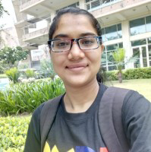 | Sumindar Kaur Saini did B.E in Computer Science and Engineering, and is currently pursuing M.E. in Computer Science and Engineering from University Institute of Engineering and Technology, Panjab University, Chandigarh, India. She has published ten papers in an International journals and conferences with 82 citations in Google Scholar (having an h-index of 4, i10-index of 2). In the field of engineering, her research interests include machine learning, deep learning, medical image processing of cancerous images, data analysis, autonomous object detection and micro-quadcopter-based search and rescue operations.
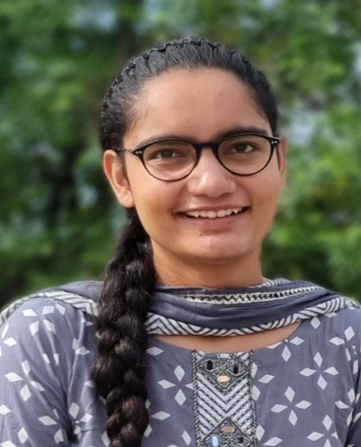 | Harleen Kaur is pursuing her B.E. in Computer Science and Engineering from University Institute of Engineering and Technology, Panjab University, Chandigarh. Currently she is in 6th semester of B.E. Her research interests include medical image processing of cancerous images, machine learning, deep learning.  She is currently working as a research intern at Design Innovation Centre (DIC) funded by MHRD.
 | Rishabh Verma is a pre-final year student at University Institute of Engineering and Technology, Punjab University pursuing Bachelor's degree in Informative Technology. He is a web and Ai enthusiast who has worked on many projects in both the fields in deep learning including image processing, image processing and full stack development . He was selected for Flipkart Grid and SIH 2nd round
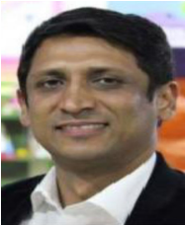 | Dr. Prashant Jindal received his B.Tech., M.Tech. and Ph.D. degree in Mechanical Engineering. He has been into the teaching profession since 2003 and has published many papers in refereed International Journals and conference proceedings. He is working as Assistant Professor in the Department of Mechanical engineering, University Institute of Engineering. & Technology, Panjab University, Chandigarh, India. Currently, he is also working as Commonwealth Rutherford Fellow within the Medical Design Research Group Nottingham Trent University, Nottingham, UK. He is also working on various research projects funded by MHRD and DRDO. His research interest includes Medical devices and Restorative technologies.

