Appendix
Figure A: Hindi Mental State Examination (HMSE)
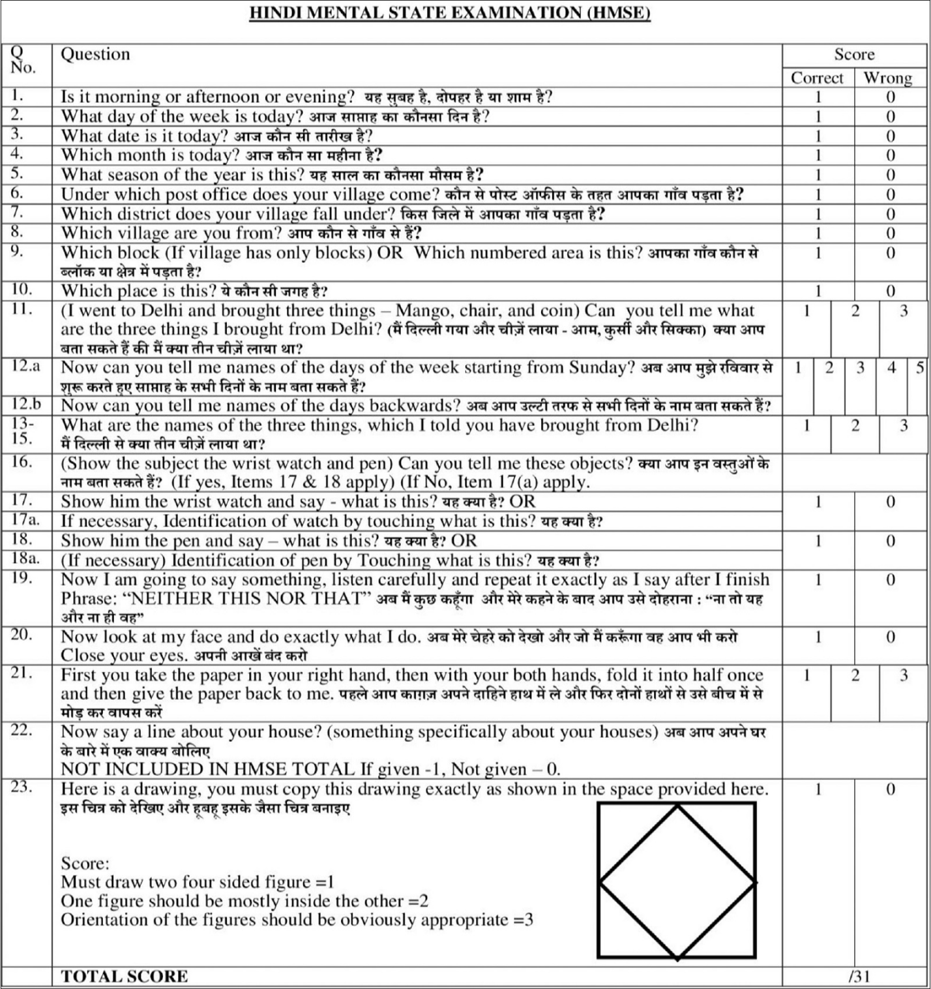

Figure B: Barthel’s index of activities of daily living
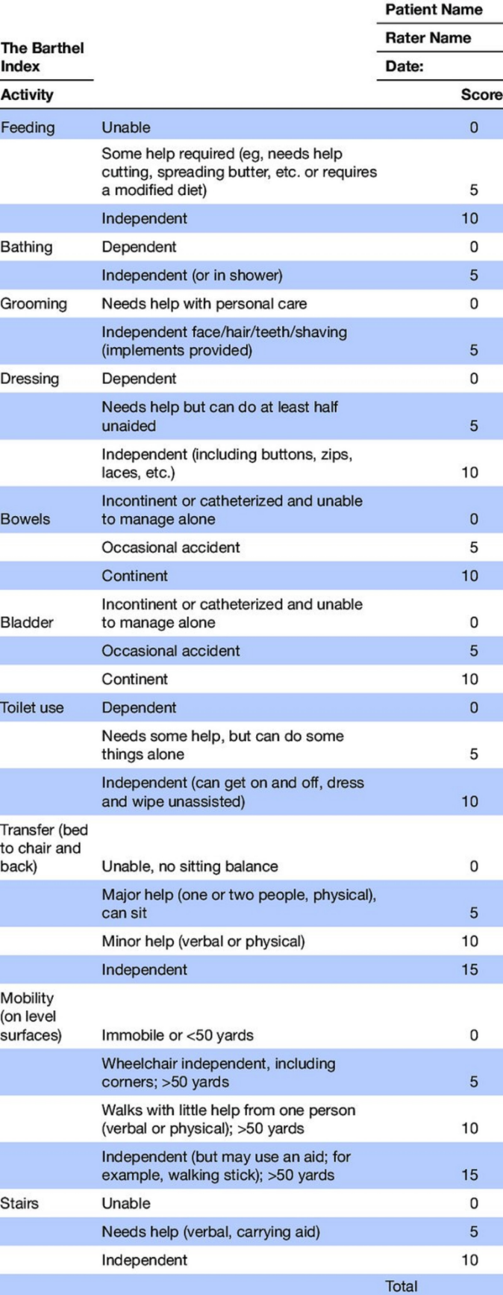

Figure C: Timed up and go test (TUG)

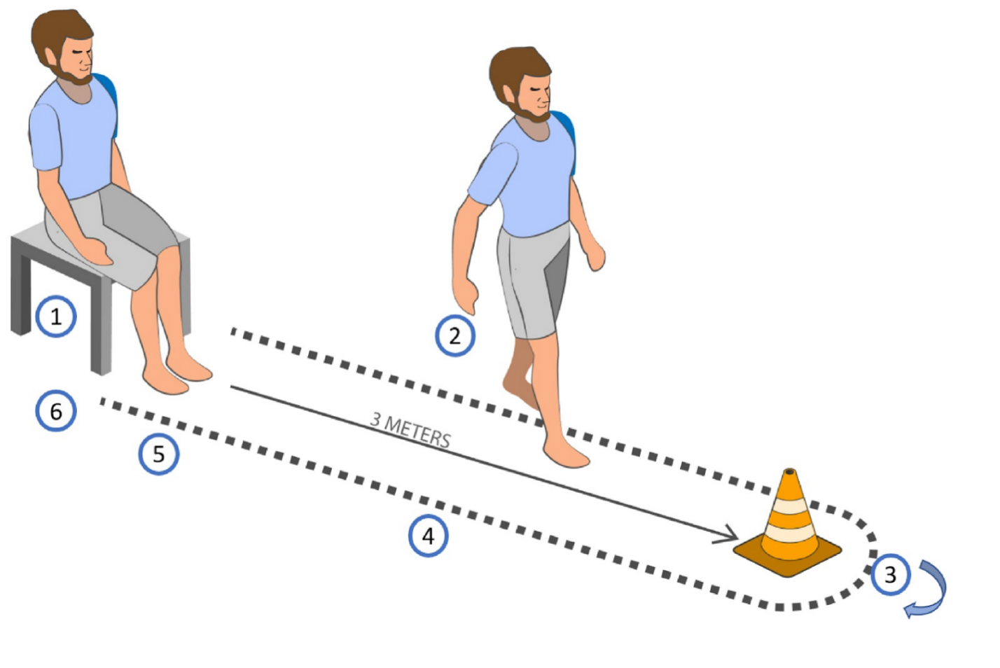

Figure D: Hand dynamometer
