To better reveal the effect of initial packing state of vibrated granular balls, ten groups of differnet initial granular packing states (as shown in FIG.1) are further investigated by vibrating the granular container with same excitation amplitude (1.5mm) but different excitation frequency (15Hz-150Hz). Seven granular motion patterns are obtained in the interested range of excitation frequency, as shown in FIG.2.
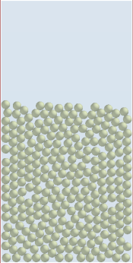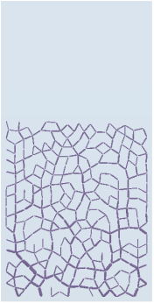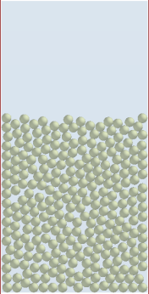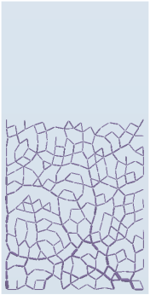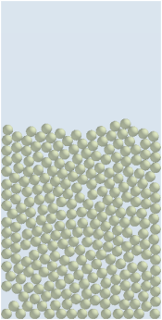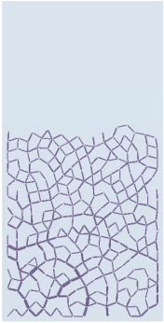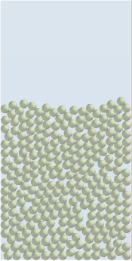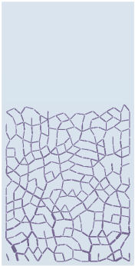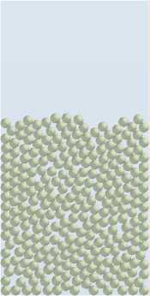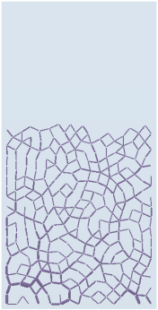
A B C D E
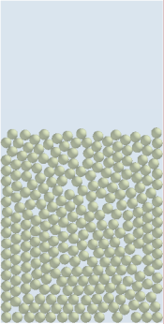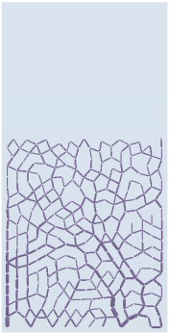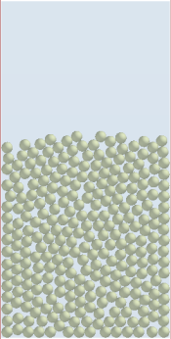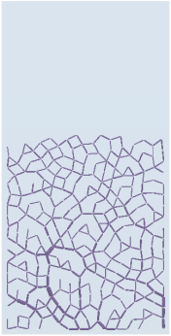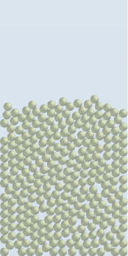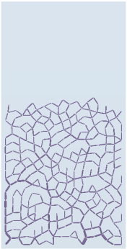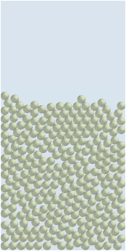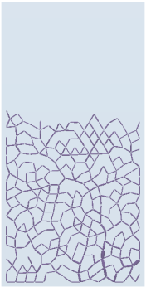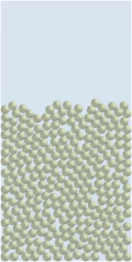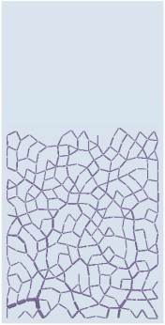
F G H I J
FIG.1 Different initial packing states of granular balls. In every sub-graph, the left one is granular packing structure while the right one is the corresponding force chain network.
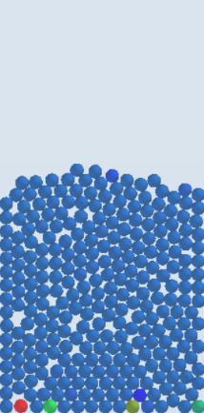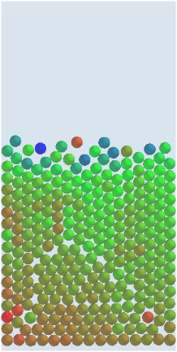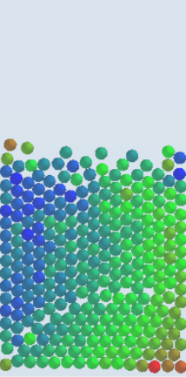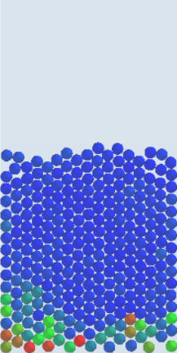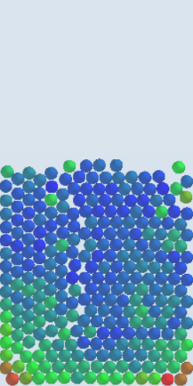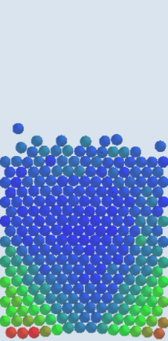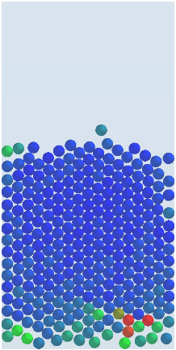
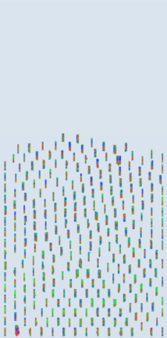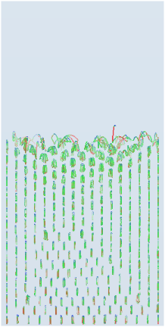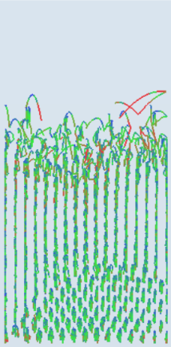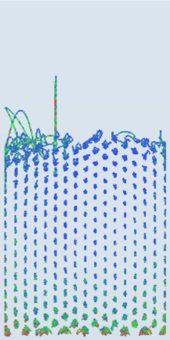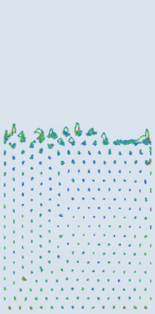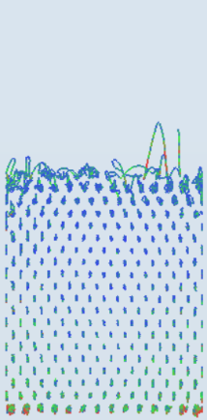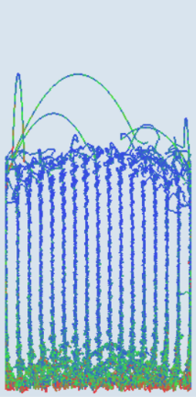
SB () BB () UB () DI () HS () WS () LE ()
FIG.2 Different motion patterns of vibrated granular balls. Here, SB (), BB (), UB (), DI (), WS (), HS () and LE () represents the Solid-like bed, Bouncing bed, Undulation bed, Density inversion, Wave-solid state, Hybrid state (HS) of DI and WS, Leidenfrost effect, respectively. In every sub-graph, the top one is the snapshot of granular bed at the current time, the bottom one is the stream of vibrated granular balls in 10 cycles. The color indicates the instantaneous velocity magnitude of granular balls with blue, green and red representing the lower, middle and higher value respectively.
The changes of motion pattern of vibrated granular balls with the excitation frequency are shown in Table 1 and Table 2. It can be observed by combining TABLE 1 with TABLE 2 that the dynamical behavior of granular balls subjecyed to excitation from 65Hz to 145Hz is significantly affected by their initial packing state, which mainly involves three granular motion patterns before LE (), i.e., DI (), HS () and WS (). From the distribution of these three granular motion patterns in TABLE 2 point of view, DI () doesn't seem to be the only route to LE ().
TABLE 1 Granular motion patterns obtained by vibrating one granular system of same initial granular packing state (IGPS) ten times
Groups | IGPS | Excitation frequency（Hz）
Groups | IGPS | 15 | 20 | 25 | 30 | 35 | 40 | 45 | 50 | 55 | 60 | 65 | 70 | 75 | 80 | 85 | 90 | 95 | 100 | 105 | 110 | 115 | 120 | 125 | 130 | 135 | 140 | 145 | 150
1 | A |  |  |  |  |  |  |  |  |  |  |  |  |  |  |  |  |  |  |  |  |  |  |  |  |  |  |  | 
2 | A
3 | A
4 | A
5 | A
6 | A
7 | A
8 | A
9 | A
10 | A
TABLE 2 Granular motion patterns obtained by vibrating ten granular systems of differnet initial granular packing states (IGPSs)
Groups | IGPSs | Excitation frequency（Hz）
Groups | IGPSs | 15 | 20 | 25 | 30 | 35 | 40 | 45 | 50 | 55 | 60 | 65 | 70 | 75 | 80 | 85 | 90 | 95 | 100 | 105 | 110 | 115 | 120 | 125 | 130 | 135 | 140 | 145 | 150
1 | A
2 | B
3 | C
4 | D
5 | E
6 | F
7 | G
8 | H
9 | I
10 | J
The changes of dissipation characteristics of vibrated granular balls with the excitation frequency are shown in FIG.3 and FIG.4. It can be observed that the dissipation characteristics of vibrated granular balls is affected by their initial packing state, where the potential energy of vibrated granular balls is most sensitive to the initial granular packing state. On the whole, the larger the excitation frequency, the more significant the effect of the initial packing state of granulr balls.
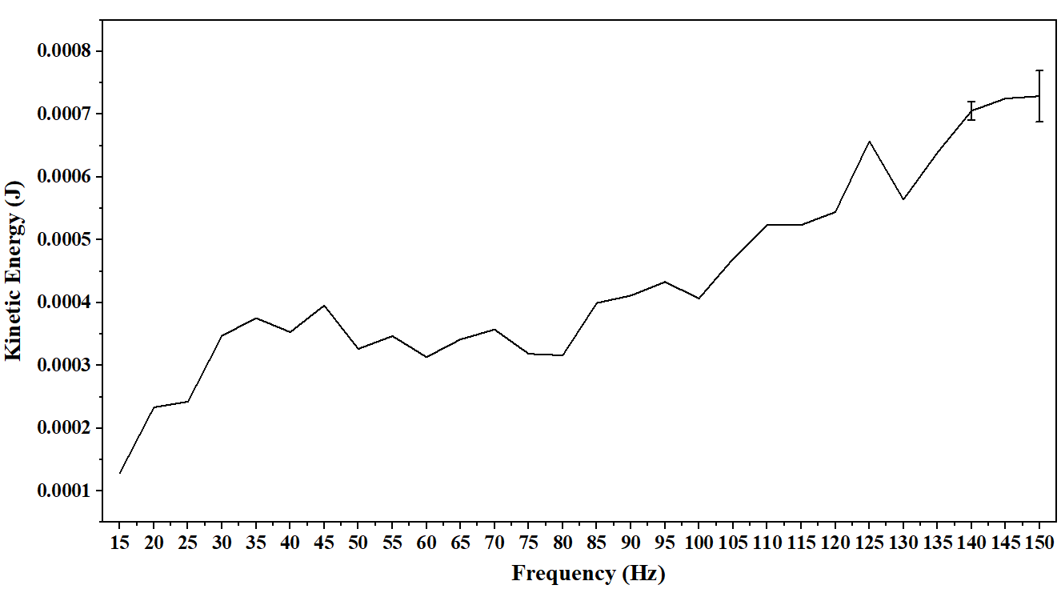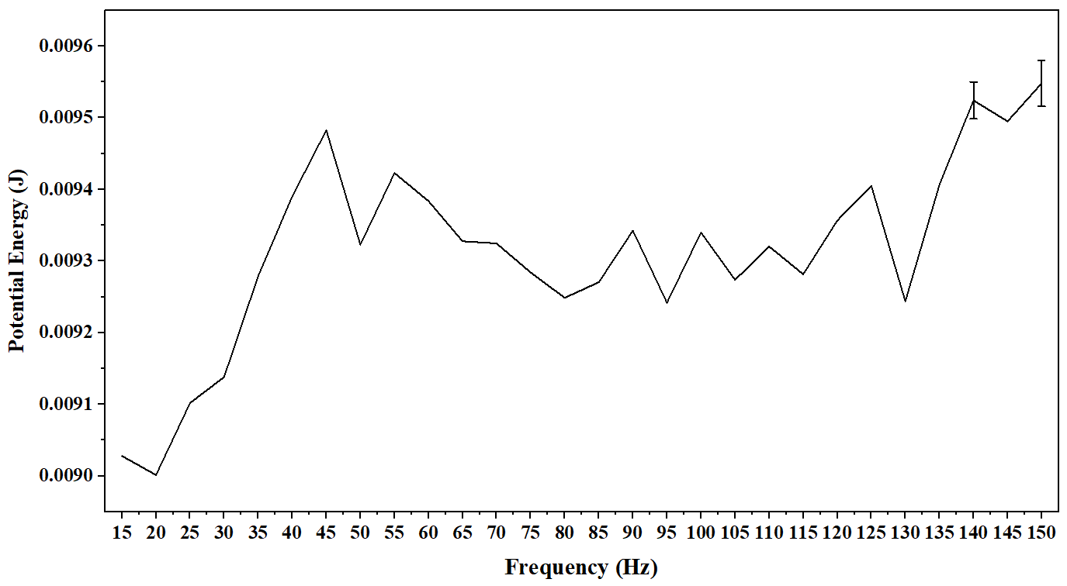
(a) (b)
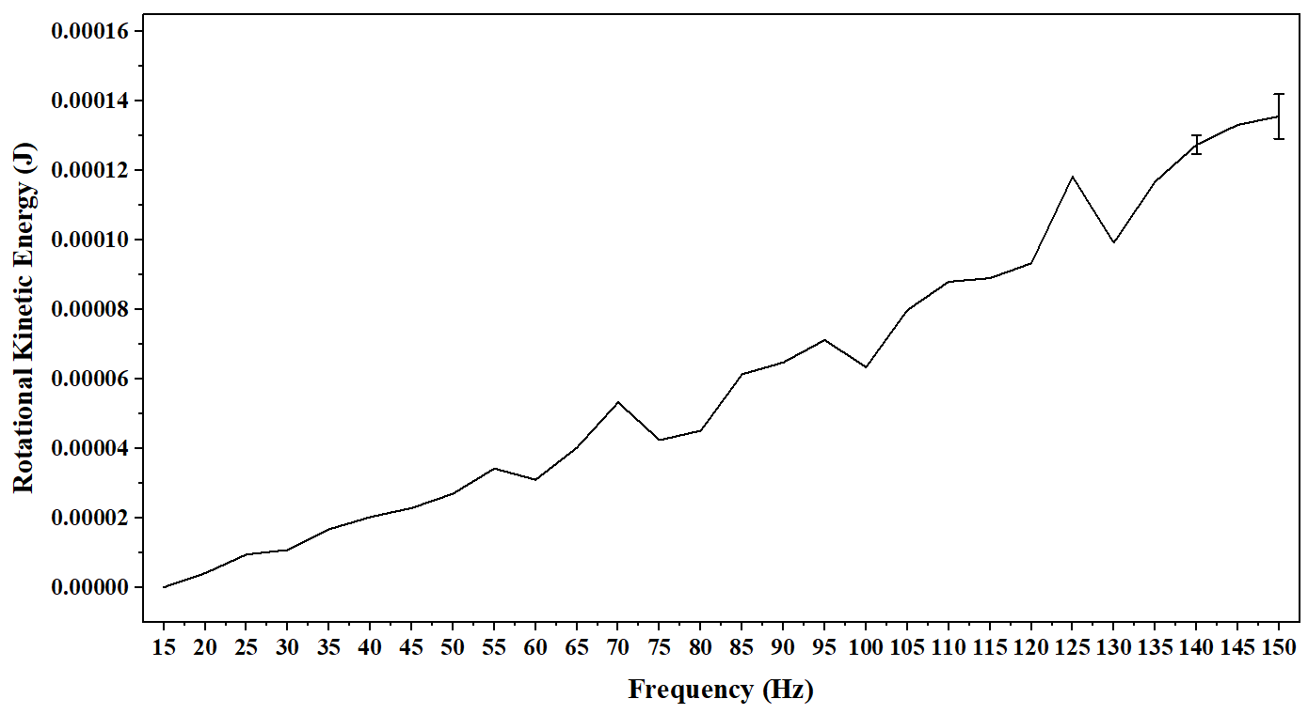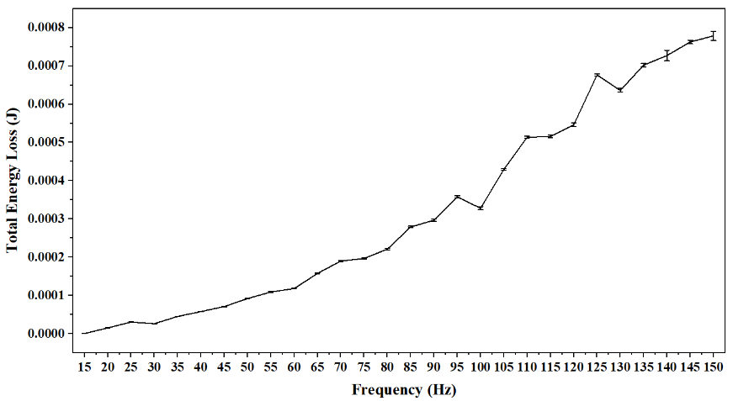
(c) (d)
FIG.3 Dissipation characteristics of vibrated granular balls. Here, (a), (b), (c) and (d) are respectively the root mean square difference curves of translational kinetic energy, potential energy, rotational kinetic energy and total energy loss of granular balls obtained by vibrating one granular system of same initial granular packing state ten times.
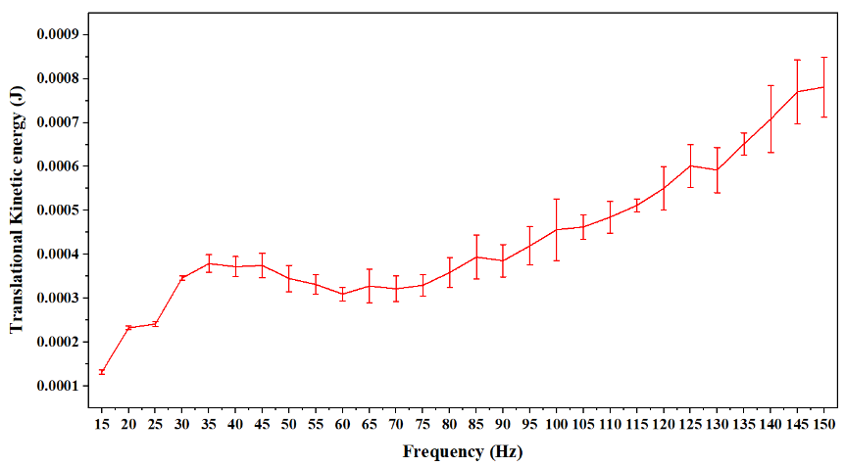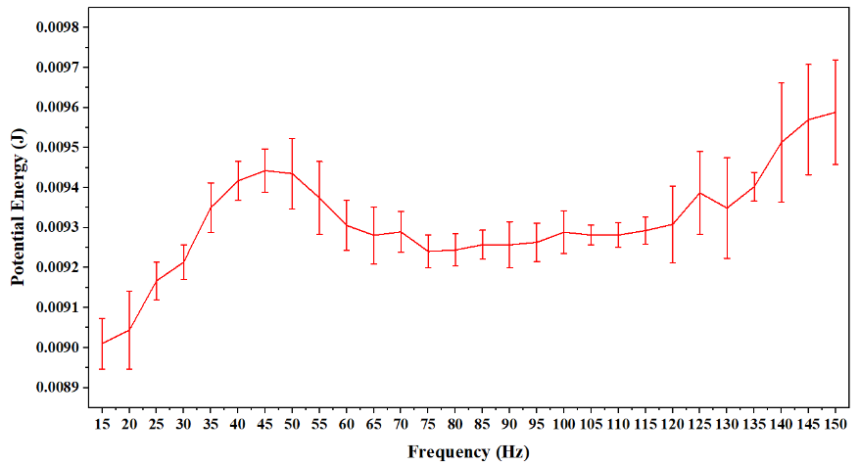
(a) (b)
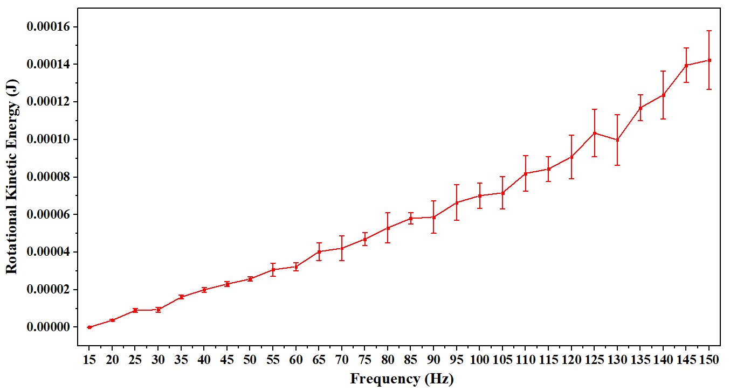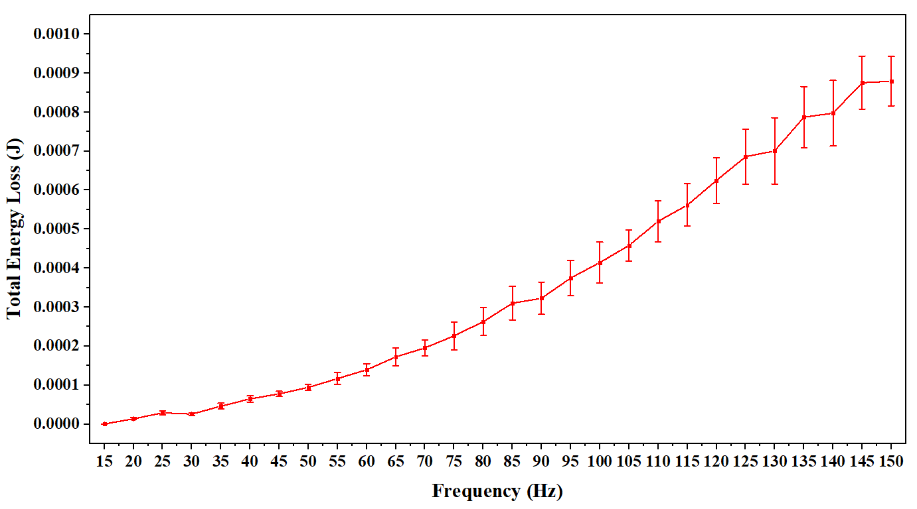
(c) (d)
FIG.4 Dissipation characteristics of vibrated granular balls. Here, (a), (b), (c) and (d) are respectively the root mean square difference curves of translational kinetic energy, potential energy, rotational kinetic energy and total energy loss of granular balls obtained by vibrating ten granular systems of differnet initial granular packing states.

