On the interfacial deformations and thermal characteristics exhibiting self-similar behavior under the action of a line heat source
Supplementary Information

S1. Variation of wire temperature
Fig S1 depicts the transient variation of the temperature of the wire placed at depth L from the air-liquid interface for different heating rates Q. It is evident that the wire temperature T_{w} increases with the heating power and distinct temperature profiles are seen for different heating values for all pool depths. The temperature increases sharply at the onset of power input to the wire (t ≈10 s) and continues to increase at a steady rate till t ≈ 120 s for all the cases. It is observed that the wire temperature decreases with the increasing depth from the interface as the maximum wire temperatures are seen for L = 1 mm [Fig S1(a)] and the lowest in the case of L = 7 mm [Fig S1(d)]. This is indicative of the fact that, at any given heating rate, heat dissipation from the wire increases as its depth from the interface increases.
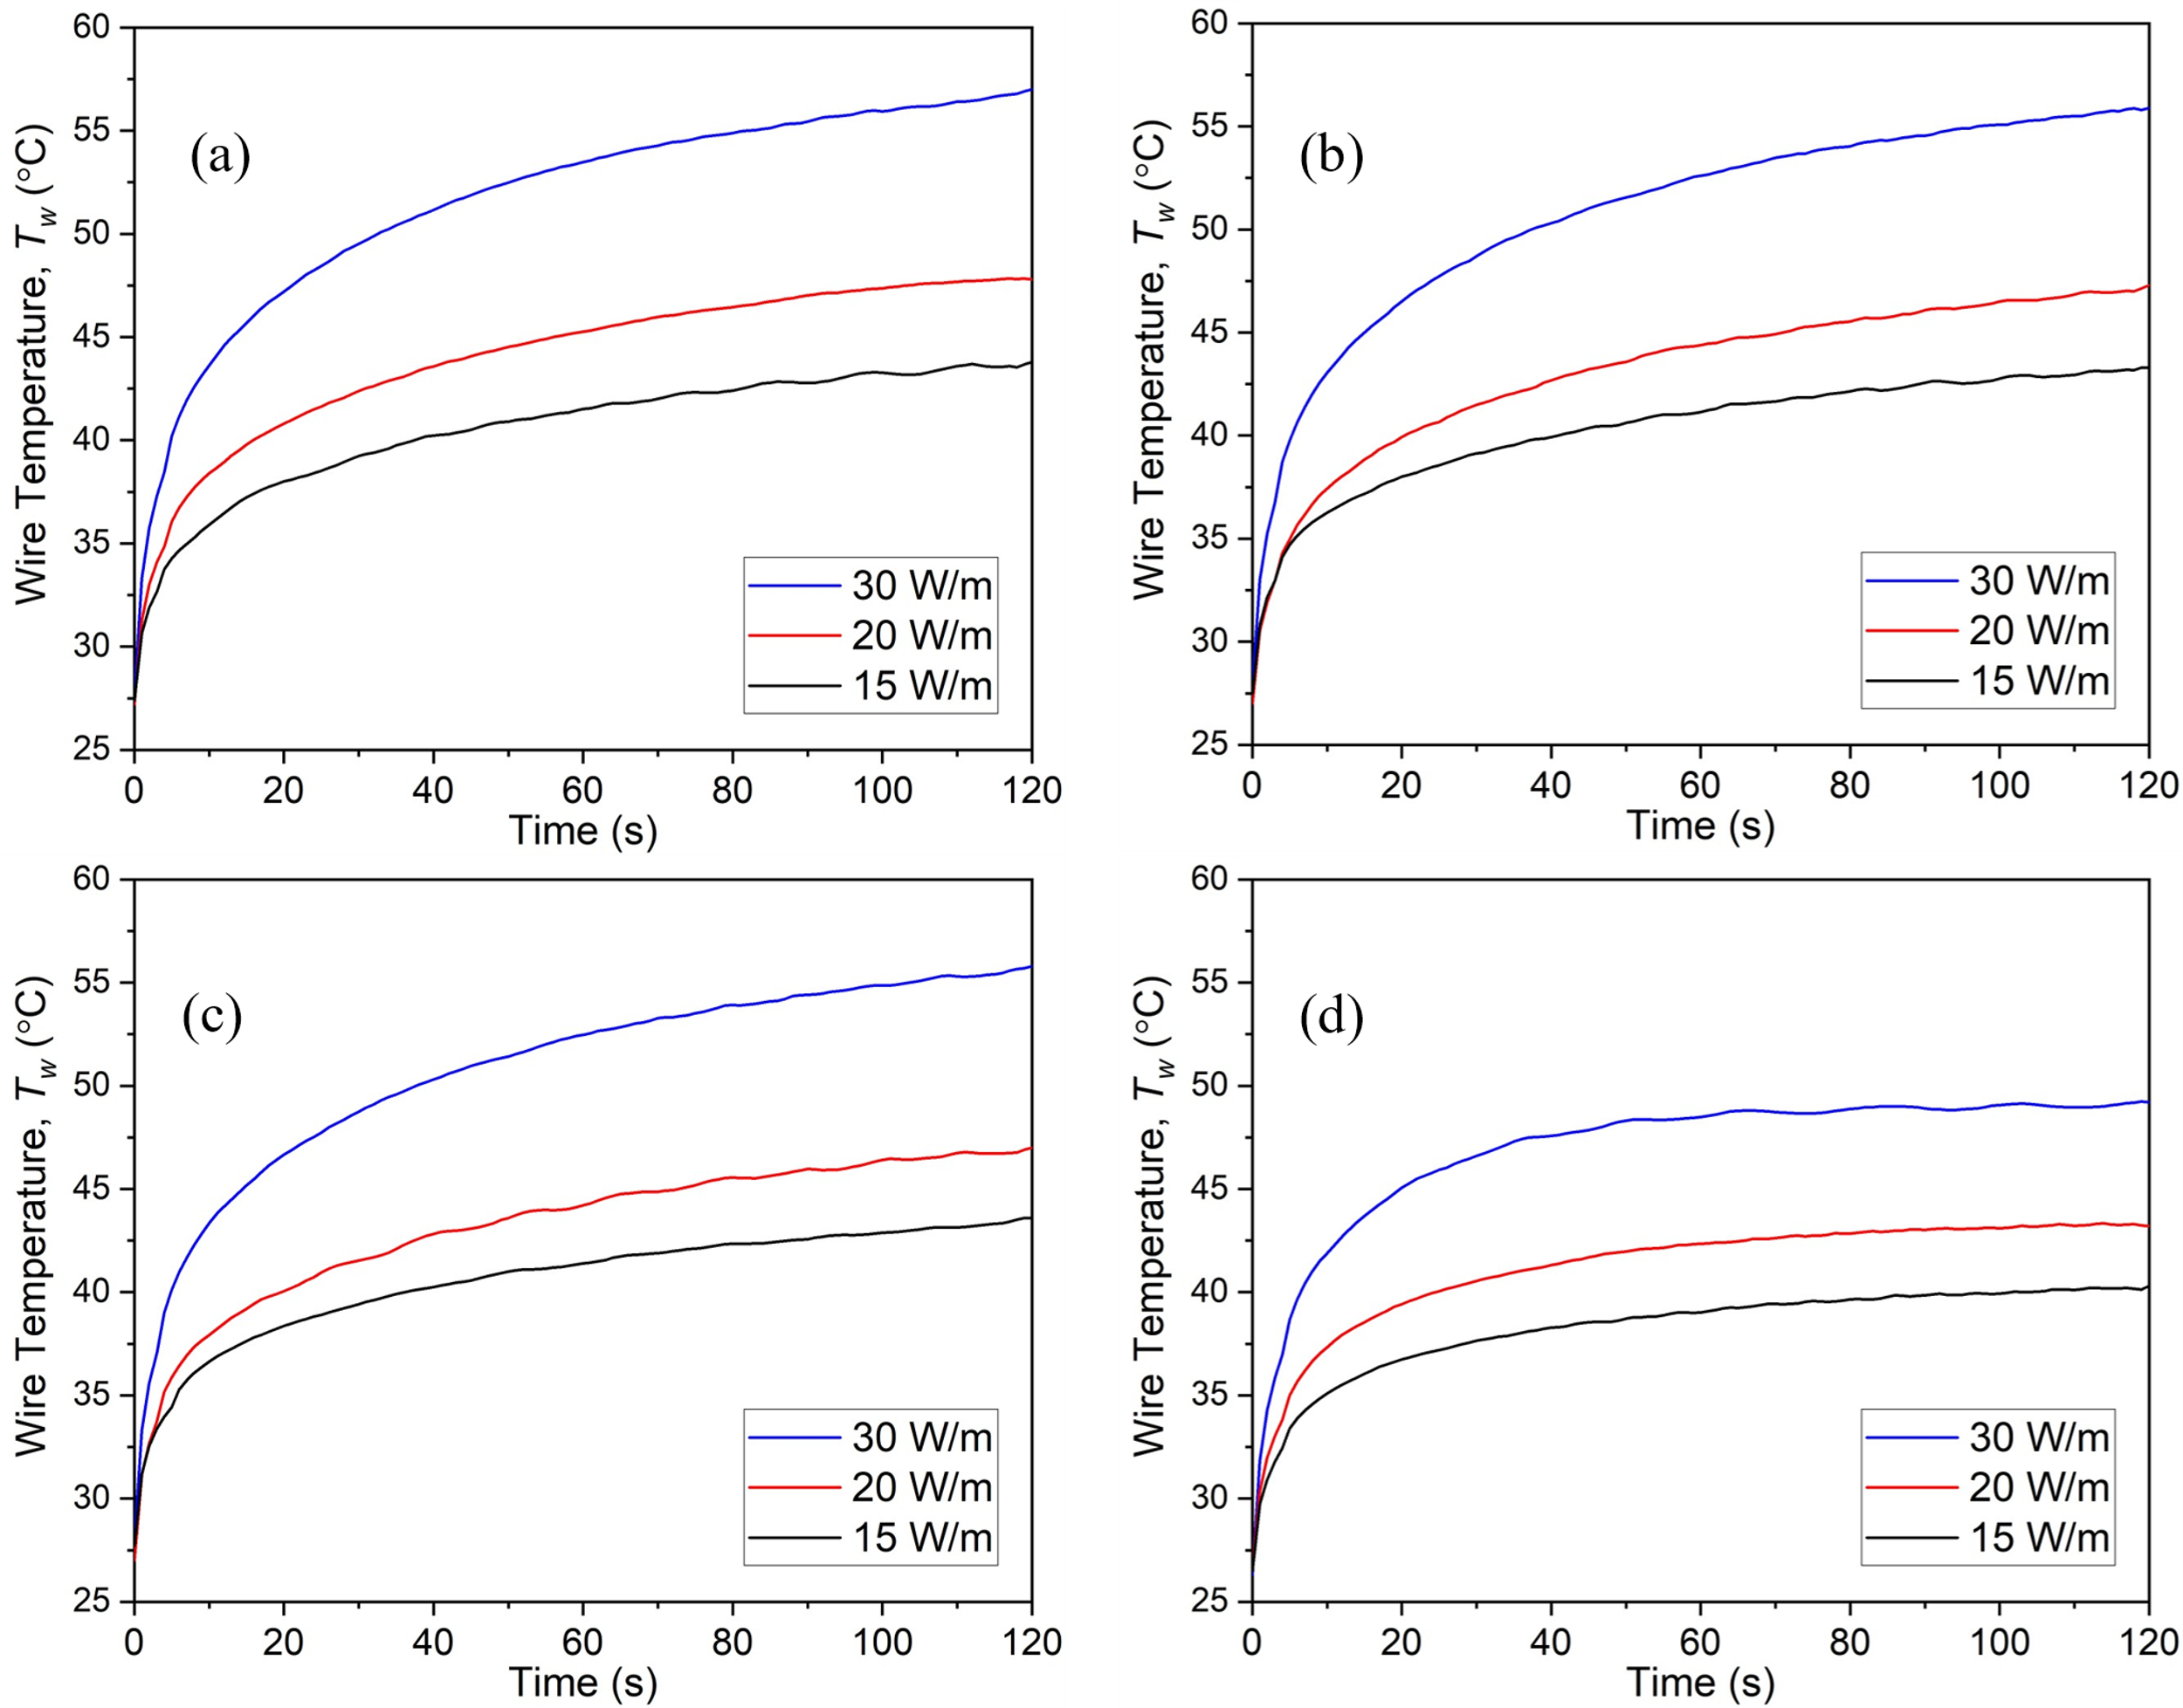
Fig S1. Transient evolution of the wire temperature at different heating rate (Q) for wire depths of a) L = 1 mm b) L = 2 mm c) L = 3 mm and d) L = 7 mm

S2. Temperature difference between the wire and the interface
The phenomenon of interface deformation is driven by the temperature difference (ΔT) between the wire and the interface, expressed as
Here T_{w} is the wire temperature and T_{int} is the temperature of the interface region located directly above the wire at any given time instant t. The experimentally recorded variation of temperature difference ΔT between the wire and the interface with time is shown in Fig S2.
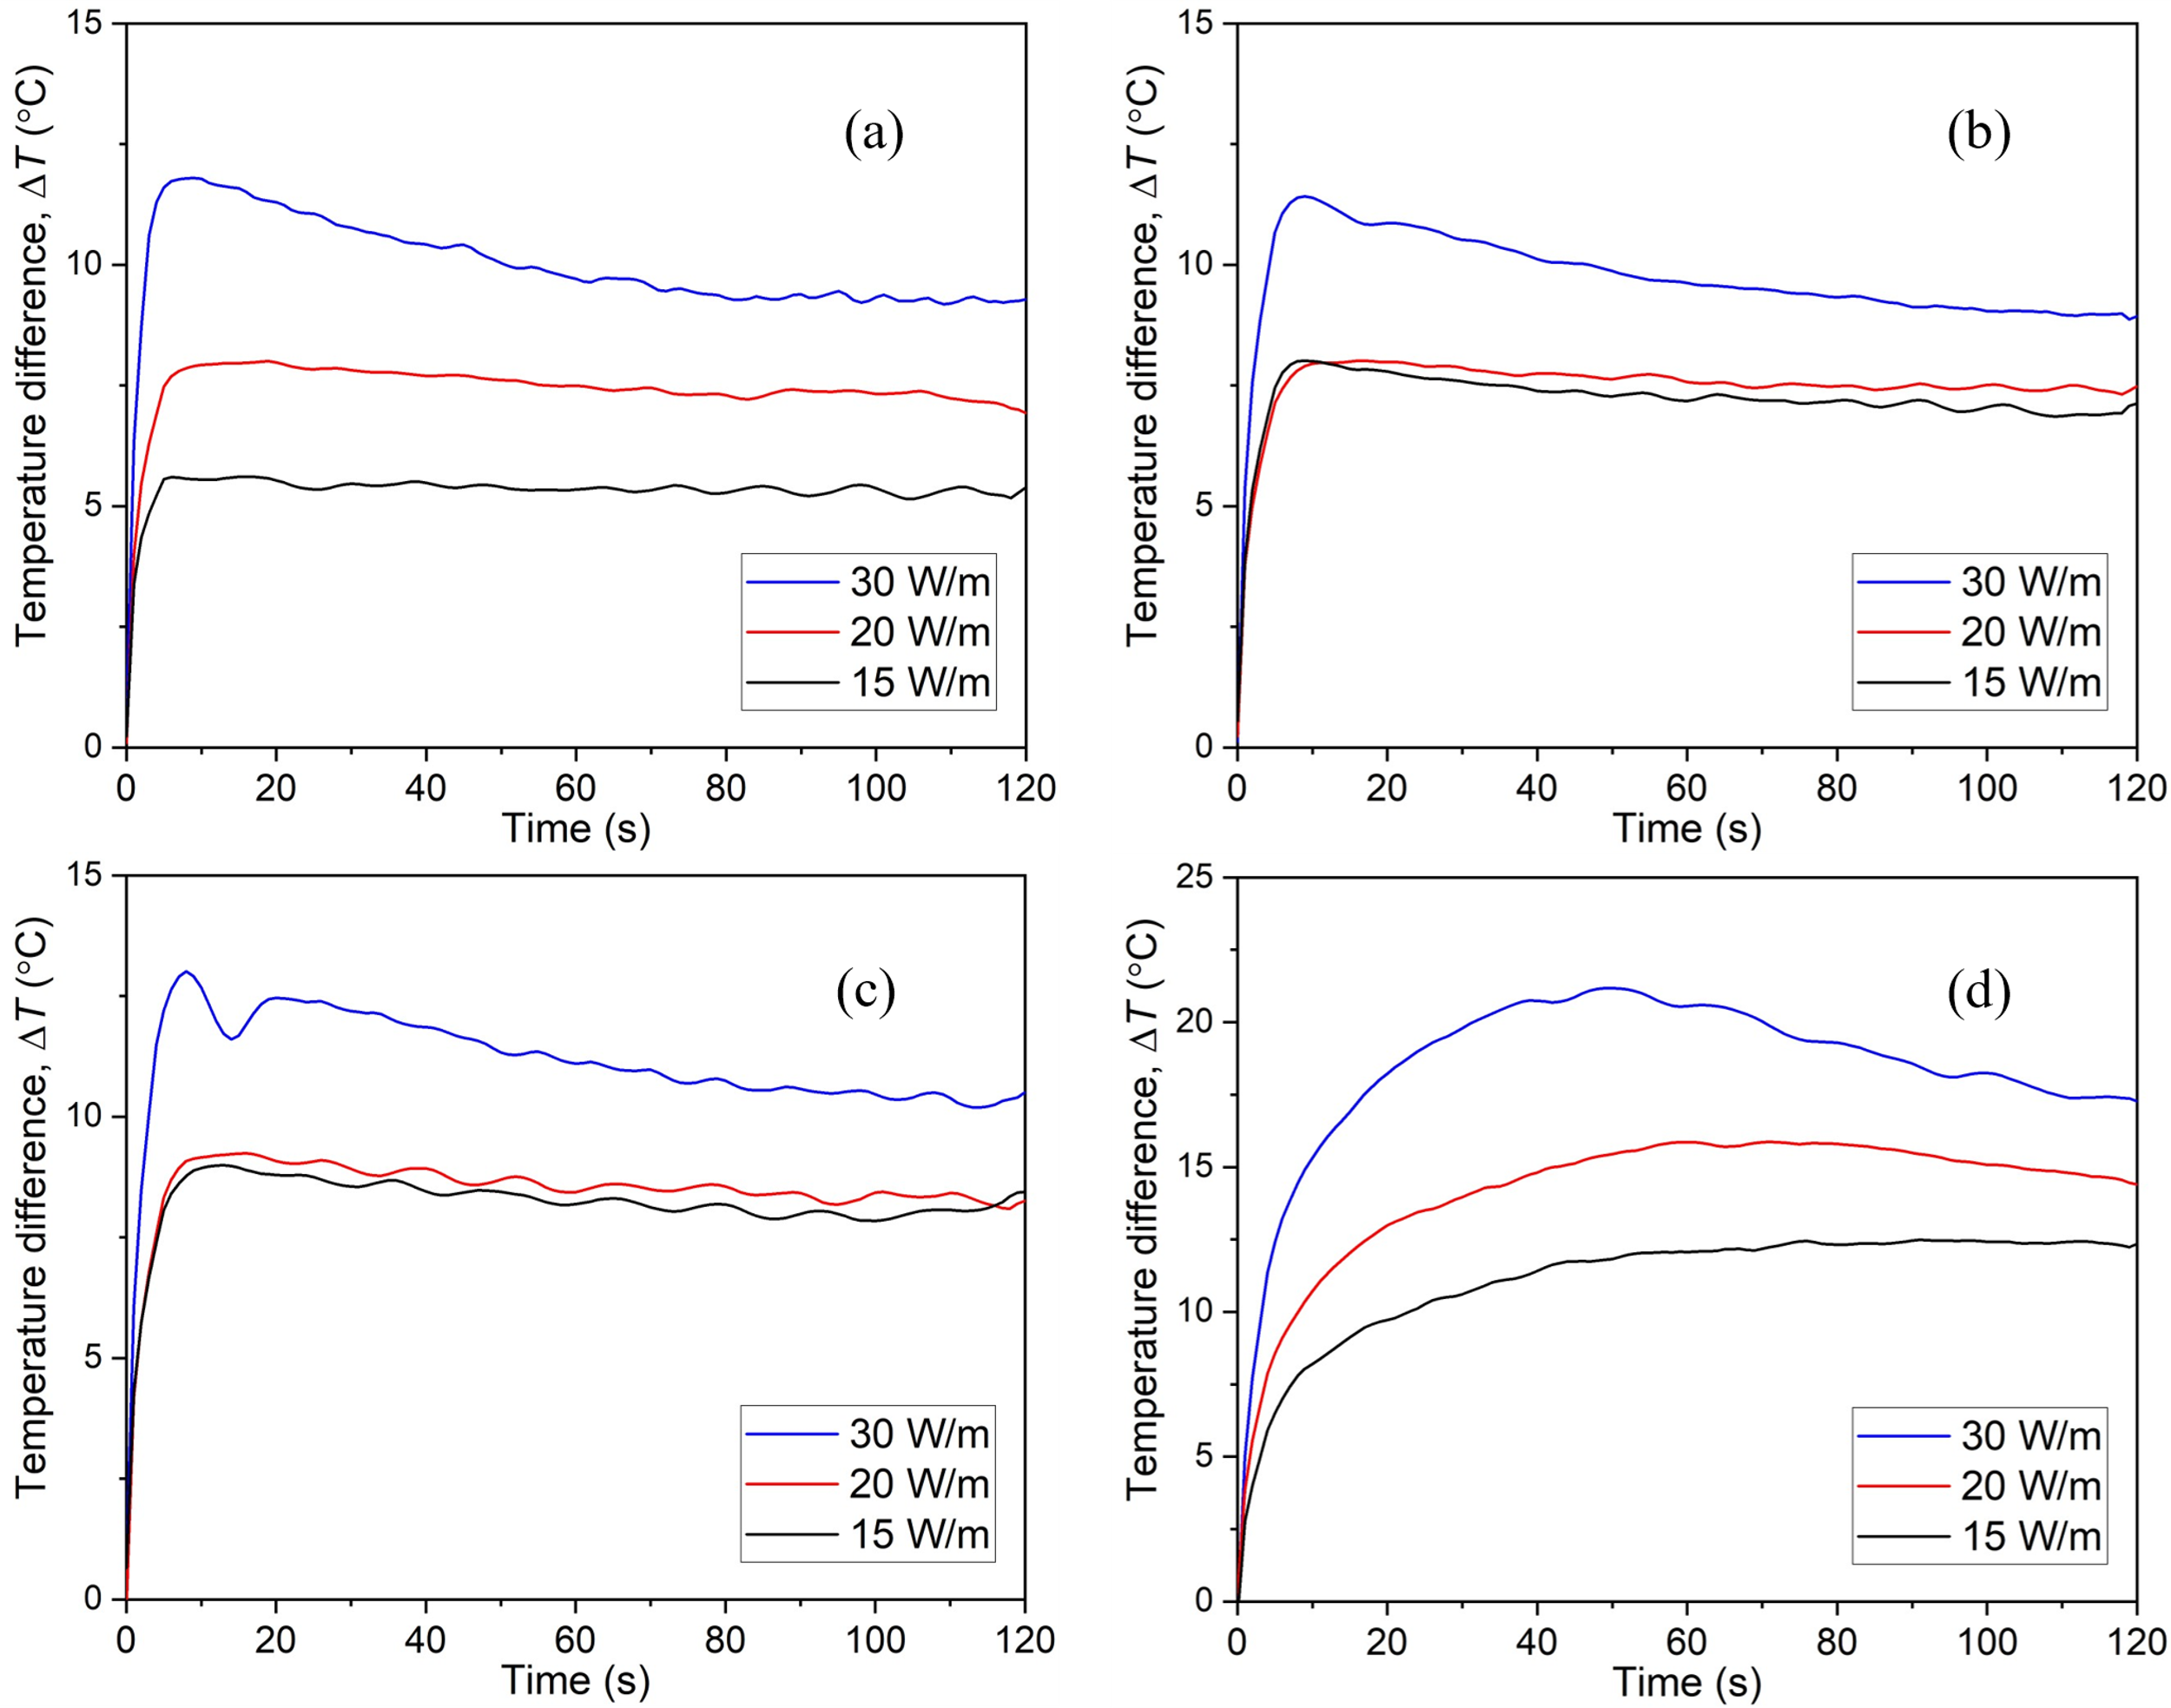
Fig S2. Transient variation of temperature difference between the wire and interface for different heating rate Q at wire depths a) L = 1 mm b) L = 2 mm c) L = 3 mm and d) L = 7 mm
It can be observed that the temperature difference (ΔT) between the wire and the interface decreases with time even though the temperature of the wire increases. This is to be attributed to the heat transfer from the wire to the liquid and thus, to the interface with time, as the system approaches steady state. Distinctively different trends in the temperature difference (ΔT) profiles are seen for the case of L = 7 mm compared to the other wire depths. For the cases of L = 1, 2 and 3 mm, the peak temperature difference is seen at t ≈ 10 s, which is the same time instant t where a sharp increase in the wire temperature is observed in Fig S1. On the other hand, the peak temperature difference is observed at a much later time instant (t ≈ 50 s) for all heating rates in the case of L = 7 mm. This is due to the fact that the heat transfer to the interface takes place over a larger distance for the case of L = 7 mm and thus takes a larger time for the increase in the interface temperature, as shown in Fig 9(d).
Fig S2(a) shows temperature difference (ΔT) profiles at varying heating rates for L = 1mm. The wire depths of L = 2 and 3mm exhibit similar profiles, and the temperature differences at heating rates of Q = 15 and 20 W/m are also comparable. Due to the increased depth of wire from the interface in the cases of L = 2 and 3 mm, the heat transfer to the interface is delayed. As a result, a larger temperature difference (ΔT) is observed at Q = 15 W/m in the cases of L = 2 and 3 mm. This delay is even more prominent in the case of L = 7 mm, leading to a larger temperature difference between the interface and the wire during the process [Fig S2(d)]. It should be noted that convection velocity u_{conv} (given in Equation 4) follows similar trends as the temperature gradient (ΔT), as it is a linear function of the temperature gradient.

S3. Competing mechanisms of heat transfer
Given the range of temperature levels associated with the experiments reported, the plausible primary modes of heat dissipation that are at interplay include conduction and convective phenomena. Due to high viscosity of the aqueous glycerol solution employed as the working fluid, it is expected that the viscous effects would tend to retard/resist any possible buoyancy-induced bulk fluid movement (that manifests itself into natural convection currents) and hence the heat transfer between the line source and the interface would be predominantly conductive through the intermediate fluid layers. For any given heat input, this becomes particularly important at low depths of the wire from the interface. However, at higher wire depths, the increasing potential allows the buoyant forces to overcome the viscous retarding effects, leading to the onset of (buoyancy-driven) bulk fluid movement and hence convective currents within the differentially heated volume of the fluid layers. Natural convection sets in and dominates the mode of heat dissipation. In order to characterize these natural convection effects, the Rayleigh number (Ra) is quantified for the different cases of wire positions and heating power.
Rayleigh number (Ra) is defined as the ratio of the timescale for diffusive heat transport via conduction (τ_{cond}) to the timescale for convective heat transport (τ_{conv}) and is given as
The timescale for diffusion or conduction heat transport (τ_{cond}) from the wire at depth L to the interface can be written as
where, α is the thermal diffusivity of the aqueous glycerol solution used in the study. The timescale for convective heat transfer is derived from the convection velocity (u_{conv}) given in Equation 4 of the main text and can be written as
Thus, from Equations S3 and S4, Rayleigh number Ra is defined as:
Based on Equation S5, the evolution of the Rayleigh number with time at different heating rates and wire depths is shown in Fig S3, and the average Rayleigh number at different wire depths and heating rates is depicted in Fig S4. It is evident from Fig S3 that the Rayleigh number increases with time for all cases of wire depth and heating rates. It should be noted that viscosity (μ) being an inverse function of temperature, decreases exponentially as the average temperature of the liquid layer between the wire and the interface increases (Cheng 2008; Volk and Kähler 2018). As a result, the Rayleigh number increases (at Q = 30 W/m) or remains more or less constant (at Q = 15 and 20 W/m) despite the decrease in the driving temperature difference (ΔT) between the wire and the interface. It can be seen in Fig S4 that the average Rayleigh number is very low (Ra < 4) for a wire depth of L = 1 mm. As discussed earlier, the high viscosity of the fluid as well as the close proximity of the heated wire to the interface lead to comparable heat transfer through conduction and convection, which is reflected in the lower range of Rayleigh number at L = 1 mm. As the distance between the wire and the interface increases, the increased potential allows the buoyancy effects to overcome the viscous forces and thus, convection heat transfer becomes more prominent. This behavior is reflected in quantitative terms in the form of rise of Rayleigh number as the wire depth increases (Fig S4). Compared to wire depths of L = 1, 2 and 3 mm, significantly larger values of Rayleigh number are observed at L = 7 mm, which suggest that convective currents are majorly responsible for the heat transfer in this case. Due to these strong convective currents, a three-dimensional flow field is established, which results in asymmetric interfacial deformations. The trends in the Rayleigh number are in line with the observations made above (see section S1), as the wire temperature is the lowest in the case of wire at L = 7 mm, indicating higher rates of heat transfer from the wire (through convection) and thus, higher Rayleigh number.
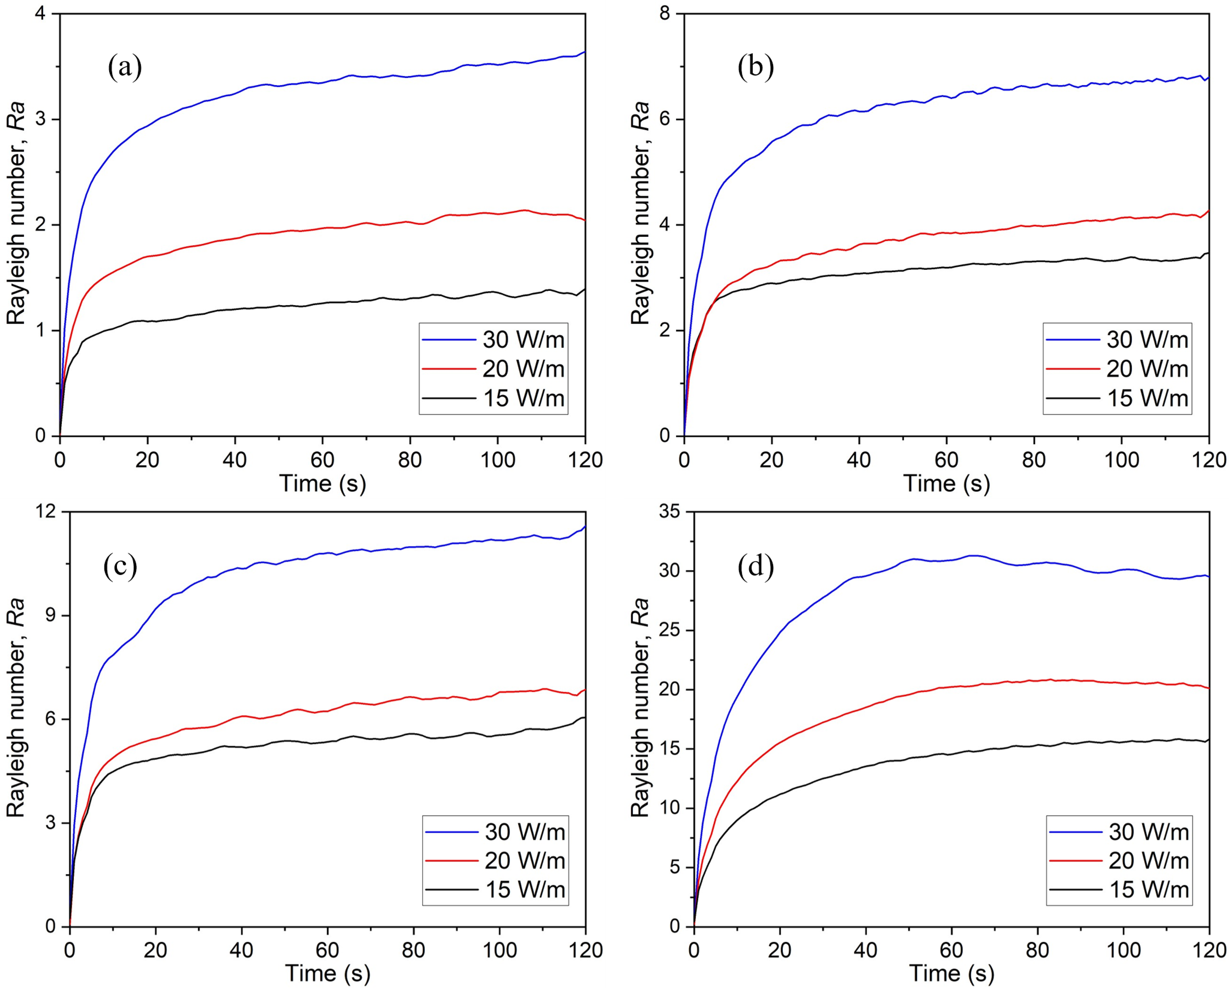
Fig S3. Rayleigh number variations with time at different heating rate Q for wire depths a) L = 1 mm b) L = 2 mm c) L = 3 mm and d) L = 7 mm
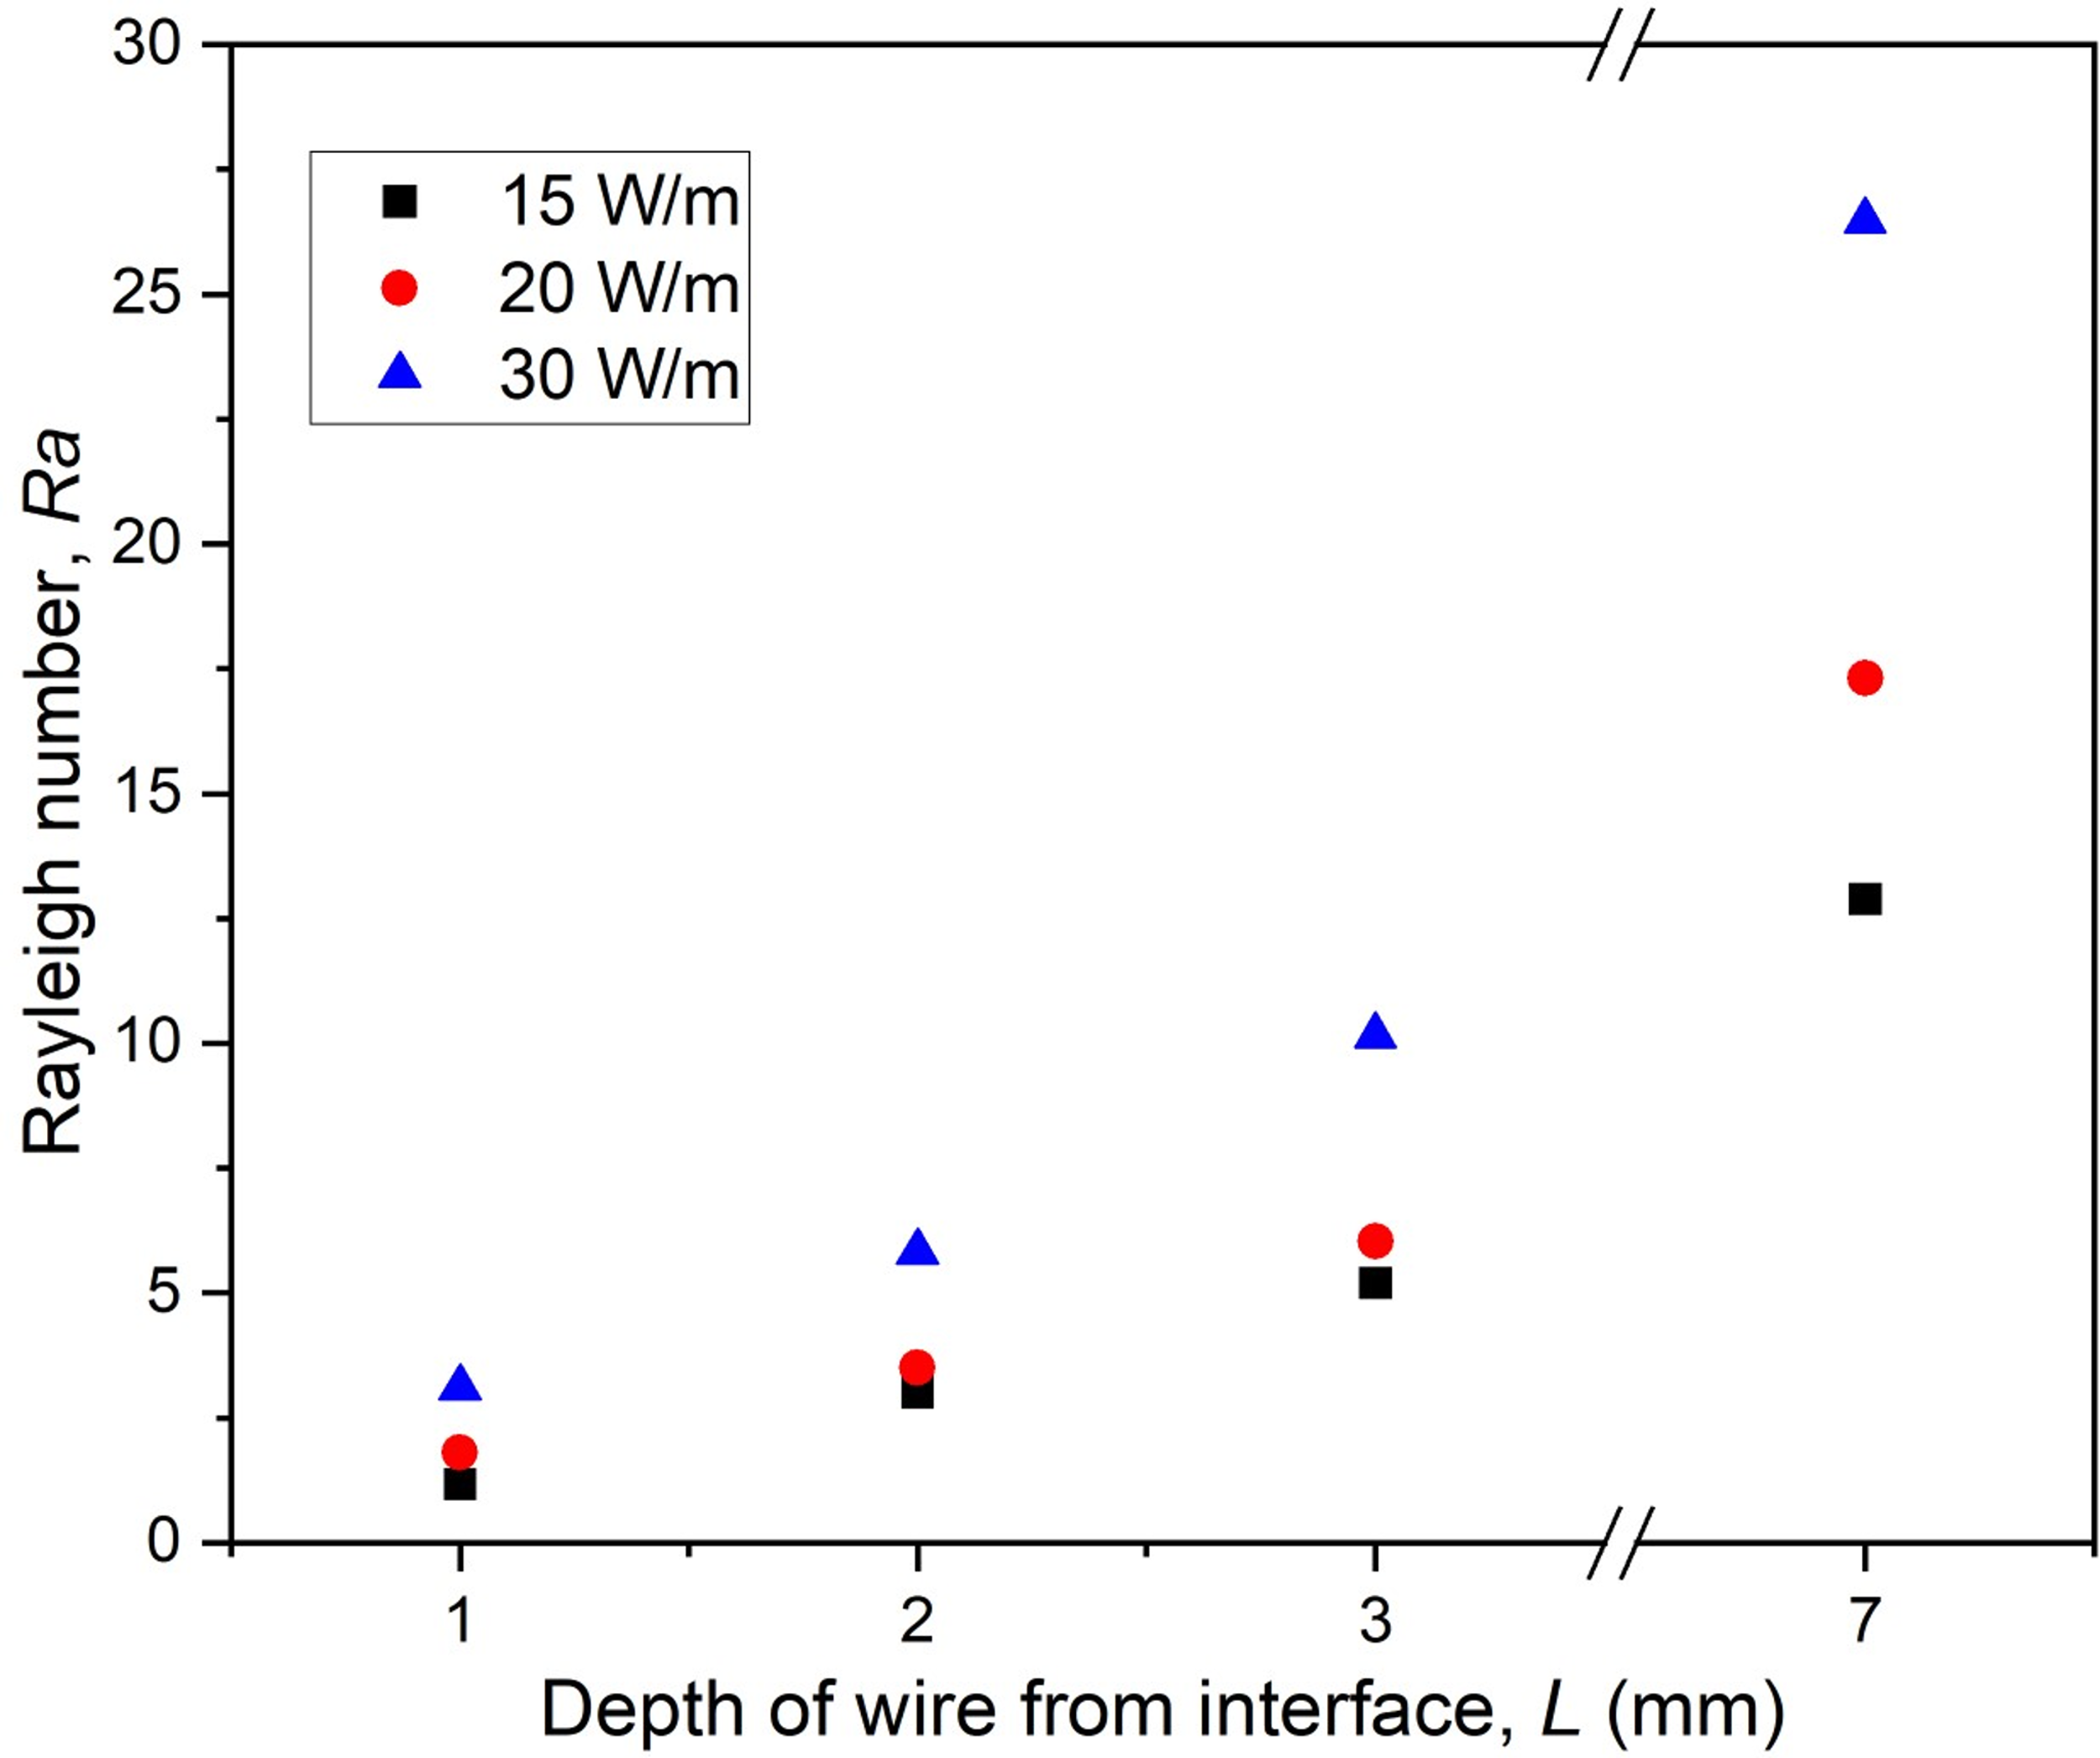
Fig S4. Time average Rayleigh number at different heating powers and wire depths
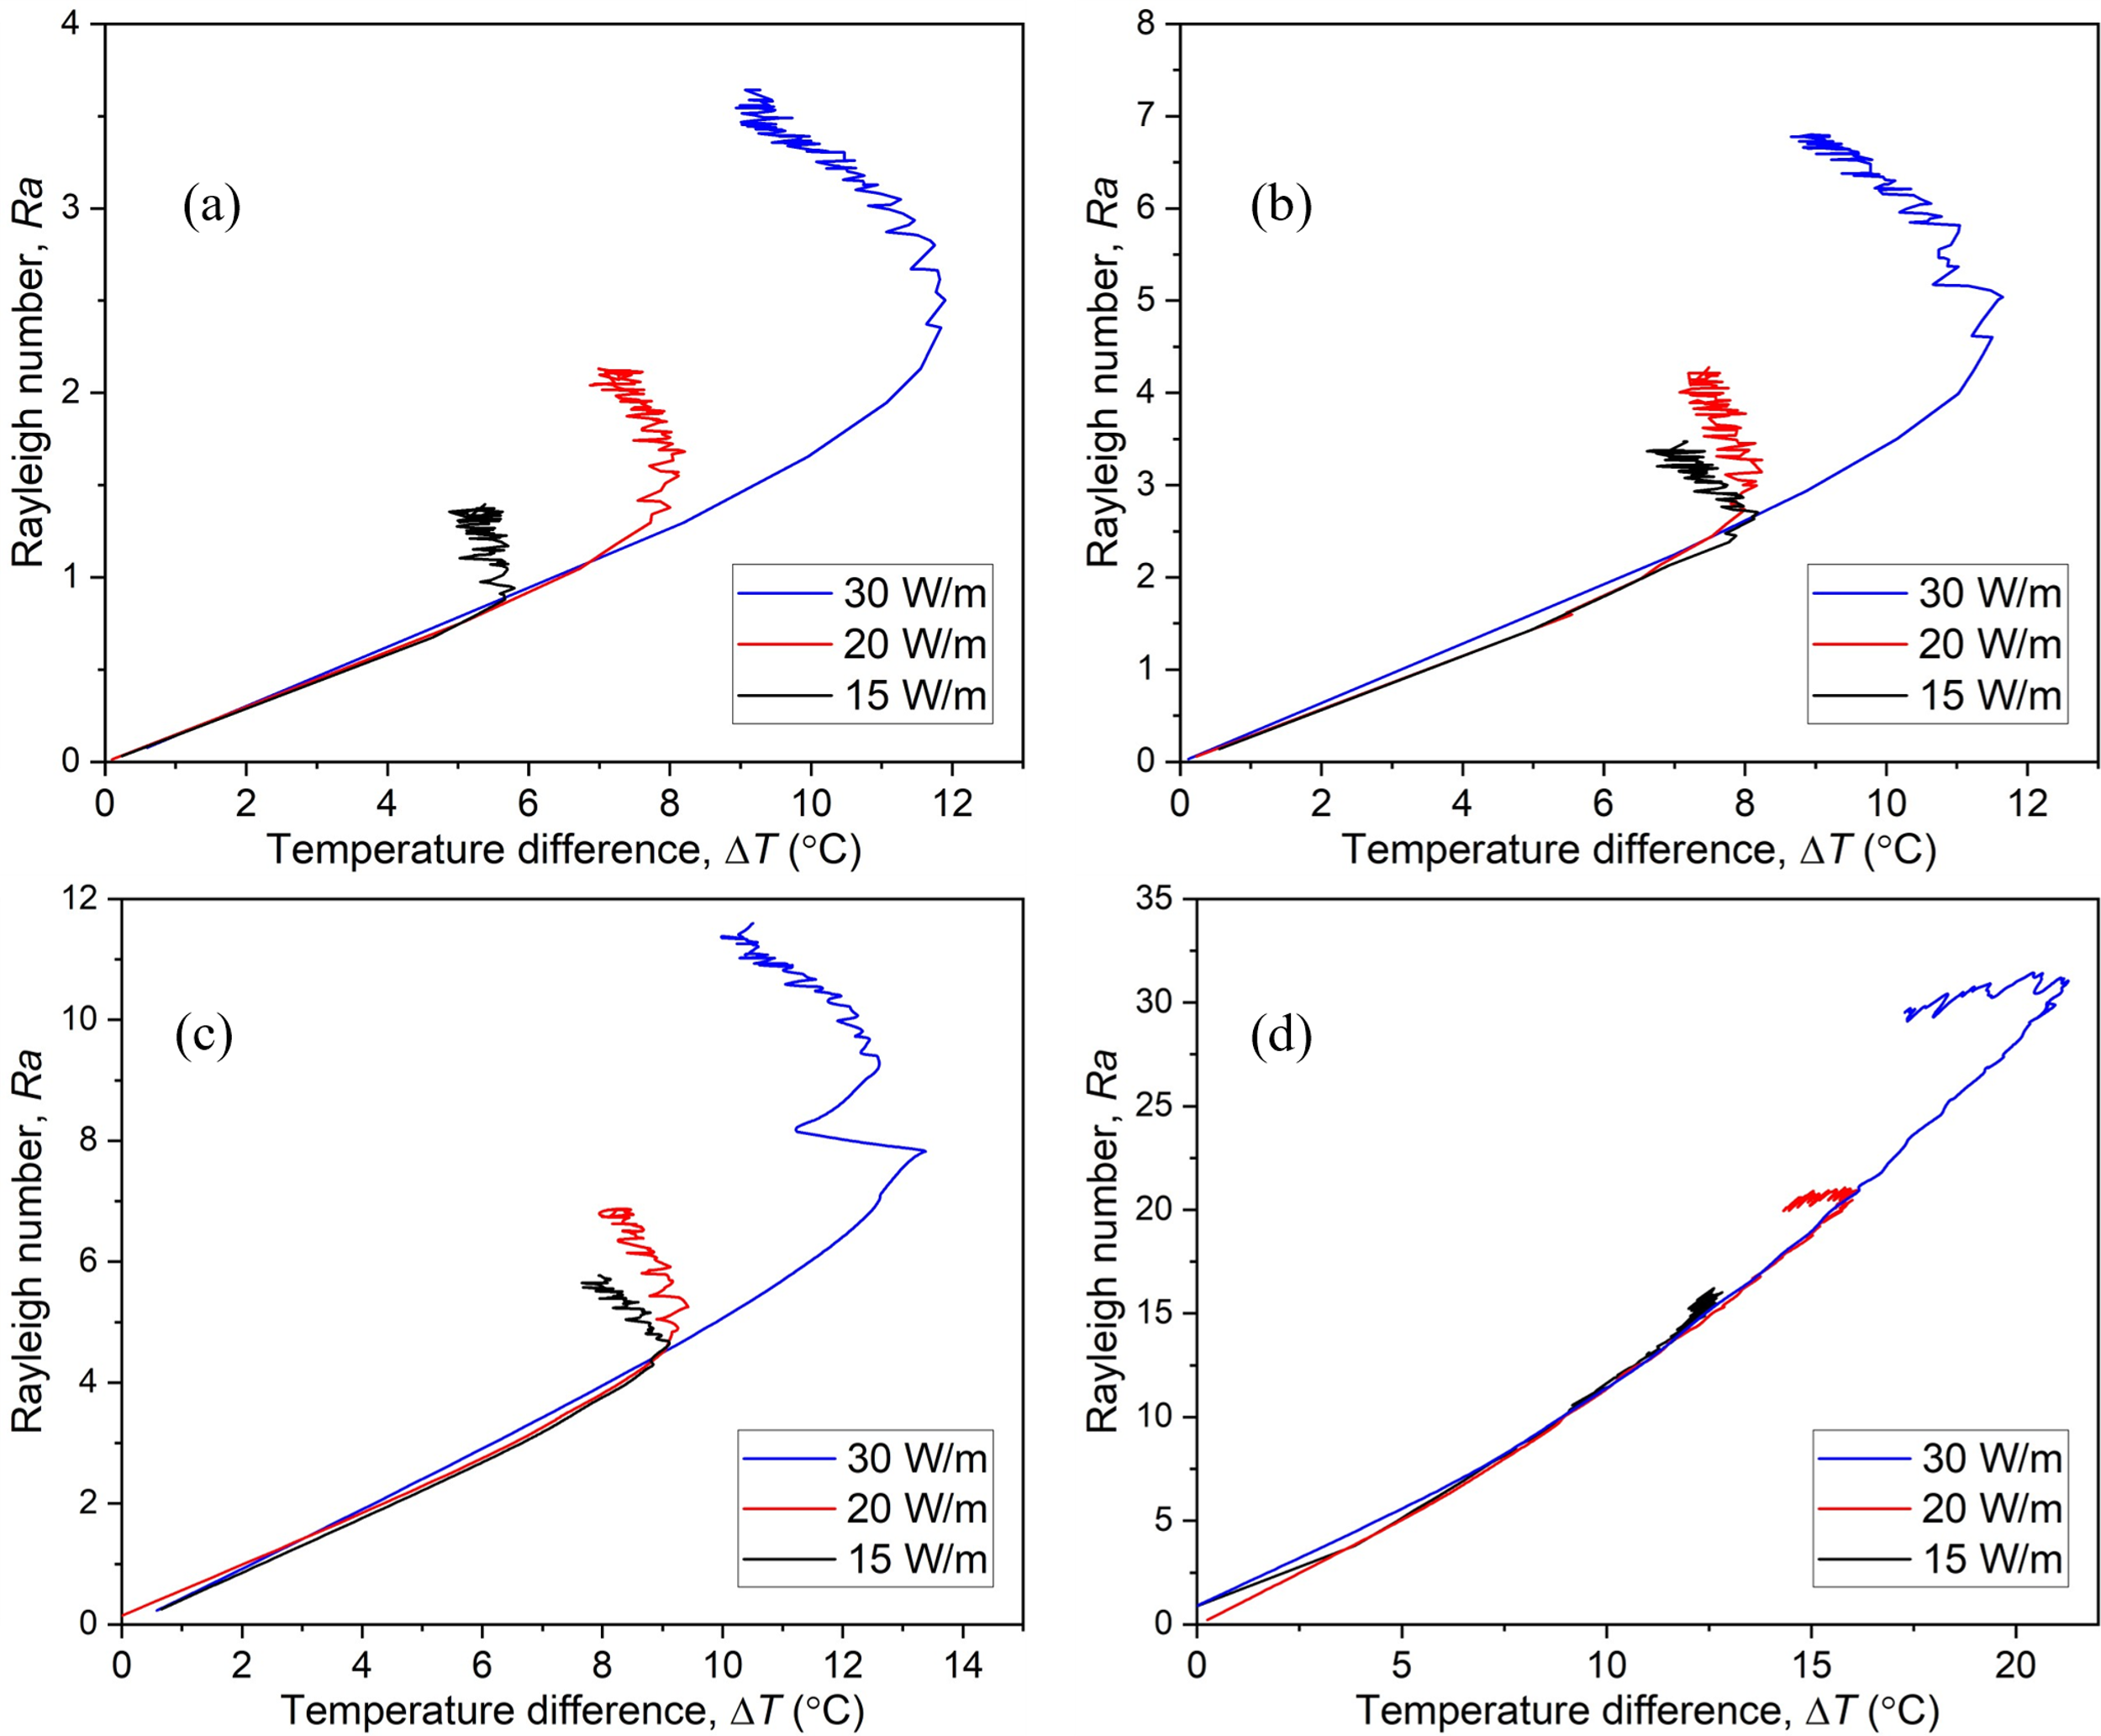
Fig S5. Variation of Rayleigh number with the temperature difference between the wire and the interface at different heating power Q for wire depths a) L = 1 mm b) L = 2 mm c) L = 3 mm and d) L = 7 mm
Fig S5 depicts the corresponding variation of Rayleigh number with the temperature difference (ΔT) between the wire and the interface. It can be seen that there is a linear variation of Rayleigh number at lower values of ΔT and at a given wire depth L, the slope of the plot is constant. This linear behavior corresponds to the initial rise in the temperature difference between the wire and the interface. It is also seen that the initial slope increases with the depth of the wire. However, as the temperature difference between the wire and the interface starts to decrease, the Rayleigh number of the process continues to increase in the case of L = 1, 2 and 3 mm, as seen in Fig S5. Again, the wire depth of L = 7 mm exhibits a different behavior, attaining a nearly constant value of Rayleigh number after the initial linear increase with ΔT and this trend is seen at all heating rates Q.

S4. Emissivity of the interface
The emissivity of the interface is determined by calibrating the temperature measurements of the liquid bulk and the interface using a k-type thermocouple immersed in the liquid and an IR camera, respectively. The liquid used in the present study (glycerol) has very low evaporation rate and it can be reasonably assumed that the temperature of the interface and the liquid bulk are the same once the system achieves steady state conditions. Based on this, the system was allowed to attain steady-state condition at different temperatures (24°C to 41°C) using a constant temperature heating platform, and the temperature was measured by the thermocouple immersed in the liquid. Simultaneously, interface temperature measurements were carried out using the IR camera. The emissivity was adjusted on the IR camera (ε = 0.88) such that the temperature measurements from the thermocouple and the mean temperature of the interface were in correspondence with each other. Fig S6 shows the comparison of the bulk liquid temperature and the corresponding interface temperature for interface emissivity ε = 0.88. It is clear that the two measurements are in close agreement with each other and any variation lies well within the uncertainties (of ±1 °C) associated with each of these measurements.
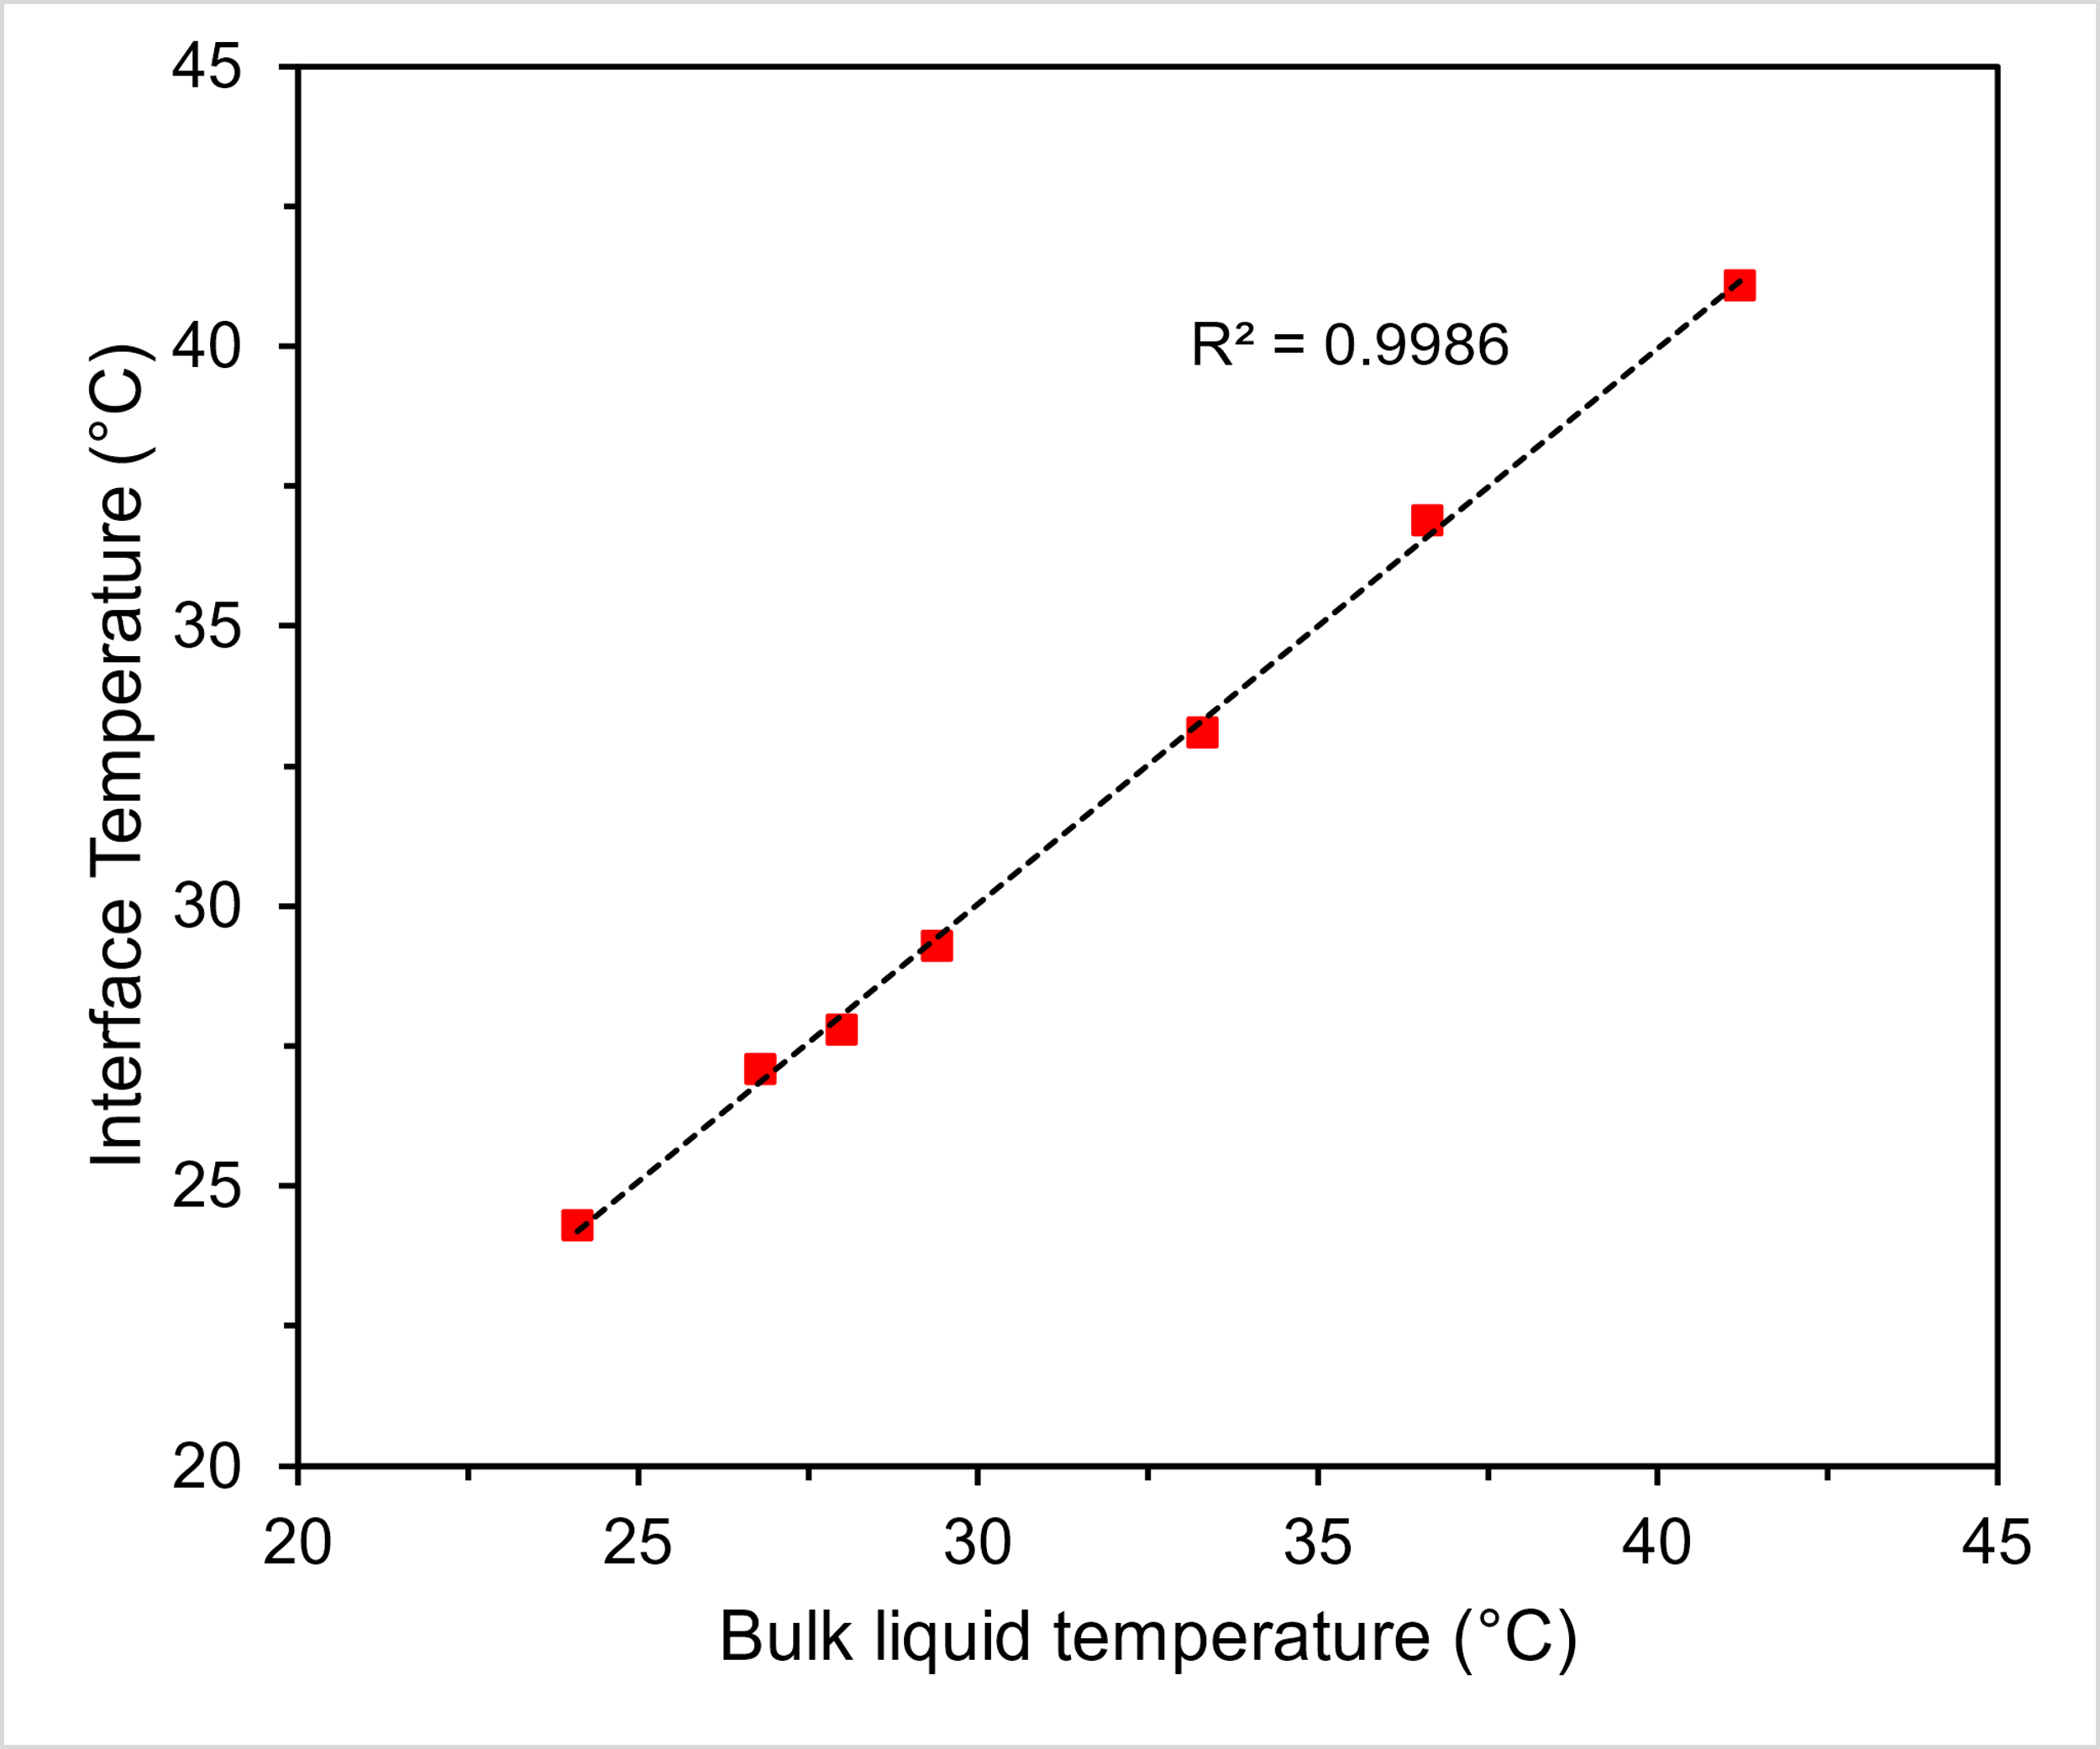
Fig S6. Comparison of bulk liquid temperature and interface temperature at interface emissivity of ε = 0.88

References
Cheng N-S (2008) Formula for the Viscosity of a Glycerol−Water Mixture. Ind Eng Chem Res 47:3285–3288. https://doi.org/10.1021/ie071349z
Volk A, Kähler CJ (2018) Density model for aqueous glycerol solutions. Exp Fluids 59:1–4. https://doi.org/10.1007/s00348-018-2527-y

