Primer | Sequences （5' to 3'）
mTimp1-F | TGAGCCCTGCTCAGCAAAGA
mTimp1-R | GAGGACCTGATCCGTCCACAA
mCollagen I-F | ACCTGTGTGTTCCCTACTCA
mCollagen I-R | GACTGTTGCCTTCGCCTCTG
mGAPDH-F | CTCATGACCACAGTCCATGC
mGAPDH-R | CACATTGGGGGTAGGAACAC
mβ-actin-F | ATGACCCAGATCATGTTTGA
mβ-actin-R | TACGACCAGAGGCATACAG
mMCP1-F | TCCCAATGAGTAGGCTGGAG
mMCP1-R | TCTGGACCCATTCCTTCTTG
mTNFα-F | CCAGGCGGTGCCTATGTCTC
mTNFα-R | CAGCCACTCCAGCTGCTCCT
mPlin5-F | TGTCCAGTGCTTACAACTCGG
mPlin5-R | CAGGGCACAGGTAGTCACAC
mHmox1-F | AGGTACACATCCAAGCCGAGA
mHmox1-R | CATCACCAGCTTAAAGCCTTCT
mAcsl4-F | CCTGAGGGGCTTGAAATTCAC
mAcsl4-R | GTTGGTCTACTTGGAGGAACG
mPtgs2-F | TTCAACACACTCTATCACTGGC
mPtgs2-R | AGAAGCGTTTGCGGTACTCAT
mNox2-F | AGTGCGTGTTGCTCGACAA
mNox2-R | GCGGTGTGCAGTGCTATCAT
mTfr1-F | CTCAGTTTCCGCCATCTCAGT
mTfr1-R | GCAGCTCTTGAGATTGTTTGCA
mHamp1-F | GCACCACCTATCTCCATCAACA
mHamp1-R | TTCTTCCCCGTGCAAAGG
mHamp2-F | ACACAAGTCCTTAGACTGCACA
mHamp2-R | TTCTGCATTGGGATCGCAAT
mFth-F | CCATCAACCGCCAGATCAAC
mFth-R | GAAACATCATCTCGGTCAAA
mFtl-F | CGTCTCCTCGAGTTTCAGAAC
mFtl-R | CTCCTGGGTTTTACCCCATTC
Table S1. Sequences of primers used for qPCR.

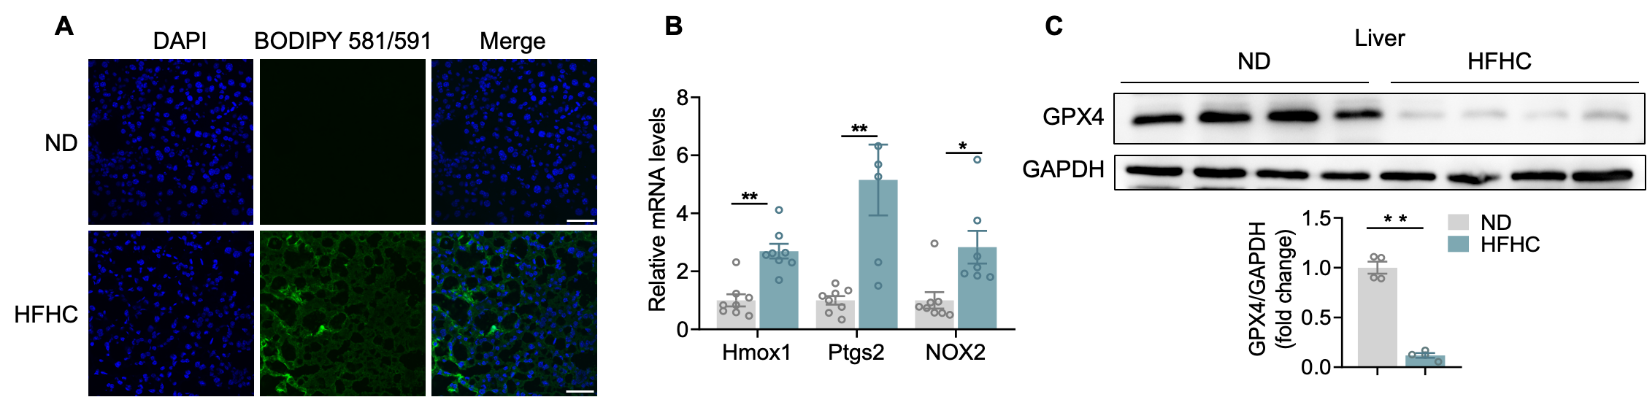
Figure S1. HFHC diet treatment induced ferroptosis in mouse livers. (A) Confocal images of liver sections labeled with C11-BODIPY and DAPI from mice fed ND or an HFHC diet. Green and blue colors indicate lipid ROS (peroxidated lipids) and nucleus respectively. (B) Hepatic mRNA levels of Hmox1, Acsl4, Ptgs2, NOX2 were measured by RT-PCR in ND and HFHC-diet fed mice (n=8/group). (C)Western blot showing expression level of GPX4 in the indicated group, GAPDH served as a loading control. Summary data are presented as mean ± SEM. *<0.05, **<0.01. Abbreviations: Tfr1: transferrin receptor; Hamp1: Hepcidin Antimicrobial Peptide1; Hamp2: Hepcidin Antimicrobial Peptide2; Fth: Ferritin heavy chain; Ftl: ferritin light chain.

