SUPPLEMENTAL MATERIAL

Supplemental Table S1. Description of demographic and clinical information of all participating children from the 4 cohorts according to ECC clinical subtype defined at the moderate/severe caries lesion detection threshold.
 | ECC subtype considering moderate/severe lesions¹ among all participants, n (col %) or mean (SD)
 | I | II | III | IV | V
ZOE 2.0, n (row %) | 4,001 (62) | 1,043 (16) | 729 (11) | 340 (5) | 291 (5)
Age, months (SD) | 53 (7) | 56 (7) | 53 (7) | 57 (6) | 56 (7)
Sex, girl n (%) | 2,039 (51) | 519 (50) | 361 (50) | 177 (52) | 122 (42)
ECC experience¹
Number of affected tooth surfaces, mean dmfs² (SD) | 1 (1) | 9 (4) | 18 (9) | 34 (9) | 55 (11)
Cases¹ with history of restorative or surgical care, n (%) | 268 (7) | 620 (59) | 443 (61) | 327 (96) | 282 (97)
NHANES, n (row %) | 2,874 (73) | 643 (16) | 200 (5) | 158 (4) | 83 (2)
Age, months (SD) | 52 (10) | 56 (10) | 55 (10) | 60 (8) | 57 (9)
Sex, girl n (%) | 1,404 (49) | 314 (49) | 103 (52) | 76 (48) | 40 (48)
ECC experience¹
Number of affected tooth surfaces, mean dmfs² (SD) | 0 (0) | 5 (3) | 18 (8) | 22 (8) | 47 (12)
Cases¹ with history of restorative or surgical care, n (%) | 44 (2) | 293 (46) | 129 (65) | 146 (92) | 76 (92)
SKaPa, n (row %) | 182,164 (88) | 11,940 (6) | 7,759 (4) | 4,605 (2) | 1,644 (1)
Age, months (SD) | 50 (9) | 54 (8) | 51 (8) | 55 (8) | 52 (8)
Sex, girl n (%) | 88,790 (49) | 5,702 (48) | 3,495 (45) | 1,955 (42) | 689 (42)
ECC experience¹
Number of affected tooth surfaces, mean dmfs² (SD) | 0 (0) | 4 (2) | 6 (4) | 13 (6) | 31 (14)
Cases¹ with history of restorative or surgical care, n (%) | 2,767 (2) | 7,698 (65) | 4,343 (56) | 3,835 (83) | 1,426 (87)
Wide Smiles, n (row %) | 7,083 (89) | 574 (7) | 223 (3) | 29 (0.4) | 88 (1)
Age, months (SD) | 54 (7) | 54 (7) | 54 (7) | 52 (8) | 53 (8)
Sex, girl n (%) | 3,397 (49) | 285 (51) | 98 (45) | 15 (52) | 44 (51)
ECC experience¹
Number of affected tooth surfaces, mean dmfs² (SD) | 1 (2) | 1 (2) | 1 (3) | 0 (1) | 2 (4)
Cases¹ with history of restorative or surgical care, n (%) | 248 (4) | 18 (3) | 13 (6) | 0 (0) | 6 (7)
¹defined at the ICDAS ≥3 caries lesion detection threshold; ²dmfs, the number of decayed, missing due to caries, or filled (restored) primary tooth surfaces

Supplemental Table S2. Concordance of ECC clinical subtypes among monozygotic (MZ) twins, 1st degree relatives (full siblings, FS), and 2nd (half-siblings, HS) and 3rd degree (first cousins, FC) relatives in the ZOE 2.0 study. These Latent Class Analysis derived clinical subtypes memberships are contrasted with matched-size groups of participants that are ordered in terms of caries burden (dmfs, a proxy of cumulative disease severity) a ‘positive’ control, and 5 randomly assigned groups of participants of matched size. Concordances are derived from Cohen’s κ with 95% confidence intervals in parentheses.
 | MZ | FS | HS/FC
Number of individuals | 82 | 489 | 673
Number of pairs | 41 | 259 | 382
Established caries lesion detection threshold (ICDAS ≥3) in the entire sample
Latent Class Analysis derived 5 clinical subtypes | 0.40 (0.17, 0.63) | 0.23 (0.14, 0.32) | 0.05 (-0.01, 0.11)
Caries burden (dmfs) ordered 5 participant groups | 0.44 (0.24, 0.64) | 0.23 (0.14, 0.33) | 0.10 (0.03, 0.16)
Randomly assigned 5 participant groups | -0.08 (-0.22, 0.05) | 0.03 (-0.04, 0.11) | -0.02 (-0.07, 0.04)
Early-stage caries lesion detection threshold (ICDAS ≥1) ECC cases-only
Latent Class Analysis derived 5 clinical subtypes | 0.45 (0.24, 0.65) | 0.18 (0.10, 0.27) | 0.04 (-0.01, 0.09)
Caries burden (dmfs) ordered 5 participant groups | 0.49 (0.31, 0.67) | 0.16 (0.08, 0.24) | 0.04 (-0.01, 0.10)
Randomly assigned 5 participant groups | 0.01 (-0.14, 0.17) | -0.02 (-0.08, 0.04) | 0.00 (-0.05, 0.06)
Established caries lesion detection threshold (ICDAS ≥3) ECC cases-only
Latent Class Analysis derived 5 clinical subtypes | 0.23 (0.03, 0.43) | 0.14 (0.06, 0.23) | 0.07 (0.02, 0.13)
Caries burden (dmfs) ordered 5 participant groups | 0.38 (0.31, 0.67) | 0.15 (0.06, 0.23) | 0.09 (0.03. 0.14)
Randomly assigned 5 participant groups | -0.05 (-0.22, 0.12) | -0.01 (-0.08, 0.05) | -0.02 (-0.08, 0.03)

Supplemental Table S3. Confusion matrices of actual versus neural network-predicted ECC subtype classifications and corresponding and estimates of classification accuracy. ECC subtypes were based on the established/severe caries-detection threshold among the entire population, i.e., including caries-free participants. The boosted neural network was applied to training (80%) and validation (20%) data in the ZOE 2.0 study and included caries experience information for 10 easily-examinable tooth surfaces, i.e., the facial/buccal surfaces of the upper anterior 6 maxillary teeth (primary canines and incisors) and the occlusal surfaces of the lower 4 primary molars. Measures of classification performance of models including information from additional (i.e., 16 and 20) index tooth surfaces are presented in Supplemental Figure S3.
Training data
n=4983 |  | model-predicted ECC subtype (n participants) |  |  |  |  | measures of classification accuracy
 |  | I | II | III | IV | V | AUC | Se | PPV | Sp
actual ECC subtype | I | 2980 | 102 | 29 | 0 | 0 | 0.971 | 0.958 | 0.937 | 0.894
actual ECC subtype | II | 168 | 597 | 24 | 13 | 3 | 0.925 | 0.742 | 0.696 | 0.938
actual ECC subtype | III | 30 | 34 | 417 | 33 | 64 | 0.963 | 0.721 | 0.791 | 0.975
actual ECC subtype | IV | 1 | 124 | 35 | 88 | 13 | 0.961 | 0.337 | 0.629 | 0.989
actual ECC subtype | V | 0 | 1 | 22 | 6 | 199 | 0.991 | 0.873 | 0.713 | 0.983
Validation data
n=1245 |  | model-predicted ECC subtype (n participants) |  |  |  |  | measures of classification accuracy
 |  | I | II | III | IV | V | AUC | Se | PPV | Sp
actual ECC subtype | I | 741 | 27 | 9 | 0 | 0 | 0.965 | 0.954 | 0.931 | 0.882
actual ECC subtype | II | 45 | 146 | 8 | 3 | 0 | 0.923 | 0.723 | 0.702 | 0.941
actual ECC subtype | III | 9 | 2 | 109 | 6 | 18 | 0.962 | 0.757 | 0.779 | 0.972
actual ECC subtype | IV | 1 | 33 | 5 | 22 | 4 | 0.957 | 0.338 | 0.667 | 0.991
actual ECC subtype | V | 0 | 0 | 9 | 2 | 46 | 0.992 | 0.807 | 0.676 | 0.981
AUC, area under the receiver operator characteristic curve; Se, sensitivity; PPV, positive predictive value; Sp, specificity

Supplemental Table S4. Descriptive and clinical information (early childhood caries, ECC, experience) of preschool-age children included in the 4 contributing cohorts.
 | ZOE 2.0  (US) | NHANES (US) | SKaPa (Sweden) | Wide Smiles (Australia)
Demographic information
All participants (N) | 6,404 | 3,958 | 208,112 | 7,997
Age, months (SD) | 53 (7) | 53 (10) | 50 (9) | 54 (7)
Sex, girl - n (%) | 4,058 (50) | 1,939 (49) | 100,631 (48) | 3,839 (49)
Dental caries (ECC) experience
Cases at the established disease threshold¹, n (%) | 3,465 (54) | 1,313 (33) | 31,939 (15) | 1,380 (17)
Cases² with history of restorative or surgical care, n (%)³ | 1,940 (56) | 688 (47) | 20,069 (63) | 285 (21)
Number of affected tooth surfaces, mean dmfs⁴ (SD) | 8 (14) | 11 (13) | 6 (8) | 4 (5)
Cases at the early-stage disease threshold⁵, n (%) | 5,882 (92) | n/a | 38,289 (18) | 3,016 (38)
mean number of affected tooth surfaces, dmfs⁴ (SD) | 15 (15) | n/a | 6 (8) | 4 (4)
¹International Caries Detection and Assessment System (ICDAS) codes ≥3; ²defined at the ICDAS ≥3 threshold; ³percent estimated among cases; ⁴dmfs, the number of decayed, missing due to caries, or filled (restored) primary tooth surfaces; ⁵ICDAS codes ≥1

Supplemental Figure S1. Distribution of caries experience among clusters of tooth surfaces (i.e., percent of surfaces that are caries affected) across the 5 ECC clinical subtypes.
 | ECC clinical subtype
 | I | II | III | IV | V
Second molar pits and fissures | 40 | 79 | 69 | 91 | 94
First molar occlusal surfaces | 16 | 60 | 57 | 84 | 96
Molar smooth surfaces | 1 | 10 | 14 | 60 | 77
Canine facial/Lateral proximal surfaces | 2 | 7 | 41 | 22 | 78
Maxillary centrals, Lateral facial | 7 | 13 | 82 | 41 | 97
Canines/Mandibular Laterals | 0 | 1 | 3 | 4 | 24
Mandibular centrals | 0 | 0 | 3 | 2 | 21

Supplemental Figure S2. Visual representation of the 5 clinical subtypes of early childhood caries (ECC) in a sensitivity analysis considering only cases at the established caries lesion detection threshold (ICDAS ≥3) without any previous evidence of restorative dental treatment. These ‘unrestored’ case-only samples are derived from ZOE 2.0 participants with untreated-only disease (n=1,509), NHANES (n=625), and SKaPa (n=11,346). Red color intensities represent gradients of increasing proportions of individuals with caries experience in each of 88 primary tooth surfaces.

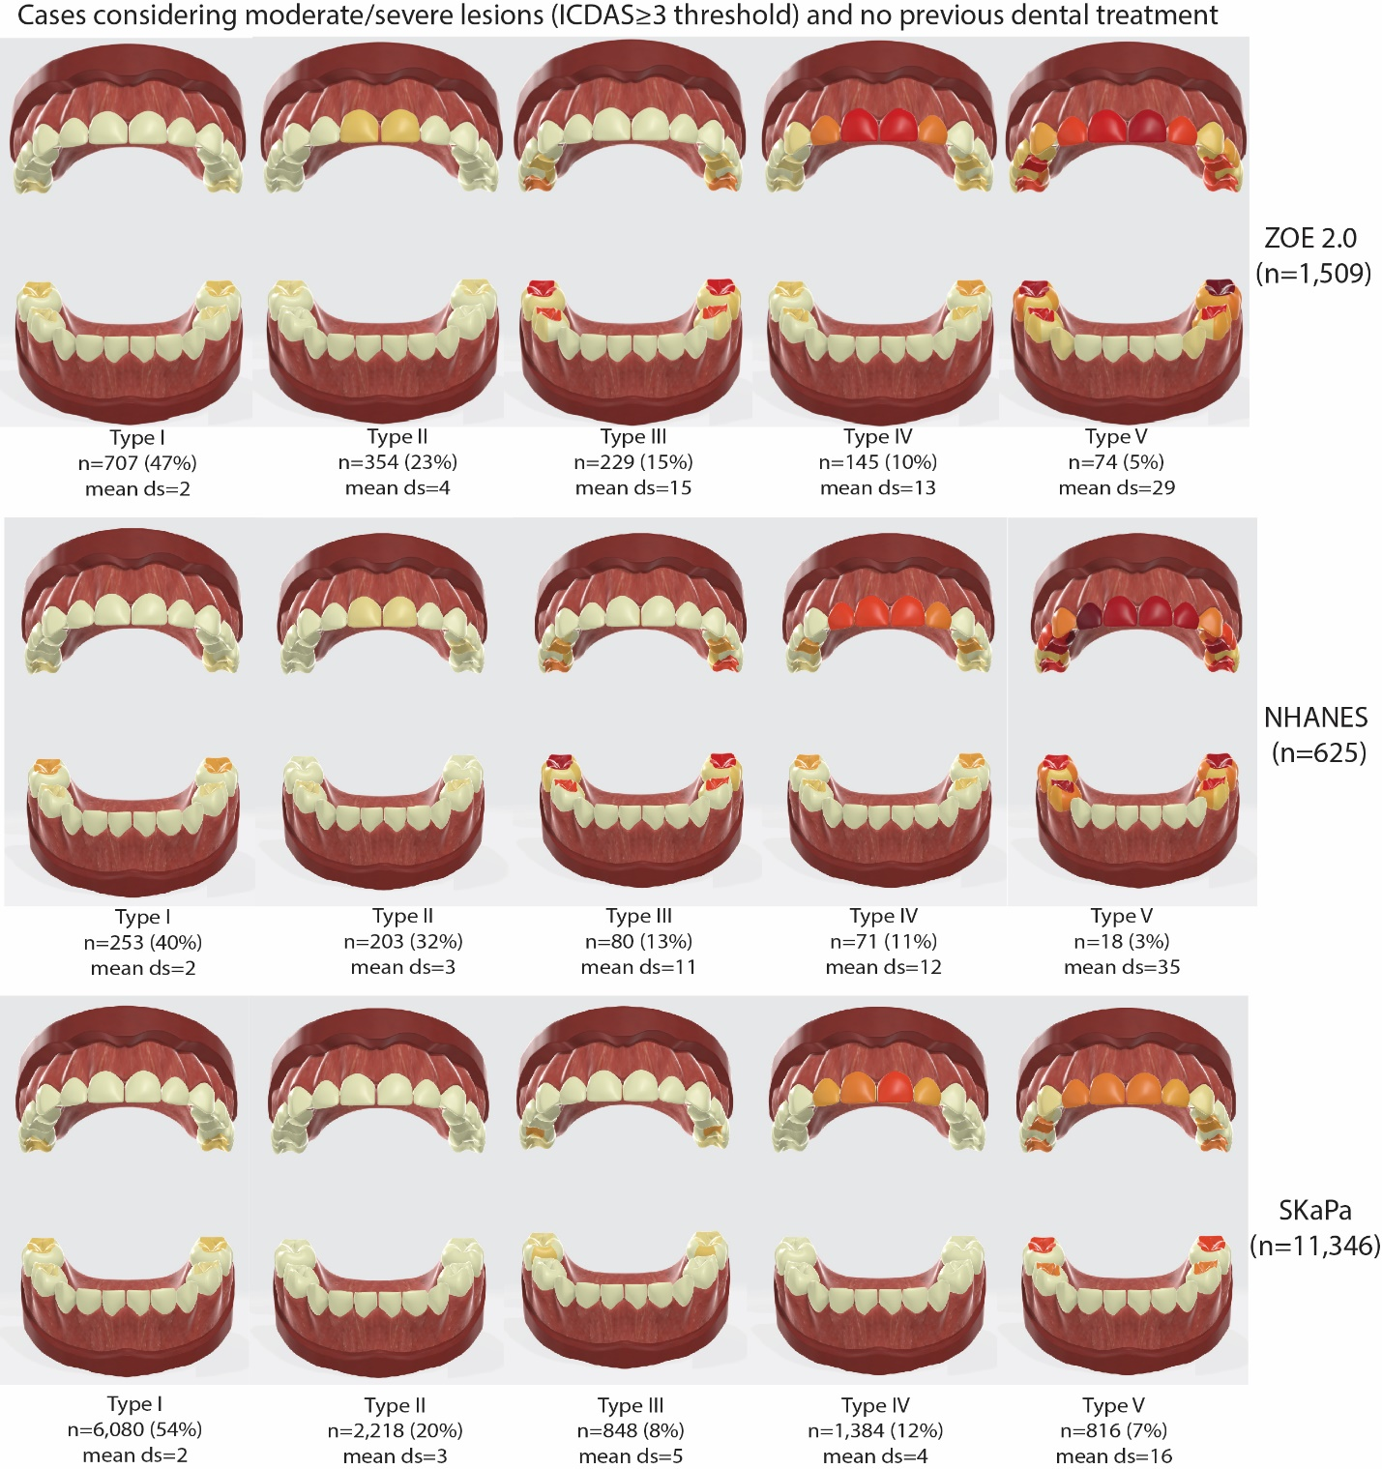

Supplemental Figure S3. Performance of 3 sets of index teeth for classifying participants in ECC clinical subtypes, using a boosted neural network model in training (80% or n=4983) and validation (20% or n=1245) data in the ZOE 2.0 study. The 3 sets of index tooth surfaces include: facial/buccal surfaces of maxillary anterior teeth (4 primary incisors and 2 primary canines) and occlusal surfaces of lower posterior teeth (4 primary molars)—10 surfaces; first set plus proximal surfaces between the 4 maxillary incisors—16 surfaces; second set plus interproximal areas between maxillary lateral incisors (distal surfaces) and canines (mesial surfaces)—20 surfaces.
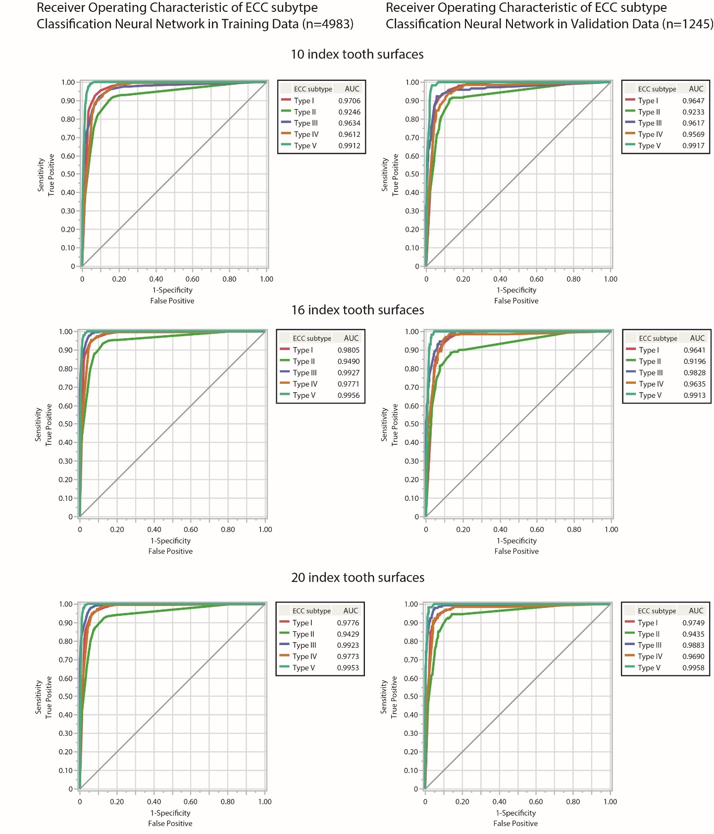
Supplemental Figure S4. Dendrogram illustrating the clustering of the 88 primary tooth surfaces according to caries experience in the ZOE 2.0 study obtained via hierarchical clustering. A 7-cluster solution, presented below, was used to describe differences in caries experience distribution between the 5 ECC clinical subtypes. Differently colored nodes represent distinct clusters of surfaces that are described by name.

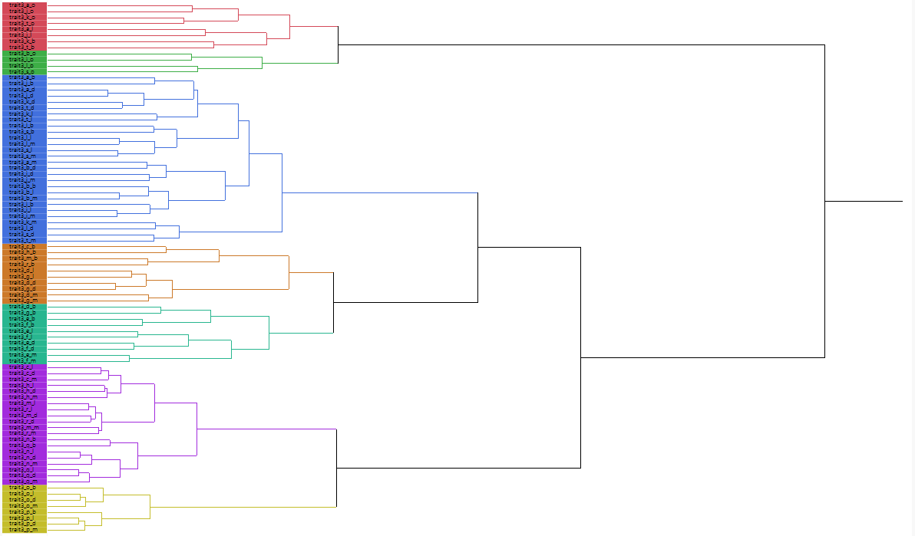
Second molar pits & fissures
First molar occlusal surfaces
Molar smooth surfaces
Canine facial/ Lateral proximal surfaces
Maxillary centrals, Lateral facial surfaces
Canines/Mandibular Laterals
Mandibular centrals

