Graphic Abstract
Zinc Oxide Nanoparticles (ZnO NPs) Treated Two Types of Osteosarcoma Cell Lines for Identifying Differentially Expressed Genes
Xiangfei Guo, Linbang Wang, Honghao Yang, Guanping He
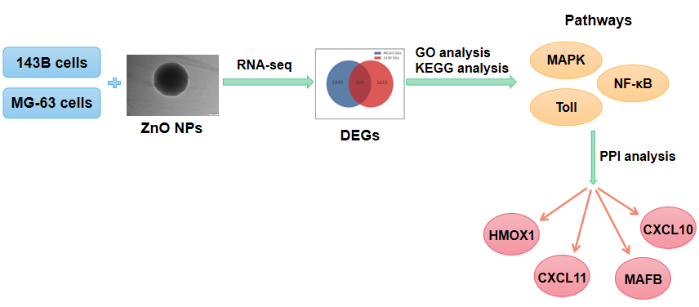
In this study, we use RNA-seq analysis to deeply investigate the potential biological mechanism in the process of ZnO NPs-treated different types of OS cell lines. We detected that 928 genes (DEGs) differentially expressed both in 143B and MG-63 cells, and we validated the top eight DEGs using RT-qPCR. Kyoto Encyclopedia of Genes and Genomes (KEGG) classification analysis found that the MAPK, Toll-like receptor and NF-κB pathways were co-enriched in both OS cell lines. The Protein-protein Interaction (PPI) analysis identified HMOX1, MAFB, CXCL10, and CXCL11 as key players involved in various biological events in OS cells following ZnO NPs treatment. Our findings provide insights into the potential antitumor mechanisms and exploitable biological effects arising from ZnO NPs treatment in OS.

