Supplyment Fig.1
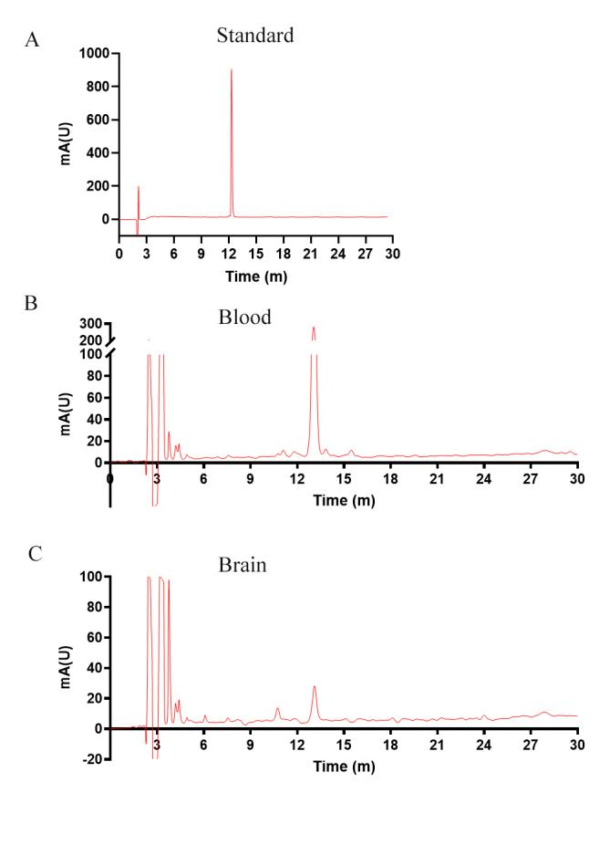
Rus was synthesized and analyzed by HPLC in I/R injury. A) The standard of Rus. B) Rus in blood. C) Rus in brain.

Supplyment Fig.2
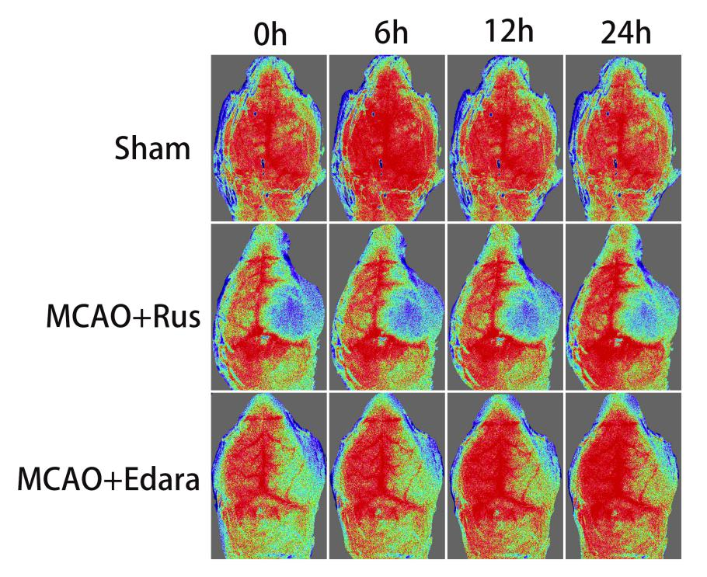
Effect of Rus/Edara on regional cerebral blood flow in mice with cerebral I/R. The representative images of cerebral blood flow of ipsilateral cortex in different groups. The magnitude of CBF is represented by different colors, with blue to red denoting low to high.

